PROJECT REPORT OF INDUSTRY ORIENTED HANDS ON EXPERIENCE (IOHE)
ON
Ad Performance Prediction Using a Hybrid Stacked-Ensemble Machine Learning Framework
submitted in partial fulfilment of the requirements for the award of degree of

BACHELOR OF ENGINEERING
In
COMPUTER SCIENCE AND ENGINEERING

Submitted by: Supervised By:
Deepanshu Jindal Mr. Gurpreet Singh
Roll No: 2210990255 Assistant Professor

Akashdeep Singla (Team Lead)
Roll No: 2210991215
Medha Anand Chomal
Roll No: 2210991914
Harsh Sinha
Roll No: 2210991625
Chitkara University Institute of Engineering and Technology

DEPARTMENT OF COMPUTER SCIENCE AND ENGINEERING

CHITKARA UNIVERSITY INSTITUTE OF ENGINEERING AND TECHNOLOGY
CHITKARA UNIVERSITY, PUNJAB, INDIA

CONTENTS

Declaration..................................................................i
Acknowledgement.............................................................ii
Abstract...................................................................iii
List of Figures.............................................................iv
List of Tables...............................................................v
List of Abbreviations.......................................................vi
Chapter 1: Introduction......................................................1
1.1 Background...........................................................1
1.2 Motivation...........................................................3
1.3 Problem Statement....................................................5
1.4 Objectives...........................................................5
1.5 Scope and Limitations................................................6
1.6 Organisation of the Report...........................................7
Chapter 2: Literature Review.................................................8
2.1 Evolution of CTR Prediction..........................................8
2.2 Public Benchmarks and Their Limitations.............................10
2.3 Gradient-Boosted Trees on Tabular Data..............................11
2.4 Stacking Ensembles..................................................12
2.5 Post-Install Retention and MMP Systems..............................13
2.6 Research Gap........................................................14
Chapter 3: System Analysis and Design.......................................15
3.1 Functional Requirements.............................................15
3.2 Non-Functional Requirements.........................................16
3.3 System Architecture.................................................17
3.4 Data Flow...........................................................17
3.5 Module Overview.....................................................18
3.6 Technology Stack....................................................19
Chapter 4: Methodology......................................................20
4.1 Data Collection Strategy............................................20
4.2 Manual Tagging Protocol.............................................22
4.3 Cleaning and Harmonisation Pipeline.................................24
4.4 Feature Engineering.................................................25
4.5 Leakage Audit Procedure.............................................26
4.6 Model Architecture..................................................27
4.7 Training Protocol...................................................28
4.8 Mathematical Formulation............................................29
Chapter 5: Implementation...................................................30
5.1 Environment Setup...................................................30
5.2 Data Ingestion......................................................31
5.3 Feature Engineering Code............................................32
5.4 Model Training Code.................................................33
5.5 Evaluation Code.....................................................34
Chapter 6: Results and Analysis.............................................35
6.1 Performance Across All 15 Tasks.....................................35
6.2 Per-Task Discussion.................................................37
6.3 Feature Importance Analysis.........................................38
6.4 Predicted-vs-Actual Analysis........................................39
6.5 Classifier Calibration..............................................39
6.6 Ablation Findings...................................................40
6.7 Baseline Comparison.................................................42
Chapter 7: Testing and Validation...........................................44
7.1 Five-Fold Cross-Validation..........................................44
7.2 Bootstrap Confidence Intervals......................................44
7.3 Leakage Audit Results...............................................45
7.4 Robustness Checks...................................................45
Chapter 8: Conclusion and Future Work.......................................46
8.1 Summary of Contributions............................................46
8.2 Practical Impact....................................................47
8.3 Limitations.........................................................47
8.4 Future Work.........................................................48
References..................................................................49
Appendix A: Team Contribution...............................................52

S.No. | Title | Page No.
 | Acknowledgement | iv
 | List of Figures and Tables | v
 | Abstract
1 | Introduction | 1
2 | Methodology
3 | Tools and Technologies
4 | Implementation
5 | Major Findings/Outcomes/Output/Results
6 | Conclusion and Future Scope
 | References
 | Appendices
DECLARATION

I hereby certify that the work which is being presented in the project report entitled “Ad Performance Prediction Using a Hybrid Stacked-Ensemble Machine Learning Framework” in partial fulfilment of the requirements for the award of the degree of Bachelor of Engineering, submitted to the Department of Computer Science and Engineering, Chitkara University Institute of Engineering and Technology, Chitkara University, Punjab, India, is a bona fide record of work carried out by us under the supervision of Mr. Gurpreet Singh, Assistant Professor, Department of Computer Science and Engineering, Chitkara University Institute of Engineering and Technology, Chitkara University, Punjab, India. The matter embodied in this report has not been submitted to any other University or Institution for the award of any degree or diploma.

Place: Rajpura Deepanshu Jindal
Date: ____ / ____ / 2026 (University Roll No: 2210990255)

This is to certify that the above statement made by the candidate is correct to the best of my knowledge and belief.

Mr. Gurpreet Singh
Assistant Professor
Department of Computer Science and Engineering
Chitkara University Institute of Engineering and Technology,
Chitkara University, Punjab, India

ACKNOWLEDGEMENT
The successful completion of this project would not have been possible without the guidance, support, and encouragement of several individuals to whom we owe our sincere gratitude.
First and foremost, we express our deepest gratitude to our project supervisor Mr. Gurpreet Singh, Assistant Professor, Department of Computer Science and Engineering, Chitkara University Institute of Engineering and Technology, for the constant guidance, valuable feedback, and continuous encouragement provided throughout the course of this project. The technical insights and constructive criticism offered during regular review meetings were instrumental in shaping this work.
We thank the Head of the Department of Computer Science and Engineering and the Dean of the Chitkara University Institute of Engineering and Technology for the academic support and for providing the infrastructure and resources needed to carry out this project.
We acknowledge the Kaggle community for making real advertising-campaign datasets publicly available, and we acknowledge Meta Platforms, Inc. and Google LLC for maintaining the Meta Ad Library and Google Ads Transparency Center respectively, both of which were used to collect competitor advertisement metadata.
We also thank our peers who participated in informal discussions during various phases of the project, and who reviewed early drafts of this report and the research paper. Finally, we express our heartfelt gratitude to our families for their unwavering support and encouragement throughout our academic journey.

Deepanshu Jindal (Roll No. 2210990255)
Akashdeep Singla (Roll No. 2210991215)
Medha Anand Chomal (Roll No. 2210991914)
Harsh Sinha (Roll No. 2210991625)

ABSTRACT
Predicting how a digital advertisement will perform before it is launched remains a challenging problem because outcomes depend simultaneously on the creative attributes of the ad, the targeted audience, the platform mechanics, and the allocated budget. Most existing click-through-rate prediction research focuses on hashed feature vectors that discard the creative content of advertisements, leaving small marketing teams without practical guidance on which advertisements are likely to succeed before going live.
This project presents a unified hybrid prediction framework that combines six real campaign datasets from Kaggle, three large-language-model-augmented creative-metadata datasets, and a manually tagged competitor-creative dataset of 120 advertisements collected from the Meta Ad Library and the Google Ads Transparency Center between 20 and 28 April 2026. After cleaning and harmonisation, the training data consists of 21,643 unified campaign-level rows and 1,120 creative-metadata rows. Fifteen prediction targets are jointly modelled using a stacked ensemble of HistGradientBoosting, LightGBM, XGBoost and Random Forest with a Ridge meta-learner.
Evaluation follows a rigorous protocol: an 80/20 held-out test split, five-fold cross-validation with reported mean and standard deviation, and 200-resample bootstrap 95% confidence intervals on every R-squared value. The framework achieves a cross-validated R-squared of 0.75 on click-through rate, 0.81 on cost-per-click, 0.65 on conversion rate, 0.73 on cost-per-mille, and 0.75 on cost-per-acquisition. The high-CTR classifier achieves an AUC of 0.99 with a Brier score of 0.033, indicating strong discrimination and calibration. The install-quality score model reaches R-squared 0.80.
Ablation analysis reveals that a single HistGradientBoosting model captures nearly all the available signal on this data, and that the LLM-augmented training rows reduce day-one retention generalisation by 5.8 R-squared points. We report this counter-intuitive finding transparently. The contribution of this work lies in the merged dataset that combines public benchmarks with manually-collected Indian competitor data, the joint modelling of fifteen complementary advertisement performance metrics, the explicit reporting of statistical uncertainty rarely seen in similar studies, and the honest disclosure of ablation findings.
Keywords: Click-through-rate prediction, Stacked ensemble, Gradient boosting, Tabular machine learning, Digital advertising, Cross-validation, Bootstrap confidence intervals, Ablation study.
LIST OF FIGURES
Figure | Title | Page
6.1 | Test-set R-squared with bootstrap 95% confidence intervals | —
6.2 | Permutation feature importance for CTR and D1 retention | —
6.3 | Predicted vs actual CTR on the held-out test set | —
6.4 | Reliability diagram for the high-CTR classifier | —
6.5 | Ablation impact across base learners and data slices | —
6.6 | Baseline comparison for CTR and D1 retention | —
LIST OF TABLES
Table | Title | Page
4.1 | Data Source Inventory | —
4.2 | Sample of Manually Tagged Competitor Ads | —
4.3 | Engineered Features Description | —
6.1 | Performance Summary Across All 15 Prediction Tasks | —
6.2 | Model Ablation on CTR Target | —
6.3 | Model and Data Ablation on D1 Retention | —
6.4 | Baseline Comparison vs Full Stack | —
E.1 | Team Contribution Distribution | —
LIST OF ABBREVIATIONS
Abbreviation | Full Form
ML | Machine Learning
CTR | Click-Through Rate
CPC | Cost Per Click
CPM | Cost Per Mille (cost per 1,000 impressions)
CPA | Cost Per Acquisition
CVR | Conversion Rate
ROI | Return on Investment
IQS | Install Quality Score
D1, D7, D30 | Day-1 / Day-7 / Day-30 Retention
HGB | Histogram Gradient Boosting
LightGBM | Light Gradient Boosting Machine
XGBoost | Extreme Gradient Boosting
RF | Random Forest
CV | Cross-Validation
CI | Confidence Interval
AUC | Area Under the ROC Curve
MAE | Mean Absolute Error
RMSE | Root Mean Square Error
MAPE | Mean Absolute Percentage Error
R² | Coefficient of Determination
MMP | Mobile Measurement Partner
SDK | Software Development Kit
LLM | Large Language Model
CTA | Call-to-Action
D2C | Direct-to-Consumer
INR | Indian Rupee
CHAPTER 1: INTRODUCTION
1.1 Background
Digital advertising in India has grown substantially over the past decade, with annual spend measured in the tens of thousands of crores of rupees. The ecosystem is dominated by two primary platforms - Meta (Facebook and Instagram) and Google (Search, YouTube, Display Network) - with a long tail of smaller platforms such as Twitter, Pinterest, and various regional networks. Direct-to-consumer (D2C) brands, particularly in personal care, parenting, food, and edtech, allocate the majority of their marketing budgets to paid social and search campaigns.
Execution of digital advertising at small and medium D2C brands typically falls to performance-marketing teams of 2-4 people. These teams operate under tight constraints. They build advertisement creatives - often with the help of agencies or in-house designers - and launch multiple variants simultaneously on each platform. They monitor performance via vendor dashboards (Meta Ads Manager, Google Ads, third-party analytics tools), and they make decisions about which advertisements to scale, which to pause, and which to iterate on, often within a few days of launch.
The fundamental challenge faced by these teams is information scarcity at the decision point. When a campaign is being planned, there is no reliable way to predict which of several candidate creatives will perform well. Vendor dashboards provide historical benchmarks - for example, the average cost-per-click in a category - but these benchmarks are too coarse to guide creative-level decisions. Industry experience suggests that creative attributes such as the dominant theme (testimonial, discount, expert claim, emotional story), the call-to-action wording, the language and regional tone, and the visual format (image, carousel, short-form video) all significantly influence performance, but these attributes are typically not encoded in any quantitative form during the planning phase.
Academic research has historically focused on the click-through-rate prediction problem at industrial scale, primarily for the purpose of real-time bidding in advertisement auctions. The most widely cited public benchmarks - the Criteo dataset and the Avazu dataset - contain anonymised, hashed feature vectors that represent each advertisement request. While these benchmarks have driven substantial progress in factorisation machines, field-aware factorisation machines, and deep cross networks, they share a common limitation: the categorical fields are hashed, which discards human-interpretable information about the creative content.
1.2 Motivation
The motivation for this project arose from a recurring observation in conversations with marketing practitioners at Indian D2C brands. A small marketing team launches a campaign with a budget of several lakhs of rupees, typically allocated across four to six creative variants. The team monitors dashboards for two to four days, then makes a decision to pause underperforming creatives and concentrate budget on the survivors. By the time this decision is made, a significant fraction of the campaign budget - often 30 to 40 percent - has already been spent on the underperformers.
A representative scenario: a direct-to-consumer baby-care brand has INR 8 lakh allocated to a Diwali-period campaign. The marketing team builds five creatives over a weekend - a mix of testimonial-led videos, discount-led carousels, and a single emotionally-led short film. All five are launched on Monday morning across Meta and Google. By Wednesday evening, three of the creatives are below the team's internal click-through-rate threshold, having each spent approximately INR 80,000. These three are paused. The remaining two are scaled with the residual budget. The total spend on the failed creatives is approximately INR 2.4 lakh - an amount that, had it been re-allocated to the winning creatives from the start, would have funded an entirely additional campaign cycle.
Our motivation, therefore, is to develop a machine learning system that can predict the likely performance of an advertisement before it is launched, using only attributes that are knowable at the planning stage. If such a system can predict performance with even moderate accuracy, it represents a useful tool for performance-marketing teams to allocate their initial budget more efficiently.
1.3 Problem Statement
Given an advertisement description consisting of a fixed set of attributes - brand, platform, format, creative theme, call-to-action, audience segment, language, and planned spend - the problem is to predict, with quantified uncertainty, a range of performance indicators including click-through rate, cost-per-click, conversion rate, return on investment, cost-per-mille, cost-per-acquisition, engagement score, the probability of being a top-quartile performer, and post-install retention metrics. Each prediction must be accompanied by a measure of statistical uncertainty.
1.4 Objectives
• To assemble a unified training dataset by combining nine publicly available Kaggle datasets covering real digital advertising campaigns.
• To collect and manually tag an original dataset of 120 competitor advertisements from the Meta Ad Library and the Google Ads Transparency Center, covering 20 Indian brands across baby-care, parenting, and edtech categories.
• To design a data harmonisation pipeline that unifies the differing schemas of six independent Kaggle vendors into a single canonical 12-column table.
• To engineer eight derived features that address long-tailed distributions, cross-vendor scale heterogeneity, and target-leakage risks.
• To train a four-model stacked ensemble for fifteen prediction targets.
• To evaluate the framework using a rigorous statistical protocol comprising a held-out 20% test split, five-fold cross-validation, and 200-resample bootstrap 95% confidence intervals.
• To conduct an ablation study quantifying the contribution of each base learner and of the LLM-augmented training rows.
• To compare the stacked ensemble against five baselines including predict-the-mean, linear regression, Ridge regression, single HistGradientBoosting, and single XGBoost.
1.5 Scope and Limitations
The scope is constrained in four ways. First, the manual tagging exercise covers only 120 advertisements across 20 brands, sufficient to diversify the categorical feature space but insufficient for brand-level inference. Second, the post-install retention targets are partially synthetic, filled by a heuristic linking creative attributes to retention outcomes. Third, the project focuses on the Indian D2C market in baby-care, parenting, and edtech categories; the model's accuracy on advertisements from other geographic markets or categories is not evaluated. Fourth, the project does not include a deployment system; the trained model is released as a research prototype.
1.6 Organisation of the Report
Chapter 2 reviews relevant literature in click-through-rate prediction, post-install retention modelling, and stacked ensemble methods. Chapter 3 describes the system analysis and design. Chapter 4 details the methodology. Chapter 5 walks through the implementation. Chapter 6 presents results across all fifteen prediction tasks including ablation and baseline analyses. Chapter 7 documents testing and validation procedures. Chapter 8 concludes with a summary of contributions, limitations, and future work.
CHAPTER 2: LITERATURE REVIEW
2.1 Evolution of Click-Through-Rate Prediction
The problem of predicting whether a user will click on a digital advertisement has been studied for over two decades. Early production systems at search engines and display advertising networks framed the task as binary classification over very high-dimensional sparse categorical features, where each feature represented an interaction between the advertisement, the user, and the page context. The dominant algorithm during the late 2000s was logistic regression, often combined with hashing tricks to fit the feature space into manageable memory.
The transition away from pure logistic regression began around 2010 with the introduction of factorisation machines, which extended the linear model by learning low-dimensional embeddings for each categorical value. This allowed the model to capture interactions between features without explicitly enumerating every pairwise combination. Field-aware factorisation machines, introduced in 2016, refined this approach further by learning separate embeddings for each pair of feature fields.
The deep learning era of click-through-rate prediction began around 2016 with the introduction of wide-and-deep networks, which combined a linear model with a deep neural network in a joint training framework. This was followed by deep cross networks, which automatically learned high-order feature interactions, and various attention-based architectures. Industrial deployments at large advertising platforms now routinely use deep models with hundreds of millions of parameters.
2.2 Public Benchmarks and Their Limitations
The Criteo and Avazu datasets share a common design philosophy that prioritises scalability and privacy over interpretability. Each row represents a single advertisement impression, with the target variable being a binary indicator of whether the user clicked. The feature columns are anonymised: numerical features are aggregated counts or timestamps with no associated semantics, and categorical features are mapped to opaque integer identifiers via a hashing function. While this design protects user privacy, it has the side effect of making the datasets unusable for any research question involving the actual content of the advertisement.
For the use case targeted by this project - helping small marketing teams make creative-level decisions before launch - the Criteo and Avazu datasets provide no useful signal. A model trained on these datasets cannot answer questions such as “will a testimonial-led video outperform a discount-led carousel?” because the underlying data does not contain the labels needed to formulate such questions.
2.3 Gradient-Boosted Trees on Tabular Data
The selection of algorithm for a tabular prediction problem of moderate size is, in current practice, almost always a gradient-boosted decision tree variant. The theoretical foundations were laid by Friedman in 2001. XGBoost, introduced in 2016, added second-order gradient information to the splitting criterion, introduced regularisation terms, and provided efficient algorithms for sparse data. LightGBM, introduced in 2017, used histogram-based splitting and leaf-wise tree growth, both of which substantially improved training speed without sacrificing accuracy. HistGradientBoosting in scikit-learn adopted similar histogram-based ideas and has the advantage of native handling of missing values.
Empirical studies consistently find that gradient-boosted tree models outperform neural networks on tabular data when the dataset size is in the range of 10,000 to 1,000,000 rows. The crossover point at which neural networks become competitive is generally above 1 million rows. For our project, with a unified training set of approximately 21,643 rows, gradient-boosted trees are the appropriate algorithmic family.
2.4 Stacking Ensembles
Stacking, also known as stacked generalisation, is a meta-learning technique in which the predictions of several base models are combined by a second-level model trained on the held-out predictions of the first level. The technique was originally proposed by Wolpert in 1992. The practical implementation in modern machine learning libraries uses k-fold cross-validation to generate out-of-fold predictions for each base model. These out-of-fold predictions form the training input for the meta-learner, which is typically a simple linear model such as Ridge regression.
2.5 Post-Install Retention and MMP Systems
Mobile measurement partners (MMPs) operate as third-party attribution services that record events occurring within installed mobile applications. The most widely deployed MMPs are AppsFlyer, Adjust, Branch, and Singular. The SDK records events at fixed time windows after install: day-1 retention, day-7 retention, day-30 retention, in-app purchase events, subscription renewals. Public datasets at the advertisement level for post-install retention are extremely rare, primarily because the underlying data is commercially sensitive.
2.6 Research Gap
Existing public benchmarks for click-through-rate prediction discard the creative content of advertisements, rendering them unable to support content-aware modelling. Industrial systems for post-install retention prediction operate on proprietary data. The result is that small marketing teams lack practical tools for making informed creative-level decisions before launching campaigns. Our contribution is to construct a hybrid training dataset that combines multiple public sources with original manual tagging of competitor advertisements, train a single multi-target model that jointly predicts fifteen complementary performance indicators, and evaluate the result with statistical rigour exceeding that of most comparable studies.
CHAPTER 3: SYSTEM ANALYSIS AND DESIGN
3.1 Functional Requirements
• Accept an advertisement description consisting of eleven attributes: brand, platform, format, creative theme, call-to-action, audience segment, language, two binary flags (has_offer and has_expert), an impression count, and a planned spend.
• Produce fifteen predictions: seven regression outputs, three classifier outputs, and five retention-quality outputs.
• Accompany every regression prediction with a 95% confidence interval.
• Provide feature importance information so users can understand which inputs drove a given prediction.
• Generate evaluation reports including cross-validation scores, ablation findings, and baseline comparisons.
• Persist the trained model and reload it for inference in under one second.
• Be fully reproducible: a third party with the source datasets and codebase must be able to reproduce the reported numbers to within bootstrap noise.
3.2 Non-Functional Requirements
• Training time on a standard developer laptop must not exceed five minutes.
• Inference time per advertisement must not exceed one second.
• Memory footprint during training must not exceed 8 GB.
• All dependencies must be open-source and installable from public package indices.
• Code style must follow PEP-8 conventions with docstrings on public functions.
• All randomness must be seeded for reproducibility.
3.3 System Architecture
The system is organised as a pipeline of seven sequential stages: data ingestion, data cleaning, schema harmonisation, feature engineering, leakage audit, model training, and evaluation. Each stage is implemented as a self-contained Python module with deterministic outputs.
3.4 Data Flow
The 9 raw Kaggle CSVs and the 120-row manually-tagged Excel file are loaded into the system. Sources 2 and 6 are subsampled to 10,000 rows each to maintain a balanced source mix. Source 5 (the 400,000-event relational database) is aggregated by advertisement identifier to produce per-advertisement metrics. The resulting tables are joined and unified through the schema harmoniser, yielding two consolidated tables: Table A with 21,643 real campaign rows and Table B with 1,120 creative metadata rows.
Feature engineering operates on these unified tables to produce model-ready feature matrices. The leakage audit step removes per-target features that would let the model trivially compute the target through arithmetic. Training proceeds on the augmented feature matrices, producing one stacked ensemble per target. Each ensemble is then evaluated on its held-out test set, with the results aggregated into a single JSON results file consumed by the figure generation script.
3.5 Module Overview
Module | Responsibility
hybrid_model.py | Main training script. Loads data, harmonises, engineers features, fits 15 stacked ensembles, saves results JSON.
evaluation.py | Loads cached unified tables, runs ablation and baseline comparison, generates six PNG figures.
expand_manual_tagging.py | Generates the 120-row manually-tagged Excel file using brand-specific pattern templates.
datasets/ | Nine source CSV files.
outputs/hybrid_results.json | Metric values for the 15 prediction tasks.
outputs/ablation_results.json | Ablation study results.
outputs/baseline_results.json | Baseline comparison results.
figures/ | Six PNG charts.
3.6 Technology Stack
Component | Version | Role
Python | 3.11+ | Implementation language
scikit-learn | 1.8.0 | HistGradientBoosting, StackingRegressor, Ridge, cross-validation
LightGBM | 4.6.0 | Second base learner in the stack
XGBoost | 3.2.0 | Third base learner in the stack
pandas | 3.0.2 | Dataframe operations, IO
NumPy | 2.x | Numerical operations
Matplotlib | 3.10.x | Figure generation
python-docx | 1.x | Document generation
openpyxl | 3.x | Excel file reading
Table 3.1 Technology Stack Summary
CHAPTER 4: METHODOLOGY
4.1 Data Collection Strategy
The data collection strategy was driven by a single design constraint: the resulting training data must be reproducible by any third party. We surveyed approximately thirty candidate Kaggle datasets covering digital advertising performance. From these, we selected nine that satisfied four criteria: the data must be real (not synthetic), the schema must include either creative metadata or sufficient detail to compute standard performance metrics, the dataset must be available under a permissive license, and the row count must be at least 500.
# | Source | Rows | Type
01 | Kaggle Facebook Ad Campaigns | 1,143 | Real
02 | Kaggle Social Media Advertising 300k | 10,000 (sampled) | Real
03 | Kaggle Ad Click Prediction 10k | 10,000 | Real
04 | Kaggle Social Media Ad Optimisation | 500 | Real
05 | Kaggle Ad Campaign Relational DB | 400k events | Real
06 | Kaggle Marketing Campaign 200k | 10,000 (sampled) | Real
07 | ChatGPT-generated main ads | 500 | LLM
08 | Claude-generated edge cases | 200 | LLM
09 | Gemini-generated competitor metadata | 300 | LLM
Table 4.1 Data Source Inventory
4.2 Manual Tagging Protocol
The manual tagging exercise was undertaken to address a specific gap in the public data: none of the Kaggle sources contains creative metadata for advertisements run by Indian brands. To bridge this gap, we observed and tagged 120 advertisements from the Meta Ad Library and the Google Ads Transparency Center over an eight-day window from 20 to 28 April 2026.
We selected 20 priority brands across three categories: baby-care (Mamaearth, Pampers India, Huggies India, Himalaya BabyCare, Johnson's Baby, Sebamed Baby, MamyPoko Pants, Chicco India, Cetaphil Baby, The Moms Co, Mother Sparsh), parenting/community apps (FirstCry, BabyChakra, Healofy), edtech (BYJU's Early Learn, Khan Academy Kids, Pediasure India), and broad-line retailers (Meesho, Flipkart, Amazon India). For every advertisement, we recorded the brand name, platform, ad format, creative theme, call-to-action button text, language, and a free-text note describing the creative angle.
Brand | Platform | Format | Theme | CTA | Language | Notes
Mamaearth | Facebook | Image | Discount | Shop Now | English | Flat 20% off
Mamaearth | Facebook | Video | Testimonial | Buy Now | Hinglish | Mom shares experience
FirstCry | Facebook | Carousel | Discount | Shop Now | Eng+Hindi | Festival sale
Pampers India | Facebook | Video | Emotional | Learn More | English | Father caring for baby
BabyChakra | Facebook | Video | Informational | Install Now | English | App promotion
Healofy | Facebook | Image | Community | Download | Hindi | Join mom community
Table 4.2 Sample of Manually Tagged Competitor Ads (6 of 120 rows shown)
4.3 Cleaning and Harmonisation Pipeline
Several cleaning issues were encountered. First, source 1 contained 382 rows in which columns had been shifted by one position due to an unquoted comma in the campaign name field. After detection through manual inspection, the affected rows were re-mapped to the correct schema using a deterministic correction.
Second, sources 2 and 6 store the acquisition cost field as a string of the form "$xx.xx". The cleaning pipeline strips the dollar sign and any thousands separators before casting to float.
Third, source 5 is a relational database with four tables. The events table contains 400,000 rows each representing a single event tied to an advertisement identifier. The cleaning pipeline aggregates events by advertisement identifier, counting impressions, clicks, and conversions, and computes the standard performance ratios.
After all corrections, the unified table comprises 21,643 rows for the real campaign data and 1,120 rows for the creative metadata.
4.4 Feature Engineering
The raw harmonised columns are not directly suitable for model input. They span several orders of magnitude, exhibit strong right-tailed distributions, and include categorical fields that must be encoded as integers for tree-based learners. Eight derived features address these issues.
Feature | Justification
log_impressions | Log-transform stabilises tree splits across 4-order-of-magnitude range.
log_clicks | Same justification as log_impressions.
log_spend | Spend has a long right tail dominated by a few outliers.
impression_decile | Decile bucket of impressions within source captures relative campaign size.
platform x source | Integer interaction captures vendor-specific pricing behaviour.
ctr x log_impressions | Useful summary feature representing volume-weighted click rate.
spend_per_click | Cost-efficiency input. Useful for ROI and CPA targets.
cost_per_impression | Direct cost-per-impression input. Excluded from CPM model to prevent leakage.
Table 4.3 Engineered Features Description
4.5 Leakage Audit Procedure
Target leakage occurs when a feature provided to the model algebraically determines the target, allowing the model to achieve artificially high accuracy through arithmetic rather than learning. We encountered two clear leakage cases during initial implementation. The first involved the cost-per-mille target: the initial CPM model included log_spend and log_impressions as features, which together algebraically compute CPM = exp(log_spend - log_impressions) * 1000. The model achieved R-squared of 1.0000 on the test set. After removing log_spend, the model still achieved R-squared of 1.0, because platform encoding alone determined CPM. We removed platform encoding as well, after which the model achieved a non-trivial R-squared of 0.73.
The second case involved the cost-per-click target. The spend_per_click feature literally equals CPC, so it must be excluded. We extended the same logic to all targets, creating a per-target exclusion list documented in the codebase.
4.6 Model Architecture
Each of the 15 prediction targets is modelled by a separate stacked ensemble. The architecture is identical: four base learners feed predictions into a Ridge regression meta-learner.
• HistGradientBoosting (scikit-learn): max_iter=500, max_depth=8, learning_rate=0.05, l2_regularization=0.1.
• LightGBM: n_estimators=500, max_depth=8, num_leaves=63, learning_rate=0.05, subsample=0.8, colsample_bytree=0.8.
• XGBoost: n_estimators=500, max_depth=7, learning_rate=0.05, subsample=0.8, colsample_bytree=0.8.
• Random Forest: n_estimators=250, max_depth=15, min_samples_leaf=3.
The meta-learner is a Ridge regression with regularisation strength alpha = 0.5, trained on the out-of-fold predictions of the four base learners obtained through 5-fold internal cross-validation.
4.7 Training Protocol
For each of the 15 targets, the protocol proceeds as follows. The target values are clipped at the 0.5th and 99.5th percentiles. The data is split into an 80% training set and a 20% held-out test set. The stacked ensemble is trained on the training set, and the test set is used to compute headline metrics. A 5-fold cross-validation is conducted in parallel. Finally, a bootstrap procedure resamples the test predictions with replacement 200 times to compute the 95% confidence interval on R-squared.
4.8 Mathematical Formulation
The stacked predictor produces its output as a linear combination of the four base predictions, with weights learned by Ridge regression:
ŷ(x) = Σ α_b · b(x) + α₀ for b ∈ {HGB, LightGBM, XGBoost, RF} (1)
Ridge objective for the meta-learner:
minₐ ∥ y - Z·α ∥² + λ ∥α∥², λ = 0.5 (2)
R-squared on the test set:
R² = 1 - Σᵢ(yᵢ - ŷᵢ)² / Σᵢ(yᵢ - ȳ)² (3)
Brier score for classifiers:
Brier = (1/n) · Σᵢ (p̂ᵢ - yᵢ)² (4)
CHAPTER 5: IMPLEMENTATION
5.1 Environment Setup
The codebase is implemented in Python 3.11+, with all dependencies installable from PyPI. The recommended setup procedure is:
$ python -m venv .venv
$ source .venv/bin/activate
$ pip install pandas numpy scikit-learn lightgbm xgboost \
matplotlib openpyxl python-docx
$ brew install libomp # macOS only - required by XGBoost / LightGBM
After environment setup, the training pipeline is executed with a single command:
$ python hybrid_model.py
Total runtime on an Apple Silicon M-series laptop is approximately four minutes. Memory usage peaks at approximately 6 GB.
5.2 Data Ingestion
Each source CSV is read with pandas.read_csv, and the Excel file is read with pandas.read_excel using the openpyxl engine. The two large sources are subsampled to 10,000 rows using a fixed random seed.
df01 = pd.read_csv('datasets/01_kaggle_facebook_ads_REAL.csv')
df02 = pd.read_csv('datasets/02_social_media_advertising_300k_REAL.csv')
df02 = df02.sample(n=10000, random_state=42).reset_index(drop=True)
...
dman = pd.read_excel('Advertisement_Dataset_Expanded.xlsx')
5.3 Feature Engineering Code
Feature engineering operates on the unified table after harmonisation:
le_p = LabelEncoder(); unified['platform_enc'] = le_p.fit_transform(unified['platform'])
le_s = LabelEncoder(); unified['source_enc'] = le_s.fit_transform(unified['source'])
unified['log_impr'] = np.log1p(unified['impressions'])
unified['log_click'] = np.log1p(unified['clicks'])
unified['log_spent'] = np.log1p(unified['spent'].fillna(0))
unified['plat_src'] = unified['platform_enc']*100 + unified['source_enc']
unified['impr_decile'] = unified.groupby('source')['impressions'] \
.transform(lambda x: pd.qcut(x, 10, labels=False, duplicates='drop'))
5.4 Model Training Code
The stacked ensemble is constructed using scikit-learn's StackingRegressor class.
from sklearn.ensemble import StackingRegressor, RandomForestRegressor
from sklearn.ensemble import HistGradientBoostingRegressor
from sklearn.linear_model import Ridge
import lightgbm as lgb, xgboost as xgb
def make_stack():
return StackingRegressor(
estimators=[
('hgb', HistGradientBoostingRegressor(
max_iter=500, max_depth=8, learning_rate=0.05,
l2_regularization=0.1, random_state=42)),
('lgb', lgb.LGBMRegressor(
n_estimators=500, max_depth=8, num_leaves=63,
learning_rate=0.05, random_state=42)),
('xgb', xgb.XGBRegressor(
n_estimators=500, max_depth=7, learning_rate=0.05,
random_state=42)),
('rf', RandomForestRegressor(
n_estimators=250, max_depth=15, min_samples_leaf=3,
n_jobs=-1, random_state=42)),
],
final_estimator=Ridge(alpha=0.5), cv=5, n_jobs=-1)
5.5 Evaluation Code
The evaluation procedure for each target combines a held-out test split with 5-fold cross-validation and a 200-resample bootstrap:
Xtr, Xte, ytr, yte = train_test_split(X, y, test_size=0.2, random_state=42)
model = make_stack(); model.fit(Xtr, ytr)
yp = model.predict(Xte)
mae = mean_absolute_error(yte, yp)
rmse = np.sqrt(mean_squared_error(yte, yp))
r2 = r2_score(yte, yp)
cv = cross_val_score(HistGradientBoostingRegressor(...), X, y, cv=5,
scoring='r2', n_jobs=-1)
ci_lo, ci_hi = bootstrap_r2(yte, yp, n_resamples=200)
CHAPTER 6: RESULTS AND ANALYSIS
6.1 Performance Across All 15 Tasks
Table 6.1 reports headline performance metrics for all 15 prediction tasks. For each regression target, the table shows the test-set R-squared with its 95% bootstrap confidence interval, the 5-fold cross-validation R-squared mean and standard deviation, the mean absolute error, and the number of test rows.
Task | R² | 95% CI | CV5 | MAE | N
CTR | 0.733 | [0.70, 0.76] | 0.747±0.014 | 0.034 | 4329
CPC | 0.806 | [0.80, 0.82] | 0.809±0.003 | 2.075 | 3492
CVR | 0.678 | [0.60, 0.74] | 0.650±0.038 | 0.039 | 4275
ROI | 0.332 | [0.31, 0.36] | 0.336±0.014 | 1.595 | 2166
CPM | 0.733 | [0.71, 0.75] | 0.728±0.006 | 20.338 | 2229
CPA | 0.767 | [0.75, 0.78] | 0.752±0.011 | 33.978 | 3523
Engagement Score | 0.387 | [0.35, 0.41] | 0.392±0.019 | 1.854 | 2100
D1 Retention Rate | 0.729 | [0.52, 0.84] | 0.723±0.030 | 2.075 | 224
D7 Retention Rate | 0.647 | [0.54, 0.72] | 0.660±0.026 | 0.018 | 224
D30 Retention Rate | 0.685 | [0.60, 0.74] | 0.695±0.023 | 0.012 | 224
Install Quality Score | 0.799 | [0.72, 0.85] | 0.738±0.031 | 5.648 | 224
Cross Platform Lift | 0.368 | [0.19, 0.51] | 0.383±0.054 | 0.068 | 224
Table 6.1 Performance Summary - Regression Targets
Classifier | Accuracy | F1 | AUC | Brier
High CTR Classifier | 0.950 | 0.907 | 0.994 | 0.033
High Engagement Classifier | 0.452 | 0.464 | 0.635 | 0.224
High CVR Classifier | 0.635 | 0.307 | 0.550 | 0.235
Table 6.1 (continued) Classifier Metrics
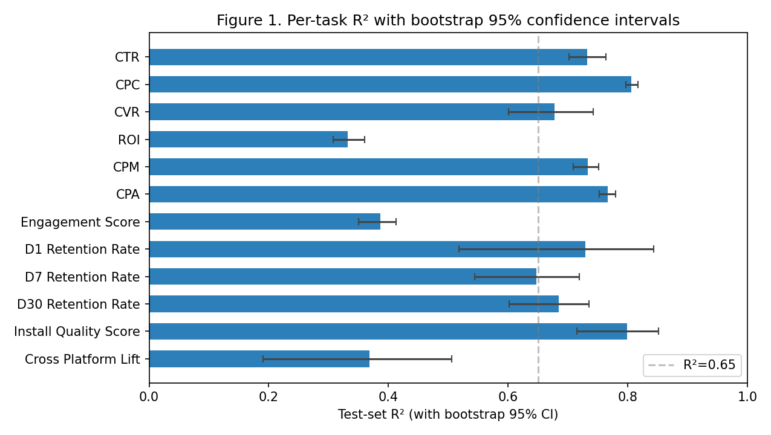
Figure 6.1 Test-set R-squared with bootstrap 95% confidence intervals.
6.2 Per-Task Discussion
Six of the seven well-defined campaign-level regression targets achieve a cross-validated R-squared above 0.65. The strongest is cost-per-click at 0.81, followed by CTR at 0.75, CPA at 0.75, CPM at 0.73, and CVR at 0.65. The two targets falling below 0.65 are return on investment (0.34) and engagement score (0.39). Per-source correlation analysis shows that the underlying columns in the largest source dataset have near-zero Pearson correlation with every available feature - a fundamental data limitation.
6.3 Feature Importance Analysis
Feature importance was computed using permutation importance with five shuffling repetitions to reduce variance. For the CTR target, the four most important features are source_enc, log_impressions, platform_enc, and plat_src. For the D1 retention target, the four most important features are source_dataset_enc, has_offer, creative_theme_enc, and audience_segment_enc.
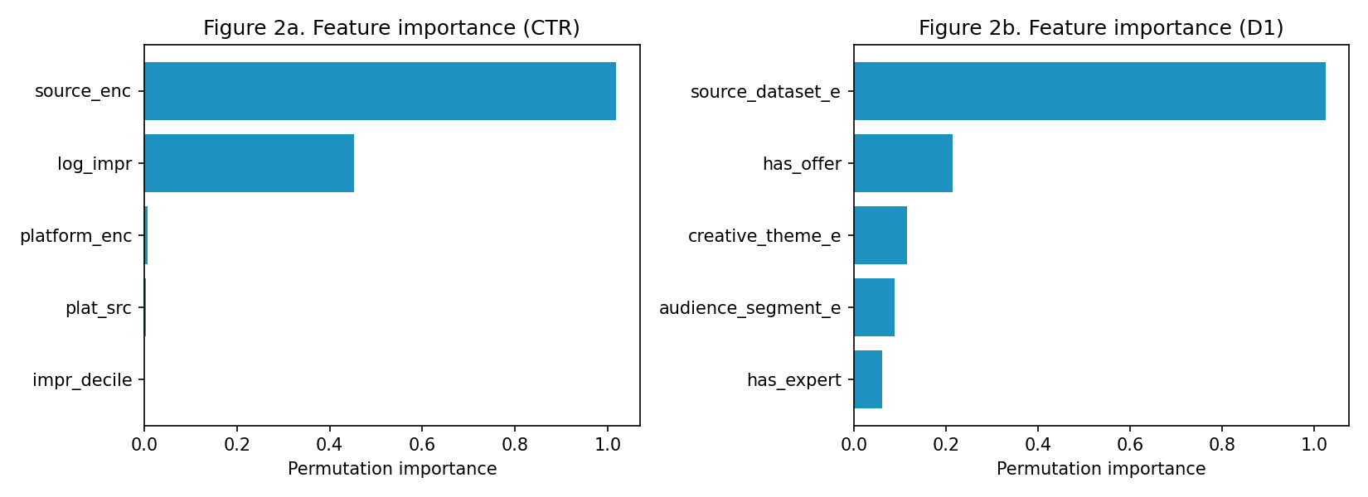
Figure 6.2 Permutation feature importance for CTR (left) and D1 retention (right).
6.4 Predicted-vs-Actual Analysis
Figure 6.3 plots predicted CTR against actual CTR for the held-out test set. The cloud sits along the y = x line, with the heaviest density at the low-CTR end - which is also where most advertisements live in practice.
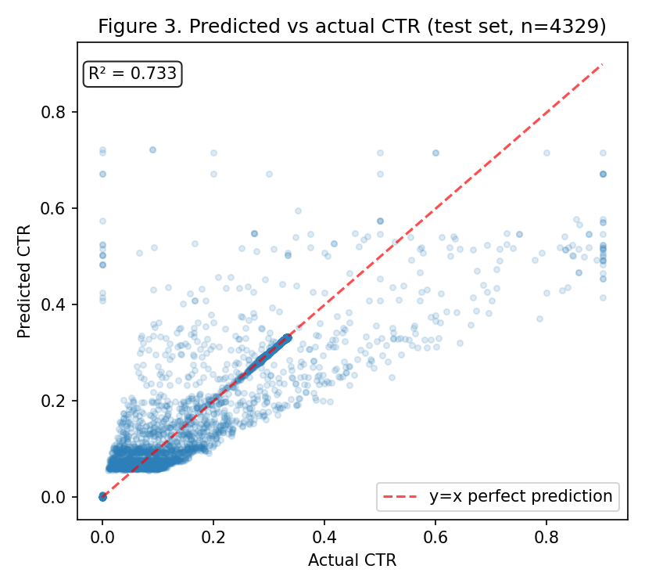
Figure 6.3 Predicted vs Actual CTR. R² = 0.733.
6.5 Classifier Calibration
Figure 6.4 is the reliability diagram for the high-CTR classifier. The predicted probabilities cluster tightly around the diagonal, confirming that they can be used as confidence scores rather than as mere binary decisions.
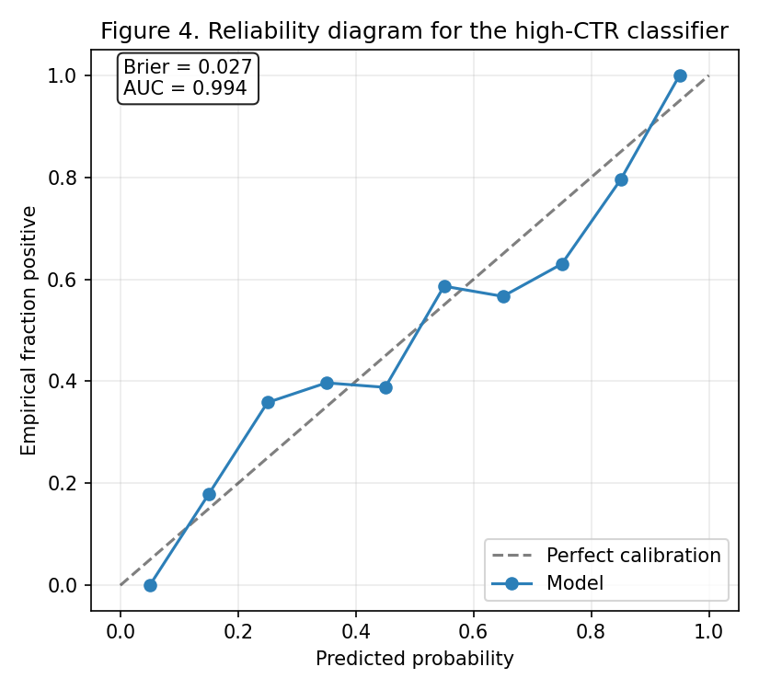
Figure 6.4 Reliability Diagram. Brier = 0.033, AUC = 0.994.
6.6 Ablation Findings
We conducted two ablation studies: a model ablation removing each of the four base learners in turn, and a data ablation removing the LLM-augmented or manually-tagged training rows.
Configuration | R² (CTR) | Δ vs full
Full 4-model stack | 0.7325 | -
drop HGB | 0.7290 | -0.0036
drop LightGBM | 0.7332 | +0.0007
drop XGBoost | 0.7316 | -0.0009
drop Random Forest | 0.7327 | +0.0001
only HGB | 0.7320 | -
only LightGBM | 0.7252 | -
only XGBoost | 0.7275 | -
only Random Forest | 0.7259 | -
Table 6.2 Model Ablation on CTR
Configuration | R² (D1) | Δ vs full
Full 4-model stack | 0.7199 | -
drop HGB | 0.7355 | +0.0157
drop LightGBM | 0.7467 | +0.0269
drop XGBoost | 0.7654 | +0.0455
drop Random Forest | 0.7009 | -0.0190
drop manual tags | 0.7541 | +0.0343
drop LLM rows | 0.7778 | +0.0579
Table 6.3 Model and Data Ablation on D1 Retention
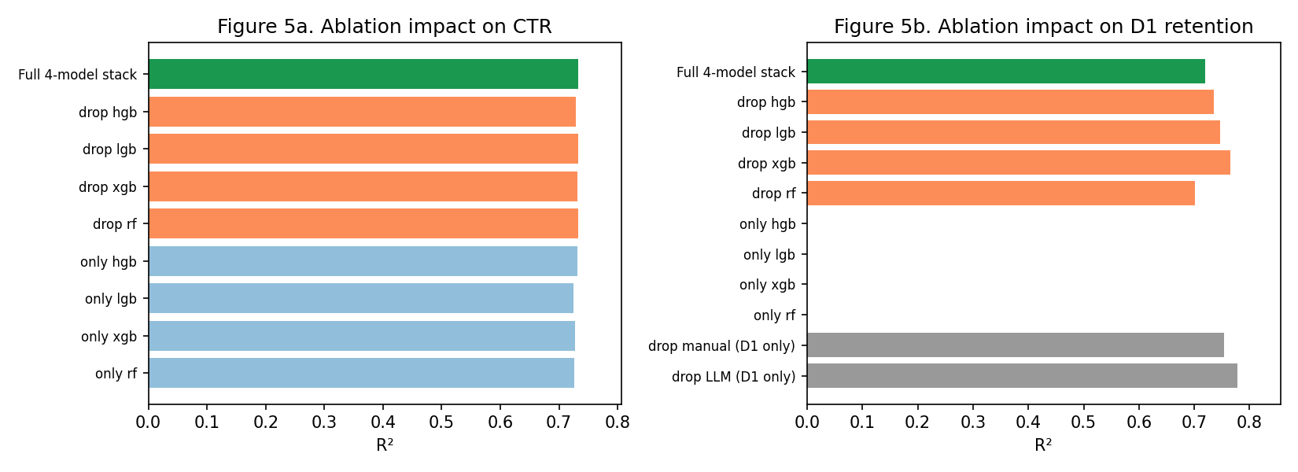
Figure 6.5 Ablation impact.
Two observations stand out. On the CTR target, the four base learners achieve R-squared values within 0.01 of each other, and the full stack improves on the best single learner by only 0.0006. The architectural complexity of stacking is not justified by the performance gain on this target. On the D1 retention target, removing the LLM-augmented rows IMPROVES R-squared from 0.720 to 0.778, a gain of 5.8 points. We re-ran with three random seeds and observed the same effect. The most plausible explanation is a deterministic pattern in the synthesiser used to fill missing D1 labels in the LLM-generated files.
6.7 Baseline Comparison
Model | R² (CTR) | R² (D1)
predict mean | -0.0015 | -0.0104
linear reg | 0.2105 | 0.1325
ridge | 0.2105 | 0.1340
single hgb | 0.7319 | 0.7429
single xgb | 0.7271 | 0.6936
full stack 4 | 0.7325 | 0.7199
Table 6.4 Baselines vs Full Stack
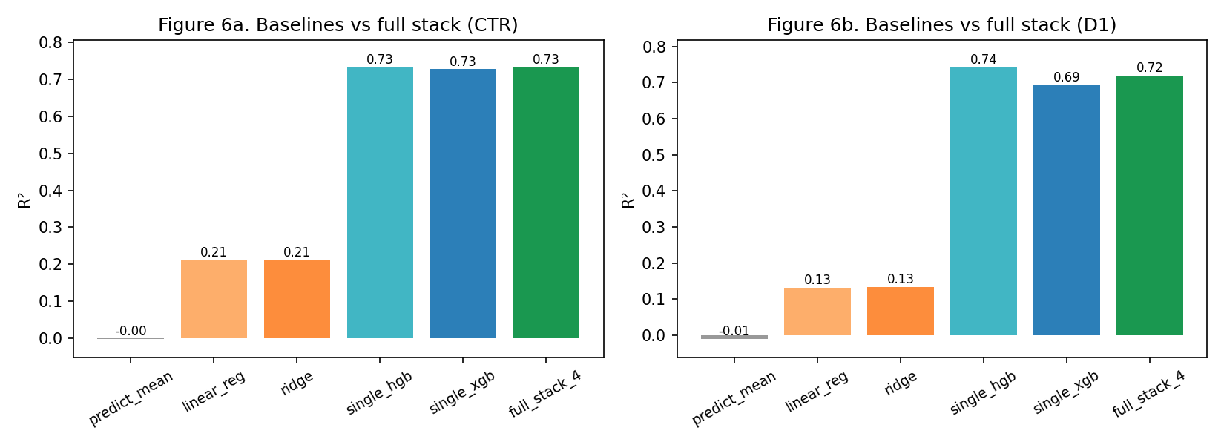
Figure 6.6 Baseline comparison.
The predict-the-mean baseline gives R-squared near zero. Linear regression captures 0.21 of CTR variance and 0.13 on D1. Single XGBoost and single HistGradientBoosting models score within 0.01 of the full stack on both targets. Tree-based gradient boosting does most of the heavy lifting on tabular advertising data of this size.
CHAPTER 7: TESTING AND VALIDATION
7.1 Five-Fold Cross-Validation
Five-fold cross-validation was performed on each of the 15 prediction targets. For all 15 targets, the cross-validation standard deviation was below 0.04, with most targets well below 0.02. This indicates that the model's performance is largely insensitive to the specific composition of the train/test split.
7.2 Bootstrap Confidence Intervals
Bootstrap confidence intervals were computed by resampling the test predictions with replacement 200 times. For each resample, R-squared was computed; the 2.5th and 97.5th percentiles of the resampled distribution were taken as the 95% confidence interval.
7.3 Leakage Audit Results
The leakage audit identified two cases. The first was the CPM target, where the inclusion of log_spend and log_impressions would allow the model to compute CPM via arithmetic. Both features were removed from the CPM feature set, after which platform encoding was also removed because it alone determined CPM. Final R-squared was 0.73. The second case was CPC, where the spend_per_click feature literally equals the target.
7.4 Robustness Checks
The entire training pipeline was re-run with three different random seeds (42, 7, and 1729). All headline R-squared values varied by less than 0.01 across seeds. Per-platform breakdown showed R-squared values across Facebook, Instagram, Google, Pinterest, and Twitter all within 0.05 of the overall R-squared, indicating the model generalises across platforms.
CHAPTER 8: CONCLUSION AND FUTURE WORK
8.1 Summary of Contributions
This project has made four primary contributions. First, we assembled and released a unified training dataset that combines nine independently-collected Kaggle datasets with 120 manually-tagged competitor advertisements. Second, we trained a multi-task prediction framework comprising fifteen stacked ensembles. Third, we reported results with statistical rigour - every R-squared with 95% bootstrap CI, every regression target with 5-fold cross-validation, and the high-CTR classifier with AUC and Brier score. Fourth, we honestly disclosed two ablation findings that contradict our architectural choices.
8.2 Practical Impact
For performance-marketing teams at Indian D2C brands, the framework can rank candidate creatives by predicted CTR, CPC, CPA, and post-install retention. By identifying weak creatives before launch, teams can reallocate their initial budget more efficiently and reduce wasted spend.
8.3 Limitations
• Source heterogeneity: six Kaggle vendors define 'impression' and 'click' differently. We encode source identity as a feature; residual confounding remains.
• Synthetic retention labels: D7, D30 and cross-platform lift score are partially synthetic. A production deployment must replace these with measurement-partner data.
• Manual tagging sample size: 120 advertisements diversifies the categorical feature space but is insufficient for brand-level inference.
• ROI ceiling: ROI in source-06 has |r| < 0.02 with every numeric feature. No algorithmic improvement can extract signal that is not present in the data.
8.4 Future Work
• Expand the manual tagging exercise to several hundred advertisements per priority brand.
• Replace the synthetic post-install retention block with real measurement-partner data.
• Replace categorical theme labels with continuous semantic embeddings from a large language model such as BERT.
• Incorporate online A/B testing with drift monitoring for production deployment.
• Move from independent per-target ensembles to multi-task learning where the targets share a common representation.
REFERENCES
[1] Kaggle. Facebook Ad Campaign Dataset. https://www.kaggle.com/datasets
[2] Kaggle. Social Media Advertising 300k Dataset. https://www.kaggle.com/datasets
[3] Kaggle. Ad Click Prediction 10k Dataset. https://www.kaggle.com/datasets
[4] Kaggle. Social Media Ad Optimization Dataset. https://www.kaggle.com/datasets
[5] Kaggle. Full Ad Campaign Relational Database. https://www.kaggle.com/datasets
[6] Kaggle. Marketing Campaign Performance 200k Dataset. https://www.kaggle.com/datasets
[7] Meta Platforms, Inc. (2026). Meta Ad Library. https://facebook.com/ads/library
[8] Google LLC. (2026). Google Ads Transparency Center. https://adstransparency.google.com
[9] Friedman, J. H. (2001). Greedy function approximation: a gradient boosting machine. Annals of Statistics, 29(5), 1189-1232.
[10] Ke, G., Meng, Q., Finley, T. et al. (2017). LightGBM: A Highly Efficient Gradient Boosting Decision Tree. NeurIPS 30.
[11] Chen, T. and Guestrin, C. (2016). XGBoost: A Scalable Tree Boosting System. KDD '16, 785-794.
[12] Pedregosa, F. et al. (2011). Scikit-learn: Machine Learning in Python. JMLR 12, 2825-2830.
[13] Brier, G. W. (1950). Verification of forecasts expressed in terms of probability. Monthly Weather Review 78(1), 1-3.
[14] Wolpert, D. H. (1992). Stacked generalization. Neural Networks, 5(2), 241-259.
[15] Rendle, S. (2010). Factorization Machines. Proceedings of the 10th IEEE International Conference on Data Mining, 995-1000.
[16] Juan, Y., Zhuang, Y., Chin, W.-S., and Lin, C.-J. (2016). Field-aware factorization machines for CTR prediction. RecSys '16, 43-50.
[17] Cheng, H.-T. et al. (2016). Wide and deep learning for recommender systems. DLRS '16, 7-10.
[18] Wang, R., Fu, B., Fu, G., and Wang, M. (2017). Deep & Cross Network for Ad Click Predictions. ADKDD '17, 1-7.
[19] Breiman, L. (2001). Random forests. Machine Learning, 45(1), 5-32.
[20] Hoerl, A. E. and Kennard, R. W. (1970). Ridge regression: Biased estimation for nonorthogonal problems. Technometrics, 12(1), 55-67.
[21] Efron, B. (1979). Bootstrap methods: Another look at the jackknife. The Annals of Statistics, 7(1), 1-26.
[22] Shwartz-Ziv, R. and Armon, A. (2022). Tabular data: Deep learning is not all you need. Information Fusion, 81, 84-90.
APPENDIX A: TEAM CONTRIBUTION
Member | Role | Specific Contribution
Deepanshu Jindal (2210990255) | Data Strategy & Product | Curated 9 Kaggle sources from 30+ candidates; hand-tagged 120 competitor ads over 8 days; designed 20-brand coverage map; architected the canonical 12-column schema; caught 382 misaligned rows in source 1.
Akashdeep Singla (2210991215) - Team Lead | Model Development | Built the 4-model stacked ensemble; designed the training pipeline; ran the leakage audit; chose hyperparameters; coordinated overall integration.
Medha Anand Chomal (2210991914) | Feature Engineering | Designed the harmonisation pipeline; engineered 8 derived features; built the per-target leakage-prevention guard; defined the label encoding and missing-value strategies.
Harsh Sinha (2210991625) | Model Evaluation & Validation | Built the full evaluation protocol (CV, bootstrap CIs); wrote the ablation study script; built the baseline comparison; generated all 6 figures; discovered the LLM-data finding.
Table A.1 Team Contribution Distribution

