Original Research Article

Structure-Preserving Neural Lyapunov Functions for Nonlinear Systems: Verification Conditions and Robust Stability Bounds
Caglar Uyulan
Faculty of Engineering and Architecture, Department of Mechanical Engineering, İzmir Katip Çelebi University, İzmir, Türkiye
ORCID: 0000-0002-6423-6720
Corresponding author: caglar.uyulan@ikcu.edu.tr
Word count: 2,871 words (main text excluding abstract, equations, tables, figure captions, references, and declarations)

Abstract
Neural Lyapunov functions are useful only when their stability inequalities can be separated from training accuracy and checked on a continuous operating set. This paper develops a proof-oriented framework for structure-preserving neural Lyapunov functions in nonlinear systems. The architecture enforces the equilibrium condition and a quadratic lower bound, while derivative-aware learning shapes the orbital derivative. The main theoretical contribution is a box-wise verification result based on radial Jacobian enclosures, followed by complete proofs of invariant-sublevel, robust-perturbation, and two-subsystem coupling guarantees. A ten-seed numerical study and an untouched Monte Carlo test quantify finite-sample behavior separately from continuum claims. An auditable two-state benchmark illustrates the interval calculation, and a non-polynomial Lyapunov benchmark tests the learning stage outside the polynomial-certificate setting. The paper also states explicitly which numerical conclusions require sound outward-rounded interval arithmetic, avoiding the use of heuristic floating-point guards as formal proofs. This separation prevents numerical evidence from being overstated as proof.
Keywords: neural Lyapunov functions; nonlinear systems; stability verification; interval analysis; region of attraction; robust stability

1. Introduction
Lyapunov functions provide a central route from nonlinear system dynamics to stability guarantees. For a locally Lipschitz closed-loop vector field, positivity of a scalar function and negativity of its orbital derivative can establish stability without solving the state equations explicitly [1-3]. Classical construction methods include quadratic matrix equations, sum-of-squares programming, and optimization- or PDE-based searches [4-7]. A recurring difficulty is that an accurate approximation of a Lyapunov function does not necessarily preserve the sign of its orbital derivative.
This issue is particularly important for neural Lyapunov methods. Earlier work has considered value approximation and compositional structure [8-10], adaptive safe learning [11], learner-falsifier control [12], formal synthesis [13], positive-definite neural architectures [14], certificate learning from data [15], unknown dynamics [16], learned Lyapunov/barrier/contraction certificates [17], compositional systems [18], discrete-time control [19], verifier-aware state and output feedback [20], Lyapunov-guided exploration [21], physics-informed Lyapunov/Zubov learning [22], Zubov-based domain expansion [23], and certified branch-and-bound training [24]. Robust adaptive control and universal approximation provide complementary context for learned control models [25,26], while gradient-based neural training commonly uses optimizers such as Adam [27]. Control-Lyapunov and barrier-function formulations connect such certificates to feedback synthesis and safety filtering [28,29]. Convex Lyapunov construction remains an important classical comparator [30]. Recent results also include polynomial systems without global polynomial Lyapunov functions [31] and strict neural-certificate verification [32]. Validated interval arithmetic provides one route to sound machine-level inclusion bounds [33].
The present study does not claim a new universal neural architecture. Its contribution is a proof-oriented systems-and-control workflow that separates four logically different layers: structural properties imposed by the neural parameterization, derivative-aware learning, finite-sample falsification, and continuum verification. A radial mean-value representation converts the derivative condition into a box-wise matrix inequality with an explicit verification domain. Complete proofs are then given for invariant sublevels, structured perturbations, and a two-subsystem coupling bound. The statistical experiment is defined independently of the deterministic Cartesian grid, and the exact event entering the Clopper-Pearson bound is stated. Finally, the article distinguishes sound outward-rounded interval verification from heuristic floating-point padding; only the former supports a formal continuum claim.
The numerical study uses an analytically auditable nonlinear benchmark to expose implementation errors and a second benchmark whose stable polynomial vector field has no global polynomial Lyapunov function. The principal neural model is trained without analytical value anchors, evaluated over ten seeds, selected on a dedicated validation set, and tested on an untouched final set. The resulting emphasis is not that a neural certificate should replace a known analytical one, but that learned Lyapunov functions should be accompanied by explicit assumptions, proofs, reproducible verification conditions, and bounded claims.

2. Problem formulation and verification methodology

2.1 Closed-loop problem and evidence levels
After shifting an equilibrium to the origin, consider the autonomous closed-loop system
$$\dot{x}=f_{κ}\left(x\right):=f\left(x,κ_{ω}\left(x\right)\right), f_{κ}\left(0\right)=0, x∈D⊂R^{n}.$$ | (1)
Assume that $f_{κ}$ is locally Lipschitz on an open set containing the compact verification domain $D$. A continuously differentiable function $V$ is a strict Lyapunov function on $D$ if
$$V\left(0\right)=0, V\left(x\right)>0, \dot{V}\left(x\right)=∇V{\left(x\right)}^{⊤}f_{κ}\left(x\right)<0, x∈D, x≠0.$$ | (2)
A sublevel set becomes a certified inner ROA estimate only when it is contained in the interior of the verified domain and the derivative inequality holds throughout the set:
$$Ω_{ρ}:=\{x∣V\left(x\right)≤ρ\}, Ω_{ρ}⊂int\left(D\right), \dot{V}\left(x\right)<0 ∀x∈Ω_{ρ}, x≠0.$$ | (3)
If $\hat{V}=V_{ref}+e$ where $V_{ref}$ is a valid certificate, value approximation alone is insufficient because
$$\dot{\hat{V}}\left(x\right)={\dot{V}}_{ref}\left(x\right)+∇e{\left(x\right)}^{⊤}f_{κ}\left(x\right).$$ | (4)
Thus, small value error can coexist with a sign error in the orbital derivative. The evidence hierarchy used here separates architectural properties, sampled falsification, continuum verification, robustness bounds, and compositional conditions (Table 1).
Table 1. Evidence layers and their scope.
Layer | Mechanism | Valid conclusion | Remaining limitation
Architectural constraint | Quadratic floor plus squared feature difference | $V\left(0\right)=0$ and $V\left(x\right)≥ε∥x∥_{2}^{2}$ for all $x$ | Derivative sign and useful sublevel size
Independent sampling | Held-out grid, Monte Carlo states, trajectories | Finite-set falsification and distributional evidence | Uniform continuum inequality
Interval/Jacobian branch-and-bound | Validated outward-rounded interval extensions and adaptive splitting | Derivative inequality on all encoded states when the interval assumptions hold | Model mismatch and verifier scalability
Robustness bound | Verified gradient gain and structured model-error gain | Stability for the stated uncertainty class | Validity of the uncertainty envelope
Compositional bound | Local decay and a sum-Lyapunov coupling inequality | Stability of the stated interconnected case | General heterogeneous graphs and couplings

2.2 Benchmark consistency analysis
As a motivating reproducibility case, the value-regression benchmark in [8] and its associated implementation were examined at the equation and code levels. The analysis identified several failure modes that can alter the quantified stability statement: a vector gradient was compared directly with scalar radial bounds; a four-state example contained an even-power channel; the printed dynamics and code differed in one exponent; and one grid construction paired coordinates rather than forming a Cartesian product.
For the candidate $V=x_{1}^{4}+x_{2}^{2}+x_{3}^{6}+x_{4}^{2}$ with even-power dissipative channels, the orbital derivative contains odd powers:
$$\dot{V}=−4x_{1}^{5}−2x_{2}^{2}−6x_{3}^{7}−2x_{4}^{2}.$$ | (5)
Setting $x_{2}=x_{3}=x_{4}=0$ and $x_{1}<0$ gives $\dot{V}>0$. Moreover, the scalar equation $\dot{ξ}=−ξ^{2}$ has the solution $ξ\left(t\right)=ξ_{0}/\left(1+ξ_{0}t\right)$, so $ξ_{0}=−0.5$ produces finite escape at $t=2$. In a uniform 250,000-state check of this benchmark, 19.0952% of states violated Lyapunov decrease. The principal study therefore uses a different nonlinear system with an analytically known energy identity so that the learned and verified quantities can be checked against a reliable reference.
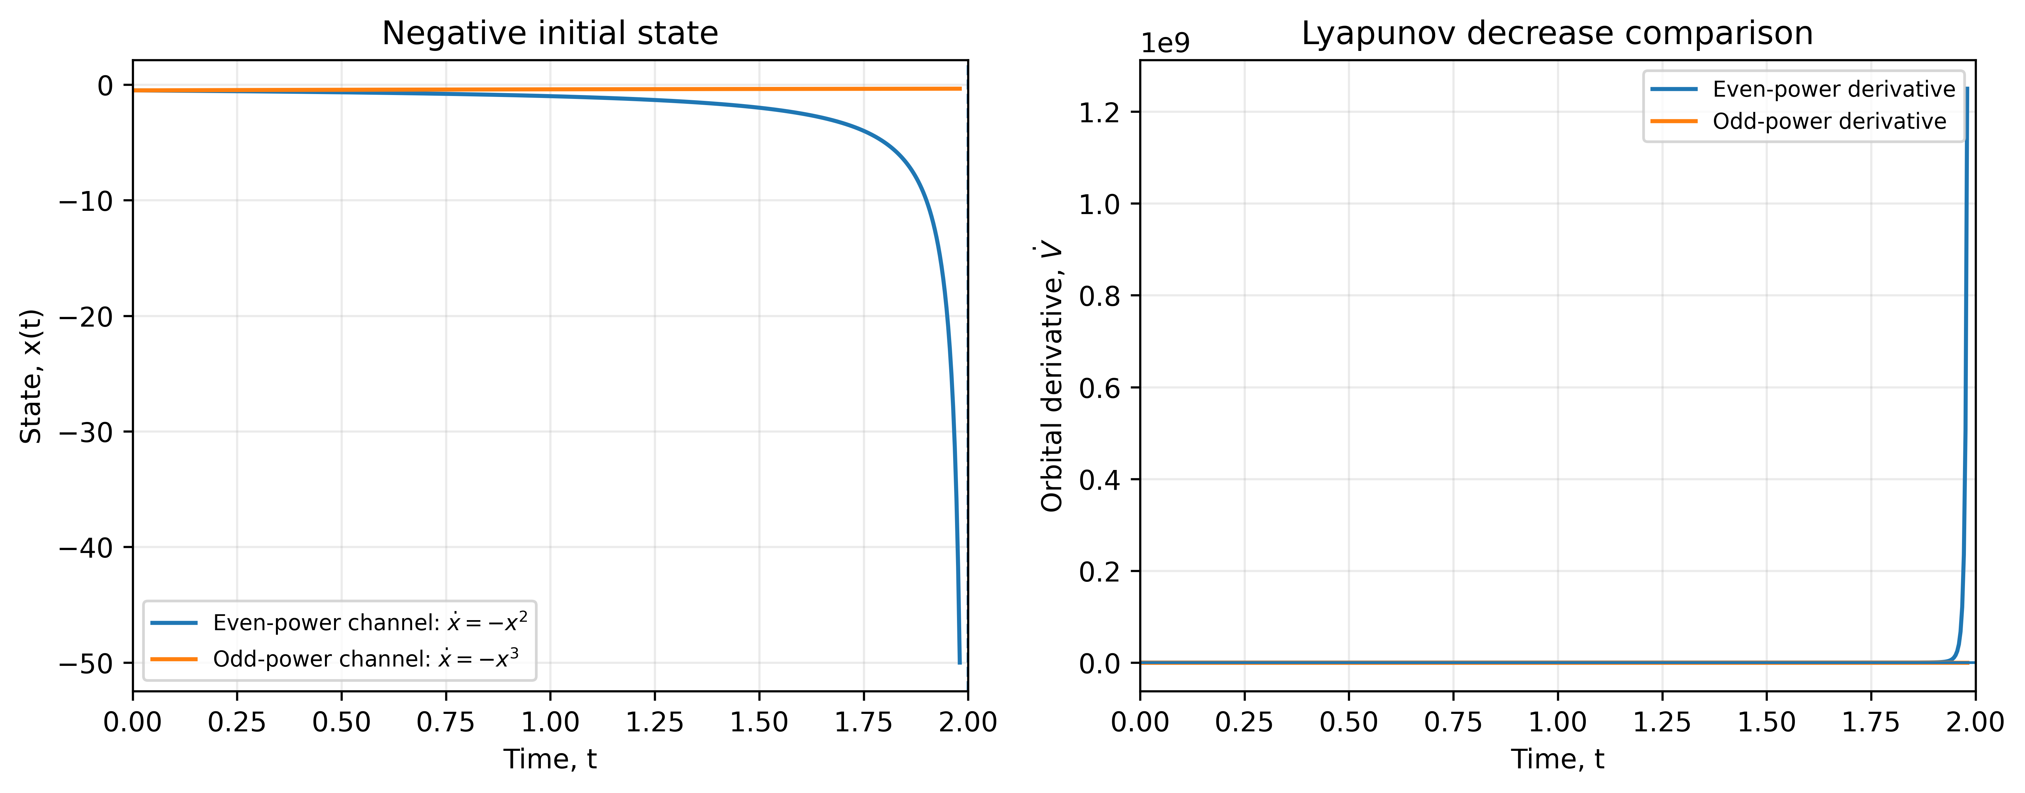
Figure 2. Consistency analysis of the even-power benchmark. A negative initial state under $\dot{ξ}=−ξ^{2}$ reaches finite escape while the associated candidate derivative becomes positive; the odd-power comparison retains dissipative behavior.

2.3 Structure-preserving neural candidate
Let $ϕ_{θ}:R^{n}→R^{r}$ be a differentiable feature network. The candidate is
$$V_{θ}\left(x\right)=ε∥x∥_{2}^{2}+∥ϕ_{θ}\left(x\right)−ϕ_{θ}\left(0\right)∥_{2}^{2}, ε>0.$$ | (6)
This construction is a smooth vector-feature specialization of Lyapunov-Net [14]. It enforces $V_{θ}\left(0\right)=0$ and $V_{θ}\left(x\right)≥ε∥x∥_{2}^{2}$ independently of the trainable parameters. The principal network uses a 2-24-8 tanh feature map with 272 trainable parameters. The architectural floor removes equilibrium anchoring and positivity from the optimization burden, leaving derivative shaping as the principal learning problem. The tanh activation is used because it is smooth, has bounded derivatives, and admits simple interval enclosures for the Jacobian. Although feedforward networks have universal approximation capability [26], universal approximation is not used as a stability argument here: the certificate is accepted only when the required inequalities are enforced algebraically or verified on the continuum. This distinction is important because representational capacity provides no direct control of orbital-derivative sign.

2.4 Derivative-aware objective, sampling, and model selection
With $q\left(x\right)=∥x∥_{2}^{2}$, define the Lyapunov transport residual $r_{θ}$ and prescribed-decay margin $m_{θ}$ as
$$r_{θ}\left(x\right)=∇V_{θ}{\left(x\right)}^{⊤}f_{κ}\left(x\right)+∥x∥_{2}^{2}, m_{θ}\left(x\right)=∇V_{θ}{\left(x\right)}^{⊤}f_{κ}\left(x\right)+c∥x∥_{2}^{2}.$$ | (7)
The training objective is
$$L\left(θ\right)=E\left[\frac{r_{θ}{\left(x\right)}^{2}}{{\left(∥x∥_{2}^{2}+η\right)}^{2}}\right]+λ_{h}E\left[\frac{max{\left(m_{θ}\left(x\right),0\right)}^{2}}{{\left(∥x∥_{2}^{2}+η\right)}^{2}}\right]+λ_{a}L_{a},$$ | (8)
The positive-part penalty is evaluated as $max\left(m_{θ}\left(x\right),0\right)$. The principal configuration uses $ε=0.02$, $c=0.15$, $η=0.05$, $λ_{h}=8$, and $λ_{a}=0$. Hence, the principal model receives no exact $V_{ref}$ values. Uniform states, near-origin Gaussian states, and recycled hard states are mixed during training. Every 200 iterations, 12,000 fresh states are scored and the 192 largest decay margins are recycled into subsequent batches. Adam [27] with a cosine-decayed learning rate is used for optimization.
Analytical value anchors are used only in an ablation ($λ_{a}=0.05$) and are excluded from the principal ten-seed experiment and the selected network.
Ten seeds, 20260826-20260835, are trained for 2,200 iterations. Model selection uses a fixed 50,000-state validation set generated with seed 314159. After the selected network is fixed, the final Cartesian grid and the Monte Carlo experiment are generated independently. The $181×181$ grid is used only for deterministic falsification and visualization; it is never included in a binomial probability calculation. The Monte Carlo experiment consists of $N=200000$ IID uniform draws from the verification square, with the equilibrium tested separately. The event used for the statistical calculation is
$$E_{τ}:=\{x∣∥x∥_{2}^{2}>{10}^{−8}, m_{θ}\left(x\right)>τ\}, τ={10}^{−10}.$$ | (9)
Thus, the statistical statement concerns the probability of a numerically detected margin failure above the declared tolerance, not the probability of the exact mathematical event $m_{θ}\left(x\right)>0$. If zero events $E_{τ}$ are observed in $N$ IID draws, the exact one-sided Clopper-Pearson upper bound at confidence level $γ$ is
(p_U=1-(1-)^{1/N}, , N=200000).
The exclusion radius and tolerance are therefore part of the event definition. The continuum statement, when claimed, must come from Theorem 2 with sound interval arithmetic rather than from this probability bound.

2.5 Radial interval enclosures and box-wise verification
The verification argument is stated independently of any particular floating-point implementation. Let $Q⊂D$ be an axis-aligned box and define its radial hull
$$R\left(Q\right):=hull\left(\{0\}∪Q\right).$$ | (10)
For every $x∈Q$, the entire segment $\{τx:0≤τ≤1\}$ lies in $R\left(Q\right)$. By the fundamental theorem of calculus,
$$ϕ_{θ}\left(x\right)−ϕ_{θ}\left(0\right)=B_{θ}\left(x\right)x, B_{θ}\left(x\right):=\int_{0}^{1}{J_{ϕ_{θ}}}\left(τx\right) dτ.$$ | (11)
Hence
$$∇V_{θ}\left(x\right)=G_{θ}\left(x\right)x, G_{θ}\left(x\right):=2εI+2J_{ϕ_{θ}}{\left(x\right)}^{⊤}B_{θ}\left(x\right).$$ | (12)
Because $f_{κ}\left(0\right)=0$ and $f_{κ}∈C^{1}$ on a neighborhood of $R\left(Q\right)$, the same radial identity gives
$$f_{κ}\left(x\right)=F_{κ}\left(x\right)x, F_{κ}\left(x\right):=\int_{0}^{1}{J_{f_{κ}}}\left(τx\right) dτ.$$ | (13)
Let $J_{ϕ}\left(R\left(Q\right)\right)$ and $J_{f}\left(R\left(Q\right)\right)$ be sound outward-rounded interval extensions of the corresponding Jacobians. Then $B_{θ}\left(x\right)∈J_{ϕ}\left(R\left(Q\right)\right)$ and $F_{κ}\left(x\right)∈J_{f}\left(R\left(Q\right)\right)$ componentwise. For the two-layer tanh feature map used here,
$$J_{ϕ_{θ}}\left(x\right)=D_{2}\left(x\right)W_{2}D_{1}\left(x\right)W_{1}, D_{i}\left(x\right)=diag\left[{sech}^{2}\left(z_{i}\left(x\right)\right)\right],$$ | (14)
so interval bounds follow by enclosing each affine pre-activation, applying monotonic tanh and ${sech}^{2}$ bounds, and using outward-rounded interval matrix products. Define
$$H_{θ}\left(x\right):=sym\left(G_{θ}{\left(x\right)}^{⊤}F_{κ}\left(x\right)\right)+cI, sym\left(M\right):=\frac{M+M^{⊤}}{2}.$$ | (15)
Then the prescribed margin satisfies
$$m_{θ}\left(x\right)={\dot{V}}_{θ}\left(x\right)+c∥x∥_{2}^{2}=x^{⊤}H_{θ}\left(x\right)x.$$ | (16)
Lemma 1 (radial enclosure). If $J_{ϕ}\left(R\left(Q\right)\right)$ encloses $J_{ϕ_{θ}}\left(y\right)$ and $J_{f}\left(R\left(Q\right)\right)$ encloses $J_{f_{κ}}\left(y\right)$ for every $y∈R\left(Q\right)$, then the interval constructions above enclose $B_{θ}\left(x\right)$, $F_{κ}\left(x\right)$, $G_{θ}\left(x\right)$, and $H_{θ}\left(x\right)$ for every $x∈Q$.
Proof. For any fixed matrix entry, $B_{ij}\left(x\right)$ is the integral over $τ∈\left[0,1\right]$ of a scalar function whose values all belong to the corresponding Jacobian interval on $R\left(Q\right)$. An interval is convex, so the integral average also belongs to that interval. The same argument applies to $F_{κ}$. Inclusion isotonicity of outward-rounded interval addition and multiplication then propagates the enclosures through (12) and (15). $▫$
Theorem 2 (box-wise Lyapunov decrease). Let $Q⊂D$ be a box and let $H_{Q}$ be a sound interval matrix enclosure of $H_{θ}\left(x\right)$ for all $x∈Q$. If a sound upper bound ${\overline{λ}}_{Q}$ satisfies
$$λ_{max}\left(H_{θ}\left(x\right)\right)≤{\overline{λ}}_{Q}<0 ∀x∈Q,$$ | (17)
then
$${\dot{V}}_{θ}\left(x\right)≤−c∥x∥_{2}^{2} ∀x∈Q, x≠0.$$ | (18)
For a symmetric $2×2$ interval matrix, one valid computable choice is the maximum Gershgorin upper bound formed with outward-rounded diagonal upper endpoints and the largest possible absolute off-diagonal value.
Proof. By (16), $m_{θ}\left(x\right)=x^{⊤}H_{θ}\left(x\right)x$. For every $x∈Q$, the Rayleigh quotient gives $x^{⊤}H_{θ}\left(x\right)x≤λ_{max}\left(H_{θ}\left(x\right)\right)∥x∥_{2}^{2}$. Under (17), $m_{θ}\left(x\right)<0$ for every nonzero $x$, which is equivalent to (18). $▫$
A branch-and-bound verifier covers $D$ by boxes and applies Theorem 2 where the matrix enclosure is sufficiently sharp; away from the equilibrium, a direct natural interval extension of $m_{θ}$ may also be used. The theorem requires sound interval extensions. A fixed padding such as ${10}^{−12}\left(1+M\right)$ is an engineering guard, not a proof that accumulated roundoff and transcendental-function errors are enclosed. Publication-grade continuum claims therefore require validated outward rounding, for example through INTLAB or another sound verifier [33].

2.6 Stability, robustness, and coupled-system results
Theorem 3 (positive definiteness and regularity). Let $ϕ_{θ}∈C^{1}\left(R^{n},R^{r}\right)$ and $ε>0$. Then
$$V_{θ}\left(x\right)=ε∥x∥_{2}^{2}+∥ϕ_{θ}\left(x\right)−ϕ_{θ}\left(0\right)∥_{2}^{2}$$ | (19)
belongs to $C^{1}$, satisfies $V_{θ}\left(0\right)=0$, obeys $V_{θ}\left(x\right)≥ε∥x∥_{2}^{2}$ for all $x$, and is radially unbounded.
Proof. Composition and finite sums of $C^{1}$ functions are $C^{1}$. At $x=0$ both terms vanish. For $x≠0$, the first term is strictly positive and the second is nonnegative, proving positive definiteness and the lower bound. Since $ε∥x∥_{2}^{2}→∞$ as $∥x∥_{2}→∞$, $V_{θ}$ is radially unbounded. $▫$
Corollary 1 (invariant sublevel and exponential estimate). Let $D$ be compact and suppose that on $D$
$$ε∥x∥_{2}^{2}≤V_{θ}\left(x\right)≤b∥x∥_{2}^{2}, {\dot{V}}_{θ}\left(x\right)≤−c∥x∥_{2}^{2},$$ | (20)
with $b,c>0$. If $Ω_{ρ}:=\{x:V_{θ}\left(x\right)≤ρ\}⊂intD$, then $Ω_{ρ}$ is forward invariant and every solution starting there satisfies
$$∥x\left(t\right)∥_{2}≤\sqrt{\frac{b}{ε}} exp​\left(−\frac{ct}{2b}\right)∥x\left(0\right)∥_{2}.$$ | (21)
Proof. On $∂Ω_{ρ}$ away from the origin, ${\dot{V}}_{θ}<0$, so no trajectory can cross from $Ω_{ρ}$ to larger values of $V_{θ}$. Thus the sublevel is forward invariant. The upper bound in (20) implies $∥x∥_{2}^{2}≥V_{θ}/b$, hence ${\dot{V}}_{θ}≤−\left(c/b\right)V_{θ}$. The comparison lemma gives $V_{θ}\left(t\right)≤V_{θ}\left(0\right)e^{−ct/b}$. Combining this with the lower and upper quadratic bounds yields (21). $▫$
Proposition 1 (robust local stability on a certified sublevel). Assume (20) on $D$ and, in addition,
$$∥∇V_{θ}\left(x\right)∥_{2}≤g∥x∥_{2}, x∈D.$$ | (22)
Let the true dynamics be $f_{true}\left(x\right)=f_{κ}\left(x\right)+δBx$. Define
$$c_{δ}:=c−\left|δ\right|g∥B∥_{2}.$$ | (23)
If $c_{δ}>0$ and $Ω_{ρ}⊂intD$, then $Ω_{ρ}$ is forward invariant for the perturbed dynamics and
$$∥x\left(t\right)∥_{2}≤\sqrt{\frac{b}{ε}} exp​\left(−\frac{c_{δ}t}{2b}\right)∥x\left(0\right)∥_{2}, x\left(0\right)∈Ω_{ρ}.$$ | (24)
Proof. By Cauchy-Schwarz and (22), ${\dot{V}}_{true}≤−c∥x∥_{2}^{2}+\left|δ\right|∥∇V∥_{2}∥B∥_{2}∥x∥_{2}≤−c_{δ}∥x∥_{2}^{2}$. Since $c_{δ}>0$, the same boundary argument used in Corollary 1 proves invariance, and replacing $c$ by $c_{δ}$ in that proof gives (24). $▫$
Proposition 2 (two-subsystem sum-Lyapunov bound). Consider two identical subsystems with states $z_{1},z_{2}∈D$ and coupling
$${\dot{z}}_{i}=f_{κ}\left(z_{i}\right)+κ\left(z_{j}−z_{i}\right), i≠j.$$ | (25)
Suppose (20) and (22) hold for each isolated subsystem. Let $V_{Σ}=V_{θ}\left(z_{1}\right)+V_{θ}\left(z_{2}\right)$. Then
$${\dot{V}}_{Σ}≤−\left(c−2\left|κ\right|g\right)\left(∥z_{1}∥_{2}^{2}+∥z_{2}∥_{2}^{2}\right).$$ | (26)
Consequently, if $\left|κ\right|<c/\left(2g\right)$ and a joint sublevel
$$S_{ρ}:=\{\left(z_{1},z_{2}\right):V_{θ}\left(z_{1}\right)+V_{θ}\left(z_{2}\right)≤ρ\}⊂int\left(D\right)×int\left(D\right),$$ | (27)
then $S_{ρ}$ is forward invariant and the interconnected origin is exponentially stable on $S_{ρ}$.
Proof. The isolated terms contribute at most $−c\left(∥z_{1}∥^{2}+∥z_{2}∥^{2}\right)$. The two coupling terms satisfy $\left|κ\right| ∥∇V\left(z_{i}\right)∥ ∥z_{j}−z_{i}∥≤\left|κ\right|g∥z_{i}∥\left(∥z_{i}∥+∥z_{j}∥\right)$. Summing the two inequalities gives at most $\left|κ\right|g{\left(∥z_{1}∥+∥z_{2}∥\right)}^{2}≤2\left|κ\right|g\left(∥z_{1}∥^{2}+∥z_{2}∥^{2}\right)$, proving (26). If the coefficient is positive, $V_{Σ}$ strictly decreases away from the origin; the boundary argument then proves invariance of (27), and the quadratic bounds imply exponential convergence. $▫$
The term “small gain” is reserved here for the broader ISS/operator framework [4,5,18]. Proposition 2 is a direct sum-Lyapunov coupling bound for two identical diffusive subsystems, not a general network small-gain theorem.

2.7 Benchmark systems and comparators
The principal two-state benchmark is nonlinear but analytically auditable:
$$f\left(x\right)=Ax+0.6x_{1}JPx, A=\left[\begin{matrix}−1 & 4 \\ −0.5 & −1\end{matrix}\right], J=\left[\begin{matrix}0 & −1 \\ 1 & 0\end{matrix}\right].$$ | (28)
With
$$P=\left[\begin{matrix}17/48 & 7/24 \\ 7/24 & 5/3\end{matrix}\right], A^{⊤}P+PA=−I,$$ | (29)
the exact reference $V_{ref}\left(x\right)=x^{⊤}Px$ satisfies
$${\dot{V}}_{ref}\left(x\right)=−∥x∥_{2}^{2},$$ | (30)
because ${\left(Px\right)}^{⊤}J\left(Px\right)=0$. This example is intentionally favorable to classical analysis and is used as a calibration case; no superiority over the exact quadratic is claimed.
A second benchmark tests the learning stage in a qualitatively different regime:
$${\dot{x}}_{1}=−x_{1}+x_{1}x_{2}, {\dot{x}}_{2}=−x_{2}.$$ | (31)
Ahmadi, Krstic, and Parrilo showed that this globally asymptotically stable polynomial vector field admits no global polynomial Lyapunov function [31]. A valid non-polynomial certificate is
$$V_{log}\left(x\right)=log\left(1+x_{1}^{2}\right)+x_{2}^{2},$$ | (32)
for which direct differentiation gives
$${\dot{V}}_{log}\left(x\right)=−\frac{x_{1}^{2}+2x_{2}^{2}+x_{1}^{2}x_{2}^{2}+{\left(x_{1}−x_{1}x_{2}\right)}^{2}}{1+x_{1}^{2}}<0, x≠0.$$ | (33)
This system is used only as a sampled stress test of neural candidate generation on ${\left[−1.9,1.9\right]}^{2}$. The stress-test network has a bias-free 2-8-4 tanh feature map, $ε=0.02$, prescribed margin coefficient $c=0.03$, and seed 20261016. Its exact exported weights are supplied as machine-readable supplementary material. The stress test does not receive $V_{log}$ values during training.
The principal structure-preserving network is compared with an unconstrained scalar tanh network trained using the same derivative objective, hard-state schedule, iteration count, and final test protocol, with positivity imposed only by a sampled penalty. The exact quadratic is retained as a classical reference. Published Lyapunov-Net, SMT, bound-propagation, and CT-BaB methods are compared methodologically rather than by reimplementation because their controller parameterizations, verification engines, and benchmark definitions differ materially [13,14,20,22-24,32].

3. Numerical results

3.1 Multi-seed performance and untouched final test
Across ten independent seeds, all models passed the sampled decay gate. Mean training time was 39.354 s (standard deviation 3.049 s), mean normalized transport/PDE RMSE was 0.119869 (0.003758), and mean worst normalized decay margin was -0.700887 (0.004956). Seed 20260834 was selected using only the 50,000-state validation set. The untouched 200,000-state Monte Carlo test produced zero occurrences of the declared numerical event $E_{τ}$, corresponding to a one-sided 95% Clopper-Pearson upper bound of $1.498×{10}^{−5}$ for the probability of $E_{τ}$ under the uniform IID sampling model. This bound does not apply to margins in $(0,τ]$ and is not a continuum certificate.
Table 2. Multi-seed and untouched-test statistics.
Quantity | Mean | Std. | Range / outcome
Training time (s) | 39.354 | 3.049 | 37.35-47.28
Transport/PDE RMSE | 0.119869 | 0.003758 | 0.11479-0.12653
Worst normalized decay margin | -0.700887 | 0.004956 | -0.71085 to -0.69732
Sampled gate success | 10/10 | - | all independent seeds
Selected seed | 20260834 | - | chosen on the validation set only
Untouched Monte Carlo | 0/200000 | - | zero $E_{τ}$ events; 95% upper bound $1.498×{10}^{−5}$
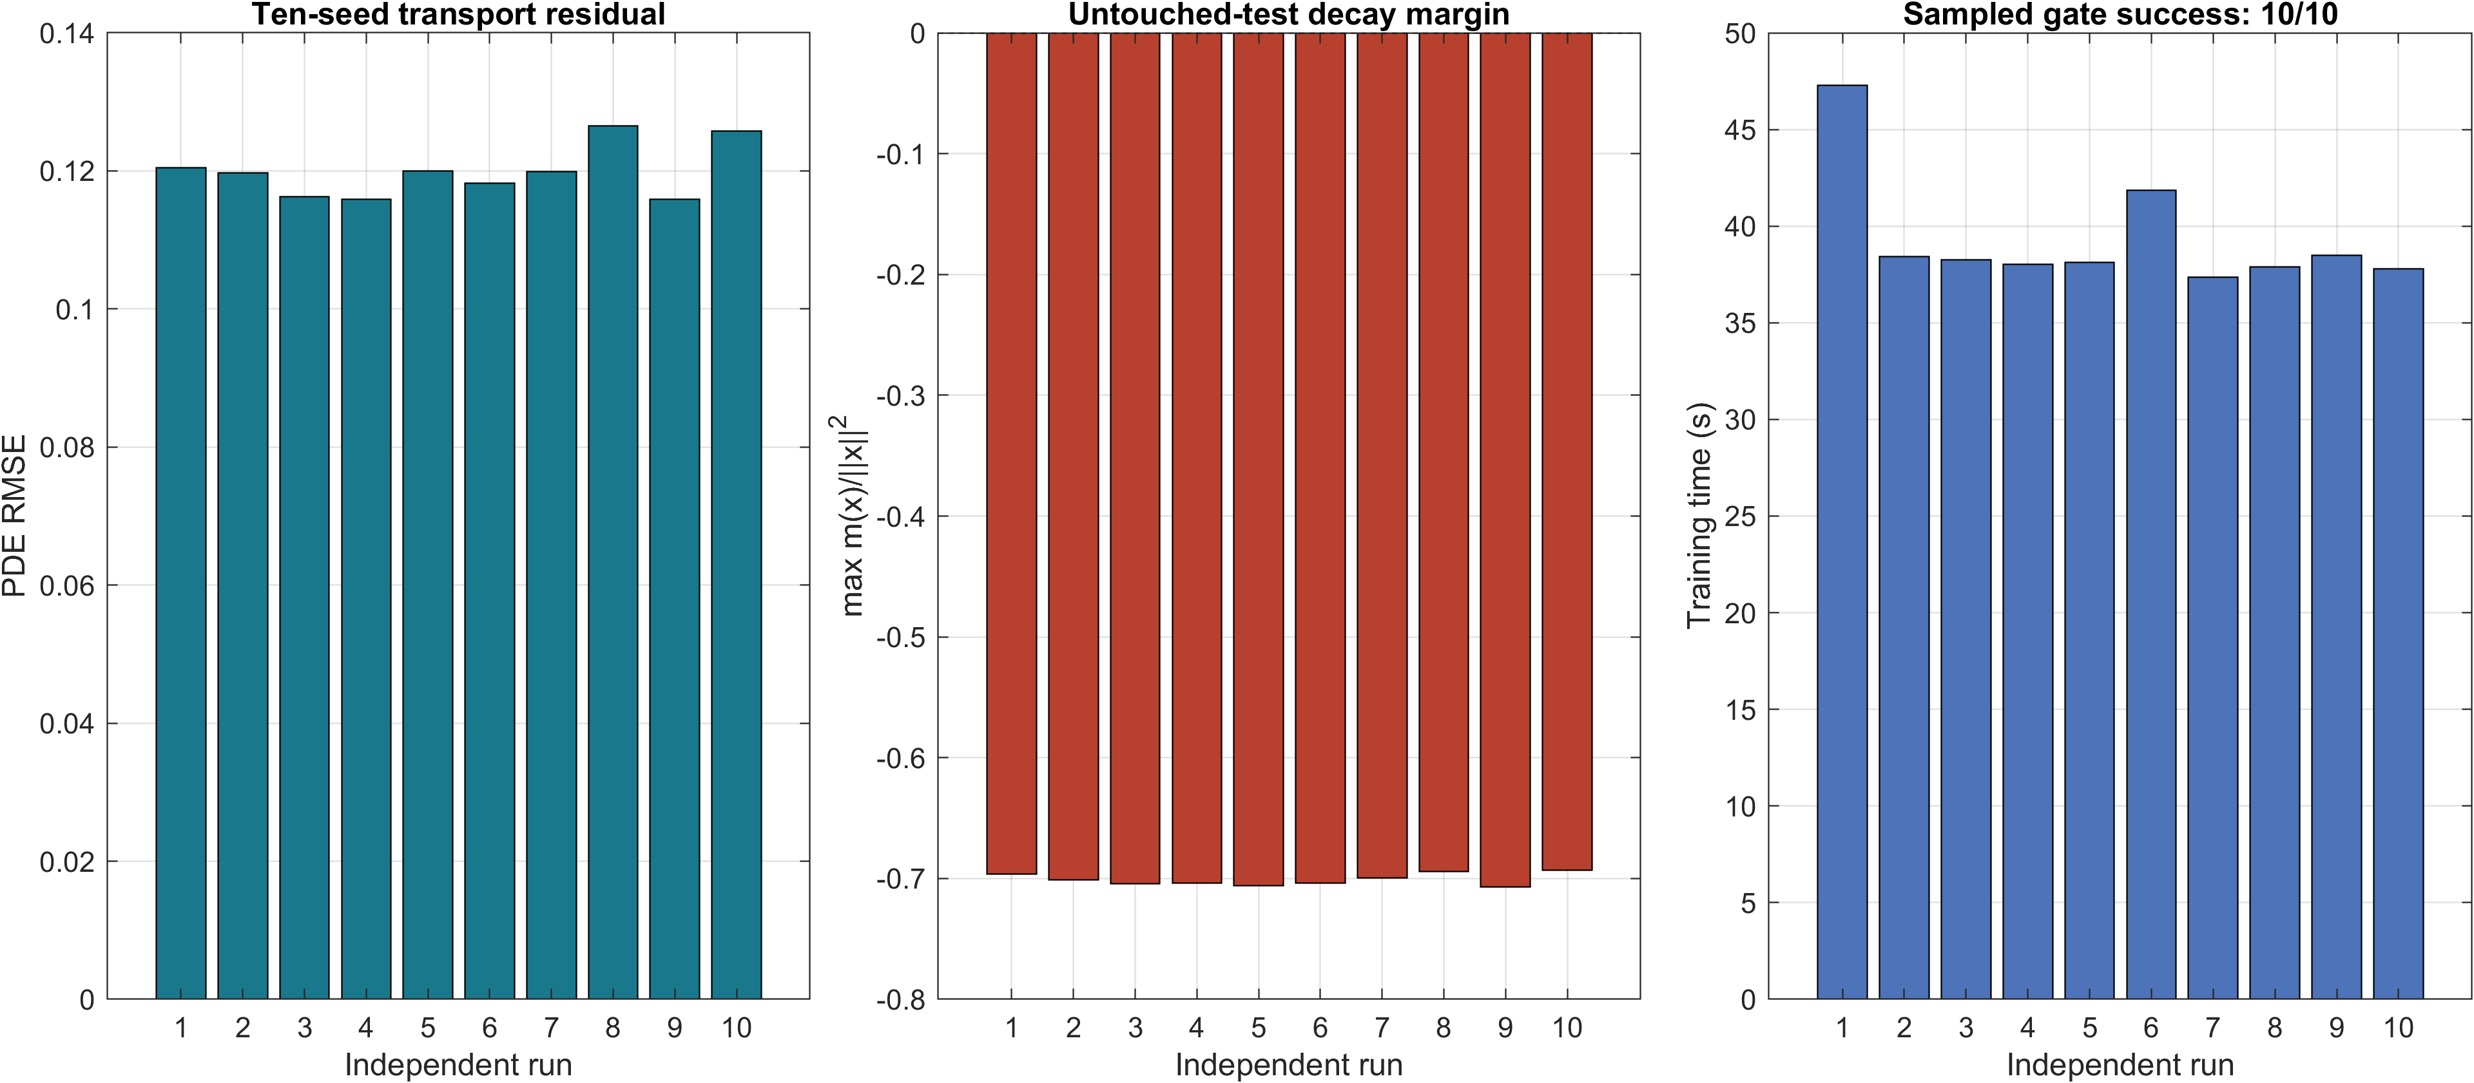
Figure 3. Ten independent training runs. Transport residual, untouched-test normalized decay margin, and training time are shown for each seed.

3.2 Guarded interval calculation on the auditable benchmark
The branch-and-bound implementation explored 6,541 boxes over ${\left[−2,2\right]}^{2}$ and left no unresolved box under its documented numerical guard. The central square ${\left[−0.2,0.2\right]}^{2}$ was accepted by the matrix criterion, with a computed upper eigenvalue bound of $−0.0902273$; outer terminal boxes were accepted by direct interval evaluation, with the closest reported upper margin equal to $−5.9957×{10}^{−5}$. The same computation produced the numerical bounds $g≤4.6406655$ and $b≤3.7699728$ and the candidate sublevel $ρ=0.04$.
These quantities are useful reproducibility targets, but the fixed padding used for this calculation is not treated as a proof of outward rounding. Accordingly, Table 3 labels the result “guarded interval calculation.” If the same partition and upper bounds are reproduced with a validated outward-rounded package, Theorem 2 and Corollary 1 convert them immediately into a continuum certificate. This separation removes the logical dependence of the theoretical results on an unproved floating-point error model.
Table 3. Guarded interval calculation for the selected network.
Quantity | Reported value | Mathematical status in this article
Domain | ${\left[−2,2\right]}^{2}$ | encoded computational domain
Central matrix box | ${\left[−0.2,0.2\right]}^{2}$ | computed matrix upper bound $−0.0902273$
Explored boxes | 6,541 | 0 unresolved under stated guard
Closest outer upper bound | $−5.9957×{10}^{−5}$ | negative computed bound
Gradient gain | $g≤4.6406655$ | numerical enclosure target
Value coefficient | $b≤3.7699728$ | numerical enclosure target
Candidate sublevel | $ρ=0.04$ | containment follows once $b,c$ are soundly certified
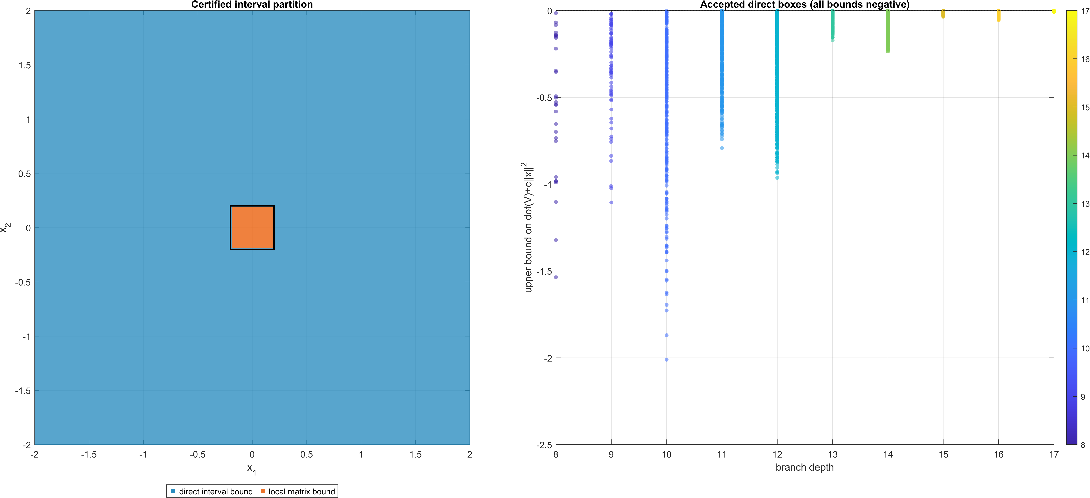
Figure 4. Partition generated by the guarded interval calculation. The mathematical use of this partition requires sound outward-rounded interval primitives.
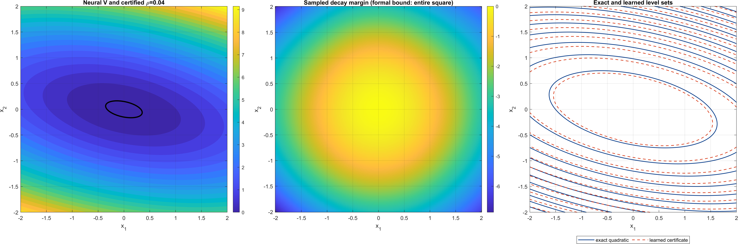
Figure 5. Selected structure-preserving candidate. The contour $ρ=0.04$ is a candidate invariant sublevel; it becomes certified when the derivative and upper-value bounds are reproduced with sound interval arithmetic.

3.3 Ablation and sensitivity
At a fixed 1,600-iteration budget, the normalized transport residual produced the largest reduction in PDE RMSE relative to positive value regression. The decay hinge produced the strongest sampled margin in the cumulative sequence, while near-origin sampling provided a smaller additional gain. Privileged anchors and hard-state recycling were not uniquely necessary on this analytically benign benchmark. All 17 one-factor sensitivity settings passed the sampled gate. This result supports robustness of the learning stage, but does not imply that every component is theoretically necessary.
Table 4. Cumulative ablation at a fixed 1,600-iteration budget.
Cumulative variant | PDE RMSE | Worst margin ratio | Observed gate
Positive value regression | 0.7319 | -0.3045 | pass on calibration benchmark
+ transport residual | 0.0962 | -0.7339 | largest residual improvement
+ decay hinge | 0.0907 | -0.7414 | strongest sampled margin
+ near-origin sampling | 0.0897 | -0.7424 | minor additional gain
+ normalization | 0.1303 | -0.6849 | changes objective weighting
+ privileged anchors | 0.1323 | -0.6805 | not required for sampled gate
+ hard-state recycling | 0.1427 | -0.6741 | not uniquely causal here
Full without anchors | 0.1402 | -0.6796 | principal specification
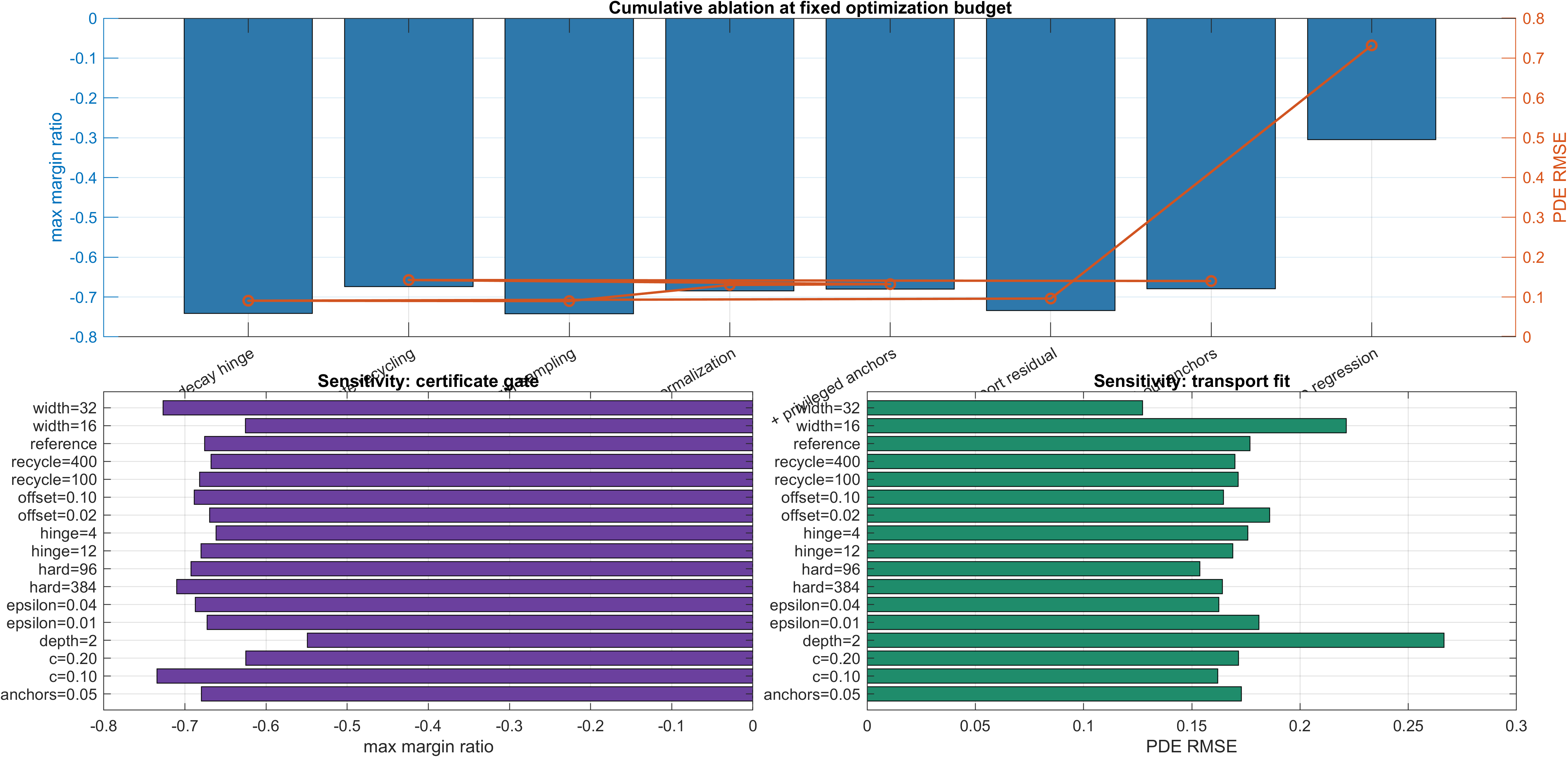
Figure 6. Cumulative ablation and one-factor sensitivity analysis.

3.4 Baseline comparison
The derivative-trained unconstrained network retained two derivative failures and three prescribed-margin failures among 232,761 final states, with worst normalized margin 1.8111. The structure-preserving network showed no sampled positivity, derivative, or prescribed-margin failures. The exact quadratic remains the strongest result on the calibration benchmark; the neural experiment tests whether a learned representation can satisfy the same structural conditions without value supervision.
Table 5. Numerical baselines on the calibration benchmark.
Method | Positivity | Derivative / margin failures | Worst normalized margin | Status
Exact quadratic / degree-2 SOS | analytic | 0 / 0 | -0.8500 | global analytical identity
Derivative-trained unconstrained DNN | sampled positive | 0.000859% / 0.001289% | 1.8111 | fails untouched final gate
Structure-preserving DNN | architectural | 0 / 0 sampled | -0.7109 | guarded interval calculation on ${\left[−2,2\right]}^{2}$

3.5 Non-polynomial Lyapunov stress test
For system (31), the bias-free 2-8-4 structure-preserving network was trained from derivative information only on ${\left[−1.9,1.9\right]}^{2}$. On a $401×401$ Cartesian grid, no point with $∥x∥_{2}^{2}>{10}^{−12}$ violated ${\dot{V}}_{θ}+0.03∥x∥_{2}^{2}≤0$; the worst sampled ratio $\left({\dot{V}}_{θ}+0.03∥x∥_{2}^{2}\right)/∥x∥_{2}^{2}$ was $−0.01983$. A separate 200,000-point uniform Monte Carlo test also produced zero detected violations and a worst sampled ratio of $−0.02064$. These numbers are sampled evidence only; they are not promoted to a continuum certificate.
The benchmark is nevertheless informative because the obstruction is structural: the globally asymptotically stable polynomial vector field is known not to admit a global polynomial Lyapunov function [31]. The exact non-polynomial function (32) provides an independent analytical reference, while the neural model receives no values from that reference during training. Exact network weights are supplied in supplementary CSV form so that the sampled experiment can be reproduced independently.
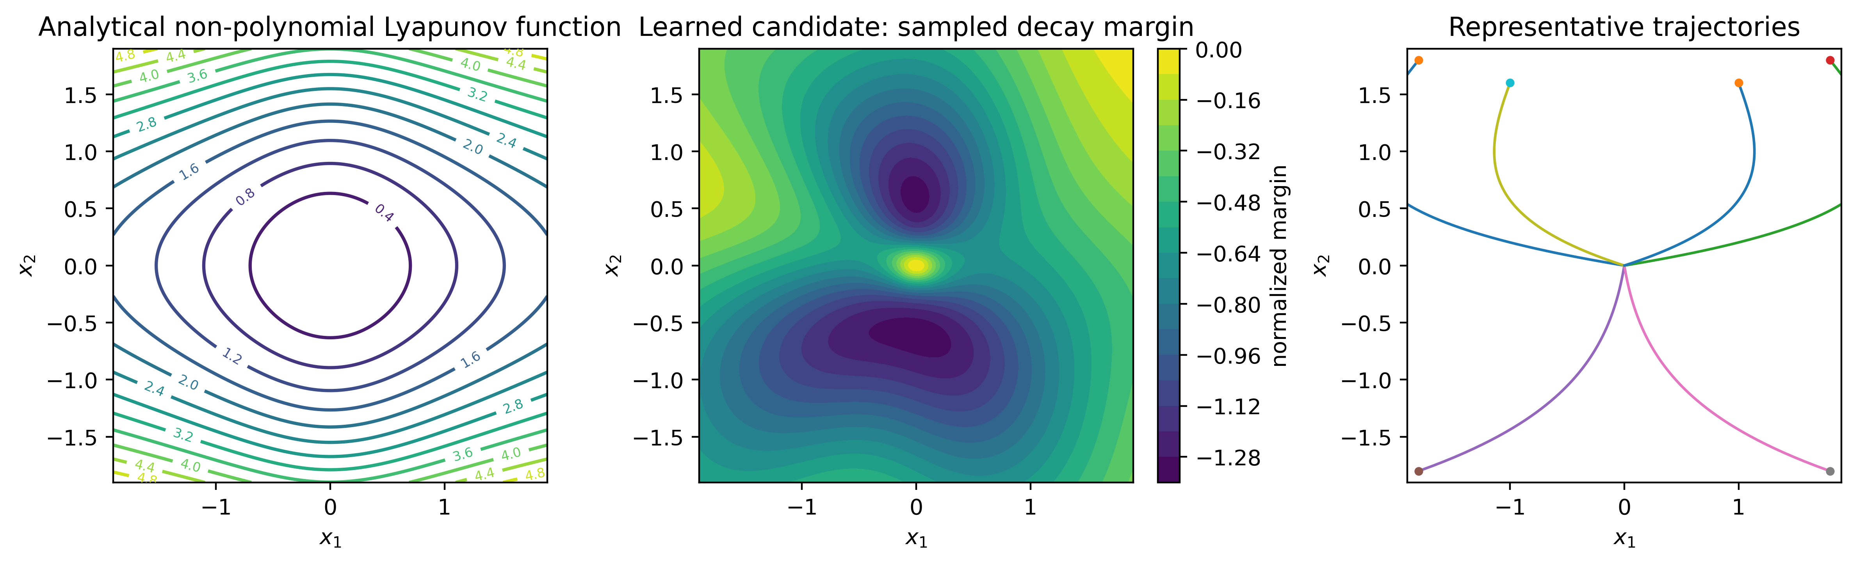
Figure 7. Non-polynomial Lyapunov benchmark. Left: analytical logarithmic certificate. Middle: sampled normalized decay margin of the learned candidate on ${\left[−1.9,1.9\right]}^{2}$. Right: representative trajectories.

3.6 Robustness and coupled-system interpretation
If the numerical bounds $b=3.7699728$ and $g=4.6406655$ are reproduced by sound interval arithmetic together with $c=0.15$, Proposition 1 yields the sufficient structured perturbation threshold
$$\left|δ\right|<\frac{c}{g∥B∥_{2}}=0.1104129, ∥B∥_{2}=0.2927461.$$ | (34)
The guarantee is local to any verified sublevel $Ω_{ρ}⊂intD$ and uses the reduced rate $c_{δ}=c−\left|δ\right|g∥B∥_{2}$. Likewise, Proposition 2 requires
$$\left|κ\right|<\frac{c}{2g}=0.0161615$$ | (35)
and applies only on a joint invariant sublevel $S_{ρ}⊂int{\left(D\right)}^{2}$. The absolute value in (35) is essential; a one-sided condition $κ<c/\left(2g\right)$ would incorrectly admit arbitrarily large negative coupling.

4. Discussion

4.1 Position relative to existing methods
The contribution is an evidence and verification workflow rather than an isolated neural architecture or loss. The quadratic floor and squared feature difference are related to positive architectures such as Lyapunov-Net [14], while derivative-aware learning and learner-falsifier ideas are established in the literature [12,13,15,16]. More general verification engines include SMT, bound propagation, and training-time branch-and-bound [20,22-24]. The interval/Jacobian construction studied here is intentionally narrower: it exploits smooth low-dimensional dynamics to expose the intermediate bounds that connect a learned candidate to invariant-set, robustness, and coupling statements.
The different evidence layers answer different questions. Architectural constraints establish properties that hold for every set of trainable weights; held-out tests search efficiently for ordinary failures; interval verification addresses a worst-case continuum statement on the encoded domain; and robustness calculations allocate part of the verified decay margin to a specified uncertainty class. The analytically known quadratic certificate remains superior on the calibration benchmark. The neural result is therefore a test of auditable learned representation, not evidence that neural functions should replace exact classical certificates when these are available.

4.2 Control use
For control-affine dynamics $\dot{x}=f\left(x\right)+g\left(x\right)u$, a hard CLF filter may be written as
$$u^{*}\left(x\right)=arg\min_{u∈U}∥u−u_{NN}\left(x\right)∥_{2}^{2} \text{subject to} ∇V_{θ}{\left(x\right)}^{⊤}\left[f\left(x\right)+g\left(x\right)u\right]≤−c∥x∥_{2}^{2}.$$ | (36)
If the constraint is feasible throughout the certified operating set, it preserves the verified decrease condition. If hard feasibility is unavailable, a soft formulation can penalize a slack variable,
$$\min_{u∈U, s≥0}∥u−u_{NN}\left(x\right)∥_{2}^{2}+ps^{2} \text{subject to} ∇V_{θ}{\left(x\right)}^{⊤}\left[f\left(x\right)+g\left(x\right)u\right]≤−c∥x∥_{2}^{2}+s, p>0.$$ | (37)
but strict Lyapunov decrease is not guaranteed when $s>0$. A verified offline $V_{θ}$ also does not automatically certify estimator error, actuator limits, sampling, or quantization; these effects must match the verified model or enter an explicit uncertainty argument. Proposition 2 is likewise a two-subsystem sum-Lyapunov result, not a general graph small-gain theorem.

4.3 Limitations
The main limitation is machine-level soundness of the guarded interval calculation. Fixed floating-point padding does not prove outward enclosure of all arithmetic and transcendental-function errors. The theoretical results therefore become a formal machine certificate only when the same box conditions are reproduced with validated outward-rounded interval primitives or another sound verification engine. The calibration benchmark is intentionally favorable to classical analysis, while the non-polynomial stress test is presently supported only by finite testing. Higher-dimensional formal scaling, heterogeneous interconnections, delays, hybrid modes, sensor uncertainty, and sampled-data implementations remain outside the claims. The structured robustness result applies only to the stated perturbation class, and the Monte Carlo confidence bound applies only to the explicitly defined event under IID uniform sampling.

5. Conclusions
This study separates structural guarantees, finite falsification, and continuum verification in neural Lyapunov analysis. A radial-enclosure theorem and complete stability, robustness, and two-subsystem coupling proofs make the domain and assumptions explicit. The numerical calibration study shows how structural parameterization can remove failures left by an unconstrained neural baseline, while the non-polynomial benchmark tests derivative-aware learning beyond globally polynomial Lyapunov templates. Guarded branch-and-bound values remain reproducibility targets; a formal machine certificate requires sound outward-rounded interval arithmetic. This separation of theorem, numerical evidence, and verifier assumptions provides a conservative basis for using learned Lyapunov functions in nonlinear control.

Acknowledgements
None.

Author contributions
Caglar Uyulan: Conceptualization; Methodology; Software; Validation; Formal analysis; Investigation; Visualization; Writing - original draft; Writing - review and editing.

Statements and Declarations

Ethical considerations
Not applicable. The study consists of mathematical analysis and numerical simulations and does not involve human participants, human data, animals, or biological material.

Consent to participate
Not applicable.

Consent for publication
Not applicable.

Declaration of conflicting interest
The author declared no potential conflicts of interest with respect to the research, authorship, and/or publication of this article.

Funding statement
The author received no financial support for the research, authorship, and/or publication of this article.

Data availability
Machine-readable parameters for the non-polynomial stress-test network and computational supplementary files are supplied with the submission. The guarded interval values reported in the article are reproducibility targets and are not presented as a substitute for validated outward-rounded verification.

Generative AI disclosure
OpenAI ChatGPT was used to assist with language refinement, manuscript organization, code/document preparation, reference cross-checking, and formatting. The author independently checked the mathematical derivations, numerical outputs, references, and scientific claims and takes full responsibility for the final manuscript.

Appendix A. Verification derivations

A.1 Complete interval formulas for the two-layer tanh feature map
For $z_{1}=W_{1}x+b_{1}$, $a_{1}=tanhz_{1}$, $z_{2}=W_{2}a_{1}+b_{2}$, and $ϕ_{θ}=tanhz_{2}$, define interval vectors $\left[z_{1}\right]\left(Q\right)$, $\left[a_{1}\right]\left(Q\right)$, $\left[z_{2}\right]\left(Q\right)$ by outward-rounded affine arithmetic and monotone tanh evaluation. The derivative intervals are
$$\left[D_{1}\right]\left(Q\right)=diag\left(\left[{sech}^{2}\right]\left(\left[z_{1}\right]\left(Q\right)\right)\right), \left[D_{2}\right]\left(Q\right)=diag\left(\left[{sech}^{2}\right]\left(\left[z_{2}\right]\left(Q\right)\right)\right),$$ | (38)
and
$$\left[J_{ϕ}\right]\left(Q\right)=\left[D_{2}\right]\left(Q\right)W_{2}\left[D_{1}\right]\left(Q\right)W_{1}.$$ | (39)
For the radial hull $R\left(Q\right)$, Lemma 1 gives $B_{θ}\left(x\right)∈\left[J_{ϕ}\right]\left(R\left(Q\right)\right)$. Therefore
$$\left[G\right]\left(Q\right)=2εI+2\left[J_{ϕ}\right]{\left(Q\right)}^{⊤}\left[J_{ϕ}\right]\left(R\left(Q\right)\right)$$ | (40)
encloses $G_{θ}\left(x\right)$. For the principal benchmark,
$$F\left(x\right)=A+0.6x_{1}JP,$$ | (41)
so $\left[F\right]\left(Q\right)$ follows directly from the interval for $x_{1}$. The symmetric interval matrix is
$$\left[H\right]\left(Q\right)=sym\left(\left[G\right]{\left(Q\right)}^{⊤}\left[F\right]\left(Q\right)\right)+cI.$$ | (42)
For a symmetric $2×2$ interval matrix with diagonal intervals $\left[h_{11}\right]$, $\left[h_{22}\right]$ and off-diagonal interval $\left[h_{12}\right]$, a sufficient eigenvalue upper bound is
$${\overline{λ}}_{Q}=max\{{\overline{h}}_{11}+max\left(\left|{\underline{h}}_{12}\right|,\left|{\overline{h}}_{12}\right|\right),{\overline{h}}_{22}+max\left(\left|{\underline{h}}_{12}\right|,\left|{\overline{h}}_{12}\right|\right)\}.$$ | (43)
Every arithmetic operation and elementary function evaluation must be outward rounded for Theorem 2 to apply.

A.2 Bounds $b$ and $g$
From (11),
$$V_{θ}\left(x\right)≤\left(ε+∥B_{θ}\left(x\right)∥_{2}^{2}\right)∥x∥_{2}^{2}.$$ | (44)
Thus any sound bound $\max_{x∈D}∥B_{θ}\left(x\right)∥_{2}≤β$ yields $b=ε+β^{2}$. Likewise, (12) gives
$$∥∇V_{θ}\left(x\right)∥_{2}≤∥G_{θ}\left(x\right)∥_{2}∥x∥_{2},$$ | (45)
so any sound bound $\max_{x∈D}∥G_{θ}\left(x\right)∥_{2}≤g$ establishes (22). These suprema may be bounded box-wise and maximized over the accepted partition. The origin requires no special division because both inequalities are homogeneous in $∥x∥_{2}$ after the mean-value representation.

A.3 Boundary containment
On the boundary of $D={\left[−2,2\right]}^{2}$, at least one coordinate has magnitude exactly two, hence $∥x∥_{2}^{2}≥4$. Therefore $V_{θ}\left(x\right)≥0.02×4=0.08$ on $∂D$. Choosing $ρ=0.04$ proves $Ω_{0.04}⊂intD$ whenever $V_{θ}$ is continuous. Outside $D$, at least one coordinate has magnitude greater than two and consequently $V_{θ}\left(x\right)>0.08$.

References
- Lyapunov AM. The general problem of the stability of motion. Int J Control 1992; 55: 531-534. doi:10.1080/00207179208934253.
- Khalil HK. Nonlinear Systems. 3rd ed. Upper Saddle River, NJ: Prentice Hall, 2002.
- Haddad WM and Chellaboina V. Nonlinear Dynamical Systems and Control: A Lyapunov-Based Approach. Princeton, NJ: Princeton University Press, 2008. doi:10.1515/9781400832243.
- Jiang ZP, Teel AR and Praly L. Small-gain theorem for ISS systems and applications. Math Control Signals Syst 1994; 7: 95-120. doi:10.1007/BF01211469.
- Dashkovskiy SN, Ruffer BS and Wirth FR. An ISS small gain theorem for general networks. Math Control Signals Syst 2007; 19: 93-122. doi:10.1007/s00498-007-0014-8.
- Parrilo PA. Structured Semidefinite Programs and Semialgebraic Geometry Methods in Robustness and Optimization. PhD thesis, California Institute of Technology, Pasadena, CA, 2000.
- Prajna S, Papachristodoulou A and Parrilo PA. Introducing SOSTOOLS: a general purpose sum of squares programming solver. In: Proceedings of the 41st IEEE Conference on Decision and Control, Las Vegas, NV, USA, 10-13 December 2002, vol. 1, pp.741-746. IEEE. doi:10.1109/CDC.2002.1184594.
- Uyulan C. Efficient computation of Lyapunov functions using deep neural networks for the assessment of stability in controller design. Research Square, 2023. doi:10.21203/rs.3.rs-3698604/v1.
- Grune L. Computing Lyapunov functions using deep neural networks. J Comput Dyn 2021; 8: 131-152. doi:10.3934/jcd.2021006.
- Grune L. Overcoming the curse of dimensionality for approximating Lyapunov functions with deep neural networks under a small-gain condition. IFAC-PapersOnLine 2021; 54: 317-322. doi:10.1016/j.ifacol.2021.06.152.
- Richards SM, Berkenkamp F and Krause A. The Lyapunov neural network: adaptive stability certification for safe learning of dynamical systems. In: Proceedings of the 2nd Conference on Robot Learning, 2018, PMLR 87, pp.466-476.
- Chang YC, Roohi N and Gao S. Neural Lyapunov control. In: Advances in Neural Information Processing Systems 32, 2019.
- Abate A, Ahmed D, Giacobbe M, et al. Formal synthesis of Lyapunov neural networks. IEEE Control Syst Lett 2021; 5: 773-778. doi:10.1109/LCSYS.2020.3005328.
- Gaby N, Zhang F and Ye X. Lyapunov-Net: a deep neural network architecture for Lyapunov function approximation. In: Proceedings of the 61st IEEE Conference on Decision and Control, Cancun, Mexico, 6-9 December 2022, pp.2091-2096. IEEE. doi:10.1109/CDC51059.2022.9993006.
- Boffi NM, Tu S, Matni N, et al. Learning stability certificates from data. In: Proceedings of the 4th Conference on Learning for Dynamics and Control, 2021, PMLR 155, pp.1341-1350.
- Zhou R, Quartz T, De Sterck H, et al. Neural Lyapunov control of unknown nonlinear systems with stability guarantees. In: Advances in Neural Information Processing Systems 35, 2022.
- Dawson C, Gao S and Fan C. Safe control with learned certificates: a survey of neural Lyapunov, barrier, and contraction methods for robotics and control. IEEE Trans Robot 2023; 39: 1749-1767. doi:10.1109/TRO.2022.3232542.
- Zhang S, Xiu Y, Qu G, et al. Compositional neural certificates for networked dynamical systems. In: Proceedings of the 5th Annual Learning for Dynamics and Control Conference, 2023, PMLR 211, pp.272-285.
- Wu J, Clark A, Kantaros Y, et al. Neural Lyapunov control for discrete-time systems. In: Advances in Neural Information Processing Systems 36, 2023.
- Yang L, Dai H, Shi Z, et al. Lyapunov-stable neural control for state and output feedback. In: Proceedings of the 41st International Conference on Machine Learning, 2024, PMLR 235, pp.56033-56046.
- Zhang S and Fan C. Learning to stabilize high-dimensional unknown systems using Lyapunov-guided exploration. In: Proceedings of the 6th Annual Learning for Dynamics and Control Conference, 2024, PMLR 242, pp.52-67.
- Liu J, Meng Y, Fitzsimmons M, et al. Physics-informed neural network Lyapunov functions: PDE characterization, learning, and verification. Automatica 2025; 175: 112193. doi:10.1016/j.automatica.2025.112193.
- Li H, Zhong X, Hu B, et al. Two-stage learning of stabilizing neural controllers via Zubov sampling and iterative domain expansion. In: Advances in Neural Information Processing Systems 38, 2025.
- Shi Z, Li H, Hsieh CJ, et al. Certified training with branch-and-bound for Lyapunov-stable neural control. In: Proceedings of the 8th Annual Learning for Dynamics and Control Conference, 2026, PMLR 331, pp.788-808.
- Huh S, Tonietti G and Bicchi A. Neural network based robust adaptive control for a variable stiffness actuator. In: Proceedings of the 16th Mediterranean Conference on Control and Automation, Ajaccio, France, 25-27 June 2008, pp.1028-1034. IEEE. doi:10.1109/MED.2008.4602032.
- Hornik K, Stinchcombe M and White H. Multilayer feedforward networks are universal approximators. Neural Netw 1989; 2: 359-366. doi:10.1016/0893-6080(89)90020-8.
- Kingma DP and Ba J. Adam: a method for stochastic optimization. In: Proceedings of the 3rd International Conference on Learning Representations, San Diego, CA, USA, 2015.
- Sontag ED. A universal construction of Artstein’s theorem on nonlinear stabilization. Syst Control Lett 1989; 13: 117-123. doi:10.1016/0167-6911(89)90028-5.
- Ames AD, Xu X, Grizzle JW, et al. Control barrier function based quadratic programs for safety critical systems. IEEE Trans Automat Control 2017; 62: 3861-3876. doi:10.1109/TAC.2016.2638961.
- Johansen TA. Computation of Lyapunov functions for smooth nonlinear systems using convex optimization. Automatica 2000; 36: 1617-1626. doi:10.1016/S0005-1098(00)00088-1.
- Ahmadi AA, Krstic M and Parrilo PA. A globally asymptotically stable polynomial vector field with no polynomial Lyapunov function. In: Proceedings of the 50th IEEE Conference on Decision and Control and European Control Conference, Orlando, FL, USA, 12-15 December 2011, pp.7579-7580. IEEE. doi:10.1109/CDC.2011.6161499.
- Liu J and Fitzsimmons M. On strict verification of neural Lyapunov functions. IFAC-PapersOnLine 2025; 59: 304-309. doi:10.1016/j.ifacol.2025.11.051.
- Rump SM. INTLAB - INTerval LABoratory. In: Csendes T (ed.) Developments in Reliable Computing. Dordrecht: Kluwer Academic Publishers, 1999, pp.77-104.

