Analysis Report

# Detected Libraries & Frameworks

* Data handling & math: numpy, pandas
* Visualization: matplotlib, seaborn
* Preprocessing: StandardScaler, PCA, train_test_split
* Modeling: LinearRegression (scikit-learn)
* Evaluation: mean_squared_error (MSE), r2_score (R²)
* Deep Learning reference: keras/tensorflow (import detected, but not clearly used in training snippet)

# Data-related Findings

- The dataset may be loaded via a different method (e.g., load_dataset()) or inside a custom function.  
- Target variable is y_ratings (movie ratings), indicating this is a regression task.

# Preprocessing Steps

* Scaling — StandardScaler.fit_transform used to normalize feature values.
* Dimensionality reduction — PCA applied to reduce dimensionality before modeling.
* Train-test split — train_test_split(..., random_state=42) ensures reproducibility.

# Models & Training

The primary model used is Linear Regression from scikit-learn.

Example training snippet:

X_train, X_test, y_train, y_test = train_test_split(  
 X_pca, y_ratings, test_size=0.2, random_state=42  
)  
  
model = LinearRegression()  
model.fit(X_train, y_train)  
  
y_pred = model.predict(X_test)  
  
print('MSE:', mean_squared_error(y_test, y_pred))  
print('R²:', r2_score(y_test, y_pred))

🔹 Idea of the model: PCA reduces correlated features into orthogonal components. Linear Regression then learns a weighted combination of these components to predict movie ratings.

# Evaluation

* Metrics explicitly printed: Mean Squared Error (MSE) and R² score.
* From the extracted plots:  
   - PCA scatter plot shows data distribution in reduced feature space.  
   - Predicted vs Actual scatter shows predictions against true ratings.

# Principal Component Analysis

### PCA in Movie Rating Prediction

* **Why use PCA?**  
  Movie datasets often have many features (e.g., genre indicators, cast, budget, duration, user reviews). Many of these are correlated (e.g., budget & revenue, director & actor collaborations).  
  PCA compresses these into fewer **uncorrelated components** while retaining most of the variance (information).
* **How it helps here:**
  1. **Reduces dimensionality** → makes training faster and avoids overfitting.
  2. **Removes multicollinearity** → Linear Regression struggles if predictors are highly correlated, PCA fixes that.
  3. **Visualization** → Scatter plots of PCA components let you see if movies form clusters (e.g., movie vs low-budget).

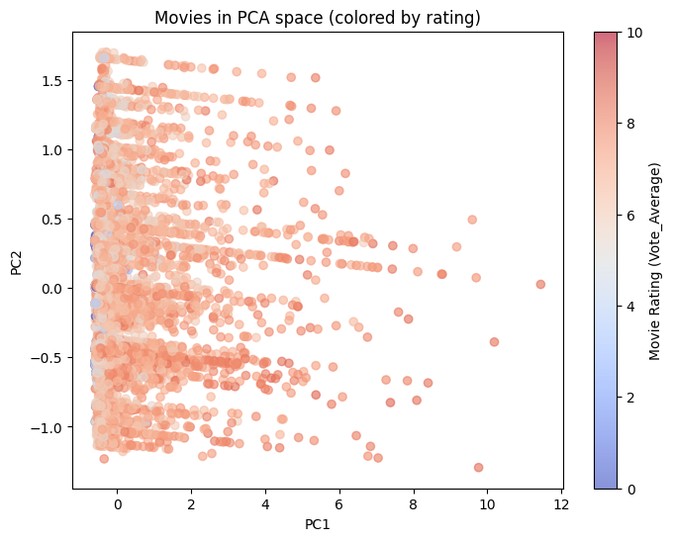

**What the plot shows:**

* The **x-axis** = true (actual) movie ratings.
* The **y-axis** = predicted ratings from the Linear Regression model.
* The **red dashed diagonal line** represents an “ideal” case where predicted = actual.
* **Significance:**
* If points lie **close to the diagonal**, it means predictions are accurate.
* In your plot, predictions seem to cluster around a narrow band (around rating 6–7), which suggests the model has limited variability and struggles to capture extremes (very low or very high ratings).
* This highlights both the **baseline predictive ability** and the **limitations** of Linear Regression on this dataset.
* **How to use in report:**
* The Predicted vs Actual plot shows that the regression model mostly predicts average ratings (around 6–7), while struggling with movies at the extremes.
* The clustering away from the diagonal indicates that while the model captures general trends, it lacks precision for outliers.

# Linear Regression

* **Why use Linear Regression?**  
  It’s one of the simplest models to map numeric features → target (here, ratings).  
  It assumes:

Rating=w1​⋅PC1​+w2​⋅PC2​+...+wk​⋅PCk​+b

* **How it helps here:**

1. Provides **baseline prediction** for movie ratings.
2. **Interpretability** → coefficients show which PCA components (and thus which original features) most strongly influence ratings.
3. Works well if relationships are roughly **linear**.

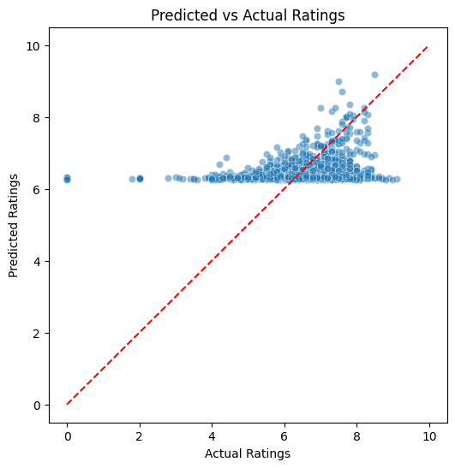

# 

**What the plot shows:**

* Movies are projected into **two principal components (PC1 and PC2)**.
* The **color gradient** represents movie ratings (blue = low rating, red = high rating).

**Significance:**

* PCA compresses many original features into just two axes, allowing visualization of patterns.
* Here, the movies spread along PC1, but ratings (colors) appear fairly mixed — meaning ratings are not easily separable just by the top two components.
* This suggests that while PCA reduces dimensionality, predicting ratings requires more complex interactions across multiple components.

**How to use in report:**

* The PCA plot visualizes movies in reduced 2D feature space, with colors indicating ratings.
* The distribution shows that ratings do not cluster strongly in PCA space, implying that ratings depend on a combination of multiple hidden factors.
* This supports the use of regression to combine PCA components for prediction.

# PCA+Linear Regression

1. **Input Data:** Movie features (e.g., budget, cast, reviews).
2. **Scaling:** StandardScaler makes all features comparable.
3. **PCA:** Reduces dataset to fewer uncorrelated features (PCs).
4. **Linear Regression:** Fits a model to predict ratings from these PCs.
5. **Evaluation:** Outputs metrics like **MSE** and **R²**, and plots (Predicted vs Actual ratings).

In short:

* **PCA** helps simplify and clean up messy, high-dimensional movie data.
* **Linear Regression** then provides a straightforward way to predict ratings.
* Together, they form a neat pipeline: **“Compress features → Predict ratings → Evaluate.”**

# Recommendations & Next Steps

* Model robustness — Compare Ridge and Lasso regression; try tree-based models (Random Forest, XGBoost, LightGBM).
* Evaluation — Add more metrics (MAE, RMSE) and perform cross-validation.
* Data considerations — Verify dataset quality, missing values, balance of rating distribution.
* Reproducibility — Save model coefficients, add requirements.txt, fix random seeds.

# Limitations of this Static Analysis

This analysis was conducted without executing the notebook.  
- Metrics and plots included are based on extracted outputs, not freshly computed values.  
- Any runtime errors, warnings, or updated results are not visible here.  
- To confirm accuracy and obtain latest results, run the notebook end-to-end.

# Codes and Outputs

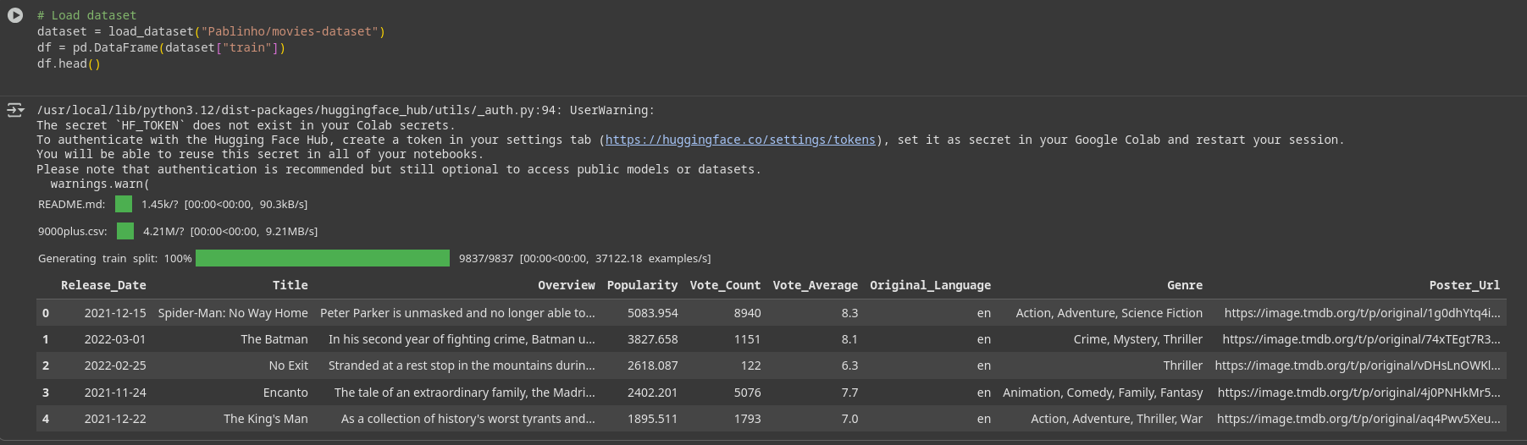

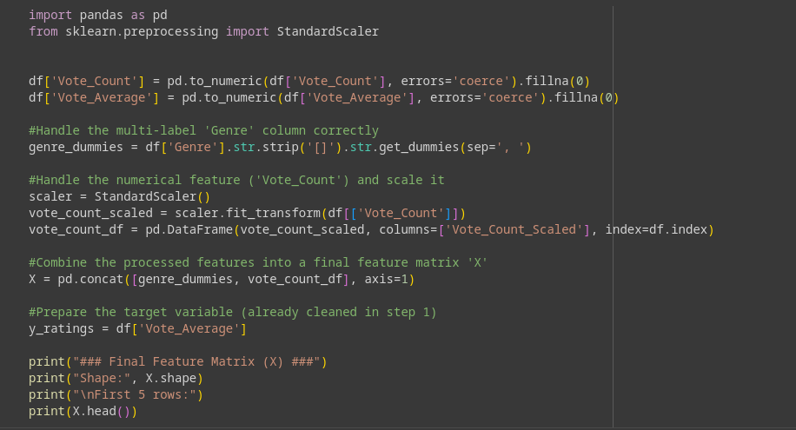

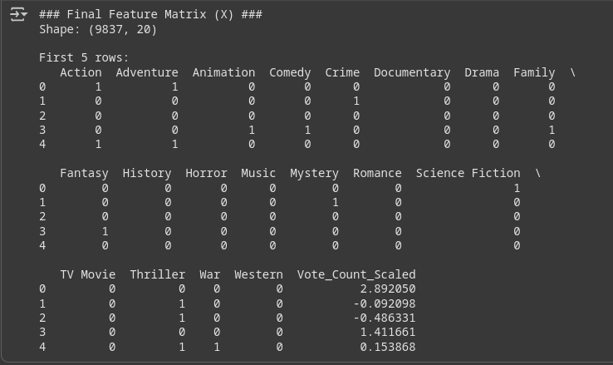

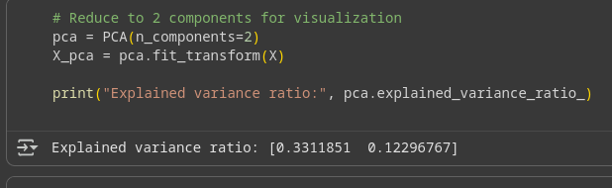

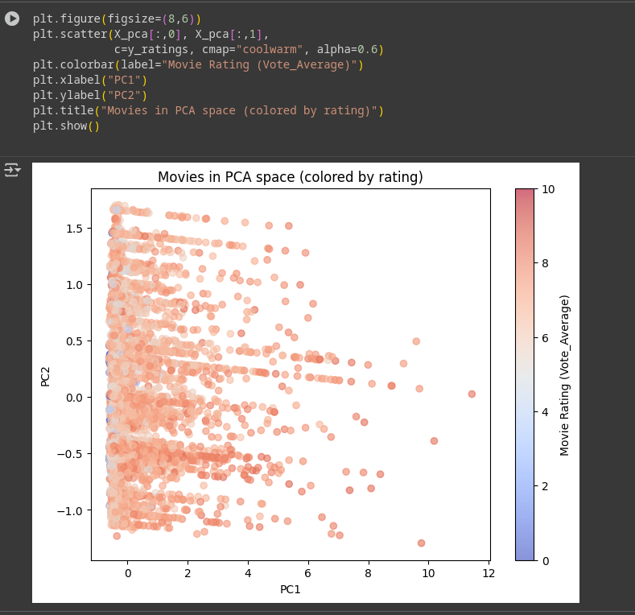

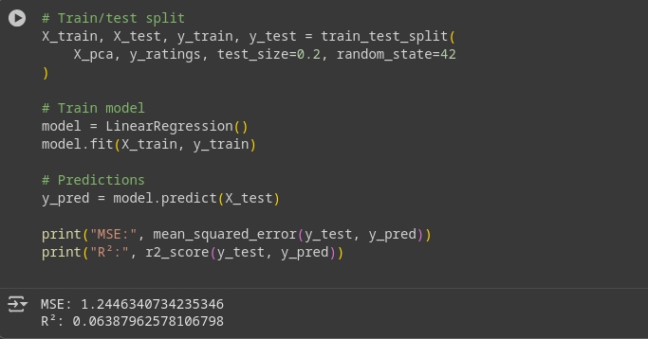

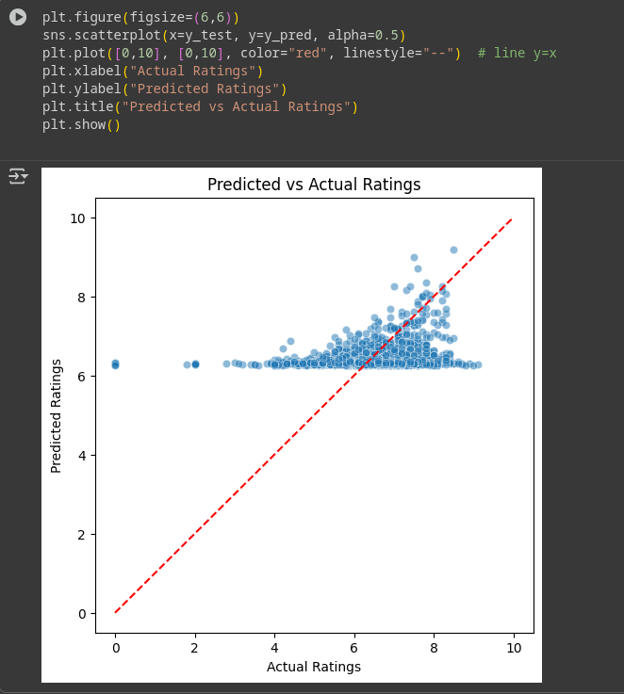

All the codes and outputs are shown from collab.