An Agricultural Water Use Package for MODFLOW and GSFLOW

By Richard G Niswonger1

1U.S. Geological Survey, 345 Middlefield Road, MS 470, Menlo Park, CA 94025, [rniswon@usgs.gov](mailto:rniswon@usgs.gov)

**Abstract**

The Agricultural Water Use (AG) Package was developed for simulating demand-driven and supply-constrained agricultural water use in MODFLOW and GSFLOW models. The AG Package uses pre-existing hydrologic simulation provided by MODFLOW and GSFLOW. Three options are available for simulating water use for agriculture: 1) user-specified demands, 2) demands determined by a user-specified irrigation trigger value that is compared to the ratio of the simulated actual to potential evapotranspiration (ET), and 3) demands determined by minimizing the difference between potential and actual ET. The latter two approaches use energy and soil-water balance to determine crop-water demands. Irrigation withdrawals are diverted into canals and routed to fields using the MODFLOW SFR Package, or irrigation water is provided/supplemented by groundwater. Combined with MODFLOW or GSFLOW, the AG Package can simulate dynamic water use by agriculture in developed basins while providing flexibility to represent a range of irrigation practices.

# Keywords

Integrated hydrologic modeling, agricultural water use, GSFLOW, MODFLOW, drought, irrigation withdrawals, water resources, conjunctive use, surface water and groundwater interactions

# Software and/or data availability section

Software and data used for this work, model input files for each example problem, and ancillary data are available through the GitHub repository [https://github.com/rniswon/mfnwt/tree/AgOptions]. The Agricultural (AG) Water Use Package was developed by Richard Niswonger ([rniswon@usgs.gov](mailto:rniswon@usgs.gov)), and was released February 2020 and runs on Windows, Unix, and Macintosh operating systems and requires no specific hardware or software to run. GSFLOW and its components are written in Fortran, and the program files are less than 10 Mbytes; The AG Package, including source code, compiled binary files for Windows and Unix, example problems, and Jupyter Notebooks for plotting results are provided through the MFNWT Github repository.

# Introduction

Agriculture is a major water consumer in many basins around the world, and estimating irrigation withdrawals in hydrologic models is important for water resources planning and management (Wang et al., 1996; Jones et al., 2017). Water management decision support software is paramount in many river basins in the western United States and other parts of the world for adapting to climate change and population growth, and for evaluating new water management strategies (Tian et al., 2015). Hydrologic models that incorporate surface water and groundwater can provide valuable information about water resources sustainability in conjunctive-use systems. This is especially true for agricultural regions susceptible to climate change and population growth that stress water supplies (Faunt, 2009; Elliott et al., 2014; Gorelick and Zheng, 2015).

Hydrologic software such as MODFLOW simulates 3-dimensional groundwater flow and includes many add-on capabilities, such as representation of surface-water features and other hydrologic processes (Harbaugh, 2005; Langevin et al., 2017). GSFLOW is the integration of MODFLOW and PRMS and can simulate all major hydrologic processes in watersheds, including distributed energy and water consumption by plants (Markstrom et al., 2008; Markstrom et al., 2015). GSFLOW can simulate partitioning of precipitation into snowpack, runoff, evapotranspiration (ET), and groundwater flow using energy and water balance approaches (Markstrom et al., 2008).

MODFLOW and GSFLOW have been used for simulating regional-scale agricultural systems (Hu et al., 2010; Morway et al., 2013; Bailey et al., 2016; Wu et al., 2016; Guzman et al., 2015; Woolfenden and Nishikawa, 2014; Essaid and Caldwell, 2017). An add on to MODFLOW called the Farm Process was developed to represent agricultural systems supplied by surface water and groundwater (Schmid et al., 2006; Hanson et al., 2010; Hanson et al., 2014). A common approach for simulating agricultural systems in regional integrated models is to estimate irrigation demands as a pre-processing step, where a separate soil-water balance model is used to calculate demands. Irrigation demands are subsequently specified to a regional integrated model that does not simulate field soil-water balance (Dogrul et al., 2011). The Farm Process for MODFLOW-2005 assumes the irrigation demand is independent of a farm’s soil water content, and that precipitation can be subtracted from reference ET to account for rain-fed crop consumption (Hanson et al., 2010, 2014). Another approach presented herein is to include simulation of soil-water balance within the hydrologic simulator to better represent soil-water in irrigated lands. The advantage of this approach is that simulated soil water conditions can be used to estimate the rain-fed component of crop consumption for the estimation of irrigation withdrawals (e.g., Huntington et al., 2017).

Here an Agricultural (AG) water use package is presented for MODFLOW and GSFLOW for regional/river-basin scale simulations. The AG Package also can simulate conjunctive use of surface water and groundwater by automatically pumping groundwater when surface water availability is less than demand (Schmid et al., 2006). Because irrigation demand, irrigation efficiency, and crop consumption can be simulated using daily climatic conditions, the model can be used to simulate impacts of climate change on water supply. The AG Package can represent changes in land use, including changes in crop type, expansion or contraction of farmlands, or changes in irrigation technology through existing features in GSFLOW and recent enhancements (Regan and LaFontaine, 2017). Changes in land use can be simulated using the dynamic parameters capability in GSFLOW to represent changes in vegetation cover type, crop coefficients, and other input parameters that vary with changes in land use (Regan and LaFontaine, 2017).

Climate variability can cause regional shifts in agricultural demand due to systematic changes in soil moisture and irrigated areas, and indirectly as reductions in return flows (Fischer et al., 2007). Interactions such as these occur over time periods that span irrigation events or irrigation seasons, or they can span much longer time periods due to multi-year shifts in climate and groundwater supply. Evolving supply and demand conditions such as these support simulating demand using energy and soil-water balance within integrated hydrologic models rather than estimating demands as a pre-processing step or independent of soil moisture. The AG Package for MODFLOW and GSFLOW provides a wholistic approach for representing dynamic irrigation withdrawals and can be used for planning and assessing impacts of agriculture on other water-use sectors and for evaluating long-term sustainability. The AG Package also provides necessary capabilities for integration of GSFLOW with river/reservoir-operations models such as MODSIM for simulating impacts of water use priorities on agricultural systems (Labadie, 2010; Morway et al., 2016; Niswonger et al., 2017; Kitlasten et al., 2020).

Two example problems are presented for representing agriculture in MODFLOW and GSFLOW, and these examples are run using different options to demonstrate application of the new package and its capabilities for simulating agricultural water use for different hydrographic settings and irrigation practices. Example problem 1 demonstrates the new package in a MODFLOW simulation and represents an agricultural basin in northwest Nevada (Prudic et al., 2004). The second example demonstrates the package in a GSFLOW simulation and represents an undeveloped basin in northeast California, including hypothetical irrigated regions. Previously published work provides theory and application of MODFLOW and GSFLOW, and only new theoretical and implementation details for the AG Package are provided herein. Readers can refer to these published works for simulation capabilities related to MODFLOW and GSFLOW, including energy and water balance calculations for hydrologic simulations that are used by the AG Package (Harbaugh, 2005; Markstrom et al., 2008; Niswonger et al., 2011).

General descriptions of the components in an agricultural system are provided here to set the context for the theoretical explanation of these components. This is followed by descriptions of the integration between the agricultural system and the regional hydrologic system. Details of the algorithms and model code developed for the AG Package are provided, as wells as explanation of the various options that can be used to simulate agricultural water use. Two different example models are described to illustrate the implementation of the AG Package, using both the MODFLOW and GSFLOW hydrologic modeling frameworks. Results of these models and their discussion are provided to highlight appropriate use of different model options and implications of these options in the model results.

# Methods

### Irrigation water delivery

In practice, irrigation is withdrawn from one location, and it is routed through reservoirs, streams, canals, pipes, and furrows to its place of use (Fig. 1). A place of use is an agricultural field where plant roots uptake water from shallow soils. As water is delivered to fields, part of it is lost along the way due to ET, leaky pipes and canals, misdirected surface flows, and seepage. Irrigation water also can increase during delivery if the irrigation system gains from other sources. Not all the water applied to fields is used by the crop, and instead there are field losses due to surface runoff, seepage below the plant roots, and soil evaporation. Field losses depend on field conditions and the irrigation practices that vary with irrigation approach, such as flood, sprinkler, and drip irrigation. Conveyance and other system gains and losses cause irrigation withdrawals to be different than crop consumption. This difference is referred to as the system efficiency (Allen et al., 1998). The AG Package was developed to represent these processes explicitly using hydrologic simulation capabilities in MODFLOW and GSFLOW or implicitly by specifying efficiency factors to represent all or a portion of the system gains and losses.

#### Surface water irrigation

Surface water delivery for irrigation is simulated by the MODFLOW Streamflow-Routing (SFR) Package, including open channel flow in streams and canals, or non-pressurized flow through pipes (Prudic et al., 2004; Niswonger and Prudic, 2005). Surface water demands for diverting irrigation water and applying it to fields can be set by user-specified values, or they can be calculated by the model using field-based crop-water demands. SFR routes steady or kinematic flow by coupling continuity and Manning’s equation and user-defined relationships between flow, area, and depth to represent a variety of flow geometries. SFR neglects diffusion and other acceleration terms in the shallow water and pipe flow equations; however, as times steps are typically 1 day or longer, this simplification is generally applicable for regional agricultural systems.

Diversion segments are used to deliver irrigation water and are initialized in the SFR input file. Diversion segments can be designated as irrigation segments in the AG input file to apply diverted surface water to fields. SFR diversion flow rates are constrained by the amount of water flowing in the upstream segment and 1 of 4 water-use priority options (Prudic et al., 2004).

Surface reservoirs are simulated by the MODFLOW Lake (LAK) Package (Merritt and Konikow, 2000) for MODFLOW simulations and/or open detention storage reservoirs for GSFLOW simulations (Regan and LaFontaine, 2017). SFR routes channel flows into and out of reservoirs represented by LAK and open detention storage reservoirs. Diversion segments and reservoirs represented by SFR and LAK are integrated with the groundwater flow equation to simulate surface water and groundwater interactions; however, open detention reservoirs do not interact with groundwater.

#### Groundwater irrigation

Groundwater irrigation is provided by wells that can pump water from a groundwater cell. Wells are defined, and maximum pumping rates are specified, within the AG Package input file. Irrigation wells are assumed to have a screened interval that spans the model cell thickness, and smoothing functions are used to reduce the pumping rate to zero as the water table drops below the cell bottom (Niswonger et al., 2011). Non-irrigation wells, such as public supply or thermoelectric wells are handled outside of the AG Package using one of the other MODFLOW well packages (Harbaugh, 2005). AG wells must have negative pumping rates to represent flow out of an aquifer. Groundwater wells are designated in AG as irrigation wells to apply pumped groundwater to fields. Pumping rates for irrigation wells can be set by user-specified values, or they can be calculated by the model using groundwater irrigation demands. Pumping rates also can be calculated by the model to supplement surface water rights, such that all or a portion of the shortage is pumped from groundwater. However, this version of the AG Package cannot be used to represent the use of surface water to supplement a groundwater right.

#### Mapping point of diversion to place of use

Irrigation provided by diversion segments and groundwater wells is applied to designated cells or Hydrologic Response Units (HRUs) with a user-specified mapping between numerically identified SFR segments, AG wells, and cells/HRUs. MODFLOW simulations require that AG features (irrigation diversions or wells) be associated with MODFLOW cells because surface spatial units in MODFLOW are cells. However, for GSFLOW simulations, surface spatial units are HRUs, and AG Package features must be associated with HRUs. The point of diversion is located at the upstream end of a diversion segment or well used for irrigation, and the place of use is the area of fields irrigated by the diversion. MODFLOW cells are identified by their row and column, HRUs are identified by their hru_id, diversion segments are identified by their SFR segment number, and wells are identified by their AG well number. Mapping identifiers are input to the AG input file, and they can change during a simulation to represent changes in withdrawal locations or irrigated lands. SFR diversion segments can consist of 1 or more reaches, where reaches are the length of stream or canal that spans a single model cell. A segment can span many model cells to represent great distances between a withdrawal point and irrigated field, and diversion segments can divert from other diversion segments. Irrigation cannot be applied to a partial area of a cell in MODFLOW, which could be a limitation in models with cells that are larger than fields. However, irrigation can be applied to a fraction of an HRU using the impervious fraction parameter, and non-irrigated areas within an HRU are assumed to be impervious. A diversion and/or well can provide water for multiple cells/HRUs, or multiple diversions and/or wells can provide water for a single cell/HRU. Additionally, a well can supplement several diversions, or several wells can supplement one or more diversions. If multiple SFR diversions supply irrigation to a single cell/HRU then the order that water is diverted occurs in the same order that the irrigation segments are specified. However, if multiple wells supply a single cell/HRU then the demand is split evenly among the wells.

### Simulating crop consumption

ET can be simulated using soil-water balance over any time step length for MODFLOW simulations, or ET can be simulated using daily energy and water balance for GSFLOW simulations (Markstrom et al., 2008; Niswonger et al., 2011). Actual crop ET () can be calculated by UZF as a function of the depth-dependent soil water contents using a kinematic-wave formulation (Niswonger et al., 2006), or can be calculated by PRMS as a function of volume-averaged soil saturation using a nonlinear soil-water reservoir approach (Markstrom et al., 2008; Markstrom et al., 2015). Crop-specific ET demand is calculated by multiplying the crop coefficient (by the reference ET (; Allen et al., 1998). A single crop coefficient approach is used by the AG Package, and represents crop-specific information including growth patterns and soil evaporation; seasonal values for common crops are available in the literature (Allen et al., 1998).

If using UZF to represent agricultural fields then the product is input for the UZF variable PET. If using PRMS to represent agricultural fields, is calculated using one of six options available in PRMS, including Jensen-Haise, Hargraeves-Semani, Penman-Monteith, Priestly-Taylor, Hamon, and pan potential ET modules (Markstrom et al., 2015). Example problem 2 below demonstrates how is incorporated into GSFLOW simulations using the PRMS Jensen-Haise formulation. Other than including into the calculation of all other PRMS input does not change due to the AG Package.

Sub-irrigation is a process in which plants use shallow groundwater to meet crop water demands. Growers apply less irrigation water where there is shallow groundwater beneath their crops, thus this process is important for estimating irrigation demand. Sub-irrigation is simulated by UZF assuming a linear capillary rise as a function of groundwater head; sub-irrigation is simulated in GSFLOW by groundwater discharge to the PRMS soil zone due to linear capillary rise or saturated discharge conditions (Niswonger et al., 2006; Markstrom et al., 2008). Total crop consumption for a cell () is calculated in UZF by summing the unsaturated zone and groundwater , where groundwater is a linear function of the water table elevation above the root depth and is zero when the water table is below the root depth (UZF input variable EXTDP).

Additional to the previously available approach for simulating in UZF, a new option was added to simulate crop consumption using a pressure gradient approach. This approach is recommended for the AG Package and ETDEMAND option, and a description is provided here because it was not included in the original UZF or GSFLOW documents. For this case, the capillary pressures are calculated in the crop root zone using the Brooks-Corey retention function and 3 new UZF input variables, including the root activity function, air entry pressure, and root pressure (Lappala et al., 1987). is calculated using:

. (1)

Where is the thickness of the root zone or ET extinction depth that can change during the growing season (L); is unsaturated hydraulic conductivity as a function of water content (LT-1), is the root activity function that can change during the growing season (L-2); is capillary pressure head as a function of water content (L), and is the negative root pressure head (L). Variables in equation 1 are calculated using Brooks and Corey (1966) unsaturated hydraulic conductivity and capillary pressure functions. This option also is documented by Langevin et al. (2017).

### Simulating irrigation return flows

Irrigation return flow is water that returns to a surface water body or seeps to groundwater rather than entering the atmosphere due to ET. It is considered return flow because the water becomes available to other growers or for other uses in the system. Return flow can occur anywhere between a withdrawal and a field, including the area where irrigation is applied. Gains and losses in the irrigation infrastructure are represented by the integration of surface water and groundwater in SFR and LAK for the channel and surface reservoir domains (canal or pond), and gains and losses are simulated by UZF or PRMS for the overland flow domain (field). Return flow also occurs between the overland flow domain and the channel and reservoir domains. Groundwater return flow occurs as irrigation percolates beneath the UZF ET extinction depth or through the base of the soil zone defined in PRMS. There is no explicit representation of irrigation for salt leaching; however, specified amounts of irrigation can be applied to cells/HRUs to represent salt leaching. Effects of salt stress on are neglected. Exchanges between surface water and groundwater are simulated using implicit coupling of the surface water and groundwater equations, or to the kinematic-wave equation for unsaturated flow where streams are separated from groundwater by an unsaturated zone (Niswonger and Prudic, 2005). Pipe networks represented by SFR segments can be made semi-pervious to represent leaky pipes.

There is no explicit representation of irrigation technology in the AG Package, such as sprinkler and drip equipment; however, differences in how irrigation is applied can be emulated using irrigation scheduling and application rates. Accordingly, water can be applied to fields at a greater rate to represent flood irrigation, and at a lower rate to represent sprinkler irrigation, for example. Depending on the application rate and duration, a portion of this water will runoff and flow laterally toward another surface water body. Runoff is routed in UZF using the IRUNBND procedure for MODFLOW simulations and by the PRMS cascade routing procedure for GSFLOW simulations (Niswonger et al., 2006; Markstrom et al., 2008; Henson et al., 2013). Additionally, applied irrigation water can pass through the root zone beneath a field and deep percolate to the water table. The amount of deep percolation also is dependent on irrigation technology, scheduling, and field hydraulic properties that can vary for each cell/HRU representing fields in the model. Alternatively, irrigation return flow can be set using irrigation efficiency factors or a combination of explicitly represented infrastructure and efficiency factors.

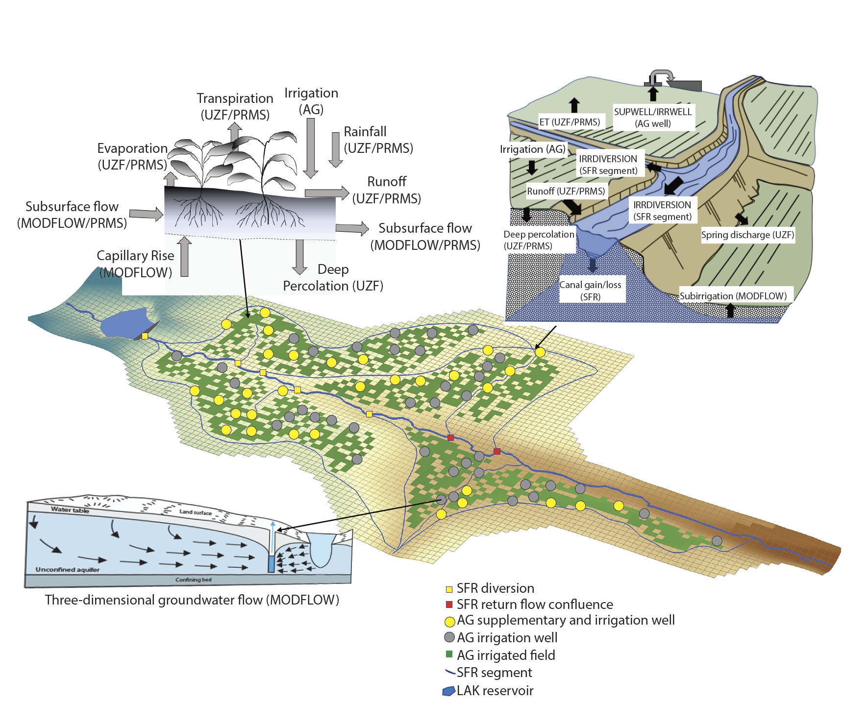

1. Illustration showing how regional agricultural processes are represented in MODFLOW and GSFLOW. Surface water and groundwater can be used for irrigation by designating diversion segments as irrigation diversions (IRRDIVERSION) and designating wells as irrigation wells (IRRWELLS) and/or supplementary wells (SUPWELLS) in the AG Package. Diversion segments are included as part of the regional stream network within the Streamflow Routing (SFR) Package and are designated as irrigation segments in the AG Package.

## Irrigation demand and scheduling

Irrigation demand can be specified directly by the user, or demand can be calculated by the model using the ET deficit equal to the reference ET times the crop coefficient for well-watered conditions minus the simulated actual ET. Three options are provided in order to support applications to systems with differing amounts of data and differing agricultural practices. For example, if irrigation diversions and/or groundwater withdrawals are accurately known then option 1 described below is suitable. If irrigation withdrawals are uncertain, and crop consumption rates are more certain then options 2 or 3, depending on irrigation practices, are suitable. Only one of the options can be used in a single simulation.

### Option 1: User-specified irrigation demand and schedule using surface water diversions and/or groundwater wells

Option 1 is the default approach (Fig. 2A), and irrigation demand is set using time varying surface water diversions specified in SFR tabfiles, or time varying pumping rates specified in AG. Alternatively, the user can have the model calculate irrigation demand using options 2 or 3, in which case the time varying surface water diversions specified in SFR tabfiles, or time varying pumping rates specified in AG represent maximum irrigation withdrawals.

For option 1, irrigation water is applied to MODFLOW cells or PRMS HRUs; ET and groundwater and surface water return flow is simulated using explicit representation of irrigation delivery infrastructure. Or, infrastructure can be represented implicitly using efficiency factors, and the difference between irrigation water delivery and crop consumption is applied as groundwater return flow, and surface water return flow is assumed to be zero.

In many agricultural regions, irrigation is provided by surface water, and groundwater is used to supplement surface water during drought or seasonally low flow periods. Irrigation wells can be designated as supplementary wells, and rather than specifying pumping rates, pumping rates are calculated as the difference between the irrigation demand and the actual diverted surface water rate, referred to as the surface water shortfall (; L3T-1):

. (2)

Where is the volumetric demand rate for the irrigation period required for crop growth in 1 or more cells/HRUs supplied by a diversion (L3T-1), is the volumetric diversion rate that can be less than or equal to if surface water supplies limit the diversion rate (L3T-1); is the maximum percentage of that will be supplemented by groundwater. The volumetric rate of supplementary groundwater irrigation for a diversion that can be supplied by 1 or more wells is calculated as (L3T-1):

, (3)

where is the fraction of that will be supplemented by groundwater.

When using efficiency factors to simulate crop consumption, and if water is supplied by surface water and supplemented by groundwater, for each cell/HRU is calculated as:

. (4)

And for groundwater only irrigation, for each cell/HRU is calculated as:

. . (5)

Where is the actual ET for cell/HRU n (LT-1); ncell and nHRU are the total number of MODFLOW cells or PRMS HRUs irrigated by a diversion or groundwater well; is the user-specified fraction of the diverted irrigation water that will be applied to cell n; is the groundwater irrigation delivered to one or more cells/HRUs (L3T-1); is the groundwater irrigation efficiency factor; is the user-specified surface water irrigation efficiency; and is the area for cell/HRU n(L2). Groundwater return flow for a diversion and/or groundwater or supplemental well (; L3T-1-1) is calculated as:

. (6)

The amount of groundwater return flow applied to each cell/HRU (; LT-1) is:

(7)

If efficiency factors are used to represent crop consumption ( and > 0), then the UZF input variable PET and PRMS input parameter JH_coef (for the Jensen-Haise formulation) should be set to zero for cells/HRUs that contain fields. Note that efficiency factors partition water that is applied to fields into and ; however, system gains/losses that occur between the point of diversion and the place of use, not including field gains/losses, must be simulated using pervious SFR segments or combined with field gains/losses using efficiency factors. Surface water return flows that occur due to irrigation rates applied in excess of the vertical hydraulic conductivity of the field are not represented using approach 1.

### Option 2: Triggered irrigation events

Option 2 is activated when the character input variable TRIGGER is specified in the AG input file (Fig. 2B). Once the irrigation event is triggered, the user specified diversion or pumped amount is delivered and applied to fields for the user-specified irrigation period. Diversions are specified using SFR tabfiles, and pumping rates are specified in AG. Supplementary groundwater pumping can be used to satisfy a surface water demand after an irrigation event is triggered as described in option 1. Irrigation events can be triggered consecutively if the ET ratio remains below the specified threshold.

Irrigation automatically starts when the ET ratio summed over all cells/HRUs supplied by a diversion or AG well decreases below a user-specified threshold. During the growing season, irrigation is turned on when:

. (8)

, (9)

and

. (10)

Where is the user specified ET deficit threshold that triggers an irrigation event and is a value between zero and 1; is the sum of actual ET for all cells/HRUs irrigated by a diversion or well (L3T-1); is the sum of crop ET for well-watered conditions for all cells (UZF input variable PET multiplied by the cell area) or HRUs (PRMS calculated value PET times pervious HRU area) irrigated by a diversion or well (L3T-1); is the crop coefficient for cell/HRU n; and is the reference ET for cell/HRU n. An irrigation event for a diversion or well continues until:

, (11)

where and (T) are the elapsed and specified irrigation time, respectively. Conditions for starting a new irrigation period are evaluated at the end of each period.

### Option 3: Optimal net irrigation water requirement

Option 3 is activated when the character input variable ETDEMAND is specified in the AG input file (Fig. 2C). Net irrigation withdrawal (NIW; L) is the total annual irrigation withdrawal required for plant growth divided by the irrigated area. NIW is calculated by the model according to:

, (12)

where (L) is the quantity of irrigation water loss or gain that occurs between the point of diversion up to and including the place of use divided by the irrigated area; and is the annual gross irrigation withdrawal defined as the irrigation withdrawal required for plant growth divided by the irrigated area, including gains and losses that occur during delivery and on the field (L). Supplementary groundwater pumping can be used to supply the GIW as described in option 1. Surface water and groundwater return flows can occur during delivery and on farms.

GIW is calculated by the model as the amount of water that must be diverted and/or pumped such that the difference between the simulated and is minimized. For MODFLOW simulations, the product under well-watered conditions () is specified as variable PET in UZF. For GSFLOW, is calculated as:

. (13)

The volumetric rate of water consumed by a crop for well-water conditions () is:

, (14)

where is calculated using the previously described approaches and is multiplied by internally for GSFLOW simulations. The diversion and/or pumped amount is calculated by minimizing (min) the ET deficit (; LT-1) as:

, (15)

subject to the amount of surface water that can be diverted and/or groundwater that can be pumped. As with option 2, and are summed over all fields irrigated by a diversion and/or a well. In addition to simulated water supply constraints, values specified for diversions using SFR tabfiles and pumping rates specified in AG can be used to constrain irrigation timing and maximum amounts.

A solution to equation 15 is accomplished by determining the minimum amount of water required to be diverted or pumped to meet the crop-water demand. The volumetric rate of crop consumption for a time step can be written as a function of the irrigation demand as:

(16)

And after substituting and re-arranging terms, equation 16 becomes:

. (17)

Where is an iteration counter for solving nonlinearities between irrigation demand and crop consumption; and are total irrigation water diverted and/or pumped for iterations i+1 and i, respectively (L3T-1); and are the crop consumption for iterations i+1 and i, respectively (L3T-1). Note that also is the MODFLOW or GSFLOW outer iteration counter (Markstrom et al., 2008; Niswonger et al., 2011).

The amount of water that is applied to each cell/HRU n (; LT-1) that is irrigated by a diversion/well is:

. (18)

Where and are the fractions of the total irrigation water delivery from surface water and groundwater applied to each cell/HRU n, respectively.

### Constraining surface water diversions and groundwater pumping rates

Diversion and pumping rates are automatically constrained by the supply of surface water at the upstream diversion point and by the water table elevation in the cell that contains the well. Pumping rates specified in the AG input file are used to set the groundwater irrigation rate for option 1, or they can be used to set the maximum irrigation pumping rate for options 2 and 3. Additional constraints can be applied to surface water diversions for all 3 options using diversion rates specified in SFR tabfiles and 1 of 4 diversion priority options in SFR (Prudic et al., 2004):

1. demand is greater than the flow available in the upstream segment, and the diversion is reduced to the amount available;
2. demand is greater than flow available in the upstream segment, and no water is diverted from the stream;
3. demand is greater than a specified fraction of the flow in the upstream segment, and the diversion is reduced to the fraction of flow;
4. diversion is set equal to demand only if the remaining streamflow in the upstream segment exceeds the value specified in the SFR tabfile, otherwise no water is diverted.

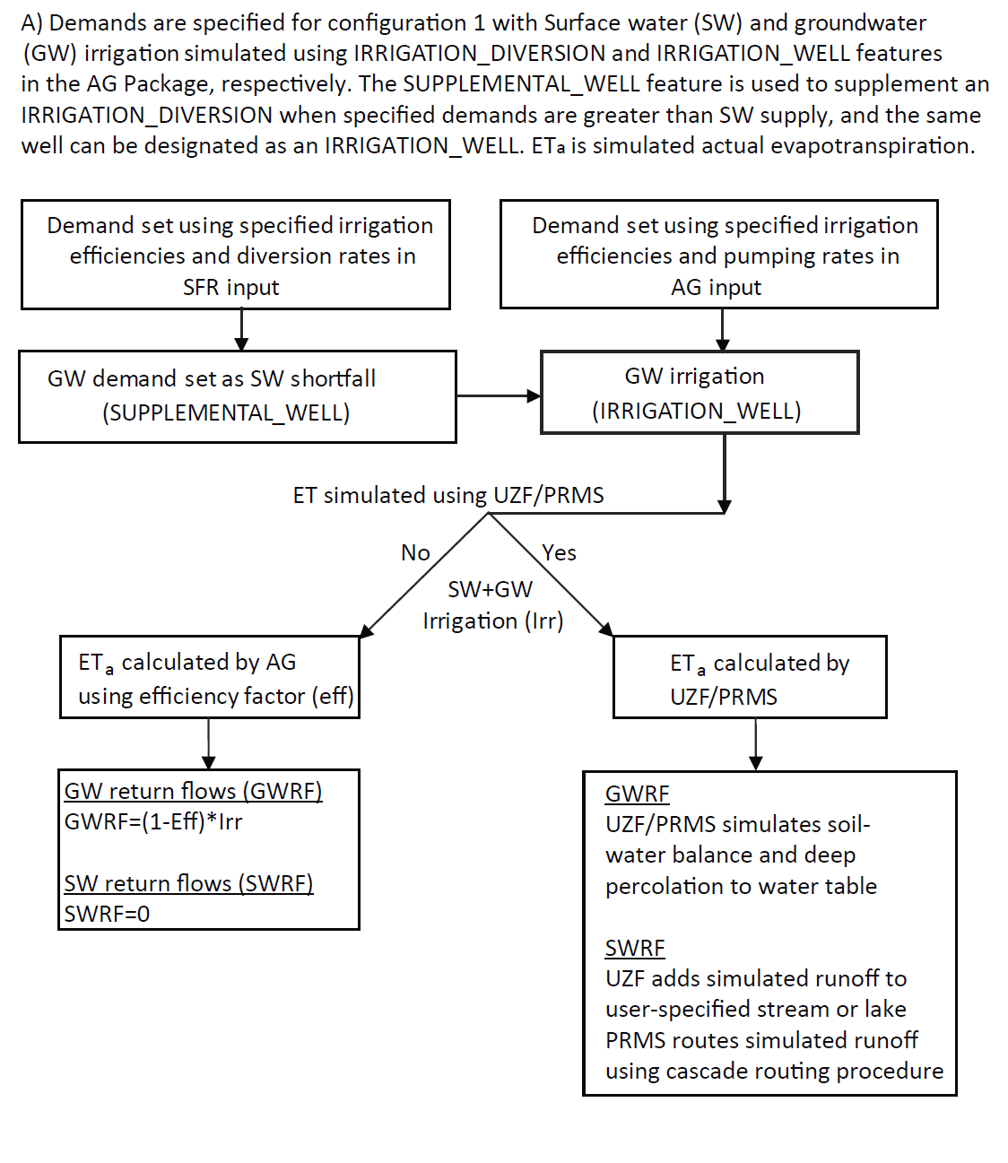

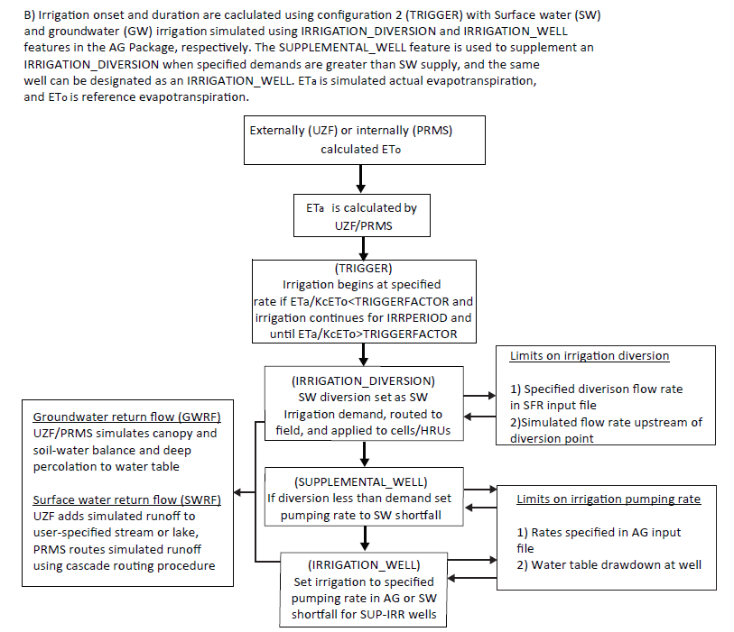

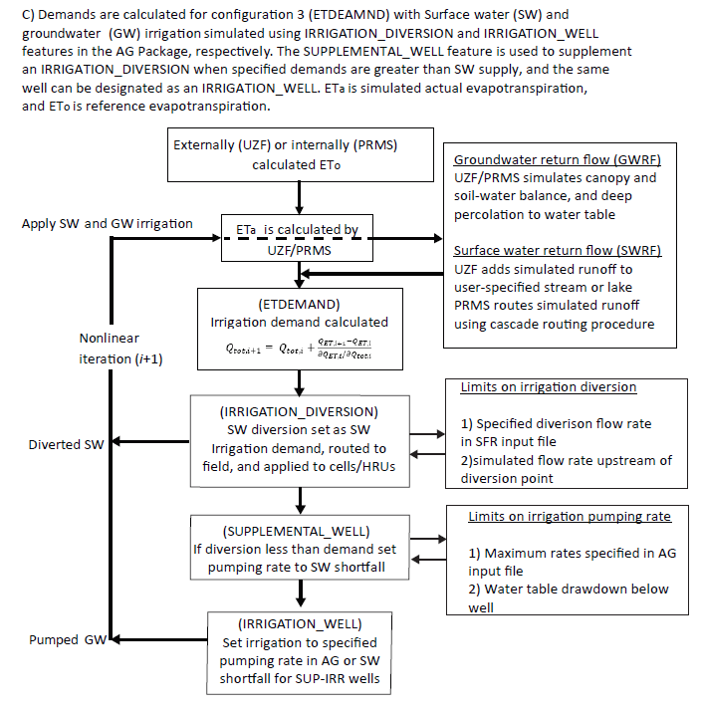

1. Flow charts showing three different approaches for simulating agricultural water use with the AG Package; A) demands set by user (AG Package default); B) demands calculated by activating irrigation events using an ET trigger (AG Package character input TRIGGER); C) demands calculated using the minimum irrigation water requirement (AG Package character input ETDEMAND).

# Description of Example Problems

Two example problems are presented to illustrate the capabilities of the AG Package for simulating water use by agriculture. Example problem 1 is a MODFLOW simulation that was modified from Test 1 presented previously by Prudic and others (2004). Test problem 2 is a GSFLOW simulation that was modified from the Sagehen Creek Watershed GSFLOW example problem (Markstrom et al., 2008). Although there is no agriculture in the Sagehen Creek Watershed, the AG Package was added for this example to simulate irrigation from surface water and supplementary wells to several HRUs in the lower part of the watershed that represent hypothetical agricultural fields. Both example problems retain the units used in their original presentations, and thus example problem 1 uses English units and example problem 2 uses metric units.

## Example Problem 1: MODFLOW with conjunctive use of surface water (SW) and groundwater (GW), ETDEMAND option

This model represents an alluvial river basin in a semi-arid region. The basin receives most of its precipitation in the surrounding mountains, and intermittent streams drain the mountains and flow into a perennial river that crosses the southern portion of the valley (Fig. 3). The valley aquifer consists of alluvium dominated by sand and gravel, and the mountains consist of bedrock that has much lower hydraulic conductivity than the valley alluvium. Recharge in the basin primarily occurs as seepage loss from the intermittent stream channels and to a lesser extent as groundwater flowing to the valley from the mountain block and diffuse recharge through valley sediment.

Prudic and others (2004) present additional details describing this test problem, including representation of the stream network, and distribution of recharge and ET parameters used within the model. Niswonger and others (2006) describe modifications made to this example to replace the ET and Recharge Packages with the UZF Package; excess applied infiltration and rejected infiltration/spring discharge is routed to streams.

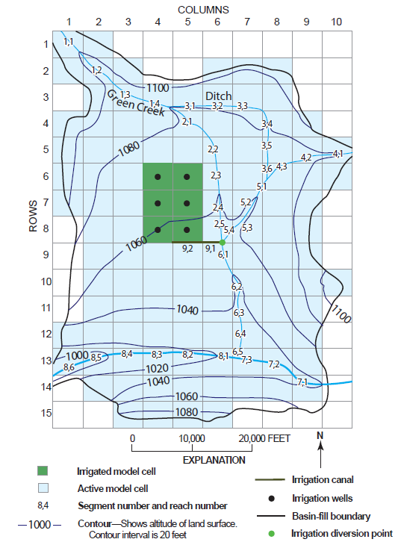

1. Map showing basin topography, streams and canals, and agricultural region for example problem 1.

The model domain extends to a maximum of 520 feet below land surface in the valley bottom; and extends laterally 14 miles in the north-south direction, and 9.5 miles in the east-west direction (Fig. 3). The model is discretized into 1 layer, 15 rows, and 10 columns, and only model cells coincident with the basin fill are active; consolidated rocks are not included. Layer 1 ranges in thickness between 130 feet and 520 feet. Model cells have a constant dimension of 5000 feet in the row and column directions. A total of 3,440 acres (6 model cells) are irrigated for agriculture in the central part of the basin; irrigation water is diverted from the Green River (Fig. 3) and pumped from the shallow aquifer beneath the fields. Two tributary streams that enter the model from the northwest and northeast join the mainstem in the southern part of the model (Fig. 3). Simulations included an initial steady state stress period followed by forty-eight transient stress periods. Each stress period represents a calendar month that is divided into daily time steps. The simulation begins on January 1. Results are presented for the final 2 years of the simulation, as the steady state stress period and first 2 years of the simulations are used to establish initial conditions.

Hydraulic conductivity and specific yield of the water table aquifer increase in the valley bottoms that comprise of floodplains or new alluvium of the tributary streams and river. Monthly was specified (as UZF input variable PET) using annual estimates disaggregated into monthly values using average monthly temperatures (Prudic and Herman**,** 1996). Users are referred to the input files for this problem that accompany this work for additional details.

Two versions of example problem 1 are presented. Example problem 1a (EP1a) simulates irrigation water provided by surface water and supplementary groundwater, and example problem 1b (EP1b) that simulates irrigation water provided solely by groundwater. Both models simulate irrigation demands using the ETDEMAND approach that minimizes the ET deficit using equation 17. Figure 3 shows the cells designated as agricultural fields that receive irrigation. SFR diversion segment number 9 was used to divert water from the Green River and route it to the fields (Fig. 3). NIWR is satisfied solely by groundwater in EP1b.

## Example Problem 2: GSFLOW-Conjunctive use of SW and GW, ETDEMAND verses TRIGGER options

Example problem 2 was developed by modifying the GSFLOW Sagehen example problem (Markstrom et al., 2008) to include agricultural fields in the lower part of the basin (Fig. 4). Sagehen Creek drains a of 27 km2 watershed on the east slope of the northern Sierra Nevada. Geology of the Sagehen Creek watershed consists of granodiorite bedrock overlain by andesitic, tertiary volcanic material, which are overlain by till and alluvium composed of granodiorite and andesite clasts and some quaternary gravels (Burnett and Jennings, 1965). The principal aquifer (model layer 2) was assumed to consist of volcanic material with thickness ranging between 50 and 300 m. A veneer of alluvium covers the volcanic material that is thicker along channels in the lower section of the watershed (Burnett and Jennings, 1965). Alluvium (model layer 1) was assumed to range in thickness between 0 and 10 m. The model domain extends laterally 6.4 km in the north-south direction, and 7.1 km in the east-west direction (Fig. 4). The model is discretized into 90x90 m cells using 2 layers, 71 rows, and 79 columns. Eighteen years are simulated, each year is divided into 12 stress periods, each period represents a calendar month and is divided into daily time steps. The transient simulation begins on October 1.

Two versions of example problem 2 are presented. Example problem 2a (EP2a) and example problem 2b (EP2b) simulate demand using the ETDEMAND and TRIGGER options, respectively. Figure 4 shows the cells designated as agricultural fields that receive irrigation, including 34 cells irrigated by 2 segments that divert water from Sagehen Creek. Segment 18 supplies water for 14 cells, and segment 19 supplies water for 20 cells (Fig. 4). All 34 irrigated cells sum to an area to 27.5 hectares. Irrigation can be nonzero during the growing season (June 1-August 30) and zero outside the growing season. These constraints on the surface water diversions for irrigation were specified using SFR tabfiles that define maximum diversion amounts for segment numbers 18 and 19. Wells were placed in each agricultural cell for supplementary pumping to meet irrigation requirements.

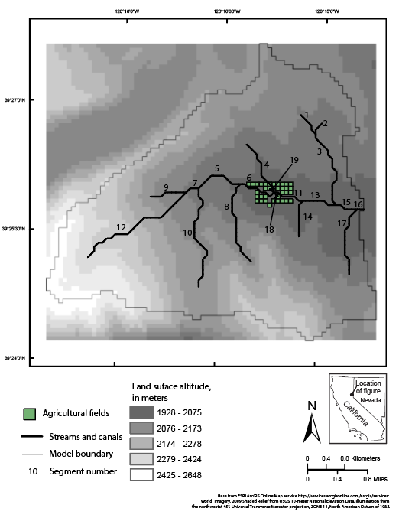

1. Map of Sagehen Creek watershed with hypothetical irrigated fields used in example problem 2.

# Results

## Example Problem 1a: Impacts of SW supply on supplementary GW pumping

EP1a was run with high and low inflow hydrographs (Fig. 5) representing average and drought years, respectively, to evaluate how differences in surface water supply impact the relative proportions of surface water and supplemental groundwater used for irrigation (Fig. 6). Specified surface water inflow enters the model through segment 1 over the northeast corner of the model boundary (Fig. 3). Maximum surface water diversions rates were set in a SFR tabfile for segment 9 with an irrigation period from April 1 to September 30, and a maximum rate of 100 ft3/s, which is greater than the maximum irrigation demand, and thus, only the amount of flow in segment upstream of the irrigation segment will constrain irrigation (option 1). Soil and crop properties for EP1a are those of the fine-textured soil shown in Table 1.

Figure 6 shows the proportions of surface water and supplementary groundwater used for irrigation for the average and drought conditions. For this example, irrigation demand is nearly equal to crop consumption due to the values of ET extinction depth, saturated water content, and natural rainfall. Supplementary groundwater makes up a greater proportion of the irrigation water supply during the low flow hydrograph (53%) relative to the high flow hydrograph (42%) due to surface water supply constraints (Fig. 5). Average annual irrigation water requirements were the same for both simulations (2.58 feet) and slightly less than the annual average crop consumption (2.6 feet) due to small amounts of precipitation in the valley. Supplementary pumping rates increase abruptly right as the flow at the diversion point decreases and then re-equilibrate as the crop demand (ETa) decreases; similarly, pumping rates decrease abruptly when the demand decreases abruptly (Fig. 6)

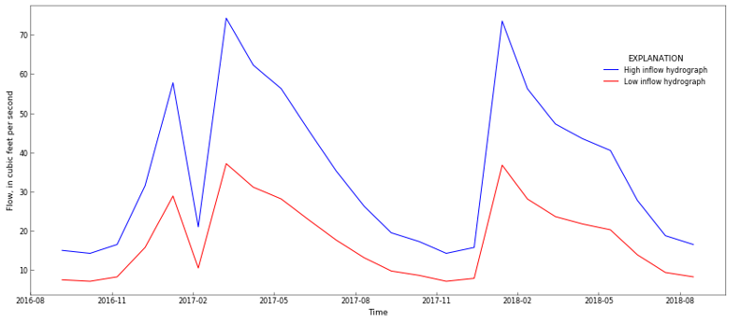

1. Inflow hydrographs specified in the SFR Package input file for test model 1a, representing years of average (high inflow) and below average (low inflow) precipitation.

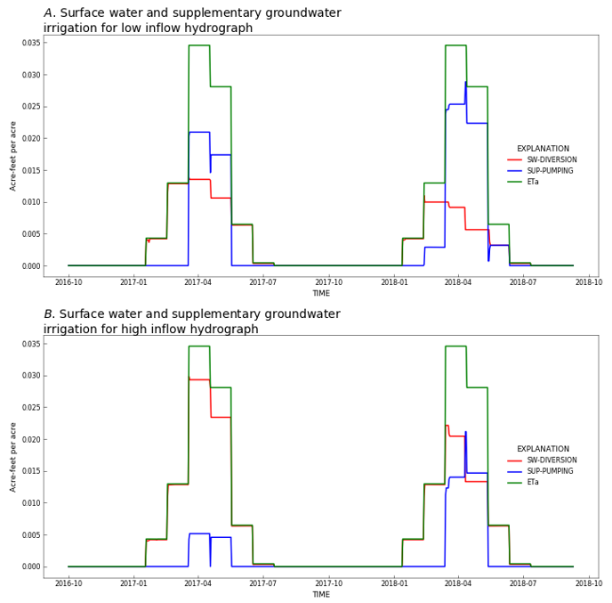

1. Irrigation provided by surface water diversions and groundwater pumping for A) low, and B) high inflow hydrographs shown in Figure 5.

## Example Problem 1b: Impacts of soil properties on GW irrigation demand

This example problem is run for 2 different agricultural field soil types, including fine and coarse soil textures (Table 1). The coarse soil requires greater amounts of irrigation earlier during the growing season relative to the fine soil because of lower antecedent soil moisture at the onset of the growing season (Fig. 7). Faster drainage increases the average annual irrigation demand for the coarse soil (3.1 feet) relative to the fine soil (2.6 feet) due to greater amounts of groundwater return flow. Return flow is greater for coarse soils because of lower saturated water content (porosity) and greater deep percolation. As there is no constraint on irrigation supply, average annual equals the of 2.7 acre-feet per acre. Irrigation demand is slightly less than crop consumption for fine soil due to rain-fed irrigation and the larger soil storage relative to coarse soil.

1. Soil and crop parameters used in example problem 1a and 1b.

|  |  |  |
| --- | --- | --- |
|  | **Fine soil** | **Course soil** |
| Saturated water content of unsaturated zone (cubic foot of water per cubic foot of bulk volume) | 0.38 | 0.30 |
| Brooks-Corey exponent  (unitless) | 7.5 | 4.5 |
| Vertical hydraulic conductivity of the unsaturated zone (feet per day) | 4 | 8.6 |
| Evapotranspiration extinction depth  (feet) | 0.50 | 0.50 |
| Residual water content  (cubic foot of water per cubic foot of bulk volume) | 0.20 | 0.10 |
| Air entry pressure (feet of water) | -1.10 | -0.1 |
| Root pressure (feet of water) | -30.0 | -30.0 |
| Root activity function (per feet squared) | 1.0 | 1.0 |

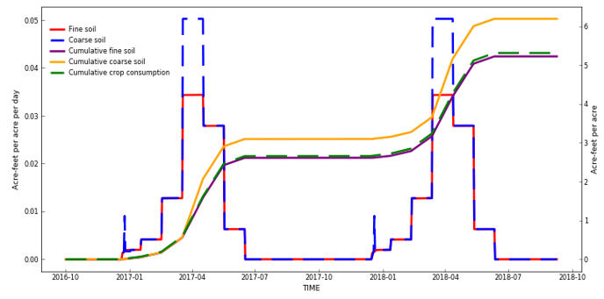

1. Groundwater pumping rates and cumulative pumping for irrigation in example problem 1b with fine and course agricultural soil properties.

## Example Problem 2a: Effects of crop coefficient on irrigation demands

EP2a illustrates the effects of the crop coefficient () on irrigation demand and crop consumption using the ETDEMAND option for irrigation (Fig. 8). is incorporated into the ET demand by multiplying the PRMS input parameter JH_COEF by the monthly values. Note that JH_CEOF can be specified for each hydrologic response unit in PRMS and for each of the 12 calendar months (Markstrom et al., 2015). As this option represents optimal irrigation scheduling to minimize the ET deficit, these results reflect optimal water use to meet crop water demand. Annual average GIWR for the period 1991-1993 is 1.1 hectare-meter per hectare for high and 0.70 hectare-meter per hectare for low . Annual average crop consumption is equal to 1.06 hectare-meters per hectare for high and 0.81 hectare-meter per hectare for low . Actual ET equals in this example because the ETDEMAND option is used, and because constraints on the irrigation amounts set in the SFR tabfile and AG pumping rates did not limit irrigation. Irrigation demand is less than crop consumption for 1992 and 1994 because of water supplied by precipitation and sub-irrigation; however, 1993 was a drought year and demand is greater than consumption.

EP2a also demonstrates the influence that early growing season antecedent soil water conditions have on crop water demand. Total annual precipitation amounts measured at the Independence Lake climate station for water years 1991, 1992, and 1993 was 83 cm, 71 cm, and 149 cm, respectively, while demand was 79, 158, and 70 percent of the crop water consumption during these years for the case of high , and 66, 129, and 62 percent of the crop water consumption during these years for the case of low (Fig. 9).

Real world irrigation practices likely cannot exactly mimic this optimal irrigation schedule for practical and logistical reasons. Nonetheless, these model results are useful for providing guidance on irrigation schedules, setting lower bounds on irrigation demand, and for providing a base model for evaluating factors affecting demand and consumption. Irrigation constraints can be superimposed onto the ETDEMAND option using SFR tabfiles and AG pumping rates to mimic real-world conditions. As will be shown in EP2b, additional flexibility in simulating irrigation practices is provided by the TRIGGER option.

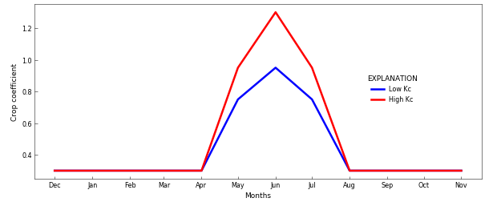

1. Seasonal crop coefficient (Kc) used for simulating agricultural water use in example problem 2a and 2b. Crop coefficients are incorporated into the evapotranspiration demand by multiplying the PRMS input parameter JH_COEF by the monthly Kc values. Note that JH_CEOF can be specified for each hydrologic response unit in PRMS and for each of the 12 calendar months.

# 

1. Comparison of agricultural water use for example problem 2a, using low and high crop coefficients (Kc) shown in Figure 8.

## Example Problem 2b: Using irrigation triggers to estimate demand

Example problem 2b is identical to EP2a, except that the TRIGGER option is used, and seasonal were set using the High curve (Fig. 8). EP2b illustrates the influence that different irrigation trigger values have on the surface water diversions and groundwater pumping rates. An irrigation event starts when the ET ratio () becomes less than the specified trigger threshold. Results are shown for a high (0.85) and low (0.35) trigger value, representing well-watered and deficit irrigation conditions, respectively. Note that the length of an irrigation period is specified as 3 days for both high and low trigger values; however, if the ET ratio is below the trigger value at the end of a period then a new irrigation period will begin immediately.

Irrigation delivery is directly proportional to the trigger value, where higher trigger values result in greater surface water diversions, pumping, and crop water consumption (Fig. 10). Irrigation demand for the period 1991-1993 is 1.4 hectare-meters per hectare for a high trigger value and 0.7 hectare-meters per hectare for a low trigger value. Annual average crop consumption is the same as EP2a (1.06 hectare-meter per hectare), except for the low trigger value simulation results in a crop consumption of 0.83 hectare-meter per hectare. A low trigger value causes the model to delay an irrigation event because the simulated ET will reduce to a lower fraction of the reference ET before an irrigation event is triggered. Accordingly, lower trigger values allow the soils to drain longer between irrigation events, and lower trigger values result in less actual ET as compared to higher trigger values (Fig. 10b). Generally, the TRIGGER option results in significantly more surface water and groundwater irrigation withdrawal relative to the ETDEMAND option. This is because the irrigation rate is specified for the TRIGGER option and may not be optimal for an agricultural field. Whereas the irrigation rate is calculated as a function of the ET deficit for the DEMAND option and reflects the optimal irrigation rate.

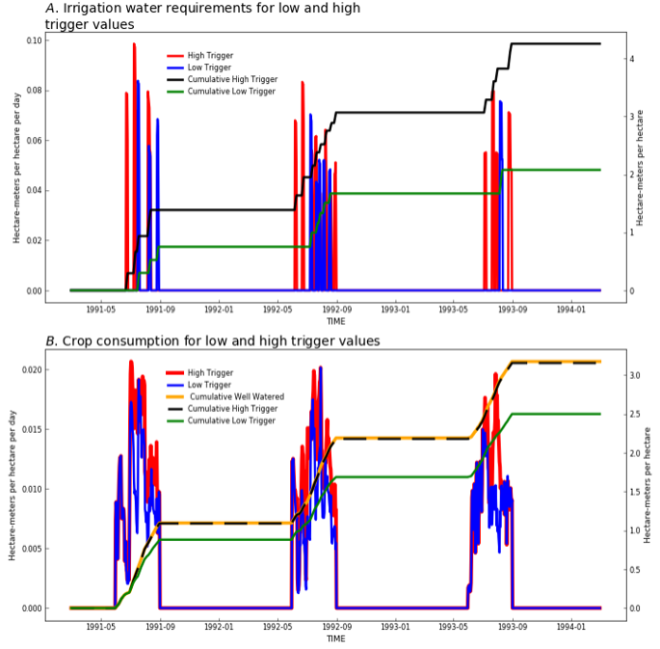

1. Comparison of agricultural water use for example problem 2a, using low and high irrigation trigger values.

# Discussion

A new package for MODFLOW and GSFLOW is presented that provides capabilities for simulating agricultural water use in regional scale hydrologic models. The AG Package can be used to estimate agricultural water use for systems where information about irrigation supply and demand are not available, or it can be used to simulate irrigation withdrawals and their impacts on water supply. The latter application is important in regions where there are competing needs for water, and climate change, population growth, and land use change are causing unknown impacts. Design of the AG Package includes flexibility for representing systems with varying amounts of data, different grower irrigation practices, and feedbacks between water supply and water use by agriculture. Water demands rely on energy and soil-water balance calculations and regionally specific conditions can be represented, such as spatial variations in temperature, solar radiation, and plant type.

Specific attributes of a region can be considered, including soil hydraulic properties, depth to groundwater, canal or pipe properties, and antecedent soil moisture and precipitation. Water consumption relies on explicit simulation of irrigation infrastructure, soil-water budgets, and surface water and groundwater availability. These design features provide flexibility for evaluating water use in a wide variety of agricultural systems, and for developing optimal irrigation schedules unique to a region. However, the effects of salinity stress on crops and crop-water use are not represented in the AG Package.

Existing software used to simulate agricultural water use in regional hydrologic models do not provide capabilities of the AG Package. The MODFLOW-based package called the Farm Process requires monthly time steps, and it does not simulate soil-water balance for the estimation of irrigation withdrawals and (Hanson et al., 2014). The AG Package simulates daily soil-water dynamics that play an important role in determining irrigation schedules and amounts. Soil-water balance is important for representing the rain-fed component of crop consumption required for estimating irrigation withdrawals (Senay et al., 2014; Allen at al., 2007). Landsat derived can be integrated through soil-water balance into hydrology models that represent both agricultural systems and the broader regional to national hydrologic system.

A variety of options are provided for mimicking different irrigation practices, specifically with regards to the timing and amounts of irrigation. Examples are presented that illustrate impacts of surface water supply on groundwater pumping (EP1a), irrigation supplied solely by groundwater (EP1b), irrigation estimated for optimal water-use conditions that minimizes the ET deficit (EP2a), and irrigation that is triggered when the ET deficit drops below a specified threshold. All these approaches are provided as options to best represent regionally specific conditions. Because irrigation water is explicitly routed and applied to individual fields, the model can be used to evaluate irrigation return flows and changes in land use.

Practical applications of integrated hydrologic models that represent agricultural water use must rely on data that characterize a broad range climactic and hydrogeologic conditions. Additionally, representation of agriculture requires characterization of water governance and irrigation practices. Complete data sets are rarely available, and integrated models provide a means of maximizing information with partial data sets by combining data with physical process equations and generalized frameworks for representing human impacts on water distribution and consumption. The AG Package for MODFLOW and GSFLOW provides a powerful decision support tool that can maximize understanding of water resources in agricultural basins and provide hindcast information about historical water budgets and system response as well as future projections of sustainability and management change.

# Conclusions

Hydrologic simulation of developed basins is difficult or impossible without representing agricultural water use. Integrated hydrologic models are useful decision support tools for developing regional water budgets and evaluating water management strategies and sustainability for human populations and ecosystem services. Despite significant data gaps in water use at regional scales, hydrologic models can complement incomplete datasets and provide a more complete picture of water resources. Process understanding, and theoretical representation of agricultural water use are well established; however, limited software is available that explicitly represents agricultural water use in regional-scale integrated hydrologic models. The AG Package for MODFLOW and GSFLOW provides a wholistic representation of agricultural water use in the context of the natural hydrologic system and other water use sectors. Through a series of simple but realistic example problems, this paper demonstrates the software’s applicability for a variety of approaches for simulating irrigation practices and associated effects on water distribution and supply in regional-scale systems.

# Acknowledgements

Support for the author was provided by the USGS Water Availability and Use Program. Additionally, support was provided by the National Science Foundation, grant number: 1360506, and the U.S. Department of Agriculture/National Institute of Food and Agriculture, grant number: 1360507. The author thanks rewiewers….

# References Cited

Allen, R. G., Pereira, L. S., Raes, D., & Smith, M. (1998). Crop evapotranspiration-Guidelines for computing crop water requirements-FAO Irrigation and drainage paper 56. FAO, Rome, 300(9), D05109.

Allen, Richard G., Masahiro Tasumi, Anthony Morse, Ricardo Trezza, James L. Wright, Wim Bastiaanssen, William Kramber, Ignacio Lorite, and Clarence W. Robison (2007). "Satellite-based energy balance for mapping evapotranspiration with internalized calibration (METRIC)—Applications." Journal of irrigation and drainage engineering 133, no. 4: 395-406.

Bailey, R. T., Wible, T. C., Arabi, M., Records, R. M., & Ditty, J. (2016). Assessing regional‐scale spatio‐temporal patterns of groundwater–surface water interactions using a coupled SWAT‐MODFLOW model. Hydrological processes, 30(23), 4420-4433.

Brooks, R.H., and Corey, A.T., 1966, Properties of porous media affecting fluid flow: American Society of Civil Engineers, Journal of Irrigation and Drainage, v. 101, p. 85–92.

Burnett, J.L., and Jennings, C.W., 1965, Chico Quadrangle, scale 1:250,000: State of California, Division of Mines and Geology.

Dogrul, E. C., Schmid, W., Hanson, R. T., Kadir, T., & Chung, F. (2011). Integrated Water Flow Model and Modflow-Farm Process: A Comparison of Theory, Approaches, and Features of Two Integrated Hydrologic Models. Department of Water Resources, California Natural Resources Agency, State of California, Sacramento, Technical Information Record.

Elliott, J., Deryng, D., Müller, C., Frieler, K., Konzmann, M., Gerten, D., M. Glotter, M. Flörke, Y. Wada, N. Best, S. Eisner, B. M. Fekete, C. Folberth, I. Foster, S. N. Gosling, I. Haddeland, N. Khabarov, F. Ludwig, Y. Masaki, S. Olin, C. Rosenzweig, A. C. Ruane, Y. Satoh, E. Schmid, T. Stacke, Q. Tang, and D. Wisser (2014). Constraints and potentials of future irrigation water availability on agricultural production under climate change. Proceedings of the National Academy of Sciences, 111(9), 3239-3244.

Essaid, H. I., & Caldwell, R. R. (2017). Evaluating the impact of irrigation on surface water–groundwater interaction and stream temperature in an agricultural watershed. Science of the Total Environment, 599, 581-596.

Faunt, C.C., ed., 2009, Groundwater Availability of the Central Valley Aquifer, California: U.S. Geological Survey Professional Paper 1766, 225 p.

Fischer, G., Tubiello, F. N., Van Velthuizen, H., & Wiberg, D. A. (2007). Climate change impacts on irrigation water requirements: effects of mitigation, 1990–2080. Technological Forecasting and Social Change, 74(7), 1083-1107.

Gorelick, S. M., & Zheng, C. (2015). Global change and the groundwater management challenge. Water Resources Research, 51(5), 3031-3051.

Guzman, J. A., Moriasi, D. N., Gowda, P. H., Steiner, J. L., Starks, P. J., Arnold, J. G., & Srinivasan, R. (2015). A model integration framework for linking SWAT and MODFLOW. Environmental Modelling & Software, 73, 103-116.

Hanson, R. T., Schmid, W., Faunt, C. C., & Lockwood, B. (2010). Simulation and analysis of conjunctive use with MODFLOW's farm process. Groundwater, 48(5), 674-689.

Hanson, Randall T., Scott E. Boyce, Wolfgang Schmid, Joseph D. Hughes, Steffen W. Mehl, Stanley A. Leake, Thomas Maddock III, and Richard G. Niswonger. One-water hydrologic flow model (MODFLOW-OWHM). No. 6-A51. US Geological Survey, 2014.

Harbaugh, A.W., 2005, MODFLOW-2005, the U.S. Geological Survey modular ground-water model -- the Ground-Water Flow Process: U.S. Geological Survey Techniques and Methods 6-A16.

Hu, Y., Moiwo, J. P., Yang, Y., Han, S., & Yang, Y. (2010). Agricultural water-saving and sustainable groundwater management in Shijiazhuang Irrigation District, North China Plain. Journal of Hydrology, 393(3-4), 219-232.

Huntington, J. L., Hegewisch, K. C., Daudert, B., Morton, C. G., Abatzoglou, J. T., McEvoy, D. J., & Erickson, T. (2017). Climate Engine: cloud computing and visualization of climate and remote sensing data for advanced natural resource monitoring and process understanding. Bulletin of the American Meteorological Society, 98(11), 2397-2410.

Jones, J.W., Antle, J.M., Basso, B., Boote, K.J., Conant, R.T., Foster, I., Godfray, H.C.J., Herrero, M., Howitt, R.E., Janssen, S. and Keating, B.A. (2017). Toward a new generation of agricultural system data, models, and knowledge products: State of agricultural systems science. Agricultural systems, 155, pp.269-288.

Kitlasten, Wesley, Morway, E.D., Niswonger, R.G., Gardner, Murphy, Triana, Enrique (in prep.), Integrated Hydrology and Operations Modeling Approach to Evaluate the Vulnerability of Agriculture in a Snow-Fed River Basin to Climate Variability

Labadie, J. W. (2010), MODSIM 8.1: River basin management decision support system; User manual and documentation.

Langevin, C. D., Hughes, J. D., Banta, E. R., Niswonger, R. G., Panday, S., & Provost, A. M. (2017). Documentation for the MODFLOW 6 Groundwater Flow Model (No. 6-A55). US Geological Survey.

Lappala, E.G., Healy, R.W., Weeks, E.P., 1987, Documentation of computer program VS2D to solve the equations of fluid flow in variably saturated porous media: U.S. Geological Survey WaterResources Investigations Report 83–4099, 184 p., accessed June 27, 2017, at <https://pubs.er.usgs.gov/publication/wri834099>.

Markstrom, S.L., Regan, R.S., Hay, L.E., Viger, R.J., Webb, R.M.T., Payn, R.A., and LaFontaine, J.H., 2015, PRMS-IV, the precipitation-runoff modeling system, version 4: U.S. Geological Survey Techniques and Methods, book 6, chap. B7, 158 p., http://dx.doi.org/10.3133/tm6B7.

Markstrom, S.L., Niswonger, R.G., Regan, R.S., Prudic, D.E., and Barlow, P.M., 2008, GSFLOW-Coupled Ground-water and Surface-water FLOW model based on the integration of the Precipitation-Runoff Modeling System (PRMS) and the Modular Ground-Water Flow Model (MODFLOW-2005): U.S. Geological Survey Techniques and Methods 6-D1, 240 p.

Merritt, M.L., and Konikow, L.F., 2000, Documentation of a Computer Program to Simulate Lake-Aquifer Interaction Using the MODFLOW Ground-Water Flow Model and the MOC3D Solute-Transport Model: U.S. Geological Survey Water-Resources Investigations Report 00-4167, 146 p.

Morway, E. D., Gates, T. K., & Niswonger, R. G. (2013). Appraising options to reduce shallow groundwater tables and enhance flow conditions over regional scales in an irrigated alluvial aquifer system. Journal of hydrology, 495, 216-237.

Morway, E. D., Niswonger, R. G., & Triana, E. (2016). Toward improved simulation of river operations through integration with a hydrologic model. Environmental Modelling & Software, 82, 255-274.

Niswonger, R.G., Prudic, D.E., and Regan, R.S., 2006, Documentation of the Unsaturated-Zone Flow (UZF) Package for modeling unsaturated flow between the land surface and the water table with MODFLOW-2005: U.S. Geological Survey Techniques and Methods 6-A19, 62 p.

Niswonger, R.G., Panday, Sorab, and Ibaraki, Motomu, 2011, MODFLOW-NWT, A Newton formulation for MODFLOW-2005: U.S. Geological Survey Techniques and Methods 6–A37, 44 p

Niswonger, R. G., Morway, E. D., Triana, E., & Huntington, J. L. (2017). Managed aquifer recharge through off‐season irrigation in agricultural regions. Water Resources Research, 53(8), 6970-6992.

Niswonger, R.G., and Prudic, D.E., 2005, Documentation of the Streamflow-Routing (SFR2) Package to include unsaturated flow beneath streams—A modification to SFR1: U.S. Geological Survey Techniques and Methods 6-A13, 50 p.

Prudic, D.E., Konikow, L.F., and Banta, E.A., 2004, A new streamflow-routing (SFR1) package to simulate streamaquifer interaction with MODFLOW-2000: U.S. Geological Survey Open-File Report 04–1042, 95 p.

Prudic, D. E., & Herman, M. E., 1996, Ground-water flow and simulated effects of development in Paradise Valley, a basin tributary to the Humboldt River in Humboldt County, Nevada U.S. Geological Survey Professional Paper No. 1409-F.

Regan, R.S., and LaFontaine, J.H., 2017, Documentation of the dynamic parameter, water-use, stream and lake flow routing, and two summary output modules and updates to surface-depression storage simulation and initial conditions specification options with the Precipitation-Runoff Modeling System (PRMS): U.S. Geological Survey Techniques and Methods, book 6, chap. B8, 60 p., https://doi.org/10.3133/tm6B8.

Schmid, W., Hanson, R. T., Maddock III, T., & Leake, S. A. (2006). User guide for the farm process (FMP1) for the US Geological Survey’s modular three-dimensional finite-difference ground-water flow model, MODFLOW-2000. US Geological Survey Techniques and Methods, 6-A17.

Senay, G. B., Gowda, P. H., Bohms, S., Howell, T. A., Friedrichs, M., Marek, T. H., & Verdin, J. P. (2014). Evaluating the SSEBop approach for evapotranspiration mapping with landsat data using lysimetric observations in the semi-arid Texas High Plains. Hydrology and Earth System Sciences Discussions, 11(1), 723-756.

Tian, Y., Zheng, Y., Wu, B., Wu, X., Liu, J., & Zheng, C. (2015). Modeling surface water-groundwater interaction in arid and semi-arid regions with intensive agriculture. Environmental Modelling & Software, 63, 170-184.

Wang, Z. M., Batelaan, O., & De Smedt, F. (1996). A distributed model for water and energy transfer between soil, plants and atmosphere (WetSpa). Physics and Chemistry of the Earth, 21(3), 189-193.

Woolfenden, L.R., and Nishikawa, Tracy, eds., 2014. Simulation of groundwater and surface-water resources of the Santa Rosa Plain watershed, Sonoma County, California: U.S. Geological Survey Scientific Investigations Report 2014–5052, 258 p., http://dx.doi.org/10.3133/sir20145052

Wu, X., Zheng, Y., Wu, B., Tian, Y., Han, F., & Zheng, C. (2016). Optimizing conjunctive use of surface water and groundwater for irrigation to address human-nature water conflicts: A surrogate modeling approach. Agricultural Water Management, 163, 380-39