An Agricultural Water Use Package for MODFLOW and GSFLOW

By Richard G Niswonger1

1U.S. Geological Survey, 345 Middlefield Road, MS 470, Menlo Park, CA 94025, [rniswon@usgs.gov](mailto:rniswon@usgs.gov)

**Abstract**

The Agricultural Water Use (AGWU) Package was developed for simulating demand-driven and supply-constrained agricultural water use in MODFLOW and GSFLOW models. The AG Package makes use of pre-existing hydrologic simulation capabilities provided by MODFLOW and GSFLOW. Distribution of water for irrigation is automatically represented using daily potential evapotranspiration and the antecedent soil-water conditions. Irrigation diversions and pumping rates are determined using the concept of net irrigation water requirement (NIWR). NIWR or available water is diverted into canals and routed to fields using the MODFLOW SFR Package, or NIWR can be supplied/supplemented by groundwater wells. The AG Package can estimate NIWR by calculating the required diversion/pumping that minimizes the difference between the well-watered crop evapotranspiration (ET) and the simulated actual ET. Alternatively, the irrigation schedule can be specified directly or can be determined by the model using field conditions as a trigger, such that when the ET deficit reaches a minimum threshold, irrigation automatically occurs for some specified irrigation time and rate. Combined with MODFLOW or GSFLOW, the AG Package can simulate dynamic water use by agriculture in developed basins while providing flexibility to represent a range of grower behaviors and irrigation infrastructure.

# Keywords

Integrated hydrologic modeling, agricultural water use, GSFLOW, MODFLOW, drought, water resources, conjunctive use, surface water and groundwater interactions

# Software and/or data availability section

Software and data used for this work, model input files for each example problem, and ancillary data are available through the GitHub repository [address]. The Agricultural Water Use Package was developed by Richard Niswonger (rniswon@usgs.gov), year first available, hardware required, software required, availability and cost. GSFLOW and its components are written in Fortran, and the program files are less than 10 Mbytes ; for data: form of repository (database, files, spreadsheet), size of archive, access form.

# Introduction

Agriculture is a major water consumer in many basins around the world, and representation of this water-use sector in hydrologic models is important for water resources planning and management (Wang et al., 1996; Jones et al., 2017). Water management decision support software is paramount in many river basins in the western United States and other parts of the world for adapting to climate change, population growth, and for evaluating new water management strategies (Tian et al., 2015). Hydrologic models that incorporate surface water and groundwater can provide valuable information about water resources sustainability in conjunctive-use systems. This is especially true for agricultural regions susceptible to climate change and population growth that stress water supplies (Faunt, 2009; Elliott et al., 2014; Gorelick and Zheng, 2015).

Hydrologic software such as MODFLOW simulates 3-dimensional groundwater flow and includes many add-on capabilities, such as representation of surface-water features and other hydrologic processes (Harbaugh, 2005; Langevin et al., 2017). GSFLOW is the integration of MODFLOW and PRMS and can simulate all major hydrologic processes in watersheds, including distributed energy and water consumption by plants (Markstrom et al., 2008). GSFLOW can simulate partitioning of precipitation into snowpack, runoff, ET, and groundwater flow using energy and water balance approaches (Markstrom et al., 2008).

MODFLOW and GSFLOW have been used for simulating regional scale agricultural systems (Hu et al., 2010; Bailey et al., 2016; Wu et al., 2016; Guzman et al., 2015; Woolfenden and Nishikawa, 2014; Essaid and Caldwell, 2017). An add on to MODFLOW called the Farm Process was developed to represent agricultural systems supplied by surface water and groundwater (Schmid et al., 2006; Hanson et al., 2010; Hanson et al., 2014). A common approach for simulating agricultural systems in groundwater and surface water models is to estimate demands as a pre-processing step, and to subsequently apply these demands to hydrology simulations to avoid simulating field-scale soil water balance (Hanson et al., 2010, Woolfenden and Nishikawa, 2014; Dogrul et al., 2011). In these cases, net irrigation water requirement (NIWR) is estimated externally and independent of evolving conditions in the hydrology model.

As presented herein, another approach is to dynamically calculate demands within an integrated surface water and groundwater hydrology model using energy and soil-water balance. The advantage of this approach is that simulated demands and water use are consistent with evolving conditions in the model. Furthermore, simulated crop consumption can be validated using independent estimates to constrain simulated irrigation water diversions and groundwater pumping (e.g., Huntington et al., 2017).

Here we present the Agricultural (AG) Water Use Package for MODFLOW and GSFLOW for basin-scale simulations. The AG Package also can simulate conjunctive use of surface water and groundwater by automatically pumping groundwater when surface water availability is less than demand (Schmid et al., 2006). Because the NIWR, irrigation efficiency, and crop consumption are simulated using daily climatic conditions, the model can be used to simulate impacts of climate change on water supply. The AG Package can represent changes in land use, including changes in crop type, expansion or contraction of farmlands, or changes in irrigation technology.

Climate variability can cause regional shifts in agricultural demand due to systematic changes in soil moisture and irrigated areas, and indirectly as reductions in return flows (Fischer et al., 2007). Interactions such as these occur over time periods that span irrigation events or irrigation seasons, or they can span much longer time periods due to multi-year shifts in climate and groundwater supply. The AG Package for MODFLOW and GSFLOW provides a wholistic approach for representing dynamic water use by agriculture and can be used for planning and assessing impacts of agriculture on other water-use sectors and for evaluating long-term sustainability. The AG Package also provides necessary capabilities for integration of GSFLOW with river/reservoir-operations models such as MODSIM (Labadie, 2010) for simulating impacts of water use priorities on agricultural systems (Morway et al., 2016; Niswonger et al., 2017).

The AG Package works with the Streamflow-Routing (SFR) and the Unsaturated Flow (UZF) Packages, and the PRMS soilzone module, and includes capabilities for simulating pumping wells, like the WELL Package for MODFLOW-NWT (Niswonger et al., 2011). The AG Package has several capabilities, including application of water flowing in SFR diversion segments as irrigation to UZF/PRMS cells/HRUs; application of groundwater pumped by wells in the AG Package as irrigation to UZF/PRMS cells/HRUs; automatic pumping of groundwater to supplement SFR diversions when the available flow in a diversion segment is less than demand; and calculation of $NIWR$ using the UZF/PRMS crop evapotranspiration (ET) deficit and simulated irrigation efficiency. Sub-irrigation also is represented where the ET demand can be supplemented by direct uptake of groundwater by plants, and irrigation scheduling can be fully automated or triggered by threshold ET deficits. Irrigation water is explicitly applied to cells/HRUs, and ET is simulated using a daily energy and soil-water balance (Markstrom et al., 2008). Surface water and groundwater return flow is routed to receiving water bodies or aquifers.

All exchanges of irrigation water between different packages (SFR, UZF, and AG) and with aquifers are calculated within the AG Package; however, the SFR and UZF Packages must be active in MODFLOW and GSFLOW to divert surface water from streams and lakes and apply irrigation water to cells/HRUs. Diversion segments must be specified within the SFR Package to deliver stream or lake water to fields. All data for supplementary and irrigation wells is specified within the AG Package input file; the AG Package calculates and applies its own boundary conditions for representing groundwater pumped by wells.

Two example problems are presented for representing agriculture in MODFLOW and GSFLOW, and these examples are run for several configurations to demonstrate application of the new package and its capabilities for simulating agricultural water use for a range of hydrographic settings. Example problem 1 demonstrates the new package in a MODFLOW simulation and represents an agricultural basin in northwest Nevada (Prudic et al., 2004). The second example demonstrates the package in a GSFLOW simulation and represents an undeveloped basin in northeast California. Previously published work provides theory and application of MODFLOW and GSFLOW , and only relevant background information and new theoretical and implementation details for the AG Package are provided herein. Readers can refer to these published works for simulation capabilities related to MODFLOW and GSFLOW, including energy and water balance calculations for hydrologic simulations that are used by the AG Package.

# Methods

## Description of the Agricultural Water Use Package

The AG Package can be used to simulate irrigation with 4 different configurations (Fig. 1) that differ in how irrigation applications are specified, supplied and timed.:

1. **NIWR supplied by specified surface water diversions and/or groundwater pumping rates**

NIWR is set using time varying surface water diversions specified in the SFR Package, or time varying pumping rates specified in the AG Package. Irrigation water is applied to UZF cells or PRMS HRUs, and ET can be simulated by UZF or PRMS, including groundwater and surface water return flows. Alternatively, crop consumption can be specified and automatically removed from the model, and the difference between irrigation water delivery and specified consumption is applied as groundwater return flow.

1. **Specified NIWR supplied by surface water diversion and supplemented by groundwater pumping**

This option is identical to (1) except that groundwater pumping rates for irrigation are not specified directly. Rather these rates are calculated as the difference between the NIWR and diverted surface water rate, referred to as the surface water shortfall (${SF}_{IRR}$):

${SF}_{IRR}={FAC}_{max}NIWR-Q_{diversion}$ (1)

Where (L3/T) is the surface water diversion rate that can be less than NIWR if surface water supplies limit the diversion rate; ${FAC}_{max}$ is the maximum fraction of NIWR that will be supplemented by groundwater. The amount of supplementary pumping is calculated as ($Q_{sup})$:

$Q_{sup}={FAC}_{sup}*{SF}_{IRR}$. (2)

Where ${FAC}_{sup}$ is the fraction of ${SF}_{IRR}$ that will be supplemented by groundwater.

1. **Optimal NIWR**

NIWR is calculated by the model according to:

$NIWR=GIWR+{IRR}_{L/G}$, (3)

Where ${IRR}_{L/G}$ is the total irrigation water loss or gain that occurs between the diversion or well and the agricultural field(s). NIWR is calculated by minimizing the difference between crop reference ET (${ET}_{0}$) for well-watered conditions (${ET}_{ww}$) and the simulated actual crop ET (${ET}_{a}$). Supplementary groundwater pumping can be used to supply the NIWR as described in option 2. On-farm surface water return flows are typically zero for this option; however, surface water return flows can occur during irrigation water delivery through canals. Groundwater return flows are often nonzero, especially for farms with coarse soils.

1. **Triggered irrigation events with specified rates and durations**

Onset of an irrigation event is triggered when the ET ratio (${ET}_{a}/{ET}_{ww}$) falls below a user specified threshold. Once the irrigation event is triggered it continues for the user-specified irrigation period at the user specified time varying application rate. Supplementary groundwater pumping can be used to supply the NIWR after an irrigation event is triggered as described in option 2. Irrigation events can be triggered consecutively if the ET ratio remains below the specified threshold. Surface water return flows can occur during delivery and on farm. Groundwater return flows are simulated.

All AG Package configurations rely on irrigation water that is supplied by SFR diversion segments (Niswonger and Prudic, 2005) and/or AG Package groundwater wells. During flow-limited or draw-down limited conditions, irrigation is reduced to the actual diverted and/or pumped amount. Runoff is simulated by UZF/PRMS using the cascade routing approach for GSFLOW simulations (Markstrom et al., 2008; Henson et al., 2013), or the UZF input option IRUNBND for MODFLOW simulations (Niswonger et al., 2006). Sub-irrigation can occur when there is shallow groundwater beneath agricultural fields, and if ET is simulated explicitly using UZF or the PRMS Soilzone Module. Groundwater ET is simulated by UZF for MODFLOW simulations using a linear function of the depth to the water table; groundwater ET is simulated in GSFLOW by groundwater discharge to the PRMS soil zone due to linear capillary rise or saturated discharge conditions (Niswonger et al., 2006; Markstrom et al., 2008).

${ET}_{ww}$ is specified in the UZF input file using the input variable PET (potential evapotranspiration) for MODFLOW simulations, or for GSFLOW simulations it is calculated using daily energy balance and one of six options available in PRMS, including Jensen-Haise, Hargraeves-Semani, Penman-Monteith, Priestly-Taylor, Hamon, and pan potential ET modules (Markstrom et al., 2015). HRU-based ET coefficients must be multiplied by the crop coefficient ($K_{c}$) in the calculation of ${ET}_{a}$ (Allen et al., 1998). Example problem 2 below demonstrates how $K_{c}$ is incorporated into GSFLOW simulations for the Jensen-Haise formulation. ${ET}_{a}$ is calculated using the UZF Package with a kinematic-wave formulation or by the PRMS Soilzone Module using a nonlinear soil-water reservoir approach (Markstrom et al., 2008).

An option for simulating ${ET}_{a}$ in the UZF Package for GSFLOW that uses a pressure gradient approach was added to support the AG Package. This is the same approach documented in the newest version of MODFLOW called MODFLOW6 (Langevin et al., 2017). For this case, the capillary pressures are calculated in the crop root zone using the Brooks-Corey retention function and 2 new UZF input variables, including the air entry pressure and root pressure (Lappala et al., 1987). ${ET}_{a}$ is calculated using:

${ET}_{a}=K\left(θ\right)[ψ\left(θ\right)-h_{root}]$ (4)

Where $K\left(θ\right)$ is unsaturated hydraulic conductivity as a function of water content (LT-1), is capillary pressure as a function of water content (L), and $h_{root}$ is the negative root pressure specified as a depth of water in the UZF Package (L). Variables in equation 4 are calculated using Brooks and Corey (1966) unsaturated hydraulic conductivity and capillary pressure functions.

## Irrigation Systems

The AG Package supports several configurations for representing irrigation systems, including using simple factors that represent the average system gains/losses and crop water consumption to using detailed representations of agricultural infrastructure and model state dependent crop-water consumption (Fig. 1). For simpler options (Figs. 1A and 1B), some fraction of the $NIWR$ can be removed from the model to represent crop consumption, as an alternative to explicitly simulating ET. For example, a surface water diversion in the SFR Package and a well in the AG Package can be used to irrigate a group of cells that contain agricultural fields. Assuming irrigation water supply (i.e., water yield) is greater than or equal to the $NIWR$ for illustrative purposes, an efficiency factor can be used to partition $NIWR$ into crop consumption and ${IRR}_{L/G}$.

$NIWR$ is calculated as:

$NIWR=Q_{demand}/A_{F}$, (5)

and

$GIWR={ET}_{ww}/EF$. (6)

Where $EF$ is the irrigation efficiency factor specified in the AG Package input file; $Q_{demand}$ is the total irrigation demand, supplied by the surface water diversion and/or groundwater pumping rate, L3T-1; and is the irrigated area (L2) that is represented by the total area of HRUs/cells that receive irrigation water, and $GIWR$ is the gross irrigation water requirement that is the amount of water that must be applied to a field such that (LT-1). As described above, ${ET}_{ww}$ is specified in MODFLOW or calculated daily by GSFLOW using energy balance calculations (Markstrom et al., 2015). $EF$ can be set to values less than one to represent surface water and groundwater return flows on fields, or it can be set to a value of 1 to represent perfect irrigation efficiency, and all water that reaches fields will be removed from the model (consumed). However, it is recommended that ET be simulated explicitly when interested in representing the impacts of infiltration capacity on irrigation water partitioning and set the model to automatically apply $GIWR$ to each cell/HRU containing fields. When simulating ET explicitly, $EF$ should be set to zero. If not simulating ET explicitly then return flows are calculated using separate efficiency factors for surface water and groundwater as:

$Q_{return}=(1-{EF}_{sw})*Q_{SW}+(1-{EF}_{GW})*Q_{GW}$. (7)

Where $Q_{return}$ is the total return flow that will percolate to the water table or runoff laterally to receiving streams or HRUs; $Q_{SW}$ and $Q_{GW}$ are the surface water and groundwater irrigation delivery rates (L3T-1), which can be less than the diversion rate and/or pumped amount due to system gains and losses from leaky canals or pipes between the point of diversion and the fields. These system losses can be simulated explicitly using pervious pipes/canals using the SFR Package, or they can be included implicitly using efficiency factors. The amount of water applied to each cell/HRU (${IRR}_{cell/HRU}$) is:

${IRR}_{cell/HRU}={FF}_{cell/HRU}*GIWR$. (8)

Where ${FF}_{cell/HRU}$ is the field factor specified in the AG Package input file to represent how the $GIWR$ is distributed among cells/HRUs that are irrigated by an SFR diversion and/or AG Package well, and *i* is the index to the cell/HRU. ${FF}_{cell/HRU}$ for all cells/HRUs irrigated by a diversion should sum to one. If efficiency factors are used (eq. 7) to represent crop consumption ( ${EF}_{sw}$ and > 0), then ET should be made zero in UZF/PRMS cells/HRUs that contain fields (Fig. 1A and 1B). If $ET$ is explicitly simulated using UZF/PRMS then irrigation is partitioned into ${ET}_{a}$, surface water return flow, and groundwater return flow using the hydraulic properties of the cell/HRU and the runoff and unsaturated flow simulation capabilities in UZF or PRMS. Note that equations 5-8 are used to simulate crop consumption and return flow due to irrigation from a single surface water diversion and/or well; however, a cell can be irrigated by multiple diversions or a combination of surface water diversions and groundwater wells.

The third approach (ETDEMAND option; Fig. 1C) for simulating agricultural water use is to have the model calculate $NIWR$ using the dynamic ET deficit. As with options 1 and 2, option 3 can be used in MODFLOW or GSFLOW simulations. $NIWR$ is not determined by the user-specified SFR diversion or the specified pumping rate, rather the NIWR is calculated as the amount of water that must be diverted and/or pumped such that the difference between the simulated ${ET}_{a}$ and ${ET}_{ww}$ is minimized. For GSFLOW, ${ET}_{ww}$ is calculated as:

${ET}_{ww}=K_{c}*{PET}_{HRU}$. (9)

The volumetric rate of water consumed by a crop under well-water conditions ($Q_{ET,ww}$) is:

$Q_{ET,ww}=\sum_{HRU=1}^{NHRU}{{ET}_{crop,HRU}A_{HRU}}$, (10)

and for MODFLOW simulations:

$Q_{ET,ww}=\sum_{cell=1}^{ncell}{{ET}_{crop,cell}A_{cell}}$. (11)

$NHRU$ and $ncell$ are the total number of HRUs or cells irrigated by a diversion, respectively. ${PET}_{HRU}$ is calculated using the previously described approaches by GSFLOW. The diversion amount is calculated by minimizing (min) the ET deficit ( ${ET}_{def})$ as:

${min\left[{ET}_{def}\right]=ET}_{ww}-{ET}_{a}$, (12)

subject to the amount of surface water available for the diversion and/or well pumping capacity/aquifer production. ${ET}_{a}$ and ${ET}_{ww}$ are summed over all fields irrigated by a diversion. In addition to simulated water supply constraints, values specified for diversions in the SFR Package input file and pumping rates specified in the AG Package can be used to constrain irrigation timing and maximum amounts. For example, specified diversions and pumping rates can be used to represent irrigation restrictions during specific time periods, or to represent water rights, surface water conveyance, or pump capacity.

Assuming for simplicity that one well is used to supplement one diversion, $NIWR$ is calculated as:

${ET}_{a,i+1}= {ET}_{a,i}+\left[{∂ET}_{a,i}/∂{NIWR}_{i}\right]{∆NIWR}_{i+1}$ (13) ,

And after substituting ${∆NIWR}_{i+1}=$ and re-arranging terms

${NIWR}_{i+1}= {NIWR}_{i}+\frac{{ET}_{a,i+1}-{ET}_{a,i}}{{∂ET}_{a,i}/∂{NIWR}_{i}}$ (14)

Where $i$ is the nonlinear iteration counter. Equation 14 is modified such that:

${NIWR}_{ww}= {NIWR}_{i}+\frac{{ET}_{ww}-{ET}_{a,i}}{{∂ET}_{a,i}/∂{NIWR}_{i}}$. (15)

Where ${NIWR}_{ww}$ is the net irrigation water requirement for well-watered conditions.

The diversion amount is calculated from $NIWR$ during each nonlinear iteration according to:

$Q_{NIWR,i+1}= {NIWR}_{i+1}*A_{F}$, (16)

and the supplemental groundwater pumping rate ( $Q_{GW,i+1})$ is calculated using equations 1 and 2; $Q_{NIWR,i+1}$ is the surface water diversion amount required to meet the $NIWR$ for nonlinear iteration (L3/T-1).

The amount of water that is applied to each cell/HRU that is irrigated by a diversion/well is:

${IRR}_{cell/HRU}= \frac{{{FRC}_{SW,cell/HRU}Q}_{SW}+{{FRC}_{SUP,cell/HRU}Q}_{GW}}{A_{cell/HRU}}$. (17)

Where ${FRC}_{SW,cell/HRU}$ and ${FRC}_{SW,cell/HRU}$ are the fractions of the total irrigation water delivery from surface water and groundwater, respectively.

The fourth approach (TRIGGER option; Fig. 1D) for simulating agricultural water use automatically starts irrigation events when the ET ratio (${ET}_{a}/{ET}_{ww}$) decreases below a user-specified threshold for each agricultural system in the model (Fig. 1D). During the growing season, irrigation is turned on when:

${ET}_{a}/{ET}_{ww}<{FCT}_{Trigger}$, (18)

And the irrigation event continues until:

$T_{irr}≥ T_{period}$. (19)

Where ${FCT}_{Trigger}$ is the user specified ET deficit threshold that triggers an irrigation event, and $T_{irr}$ and $T_{period}$ (T) are the elapsed and specified irrigation time, respectively. As with the ETDEMAND option, ${ET}_{a}$ and ${ET}_{ww}$ are summed over all fields irrigated by a diversion/well, and ET is simulated using energy and water balance formulations, and water is explicitly diverted and/or pumped and applied to fields. The surface water irrigation or groundwater pumping rates for this option are set as the user-specified SFR diversion rate and AG well pumping rate, respectively, subject to water supply constraints.

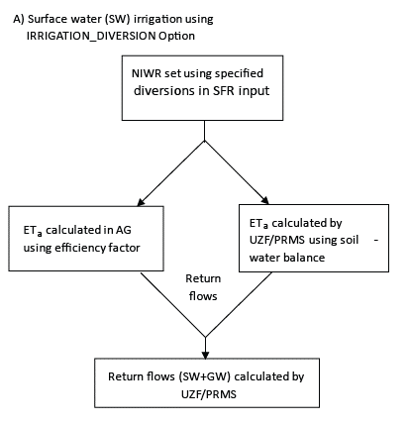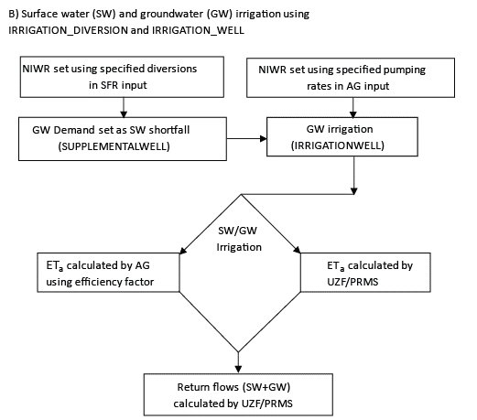

Is A) configuration 1? The manuscript text indicates that GW can also be used for irrigation. Is B) configuration 2? The flow charts for these two cases don’t match the way the cases are described in the manuscript. Configuration 1 in the manuscript includes A and part of B(specified pumping).

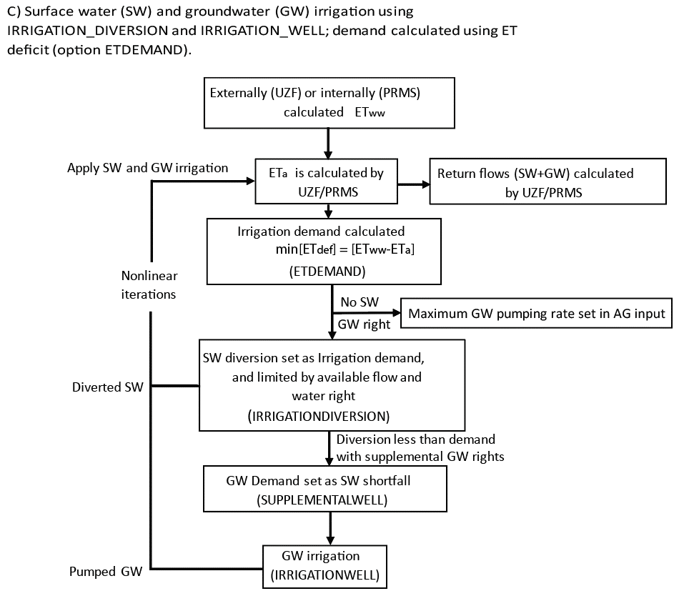

not converged

converged

right

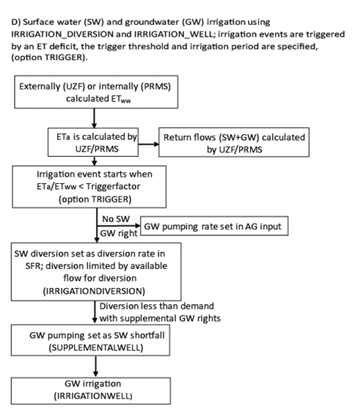

I don’t think this box is in the right place

right

1. Flow charts showing four different configurations for using the agricultural Water Use Package; A) Surface water irrigation using IRRIGATION_DIVERSION Option; B) Surface water (SW) and groundwater (GW) irrigation using IRRIGATION_DIVERSION and IRRIGATION_WELL; C) Surface water and groundwater irrigation using IRRIGATION_ DIVERSION and IRRIGATION_WELL, demand calculated as ET deficit using ETDEMAND;.D) Surface water and groundwater irrigation using IRRIGATION_ DIVERSION and IRRIGATION_WELL, irrigation events are started when ${ET}_{a}/{ET}_{ww}$ is below Triggerfact using option TRIGGER.

# Example Problems

Two example problems are presented to illustrate the capabilities of the AG Package for simulating water use by agriculture in MODFLOW-NWT and GSFLOW. Example problem 1 is a MODFLOW simulation that was modified from Test 1 presented previously by Prudic and others (2004). Test problem 2 is a GSFLOW simulation that was modified from the Sagehen Creek Watershed GSFLOW example problem. Although there is no agriculture in the Sagehen Creek Watershed, the AG Package was added for this example to simulate irrigation from surface water and supplementary wells to several HRUs in the lower part of the watershed that represent hypothetical agricultural fields. Both example problems retain the units used in their original presentations, and thus example problem 1 uses English units and example problem 2 uses metric units.

## Example Problem 1

This model represents an alluvial river basin in a semi-arid region. The basin receives most of its precipitation in the surrounding mountains, and intermittent streams drain the mountains and flow into a perennial river that crosses the southern portion of the valley (Fig. 2). The valley aquifer consists of alluvium dominated by sand and gravel, and the mountains consist of bedrock that has much lower hydraulic conductivity than the valley alluvium. Recharge in the basin primarily occurs as seepage loss from the intermittent stream channels and to a lesser extent as groundwater flowing to the valley from the mountain block and diffuse recharge through valley sediment.

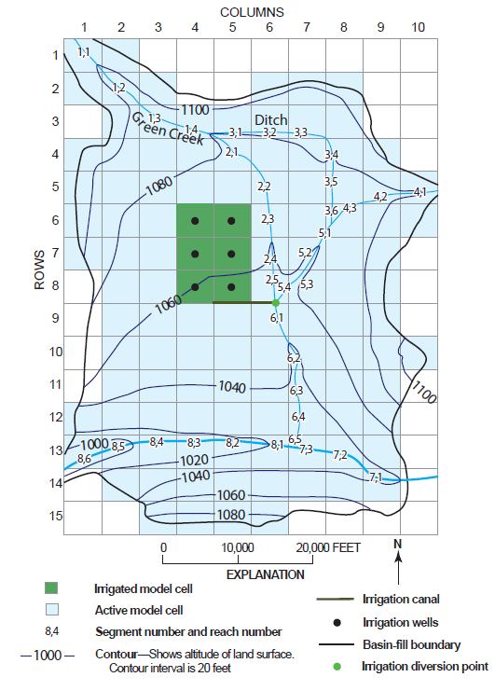

1. Map showing basin topography, streams and canals, and agricultural region for example problem 1.

The model domain extends to a maximum of 520 feet below land surface in the valley bottom; and extends laterally 14 miles in the north-south direction, and 9.5 miles in the east-west direction (Fig. 2). The model is discretized into 1 layer, 15 rows, and 10 columns, and only model cells coincident with the basin fill are active; consolidated rocks are not included. Layer 1 ranges in thickness between 130 feet and 520 feet. Model cells have a constant dimension of 5000 feet in the row and column directions. Two tributary streams that enter the model from the northwest and northeast join the mainstem in the southern part of the model (Fig. 2). An initial steady state stress period followed by forty-eight transient stress periods are simulated. Each stress period represents a calendar month and is divided into daily time steps. The simulation begins on January 1. Results are presented for the final 2 years of the simulation, as the steady state stress period and first 2 years of the simulations are used to establish initial conditions.

Hydraulic conductivity and specific yield of the water table aquifer increase in the valley bottoms that are comprised of floodplains or new alluvium of the tributary streams and river. Prudic and others (2004) present additional details describing this test problem, including representation of the stream network, and distribution of recharge and ET parameters used within the model. Niswonger and others (2006) describe modifications made to this example to replace the ET and Recharge Packages with the UZF Package; excess applied infiltration and rejected infiltration/spring discharge is routed to streams. ${ET}_{ww}$ is specified in UZF Package and varies monthly. Other UZF Package input values were modified from previous values to better represent agricultural water use, and user are referred to the input files for this problem that accompany this work. A total of 3,440 acres are irrigated for agriculture in the central part of the basin; irrigation water is diverted from the Green River and pumped from the shallow aquifer beneath the fields.

Two versions of example problem 1 are presented. Example problem 1a (EP1a) simulates irrigation water provided by surface water and supplementary groundwater, and example problem 1b (EP1b) simulates irrigation water provided solely by groundwater. Both models simulate irrigation demands using the ETDEMAND approach that minimizes the ET deficit using equation 15. Figure 2 shows the cells designated as agricultural fields that receive irrigation. SFR diversion segment number 9 was used to divert water from the Green River and route it to the fields (Fig. 2). EP1b is like EP1a, except that NIWR is satisfied solely by groundwater, and there is no control on irrigation periods.

## Example Problem 2

Example problem 2 was developed by modifying the GSFLOW Sagehen example problem (Markstrom, 2008) to include agricultural fields in the lower part of the basin (Fig. 3. Sagehen Creek drains a of 27 km2 watershed on the east slope of the northern Sierra Nevada. Geology of the Sagehen Creek watershed consists of granodiorite bedrock overlain by andesitic, tertiary volcanic material, which are overlain by till and alluvium composed of granodiorite and andesite clasts and some quaternary gravels (Burnett and Jennings, 1965). The principal aquifer (model layer 2) was assumed to consist of volcanic material with thickness ranging between 50 and 300 m. A veneer of alluvium covers the volcanic material that is thicker along channels in the lower section of the watershed (Burnett and Jennings, 1965). Alluvium (model layer 1) was assumed to range in thickness between 0 and 10 m. The model domain extends laterally 6.4 km in the north-south direction, and 7.1 km in the east-west direction (Fig. 3). The model is discretized into 90x90 m cells using 2 layers, 71 rows, and 79 columns. Eighteen years are simulated, each year is divided into 12 stress periods, each period represents a calendar month and is divided into daily time steps. The transient simulation begins on October 1.

Two versions of example problem 2 are presented. Example problem 2a (EP2a) simulates NIWR by minimizing the ET deficit (ETDEMAND option), and example problem 2b (EP2b) uses the ET deficit trigger (TRIGGER option) to simulate irrigation. Figure 3 shows the cells designated as agricultural fields that receive irrigation, including 34 cells irrigated by 2 segments that divert water from Sagehen Creek. Segment 24 supplies water for 14 cells, and segment 25 supplies water for 20 cells. All 34 irrigated cells sum to an area to 27.5 hectares. Irrigation can be nonzero during the growing season (June 1-August 30) and zero outside the growing season. These constraints on the surface water diversions for irrigation were specified using time series inflow files for SFR segment numbers 24 and 25. Wells were placed in each agricultural cell for supplementary pumping to meet irrigation requirements.

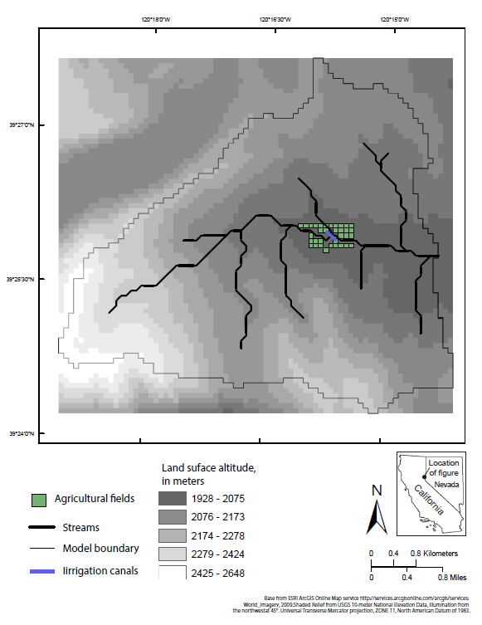

1. Map of Sagehen Creek watershed with hypothetical irrigated fields used in example problem 2.

# Results

## Example Problem 1a

EP1a was run with high and low inflow hydrographs (Fig. 4) representing average and drought years, respectively, to evaluate how differences in surface water supply impact the relative proportions of surface water and supplemental groundwater used for irrigation. In many agricultural regions, irrigation is provided by surface water and groundwater to supplement surface water during drought or seasonally low flow periods. Maximum surface water diversions rates were set within the SFR Package time series input files for an irrigation period from April 1 to September 30, and a maximum rate of 100 ft3/s is specified to allow the amount of water flowing in the stream from which water is diverted to control diversion amounts during the irrigation season. Soil and crop properties for EP1a are those of the fine-textured soil shown in Table 1.

Figure 5 shows the proportions of surface water and supplementary groundwater used for irrigation for the average and drought conditions. Supplementary groundwater makes up a greater proportion of the irrigation water supply during the low flow hydrograph (53%) relative to the high flow hydrograph (42%) due to surface water supply constraints (Fig. 5). Average annual irrigation water requirements were the same for both simulations (2.58 feet) and slightly less than the annual average crop consumption (2.6 feet) due to small amounts of precipitation in the valley. Note that although the inflow hydrographs were difference for the simulations, the valley precipitation was assumed equal.

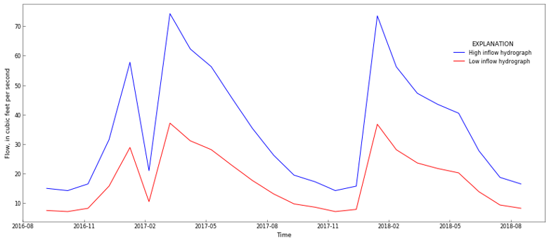

1. Inflow hydrographs specified in the SFR Package input file for test model 1a, representing years of average (high inflow) and below average (low inflow) precipitation.

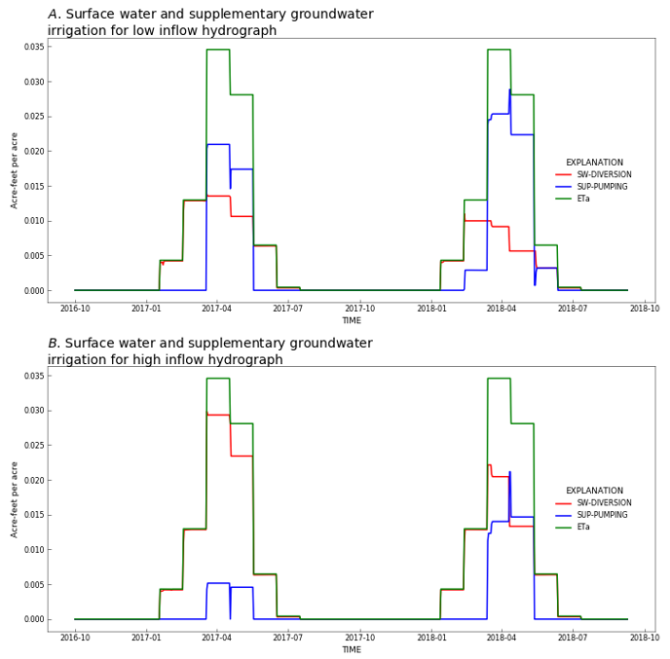

1. Irrigation provided by surface water diversions and groundwater pumping for A) low, and B) high inflow hydrographs shown in Figure 4.

## Example Problem 1b

This example problem is run for 2 different agricultural field soil types, including fine and coarse soil textures (Table 1). The coarse soil requires greater amounts of irrigation earlier during the growing season relative to the fine soil because of lower antecedent soil moisture at the onset of the growing season (Fig. 6). Faster drainage increases the average annual NIWR for the coarse soil (3.1 feet) relative to the fine soil (2.6 feet) due to greater amounts of groundwater return flows because irrigation water infiltrates faster than it can be used by the roots in the coarse soil. Because there is no constraint on irrigation supply, average annual ${ET}_{a}$ equals the ${ET}_{WW}$ of 2.7 acre-feet per acre.

1. Soil and crop parameters used in example problems 1a and 1b.

|  |  |  |
| --- | --- | --- |
|  | **Fine soil** | **Course soil** |
| Saturated water content of unsaturated zone (cubic foot of water per cubic foot of bulk volume) | 0.38 | 0.30 |
| Brooks-Corey exponent  (unitless) | 7.5 | 4.5 |
| Vertical saturated? hydraulic conductivity of the unsaturated zone (feet per day) | 8.6 | 4 |
| Evapotranspiration extinction depth  (feet) | 0.50 | 0.50 |
| Residual water content  (cubic foot of water per cubic foot of bulk volume) | 0.20 | 0.10 |
| Air entry pressure (feet of water) | -1.10 | -0.1 |
| Root pressure (feet of water) | -30.0 | -30.0 |

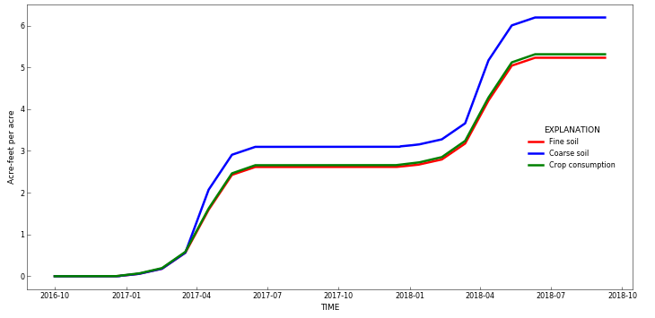

1. Cummulative groundwater pumping for irrigation in example problem 1b with fine and course agricultural soil properties.

## Example Problem 2a

EP2a illustrates the effects of the crop coefficient ($K_{c}$) on NIWR and ET using the ET demand approach for irrigation (Fig. 7). As the ET demand option represents optimal irrigation scheduling to minimize the ET deficit, these results reflect optimal water use to meet crop water demand. Annual average NIWR for the period 1991-1993 is 0.97 hectare-meter per square meter for high $K_{c}$ and 0.70 hectare-meter per square meter for low $K_{c}$. Annual average crop consumption is equal to 1.06 hectare-meters per square meter for high $K_{c}$ and 0.81 hectare-meter per square meter for low $K_{c}$. Actual ET equals well-watered ET in this example because the ET demand approach is used and there are no constraints on irrigation amounts. Irrigation water delivery is less than crop consumption in this example because of water supplied by precipitation and groundwater.

Real world irrigation practices likely cannot exactly mimic this optimal irrigation schedule for practical and logistical reasons. Nonetheless, these model results are useful for providing guidance on irrigation schedules, setting lower bounds on NIWR, and for providing a base model for evaluating factors affecting NIWR. As will be shown in EP2b, additional flexibility in simulating irrigation practices is provided by the TRIGGER option. Additionally, irrigation constraints can be superimposed onto ETDEMAND option to more closely mimic real-world conditions using SFR diversions and AG well time series input files. Accordingly, constraints on the timing and rates of irrigation can constrain irrigations using the ETDEMAND approach.

EP2a also demonstrates the influence that antecedent soil water conditions have on NIWR. Total annual precipitation amounts measured at the Independence Lake climate station for water years 1991, 1992, and 1993 was 83 cm, 71 cm, and 149 cm, respectively, while NIWR with low $K_{c}$ was 78, 100, and 77 percent of the crop water demand during these years (Fig. 8). Although antecedent conditions impact NIWR for the case of high $K_{c}$, the effects are lower relative to low $K_{c}$ because greater consumption depletes soil moisture more rapidly.

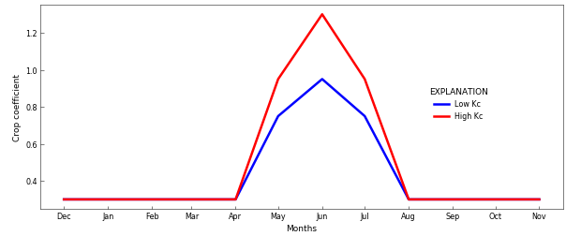

1. Seasonal crop coefficient (Kc) used for simulating agricultural water use in example problem 2a.

# 

1. Comparison of cumulative agricultural water use for example problem 2a, using low and high crop coefficients (Kc) shown in Figure 7.

## Example Problem 2b

Example problem 2b is identical to EP2a, except that the TRIGGER option was used, and the seasonal crop coefficients were set using the High $K_{c}$ curve (Fig. 7). EP2b illustrates the influence that different irrigation trigger values have on the surface water diversions and groundwater pumping rates. In this case an irrigation event starts when the ET ratio (${ET}_{a}/{ET}_{ww}$) becomes less than the specified trigger threshold. Results are shown for a high (0.85) and low (0.35) trigger value. Note that the length of an irrigation period is specified as 3 days for both high and low trigger values; however, if the ET ratio is below the trigger value at the end of a period then a new irrigation period will begin immediately.

Irrigation delivery is directly proportional to the trigger threshold, where higher trigger values result in greater surface water diversions, pumping, and crop water consumption (Fig. 9). Annual average NIWR for the period 1991-1993 is 1.4 hectare-meters per square meter for a high trigger value and 0.92 hectare-meters per square meter for a low trigger value. Annual average crop consumption is the same as EP2a (1.06 hectare-meter per square meter), except for the low trigger value simulation results in a crop consumption of 0.92 hectare-meter per square meter. Because setting a low trigger value allows the soils to drain longer between irrigation events, lower trigger values result in less actual ET as compared to higher trigger values (Fig. 9b). The TRIGGER option requires significantly more surface water and groundwater to meet crop-water requirements due to the imposed timing and rates of irrigation.

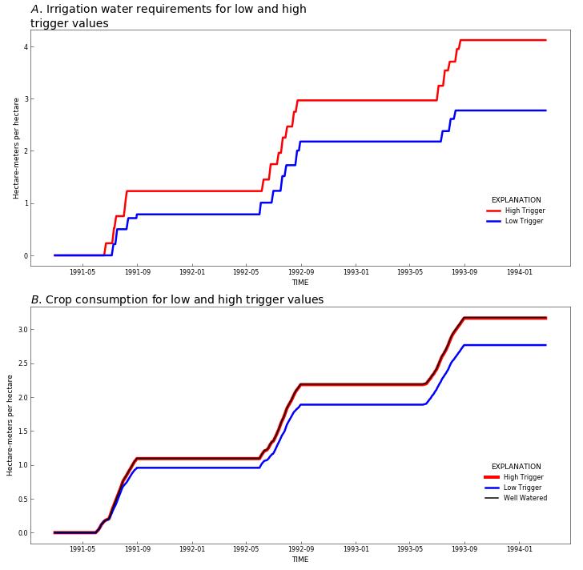

1. Comparison of cumulative agricultural water use for example problem 2b, using low and high irrigation trigger values.

# Discussion

A new package for MODFLOW and GSFLOW is presented that provides capabilities for simulating agricultural water use in regional scale hydrologic models. The AG Package can be used to estimate agricultural water use for systems where information about NIWR, surface water and groundwater use is not available, or it can be used to simulate the impacts of agricultural water use on water supply. The latter application is important in regions where there are competing needs for water, and climate change, population growth, and land use change are causing unknown impacts. Design of the AG Package includes flexibility for representing systems with varying amounts of data, different grower behavior, and feedbacks between water supply and water use by agriculture. Water demands rely on energy and soil-water balance calculations and regionally specific conditions can be represented, such as spatial variations in temperature, solar radiation, and plant type. Specific attributes of a region can be considered, including soil hydraulic properties, depth to groundwater, canal or pipe properties, and antecedent soil moisture and precipitation. Water consumption relies on explicit simulation of irrigation infrastructure, soil-water budgets, and surface water and groundwater availability. These design features provide flexibility for evaluating water use in a wide variety of agricultural systems, and for developing optimal irrigation schedules unique to a region.

A variety of options are provided for mimicking different irrigation approaches, specifically with regards to the timing and amounts of irrigation. Examples are presented that illustrate impacts of surface water supply on groundwater pumping (EP1a), irrigation supplied solely by groundwater (EP1b), irrigation estimated for optimal water-use conditions that minimizes the ET deficit (EP2a), and irrigation that is triggered when the ET deficit drops below a specified threshold. All these approaches are provided as options to best represent regionally specific conditions. Because irrigation water is explicitly routed and applied to individual fields, the model can be used to evaluate irrigation return flows and changes in land use.

Practical applications of integrated hydrologic models that represent agricultural water use must rely on data that characterize a broad range climactic and hydrogeologic conditions. Additionally, representation of agriculture requires characterization of water governance and grower behavior. Complete data sets are never available, and integrated models provide a means of maximizing information with partial data sets by combining data with physical process equations and generalized frameworks for representing human impacts on water distribution and consumption. The AG Package for MODFLOW and GSFLOW provides a powerful decision support tool that can maximize understanding of water resources in agricultural basins and provide hindcast information about historical water budgets and system response as well as future projections of sustainability and management change.

# Conclusions

Hydrologic simulation of developed basins is difficult or impossible without representing agricultural water use. Integrated hydrologic models are useful decision support tools for developing regional water budgets and evaluating water management strategies and sustainability for human populations and ecosystem services. Despite significant data gaps in water use at regional scales, hydrologic models can complement incomplete datasets and provide a more complete picture of water resources. Process understanding, and theoretical representation of agricultural water use are well established; however, limited software is available that explicitly represents agricultural water use in regional-scale integrated hydrologic models. The AG Package for MODFLOW and GSFLOW provides a wholistic representation of agricultural water use in the context of the natural hydrologic system and other water use sectors. Through a series of simple but realistic example problems, this paper demonstrates the software’s applicability for a variety of approaches for simulating irrigation practices and associated effects on water distribution and supply in regional-scale systems.

# Acknowledgements

Support for the author was provided by the USGS Water Availability and Use Program. Additionally, support was provided by the National Science Foundation, grant number: 1360506, and the U.S. Department of Agriculture/National Institute of Food and Agriculture, grant number: 1360507. The author thanks rewiewers….

# References Cited

Allen, R. G., Pereira, L. S., Raes, D., & Smith, M. (1998). Crop evapotranspiration-Guidelines for computing crop water requirements-FAO Irrigation and drainage paper 56. FAO, Rome, 300(9), D05109.

Bailey, R. T., Wible, T. C., Arabi, M., Records, R. M., & Ditty, J. (2016). Assessing regional‐scale spatio‐temporal patterns of groundwater–surface water interactions using a coupled SWAT‐MODFLOW model. Hydrological processes, 30(23), 4420-4433.

Brooks, R.H., and Corey, A.T., 1966, Properties of porous media affecting fluid flow: American Society of Civil Engineers, Journal of Irrigation and Drainage, v. 101, p. 85–92.

Burnett, J.L., and Jennings, C.W., 1965, Chico Quadrangle, scale 1:250,000: State of California, Division of Mines and Geology.

Dogrul, E. C., Schmid, W., Hanson, R. T., Kadir, T., & Chung, F. (2011). Integrated Water Flow Model and Modflow-Farm Process: A Comparison of Theory, Approaches, and Features of Two Integrated Hydrologic Models. Department of Water Resources, California Natural Resources Agency, State of California, Sacramento, Technical Information Record.

Elliott, J., Deryng, D., Müller, C., Frieler, K., Konzmann, M., Gerten, D., M. Glotter, M. Flörke, Y. Wada, N. Best, S. Eisner, B. M. Fekete, C. Folberth, I. Foster, S. N. Gosling, I. Haddeland, N. Khabarov, F. Ludwig, Y. Masaki, S. Olin, C. Rosenzweig, A. C. Ruane, Y. Satoh, E. Schmid, T. Stacke, Q. Tang, and D. Wisser (2014). Constraints and potentials of future irrigation water availability on agricultural production under climate change. Proceedings of the National Academy of Sciences, 111(9), 3239-3244.

Essaid, H. I., & Caldwell, R. R. (2017). Evaluating the impact of irrigation on surface water–groundwater interaction and stream temperature in an agricultural watershed. Science of the Total Environment, 599, 581-596.

Faunt, C.C., ed., 2009, Groundwater Availability of the Central Valley Aquifer, California: U.S. Geological Survey Professional Paper 1766, 225 p.

Fischer, G., Tubiello, F. N., Van Velthuizen, H., & Wiberg, D. A. (2007). Climate change impacts on irrigation water requirements: effects of mitigation, 1990–2080. Technological Forecasting and Social Change, 74(7), 1083-1107.

Gorelick, S. M., & Zheng, C. (2015). Global change and the groundwater management challenge. Water Resources Research, 51(5), 3031-3051.

Guzman, J. A., Moriasi, D. N., Gowda, P. H., Steiner, J. L., Starks, P. J., Arnold, J. G., & Srinivasan, R. (2015). A model integration framework for linking SWAT and MODFLOW. Environmental Modelling & Software, 73, 103-116.

Hanson, R. T., Schmid, W., Faunt, C. C., & Lockwood, B. (2010). Simulation and analysis of conjunctive use with MODFLOW's farm process. Groundwater, 48(5), 674-689.

Hanson, Randall T., Scott E. Boyce, Wolfgang Schmid, Joseph D. Hughes, Steffen W. Mehl, Stanley A. Leake, Thomas Maddock III, and Richard G. Niswonger. One-water hydrologic flow model (MODFLOW-OWHM). No. 6-A51. US Geological Survey, 2014.

Harbaugh, A.W., 2005, MODFLOW-2005, the U.S. Geological Survey modular ground-water model -- the Ground-Water Flow Process: U.S. Geological Survey Techniques and Methods 6-A16.

Hu, Y., Moiwo, J. P., Yang, Y., Han, S., & Yang, Y. (2010). Agricultural water-saving and sustainable groundwater management in Shijiazhuang Irrigation District, North China Plain. Journal of Hydrology, 393(3-4), 219-232.

Huntington, J. L., Hegewisch, K. C., Daudert, B., Morton, C. G., Abatzoglou, J. T., McEvoy, D. J., & Erickson, T. (2017). Climate Engine: cloud computing and visualization of climate and remote sensing data for advanced natural resource monitoring and process understanding. Bulletin of the American Meteorological Society, 98(11), 2397-2410.

Jones, J.W., Antle, J.M., Basso, B., Boote, K.J., Conant, R.T., Foster, I., Godfray, H.C.J., Herrero, M., Howitt, R.E., Janssen, S. and Keating, B.A. (2017). Toward a new generation of agricultural system data, models, and knowledge products: State of agricultural systems science. Agricultural systems, 155, pp.269-288.

Labadie, J. W. (2010), MODSIM 8.1: River basin management decision support system; User manual and documentation.

Langevin, C. D., Hughes, J. D., Banta, E. R., Niswonger, R. G., Panday, S., & Provost, A. M. (2017). Documentation for the MODFLOW 6 Groundwater Flow Model (No. 6-A55). US Geological Survey.

Lappala, E.G., Healy, R.W., Weeks, E.P., et al., 1987, Documentation of computer program VS2D to solve the equations of fluid flow in variably saturated porous media: U.S. Geological Survey WaterResources Investigations Report 83–4099, 184 p., accessed June 27, 2017, at https://pubs.er.usgs.gov/publication/wri834099.

Markstrom, S.L., Regan, R.S., Hay, L.E., Viger, R.J., Webb, R.M.T., Payn, R.A., and LaFontaine, J.H., 2015, PRMS-IV, the precipitation-runoff modeling system, version 4: U.S. Geological Survey Techniques and Methods, book 6, chap. B7, 158 p., http://dx.doi.org/10.3133/tm6B7.

Markstrom, S.L., Niswonger, R.G., Regan, R.S., Prudic, D.E., and Barlow, P.M., 2008, GSFLOW-Coupled Ground-water and Surface-water FLOW model based on the integration of the Precipitation-Runoff Modeling System (PRMS) and the Modular Ground-Water Flow Model (MODFLOW-2005): U.S. Geological Survey Techniques and Methods 6-D1, 240 p.

Morway, E. D., Niswonger, R. G., & Triana, E. (2016). Toward improved simulation of river operations through integration with a hydrologic model. Environmental Modelling & Software, 82, 255-274.

Niswonger, R.G., Prudic, D.E., and Regan, R.S., 2006, Documentation of the Unsaturated-Zone Flow (UZF) Package for modeling unsaturated flow between the land surface and the water table with MODFLOW-2005: U.S. Geological Survey Techniques and Methods 6-A19, 62 p.

Niswonger, R.G., Panday, Sorab, and Ibaraki, Motomu, 2011, MODFLOW-NWT, A Newton formulation for MODFLOW-2005: U.S. Geological Survey Techniques and Methods 6–A37, 44 p

Niswonger, R. G., Morway, E. D., Triana, E., & Huntington, J. L. (2017). Managed aquifer recharge through off‐season irrigation in agricultural regions. Water Resources Research, 53(8), 6970-6992.

Niswonger, R.G., and Prudic, D.E., 2005, Documentation of the Streamflow-Routing (SFR2) Package to include unsaturated flow beneath streams—A modification to SFR1: U.S. Geological Survey Techniques and Methods 6-A13, 50 p.

Prudic, D.E., Konikow, L.F., and Banta, E.A., 2004, A new streamflow-routing (SFR1) package to simulate streamaquifer interaction with MODFLOW-2000: U.S. Geological Survey Open-File Report 04–1042, 95 p.

Schmid, W., Hanson, R. T., Maddock III, T., & Leake, S. A. (2006). User guide for the farm process (FMP1) for the US Geological Survey’s modular three-dimensional finite-difference ground-water flow model, MODFLOW-2000. US Geological Survey Techniques and Methods, 6-A17.

Tian, Y., Zheng, Y., Wu, B., Wu, X., Liu, J., & Zheng, C. (2015). Modeling surface water-groundwater interaction in arid and semi-arid regions with intensive agriculture. Environmental Modelling & Software, 63, 170-184.

Wang, Z. M., Batelaan, O., & De Smedt, F. (1996). A distributed model for water and energy transfer between soil, plants and atmosphere (WetSpa). Physics and Chemistry of the Earth, 21(3), 189-193.

Woolfenden, L.R., and Nishikawa, Tracy, eds., 2014. Simulation of groundwater and surface-water resources of the Santa Rosa Plain watershed, Sonoma County, California: U.S. Geological Survey Scientific Investigations Report 2014–5052, 258 p., http://dx.doi.org/10.3133/sir20145052

Wu, X., Zheng, Y., Wu, B., Tian, Y., Han, F., & Zheng, C. (2016). Optimizing conjunctive use of surface water and groundwater for irrigation to address human-nature water conflicts: A surrogate modeling approach. Agricultural Water Management, 163, 380-39