Convolutional neural networks (CNN)
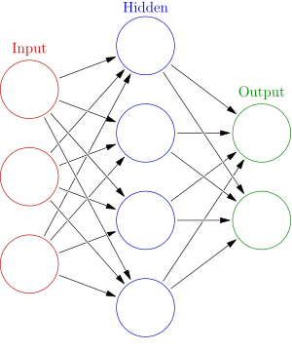
Fig. 1: Traditional NN

Traditional CNN: in these networks, each neuron is fully connected with all neurons in previous layer.

CNN: In these networks, each neuron is not connected fully with previous layer neurons. Each neuron is connected with few neurons in previous layer.
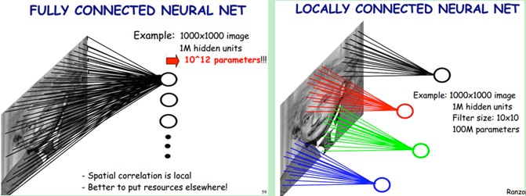
Fig. 2: Traditional NN and Convolutional NN

This exercise network structure

Input Layer | Conv. Layer | Max-pooling layer | Fully Connection Layer | Output layer
Neurons: 625 | Neurons: 32  filter_size=5x5  activation =nill | 2x2 pooling → 13x13 | Neurons=1024  activation=ReLU | Neurons=5  activation=softmax

Program Description
Instruction | Description
br=BRATS()  itr=Training_batch_iterator()  bg=Build_Graph() | Create objects of user defined classes
x = tf.placeholder(tf.float32, [None, 625])  y_ = tf.placeholder(tf.float32, [None, 5]) | Create iput and out put tensor variables
x_image = tf.reshape(x, [-1, 25, 25, 1])  W_conv1 = bg.weight_variable([5, 5, 1, 32])  b_conv1 = bg.bias_variable([32])  h_conv1 = bg.conv2d(x_image,W_conv1)+b_conv1 | First reshape 526 input to 25x25  create 32 weight variables each of size 5x5  create 32 bias variables  perform convolution  * filter size and conv layer neurons could be user defined
h_pool1 = bg.max_pool_2x2(h_conv1) | Perform pooling. It created 13x13 image from 25x25
W_fc1 = bg.weight_variable([13 * 13 * 32, 1024])  b_fc1 = bg.bias_variable([1024])  h_pool1_flat = tf.reshape(h_pool1, [-1, 13 * 13 * 32])  h_fc1 = tf.nn.relu(tf.matmul(h_pool1_flat, W_fc1) + b_fc1) | There are 32 patches of size 13x13. Connect them to 1024 neurons  h_pool1 is input to fully connected layer. Patches are reshaped by 13x13  applying ReLU activation function
W_fc2 = bg.weight_variable([1024, 5])  b_fc2 = bg.bias_variable([5])  y_conv = tf.matmul(h_fc1, W_fc2) + b_fc2  pred = tf.nn.softmax_cross_entropy_with_logits(labels=y_, logits=y_conv)  cross_entropy = tf.reduce_mean(pred) | Output layer contains 5 neurons.  Biases are defined  matrix multiplication is performed  soft max is applied on logits and then loss function cross entropy is applied on actual output y_ and predicted output logits  simplify cross entropy
train_step = tf.train.AdamOptimizer(1e-4).minimize(cross_entropy) | Define training function that tries to minimize the cross entropy.
correct_prediction = tf.equal(tf.argmax(y_conv, 1), tf.argmax(y_, 1))  accuracy = tf.reduce_mean(tf.cast(correct_prediction, tf.float32)) | tf.argmax(input, axis=None, name=None, dimension=None)  tf.argmax() returns the index of maximum value in 1th direction (column wise). If both indexes match, prediction is correct.  That gives us a list of booleans. To determine what fraction are correct, we cast to floating point numbers and then take the mean. For example,[True, False, True, True] would become [1,0,1,1] which would become 0.75.
sess = tf.Session()  sess.run(tf.global_variables_initializer()) | Start tf session and initialize variables
batch_xs, batch_ys = itr.get_next_batch(train_x, train_y, 30) | Get next batch
train_accuracy = sess.run(accuracy, feed_dict={x: batch_xs, y_: batch_ys }) | It runs accuracy graph node by providing input. It does not perform training
sess.run(train_step, feed_dict={x: batch_xs, y_: batch_ys}) | It runs graph again with provided input
test_x = br.read_test_patches(test_x)  feed_dict = feed_dict={x: test_x, y_: test_y}  print(sess.run(accuracy, feed_dict)) | Read test image patches  Find accuracy on new input

