Convolutional neural networks (CNN)
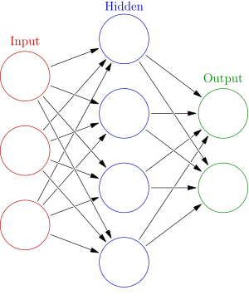
Fig. 1: Traditional NN

Traditional CNN: in these networks, each neuron is fully connected with all neurons in previous layer.

CNN: In these networks, each neuron is not connected fully with previous layer neurons. Each neuron is connected with few neurons in previous layer.
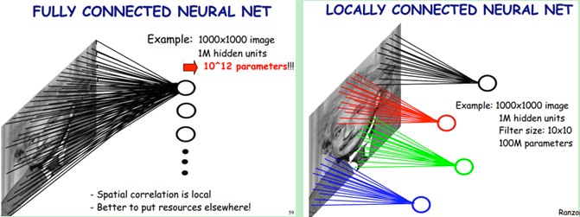
Fig. 2: Traditional NN and Convolutional NN

This exercise network structure

Input Layer | Conv. Layer | Max-pooling layer | Fully Connection Layer | Output layer
Neurons: 625 | Neurons: 32  filter_size=5x5  activation =nill | 2x2 pooling → 13x13 | Neurons=1024  activation=ReLU | Neurons=5  activation=softmax

This version of program is same as that of version v0.3 with following updates
1. most of code has been moved to Build_Graph class to make programming more easier to understand and modular.
2. “drop_out” has been introduced to make results better
Program Description
Instruction | Description
br=BRATS()  itr=Training_batch_iterator()  bg=Build_Graph() | Create objects of user defined classes
train_x, train_y, test_x, test_y = br.get_test_n_train_data('BRATS-Training/**/**/**/*.mha') | Call to method of BRATS file that returns file names of training set, classes of training set, test set file names, classes of test set
x,y_=bg.create_input_layer(625,5) | Call a method of Build-Graph class and create input layer
new_shape=[-1, 25, 25, 1]  w_shape=[5, 5, 1, 32]  b_shape=[32]  h_conv1=bg.create_conv_layer( x, new_shape, w_shape, b_shape) | Set parameters of convolutional layer and create convolutional layer using factory method of Build_Graph file.
ksize = [1, 2, 2, 1],  strides = [1, 2, 2, 1]  h_pool1 = bg.max_pool_2x2(h_conv1,ksize,strides) | Set the parameters and create pooling layer
w_shape=[13 * 13 * 32, 1024]  b_shape=[1024]  flat_shape=[-1, 13 * 13 * 32]  h_fc1=bg.create_fully_connected_layer(h_pool1, w_shape, b_shape,flat_shape) | Set parameters and create fully connected layer
h_fc1_drop,keep_prob=bg.drop_out(h_fc1) | Apply dropout
w_shape=[1024, 5]  b_shape=[5]  y_conv,cross_entropy=bg.create_output_layer(h_fc1_drop, w_shape, b_shape, y_) | Set parameters and create output layer
train_step = tf.train.AdamOptimizer(1e-4).minimize(cross_entropy) | Define training function that tries to minimize the cross entropy.
correct_prediction = tf.equal(tf.argmax(y_conv, 1), tf.argmax(y_, 1))  accuracy = tf.reduce_mean(tf.cast(correct_prediction, tf.float32)) | tf.argmax(input, axis=None, name=None, dimension=None)  tf.argmax() returns the index of maximum value in 1th direction (column wise). If both indexes match, prediction is correct.  That gives us a list of booleans. To determine what fraction are correct, we cast to floating point numbers and then take the mean. For example,[True, False, True, True] would become [1,0,1,1] which would become 0.75.
sess = tf.Session()  sess.run(tf.global_variables_initializer()) | Start tf session and initialize variables
batch_xs, batch_ys = itr.get_next_batch(train_x, train_y, 30) | Get next batch
train_accuracy = sess.run(accuracy, feed_dict={x: batch_xs, y_: batch_ys }) | It runs accuracy graph node by providing input. It does not perform training
sess.run(train_step, feed_dict={x: batch_xs, y_: batch_ys}) | It runs graph again with provided input
test_x = br.read_test_patches(test_x)  feed_dict = feed_dict={x: test_x, y_: test_y}  print(sess.run(accuracy, feed_dict)) | Read test image patches  Find accuracy on new input

