**Synopsis Abstract:** The Lokmela Rajkot, Saurashtra’s largest annual fair, faces significant crowd management challenges. Traditional monitoring methods are insufficient to handle the increasing number of visitors. This project aims to implement Artificial Intelligence (AI) to improve safety, visitor experience, and resource allocation through predictive analytics, computer vision, and AI-driven mobile applications.

**Literature Review/Existing Innovation-technology:**

1. **Computer Vision for Crowd Monitoring:** AI-powered CCTV analysis has been used in smart cities for real-time crowd density detection and anomaly detection.
2. **Predictive Analytics:** Events like the Kumbh Mela and large sports gatherings use AI models to analyze historical and real-time data for crowd predictions.
3. **Mobile AI Assistants:** Applications like Google Maps use AI-driven recommendations and real-time crowd tracking, which can be adapted for event management.
4. **AI-based Resource Allocation:** AI-driven scheduling has improved staff and security deployments in large-scale events worldwide.

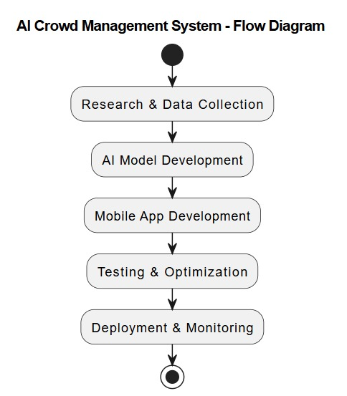

**Approach to Solve the Problem:**

1. **Data Collection and Analysis:** Utilize CCTV footage, mobile app user data, and historical event data for AI model training.
2. **Real-time Crowd Monitoring:** Implement computer vision to analyze live video feeds and detect overcrowding or potential hazards.
3. **Predictive Analytics Model:** Develop an AI model to predict peak crowd timings using historical data, weather conditions, and social media trends.
4. **AI-powered Mobile Application:** Create a user-friendly mobile app for real-time updates, personalized recommendations, and navigation assistance.
5. **Automated Resource Allocation:** Deploy AI-driven systems to assist authorities in placing staff and emergency services based on real-time analysis.
6. **Feedback Collection & Analysis:** Implement an AI-driven feedback mechanism for continuous improvement in event management.

**Roadmap to Develop Final Solution:**

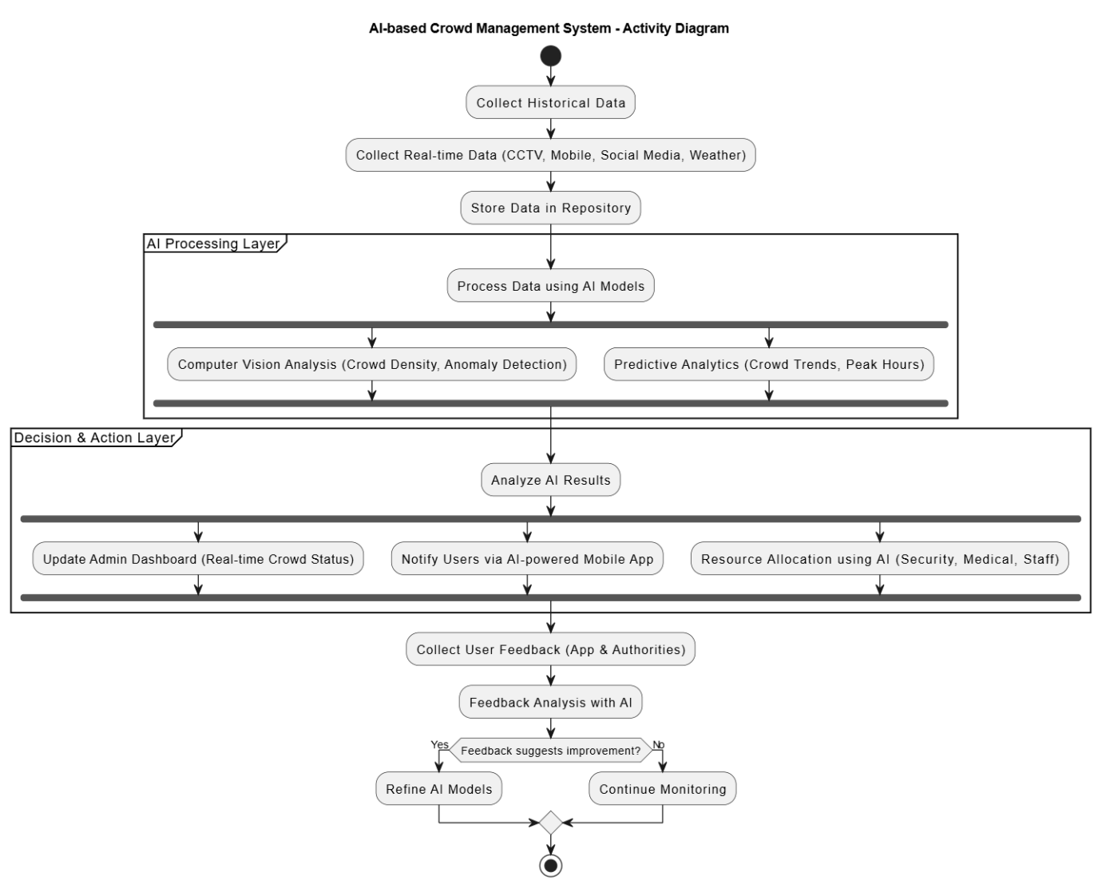

**Tools and Technologies to be Used:**

* **Computer Vision:** OpenCV, TensorFlow, YOLO
* **Predictive Analytics:** Python, R, Scikit-learn, Hadoop
* **Mobile App Development:** Flutter, React Native, Firebase
* **Cloud Computing:** AWS, Google Cloud, Microsoft Azure
* **IoT and Edge Computing:** AI-enabled surveillance cameras

**Challenges/Risks in Implementing the Prototype:**

1. **Privacy Concerns:** Ensuring data security and compliance with regulations.
2. **Real-time Processing Limitations:** Handling large volumes of real-time video data efficiently.
3. **Infrastructure Constraints:** Ensuring internet and server connectivity during high traffic hours.
4. **User Adoption:** Encouraging visitors to use the AI-powered mobile application.

**Possible Outcomes:**

* Enhanced safety and security for visitors.
* Improved event experience through personalized recommendations.
* Optimized staff and resource allocation.
* Reduction in overcrowding incidents and bottlenecks.
* Increased operational efficiency for event organizers.

**Work Done Till Date:**

* Initial feasibility study completed.
* Data collection framework designed.
* Research on AI-driven crowd management solutions conducted.
* Preliminary computer vision models tested on sample video feeds.

This document provides a structured plan for implementing AI in crowd management at Lokmela Rajkot, ensuring a safer and more enjoyable experience for all attendees.