H750IBK6核心模块使用说明书

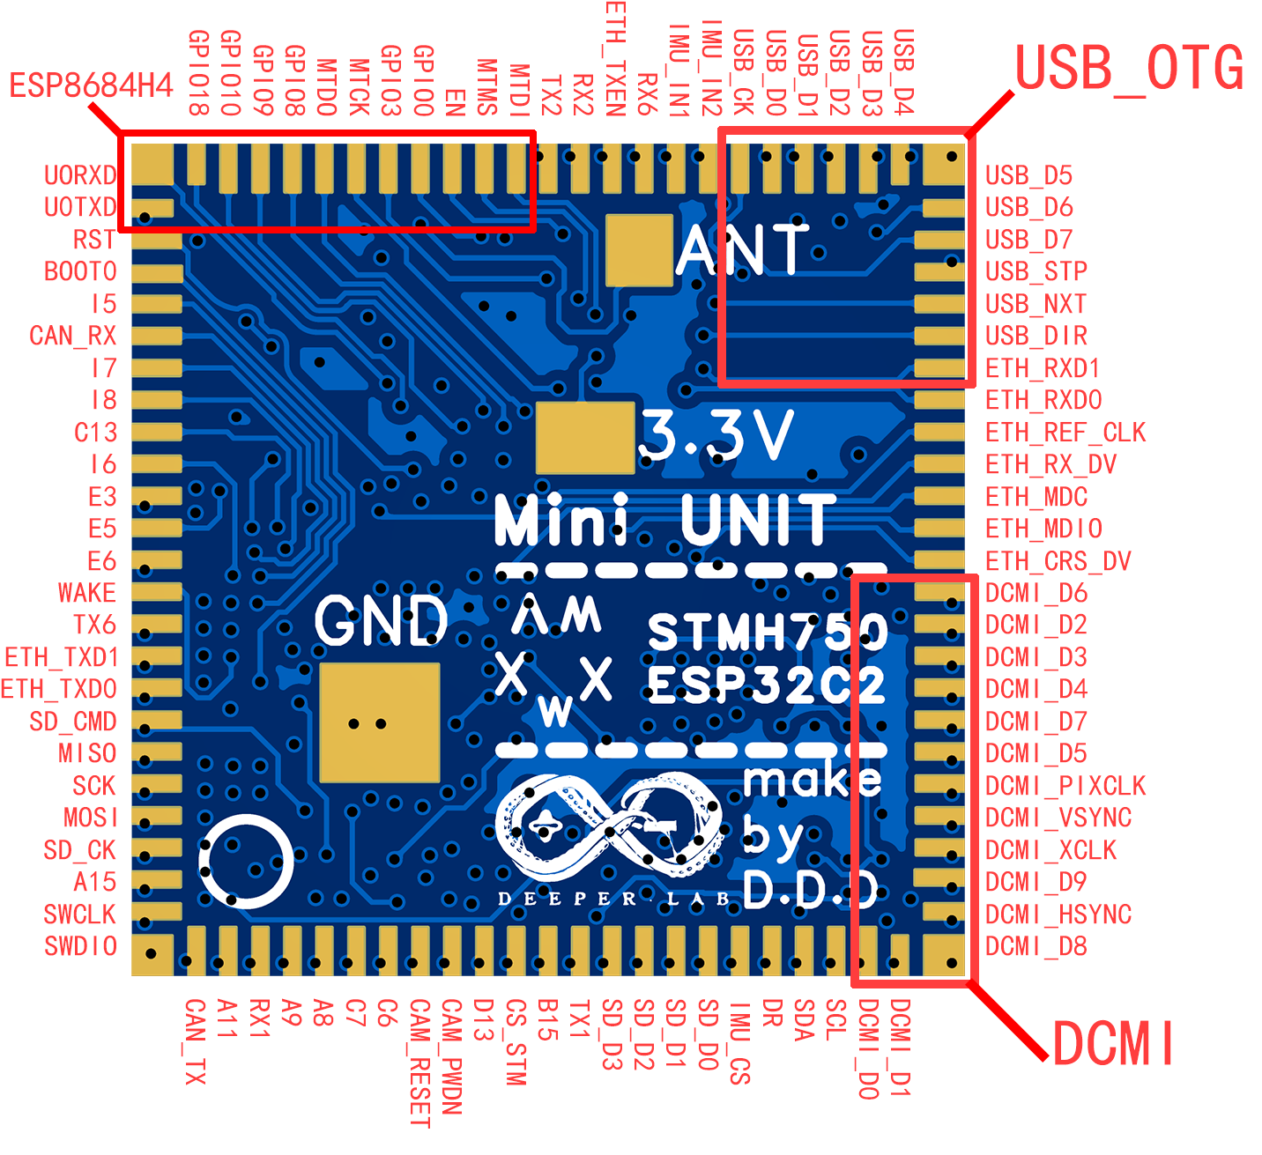

一号引脚未左上角U0RXD引脚编号顺时针排布如果不需要如上图功能可通过表一内容自行更改。

另外ESP8684H4引脚将不会在这上面赘述，请自行翻阅文件夹下的乐鑫ESP8684H4芯片手册自行查看。

表1 引脚图例

| **Id** | **功能** | **原始引脚** | **Id** | **功能** | **原始引脚** | **Id** | **功能** | **原始引脚** |
| --- | --- | --- | --- | --- | --- | --- | --- | --- |
|  | U0RXD | / |  | ETH_REF_CLK | PA1 |  | CAM_RESET | PG7 |
|  | GPIO18 | / |  | ETH_RX_DV | PH1 |  | C6 | / |
|  | GPIO10 | / |  | ETH_MDC | PC1 |  | C7 | / |
|  | GPIO9 | / |  | ETH_MDIO | PA2 |  | A8 | / |
|  | GPIO8 | / |  | ETH_CRS_DV | PA7 |  | A9 | / |
|  | MTDO | / |  | DCMI_D6 | PB8 |  | RX1 | PA10 |
|  | MTCK | / |  | DCMI_D2 | PE0 |  | A11 | / |
|  | GPIO3 | / |  | DCMI_D3 | PE1 |  | CAN_TX | PA12 |
|  | GPIO0 | / |  | DCMI_D4 | PE4 |  | SWDIO | PA13 |
|  | EN | / |  | DCMI_D7 | PB9 |  | SWCLK | PA14 |
|  | MTMS | / |  | DCMI_D5 | PI4 |  | A15 | / |
|  | MTDI | / |  | DCMI_PIXCLK | PA6 |  | SD_CK | PC12 |
|  | TX2 | PD5 |  | DCMI_VSYNC | PB7 |  | MOSI | PD7 |
|  | RX2 | PD6 |  | DCMI_XCLK | PH6 |  | SCK | PB3 |
|  | ETH_TXEN | PG11 |  | DCMI_D9 | PH7 |  | MISO | PB4 |
|  | RX6 | PG9 |  | DCMI_HSYNC | PH8 |  | SD_CMD | PD2 |
|  | IMU_IN1 | PD4 |  | DCMI_D8 | PI1 |  | ETH_TXD0 | PG13 |
|  | IMU_IN2 | PD3 |  | DCMI_D1 | PH10 |  | ETH_TXD1 | PG12 |
|  | USB_CK | PA5 |  | DCMI_D0 | PH9 |  | TX6 | PG14 |
|  | USB_D0 | PA3 |  | SCL | PH11 |  | WAKE | PB6 |
|  | USB_D1 | PB0 |  | SDA | PH12 |  | E6 | / |
|  | USB_D2 | PB1 |  | DR | PH15 |  | E5 | / |
|  | USB_D3 | PB10 |  | IMU_CS | PI3 |  | E3 | / |
|  | USB_D4 | PB11 |  | SD_D0 | PC8 |  | I6 | / |
|  | USB_D5 | PB12 |  | SD_D1 | PC9 |  | C13 | / |
|  | USB_D6 | PB13 |  | SD_D2 | PC10 |  | I8 | / |
|  | USB_D7 | PB5 |  | SD_D3 | PC11 |  | I7 | / |
|  | USB_STP | PC0 |  | TX1 | PB14 |  | CAN_RX | PI9 |
|  | USB_NXT | PC3 |  | B15 | / |  | I5 | / |
|  | USB_DIR | PI11 |  | CS_STM | PD11 |  | BOOT0 | / |
|  | ETH_RXD1 | PC5 |  | D13 | / |  | RST | / |
|  | ETH_RXD0 | PC4 |  | CAM_PWDN | PG3 |  | U0TXD | / |

其中ESP8684H4和STM32H750IBK6在核心板上使用i2c连接通讯