**SATYUG DARSHAN INSTITUTE OF ENGINEERING AND TECHNOLOGY**

DEPARTMENT OF COMPUTER SCIENCE AND ENGINEERING



(SESSION: 2020- 2021)

B.Tech CSE – 4th SEM

Lab File

Of

Design and Analysis of Algorithm (DAA)

**Submitted By: -** Deepak **Submitted To:-**

Roll No. : - CSE-19/034 Ms. Nidhi Sharma

**INDEX**

|  |  |
| --- | --- |
| 1. | WAP to allocate memory by using Malloc, Calloc and Realloc function |
| 2. | **WAP to perform DFS traversal of a graph** |
| 3. | **WAP to perform BFS traversal of a graph** |
| 4. | **WAP to find pattern in text using brute force approach** |
| 5. | **WAP to implement fractional knapsack problem using greedy approach** |
| 6  6. | **WAP to implement topological ordering of vertices in a given digraph** |
| 7. | **WAP to find max profit job sequence from a given jobs with their deadlines** |
| 8. | **WAP to find MST of given undirected graph using Kruskal’s algorithm** |
| 9. | **WAP to find MST of given undirected graph using Prim’s algorithm** |
| 10. | **WAP to implement TSP using Dynamic Programming approach** |

**Malloc, Calloc and Re-Alloc**

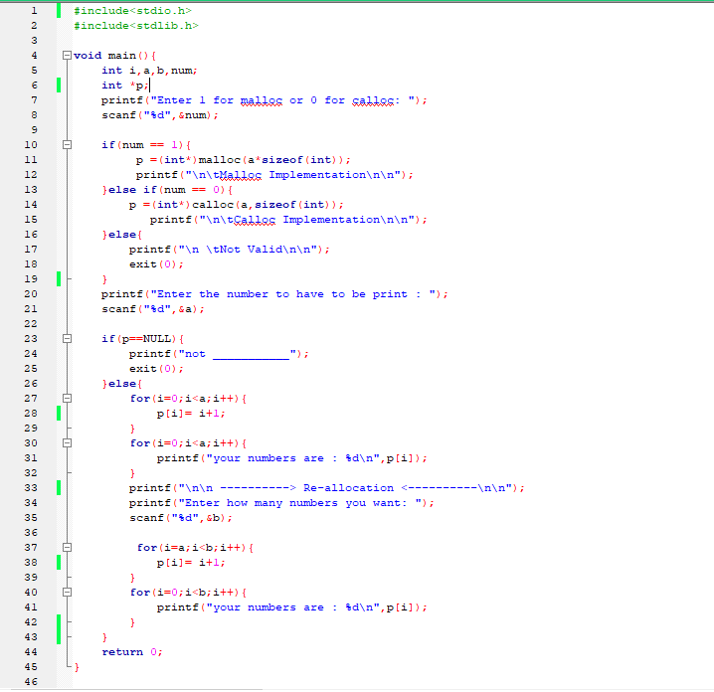

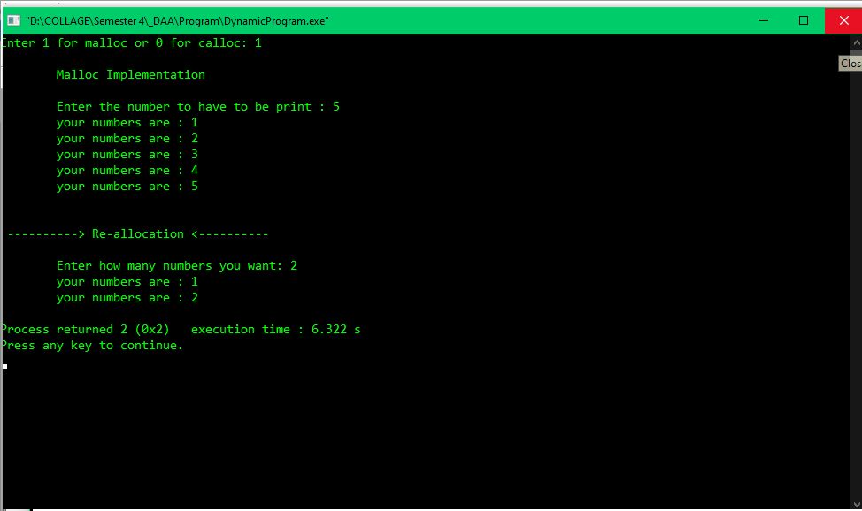

**Depth First Search (DFS)**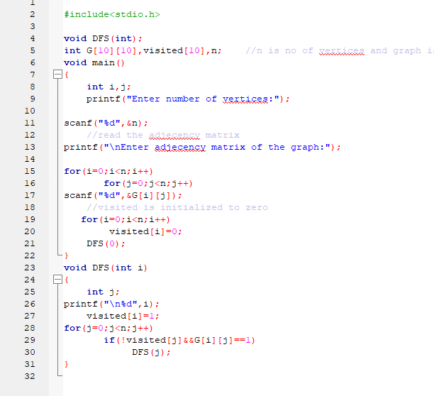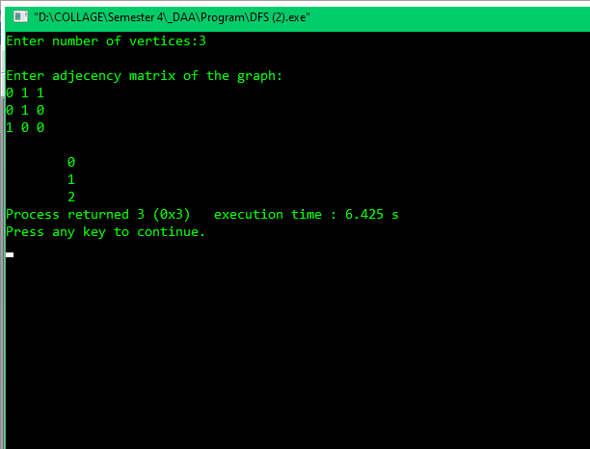

**Breath First Search (BFS)**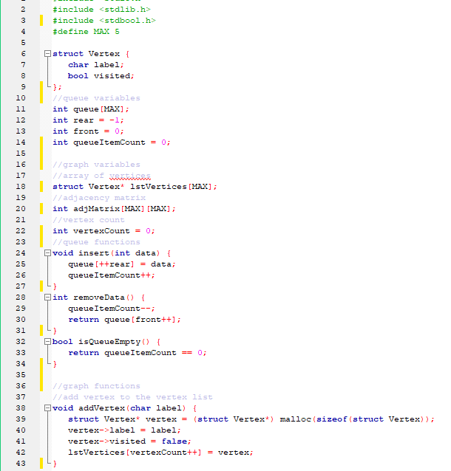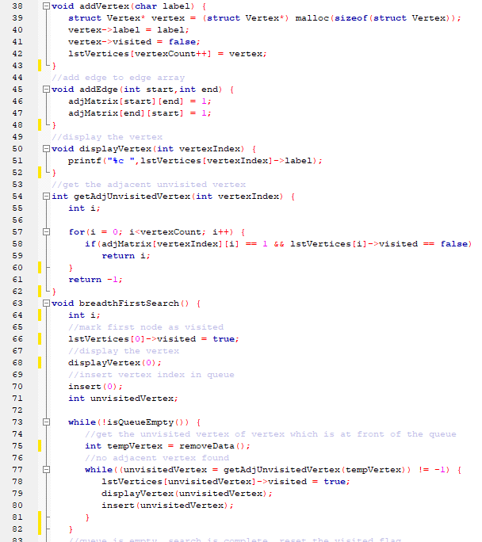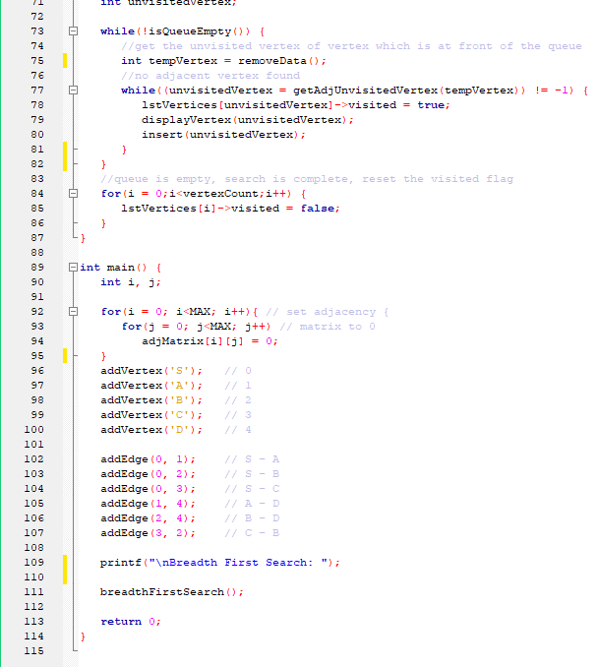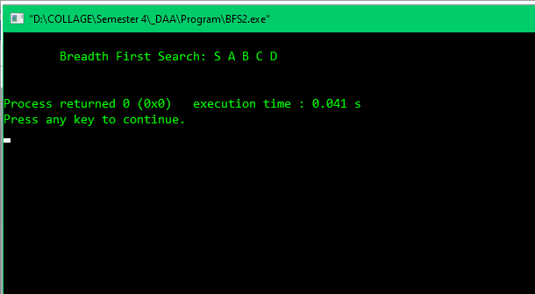

**Brute Force ( Pattern Matching)**

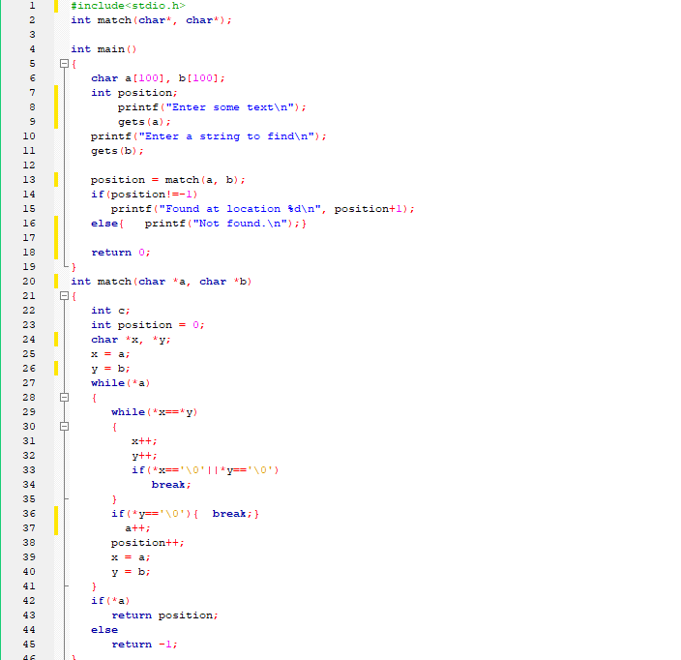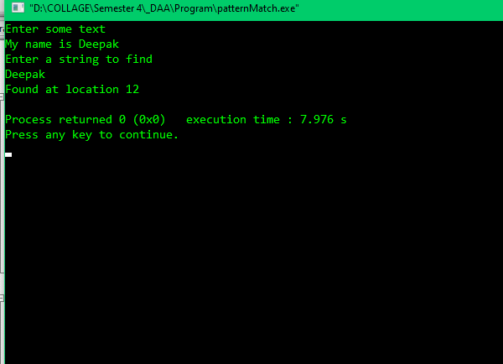

**Fraction Knapsack Problem**

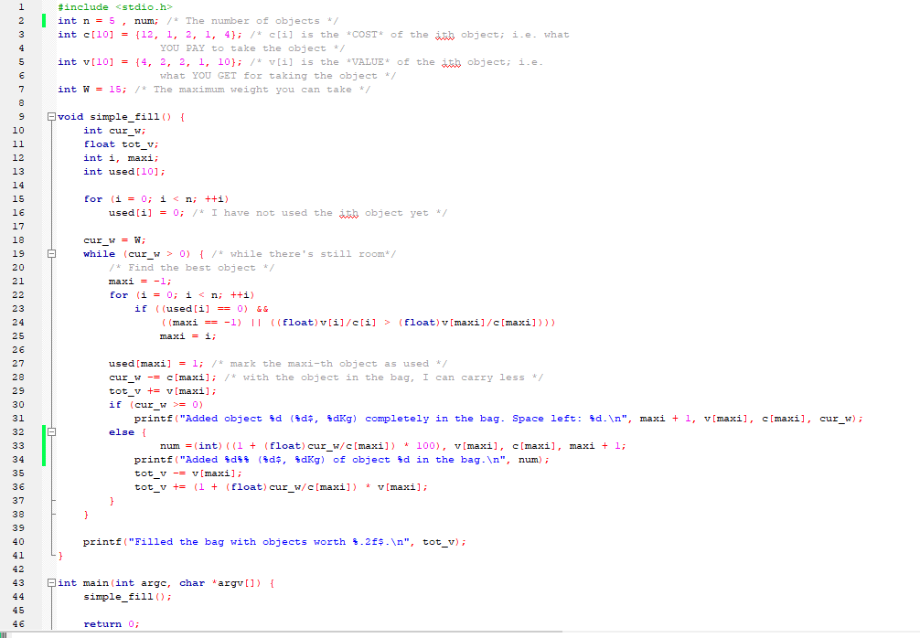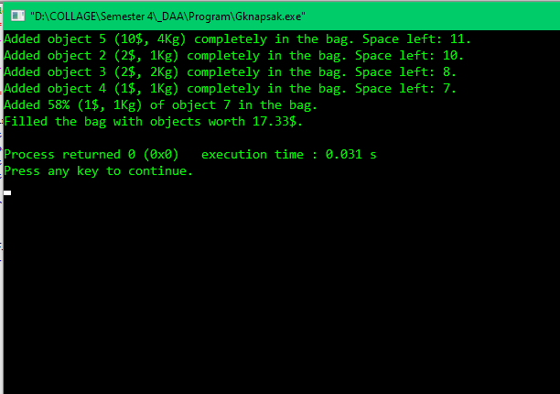

**Topologcal Sorting**

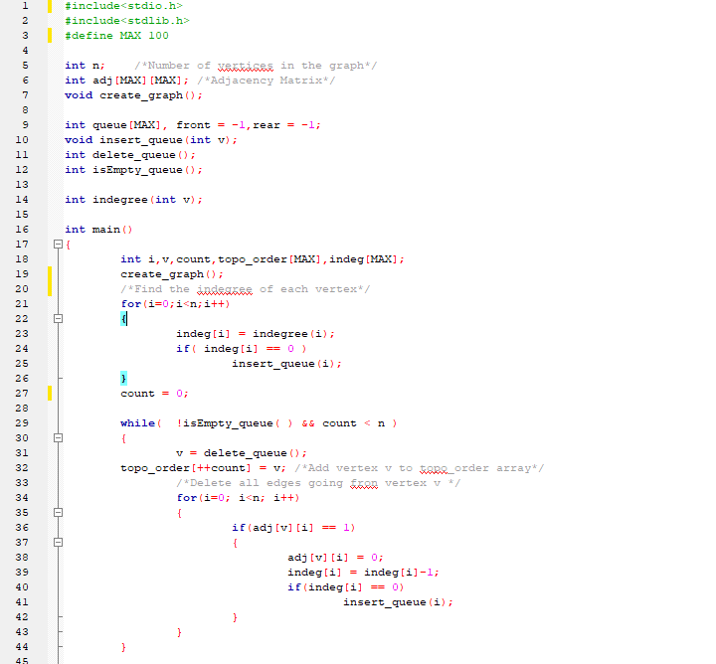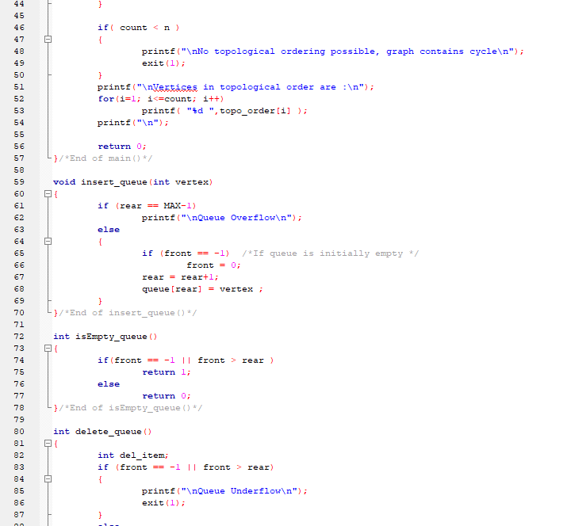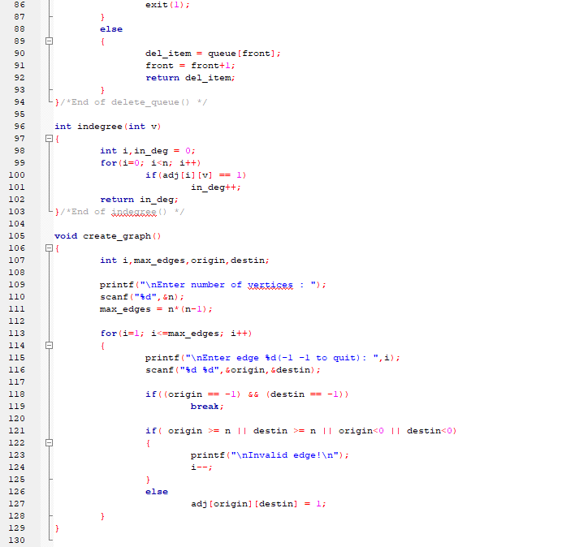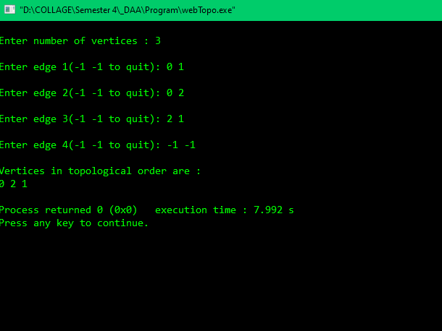

**Job sequencing with Deadlines**

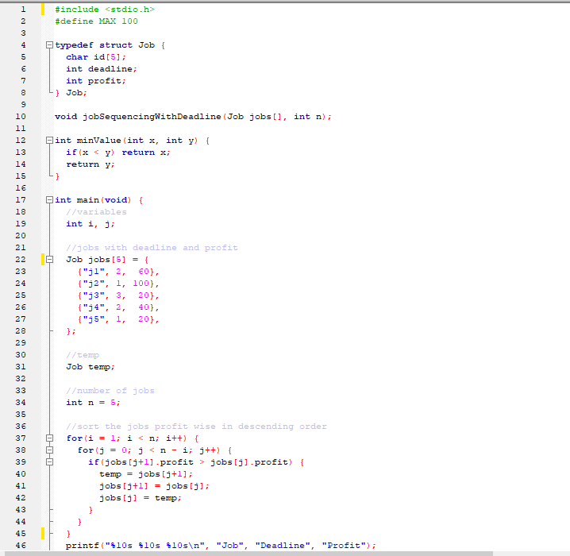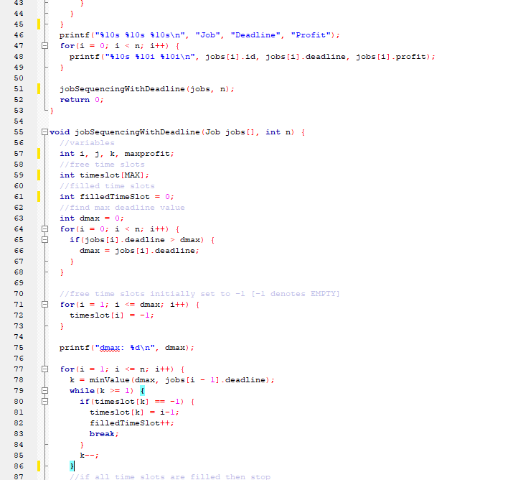

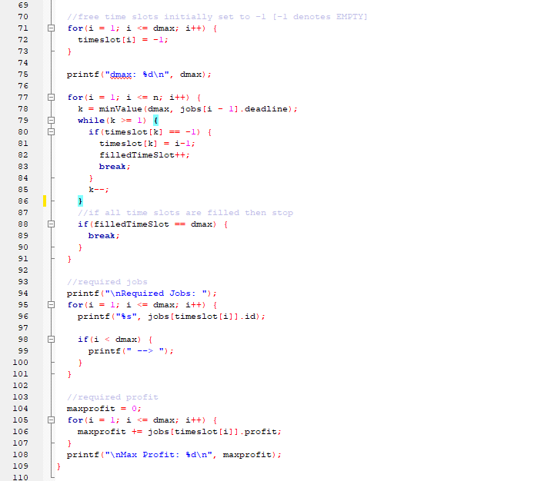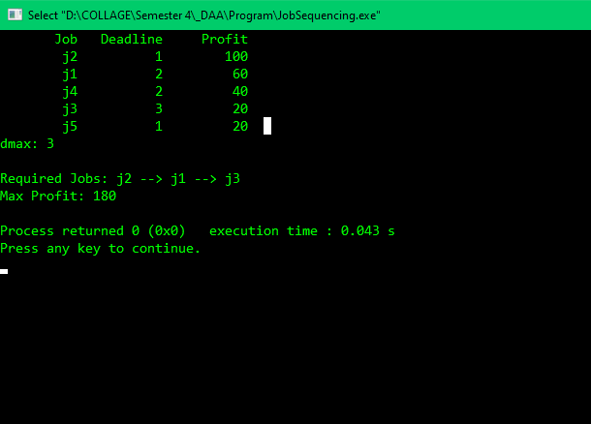

**Kruskal’s - Minimum Spanning Tree**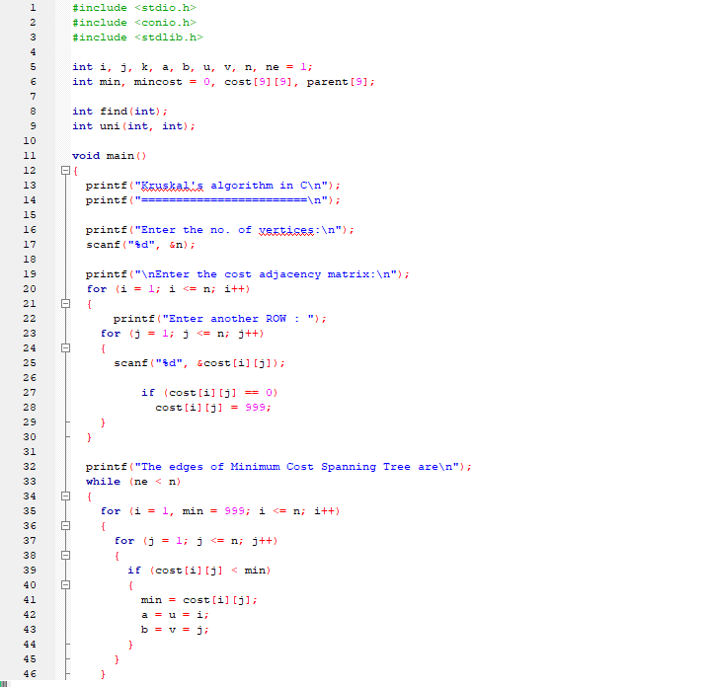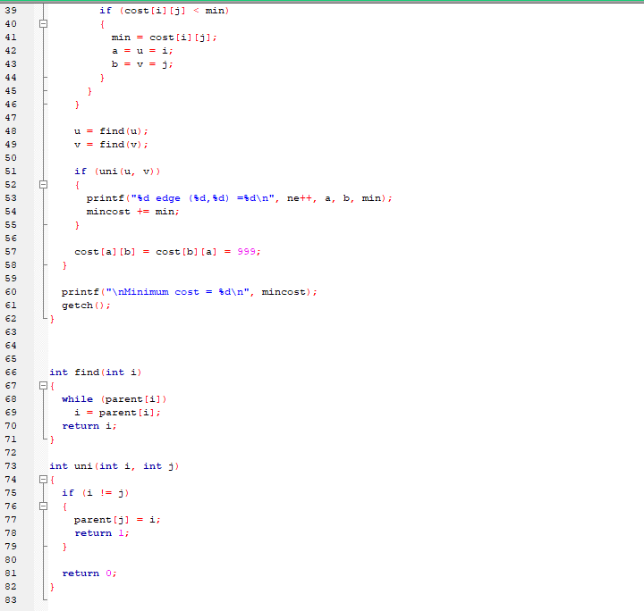

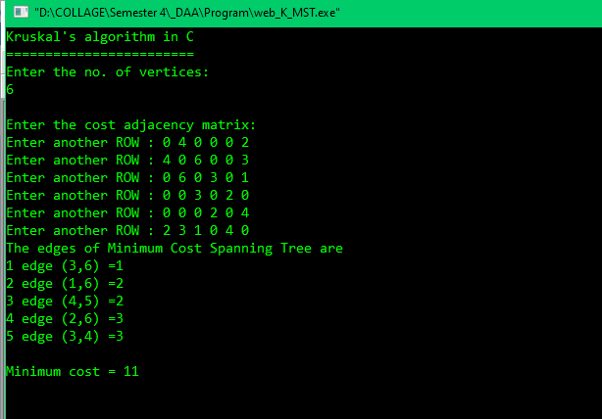

**Prim’s – Minimum Spanning Tree**

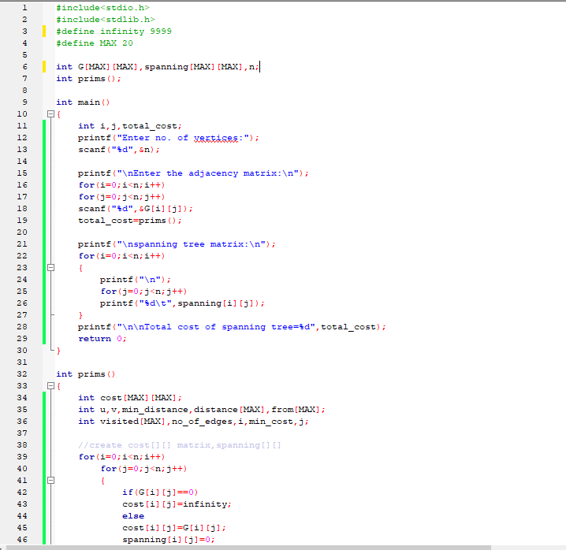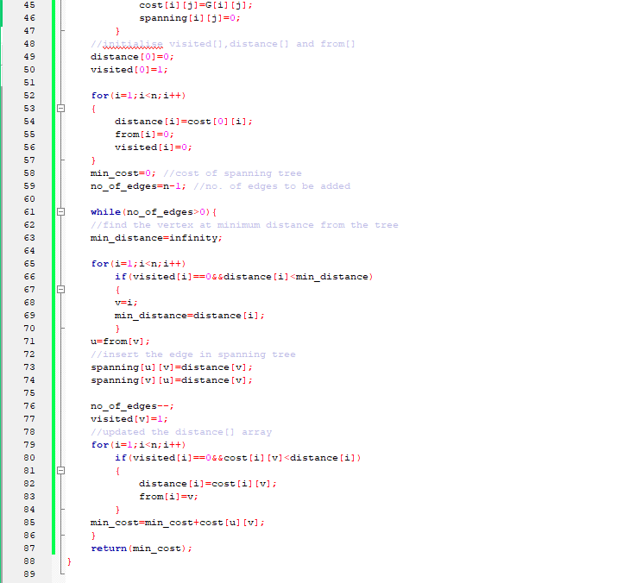

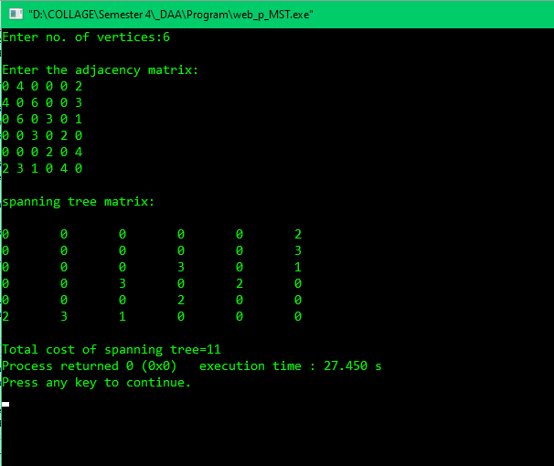

**Travelling Salesman Problem (TSP)**

