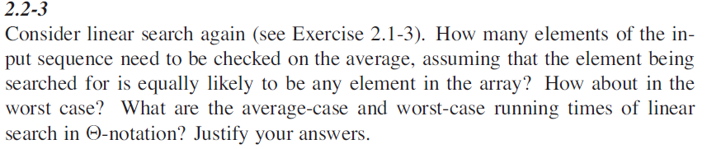

Let’s say we need to search an element key in an array A.

SEARCH(A, key) **cost time**

For i = 1 to A.length  **c1 n**

If A[i] == key  **c2 n**

Return i  **c3 1**

Return -1  **c4 1**

**T(n) = c1 n + c2 n + c3 + c4**

**T(n) = n ( c1 + c2) + c3 + c4**

Let’s c1 + c2 = a, c3 + c4 = b

**T(n) = an + b**

**Time complexity = Θ(n)**

**Worst case.**

Lets algorithms need to compare all the elements before retuning the index, therefore the complexity in this case will be **Θ(n).**

**Average case.**

Lets algorithms needs to compare only half of the element before returning the index, in this case average time complexity will be **Θ(n / 2).**