1. You baught a desktop m/c. The vendor claimed a particular CPU chip installed, but you want to check that claim. You have a Linux Live CD.How can you do?
- 1)boot live cd
- 2)open terminal
- 3)fire cat /proc/cpuinfo( information about cpu,)
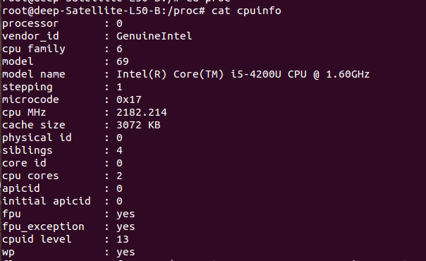

3. Write a C program which copies a given file into a new file with given name. Compile and run it under "strace" report and explain all the lines of the output.

#include <stdio.h>
#include <stdlib.h>
int main(int argc, char const *argv[])
{
FILE *fp1,*fp2;
char a;

fp1=fopen(argv[1],"r");
fp2=fopen(argv[2],"w");

do{

a=fgetc(fp1);
// writing in the file
fputc(a, fp2);

}while(a!=EOF);
return 0;
}
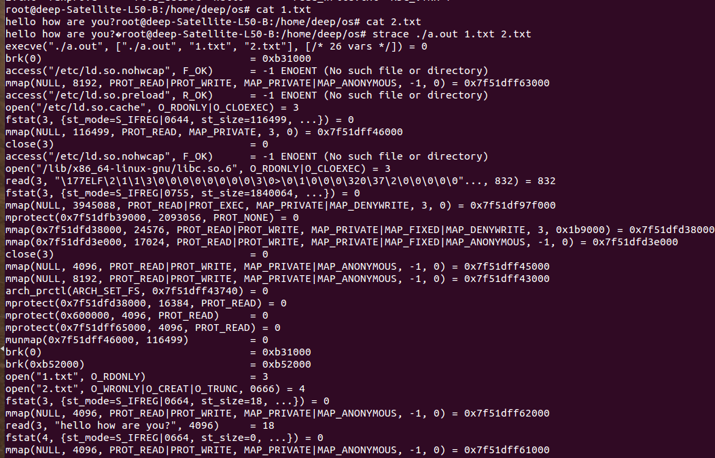

4. Write a C program which will persists for time long enough for you to obtain its memory regions map. (Keep it as simple as possible). Display and explain the map. (Hint: the information is in /proc directory)
#include <stdio.h>

int main(int argc, char const *argv[])
{
int a=10,b=20;
while(1)
{

}
return 0;
}
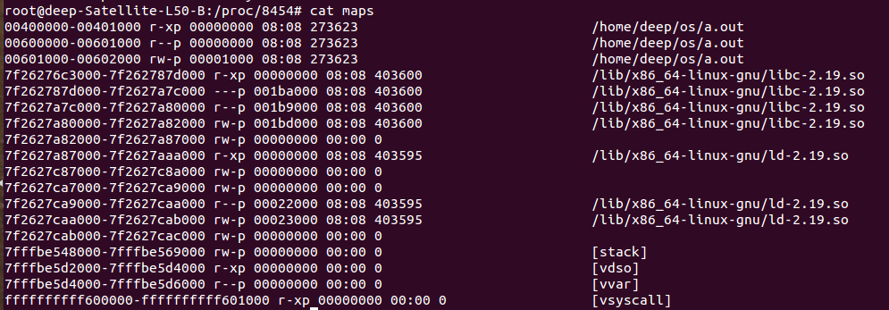

5. You baught a desktop m/c. The vendor claimed 3GB RAM installed, but you want to check that claim. You have a Linux Live CD. How can you do?
Steps:-
1)boot live cd
2)open terminal
3)fire cat /proc/meminfo( information about memory,)
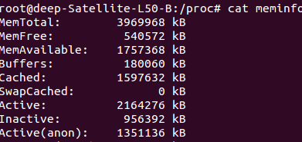

6. What per process information is available from the /proc directory? What are the ways in which you can use this information?
- Inside the /proc directory, two types of content — numbered directories, and system information files.
/proc/cpuinfo – information about CPU,
- /proc/meminfo – information about memory,
- /proc/loadvg – load average,
- /proc/partitions – partition related information,
- /proc/version – linux version
- /proc/devices – List of device drivers configured into the currently running kernel.
- /proc/dma – Shows which DMA channels are being used at the moment.
- /proc/fb – Frame Buffer devices.
- /proc/filesystems – File systems supported by the kernel.
- /proc/interrupts – Number of interrupts per IRQ on architecture.
- /proc/iomem – This file shows the current map of the system’s memory for its various devices
- /proc/ioports – provides a list of currently registered port regions used for input or output communication with a device
- /proc/loadavg – Contains load average of the system
The last column displays the last process ID used.
- /proc/locks – Displays the files currently locked by the kernel

7. Though most of the "files" in /proc directory are read−only, a few can be written into. Find 3 of them and explain for what purpose they are made writable.
1)-rw-r--r-- 1 root root 0 Apr 12 12:23 timer_stats
2)--w------- 1 root root 0 Apr 12 12:23 sysrq-trigger
3)lrwxrwxrwx 1 root root 0 Apr 12 2017 self -> 8019
If a file is writable in /proc by writing something meaningful into it we can tweak some behaviour of the kernel or trigger some action.

8. Explain use of "lsof" command with demonstartion, especially how to see all the opened files of a particular process.
- lsof meaning ‘LiSt Open Files’ is used to find out which files are open by which process.
- Command is:-lsof -p pid
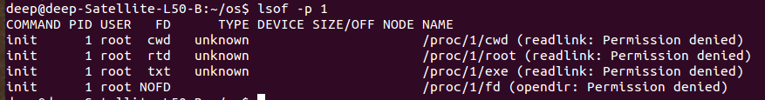
9. Explain use of "cscope" utility with demontration.
- Cscope is an interactive, screen-oriented tool that allows the user to brows through Csource filesfor specified elements of code.
- Vim provides the capability to navigate code without ever leaving the editor.
- set the CSCOPE_EDITOR environment variable.For example :
$ export CSCOPE_EDITOR=’vim’.
- Recursively find all of the .c, .cpp, .h etc files in your current directory and any subdirectories, and store the list of these filenames in cscope.files:
- find . -name “file_dec1.c” -o -name “file_dec2” > cscope.files

->cscope cscope.files

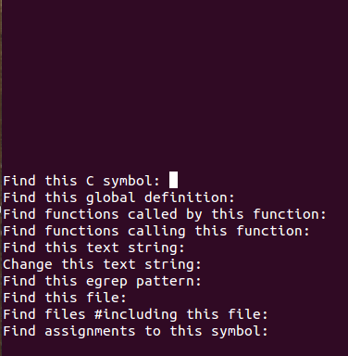

10. Explain use of "ctags" utility with demontration.
- to rapidly locate function names, class definitions,
- macro definitions and so on in a large piece of code.
- ctags works by looking at all the source files for a piece of code and finding the lines which contain symbol definitions – that is, it locates the places where the functions, variables and so on are defined. It has two distinct advantages over a more general approach using something like grep: firstly ctags understands the syntax of many languages, which allows it to find the symbols very reliably. Secondly, its output is a file in a format which can be used by many of today’s more powerful text editors to jump straight to required symbol definitions. Even in a huge piece of code spread out over hundreds of source files, finding a function is never more than a couple of key strokes away.
- In VIM use the “set tags=/path/to/tags” command.
- The VIM command to jump to a named tag is “:ta tag”, where “tag” is the symbol required. A common alternative is Ctrl-] which jumps to the symbolcurrently under thecursor. Ctrl-T is used to pop back out again.
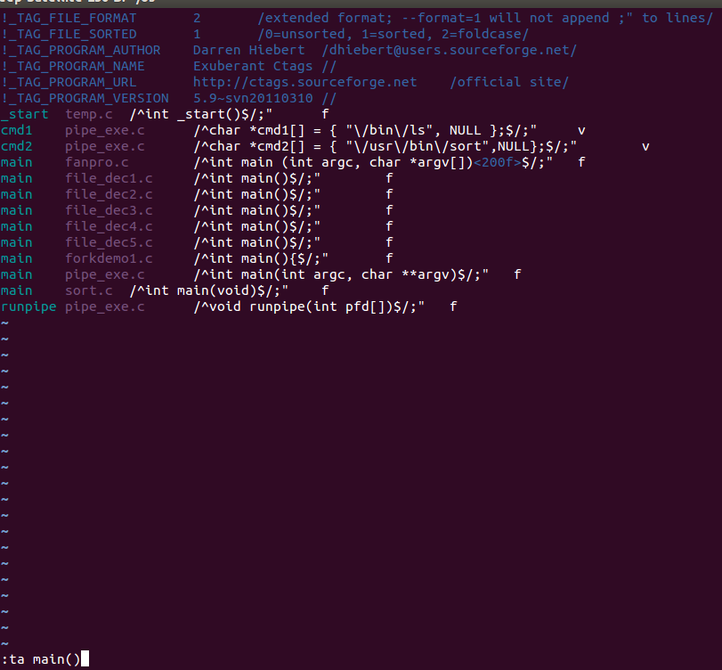

11. [U] Explain the display given by "top" utility and demonstrate:
- top command is use to moniter process in linux.it shows the top processes based on certain criterias like cpu usage or memory usage.
(i)how will you kill a process
- pressing ‘k‘ option in running top command
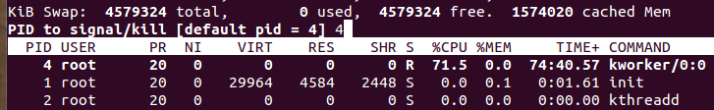
(ii) how will you display processes owned by a specific user
- pressing ‘u‘ option in running top command
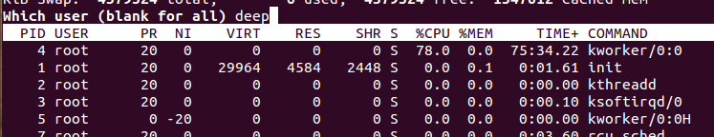
(iii) how will you change the order in which processes are displayed
- Press 'P' - to sort the process list by cpu usage.
Press 'N' - to sort the list by process id
Press 'T' - to sort by the running time.
Press 'M'-to sort the process list by memory usage.
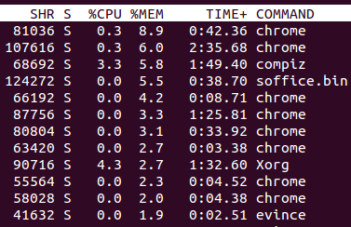

(iv) how can you decide if their is "thrashing" going on
- "thrashing" refers to a situation where the active memory set of all processes are too big to fit into memory.
- There are global counters swin and swout in /proc/vmstat - if both of them increases during some short time interval the box is probably experiencing thrashing problems.

