Level-1

A. /proc file−system:

1. What’s the CPU type and model?
Ans:-cat /proc/cpuinfo
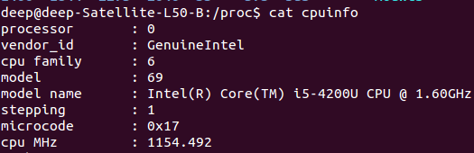

2. What version of the Linux kernel are you using?
Ans: cat /proc/version
3. How long has it been since your PC last booted?
Ans: /proc/uptime
The uptime command shows two values. The first value is the amount of time since the machine booted. The second value is the sum of time that each cpu has had had a runnable process to schedule.

4. How much of the total CPU time has been spent executing in user mode? kernel mode? idle?
Ans: cat /proc/stat
The meanings of the columns are as follows, from left to right:
- user: normal processes executing in user mode
- nice: niced processes executing in user mode
- system: processes executing in kernel mode
- idle: twiddling thumbs
- iowait: waiting for I/O to complete
- irq: servicing interrupts
- softirq: servicing softirqs
These numbers identify the amount of time the CPU has spent performing different kinds of work
user mode : 39244
kernel mode : 15108
idle mode : 888616
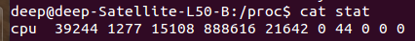

5. How much memory is configured in your PC?

6. How much memory is currently available?
->cat memunfo | head -3 |tail -1

7. How many disk read/write requests have been made?
-d : Display the device utilization report (d == disk)
-x : Display extended statistics including disk utilization
interval : It is time period in seconds between two samples . iostat 2 will give data at each 2 seconds interval.
Count : It is the number of times the data is needed . iostat 2 5 will give data at 2 seconds interval 5 times
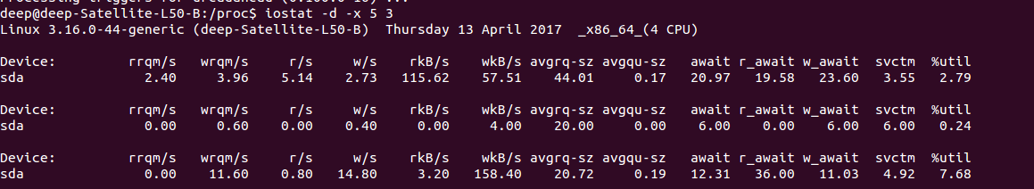
rrqm/s : The number of read requests merged per second that were queued to the hard disk
- wrqm/s : The number of write requests merged per second that were queued to the hard disk
- r/s : The number of read requests per second
- w/s : The number of write requests per second
- rsec/s : The number of sectors read from the hard disk per second
- wsec/s : The number of sectors written to the hard disk per second
- avgrq-sz : The average size (in sectors) of the requests that were issued to the device.
- Avgqu-sz : The average queue length of the requests that were issued to the device
- await : The average time (in milliseconds) for I/O requests issued to the device to be served. This includes the time spent by the requests in queue and the time spent servicing them.
- Svctm : The average service time (in milliseconds) for I/O requests that were issued to the device
- %util : Percentage of CPU time during which I/O requests were issued to the device (bandwidth utilization for the device). Device saturation occurs when this value is close to 100%.
8. How many context switches has the kernel performed?
Ans: /proc cat status
voluntary_ctxt_switches: 2874
nonvoluntary_ctxt_switches: 2801

9. How many context switches has a process had?
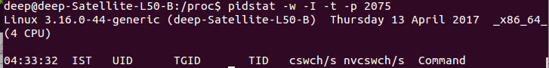
-t Also display statistics for threads associated with selected tasks.
-w Report task switching activity
-I Indicate that tasks CPU usage (as displayed by option -u ) should be divided by the total number of processors.

10. How many processes have been created since the system was booted?
Ans:

11. How many processes are there in the ready queue?
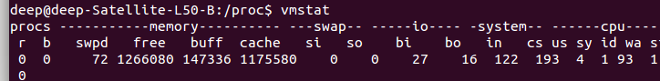
12. How many processes are blocked waiting for I/O to complete?

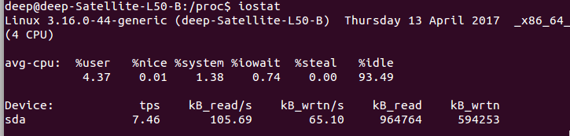
13. What does the following command do?
cd /proc/‘ps | head −2 | tail −1 | cut −f2 −d

1. Find the following "famous" code, and tell me why they are "famous".
start_kernel();
init();
struct task_struct;
struct inode;
struct file;
fork();
include/asm−generic/unistd.h
arch/ia64/kernel/entry.S : ia64_switch_to now places correct virtual mapping in in TR2 for
kernel stack. This allows us to handle interrupts without changing to physical mode.
kernel/printk.cD. Process Management:
Reference: Fork, Exec and Process control;
POSIX thread (pthread) libraries
Be sure you know the following commands:
1. ps

It produces a list of currently running process on your computer.

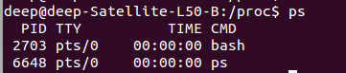

2.ps −af

-a Select all processes except both session leaders and
processes not associated with a terminal.
-f Do full-format listing.

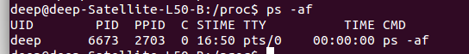

3.ps −ax
It will give full list of process.

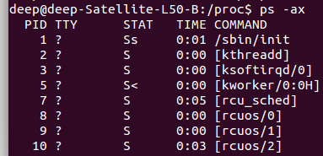

4.ps −eLf
-L Show threads, possibly with LWP and NLWP columns.

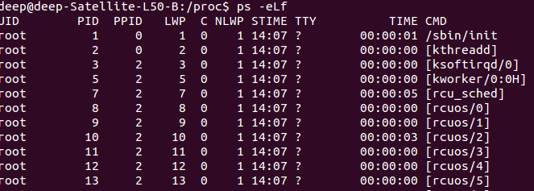

5. pstree : Shows running processes as a tree.

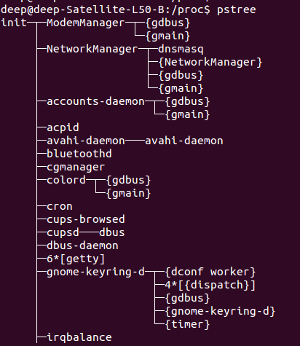

6. nice/renice

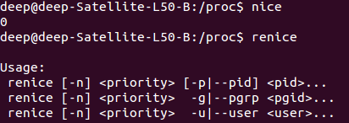

Default niceness level is 0. A process with lower niceness value is given higher priority and more CPU time.
6. top
These gives information about the process its PID, memory used, CPU used, status of the process

1. There is an example c program at the end of the wait manual page (man wait). Read it, compile it, and run it. Then answer the following questions:

a. Both exit() and _exit() are used in the program. What’s the difference?
Ans: exit() flushes io buffers and does some other things like run functions registered by atexit(). exit() invokes _end( ).
_exit() just ends the process without doing that. You call _exit() from the parent process when creating a daemon for example.

In this we want that the child process should return its Pid so, we _exit() and not exit()

b. Discuss the following line of code:
w = waitpid(cpid, &status, WUNTRACED | WCONTINUED);
Ans:
WUNTRACED also return if a child has stopped (but not traced via ptrace(2)). Status for traced children which have stopped is pro‐vided even if this option is not specified.
WCONTINUED also return if a stopped child has been resumed by delivery of SIGCONT.
If status is not NULL, wait() and waitpid() store status information in the int to which it points. This integer can be inspected with the following macros (which take the integer itself as an argument, not a pointer to it, as is done in wait() and waitpid()!):

2. system(), fork(), exec():
Compile and run the following 4 programs. Discuss what they do? What are their differences?
−−−−−−−−−−−−−−−−− prog 1 −−−−−−−−−−−−−−−−−−−−−−−−
#include <stdlib.h>
#include <stdio.h>
int main(){
printf("Running ps with system\n");
system("ps −ax &");
printf("Done.\n");
exit(0);
}
Ans:
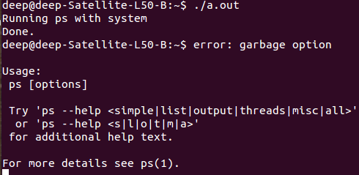

−−−−−−−−−−−−−−−−− prog 2 −−−−−−−−−−−−−−−−−−−−−−−−
#include <unistd.h>
#include <stdio.h>
int main(){
printf("Running ps with execlp\n");
execlp("ps", "ps", "−ax", 0);
printf("Done.\n");
exit(0);
}
Ans:
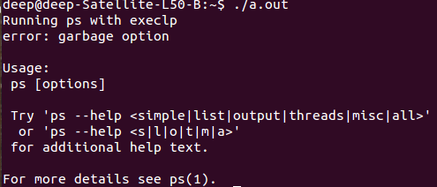

−−−−−−−−−−−−−−−−− prog 3 −−−−−−−−−−−−−−−−−−−−−−−−
#include <stdio.h>
#include <unistd.h>
int main(){
pid_t child_p;
printf("Running ps with fork\n");
child_p = fork();
execlp("ps", "ps", "−ax", 0);
return 0;
}
Ans:
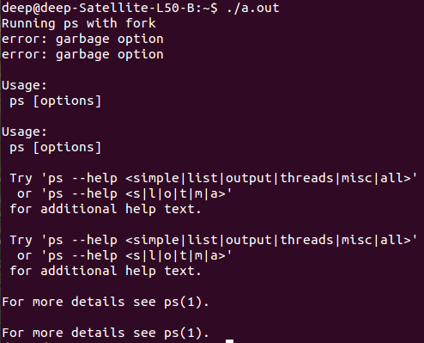

−−−−−−−−−−−−−−−−− prog 4 −−−−−−−−−−−−−−−−−−−−−−−−
#include <unistd.h>
#include <stdio.h>
int main(){
pid_t pid;
printf("Running ps again with fork\n");
pid = fork();
if ( pid == 0 ) { // in the child, do exec
execlp("ps", "ps", "−ax", 0);
}
else if (pid < 0){ // failed to fork
printf("fork failed.\n");
exit(1);
}
else {// parent
wait(NULL);
}
exit(0);
}

Ans:
