- This directory contains an array of options and information concerning various aspects of the file system.
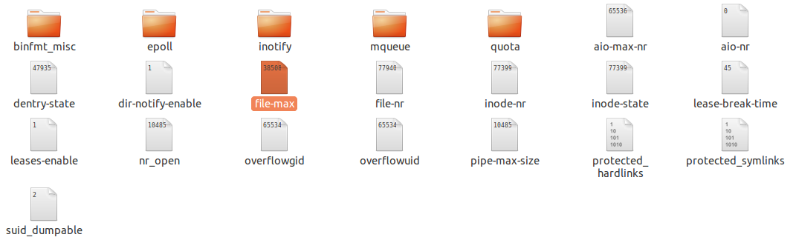
- The binfmt_misc/ directory is used to provide kernel support for miscellaneous binary formats.
- The important files in /proc/sys/fs/ include:
- dentry-state —
- Linux caches directory access to speed up sub-sequential access to the same directory, this file contains information about the status of the directory cache.
- Provides the status of the directory cache. The file looks similar to the following:
The first number reveals the total number of directory cache entries, while the second number displays the number of unused entries. The third number tells the number of seconds between when a directory has been freed and when it can be reclaimed, and the fourth measures the pages currently requested by the system. The last two numbers are not used and display only zeros.
- file-max — Lists the maximum number of file handles that the kernel allocates. Raising the value in this file can resolve errors caused by a lack of available file handles.
- file-nr — Lists the number of allocated file handles, used file handles, and the maximum number of file handles.

- overflowgid and overflowuid — Defines the fixed group ID and user ID, respectively, for use with file systems that only support 16-bit group and user IDs.
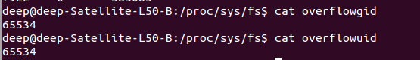
- Proc/sys/fs/dir-notify-enable:-
enable/disable dnotify interface, dnotify is a signal used to notify a process about file/directory changes. This is mainly interesting to programmers.

Proc/sys/fs/inode-nr:-number of inodes and number of free inodes

Proc/sys/fs/inode-state:-This file contains seven numbers: number of inodes, number of free inodes, preshrink, and four dummy values. nr_inodes is the number of inodes the system has allocated. Preshrink is non-zero when the nr_inodes is bigger than inode-max.

Proc/sys/fs/inotify:-
This directory contains files that can be used to limit the amount of kernel memory consumed by the inotify interface.
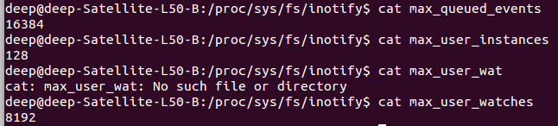
Proc/sys/fs/epoll:-
/proc/sys/fs/epoll - Configuration options for the epoll interface
--------------------------------------------------------

This directory contains configuration options for the epoll(7) interface.

max_user_watches
----------------

Every epoll file descriptor can store a number of files to be monitored
for event readiness. Each one of these monitored files constitutes a "watch".
This configuration option sets the maximum number of "watches" that are
allowed for each user.
Each "watch" costs roughly 90 bytes on a 32bit kernel, and roughly 160 bytes
on a 64bit one.
The current default value for max_user_watches is the 1/32 of the available
low memory, divided for the "watch" cost in bytes.
Proc/sys/fs/lease-break-time:-
Proc/sys/fs/mqueue:-
This directory contains files controlling the resources used by POSIX message queues.
Proc/sys/fs/suid-dumpable:-
Determines whether core dump files are produced for set-user-ID or otherwise protected/tainted binaries.
Possible values are 0,1,2:
- 0 (default) A core dump will not be produced for a process which has changed credentials or whose binary does not have read permission enabled.
- 1 (debug) All processes dump core when possible.
- 2 (suidsafe) Any binary which normally would not be dumped is dumped readable by root only. This allows the user to remove the core dump file but not to read it. For security reasons core dumps in this mode will not overwrite one another or other files. This mode is appropriate when administrators are attempting to debug problems in a normal environment.

- find current maximum size of pipe buffer:-
- find current maximum size of queue parameter:-
