Low-Level Design Report

1. Introduction
This Low-Level Design report translates the architectural decisions documented in the High-Level Design report into implementable class-level, method-level, and interface-level specifications for the Multi-Agent AI Framework for Task-Aware Model Routing and Execution project. While the HLD defines what the system does and how it is decomposed into subsystems, this LLD specifies how each subsystem is realized through concrete classes, typed interfaces, data structures, and execution workflows.
The report follows the IEEE standard for Software Design Descriptions and uses UML as the primary modeling language. All design elements are traceable to the five subsystems: MainAgent Subsystem, SubAgent Subsystem, Execution & Provider Subsystem, User Interface Subsystem, and Logging & Monitoring Subsystem.
1.1 Object design trade-offs

This section documents all major design trade-offs made at the class, object, and interface level throughout the framework. Each trade-off is analyzed with respect to the option chosen, the alternative rejected, and the rationale grounded in maintainability, performance, and extensibility.

Trade-off 1: Inheritance via Abstract BaseAgent versus Composition

Chosen approach: The BaseAgent<T extends AgentImplMetadata, M extends AgentUserMetadata> abstract class (defined in lib/agents/baseAgent.ts) serves as the foundational superclass for all agent implementations. It encapsulates the complete agent lifecycle: LLM construction (createLLMFromConfig()), LangGraph StateGraph construction (buildAgentGraph()), streaming response generation (`run()`), conditional routing (agentRoute()), and the agent node logic (agentNode()). All nine specialized agents (GitHubAgent, CodebaseAgent, FrontendAgent, HuggingFaceAgent, GoogleWorkspaceAgent, SearchAgent, CodingAgent, DataAnalystAgent, VisionAgent) extend this class and override the single abstract method createTools(runtimeSecrets?).

Rejected alternative: A composition-based approach where agents would contain a graph builder, an LLM wrapper, and a streaming handler as separate injected components.

Rationale: Inheritance was chosen because all agents share identical graph topology (agent node, tools node, conditional edges), identical streaming NDJSON output format, and identical LLM invocation patterns. The Template Method pattern embodied by BaseAgent achieves significant shared code reuse across approximately 400 lines. The createTools() abstract method serves as the single customization hook, keeping agent implementations extremely concise. The trade-off is tight coupling: if a future agent requires a fundamentally different graph topology, it cannot easily override buildAgentGraph() without fragile super-call chains. However, MainAgent demonstrates the escape path by overriding the graph construction entirely with buildOrchestratorGraph().

Impact: High positive on maintainability (single location for shared logic). Neutral on performance (graph compiled once at startup). Moderate constraint on extensibility (custom topologies require full override).

Trade-off 2: Self-Registration Pattern versus Centralized Configuration

Chosen approach: Each agent self-registers with the `AgentRegistry` singleton (`lib/agents/agentRegistry.ts`) at module load time. For example, at the bottom of `githubAgent.ts`, the agent calls `agentRegistry.register({...})` with its id, name, toolName, toolDescription, taskPrefix, instance, and getCompiledGraph callback. The MainAgent constructor triggers all registrations by importing every agent module.

Rejected alternative: A single centralized configuration file mapping agent IDs to their class constructors and configuration objects.

Rationale: Self-registration achieves open-closed compliance: adding a new agent requires only creating its four-file directory structure and adding one import line to `mainAgent.ts`. No existing files beyond the MainAgent import list need modification. The trade-off is an implicit ordering dependency: agents must be imported before MainAgent calls `agentRegistry.getAll()` in `buildOrchestratorGraph()`. Additionally, runtime behavior depends on module side effects (import-time instantiation), which can be opaque during debugging. The AgentRegistry mitigates duplicate registration via a `console.warn` on re-registration.

Impact: High positive on maintainability and extensibility (self-contained agent modules). Minor concern on performance (eager instantiation of all agents at startup regardless of usage).

Trade-off 3: Dynamic Orchestrator Graph versus Static Graph Definition

Chosen approach: The `MainAgent.buildOrchestratorGraph()` method constructs the StateGraph dynamically by iterating over all registered agents at runtime. For each agent, it adds a prepare-task node (`Prepare_{agentId}_Task`) and a subgraph node (`{agentId}_Subgraph`), connected with edges back to MainAgentNode.

Rejected alternative: Statically defining all agent nodes in the graph at compile time with hardcoded node names.

Rationale: Dynamic construction enables the graph to automatically incorporate any agents present in the registry at startup time, maintaining alignment with the self-registration pattern. The trade-off is the use of the `any` type annotation for the graph variable because LangGraph's TypeScript generics require statically known node names at compile time. This sacrifices compile-time type safety for runtime flexibility. Routing errors manifest at runtime rather than compile time.

Impact: Very high on extensibility (new agents auto-appear). Moderate concern on maintainability (suppressed type checking). Negligible on performance (compiled once at startup, cached).

Trade-off 4: Generic Type Parameterization versus Concrete Class

Chosen approach: BaseAgent is parameterized with two generic type parameters: `T extends AgentImplMetadata` for implementation metadata and `M extends AgentUserMetadata` for user-facing metadata. Both parameters have default type values (`AgentImplMetadata` and `AgentUserMetadata` respectively). The `AgentConfig<T, M>` interface mirrors this structure.

Rejected alternative: A concrete BaseAgent class with `LLMImplMetadata` hardcoded.

Rationale: The generic parameterization future-proofs the framework for non-LLM agent types (e.g., a rule-based agent with different metadata). Currently, all agents use `LLMImplMetadata` as their T parameter. The trade-off is additional type complexity not currently utilized.

Impact: High on extensibility (new metadata types without modifying base class). None on performance (generics erased at compile time). Slight overhead on maintainability (type annotations).

Trade-off 5: NDJSON Streaming versus Buffered Response

Chosen approach: The `BaseAgent.run()` method returns a `Response` object wrapping a `ReadableStream` that emits newline-delimited JSON events. Each event follows the `AgentStreamEvent` type with six event types: `agent_started`, `agent_ended`, `agent_stream`, `agent_error`, `tool_started`, `tool_ended`. The stream processes LangGraph's `streamEvents(version: "v2")` output in real time.

Rejected alternative: Buffering the entire agent response and returning it as a single JSON payload.

Rationale: Streaming enables real-time user feedback: the UI renders partial LLM output as it arrives, displays tool execution status, and shows the execution flow visualization as it unfolds. The trade-off is implementation complexity (streaming logic spans approximately 100 lines with event filtering, tool name extraction, and careful error handling within the ReadableStream callback). Additionally, stream consumers must implement incremental JSON parsing on the client side.

Impact: Positive on performance (minimal time-to-first-byte, bounded memory). Moderate overhead on maintainability (parity between stream producer and consumer). Moderate constraint on extensibility (new event types require coordinated changes).

Trade-off 6: Compiled Graph Caching with SHA-256 Version Key versus Fresh Build Per Request

Chosen approach: The `BaseAgent.getOrCreateRuntimeGraph()` method implements graph caching using a `lastConfigVersion` field compared against a 12-character SHA-256 hash computed from the agent's LLM configuration and secret key names. The hash is produced by `computeConfigVersion()` in `lib/agents/configResolver.ts`, which hashes a JSON-serialized object containing the config (minus `_configVersion`), sorted secret keys, and a boolean `hasSecrets` indicator.

Rejected alternative: Building a fresh graph for every request.

Rationale: Graph compilation involves creating LLM instances, binding tools, and building LangGraph StateGraphs. Caching eliminates this overhead for the common case where configuration does not change between requests. The trade-off is memory retention: cached graphs hold references to LLM instances and tool closures.

Impact: Significant positive on performance (avoids redundant construction). Minor on maintainability (caching logic is self-contained). Neutral on extensibility.

Trade-off 7: MCP Protocol versus Direct REST API Calls

Chosen approach: Both GitHubAgent and HuggingFaceAgent communicate via the Model Context Protocol using `@modelcontextprotocol/sdk` with `StreamableHTTPClientTransport`. A shared MCP client singleton per agent handles lazy initialization and reconnection.

Rejected alternative: Direct REST API calls using `fetch()` to GitHub's API and Hugging Face's API.

Rationale: MCP provides a standardized tool invocation interface, allowing agents to consume server-defined tools without maintaining custom API client code. The GitHub MCP server exposes 18+ tools. The trade-off is latency overhead (additional network hop through the MCP server) and dependency on remote MCP server availability.

Impact: High positive on maintainability (thin tool wrappers). Slight negative on performance (extra network hop). High positive on extensibility (new server tools immediately available).

Trade-off 8: AES-256-GCM Encryption versus Plaintext Storage

Chosen approach: The encryption module (`lib/encryption.ts`) uses AES-256-GCM with scrypt key derivation to encrypt all user-configured secrets before database storage. The key is derived from the `ENCRYPTION_SECRET` environment variable using scrypt with a fixed salt (`"agent-config-salt-v1"`). The ciphertext format is `iv:tag:encrypted` (Base64-encoded), where the IV is a random 16-byte value generated per encryption operation.

Rejected alternative: Storing secrets in plaintext, relying solely on database access controls.

Rationale: Defense-in-depth: even if the database is compromised, secrets remain encrypted. The trade-off is performance overhead on every secret read/write and operational complexity (ENCRYPTION_SECRET must be managed consistently).

Impact: Minimal on performance (AES-256-GCM is hardware-accelerated). Moderate on maintainability (key rotation requires re-encryption). Neutral on extensibility.

Trade-off 9: DynamicStructuredTool with Zod versus Static Tool Definitions

Chosen approach: All agent tools use LangChain's `DynamicStructuredTool` class with Zod schemas for parameter validation. Zod's `.describe()` chains serve dual purposes: developer documentation and LLM-readable parameter descriptions.

Rejected alternative: LangChain's `Tool` base class with manual JSON schema definitions.

Rationale: Runtime type validation, automatic JSON Schema generation for LLM function calling, and type-safe function implementations. The trade-off is coupling to Zod and runtime-only validation.

Impact: High positive on maintainability (schemas as documentation). Negligible performance. High positive on extensibility (inline tool definitions without boilerplate).

Trade-off 10: Module-level Singleton Agent Instances versus Per-request Instantiation

Chosen approach: Each agent is instantiated once at module load time and exported as a singleton (e.g., `export const githubAgent = new GitHubAgent(...)`). These singletons are shared across all HTTP requests.

Rejected alternative: Creating fresh agent instances per incoming chat request.

Rationale: Singleton agents reduce memory footprint and startup latency. The `getOrCreateRuntimeGraph()` caching mechanism allows per-user configuration without full reinstantiation. The trade-off is reduced isolation: concurrent requests share agent state, though Next.js serverless functions typically handle one request per instance.

Impact: Significant positive on performance. Positive on maintainability (single state). Moderate constraint on extensibility (request-scoped state requires careful handling).

1.2 Interface documentation guidelines

This section establishes the conventions and standards used throughout this LLD document for documenting all interfaces, types, methods, and API contracts.

1.2.1 TypeScript Interface and Type Naming Conventions

- Interfaces use PascalCase with descriptive noun phrases: DelegatableAgent, AgentConfig, SearchResult, ResolvedAgentConfig.
- Type aliases for union types use PascalCase: LLMProvider, ChatTemplateType, AgentChatRole, ChunkType.
- Type aliases for compound structures use PascalCase with a descriptive suffix: LLMImplMetadata, AgentUserMetadata, AgentStreamEvent, ExecutionStep.
- Generic type parameters use single uppercase letters with descriptive extends constraints: T extends AgentImplMetadata, M extends AgentUserMetadata.
- Constants used as discriminators use UPPER_SNAKE_CASE: AGENT_STARTED, TOOL_ENDED, API_MODEL_TYPE.

1.2.2 Interface Field Documentation

Each field in an interface is documented with an inline JSDoc comment describing its purpose. Example from the codebase (`lib/agents/agentRegistry.ts`):

```typescript
export interface DelegatableAgent {
/** Unique identifier, e.g., "github" */
id: string;
/** Display name, e.g., "GitHub Agent" */
name: string;
/** Tool name for LLM routing, e.g., "delegate_to_github" */
toolName: string;
/** Description shown to LLM for routing decisions */
toolDescription: string;
/** Prefix for task messages, e.g., "[GitHub Task]" */
taskPrefix: string;
/** The agent instance for running */
instance: BaseAgent<any>;
/** Returns the compiled LangGraph for this agent */
getCompiledGraph: () => Runnable;
}
```

All types shared between modules are defined in lib/types.ts for cross-cutting concerns, or within the relevant module directory for scoped types

1.2.3 JSDoc Standards for Methods and Functions

All public and protected methods follow JSDoc conventions:

```
/**
* [Brief description of what the method does]
* @param paramName Description of the parameter
* @returns Description of the return value
*/
```

Multi-line JSDoc blocks are used for complex methods with behavioral notes, including caching behavior, error conditions, and side effects.

1.2.4 Zod Schema Documentation for Tool Parameters

Tool parameter schemas use Zod's `.describe()` method on every parameter, serving as both developer documentation and LLM-readable descriptions:

```typescript
schema: z.object({
query: z.string().describe("Natural language query about the codebase"),
filePathPrefix: z.string().optional().describe("Filter to specific directory prefix"),
limit: z.number().optional().default(5).describe("Number of results (default: 5, max: 10)"),
})
```

Enum parameters use `z.enum()` with descriptive values. Optional parameters use `.optional()` or `.default()` with documented defaults.

1.2.5 Tool Description Conventions

Every DynamicStructuredTool includes a description field following these conventions:

1. First sentence: A concise imperative statement of what the tool does.
2. Use cases: When the tool should be invoked.
3. Capabilities: Specific operations supported.
4. Limitations: Maximum values, truncation, or fallback behavior.

1.2.6 API Route Documentation

API routes follow Next.js App Router conventions. Each route is documented with: HTTP method, request body schema, response format, authentication requirements, and error responses.

1.2.7 Database Schema Documentation

Database tables are documented with section header comments and column-level comments in the Drizzle ORM schema. Exported type aliases using `InferSelectModel` provide type-safe query results.

1.2.8 UML Diagram Conventions

Class diagrams use stereotypes: `<<abstract>>` for BaseAgent, `<<singleton>>` for AgentRegistry, `<<interface>>` for DelegatableAgent and AgentConfig, `<<factory>>` for createLLM. Visibility markers (+, -, #) indicate public, private, and protected members respectively. Generic parameters are shown in angle brackets.

1.3. Engineering standards (e.g., UML and IEEE)

1.3.1 IEEE Software Design Descriptions

This LLD document adheres to the IEEE standard for Software Design Descriptions. The standard prescribes the following elements, each addressed in the corresponding sections:

Design stakeholders and their concerns: Object design trade-offs document rationale behind design decisions, addressing maintainability, extensibility, and performance concerns.
Design views: The LLD employs multiple viewpoints:
- Logical view: Class diagrams, interface hierarchies, and type relationships.
- Process view: Sequence diagrams showing orchestration, delegation, and streaming workflows.
- Development view: Package structure, file organization, and dependency relationships.
- Physical view: Deployment topology
Design elements and their relationships:Documented through UML class diagrams with inheritance, composition, and dependency.
Design rationale: Each trade-off in Section 1.1 provides explicit rationale for design choices.
Design languages: UML for diagrams; TypeScript for implementation-level specifications.

1.3.2 UML Diagram Standards

The following UML diagram types are used throughout this LLD:

Class Diagrams: Represent the static structure of the agent framework including the BaseAgent abstract class hierarchy, AgentRegistry singleton, AgentConfig interface composition, LLMImplMetadata type, and all association/dependency relationships.

Sequence Diagrams: Document dynamic behavior including:
- The complete request lifecycle (user input to streamed response)
- MainAgent orchestration flow (delegation, task preparation, subgraph execution)
- BaseAgent.run() streaming flow
- MCP client connection lifecycle
- Configuration resolution flow

Activity Diagrams (Behavior Diagrams):
- The LangGraph StateGraph execution flow (START, agentNode, conditional routing, tools node, END)
- The MainAgent orchestrator routing logic
- The CodebaseAgent RAG pipeline
- The encryption/decryption workflow

Component Diagrams (Structure Diagrams): Document the five subsystem decomposition and inter-subsystem interfaces.

1.3.3 TypeScript and Next.js Coding Standards

TypeScript Standards:
- Strict mode with TypeScript 5.6+
- All shared types exported from `lib/types.ts` or respective module files
- Generic constraints with explicit `extends` clauses
- Readonly fields for agent configuration (`protected readonly`)
- Optional chaining for null safety
- `InferSelectModel<typeof table>` for Drizzle ORM type generation
- String literal unions as discriminated union discriminators

Next.js 15 Standards:
- App Router directory structure (`app/(chat)/api/...`)
- React Server Components by default; `"use client"` directive for client components
- Route Handlers exporting named HTTP method functions (POST, GET, DELETE)
- Server-only environment variables via `process.env`
- Turbopack development mode (`next dev --turbo`)

Code Quality:
- Ultracite (Biome-based) linter for consistent formatting
- pnpm package manager with lockfile for deterministic dependencies
- Drizzle Kit for database migration management

1.3.4 Security Standards
- NIST SP 800-38D:AES-256-GCM encryption with scrypt key derivation for all secrets at rest
- bcrypt password hashing for user authentication
- JWT session tokens via NextAuth v5
- Session-based access control on all API routes
- Zod schema validation on all incoming API requests
- Database query scoping by userId for data isolation

1.3.5 Database Standards
- Drizzle ORM with declarative schema definitions and type-safe query builders
- Drizzle Kit for migration generation and application
- Neon serverless PostgreSQL with WebSocket support and connection pool singleton
- HNSW index for pgvector cosine similarity search
- B-tree indexes for foreign key and lookup columns

1.4 Definitions, acronyms, and abbreviations

AES: Advanced Encryption Standard
AI: Artificial Intelligence
API: Application Programming Interface
CRUD Create, Read, Update, Delete
CSV Comma-Separated Values
DB Database
DTO Data Transfer Object
FK Foreign Key
GCM Galois/Counter Mode
GCS Google Cloud Storage
HLD High-Level Design
HNSW Hierarchical Navigable Small World
HTTP Hypertext Transfer Protocol
HTTPS Hypertext Transfer Protocol Secure
IEEE Institute of Electrical and Electronics Engineers
IV Initialization Vector
JSON JavaScript Object Notation
JSDoc JavaScript Documentation
JWT JSON Web Token
LLD Low-Level Design
LLM Large Language Model
MCP Model Context Protocol
NDJSON Newline Delimited JSON
NIST National Institute of Standards and Technology
ORM Object-Relational Mapping
RAG Retrieval-Augmented Generation
RBAC Role-Based Access Control
REST Representational State Transfer
S3 Simple Storage Service (AWS)
SDK Software Development Kit
SHA Secure Hash Algorithm
SQL Structured Query Language
SRP Single Responsibility Principle
SSE Server-Sent Events
TSX TypeScript JSX
UI User Interface
UML Unified Modeling Language
URL Uniform Resource Locator
UUID Universally Unique Identifier

2. Packages

This section delineates the software package structure and the operational boundaries of each module within the Multi-Agent AI Framework. The architecture rigorously adheres to the layered design patterns defined in the High-Level Design (HLD), segregating responsibilities across presentation, API management, agent orchestration, data persistence, and infrastructure. Each package is designed to follow the Single Responsibility Principle (SRP), ensuring modularity and maintainability.

2.1 Presentation (UI) Package

Directory Path: app/, components/, hooks/

Core Responsibilities:

Interface Rendering: Responsible for the construction and rendering of the reactive user interface, including the chat console, configuration dashboards, and artifact visualization panels.

State Synchronization: Manages the binding of server-side streaming data (Server-Sent Events) to the client-side UI state, ensuring real-time feedback for agent activities.

Interaction Management: Handles multimodal user inputs (text and file uploads) and applies global UI themes and layout configurations.

Key Components:

app/(chat)/*: Encompasses the page definitions, layouts, and route integrations for the chat interface.

components/chat.tsx, components/messages.tsx: Implements the chat flow visualization and message rendering logic.

components/multimodal-input.tsx: Manages the composite input interface for text commands and file attachments.

components/artifact-*.tsx: specialized renderers for structured outputs such as code blocks, data tables, and generated images.

hooks/use-*.ts(x): Custom React hooks that encapsulate UI state management and stream processing logic.

2.2 API Layer (Route Handlers) Package

Directory Path: app/(chat)/api/, app/api/

Core Responsibilities:

Request Validation: Enforces strict schema validation using Zod for all incoming client requests to ensure data integrity.

Execution Initiation: Acts as the entry point for the orchestration layer, initializing the agent runtime and managing the generation of HTTP streams.

Resource Management: Manages endpoints for file uploads via object storage and user-specific configuration APIs.

Key Components:

app/(chat)/api/chat/route.ts: The primary orchestrator entry point that handles session initialization and response streaming.

app/(chat)/api/chat/schema.ts: Defines the TypeScript interfaces and validation schemas for API payloads.

app/(chat)/api/files/upload/route.ts: Handles the secure upload and validation of binary files to Vercel Blob storage.

app/api/user_dashboard/*: Manages CRUD operations for user-specific agent preferences and configurations.

2.3 Agent Orchestration Package

Directory Path: lib/agents/

Core Responsibilities:

Lifecycle Management: Controls the initialization, execution, and caching of LangGraph state machines.

Intent Analysis: Implements the MainAgent logic for analyzing user intent and delegating tasks to specialized sub-agents.

Runtime binding: Manages the dynamic binding of tools, LLM instances, and the agent registry.

Key Components:

lib/agents/mainAgent/*: Contains the core orchestration logic, routing rules, and delegation graphs.

lib/agents/*Agent/*: Directories for specialized agents (e.g., GitHub, Vision, Codebase) containing their specific prompts and logic.

lib/agents/agentRegistry.ts: Facilitates the self-registration and runtime discovery of available agent modules.

lib/agents/baseAgent.ts: The abstract base class providing shared behaviors for event streaming, error handling, and tool execution.

2.4 LLM Provider Abstraction Package

Directory Path: lib/agents/llmFactory.ts, lib/agents/*/config.ts

Core Responsibilities:

Provider Agnosticism: Implements a factory pattern to instantiate Large Language Models regardless of the underlying provider (OpenAI, Anthropic, Ollama, etc.).

Configuration Resolution: Merges static defaults with runtime user overrides for model selection and API parameters.

Key Components:

lib/agents/llmFactory.ts: The central factory module for generating provider-agnostic BaseChatModel instances.

lib/agents/*/config.ts: Defines default model configurations and parameter constraints for individual agents.

2.5 Tools & Integrations Package

Directory Path: lib/agents/*/tools.ts, services/

Core Responsibilities:

Service Integration: Encapsulates interactions with external APIs such as GitHub, Google Workspace, and web search engines.

Schema Definition: Defines the input/output schemas for tools that agents can invoke during execution.

Protocol Standardization: Standardizes tool invocations compliant with the Model Context Protocol (MCP).

Key Components:

lib/agents/searchAgent/tools.ts: Tools for web searching, content scraping, and academic paper querying.

lib/agents/githubAgent/tools.ts: Implementations of GitHub API interactions (issues, PRs, commits) and MCP tools.

lib/agents/visionAgent/tools.ts: Wrappers for image analysis and generation services.

lib/agents/dataAnalystAgent/tools.ts: Utilities for data visualization and analysis tasks.

lib/agents/googleWorkspaceAgent/tools.ts: Interfaces for interacting with Gmail, Calendar, Drive, and Docs APIs.

lib/agents/codebaseAgent/tools.ts: Tools for semantic code retrieval via vector similarity search.

lib/agents/codingAgent/tools.ts: File system operations and code modification capabilities.

lib/agents/frontendAgent/tools.ts: Tools for emitting UI customization actions (themes, layouts).

lib/agents/huggingFaceAgent/tools.ts: Integrations for model discovery and dataset exploration on Hugging Face.

2.6 Data Persistence Package

Directory Path: lib/db/, drizzle.config.ts, migrations/

Core Responsibilities:

Relational Mapping: Manages PostgreSQL database interactions using Drizzle ORM for type-safe query construction.

State Persistence: Handles the storage of chat history, message logs, agent configurations, and user preferences.

Vector Storage: Manages the storage and retrieval of vector embeddings via pgvector to support semantic code search (RAG).

Key Components:

lib/db/schema.ts: Defines the database tables and relational schemas.

lib/db/index.ts: Configures the database client and connection pooling.

drizzle.config.ts: Configuration for ORM migrations and introspection.

2.7 Artifacts & Documents Package

Directory Path: artifacts/, components/artifact-*.tsx, lib/agents/artifacts/

Core Responsibilities:

Output Management: Manages the lifecycle, storage, and retrieval of generated artifacts (code, documents, images).

Conditional Rendering: Selects and executes the appropriate renderer component based on the artifact type.

Key Components:

artifacts/*: Logic for handling specific artifact types and templates.

components/artifact.tsx: The high-level component responsible for orchestrating the display of generated content.

2.8 Security & Auth Package

Directory Path: middleware.ts, lib/encryption.ts, auth config

Core Responsibilities:

Access Control: Manages session authentication and route protection using NextAuth.

Credential Protection: Encrypts sensitive API keys and secrets using AES-256-GCM before database storage.

Threat Mitigation: Implements rate limiting and sanitization to prevent abuse and injection attacks.

Key Components:

middleware.ts: Handles edge-level access control and session verification.

lib/encryption.ts: Utilities for cryptographic operations (encryption/decryption).

2.9 Observability & Telemetry Package

Directory Path: lib/agents/* (event stream), components/execution-flow.tsx

Core Responsibilities:+

Event Streaming: Captures and streams agent lifecycle events (e.g., agent_started, tool_used) to the client.

Trace Visualization: Constructs hierarchical execution traces to visualize the decision-making process within the UI.

Key Components:

lib/constants.ts: Defines standardized event types and telemetry constants.

components/execution-flow.tsx: Renders the visual representation of the agent execution graph.

2.10 DevOps, Scripts & Tests Package

Directory Path: scripts/, tests/, cloud-deploy/

Core Responsibilities:

Automation: Contains scripts for codebase indexing, database migrations, and maintenance tasks.

Quality Assurance: Houses unit, integration, and agent-specific test suites.

Deployment: Manages infrastructure-as-code and deployment configurations for cloud environments.

Key Components:

scripts/*: Maintenance and data preparation automation scripts.

tests/*: Test definitions and validation logic.

cloud-deploy/*: Deployment guidelines and configuration files.

2.11 Package Traceability Matrix
This section presents the Package Traceability Matrix, which systematically maps each Low-Level Design (LLD) package defined in Section 2 to its corresponding High-Level Design (HLD) subsystems and services, as well as to the related concrete implementation artifacts within the project repository. The purpose of this matrix is to ensure structural consistency, architectural compliance, and verifiable alignment between system design specifications and source code implementation.

LLD Package (Section) | HLD Reference | HLD Element | Code Artifacts (Evidence) | Trace Type
2.1 Presentation (UI) Package | Section 3.2 (User Interface Subsystem); Section 4 (UI Subsystem) | Chat interface, artifact rendering, multimodal input handling | app/(chat)/page.tsx, components/chat.tsx, components/artifact.tsx, components/multimodal-input.tsx | Direct
2.2 API Layer (Route Handlers) Package | Current software architecture (API Layer); Section 3.6 (Global software control) | Request initiation, validation, streaming entrypoint | app/(chat)/api/chat/route.ts, app/(chat)/api/chat/schema.ts, app/(chat)/api/files/upload/route.ts | Direct
2.3 Agent Orchestration Package | Section 3.2 (MainAgent Subsystem, SubAgent Subsystem); Section 3.6 (Global software control) | Orchestrator routing, agent lifecycle management, graph execution | lib/agents/mainAgent/mainAgent.ts, lib/agents/baseAgent.ts, lib/agents/agentRegistry.ts | Direct
2.4 LLM Provider Abstraction Package | Section 3.2 (Execution & Provider Subsystem); Section 4 (Execution & Provider Service) | Provider-agnostic model factory, runtime configuration merging | lib/agents/llmFactory.ts, lib/agents/configResolver.ts, lib/agents/mainAgent/config.ts, lib/agents/searchAgent/config.ts, lib/agents/codebaseAgent/config.ts | Direct
2.5 Tools & Integrations Package | Section 4 (SubAgents/createTools); Glossary (Tool) | Structured tool schemas, external service adapters | lib/agents/searchAgent/tools.ts, lib/agents/githubAgent/tools.ts, lib/agents/googleWorkspaceAgent/tools.ts, lib/agents/codebaseAgent/tools.ts, lib/agents/codingAgent/tools.ts, lib/agents/frontendAgent/tools.ts, lib/agents/visionAgent/tools.ts, lib/agents/huggingFaceAgent/tools.ts, lib/agents/dataAnalystAgent/tools.ts | Direct
2.6 Data Persistence Package | Current software architecture (Data Persistence Layer); Persistent data management | Relational schema, queries, migrations, vector persistence | lib/db/schema.ts, lib/db/queries.ts, lib/db/migrate.ts, lib/db/migrations/0001_sparkling_blue_marvel.sql, lib/db/migrations/0014_white_korvac.sql | Direct
2.7 Artifacts & Documents Package | Runtime request flow (artifact generation/persistence); Glossary (Artifact) | Artifact lifecycle management, renderer orchestration | artifacts/code/server.ts, artifacts/image/client.tsx, artifacts/text/server.ts, components/artifact.tsx, lib/artifacts/server.ts | Direct
2.8 Security & Auth Package | Access control and security; Security & Authentication | Authentication, route protection, secret encryption | middleware.ts, app/(auth)/auth.ts, lib/encryption.ts, app/(auth)/api/auth/[...nextauth]/route.ts | Direct
2.9 Observability & Telemetry Package | Section 3.2 (Logging & Monitoring Subsystem); Section 4 (Logging & Monitoring Service) | Event streaming, execution trace visualization | lib/constants.ts, app/(chat)/api/chat/route.ts, components/execution-flow.tsx | Direct
2.10 DevOps, Scripts & Tests Package | Design goals (Scalability, Self-Hosted Capability); Hardware/software mapping | Automation, verification, deployment artifacts | scripts/fetch_issues.ts, tests/mainAgent/test-main-agent.ts, cloud-deploy/GCP_DEPLOYMENT_GUIDE.md | Supporting

3. Class Interfaces

3.1 Agent Orchestration Core

3.1.1 MainAgent
HLD Mapping: Section 3.2 – Subsystem decomposition (Item 1 – MainAgent Subsystem) -> `MainAgent` (`lib/agents/mainAgent/mainAgent.ts`)
"MainAgent Subsystem: Acts as the central orchestrator responsible for high-level intent detection and workflow routing."
Evidence:
• HLD Reference: `High-Level_Design_Report.docx`, Section `3.2` (Subsystem decomposition), Item `1` (MainAgent Subsystem)
• `lib/agents/mainAgent/mainAgent.ts`
Class: `MainAgent`
Method: `run()`
• `lib/agents/mainAgent/mainAgent.ts`
Class: `MainAgent`
Method: `createRuntimeOrchestratorGraph()`
• `app/(chat)/api/chat/route.ts`
Function: `POST(request: Request)`
Call site: `agent.instance.run(agentMessages, runtimeConfig, runtimeSecrets)`
HLD Item | Code Artifact (file:line or path) | LLD Element
MainAgent Subsystem | `lib/agents/mainAgent/mainAgent.ts:25` | Root orchestrator class
Runtime request flow step 3 | `app/(chat)/api/chat/route.ts:381` | Invocation entry for orchestrator runtime
Delegation | `lib/agents/mainAgent/mainAgent.ts:121` | Tool-call based route decision (`orchestratorRoute`)
1. Purpose & Responsibilities
• Execute as the root orchestration agent for chat requests.
• Build a dynamic LangGraph orchestration graph from the registry (`agentRegistry.getAll()`).
• Route LLM tool-calls to `Prepare_<agentId>_Task` nodes and then into delegated sub-agent subgraphs.
• Stream lifecycle and token events as NDJSON (`agent_started`, `tool_started`, `agent_stream`, `agent_ended`, `agent_error`).
• Rebuild or reuse runtime orchestration graph based on `_configVersion`.

2. Public Interfaces
Method | Purpose | Inputs | Outputs | Errors
`constructor(mainAgentConfig: AgentConfig<LLMImplMetadata>, agentTools: DynamicStructuredTool[])` | Initialize orchestrator LLM/tools and graph | Agent config and delegation tools | `MainAgent` instance | Throws if underlying LLM creation/binding fails
`protected createTools(runtimeSecrets?: Record<string, string>): DynamicStructuredTool[]` | Build delegation tools from registry | Optional runtime secrets (unused directly) | Delegation tool array | None in method body
`public async run(inputMessages: AgentChatMessage[], runtimeConfig?: Partial<LLMImplMetadata>, runtimeSecrets?: Record<string, string>): Promise<Response>` | Execute orchestration and stream events | Message history, runtime config, runtime secrets | HTTP `Response` containing NDJSON stream | Emits `agent_error`; stream loop catches critical errors
`public get name(): string` (inherited) | Return agent display name | None | Agent name | None
`public get id(): string` (inherited) | Return agent id | None | Agent id | None
3. Inputs / Outputs
• Input DTO: `AgentChatMessage` (`lib/types.ts:89`)
• Runtime config DTO: `Partial<LLMImplMetadata>` with optional `subAgentConfigs` and `_configVersion` (`lib/types.ts:155-167`)
• Runtime secrets DTO: `Record<string, string>`
• Stream output schema: `AgentStreamEvent` (`lib/types.ts:185-192`)
• Event type constants: `AGENT_STARTED`, `AGENT_ENDED`, `AGENT_STREAM`, `AGENT_ERROR`, `TOOL_STARTED`, `TOOL_ENDED` (`lib/constants.ts:38-48`)
Required fields used by `MainAgent.run`:
• `inputMessages[].role`, `inputMessages[].content`
• `runtimeConfig._configVersion` for orchestrator cache decision (`lib/agents/mainAgent/mainAgent.ts:145-156`)
• `runtimeConfig.subAgentConfigs[agentId]` for delegated runtime graph override (`lib/agents/mainAgent/mainAgent.ts:210-217`)
4. State & Data Structures
Inherited state (`BaseAgent`):
• `agentTools: DynamicStructuredTool[]` (`lib/agents/baseAgent.ts:18`)
• `agentGraph: Runnable null` (`lib/agents/baseAgent.ts:19`)
• `agentLLM: Runnable null` (`lib/agents/baseAgent.ts:20`)
• `runtimeSecrets?: Record<string, string>` (`lib/agents/baseAgent.ts:21`)
• `lastConfigVersion: string null` (`lib/agents/baseAgent.ts:24`)
Orchestrator node naming scheme:
• `MainAgentNode`
• `Prepare_<agent.id>_Task`
• `<agent.id>_Subgraph`
Delegation metadata source: `DelegatableAgent` entries from registry (`lib/agents/agentRegistry.ts:8-23`)
5. Main Flows
1. `app/(chat)/api/chat/route.ts:381` calls `agent.instance.run(...)` with resolved runtime config/secrets.
2. `MainAgent.run` stores `runtimeSecrets` and converts `AgentChatMessage[]` to LangChain messages (`lib/agents/mainAgent/mainAgent.ts:227-233`).
3. `getOrCreateOrchestratorGraph(runtimeConfig)` returns cached or rebuilt graph (`lib/agents/mainAgent/mainAgent.ts:145-159`).
4. `graphToUse.streamEvents(...)` starts streaming execution events (`lib/agents/mainAgent/mainAgent.ts:238-241`).
5. Stream writes `agent_started` for MainAgent (`lib/agents/mainAgent/mainAgent.ts:255-259`).
6. On delegated path, `orchestratorRoute` selects `Prepare_<agentId>_Task`, then delegated subgraph executes (`lib/agents/mainAgent/mainAgent.ts:121-137`, `:206-219`).
7. Tool and model stream events are converted to NDJSON lifecycle events (`lib/agents/mainAgent/mainAgent.ts:291-325`).
8. Stream always writes final `agent_ended` in `finally` (`lib/agents/mainAgent/mainAgent.ts:336-341`).
6. Edge Cases & Error Handling
Case | Behavior in Code | Evidence | Status
Timeout | No explicit orchestrator timeout in `MainAgent.run` loop | `lib/agents/mainAgent/mainAgent.ts:227-349` | TODO (no explicit implementation observed in current codebase)
Invalid input | Input shape validation occurs before orchestration via Zod schema | `app/(chat)/api/chat/schema.ts:17-37` | Implemented (pre-orchestrator gate)
Tool failure | Stream loop catch emits `agent_error` payload | `lib/agents/mainAgent/mainAgent.ts:328-334` | Implemented
Provider failure | `agentNode`/runtime agent node catch and return AI error message | `lib/agents/mainAgent/mainAgent.ts:108-115`, `:188-195` | Implemented
Partial success | Streamed chunks can be emitted before later error; `finally` still emits `agent_ended` | `lib/agents/mainAgent/mainAgent.ts:320-341` | Implemented
Cancellation / Disconnect | No explicit disconnect/cancel branch inside MainAgent stream loop | `lib/agents/mainAgent/mainAgent.ts:248-343` | TODO (explicit server-side cancel handling is not implemented in current codebase)

7. Dependencies
• `MainAgent` uses `BaseAgent` (`lib/agents/mainAgent/mainAgent.ts:8`).
• `MainAgent` calls `createDelegationToolsFromRegistry` (`lib/agents/mainAgent/mainAgent.ts:10`, `:43`).
• `MainAgent` reads `agentRegistry` (`lib/agents/mainAgent/mainAgent.ts:9`, `:50`, `:131`, `:266`).
• `MainAgent` creates runtime LLM via `createLLM` (`lib/agents/mainAgent/mainAgent.ts:12`, `:177`).
• `MainAgent` creates and compiles LangGraph `StateGraph(MessagesAnnotation)` (`lib/agents/mainAgent/mainAgent.ts:55-73`, `:200-222`).

8. Diagrams
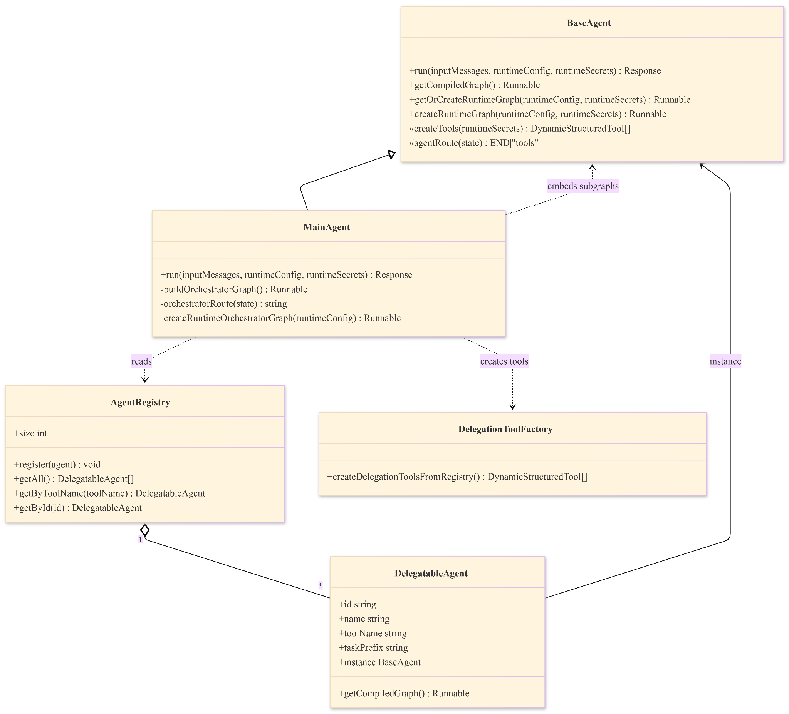
9. Testability Notes
• Unit-test `orchestratorRoute` by mocking `messages[messages.length-1].tool_calls` with registry hits/misses.
• Unit-test `createPrepareTaskNode` output message format (`[<Task Prefix>] <task>`).
• Integration-test `run` by mocking `streamEvents` to assert emitted NDJSON event order and payload keys.
• Mock points: `agentRegistry.getAll`, `agentRegistry.getByToolName`, `createLLM`, delegated `instance.getOrCreateRuntimeGraph`.

3.1.2 BaseAgent
HLD Mapping: Section 3.2 – Subsystem decomposition (Item 2 – SubAgent Subsystem) -> `BaseAgent` shared runtime (`lib/agents/baseAgent.ts`)
"SubAgent Subsystem: A suite of specialized agents extending a common BaseAgent abstract class, powered by LangGraph for state management:"
Evidence:
• HLD Reference: `High-Level_Design_Report.docx`, Section `3.2` (Subsystem decomposition), Item `2` (SubAgent Subsystem)
• `lib/agents/baseAgent.ts`
Class: `BaseAgent`
Method: `run()`
Lines: `~298-434`
• `lib/agents/baseAgent.ts`
Class: `BaseAgent`
Method: `createRuntimeGraph()`
Lines: `~231-289`
• `lib/agents/baseAgent.ts`
Class: `BaseAgent`
Method: `buildAgentGraph()`
Lines: `~89-98`

HLD Item | Code Artifact (file:line or path) | LLD Element
BaseAgent (Glossary) | `lib/agents/baseAgent.ts:12` | Shared abstract runtime implementation
LangGraph runtime loop | `lib/agents/baseAgent.ts:89-98` | `agentNode` <-> `tools` state graph
Event-driven telemetry | `lib/agents/baseAgent.ts:331-422` | Agent/tool lifecycle event emission

1. Purpose & Responsibilities
• Provide shared LLM setup, tool binding, and graph lifecycle for all sub-agents.
• Define abstract `createTools(runtimeSecrets?)` contract for tool injection.
• Provide cache-aware runtime graph creation keyed by config/version inputs.
• Provide NDJSON event streaming for lifecycle/tool/model events.
2. Public Interfaces
Method | Purpose | Inputs | Outputs | Errors
`constructor(config: AgentConfig<T, M>, agentTools: DynamicStructuredTool[])` | Initialize base metadata, bind LLM and tools, compile base graph | Agent config and initial tools | `BaseAgent` instance | Throws if model type unsupported or LLM creation fails
`public toJSON()` | Serialize metadata | None | `{ user_metadata, implementation_metadata }` | None
`public get name(): string` | Return display name | None | Name string | None
`public get id(): string` | Return id | None | Id string | None
`public getCompiledGraph(): Runnable` | Expose compiled graph | None | Compiled runnable graph | None
`public getOrCreateRuntimeGraph(runtimeConfig?: Partial<LLMImplMetadata>, runtimeSecrets?: Record<string, string>): Runnable` | Cache-aware runtime graph access | Runtime config/secrets | Reused or rebuilt graph | None
`public createRuntimeGraph(runtimeConfig?: Partial<LLMImplMetadata>, runtimeSecrets?: Record<string, string>): Runnable` | Build fresh runtime graph | Runtime config/secrets | New compiled graph | Runtime LLM/tool creation errors are handled in runtime node catch
`public async run(inputMessages: AgentChatMessage[], runtimeConfig?: Partial<LLMImplMetadata>, runtimeSecrets?: Record<string, string>): Promise<Response>` | Execute graph and stream events | Messages, config, secrets | NDJSON stream response | Emits `agent_error`; catches stream loop exceptions
`protected abstract createTools(runtimeSecrets?: Record<string, string>): DynamicStructuredTool[]` | Sub-agent tool factory contract | Runtime secrets | Tool array | Implemented by subclasses

3. Inputs / Outputs
Input message DTO: `AgentChatMessage` (`lib/types.ts:89`)
Internal conversion:
user role -> `HumanMessage`
assistant role -> `AIMessage` (`lib/agents/baseAgent.ts:303-307`)
Runtime config payload:
provider/model fields and `_configVersion` from `LLMImplMetadata` (`lib/types.ts:155-167`)
Output stream payloads:
`agent_started` with serialized input (`lib/agents/baseAgent.ts:331-338`)
`tool_started` / `tool_ended` (`lib/agents/baseAgent.ts:356-387`)
`agent_stream` chunk (`lib/agents/baseAgent.ts:389-397`)
`agent_error` (`lib/agents/baseAgent.ts:404-411`)
`agent_ended` (`lib/agents/baseAgent.ts:414-421`)

4. State & Data Structures
Metadata:
• `userMetadata: M` (`lib/agents/baseAgent.ts:14`)
• `implementationMetadata: T` (`lib/agents/baseAgent.ts:15`)
Runtime state:
• `agentTools: DynamicStructuredTool[]` (`:18`)
• `agentGraph: Runnable null` (`:19`)
• `agentLLM: Runnable null` (`:20`)
• `runtimeSecrets?: Record<string, string>` (`:21`)
• `lastConfigVersion: string null` (`:24`)
Graph structure:
• nodes: `agentNode`, `tools`
• edges: `START -> agentNode`, conditional `agentNode -> ENDtools`, `tools -> agentNode` (`:91-97`)
5. Main Flows
1. Constructor builds base LLM (`createLLMFromConfig`) and binds initial tools (`lib/agents/baseAgent.ts:34-37`).
2. Constructor compiles base graph with `agentNode` and `ToolNode` (`:89-98`).
3. `run` converts chat history into LangChain messages (`:303-307`).
4. `run` resolves cached/fresh graph via `getOrCreateRuntimeGraph` (`:310`).
5. `streamEvents` iterates runtime events (`:312-315`, `:342`).
6. Stream writer emits lifecycle and tool events as NDJSON (`:331-398`).
7. `finally` emits `agent_ended` and closes stream (`:413-424`).
6. Edge Cases & Error Handling
Case | Behavior in Code | Evidence | Status
Timeout | No explicit timeout in BaseAgent event loop | `lib/agents/baseAgent.ts:330-425` | TODO (no explicit implementation observed in current codebase)
Invalid input | No runtime schema validation inside BaseAgent; upstream API validates | `lib/agents/baseAgent.ts:298-307`, `app/(chat)/api/chat/schema.ts:17-37` | Implemented upstream
Tool failure | Stream loop catch emits `agent_error` | `lib/agents/baseAgent.ts:401-412` | Implemented
Provider failure | `agentNode` and runtime node catches return AI error message | `lib/agents/baseAgent.ts:137-143`, `:275-279` | Implemented
Partial success | Previous `agent_stream` events remain emitted even if later catch triggers `agent_error` | `lib/agents/baseAgent.ts:389-412` | Implemented
Cancellation / Disconnect | No explicit branch for aborted client connection in BaseAgent stream controller | `lib/agents/baseAgent.ts:322-425` | TODO (explicit aborted-connection branch is not implemented in current codebase)
7. Dependencies
• Uses `createLLM` factory (`lib/agents/baseAgent.ts:7`, `:51`, `:250`).
• Uses `StateGraph`, `MessagesAnnotation`, `ToolNode` (`lib/agents/baseAgent.ts:4`, `:10`, `:89-98`).
• Uses message primitives `HumanMessage`, `AIMessage`, `SystemMessage` (`lib/agents/baseAgent.ts:9`).
• Uses stream event constants (`lib/agents/baseAgent.ts:8`).
8. Diagrams
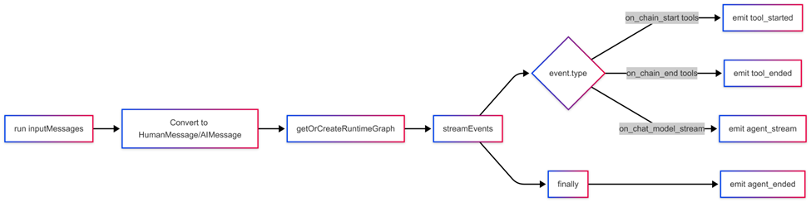
9. Testability Notes
• Unit-test `agentRoute` with synthetic `AIMessage.tool_calls` arrays.
• Unit-test `getOrCreateRuntimeGraph` cache behavior by varying `_configVersion` and secret key sets.
• Unit-test stream serialization by mocking `streamEvents` async iterator.
• Integration-test subclass `createTools(runtimeSecrets?)` interactions by injecting deterministic tool stubs.

3.1.3 AgentRegistry
HLD Mapping: Section 5 – Glossary (Term: Agent Registry) -> `AgentRegistry` singleton (`lib/agents/agentRegistry.ts`)
"Dynamic catalog of available agents enabling runtime discovery"
Evidence:
• HLD Reference: `High-Level_Design_Report.docx`, Section `5` (Glossary), Term `Agent Registry`
• `lib/agents/agentRegistry.ts`
Class: `AgentRegistry`
Method: `register()`
Lines: `~36-42`
• `lib/agents/agentRegistry.ts`
Class: `AgentRegistry`
Method: `getByToolName()`
Lines: `~57-59`
• `lib/agents/codingAgent/codingAgent.ts`
Class: `CodingAgent`
Method: module-level registration block (`agentRegistry.register({...})`)
Lines: `~29-42`

HLD Item | Code Artifact (file:line or path) | LLD Element
Agent Registry | `lib/agents/agentRegistry.ts:29-79` | Singleton registration and lookup store
Runtime discovery | `lib/agents/mainAgent/mainAgent.ts:50` | `agentRegistry.getAll()` graph composition
Delegation tool lookup | `lib/agents/mainAgent/mainAgent.ts:131` | `agentRegistry.getByToolName(...)` route selection

1. Purpose & Responsibilities
• Maintain runtime catalog of delegatable agents.
• Provide id-based and toolName-based lookup for orchestration routing.
• Provide ordered array of registered agents for graph/tool generation.
• Support module-load self-registration from each specialized agent module.

2. Public Interfaces
Method | Purpose | Inputs | Outputs | Errors
`register(agent: DelegatableAgent): void` | Register or overwrite agent metadata | Delegatable agent object | None | Logs warning on duplicate id
`getAll(): DelegatableAgent[]` | Return all agents | None | Array of registered agents | None
`getByToolName(toolName: string): DelegatableAgent | undefined` | Resolve route target by delegation tool name | Tool name string | Matching agent or `undefined` | None
`getById(id: string): DelegatableAgent | undefined` | Resolve by agent id | Agent id string | Matching agent or `undefined` | None
`get size(): number` | Count entries | None | Integer | None
3. Inputs / Outputs
Registry item schema: `DelegatableAgent` (`lib/agents/agentRegistry.ts:8-23`)
• `id`, `name`, `toolName`, `toolDescription`, `taskPrefix`, `instance`, `getCompiledGraph`
Registration examples:
• `coding-agent` (`lib/agents/codingAgent/codingAgent.ts:29-42`)
• `search-agent` (`lib/agents/searchAgent/searchAgent.ts:126-144`)
• `google-workspace-agent` (`lib/agents/googleWorkspaceAgent/googleWorkspaceAgent.ts:127-145`)
4. State & Data Structures
Store: `private agents: Map<string, DelegatableAgent> = new Map()` (`lib/agents/agentRegistry.ts:30`)
Overwrite behavior on duplicate id:
• warns then replaces map value (`lib/agents/agentRegistry.ts:37-41`)
5. Main Flows
1. Agent module evaluates and creates agent instance.
2. Module calls `agentRegistry.register({...})` during module load (`lib/agents/codingAgent/codingAgent.ts:29`).
3. MainAgent imports agent modules to trigger registration (`lib/agents/mainAgent/mainAgent.ts:15-23`).
4. MainAgent builds graph/tools from `agentRegistry.getAll()` (`lib/agents/mainAgent/mainAgent.ts:50`, `lib/agents/mainAgent/delegationToolFactory.ts:11`).
5. Runtime route uses `getByToolName` to map LLM tool call to subgraph (`lib/agents/mainAgent/mainAgent.ts:131-135`).

6. Edge Cases & Error Handling
Case | Behavior in Code | Evidence | Status
Timeout | Registry operations are synchronous map operations with no timeout policy | `lib/agents/agentRegistry.ts:29-75` | N/A (not applicable: registry is not a long-running execution component)
Invalid input | No schema validation inside `register`; compile-time type is `DelegatableAgent` | `lib/agents/agentRegistry.ts:36` | N/A (not applicable: internal typed registration contract)
Tool failure | Not handled in registry; handled downstream in agent runtime | `lib/agents/agentRegistry.ts` | N/A (not applicable: runtime/tool execution is outside registry scope)
Provider failure | Not handled in registry; occurs in agent LLM runtime | `lib/agents/agentRegistry.ts` | N/A (not applicable: provider invocation is outside registry scope)
Partial success | Duplicate `id` overwrites existing entry with warning | `lib/agents/agentRegistry.ts:37-40` | Implemented
Cancellation / Disconnect | No async stream operation in registry | `lib/agents/agentRegistry.ts` | N/A (not applicable: registry does not own streaming/session lifecycle)

7. Dependencies
• `AgentRegistry` depends on `BaseAgent<any>` and `Runnable` types (`lib/agents/agentRegistry.ts:1-3`, `:20`, `:22`).
• MainAgent depends on registry lookup/read APIs (`lib/agents/mainAgent/mainAgent.ts:50`, `:131`, `:266`).
• Delegation tool factory depends on registry enumeration (`lib/agents/mainAgent/delegationToolFactory.ts:11`).
8. Diagrams
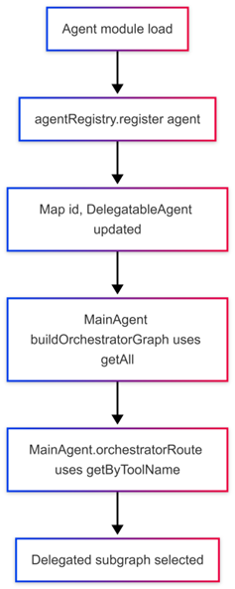
9. Testability Notes
• Unit-test duplicate registration overwrite behavior and warning path.
• Unit-test `getByToolName` and `getById` lookup correctness.
• Integration-test module import side effects to verify registry population before MainAgent graph build.

3.1.4 Delegation / Routing Engine
HLD Mapping: Section 5 – Glossary (Term: Delegation) + Section 3.6 – Global software control -> `createDelegationToolsFromRegistry`, `orchestratorRoute`, `createPrepareTaskNode`
"Process of MainAgent forwarding tasks to specialized agents"
Evidence:
• HLD Reference: `High-Level_Design_Report.docx`, Section `5` (Glossary), Term `Delegation`; Section `3.6` (Global software control)
• `lib/agents/mainAgent/delegationToolFactory.ts`
Function: `createDelegationToolsFromRegistry()`
Method focus: delegation tool generation
Lines: `~10-20`
• `lib/agents/mainAgent/mainAgent.ts`
Class: `MainAgent`
Method: `orchestratorRoute()`
Lines: `~121-140`
• `lib/agents/mainAgent/mainAgent.ts`
Class: `MainAgent`
Method: `createPrepareTaskNode()`
Lines: `~85-95`

HLD Item | Code Artifact (file:line or path) | LLD Element
Delegation | `lib/agents/mainAgent/delegationToolFactory.ts:10-20` | Delegation tool API exposed to MainAgent LLM
Intent routing | `lib/agents/mainAgent/mainAgent.ts:121-137` | Tool-call to prepare-node mapping
Task forwarding | `lib/agents/mainAgent/mainAgent.ts:85-95` | Prefix + delegated task message injection

1. Purpose & Responsibilities
• Expose one delegator tool per registered sub-agent to the MainAgent LLM.
• Route tool-calls to a dynamic prepare node and subgraph.
• Normalize delegated input as `[TaskPrefix] <task>` before entering sub-agent graph.

2. Public Interfaces
Method | Purpose | Inputs | Outputs | Errors
`createDelegationToolsFromRegistry(): DynamicStructuredTool[]` | Build delegator tools from registry entries | None | Delegation tool array | None in function body
`private orchestratorRoute(state: typeof MessagesAnnotation.State)` | Select next node by tool call | Graph state with last AI message | `END` or `Prepare_<agentId>_Task` | No throw path; unmatched tools route to `END`
`private createPrepareTaskNode(agent: DelegatableAgent)` | Build node handler for delegated task prep | Registered agent metadata | Node function returning `{ messages: [HumanMessage] }` | None in function body
3. Inputs / Outputs
Delegation tool schema (`zod`):
• `task: z.string()` (`lib/agents/mainAgent/delegationToolFactory.ts:15-17`)
Delegation tool output:
• Static acknowledgment string: ``Delegating to ${agent.name}: ${task}`` (`:18`)
Routing input:
• `lastMessage.tool_calls[]` (`lib/agents/mainAgent/mainAgent.ts:125-132`)
Routing output:
• `END` or `Prepare_<id>_Task` node name (`:133-140`)
4. State & Data Structures
Delegation metadata fields used by routing:
• `toolName`, `taskPrefix`, `id`, `name` (`lib/agents/agentRegistry.ts:14-18`)
Prepared task message format:
• `new HumanMessage(`${agent.taskPrefix} ${task}`)` (`lib/agents/mainAgent/mainAgent.ts:93`)
Dynamic graph nodes per registered agent:
• `Prepare_<agent.id>_Task`, `<agent.id>_Subgraph` (`lib/agents/mainAgent/mainAgent.ts:62-69`)
5. Main Flows
1. MainAgent graph starts at `MainAgentNode`.
2. MainAgent LLM emits delegation tool call (e.g., `delegate_to_search`).
3. `orchestratorRoute` resolves toolName via registry and returns prepare node.
4. Prepare node injects prefixed delegated task as `HumanMessage`.
5. Graph transitions to `<agent.id>_Subgraph` and executes delegated agent.
6. Graph returns from subgraph to `MainAgentNode` for aggregation or next route.
6. Edge Cases & Error Handling

Case | Behavior in Code | Evidence | Status
Timeout | No explicit timeout branch in routing/delegation code | `lib/agents/mainAgent/mainAgent.ts:121-140`, `lib/agents/mainAgent/delegationToolFactory.ts:10-20` | N/A (not applicable: routing/delegation functions are synchronous dispatch logic)
Invalid input | Missing `task` in tool args falls back to `Help with <agent.name>` in prepare node | `lib/agents/mainAgent/mainAgent.ts:90` | Implemented
Tool failure | Tool execution errors propagate to stream loop catch in `MainAgent.run` | `lib/agents/mainAgent/mainAgent.ts:291-335` | Implemented
Provider failure | Upstream provider failure in MainAgent node handled by `agentNode` catch | `lib/agents/mainAgent/mainAgent.ts:108-115` | Implemented
Partial success | Unmatched tool calls lead to `END` (current cycle completes without delegation) | `lib/agents/mainAgent/mainAgent.ts:139` | Implemented
Cancellation / Disconnect | No explicit cancellation branch in routing methods | `lib/agents/mainAgent/mainAgent.ts:85-140` | N/A (not applicable: cancellation is handled at stream execution layer, not pure routing methods)
7. Dependencies
• Delegation engine uses `agentRegistry.getAll()` and `getByToolName()`.
• Delegation engine creates `DynamicStructuredTool` via `zod` schemas.
• Routing engine depends on LangGraph node/edge wiring in MainAgent graph builder.
8. Diagrams
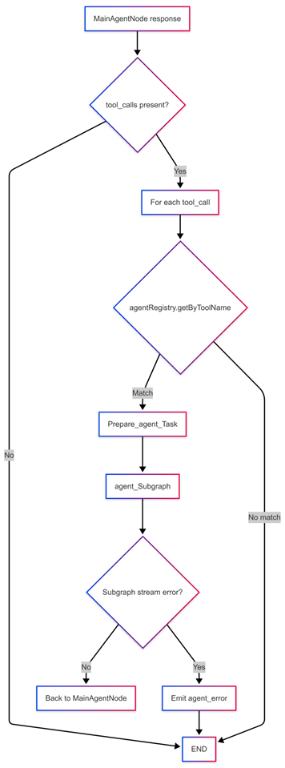

9. Testability Notes
• Unit-test tool factory size equals registry size.
• Unit-test route selection for matching, non-matching, and no-tool-call cases.
• Unit-test prepare node fallback task when tool args are absent.
• Integration-test full delegated cycle MainAgent -> Prepare -> Subgraph -> MainAgent.

3.1.5 LangGraph / GraphRunner (State Machine)
HLD Mapping: Section 3.6 – Global software control + Section 5 – Glossary (LangGraph) -> `StateGraph(...).compile()` runnable orchestration graphs
"Global control of the software is managed through an event driven, graph based orchestration engine."
Evidence:
• HLD Reference: `High-Level_Design_Report.docx`, Section `3.6` (Global software control); Section `5` (Glossary), Term `LangGraph`
• `lib/agents/baseAgent.ts`
Class: `BaseAgent`
Method: `buildAgentGraph()`
Lines: `~89-98`
• `lib/agents/mainAgent/mainAgent.ts`
Class: `MainAgent`
Method: `buildOrchestratorGraph()`
Lines: `~49-73`
• `lib/agents/mainAgent/mainAgent.ts`
Class: `MainAgent`
Method: `run()`
Lines: `~227-349` (`streamEvents` call at `~238-241`)
HLD Item | Code Artifact (file:line or path) | LLD Element
Graph-based control | `lib/agents/baseAgent.ts:91-98` | Base state graph definition
Main orchestration graph | `lib/agents/mainAgent/mainAgent.ts:55-73` | Dynamic multi-subgraph orchestration graph
Stateful execution stream | `lib/agents/baseAgent.ts:312-315`, `lib/agents/mainAgent/mainAgent.ts:238-241` | Event-driven graph runner invocation
1. Purpose & Responsibilities
• Represent agent control flow as a cyclic LangGraph state machine.
• Execute state transitions based on `AIMessage.tool_calls` decisions.
• Emit event stream (`streamEvents`) used for runtime lifecycle propagation.
2. Public Interfaces
Method | Purpose | Inputs | Outputs | Errors
`protected buildAgentGraph()` (`BaseAgent`) | Build default LLM/tool loop graph | None | Compiled `Runnable` | None in builder
`private buildOrchestratorGraph()` (`MainAgent`) | Build dynamic orchestrator graph with subgraphs | None | Compiled `Runnable` | None in builder
`public getCompiledGraph(): Runnable` (`BaseAgent`) | Expose compiled graph for embedding | None | `Runnable` | None
`streamEvents({ messages: history }, (invoked on compiled graph) | Run graph and emit LangGraph events | Message state and options | Async event stream | Stream iteration errors caught in caller run methods
3. Inputs / Outputs
Graph state model: `MessagesAnnotation.State` with `messages` channel.
Route decisions:
• BaseAgent: `agentRoute` returns `END` or `"tools"` (`lib/agents/baseAgent.ts:161-172`)
• MainAgent: `orchestratorRoute` returns `END` or `Prepare_<id>_Task` (`lib/agents/mainAgent/mainAgent.ts:121-140`)
• Output channel: LangGraph event stream consumed by `run` methods.
4. State & Data Structures
Base graph nodes:
`agentNode`, `tools`
Base graph edges:
`START -> agentNode`
conditional `agentNode -> ENDtools`
`tools -> agentNode`
Main graph nodes:
`MainAgentNode`
per-agent `Prepare_<id>_Task`
per-agent `<id>_Subgraph`
Main graph edges:
`START -> MainAgentNode`
conditional `MainAgentNode -> ENDPrepare_<id>_Task`
`Prepare_<id>_Task -> <id>_Subgraph`
`<id>_Subgraph -> MainAgentNode`
5. Main Flows
1. A compiled graph receives `messages` state.
2. Node executes (`agentNode`/`MainAgentNode`) and emits next message.
3. Conditional route function inspects `lastMessage.tool_calls`.
4. If no tool calls: transition to `END`.
5. If tool calls exist:
• Base graph -> `tools` node -> back to `agentNode`.
• Main graph -> `Prepare_<id>_Task` -> `<id>_Subgraph` -> back to `MainAgentNode`.
6. Caller consumes `streamEvents` until completion.
6. Edge Cases & Error Handling
Case | Behavior in Code | Evidence | Status
Timeout | No graph-level timeout control in state machine builders | `lib/agents/baseAgent.ts:89-98`, `lib/agents/mainAgent/mainAgent.ts:49-73` | TODO (no explicit implementation observed in current codebase)
Invalid input | Graph functions assume valid `messages` state shape from caller | `lib/agents/baseAgent.ts:106-113`, `lib/agents/mainAgent/mainAgent.ts:101-107` | TODO (no explicit implementation observed in current codebase)
Tool failure | Tool execution failures surfaced through event stream catch in run methods | `lib/agents/baseAgent.ts:401-412`, `lib/agents/mainAgent/mainAgent.ts:328-335` | Implemented in caller layer
Provider failure | Node-level catches convert failures to AI error messages | `lib/agents/baseAgent.ts:137-143`, `lib/agents/mainAgent/mainAgent.ts:111-115` | Implemented
Partial success | Graph can complete with subset of planned delegations if route returns `END` | `lib/agents/mainAgent/mainAgent.ts:125-140` | Implemented
Cancellation / Disconnect | No explicit graph interruption API usage in orchestration core | `lib/agents/baseAgent.ts`, `lib/agents/mainAgent/mainAgent.ts` | TODO (graph interruption handling is not implemented in current codebase)

7. Dependencies
• Depends on LangGraph primitives: `StateGraph`, `START`, `END`, `MessagesAnnotation`, `ToolNode`.
• Depends on LangChain message model (`AIMessage`, `HumanMessage`, `SystemMessage`).
• Depends on compiled `Runnable` interface for subgraph embedding.
8. Diagrams
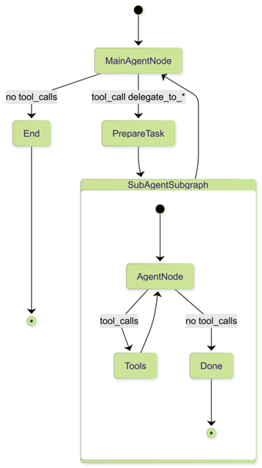
9. Testability Notes
• Unit-test route functions with deterministic `MessagesAnnotation.State` fixtures.
• Integration-test transition loops using stub tools that emit one tool call then terminate.
• Contract-test that compiled graph returns `streamEvents` sequence containing both tool and model events.

3.1.6 Runtime Graph Cache & Configuration Version Key
HLD Mapping: Section 4 – Subsystem services (`getOrCreateRuntimeGraph`) + Section 5 – Glossary (Configuration Version Key) -> runtime graph cache in `BaseAgent`, `MainAgent`, `configResolver`
"Cache key derived from runtime LLM config + secrets to reuse or rebuild agent graphs safely"
Evidence:
• HLD Reference: `High-Level_Design_Report.docx`, Section `4` (Subsystem services), `getOrCreateRuntimeGraph`; Section `5` (Glossary), Term `Configuration Version Key`
• `lib/agents/baseAgent.ts`
Class: `BaseAgent`
Method: `getOrCreateRuntimeGraph()`
Lines: `~198-222`
• `lib/agents/baseAgent.ts`
Class: `BaseAgent`
Method: `createRuntimeGraph()`
Lines: `~231-289`
• `lib/agents/configResolver.ts`
Function: `computeConfigVersion()`
Lines: `~14-28`
• `lib/agents/mainAgent/mainAgent.ts`
Class: `MainAgent`
Method: `getOrCreateOrchestratorGraph()`
Lines: `~145-159`

HLD Item | Code Artifact (file:line or path) | LLD Element
Configuration Version Key | `lib/agents/configResolver.ts:14-28` | Deterministic hash for runtime cache keying
Runtime graph caching | `lib/agents/baseAgent.ts:198-222` | Reuse/rebuild sub-agent runtime graph
Main orchestration cache | `lib/agents/mainAgent/mainAgent.ts:145-159` | Reuse/rebuild orchestrator graph
1. Purpose & Responsibilities
• Avoid unnecessary runtime graph rebuilds when effective runtime configuration is unchanged.
• Invalidate cache when `_configVersion` and secret key-set markers change.
• Ensure MainAgent cache version includes aggregated sub-agent config changes.

2. Public Interfaces
Method | Purpose | Inputs | Outputs | Errors
`getOrCreateRuntimeGraph(runtimeConfig?, runtimeSecrets?): Runnable` (`BaseAgent`) | Return cached or newly created runtime graph | Runtime config and secrets | `Runnable` graph | None
`createRuntimeGraph(runtimeConfig?, runtimeSecrets?): Runnable` (`BaseAgent`) | Build fresh runtime graph | Runtime config and secrets | New `Runnable` | Runtime node catches provider failures
`recomputeConfigVersion(llmConfig, secrets): string` | Compute cache version hash for merged config | Config + secrets map | 12-char SHA-256 prefix | None
`private getOrCreateOrchestratorGraph(runtimeConfig?): Runnable` (`MainAgent`) | Cache-aware orchestrator graph retrieval | Main runtime config | `Runnable` graph | None
3. Inputs / Outputs
Version inputs:
• `_configVersion` from resolved config (`lib/agents/configResolver.ts:220`)
• secret key set and hasSecrets marker in hash input (`lib/agents/configResolver.ts:23-26`)
MainAgent runtime assembly:
• `subAgentConfigs` collected from all resolved configs (`app/(chat)/api/chat/route.ts:355-372`)
• merged `runtimeSecrets` from all agent configs (`app/(chat)/api/chat/route.ts:359-360`)
BaseAgent local cache key format:
• ``${runtimeConfig?._configVersion 'default'}-${secretKeys}`` (`lib/agents/baseAgent.ts:209`)
4. State & Data Structures
Cache state:
• `lastConfigVersion: string null` (`lib/agents/baseAgent.ts:24`)
• `runtimeSecrets?: Record<string, string>` (`lib/agents/baseAgent.ts:21`)
Config carrier:
• `LLMImplMetadata._configVersion?: string` (`lib/types.ts:166`)
• `LLMImplMetadata.subAgentConfigs?: Record<string, Partial<LLMImplMetadata>>` (`lib/types.ts:165`)
5. Main Flows
1. API resolves user config/secrets (`resolveAgentConfig` / `resolveAllAgentConfigs`).
2. API recomputes MainAgent `_configVersion` after adding `subAgentConfigs`
3. `run` calls cache-aware graph getter:
• `MainAgent.getOrCreateOrchestratorGraph`
• delegated `BaseAgent.getOrCreateRuntimeGraph` for subgraphs (`lib/agents/mainAgent/mainAgent.ts:216`).
4. If version changed: recreate runtime graph and update `lastConfigVersion`.
5. If unchanged: reuse existing compiled graph.
6. Edge Cases & Error Handling
Case | Behavior in Code | Evidence | Status
Timeout | No timeout for cache build/reuse path | `lib/agents/baseAgent.ts:198-222`, `lib/agents/mainAgent/mainAgent.ts:145-159` | N/A (not applicable: cache accessor path is not the execution timeout boundary)
Invalid input | Empty/no runtime config falls back to existing graph | `lib/agents/baseAgent.ts:203-221`, `lib/agents/mainAgent/mainAgent.ts:148-158` | Implemented
Tool failure | Cache layer does not handle tool failure; handled during execution stream | `lib/agents/baseAgent.ts`, `lib/agents/mainAgent/mainAgent.ts` | N/A (not applicable: tool execution lifecycle is outside cache scope)
Provider failure | Runtime graph node catches provider invocation errors | `lib/agents/baseAgent.ts:275-279`, `lib/agents/mainAgent/mainAgent.ts:191-195` | Implemented
Partial success | Mixed-mode execution possible: reused orchestrator with per-subagent runtime graph refresh | `lib/agents/mainAgent/mainAgent.ts:210-217` | Implemented
Cancellation / Disconnect | No cache-level cancellation behavior | `lib/agents/baseAgent.ts:198-289` | N/A (not applicable: cancellation policy belongs to run/stream lifecycle layer)
7. Dependencies
• Depends on `crypto.createHash` in config resolver.
• Depends on DB-resolved agent configs via `resolveAgentConfig` / `resolveAllAgentConfigs`.
• MainAgent depends on sub-agent `instance.getOrCreateRuntimeGraph(...)`.
8. Diagrams
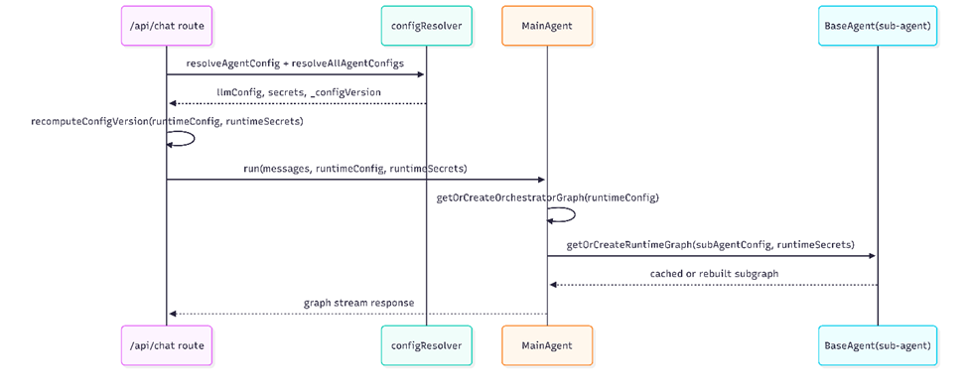
9. Testability Notes
• Unit-test `computeConfigVersion` deterministic output for stable input ordering.
• Unit-test BaseAgent cache hit/miss by toggling `_configVersion` and secret key sets.
• Integration-test MainAgent cache invalidation when any sub-agent config changes.

3.1.7 Streaming Lifecycle (Agent-side Events)
HLD Mapping: Section 4 – Subsystem services (Logging & Monitoring Service / Event Streaming) -> NDJSON lifecycle emission and execution trace assembly
"Event Streaming: Streams structured events (AGENT_STARTED, TOOL_STARTED, AGENT_ERROR) to the client for real-time feedback."
Evidence:
• HLD Reference: `High-Level_Design_Report.docx`, Section `4` (Subsystem services), `Logging & Monitoring Service` -> `Event Streaming`
• `lib/agents/baseAgent.ts`
Class: `BaseAgent`
Method: `run()`
Lines: `~298-434` (NDJSON enqueue at `~324-326`)
• `lib/agents/mainAgent/mainAgent.ts`
Class: `MainAgent`
Method: `run()`
Lines: `~227-349` (NDJSON enqueue at `~249-253`)
• `app/(chat)/api/chat/route.ts`
Function: `POST(request: Request)`
Method focus: event parsing + `ExecutionStep[]` persistence
Lines: `~94-601` (trace assembly at `~425-537`)
• `lib/types.ts`
Type: `AgentStreamEvent`
Lines: `~185-192`
HLD Item | Code Artifact (file:line or path) | LLD Element
NDJSON agent events | `lib/agents/baseAgent.ts:331-398` | Agent/tool/model event emission
Tracing and persistence | `app/(chat)/api/chat/route.ts:391-562` | Runtime event-to-execution-tree transform
Monitoring-ready event model | `lib/types.ts:197-207` | ExecutionStep hierarchy data model
1. Purpose & Responsibilities
• Emit agent lifecycle and model/tool events in stream-first format.
• Preserve stream payloads for frontend incremental rendering and trace persistence.
• Build hierarchical execution trace (`ExecutionStep[]`) from stream event order.
2. Public Interfaces
Method | Purpose | Inputs | Outputs | Errors
`run(...): Promise<Response>` (`BaseAgent`) | Emit NDJSON event stream | Messages/config/secrets | `Response` stream with event lines | Emits `agent_error` on stream-loop exceptions
`run(...): Promise<Response>` (`MainAgent`) | Emit orchestrator + delegated event stream | Messages/config/secrets | `Response` stream with event lines | Emits `agent_error` on stream-loop exceptions
`AgentStreamEvent` type | Consumer contract for event parser | `type`, `payload{name,content,id}` | Typed event object | N/A
3. Inputs / Outputs
Event input source: `graphToUse.streamEvents(...)` from LangGraph runtime.
Agent-side output event types:
• `agent_started`, `agent_stream`, `tool_started`, `tool_ended`, `agent_error`, `agent_ended`.
Persistence transformation in API route:
• Active stack: `activeAgentStack: string[]` (`app/(chat)/api/chat/route.ts:390`)
• Node index: `nodeMap: Map<string, ExecutionStep>` (`:391`)
• Root trace: `rootSteps: ExecutionStep[]` (`:392`)
Persisted assistant message parts:
• `data-agent-execution`
• `data-generated-image` (if present)
• final `text` content (`app/(chat)/api/chat/route.ts:532-550`)
4. State & Data Structures
Stream event schema: `AgentStreamEvent` (`lib/types.ts:185-192`)
Trace node schema: `ExecutionStep` (`lib/types.ts:197-207`)
• Lifecycle constants mapping (`lib/constants.ts:38-48`)
5. Main Flows
1. Agent `run` starts and emits `agent_started`.
2. During graph execution:
• tool start/end events are emitted with run ids.
• model stream events are emitted as `agent_stream` chunks.
3. API route passthrough forwards raw chunk to client and concurrently parses each NDJSON line.
4. API route updates execution tree (`running` -> `completed`) and accumulates text output.
5. On stream completion, API route stores execution tree + final text as assistant message parts.
6. Edge Cases & Error Handling
Case | Behavior in Code | Evidence | Status
Timeout | No explicit stream timeout branch in agent run loops | `lib/agents/baseAgent.ts:330-425`, `lib/agents/mainAgent/mainAgent.ts:255-343` | TODO (no explicit implementation observed in current codebase)
Invalid input | Non-JSON lines in API parser are ignored (`catch {}`) | `app/(chat)/api/chat/route.ts:523-525` | Implemented
Tool failure | Error converted to `agent_error` and mapped to active trace node error state | `lib/agents/baseAgent.ts:404-411`, `app/(chat)/api/chat/route.ts:501-509` | Implemented
Provider failure | Node-level error messages propagate via stream content and/or `agent_error` | `lib/agents/baseAgent.ts:137-143`, `:401-412` | Implemented
Partial success | Existing chunks/trace nodes are retained even if later lines fail parse | `app/(chat)/api/chat/route.ts:414-527` | Implemented
Cancellation / Disconnect | Client-side abort exists; server-side explicit agent cancellation path is not implemented | `components/chat.tsx:218-230`, `:428-443`; no corresponding cancel branch in agent runs | TODO (server-side agent cancellation path is not implemented in current codebase)

7. Dependencies
• Agent-side stream depends on LangGraph event stream API (`streamEvents`).
• API route parser depends on constants from `lib/constants.ts` and DTOs in `lib/types.ts`.
• UI consumer depends on `AgentStreamEvent` contract (`components/chat.tsx:265`).

8. Diagrams
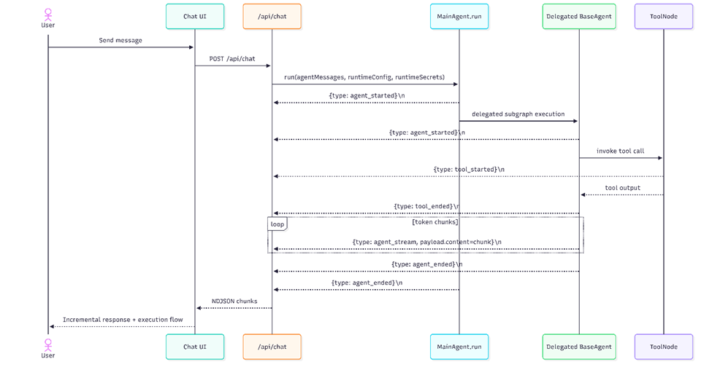
9. Testability Notes
• Unit-test NDJSON parser with split/malformed chunk boundaries.
• Integration-test that every started step eventually ends (`running -> completed/error`).
• Contract-test `AgentStreamEvent` payload fields against emitted lines.

3.1.8 Error Handling & Retry Policy
HLD Mapping: Section 3.6 – Global software control (Error Handling & Recovery) -> catch boundaries in MainAgent/BaseAgent/API route
"If a sub-agent fails or an API times out, the MainAgent catches the exception, logs the trace, and attempts a graceful fallback or informs the user without crashing the entire session."
Evidence:
• HLD Reference: `High-Level_Design_Report.docx`, Section `3.6` (Global software control), subsection `Error Handling & Recovery`
• `lib/agents/baseAgent.ts`
Class: `BaseAgent`
Method: `agentNode()`
Lines: `~106-143`
• `lib/agents/baseAgent.ts`
Class: `BaseAgent`
Method: `run()`
Lines: `~298-434` (error branch at `~401-412`)
• `lib/agents/mainAgent/mainAgent.ts`
Class: `MainAgent`
Method: `agentNode()`
Lines: `~101-116`
• `lib/agents/mainAgent/mainAgent.ts`
Class: `MainAgent`
Method: `run()`
Lines: `~227-349` (error branch at `~328-335`)
• `app/(chat)/api/chat/route.ts`
Function: `POST(request: Request)`
Method focus: top-level API error handling
Lines: `~581-600`
HLD Item | Code Artifact (file:line or path) | LLD Element
Error Handling & Recovery | `lib/agents/mainAgent/mainAgent.ts:328-341` | Orchestrator stream error boundary + guaranteed end event
Global error boundaries | `app/(chat)/api/chat/route.ts:581-600` | API-level catch and user-facing error response
Agent runtime recovery | `lib/agents/baseAgent.ts:126-143` | Empty-response fallback and provider exception conversion
1. Purpose & Responsibilities
• Prevent orchestration crash on provider/tool failures.
• Convert runtime exceptions into structured stream events or user-visible error responses.
• Guarantee stream finalization (`agent_ended`) even on stream-loop exceptions.
• Define current retry posture for orchestration core.
2. Public Interfaces
Method | Purpose | Inputs | Outputs | Errors
`protected async agentNode(state)` (`BaseAgent`) | LLM invocation + fallback conversion | State messages | `{ messages: [AIMessage | response] }` | Returns `AIMessage("Error: ...")` on catch
`protected async agentNode(state)` (`MainAgent`) | Orchestrator model invocation | State messages | `{ messages: [AIMessage | response] }` | Returns `AIMessage("Error: ...")` on catch
`run(...)` stream catch (`BaseAgent`/`MainAgent`) | Convert stream-loop exception to event | Runtime exception | `agent_error` event + final `agent_ended` | No rethrow after catch
`ChatSDKError.toResponse()` | API-surface error serialization | Error code/type | JSON HTTP error response | Maps type to status code
3. Inputs / Outputs
Error input channels:
• Provider/runtime invocation exceptions.
• Stream iteration exceptions.
• API request validation/auth/DB errors.
Error outputs:
• Stream event: `{ type: "agent_error", payload: { name, content, id } }`
• API error response JSON via `ChatSDKError` (`lib/errors.ts:55-75`)
4. State & Data Structures
Error constants: `AGENT_ERROR` (`lib/constants.ts:41`)
Error response model:
• `ErrorCode = \\`${ErrorType}:${Surface}\\`` (`lib/errors.ts:21`)
• `ChatSDKError` with `type`, `surface`, `statusCode` (`lib/errors.ts:38-53`)
Trace error state:
• `ExecutionStep.status = "error"` set when `agent_error` received (`app/(chat)/api/chat/route.ts:501-509`)
5. Main Flows
1. `agentNode` invokes model.
2. If response is empty and no tool calls, fallback assistant message is returned.
3. If response is valid, graph continues or ends.
4. Stream emits lifecycle and closes normally.
6. Edge Cases & Error Handling
Case | Behavior in Code | Evidence | Status
Timeout | No explicit orchestrator timeout/retry loop in MainAgent/BaseAgent core | `lib/agents/mainAgent/mainAgent.ts`, `lib/agents/baseAgent.ts` | TODO (no explicit implementation observed in current codebase)
Invalid input | API request validation errors return `bad_request:api` | `app/(chat)/api/chat/route.ts:97-102`, `app/(chat)/api/chat/schema.ts:17-37` | Implemented
Tool failure | Stream-loop catches and emits `agent_error`; traces mark active node error | `lib/agents/baseAgent.ts:401-412`, `app/(chat)/api/chat/route.ts:501-509` | Implemented
Provider failure | Provider invocation errors converted to AI error message in node methods | `lib/agents/baseAgent.ts:137-143`, `lib/agents/mainAgent/mainAgent.ts:111-115` | Implemented
Partial success | `finally` emits `agent_ended` even after catch, preserving prior output chunks | `lib/agents/mainAgent/mainAgent.ts:336-341`, `lib/agents/baseAgent.ts:413-424` | Implemented
Cancellation / Disconnect | Client abort exists (`AbortController`) but no explicit server retry/recovery policy in orchestration core | `components/chat.tsx:218-230`, `:428-443`; no retry loop in `MainAgent.run`/`BaseAgent.run` | TODO (server-side cancellation/recovery policy is not implemented in current codebase)

Retry Policy (orchestration core):
• Automatic retry loop for MainAgent/BaseAgent runtime invocation is not implemented.
• `TODO (no explicit implementation observed in current codebase)`: explicit retry/backoff policy for orchestrator runtime.

7. Dependencies
• Depends on `createLLM` provider factory for error sources.
• Depends on LangGraph stream event iteration for error emission boundary.
• Depends on `ChatSDKError` for API response translation.

8. Diagrams
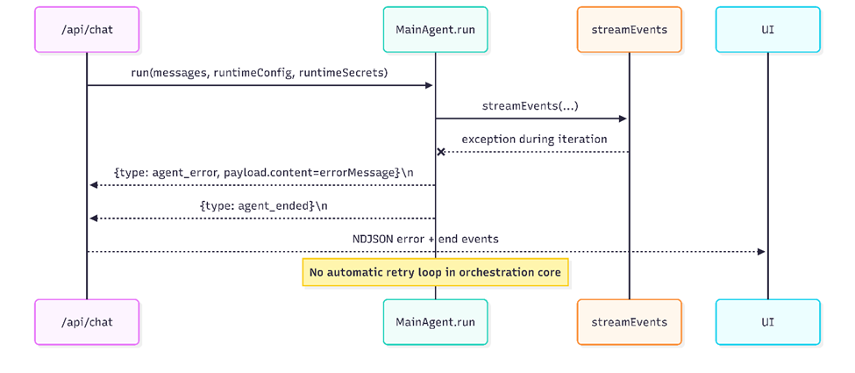
9. Testability Notes
• Unit-test provider exception path in `agentNode` for both BaseAgent and MainAgent.
• Unit-test stream-loop exception path verifies `agent_error` then `agent_ended` emission order.
• Integration-test API error mapping for malformed requests and unauthorized access.
• Retry policy tests: `TODO` until explicit retry/backoff implementation exists in orchestration core.

3.2 Provider and Data Layer
The Provider & Data Layer serves as the foundational infrastructure that enables the multi-agent framework to interact with large language models, execute tools, persist application state, store generated artifacts, and perform semantic retrieval operations. This layer abstracts away the differences between cloud-based LLM APIs, local inference engines, and various storage backends, while providing secure, performant, and type-safe access to data.
It consists of several tightly coordinated subsystems located primarily in lib/ai/, lib/agents/, lib/db/, artifacts/, and supporting utilities in lib/ and services/. The design emphasizes:
- Provider neutrality via factory and configuration patterns
- Secure handling of credentials and secrets
- Flexible artifact persistence (database + cloud object storage)
- Robust error handling across external dependencies
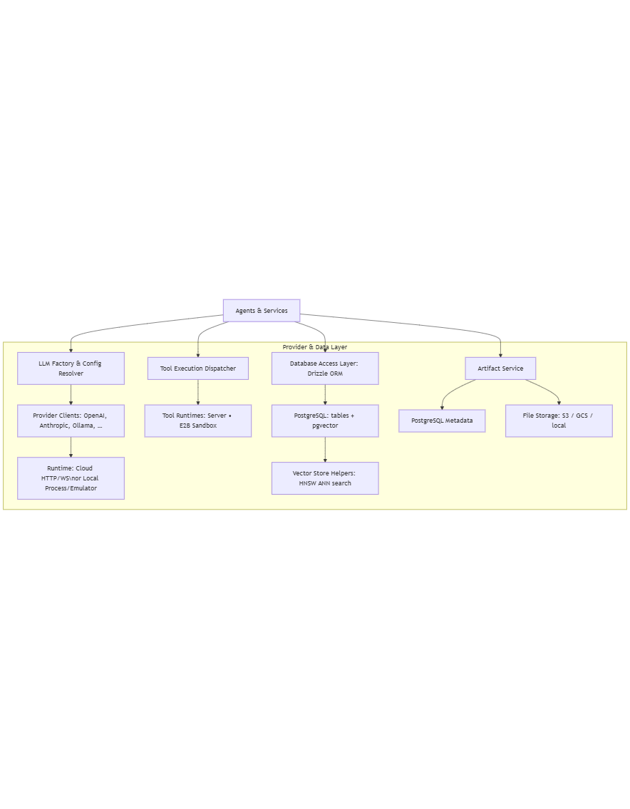
The following stack diagram illustrates the layered relationships within the Provider & Data Layer:

3.2.1 LLM Factory and Provider Selection
Location: lib/agents/llmFactory.ts + lib/ai/providers.ts + lib/ai/models.ts
The LLMFactory implements the factory pattern to create LLM instances in a provider-agnostic way. It resolves the actual provider and model based on resolved configuration and instantiates the appropriate wrapper.
- llmFactory.ts: LLMFactory returns LangChain-compatible LLM wrapper or custom streaming wrapper, getProvider returns initialized provider instance from cache or creates new
class LLMFactory {
static createLLM(config: ResolvedLLMConfig): LLMInstance {}
static getProvider(providerName: string): LLMProvider {}
…}
- providers.ts:
interface LLMProvider {
name: string;
createChatModel(config: ModelConfig): ChatModel;
createEmbeddingModel(config: EmbeddingConfig): EmbeddingModel;
getAvailableModels(): ModelMetadata[];
validateApiKey(key: string): Promise;
}
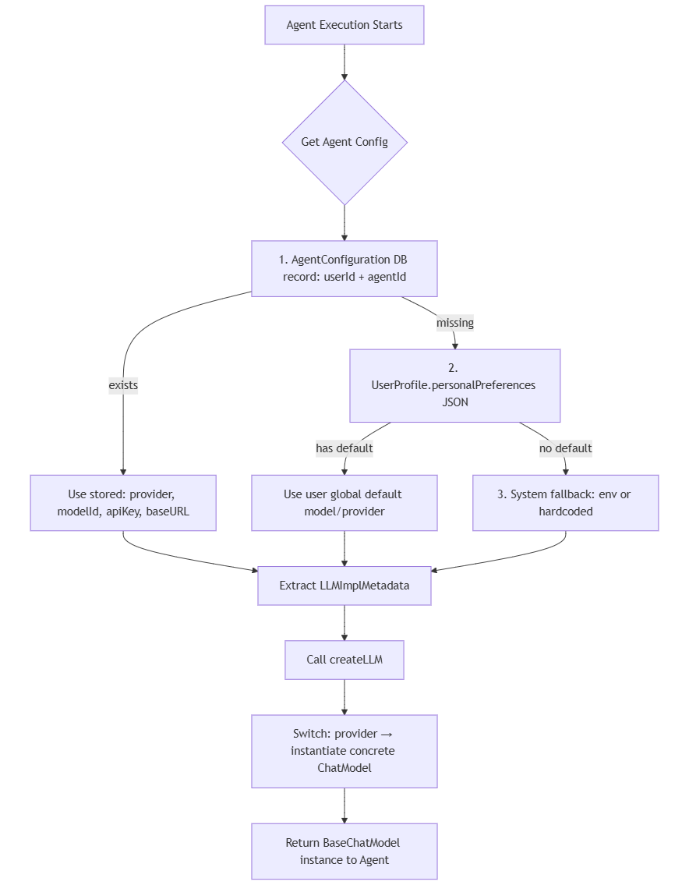
Selection process (typical flow):
- configResolver.ts → agentConfig.ts → user’s AgentConfiguration row (or fallback to defaults)
- deploymentType determines branch: "cloud" or "self-hosted"
- provider string is looked up in internal registry (providers.ts)
- LLMFactory.getProvider(provider) returns cached or fresh instance
- createChatModel() receives final merged model parameters (modelId, temperature, maxTokens, etc.)
- Returns LangChain ChatOpenAI, ChatAnthropic, ChatGoogleGenerativeAI, custom OllamaChat, etc.

Supported Providers
The factory supports the following provider categories (from providers.ts):
- OpenAI → ChatOpenAI
- Anthropic → ChatAnthropic
- Google → ChatGoogleGenerativeAI
- Groq → custom Groq wrapper (uses OpenAI-compatible endpoint)
- Mistral AI → custom Mistral wrapper
- HuggingFace → HuggingFaceInference or HuggingFaceHub
- Ollama → custom local Ollama client (http://localhost:11434 or ngrok tunnel)
- XAI (Grok) → custom Grok API client

3.2.2 Provider Configuration & Override Merge
Location: lib/agents/configResolver.ts + lib/agents/agentConfig.ts
Configuration follows a multi-level override chain:
- Hardcoded framework defaults (constants.ts)
- .env.example / .env.local environment variables
- Database row: AgentConfiguration table
- Runtime request context (e.g., temporary model switch from UI)
Core types:
- interface LLMImplMetadata {
deploymentType: 'cloud' 'self-hosted';
provider: SupportedProvider;
modelId: string;
temperature?: number;
maxTokens?: number;
topP?: number;
apiKey?: string; // encrypted in DB
baseUrl?: string; // for Ollama / self-hosted
}
- interface ResolvedLLMConfig extends LLMImplMetadata {
effectiveApiKey: string;
endpoint?: string;
headers?: Record;
}
Merge logic is applied in resolveFullConfig(userConfig, requestOverride, defaults)

3.2.3 Local vs Cloud Execution
The execution mode is controlled by a single database flag: deploymentType stored per-user, per-agent in the AgentConfiguration table.
The controlling field is declared in the database schema:
- Table: AgentConfiguration
- Column: deploymentType — varchar(16) with valid values "cloud" or "self-hosted"
- Default value (set in migration): "cloud"
- Not nullable
API validation enforces the enum during configuration updates:
- Signature (route handler): validateDeploymentType(deploymentType: string): void
- Throws ChatSDKError("bad_request:api", "...") if value is invalid
Configuration Resolution Logic
The decision is made during configuration merging in the resolver function processAgentConfiguration(userConfig: AgentConfiguration null): ResolvedAgentConfig
If deploymentType is "self-hosted", the configuration resolver forces the LLM provider to "ollama", sets the baseURL to the user-provided endpoint (required), uses the specified modelId, and clears any apiKey (not needed for local Ollama servers).
Otherwise (including the default "cloud" value), it selects the user’s chosen provider (or falls back to a global default), loads the corresponding modelId (with provider-specific default if missing), decrypts the stored apiKey or reads it from environment variables, and leaves baseURL unset.
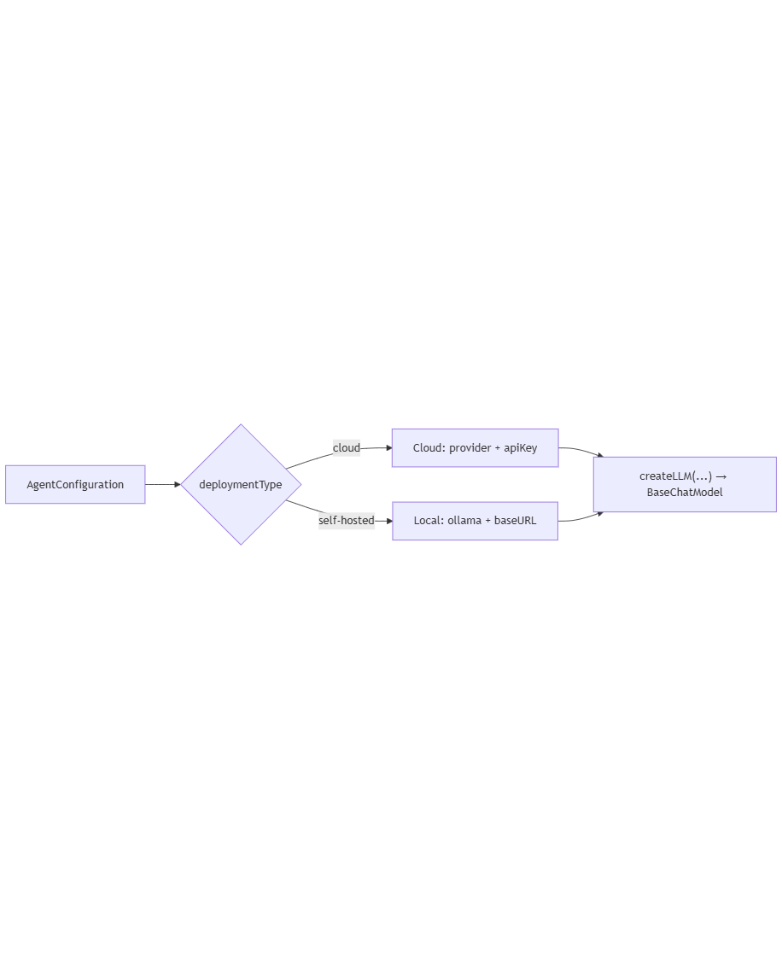
This simple conditional branch in the resolver produces a ResolvedAgentConfig object that the LLM factory then uses to instantiate the correct model client.

LLM Instantiation (Factory Branching)
- Signature: createLLM(config: ResolvedLLMConfig): BaseChatModel
The factory uses a switch/case on config.provider:
- Cloud path (default / most common)
  - Provider values: "openai", "google", "anthropic", "groq", "mistral", "huggingface", "xai", etc.
  - Instantiates LangChain wrappers: ChatOpenAI, ChatGoogleGenerativeAI, ChatAnthropic, etc.
  - Uses decrypted apiKey (or falls back to process.env.<PROVIDER>_API_KEY)
  - Makes direct HTTPS requests via official SDKs
  - Streaming is native (.stream() or token-by-token callbacks)
- Self-hosted path
  - Forced provider: "ollama"
  - Instantiates ChatOllama (custom or LangChain community wrapper)
  - Requires baseURL (e.g., http://localhost:11434 or ngrok tunnel)
  - No API key required (plain HTTP POST to /api/chat)
  - Must be pre-started via Ollama CLI/service
  - Implements same streaming interface → transparent to agent graph
Aspect | Cloud Execution | Local (Ollama) Execution
Latency | Network + provider queue | Local only (usually faster)
Cost | Per-token | Zero (after model download)
Privacy | Data leaves infrastructure | Stays on device/server
Model availability | Provider catalog | Must be manually pulled
Streaming | Native | Supported via SSE-like endpoint
Configuration field | apiKey (encrypted) | baseUrl (no key needed usually)
Error Handling & Diagnostics
- Cloud errors
  - Invalid/missing key → SDK throws → wrapped as ChatSDKError("external_api", ...)
  - Rate limit (429) → retry logic in agent or bubble up as rate_limited event
- Self-hosted errors
  - Connection refused / timeout → ChatOllama constructor or request fails
  - No explicit fallback in current code → error bubbles to AGENT_ERROR event
  - Logged in stream loop: [AgentName] CRITICAL ERROR inside stream loop: ...

3.2.4 Tool Execution Runtime
Location: lib/ai/tools/ + LangChain/LangGraph integration in agents
Agents expose structured tools to the LLM, which decides whether (and which) tools to invoke. Tool calls are validated, executed, and their results returned as observation messages, allowing the agent to continue multi-step reasoning. The entire process is streaming-aware: tool start/end events and intermediate LLM tokens are pushed to the client in real time.
Key files and their roles:
Component | File / Location | Main Responsibility
Tool definitions (per agent) | lib/agents/*/tools.ts (e.g. codebaseAgent/tools.ts) | DynamicStructuredTool instances with name, Zod schema, func implementation
Tool aggregation | lib/agents/*/tools.ts (e.g. codingAgent/tools.ts) | Composite functions like createCodebaseAgentTools(), createCodingAgentTools()
LLM + tools binding | lib/agents/baseAgent.ts | llm.bindTools(this.agentTools) in constructor + runtime re-bind
Graph construction | lib/agents/baseAgent.ts → createRuntimeGraph() | Builds LangGraph with agentNode, toolsNode = ToolNode(runtimeTools)
Routing logic | lib/agents/baseAgent.ts → agentRoute() | Inspects AI message for tool_calls → routes to "tools" or "__end__"
Tool execution & events | LangGraph ToolNode + custom event handlers | Validates args, runs tool.func, emits TOOL_STARTED_EVENT / TOOL_ENDED_EVENT
Streaming loop | lib/agents/baseAgent.ts → run() method | Streams LLM tokens + tool events (JSON payloads) to client
Runtime secrets injection | getOrCreateRuntimeGraph(secrets) | Passes user secrets → createTools(secrets) for authenticated tool instances
Core Process Steps
- Tool Creation & Binding:
Each agent implements createTools(secrets?: Record<string, string>) returning an array of DynamicStructuredTool.
Tools are bound to the LLM via .bindTools() — injecting JSON schemas into the model prompt / function-calling layer.
- Graph Execution
createRuntimeGraph() builds a LangGraph with:
  - agentNode: invokes bound LLM
  - toolsNode: ToolNode(runtimeTools) — dispatches validated calls
  - Conditional routing via agentRoute()
- Tool Invocation Cycle
LLM → emits tool_calls array → graph routes to tools node → each call is validated/executed → output becomes ToolMessage (observation) → back to agent node.
- Streaming & Client Feedback
The run() loop emits:
  - LLM token chunks
  - TOOL_STARTED_EVENT (tool name, input, run_id)
  - TOOL_ENDED_EVENT (output or error, run_id) Client renders live progress (e.g., “Executing code search…”, then result).
Tool Execution and Streaming Flow
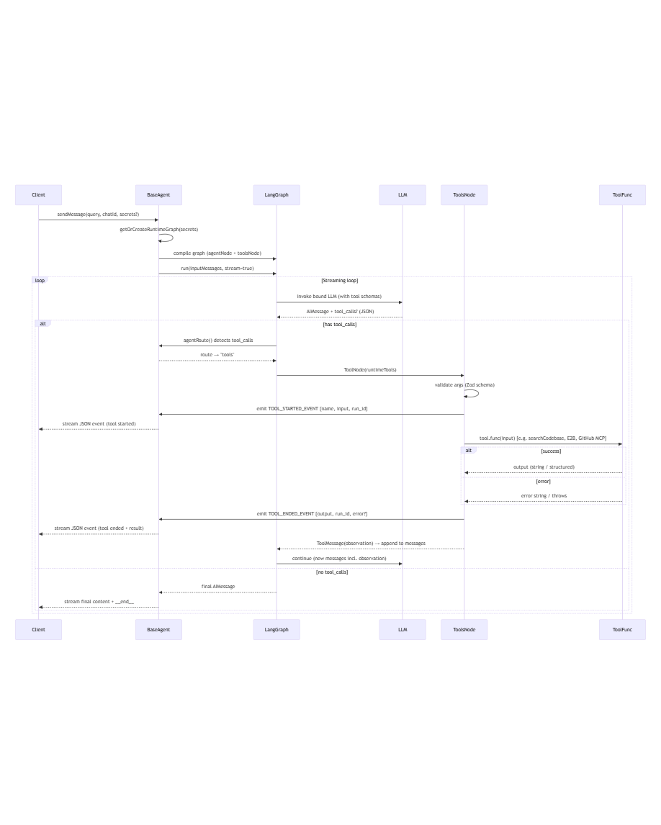

3.2.5 Database Access Layer (Drizzle / ORM)
Location: lib/db/schema.ts + lib/db/queries.ts + lib/db/pool.ts
The Database Access Layer centralizes all database interactions, enforces consistency, and abstracts low-level connection management, query building, transaction handling, migrations, and error mapping. The layer is built on Drizzle ORM.
Core Responsibilities
- Connection pooling and serverless compatibility
- Strongly-typed schema definitions and auto-generated TypeScript models
- Centralized CRUD operations and domain-specific query helpers
- Transaction management for atomic multi-step operations
- Schema migrations and evolution
- Vector column support (pgvector) for RAG embeddings
- Consistent error wrapping and visibility control
- Performance tuning via strategic indexing and batch operations
Key files and their roles:
File / Directory | Purpose | Main Exports / Content
lib/db/pool.ts | Initializes Neon serverless connection pool with WebSocket support | pool (Neon Pool instance), neonConfig.webSocketConstructor = ws
lib/db/queries.ts | Primary query interface — exports all domain-specific functions using Drizzle client | db, saveDocument, getMessagesByChatId, createChatWithMessage, searchCodebaseEmbeddings, etc.
lib/db/schema.ts | Defines all tables, columns, constraints, indexes, and relationships using pgTable | user, chat, message_v2, document, agentConfiguration, codebaseEmbedding, etc.
lib/db/migrate.ts + lib/db/migrations/ | Migration runner and generated SQL migration files | Drizzle Kit migration application logic
lib/db/utils.ts | Helper utilities (UUID generation, password hashing bridge, etc.) | generateUUID, DB-specific formatting helpers
lib/errors.ts | Centralized error class used to wrap DB failures | ChatSDKError with type-safe codes
Data Base Access Layer Architecture:
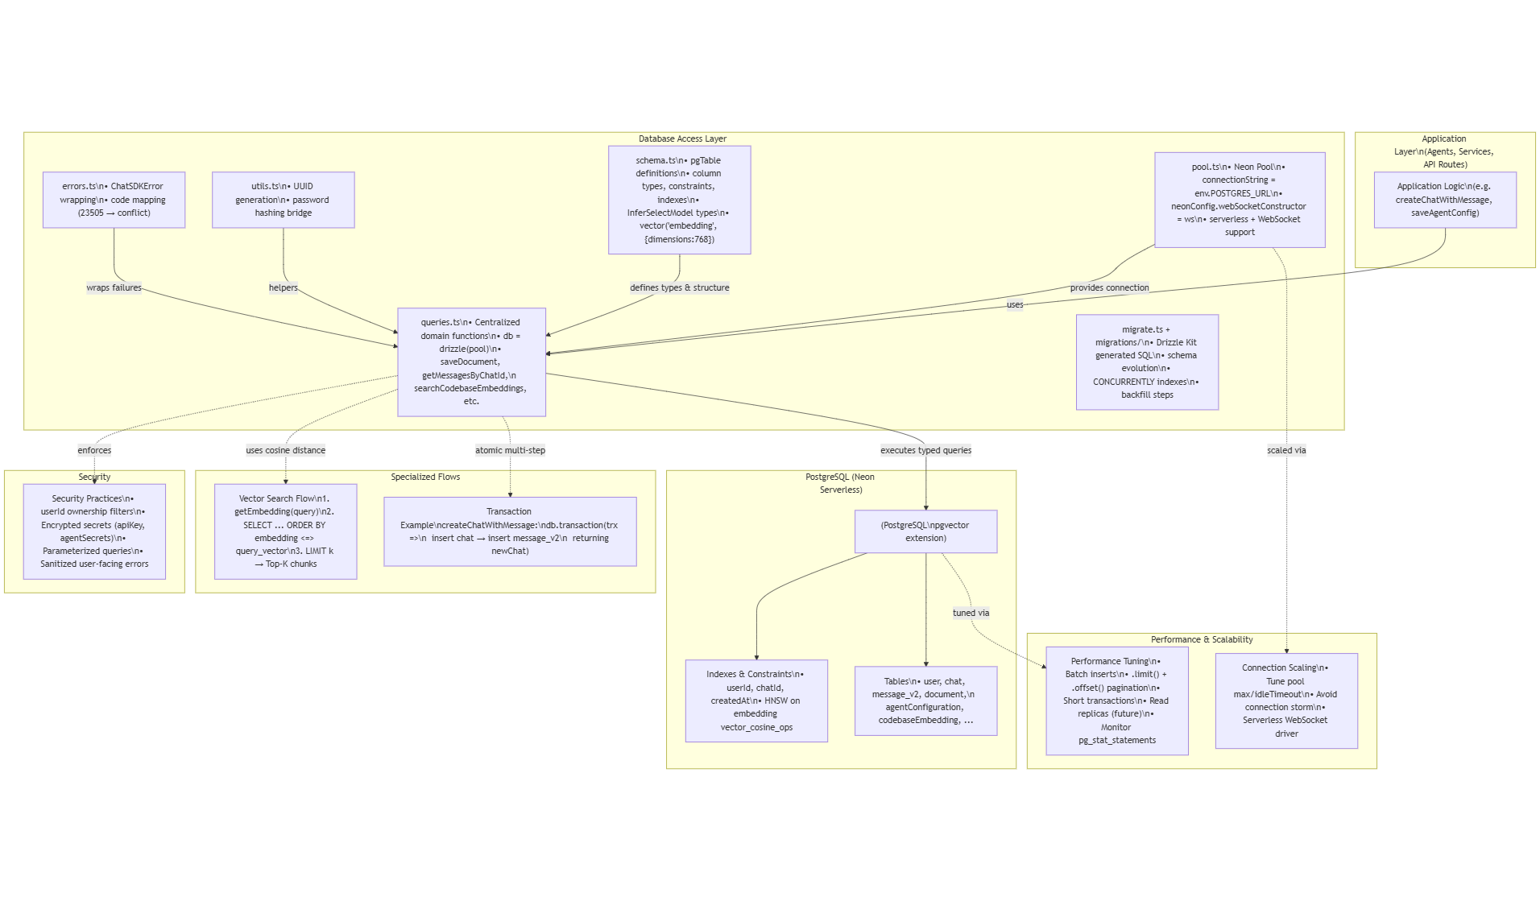

3.2.6 Vector Store Integration (pgvector / HNSW)
Location: lib/db/schema.ts (CodebaseEmbedding table) + queries.ts
Vector storage holds numeric embeddings that represent text/code semantics for fast nearest-neighbor search. Embeddings are generated, stored in PostgreSQL using the pgvector column type, and run similarity queries (RAG) to ground model responses.
- Embedding client and dims:
Embedding generation is made at lib/agents/codebaseAgent/embeddings.ts (Google embeddings client, batch helpers). embeddings.ts uses Google text-embedding-004 and sets EMBEDDING_DIMENSIONS = 768. It lazily initializes a GoogleEmbeddings client and exposes getEmbedding and getEmbeddingsBatched.
- Storage schema: schema.ts defines a CodebaseEmbedding (CodebaseEmbedding or similar) row with embedding: vector(..., { dimensions: 768 }) — that maps to PostgreSQL pgvector.
- Search query: Vector search implementation is made at lib/agents/codebaseAgent/vectorSearch.ts. vectorSearch.ts generates query embedding via getEmbedding(query), builds filters (file path prefix, chunkType), and uses drizzle-orm functions: cosineDistance(codebaseEmbedding.embedding, queryEmbedding) and orders by asc(cosineDistance(...)). Returns top-K results with distance values.
Query and Retrieval Flow
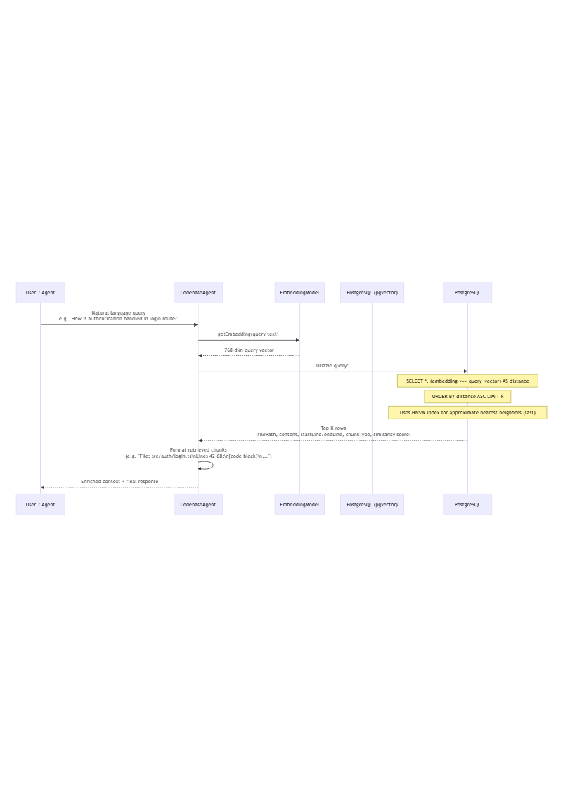
- Indexing pipeline (indexing code in codebaseAgent/indexer.ts & vectorSearch):
- Scan files → parse into chunks (functions, classes, blocks).
- Batch embed chunk texts via getEmbeddingsBatched (to avoid rate limits).
- Insert rows in CodebaseEmbedding table with embedding vector and metadata (filePath, chunkType, content, startLine/endLine).
- Query flow:
- User/agent sends natural-language query.
- getEmbedding(query) produces a 768-dim vector.
- SQL built by drizzle computes cosine distance between stored embedding vector and the query vector.
- ORDER BY asc(cosineDistance(...)) returns most similar rows; vectorSearch limits result set.
- Results are formatted and provided as context to LLM (RAG).
- RAG usage:
- Top-K snippets are formatted into the system prompt or context block, giving the LLM concrete code to reason about.

3.2.7 Artifact & File Storage
Location: artifacts/
The artifact management system is a central component of the multi-agent framework, responsible for handling, persisting, versioning, and enabling rich user interaction with outputs generated by agents. Artifacts represent tangible results beyond plain text responses — such as executable code snippets, generated images, structured data tables (sheets), or formatted documents/markdown content.
Artifacts are stored using a hybrid approach that balances performance, cost, and editability:
- Small/structured artifacts (code, text, sheets) are stored directly as text or JSON in the Document table (content column) for fast access, full-text search capability, and easy versioning.
- Large binary artifacts (especially images) are stored in cloud object storage (S3 or Google Cloud Storage) with only metadata and a reference key kept in the database.
Artifact Types and Storage Strategy
Artifact Kind | Primary Storage Location | Format in DB | Large Binary Location | Typical Size Range | Main Processing Step(s)
Code | Document.content | Plain text / Markdown | — | < 100 KB | Syntax validation, E2B sandbox execution
Image | Reference (key) in Document | JSON metadata + signed URL | S3 / GCS bucket | 100 KB – 10 MB | Compression, format conversion, thumbnail
Sheet | Document.content | JSON (array of rows/columns) | — | < 1 MB | CSV/JSON parsing, grid validation
Text/Doc | Document.content | Markdown or plain text | — | < 500 KB | Markdown rendering, sanitization
Artifact Lifecycle
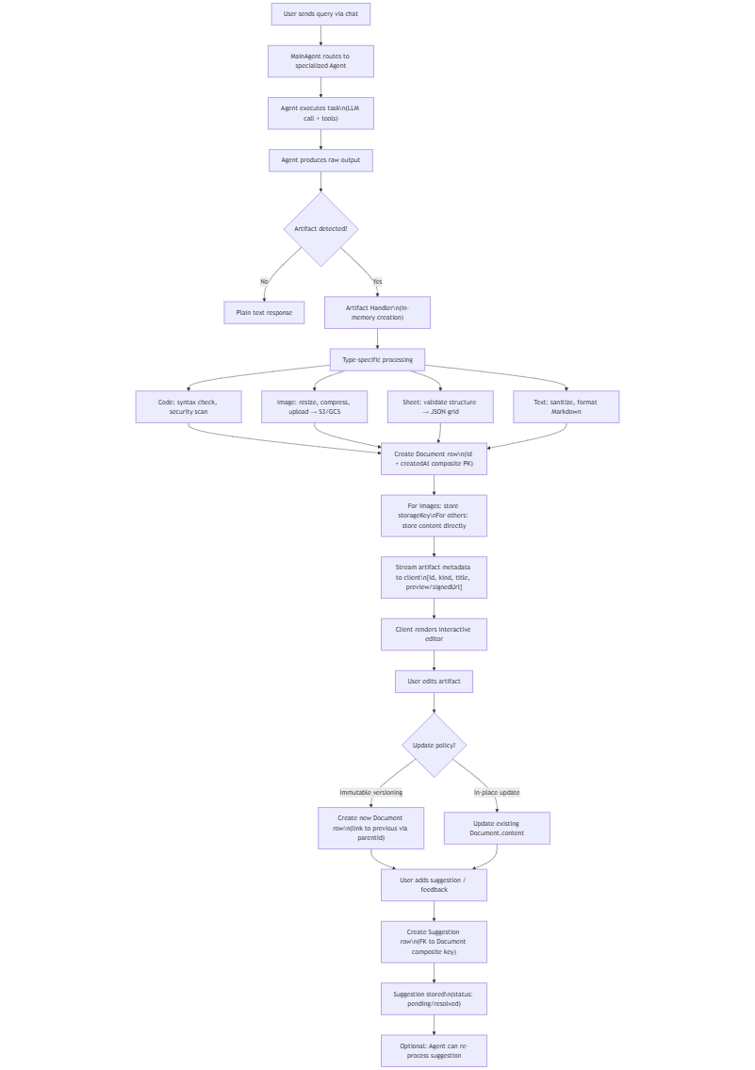
The lifecycle of an artifact follows a well-defined flow from generation to user interaction and feedback:
- Agent Generation A specialized agent (e.g., CodingAgent, VisionAgent, DataAnalystAgent) produces raw output during task execution.
- In-memory Artifact Creation & Processing The agent handler performs type-specific validation and preparation:
  - Code → syntax check (optional tree-sitter or simple parser), security scanning
  - Image → resize/compress, generate thumbnail, upload to cloud storage → get key
  - Sheet → validate structure (rows/columns), convert from agent output format to canonical JSON grid
  - Text/Doc → sanitize HTML/Markdown, apply formatting rules
- Persistence The processed artifact is saved as a new row in the Document table. For images: only metadata + storage key is stored in DB. A unique id + createdAt composite key allows immutable versioning (each edit creates a new row).
- Delivery to Client The artifact metadata (id, kind, title, preview/content snippet or signed URL) is included in the streaming response. Client renders interactive editors: Monaco for code, grid component for sheets, image viewer/editor, markdown previewer.
- User Interaction & Editing Users can edit artifacts directly in the UI. Edits trigger server actions → new Document row (preserving history) or in-place update (configurable per user/org policy).
- Feedback Loop – Suggestions Users can propose changes via the suggestion UI. Suggestions are stored in the Suggestion table (linked to Document via composite FK: documentId + documentCreatedAt). Suggestions include: original text, suggested text, description/reason, resolution status.
All mutations are implemented as server actions in artifacts/actions.ts (Next.js server actions pattern), ensuring type safety and transaction consistency.
- Server action (UI helper):
artifacts/actions.ts - getSuggestions(): server-action used by UI.
- Document handler + orchestration:
lib/artifacts/server.ts - createDocumentHandler() and documentHandlersByArtifactKind: calls handlers and persists via DB.
- Per-artifact generators (create/update):
artifacts/code/server.ts - code onCreateDocument / onUpdateDocument.
artifacts/text/server.ts - text onCreateDocument / onUpdateDocument.
artifacts/sheet/server.ts - sheet onCreateDocument / onUpdateDocument.
- AI tools that trigger handlers (used by agents/LLM):
lib/ai/tools/create-document.ts - createDocument tool: generates id, streams UI events, invokes handler.
lib/ai/tools/update-document.ts - updateDocument tool: loads doc, streams, invokes handler.
- Database persistence & suggestion functions:
lib/db/queries.ts - saveDocument, getDocumentsById, getDocumentById, deleteDocumentsByIdAfterTimestamp, saveSuggestions, getSuggestionsByDocumentId, etc.
- HTTP API endpoints:
app/(chat)/api/document/route.ts/api/document/route.ts#L1) - GET/POST/DELETE for documents.
app/(chat)/api/suggestions/route.ts/api/suggestions/route.ts#L1) - GET suggestions by documentId.

3.2.8 Provider & Data Error Handling
Unified error model: lib/errors.ts

Error Type | Typical Cause | Handling Strategy | Retry? | User Message Category
rate_limited | 429 from provider | Exponential backoff (3 attempts) | Yes | Temporary – try later
external_api | 5xx, network timeout, parsing error | Circuit breaker + fallback model/provider | Yes | Service issue
configuration | Missing/ invalid apiKey, wrong baseUrl | Return early with clear config error | No | Setup required
database | Connection failure, constraint error | Re-throw as 503, log details | Yes* | Temporary
vector_search | No embeddings or index failure | Fallback to keyword search | No | Limited results

Security, API Contracts & Monitoring
This section details the communication layer where the Multi-Agent AI Framework interacts with external clients, the security protocols ensuring data integrity, and the monitoring systems tracking performance and costs.

REST / Route Handlers
Purpose & Responsibilities
- Manages the lifecycle of chat sessions. It handles the initiation of agent-based conversations via POST requests, validates user quotas, persists messages to the database, and streams the agent's response back to the client.

Public Interfaces
- POST /api/chat: Initiates a chat session and streams the response.
- DELETE /api/chat: Deletes an existing chat session.

Inputs/Outputs
- Input (POST): JSON Body { id, message, selectedChatModel, selectedVisibilityType }.
- Output: ReadableStream (NDJSON format containing text deltas, tool events, and error details).

State & Data Structures
- ResumableStreamContext: A Redis-backed context ensuring stream continuity during network interruptions.
- RequestHints: A data structure holding geolocation data (City, Country, Lat/Long) extracted from the request headers.

Main Flows
- Validation: The request body is parsed and validated against the postRequestBodySchema.
- Authorization: The user session is verified via auth(). If invalid, a 401 Unauthorized error is returned.
- Quota Check: getMessageCountByUserId checks if the user has exceeded their daily message limit.
- Persistence: The user's message is saved to the database via saveMessages.
- Execution: The selected agent is instantiated (getAgentById) and executed. The output is piped through a passthroughStream to the client.

Edge Cases & Error Handling
- Rate Limiting: If the daily quota is exceeded, a ChatSDKError with type rate_limit:chat is thrown.
- Concurrency: If multiple requests arrive simultaneously for the same chat ID, the database transaction ensures consistency.

Dependencies
- resumable-stream (Stream management).
- tokenlens (Cost calculation).
- next-auth (Session management).

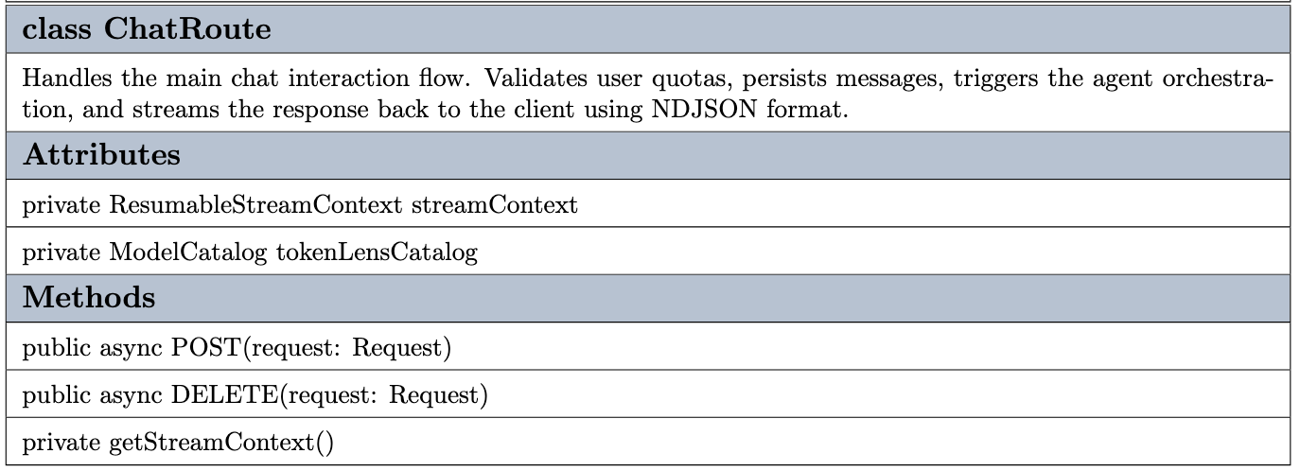

Streaming API (NDJSON)
Purpose & Responsibilities
- To improve perceived latency during long-running LLM tasks, this layer serializes agent events (thinking, tool use, generation) into a stream of Newline Delimited JSON objects.

Public Interfaces
- AgentStreamEvent: The standard data contract for all events sent over the stream.

Inputs/Outputs
- Format: NDJSON (Content-Type: application/x-ndjson).
- Event Types: AGENT_STARTED, AGENT_STREAM, TOOL_STARTED, TOOL_ENDED, AGENT_ENDED.

State & Data Structures
- Payload Structure: { type: string, payload: { id: string, content: string object, name: string } }.

Main Flows
- The agent generates a chunk of text or a tool call.
- The backend wraps this data in an AgentStreamEvent object.
- The object is JSON-stringified and appended to the response stream with a newline character.
- The client parses each line individually as it arrives.

Edge Cases & Error Handling
- Stream Interruption: If the agent fails mid-execution, an AGENT_ERROR event is pushed to the stream before closing the connection.

Dependencies
- ai SDK (Vercel).
- constants.ts.

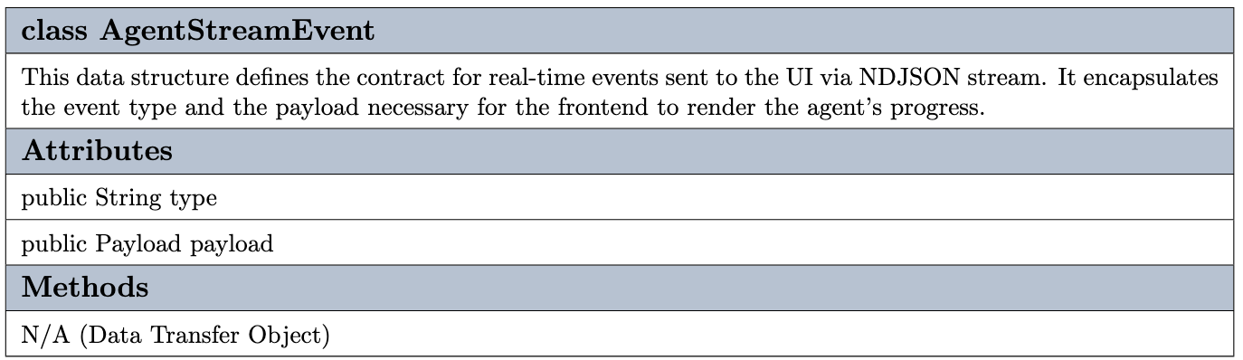
.

Request / Response DTOs
Purpose & Responsibilities
- Defines the strict data contracts (Data Transfer Objects) used for communication between the Frontend and Backend. This ensures type safety and payload validation before any processing occurs.

Public Interfaces
- ChatMessage: Represents a UI-facing message object.
- AgentChatMessage: Represents the internal message format used by the Agent Core.

Inputs/Outputs
- Input DTO: PostRequestBody validated via Zod (postRequestBodySchema).
- Output DTO: AgentStreamEvent (serialized as NDJSON).

State & Data Structures
- CustomUIDataTypes: Defines specific UI render targets like textDelta, codeDelta, and suggestion.
- Attachment: Structure for file attachments { name, url, contentType }.

Main Flows
- The API receives a raw JSON body.
- It is parsed using postRequestBodySchema.parse(json).
- The frontend ChatMessage objects are converted into AgentChatMessage objects (handling multimodal content like images).

Edge Cases & Error Handling
- Validation Failure: If the JSON structure does not match the Zod schema, a bad_request:api error is thrown immediately.
Dependencies
- zod (Schema validation).
- types.ts (Type definitions).

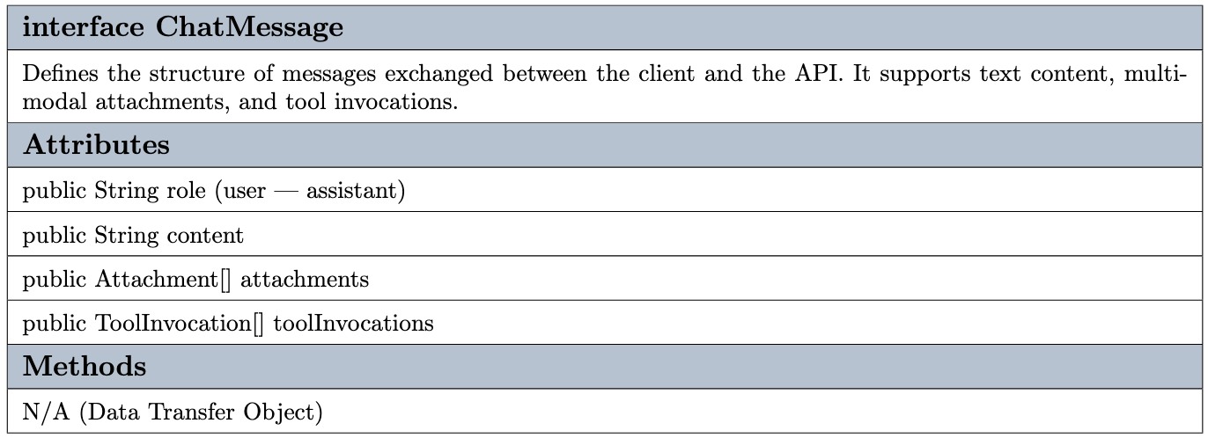

Authentication & Session Flow
Purpose & Responsibilities
- Intercepts every incoming HTTP request at the Edge Runtime level to enforce security policies, validate JWT sessions, and manage guest access.

Public Interfaces
- middleware(request): The main entry point for Next.js Edge Middleware.

Inputs/Outputs
- Input: NextRequest (specifically the Cookie header).
- Output: NextResponse.next() (Allow) or NextResponse.redirect() (Block/Redirect).

State & Data Structures
- JWT: Encrypted JSON Web Token containing the userId and email.
- Guest Regex: A pattern (/^guest-\d+$/) used to identify temporary guest accounts.

Main Flows
- The middleware extracts the session token using getToken and the AUTH_SECRET.
- If the token is valid, the request proceeds to the API routes.
- If the token is missing and the path is protected, the user is redirected to /login.
Edge Cases & Error Handling
- Environment Security: In production, the middleware strictly enforces secureCookie policies (HTTPS only).

Dependencies
- next-auth/jwt.

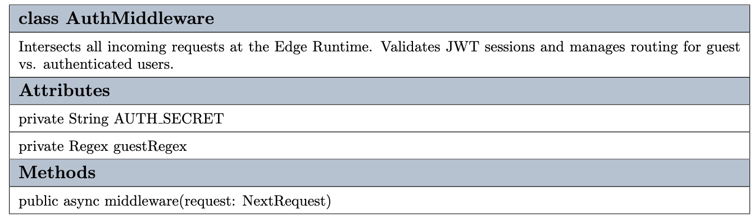
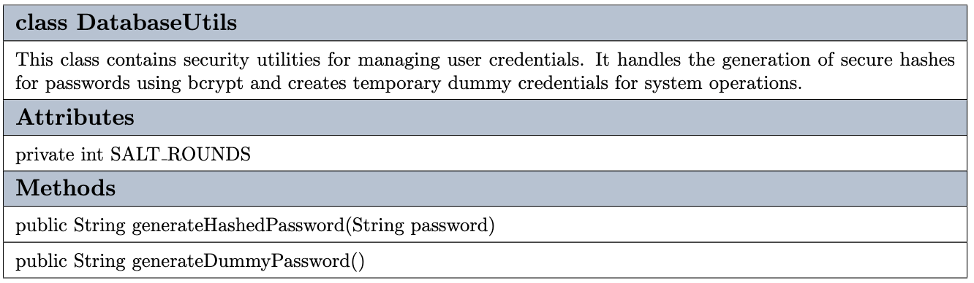
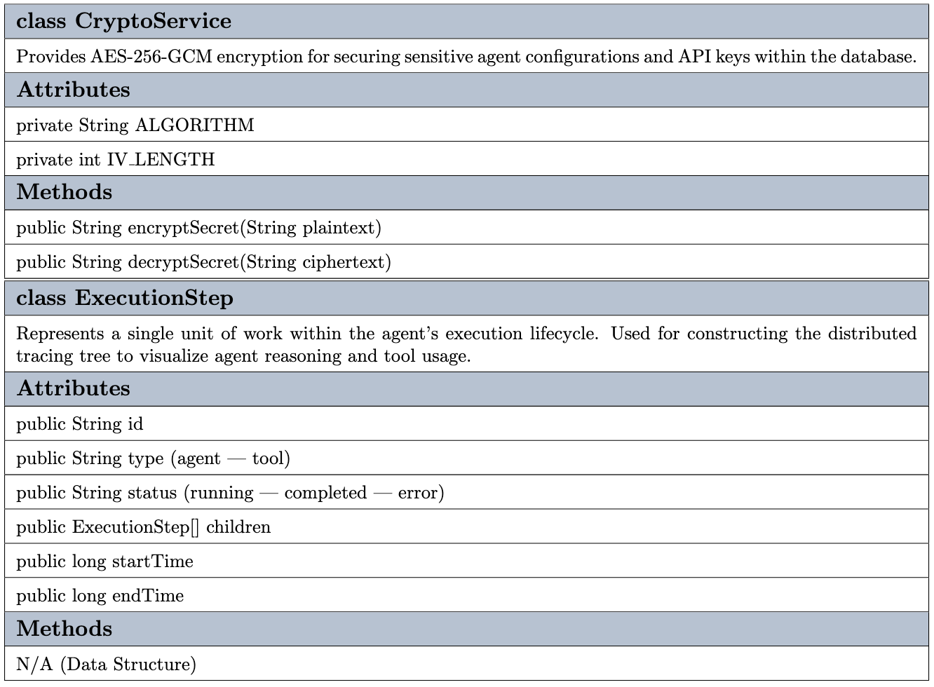

Authorization & Access Control
Purpose & Responsibilities
- Going beyond simple authentication, this layer enforces granular permissions (RBAC) and resource ownership rules (e.g., "Can this user access this chat?").

Public Interfaces
- entitlementsByUserType: Defines quotas (e.g., max messages per day) based on user roles.
- getChatById: Retrieves chat metadata for ownership verification.

Inputs/Outputs
- Input: Session object, ChatID.
- Output: Boolean (Allowed/Denied) or HTTP Error Response.

State & Data Structures
- UserType: Differentiates between free, pro, or admin users.
- Entitlements: Configuration object mapping UserTypes to resource limits.

Main Flows
- Ownership Check: The system compares chat.userId with session.user.id. If they don't match, forbidden:chat is returned.
- Entitlement Check: The system calculates usage via getMessageCountByUserId. If it exceeds maxMessagesPerDay, rate_limit:chat is returned.

Edge Cases & Error Handling
- Resource Not Found: If a chat ID doesn't exist, it is treated as a new session creation flow.
- Access Denied: Returns 403 Forbidden for ownership violations.

Dependencies
- lib/ai/entitlements (Quota definitions).
- next-auth (Session data).

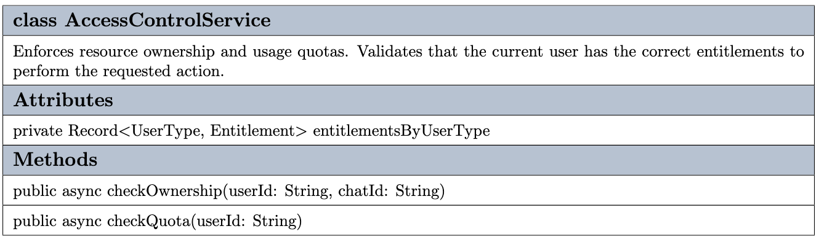

Logging & Distributed Tracing
Purpose & Responsibilities
- Provides observability into the "Black Box" of AI Agent execution. It reconstructs the hierarchical decision-making tree (Agent -> Tool -> Sub-Agent) for debugging and auditing.

Public Interfaces
- ExecutionStep: The core data structure representing a single node in the execution tree.

Inputs/Outputs
- Input: Raw stream events (AGENT_STARTED, TOOL_ENDED).
- Output: A nested JSON tree stored in the database under data-agent-execution.

State & Data Structures
- Tree Structure: Each ExecutionStep contains a children array, allowing for infinite nesting depth.
- Stack: An activeAgentStack is used during streaming to track parent-child relationships in real-time.

Main Flows
- Start: When AGENT_STARTED is received, a new ExecutionStep is pushed to the activeAgentStack.
- Child: When TOOL_STARTED is received, it is added to the children array of the current active step.
- End: When AGENT_ENDED is received, the step status is updated to completed and popped from the stack.

Edge Cases & Error Handling
- Orphaned Steps: If a stream cuts off without an ENDED event, steps remain in running state.
- Error Propagation: If AGENT_ERROR occurs, the current step is marked as error and the exception message is saved.

Dependencies
- types.ts (Structure definition).
- constants.ts (Tracing signals).
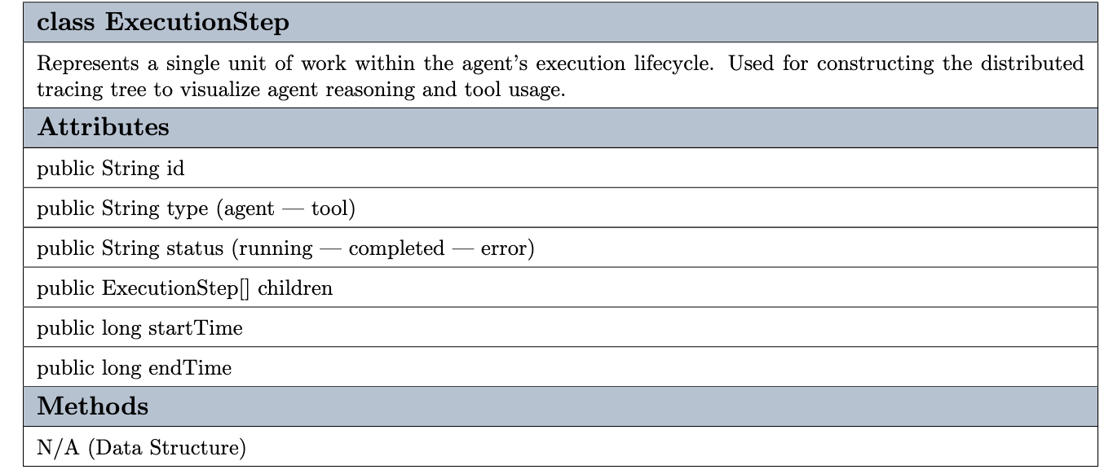

Metrics & Performance Monitoring
Purpose & Responsibilities
- Tracks the token consumption of various LLM providers, normalizes pricing data, and persists usage statistics for cost analysis.

Public Interfaces
- getUsage(): Calculates cost based on token counts.
- getTokenlensCatalog(): Retrieves the latest model pricing.

Inputs/Outputs
- Input: promptTokens, completionTokens, modelId.
- Output: AppUsage object (containing cost, latency, and detailed token breakdown).

State & Data Structures
- AppUsage: A composite type merging LanguageModelUsage and TokenLens analytics data.

Main Flows
- When an agent finishes execution (AGENT_ENDED), raw token counts are captured.
- The system fetches the TokenLens catalog (cached for 24 hours).
- getUsage calculates the total cost.
- The usage data is saved to the database via updateChatLastContextById.
Edge Cases & Error Handling
- Catalog Unavailability: If the pricing catalog cannot be fetched, the system falls back to default zero-cost calculation to prevent blocking the chat flow.

Dependencies
- Tokenlens.

API & System Error Handling
Purpose & Responsibilities
- A centralized error management layer that captures system exceptions (Database, API, Auth), sanitizes them, and returns standardized HTTP responses.

Public Interfaces
- ChatSDKError: Custom error class extending the native Error object.

Inputs/Outputs
- Input: Error Code String (e.g., not_found:chat).
- Output: JSON Response { code: string, message: string }.

State & Data Structures
- Surface: Indicates where the error occurred (database, api, auth).
- Visibility: Determines if the error details should be exposed to the client or only logged internally.

Main Flows
- A system component throws new ChatSDKError("forbidden:chat").
- The toResponse() method is called.
- The method resolves the HTTP status code (e.g., 403) and the user-friendly message via getMessageByErrorCode.

Edge Cases & Error Handling
- Data Leakage Prevention: Errors originating from the database surface are masked as generic "Something went wrong" messages to the user, while full details are logged server-side.

Dependencies
- errors.ts
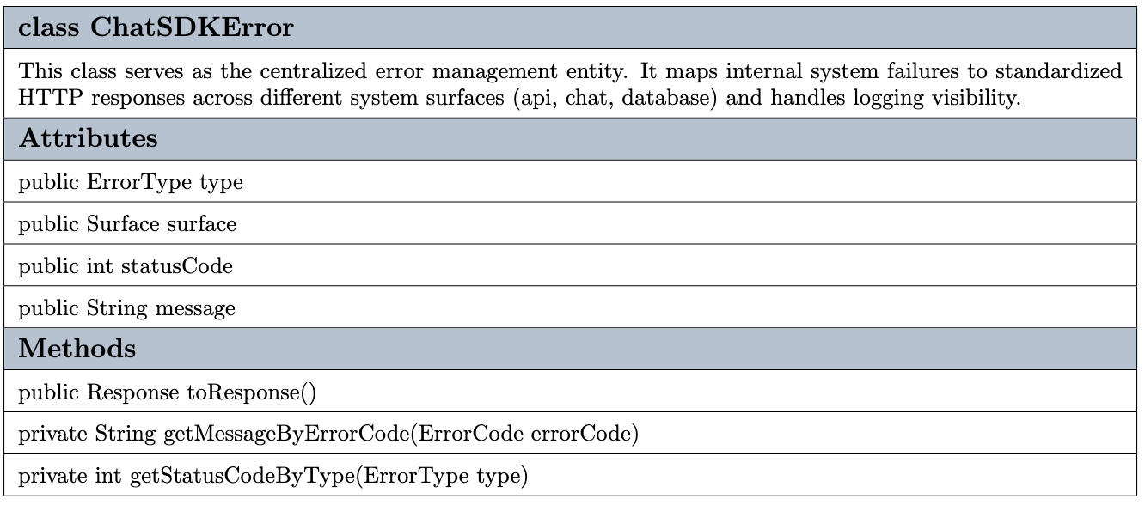

UI Stream Consumption
Purpose & Responsibilities
- This component is responsible for consuming the raw NDJSON stream events on the client side and transforming them into an interactive, visual representation of the agent's lifecycle. It provides real-time feedback on the agent's "thinking" process, tool execution duration, and final token consumption costs.

Public Interfaces
- ThinkingFlow: The primary React component used to render the execution trace.

Inputs/Outputs
- Input: steps: ExecutionStep[]
- Output: usage: Usage object { promptTokens, completionTokens, totalTokens }.

State & Data Structures
- isStreaming: A memoized boolean state that determines if the agent is currently active based on step status.
- duration: A local state tracking the elapsed time in seconds during active execution.

Main Flows
- The component receives updated steps from the chat hook.
- isStreaming calculates if any step is in the running state.
- If active, a timer increments the duration state every second.
- Upon completion, the final usage.totalTokens is displayed alongside the total execution time.

Edge Cases & Error Handling
- Empty State: If the steps array is empty or undefined, the component returns null to prevent rendering empty containers.
- Missing Usage Data: The token display logic conditionally renders only if usage data is present, preventing "undefined" errors.

Dependencies
- framer-motion (For pulse and expand animations).
- lucide-react (Status icons).
- shadcn/ui (Collapsible primitives).

