CO2-AT2 DEBUGGING

Name: V Deepa Dharshini
Reg no:192525213
Course Code: CSA0311
Course Name: Data Structures
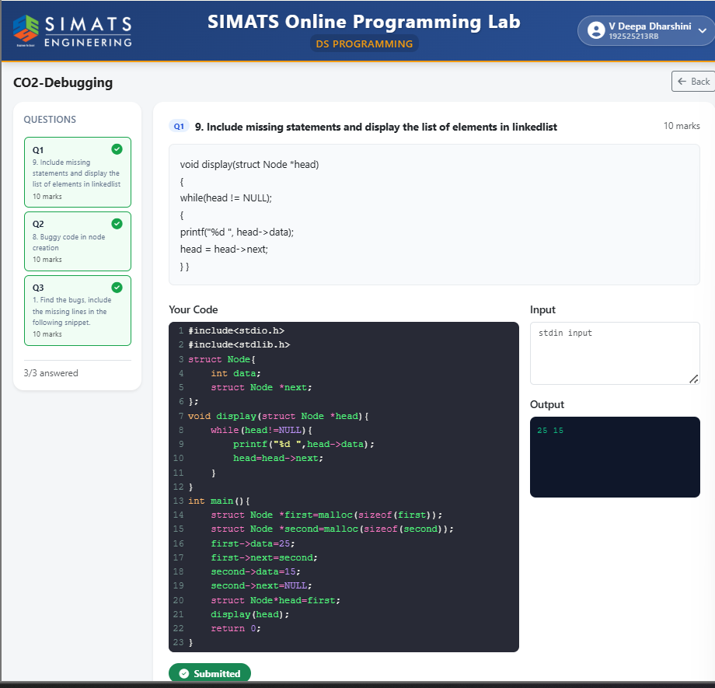
Date:31-07-26

