**AI-Powered NSAP Pension Scheme Prediction Using IBM Cloud**

**1. Set up IBM Cloud**

* Go to https://cloud.ibm.com
* Create a free **IBM Cloud Lite** account

**2. Launch Watsonx.ai Studio**

* In the **IBM Cloud dashboard**, go to **Catalog**
* Search **"watsonx.ai"**, click **Create**
* Launch **watsonx.ai Studio**

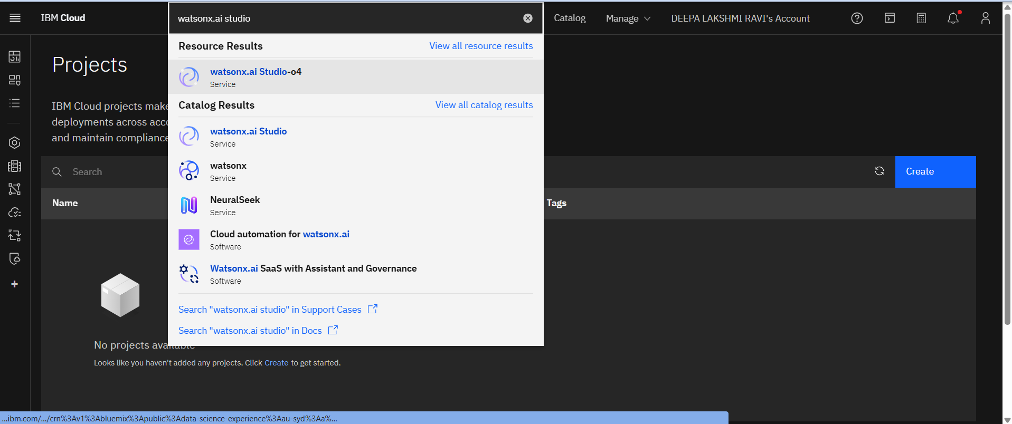



**3. Create a Project**

* Click **“Create Project”**
* Give a name: NSAP Pension Prediction
* Add **Cloud Object Storage** if prompted

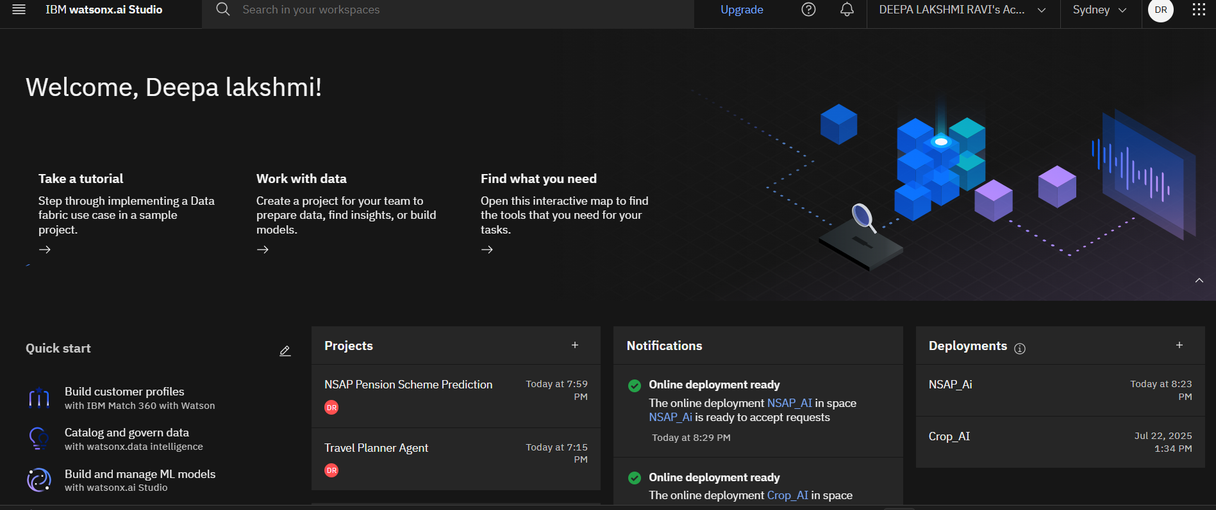

**4. Upload Dataset**

* Download dataset from:  
  [AI Kosh NSAP Pension Dataset](https://aikosh.indiaai.gov.in/web/datasets/details/district_wise_pension_data_under_the_national_social_assistance_programme_nsap_1.html)
* Inside your project → Go to **Assets > Add data asset**
* Upload the CSV file

**5. Run AutoAI Experiment**

* Click **New Asset > AutoAI Experiment**
* Choose your uploaded CSV as data source
* Select **target column**: schemecode
* Click **Run Experiment**

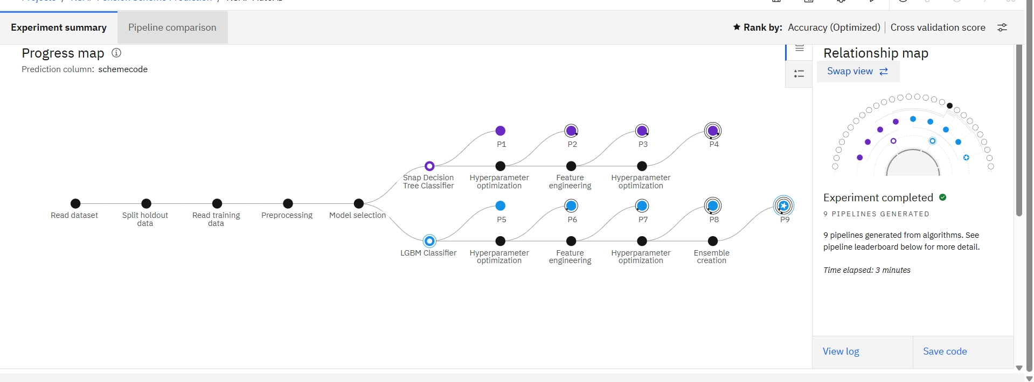

**6. Choose Best Model**

* Review model leaderboard (accuracy should be ~1.0)
* Click **Save as Model** for the top performer  
  A screenshot of a chat

  AI-generated content may be incorrect.

**7. Deploy the Model**

* Go to **Deployment Space** > Create new if needed
* Promote model to space → Deploy it
* Click **Test** tab to try sample inputs and get predictions

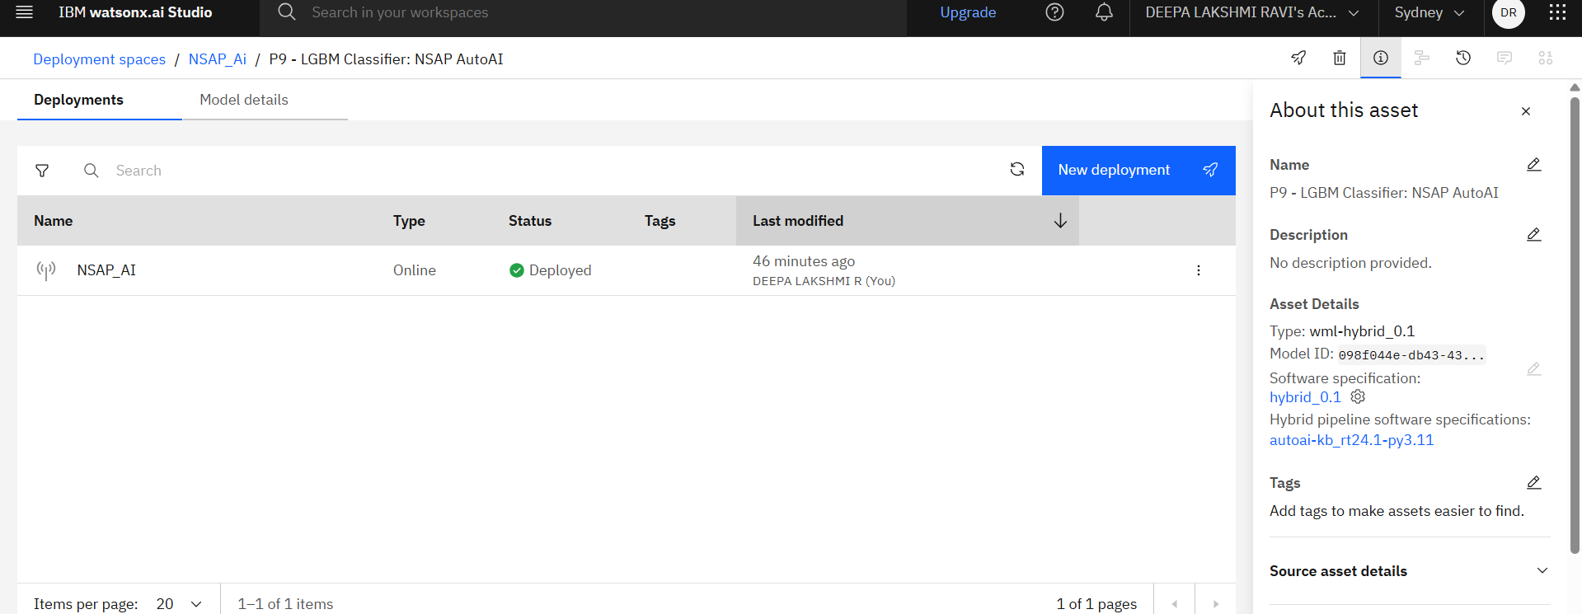

**8.Test the model online**

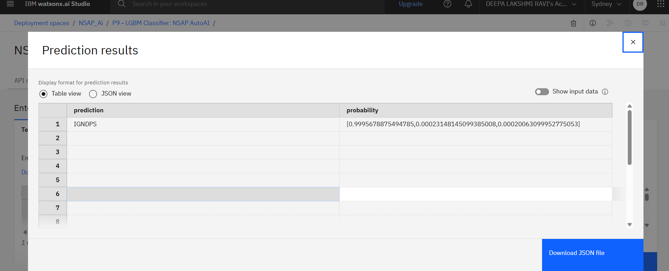

**Result**

* Model Accuracy: **100%**
* Type: **Multi-class Classification**
* Input: Beneficiary data like gender, caste, Aadhaar status
* Output: Scheme name (e.g., IGNOAPS, IGNDPS, IGNWPS)

**End Users**

* Government welfare departments
* District data officers
* Citizen Service Centers (CSCs)
* Pension applicants (via UI/API)

**Wow Factor**

* Built using **IBM AutoAI with no code**
* Achieved **100% model accuracy**
* End-to-end pipeline: Upload → Train → Deploy → Predict
* Scalable for **PAN-India scheme automation**

**Conclusion**

This project simplifies pension scheme classification using AI. It reduces manual work, improves delivery speed, and ensures that the right beneficiaries receive the right benefits.