Bundler

Step1:

Checking gem version



Step 2:

Check bundler version



Step 3: downloaded gem maruku

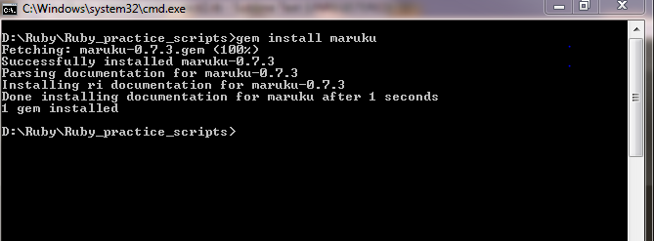

Step 4: irb

Step 5 : require ‘gemname’

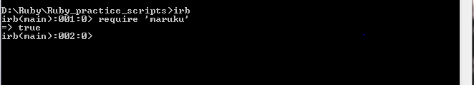

Step 6: write a statement to convert it in to html

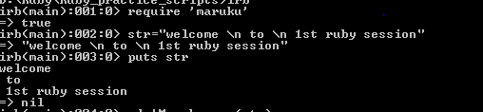

Step 7: mark directory



Step 8 : md.to_html_document

