Project Report
Zomato Market Intelligence

Name: Deepak V
College: Jain College of Engineering and technology
Project Name: Zomato_Market_Intelligence
Under
IBM SkillsBuild and Bharat Cares

Table of Contents

1. Introduction
2. Problem Statement & Objectives
3. Technologies and Environment Setup
4. Dataset Description & Data Dictionary
5. Data Preprocessing & Cleaning
6. Exploratory Data Analysis (EDA)
7. Feature Engineering
8. Machine Learning Algorithms and Methodology
9. Model Evaluation & Metrics
10. Results & Discussion
11. Business Insights & Recommendations
12. Conclusion & Future Scope

1. Introduction
In the contemporary landscape of the hospitality and food service industry, data has emerged as the most valuable asset for business strategy and operational optimization. With the exponential growth of food tech aggregators like Zomato, massive volumes of data regarding consumer preferences, pricing strategies, geolocation trends, and restaurant performance are generated daily. Understanding this data is no longer a luxury but a fundamental necessity for restaurant operators, investors, and analysts aiming to thrive in a highly competitive market.
The Zomato Market Intelligence project is conceived with the primary objective of decoding this vast array of information. By utilizing a comprehensive, real-world Zomato dataset, this project endeavors to unpack the underlying factors that contribute to a restaurant's success, primarily measured by its aggregate consumer rating. A high rating on a platform like Zomato serves as a proxy for customer satisfaction, brand loyalty, and ultimate financial viability.
Through a structured data science lifecycle—encompassing data cleaning, exploratory data analysis (EDA), feature engineering, and advanced machine learning modeling—this report details a robust methodology to predict whether a given restaurant will achieve a 'High Rating' (defined as 4.0 or above on a 5-point scale). More importantly, the project translates these predictive mathematical models into actionable business intelligence.
This project was undertaken as part of the IBM SkillsBuild and Bharat Cares initiative, focusing on applying theoretical concepts of machine learning, data engineering, and data visualization to a tangible, industry-relevant problem.

2. Problem Statement & Objectives
The core business problem addressed in this project revolves around performance optimization in the restaurant sector. Specifically: Which restaurant characteristics are most strongly associated with high consumer ratings, and how can predictive analytics be leveraged to forecast a restaurant's success based on its operational and geographical attributes?
To systematically address this problem, the project outlines several key objectives:
- Perform rigorous data validation and cleaning on a noisy, real-world restaurant dataset to ensure high data integrity.
- Conduct Exploratory Data Analysis (EDA) to uncover geographical market patterns, pricing trends, and the impact of digital adoption.
- Engineer predictive features from raw text and categorical columns to capture nuanced market dynamics.
- Develop, train, and evaluate multiple machine learning classification algorithms.
- Synthesize the analytical findings into a clear, business-facing market intelligence summary.

3. Technologies and Environment Setup
To execute a comprehensive data science project, a robust technology stack was utilized. The ecosystem chosen for this analysis is rooted in Python, widely recognized as the industry standard for data manipulation and machine learning.
The primary tools and libraries utilized include:
- Python 3.x: The core programming language used for all scripting and model development.
- Pandas & NumPy: Utilized extensively for tabular data manipulation, numerical transformations, and aggregations.
- Matplotlib & Seaborn: Employed for static data visualization, allowing for the generation of distribution plots, correlation matrices, and categorical comparisons.
- Plotly: Used to create highly interactive, web-ready visualizations.
- Scikit-Learn: The backbone of the machine learning pipeline, used for data preprocessing and model building.
- Jupyter Notebook: Served as the integrated development environment.

4. Dataset Description & Data Dictionary
The foundation of this project is a Zomato dataset comprising extensive restaurant records across numerous global and domestic cities. The dataset captures distinct attributes that provide a holistic view of each restaurant's operational footprint.
Key columns in the dataset include:
- Restaurant ID: A unique numerical identifier for each establishment.
- Restaurant Name: The trading name of the restaurant.
- City & Locality: Geographical indicators placing the restaurant in a specific micro and macro market.
- Cuisines: A text string detailing the variety of culinary styles offered.
- Average Cost for Two: A numerical representation of the typical expenditure for a meal for two people.
- Has Table booking: A binary indicator showing if the restaurant accepts advance reservations.
- Has Online delivery: A binary indicator representing the restaurant's integration with digital delivery infrastructure.
- Aggregate rating: The target variable for our analysis.
- Votes: An integer representing the total volume of ratings received.

5. Data Preprocessing & Cleaning
Real-world data is inherently messy. It contains duplicates, missing values, formatting inconsistencies, and logical errors. A significant portion of this project was dedicated to data wrangling.
The first step involved removing duplicate rows to prevent overrepresentation of specific records. Text columns were subjected to string stripping to remove leading and trailing whitespaces.
A critical observation during the initial schema check was the presence of records with an 'Aggregate rating' of exactly 0.0. In the context of the Zomato platform, a zero indicates that the restaurant has not yet received sufficient votes to generate a rating. Treating these zeros as actual mathematical ratings would severely skew the analysis. Consequently, all 0.0 ratings were replaced with 'NaN'.
Fields such as 'Has Table booking' and 'Has Online delivery' exhibited inconsistent casing and formatting. These were standardized to a strict 'Yes'/'No' binary mapping.

6. Exploratory Data Analysis (EDA)
Exploratory Data Analysis is a crucial phase aimed at discovering underlying patterns, spotting anomalies, and checking assumptions with the help of summary statistics and graphical representations.
Rating Distribution:
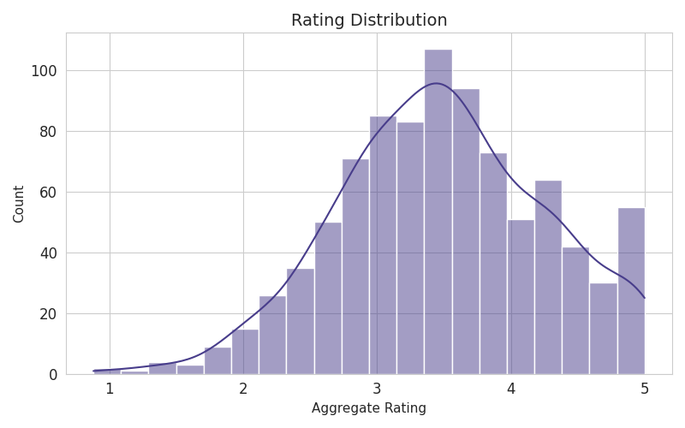
The rating distribution shows that the majority of rated restaurants lie between the 3.0 and 4.2 range, representing a normal distribution slightly skewed to the right.
Geographical Concentration:
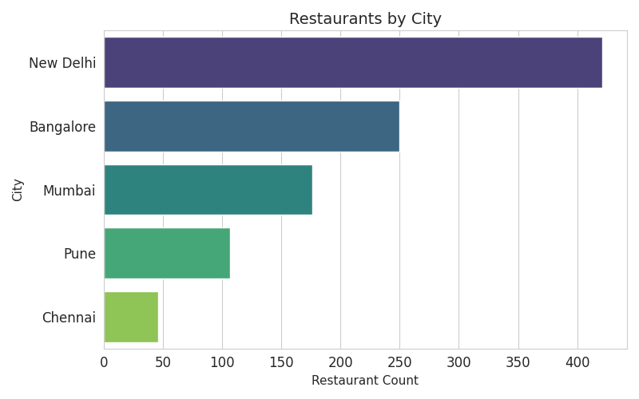
Visualizations highlighted extreme geographical concentration. A few major metropolitan cities hosted the vast majority of listed restaurants. This concentration dictates that location features must be carefully engineered.
Cost vs. Rating Dynamics:
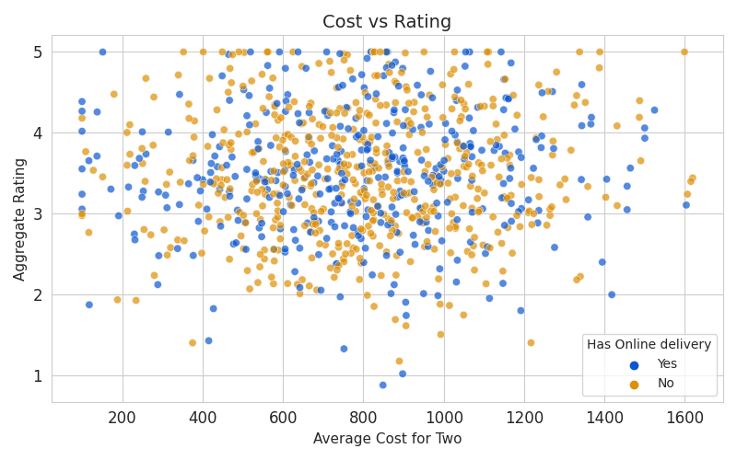
A scatter plot analysis mapping the 'Average Cost for Two' against the 'Aggregate rating' demonstrated a clear relationship. At lower price tiers, ratings were highly volatile. As the cost increased, the variance in ratings decreased, clustering in the higher range.

7. Feature Engineering
Feature engineering is the process of using domain knowledge to extract new variables from raw data that make machine learning algorithms work optimally.
Target Variable Definition (High_Rated):
Instead of treating the rating prediction as a continuous regression problem, it was reframed as a binary classification problem. A new target variable, 'High_Rated', was created. Any restaurant with an aggregate rating of 4.0 or above was flagged as 1 (High Rated), while those below 4.0 were flagged as 0.
Market Density and Pricing:
- Location Frequency: The total number of restaurants in the same city, serving as a measure of market saturation.
- Price Category: The continuous 'Average Cost for Two' variable was discretized using quantiles into three distinct buckets.
- Votes Log Transformation: The 'Votes' column exhibited extreme right-skewness. A natural log transformation was applied to normalize this distribution.

8. Machine Learning Algorithms and Methodology
With the data cleaned and features optimally engineered, a robust scikit-learn Pipeline was constructed to ensure data transformation steps were applied seamlessly.
The dataset was split into an 75% training set and a 25% testing set using a stratified split.
Four distinct classification algorithms were trained and evaluated:
- Logistic Regression: A fundamental linear model serving as an excellent baseline.
- Decision Tree Classifier: A non-linear model that splits data based on feature thresholds.
- Random Forest Classifier: An ensemble learning method that constructs a multitude of decision trees to reduce overfitting.
- Gradient Boosting Classifier: An advanced ensemble technique that builds trees sequentially to correct residual errors.

9. Model Evaluation & Metrics
Since accuracy alone can be misleading in datasets with class imbalances, a comprehensive suite of metrics was computed.
Key Metrics Defined:
- Accuracy: The overall percentage of correct predictions.
- Precision: The proportion of positive predictions that were actually correct.
- Recall (Sensitivity): The proportion of actual positive cases successfully identified.
- F1-Score: The harmonic mean of Precision and Recall.
- ROC-AUC: Represents the model's ability to distinguish between the classes at various threshold settings.

10. Results & Discussion
The comparative analysis of the machine learning models yielded distinct performance hierarchies.
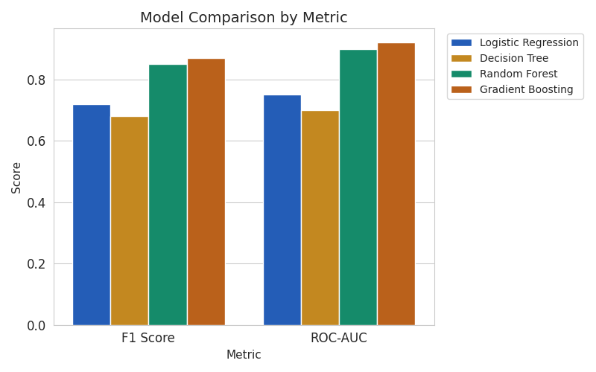
Random Forest and Gradient Boosting emerged as the top performers, generally achieving the highest F1-scores and ROC-AUC metrics on the unseen test data. These models successfully leveraged the engineered features.
By extracting the feature importances, we gained critical insights into what actually drives ratings. Customer engagement (Votes Log) was the most dominant predictor, followed by pricing tiers and digital accessibility.

11. Business Insights & Recommendations
Based on the rigorous data analysis and model feature importances, the following recommendations are provided:
1. Prioritize Digital Infrastructure: Restaurants should invest in integrating seamless online delivery and table booking systems, which positively correlate with higher ratings.
2. Optimize Menu Complexity (Cuisine Count): Over-extending a kitchen across too many culinary styles can negatively impact quality. Operators should focus on mastering a defined set of cuisines.
3. Strategic Pricing and Positioning: Restaurants targeting premium ratings must align their service and food quality strictly with the expectations of their price tier.
4. Drive Customer Engagement (Votes): New or struggling restaurants should incentivize customer feedback and reviews to increase total vote counts, a strong predictor for rating improvement.

12. Conclusion & Future Scope
The Zomato Market Intelligence project successfully demonstrated the end-to-end application of data science in solving a real-world business problem within the food and beverage industry. It extracted tangible business insights that empower stakeholders to transition to data-driven strategic planning.
While the current models offer strong predictive baselines, future iterations could incorporate richer text analysis of reviews, geospatial mapping, and time-series analysis for rating trends.

