**INSTRUCTIONS**

**STEP1: Setting up the Alexa skill**

1. Sign in into [Amazon Developer Portal](developer.amazon.com/alexa).
2. Go to the Alexa console, here you can see list of skill that you have created. Click on Create Skill to create new skill.

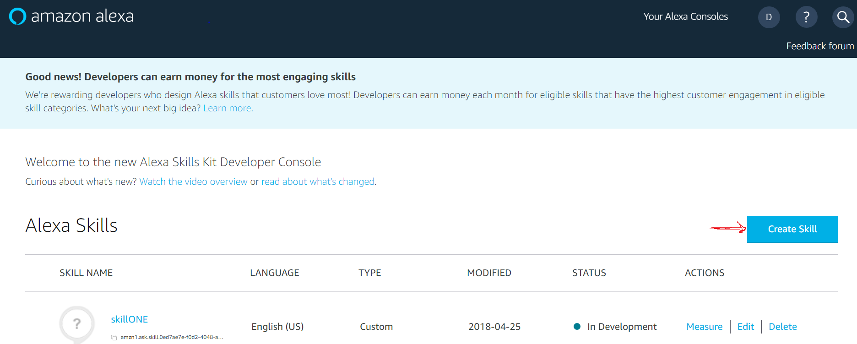

1. Enter the name for your skill and then click next

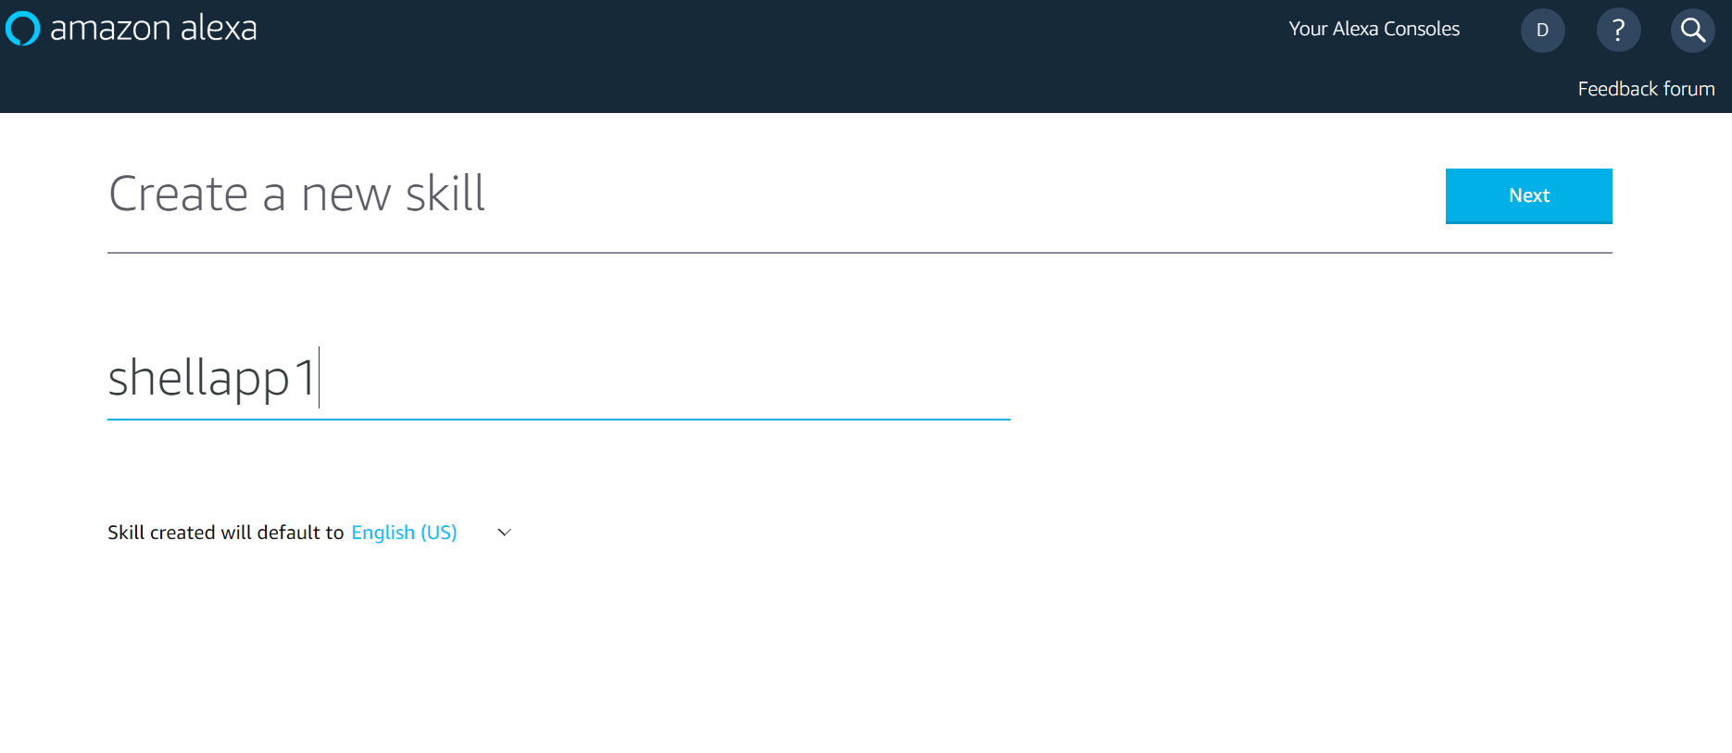

1. Select the type of skill that you want to create, some options are Flash-Briefing, Smart Home, Custom and Video. The skill matches Custom requirements so I choose custom and then hit Create Skill.

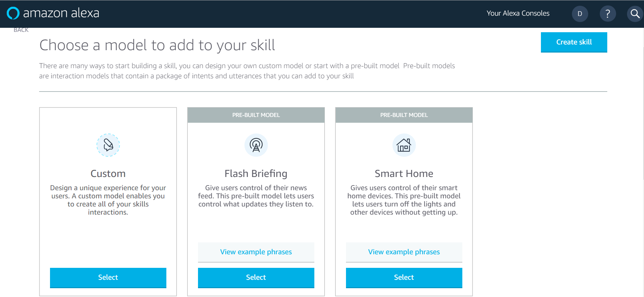

1. This is your Alexa skill development console.

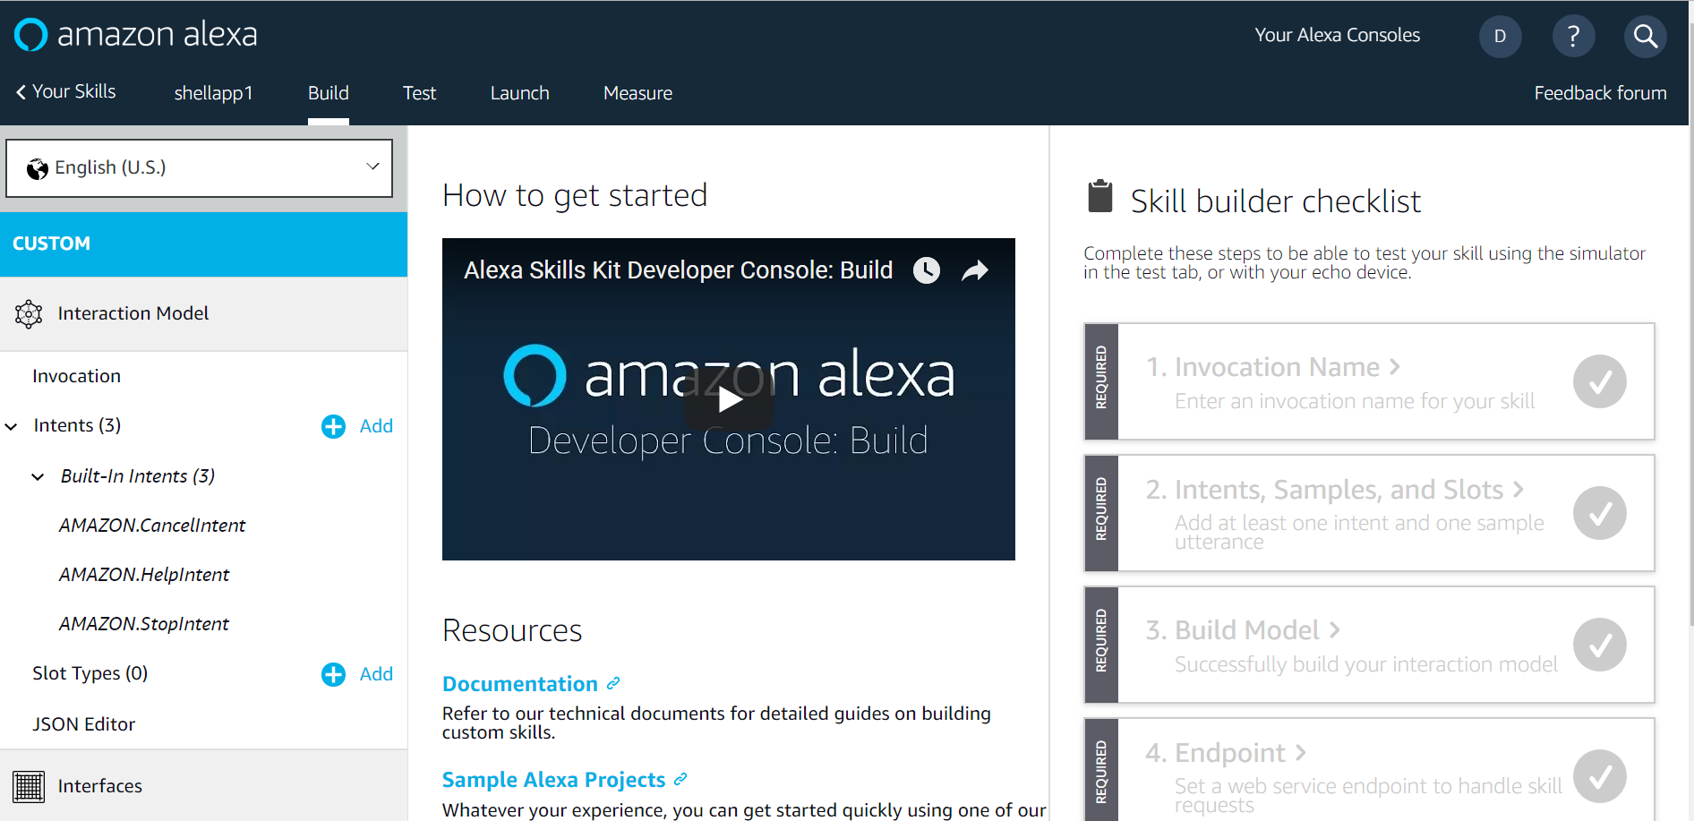

1. Next define the Invocation name for the skill which the users will say to invoke this skill.

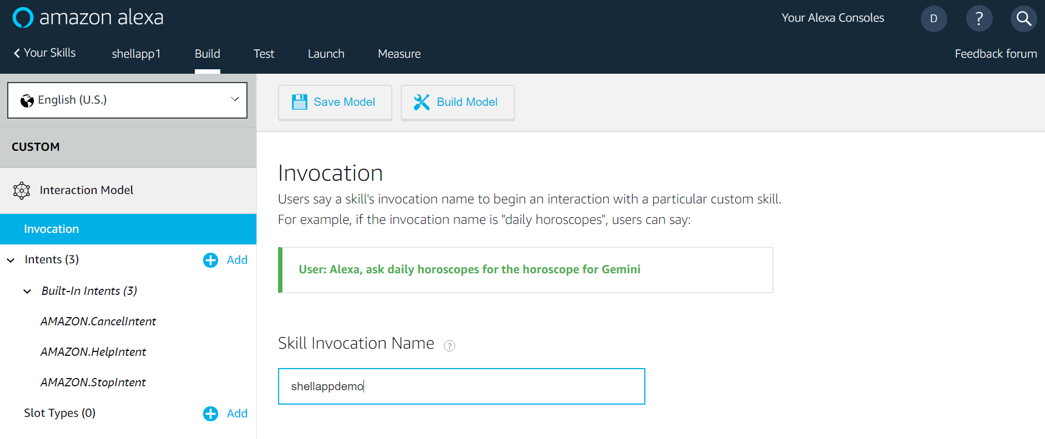

1. Now we will create Interaction model where Intents are defined and the sample utterances are provided to invoke those intents. Create New intents and slots from the GUI or directly import the IntentSchema.json file into JSON Editor.

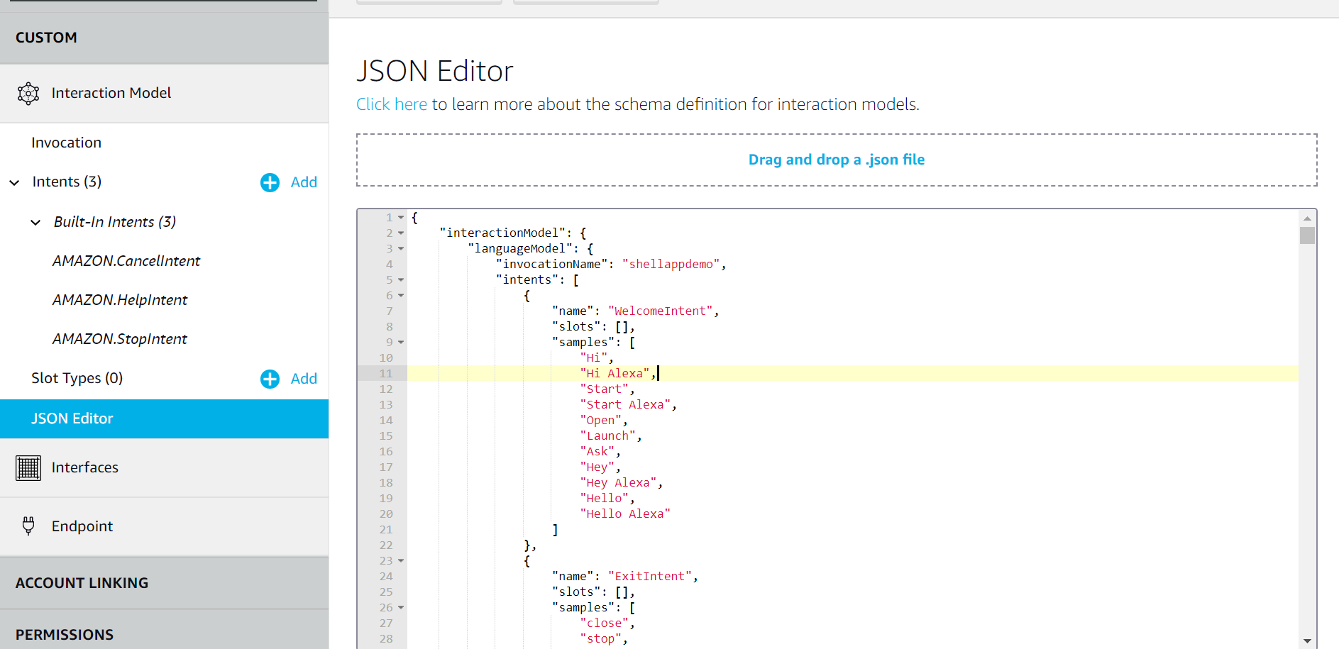

1. Save the model and open another tab in browser where we will perform STEP2.

**STEP2: Creating the Lambda Function**

1. Log in to the [AWS Management Console](aws.amazon.com). And click on Lambda which comes under Compute services provided by Amazon.

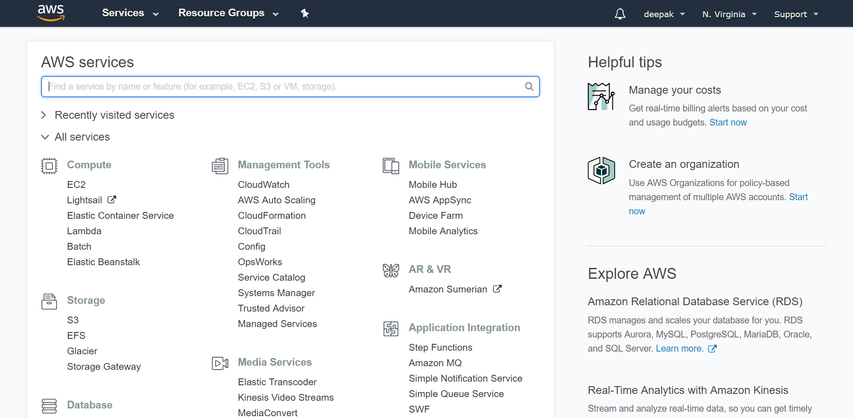

1. Click on Create function to create a Lambda function.

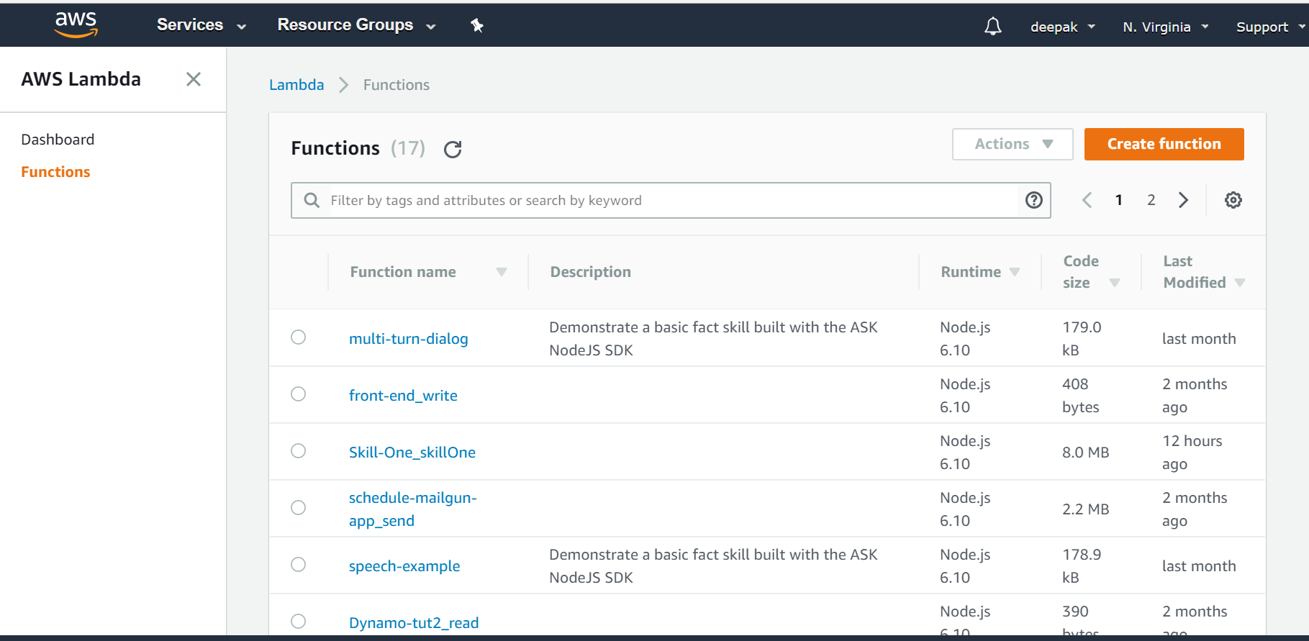

1. Give name for the lambda function, select the programming language of your choice to write the skill, choose existing role as lambda_basic_execution or you can create your new role with limited access to AWS resources and then click create function.

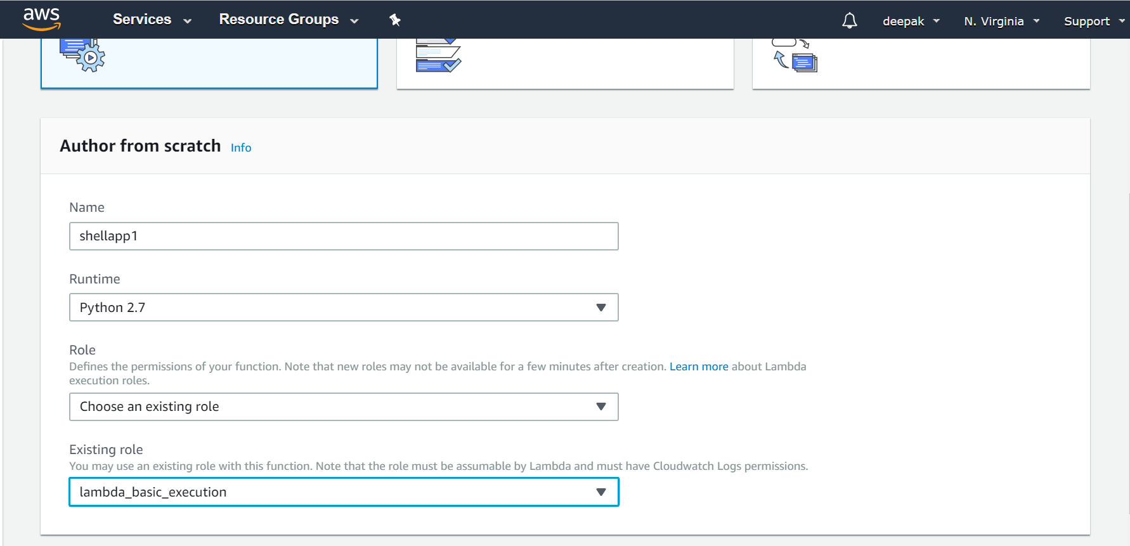

1. Copy the ARN for your lambda function. This we will require to enter in the Endpoint for Alexa skill in STEP1.

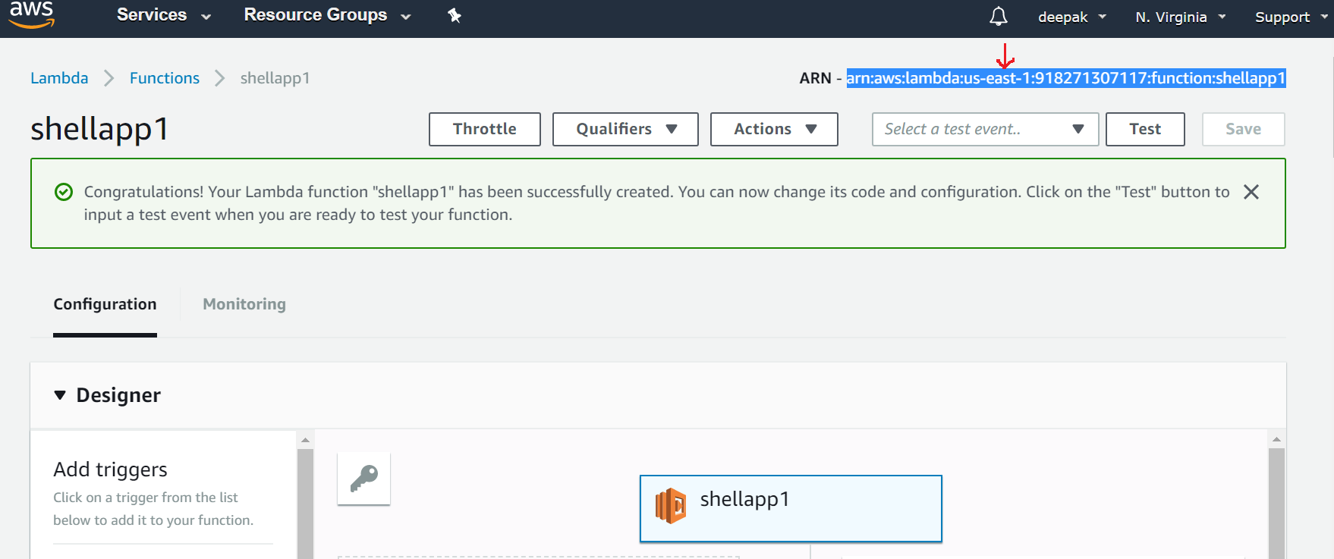

1. Edit your code inline and hit Save

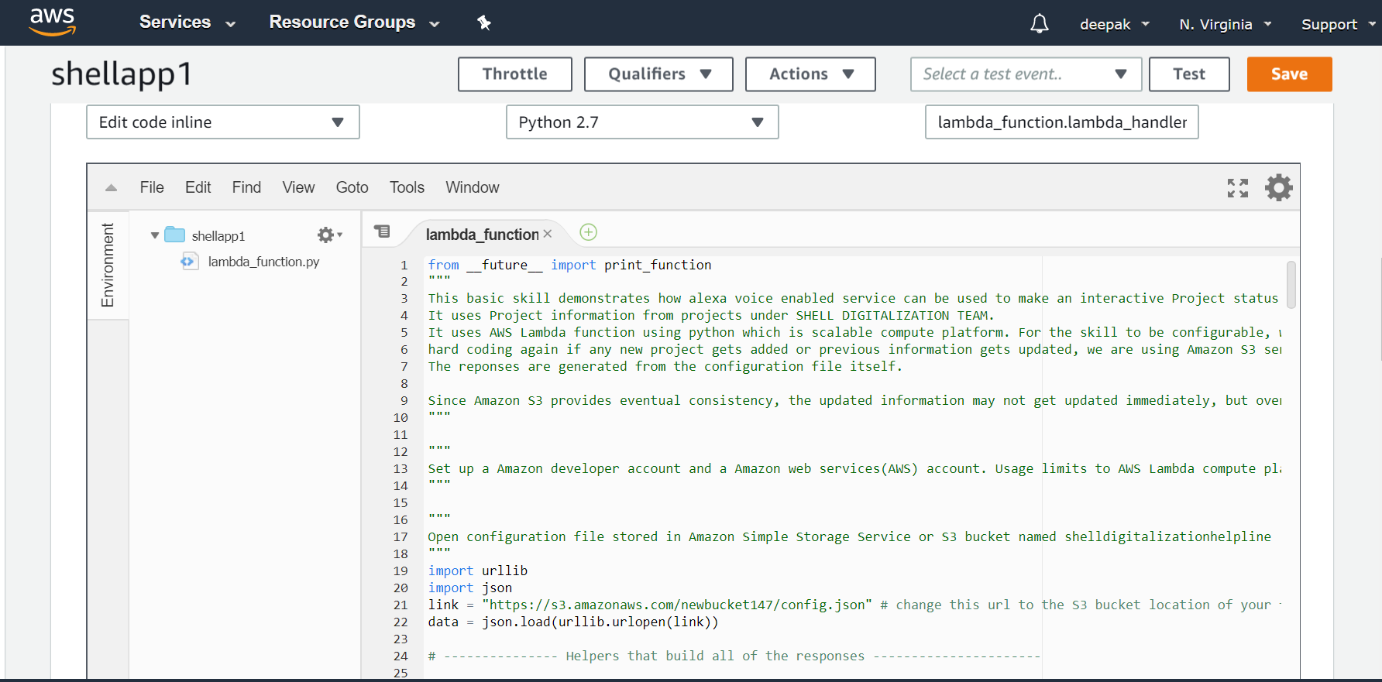

1. Now we will add trigger for this function. The Trigger is Alexa Skills Kit.

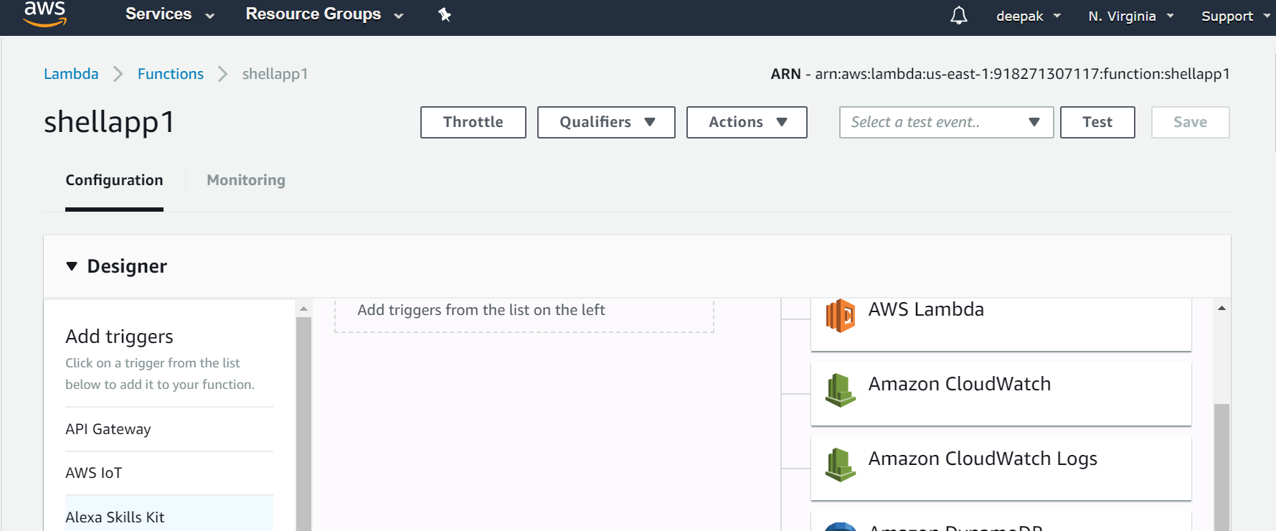

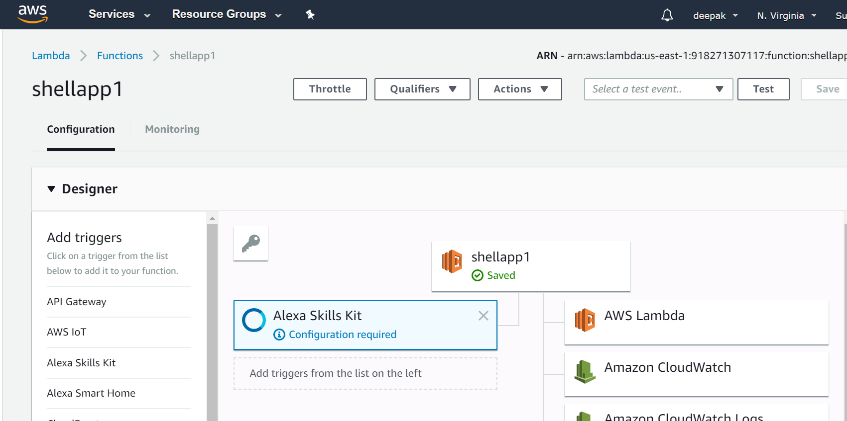

1. Now go to your Alexa developer console and move to Your skills section. Find your skill and copy the skill ID.

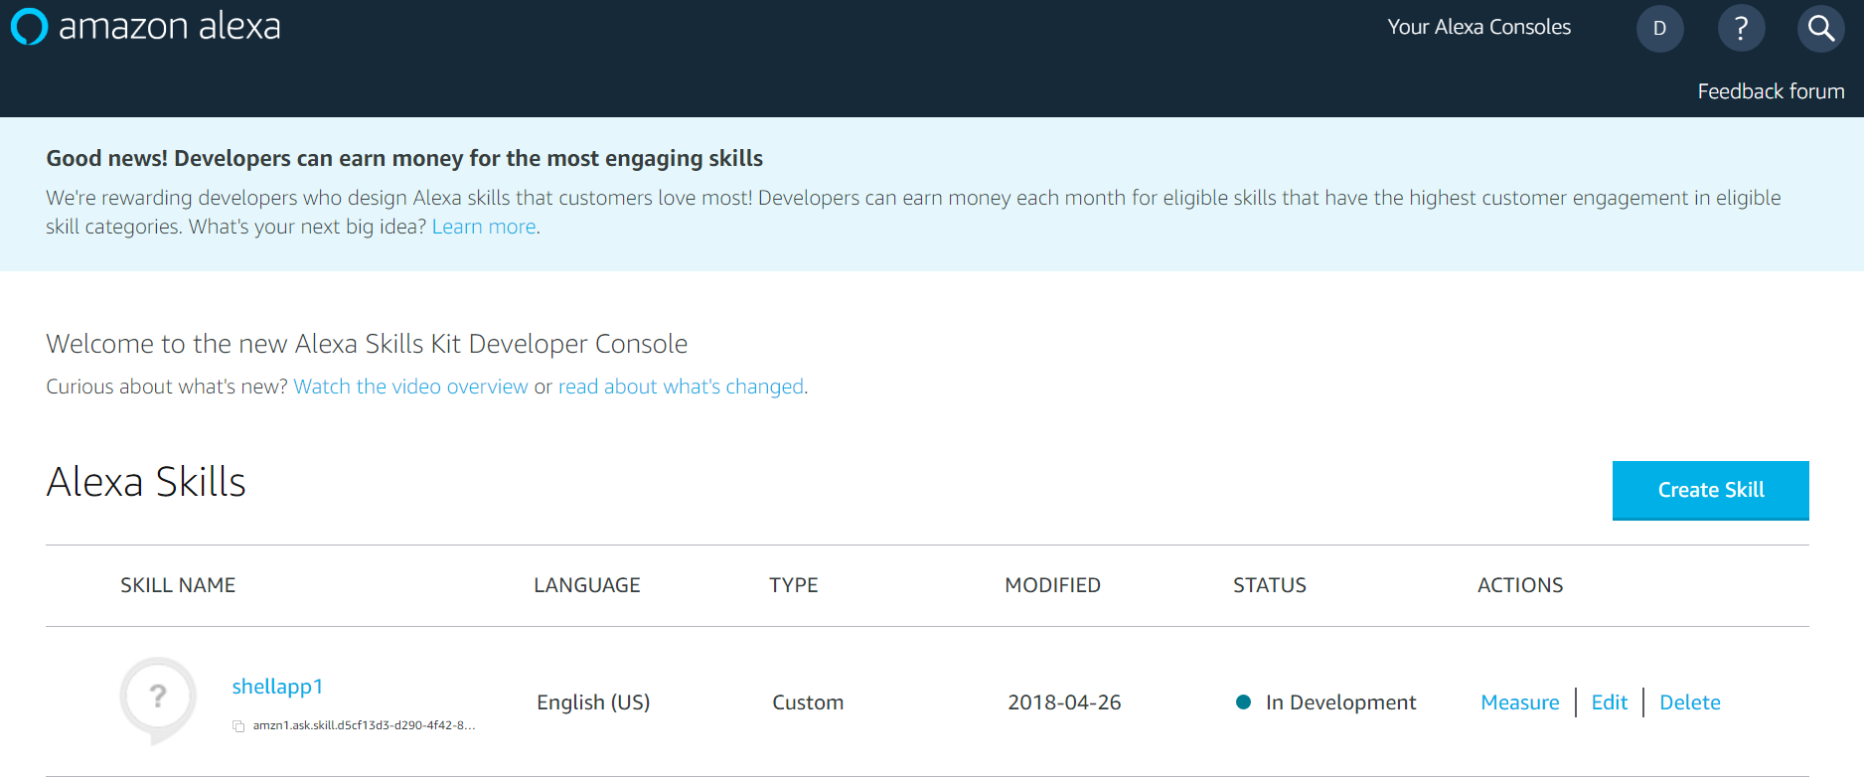

1. Now move over to AWS console and finish the trigger configuration and paste the skill ID and hit Add and then hit Save.

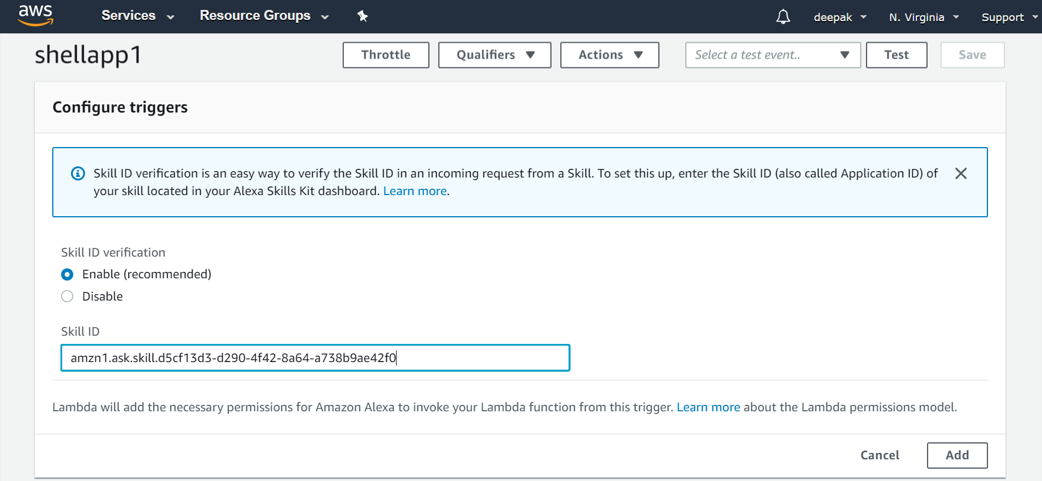

1. Copy the ARN for your lambda function. This we will require to enter in the Endpoint for Alexa skill in STEP1.



1. In the Alexa Develop console select your skill and move to the Endpoint section and click on AWS Lambda ARN. In the Default Region paste the ARN that was copied in earlier step. Hit Save Endpoints.

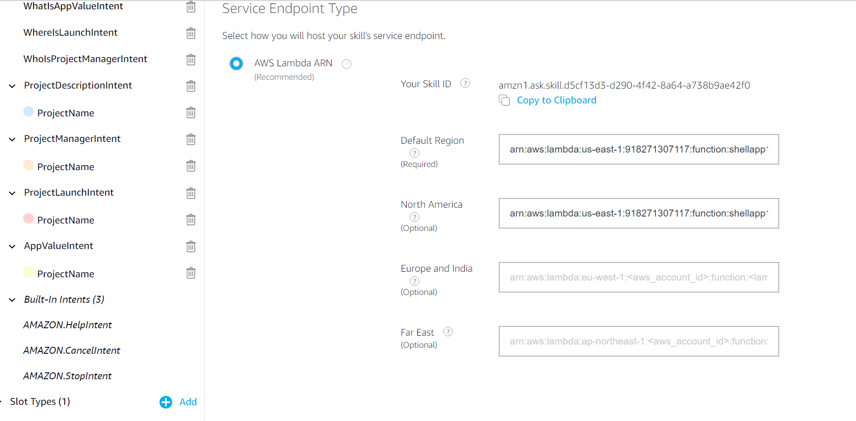

1. Now everything is complete. Hit the Build button and let the model build.

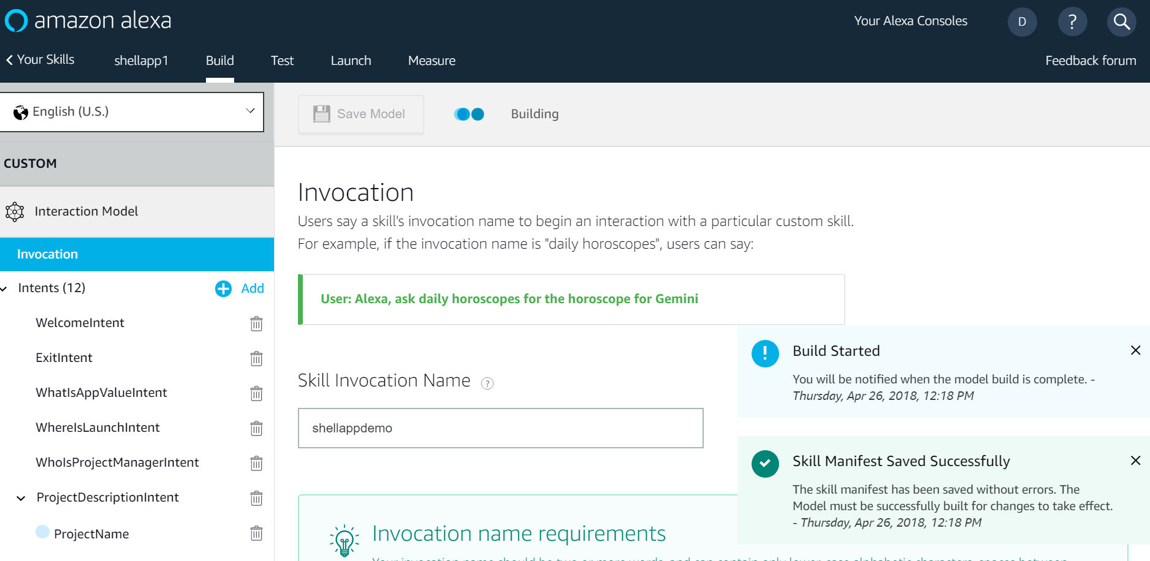

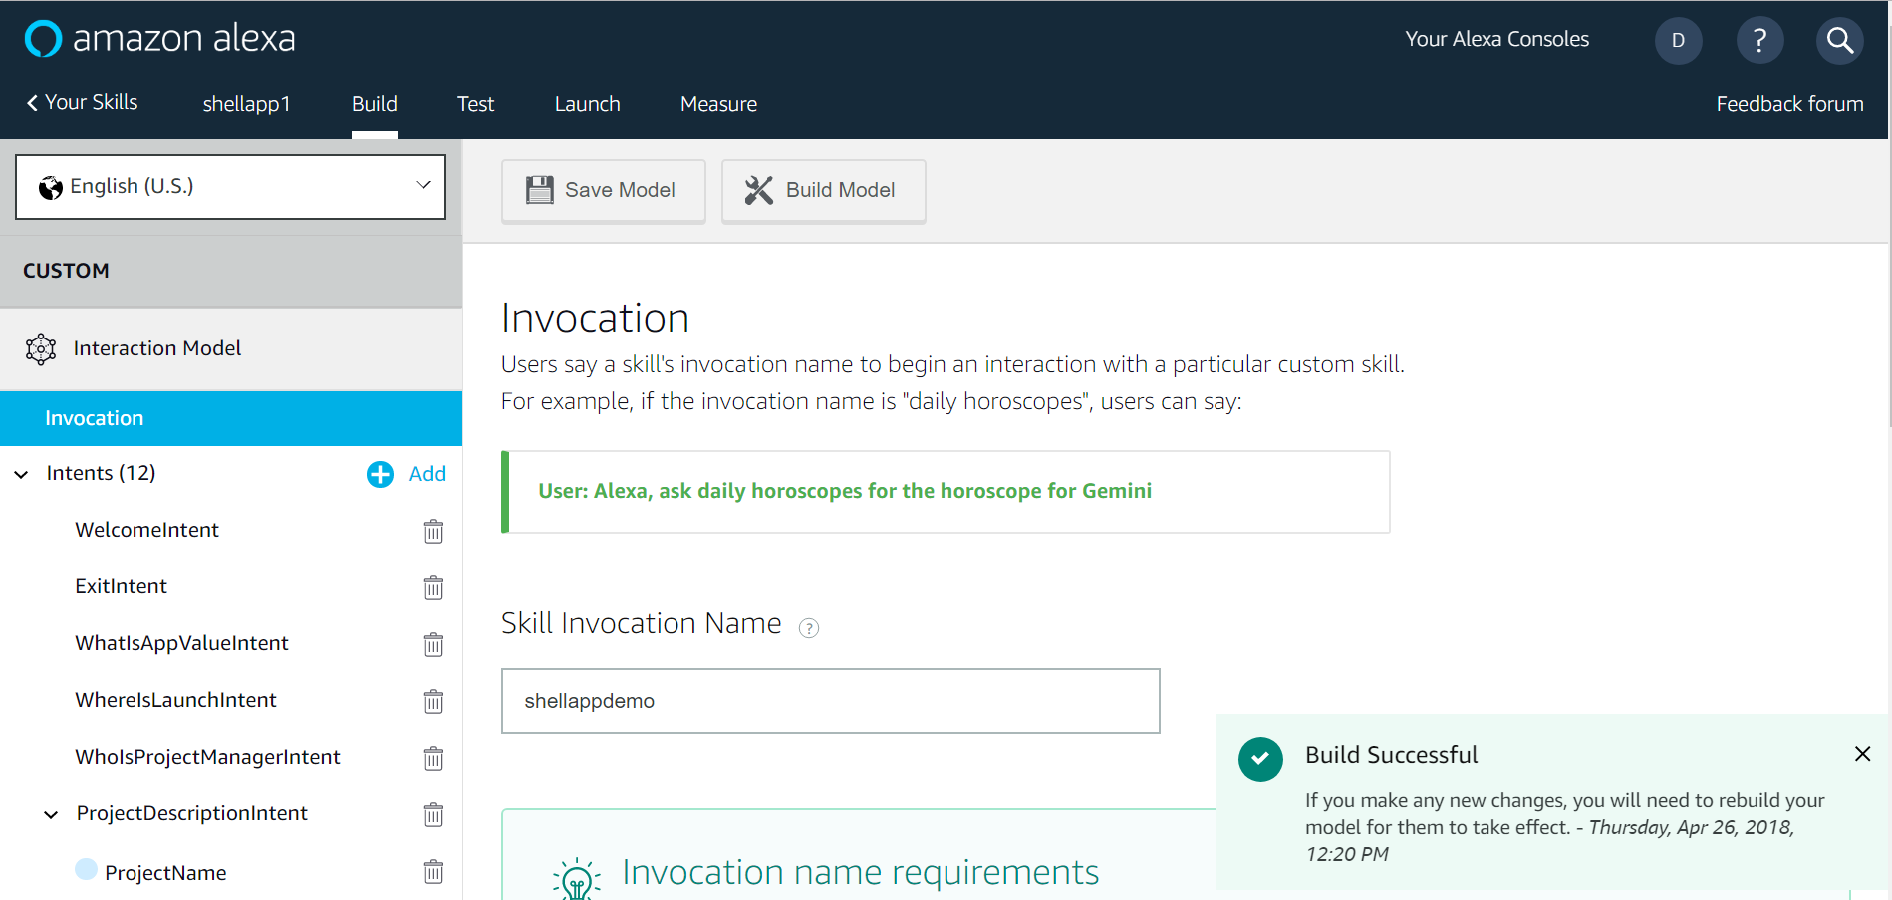

**STEP3: Configuring S3 bucket and add the project config file.**

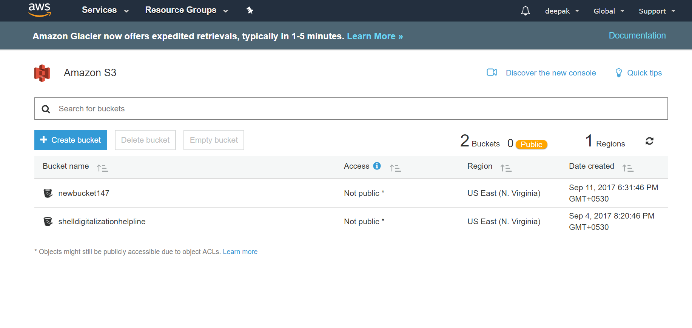

**STEP4: Testing the skill**

Once the build is successful we can test it using following ways:

* Use actual Alexa device.
* Use Service Simulator.
* Use Echo Simulator at Echosim.io

