**DOCKER**

After installing Docker

1. Check Docker version:

docker --version

1. Download a Docker Image and run it

docker run <repo-name>:<tag-name>

1. View your image on docker hub

[https://hub.docker.com/r/<repo-name](https://hub.docker.com/r/%3crepo-name)>

1. Basic concepts:

**Registry**: hub.docker.com is a default registry. It contains multiple repositories/images

**Image**: Our application and its dependencies. Think of it like a class.

**Container**: It is a running version of the image. Think of it like an Object.

1. Running on specific port:

docker run -p <host-port>:<container-port> <repo-name>:<tag-name>

1. Run the container in background:

**Detached mode without logs:**

docker run -p <host-port>:<container-port> -d <repo-name>:<tag-name>

This returns container id back.

**Detached mode with logs:**

docker logs <container-id>

Only first 4 characters of container id are sufficient

1. Get list of containers:

**List of running containers:**

docker container ls



**List of all containers, even the stopped ones:**

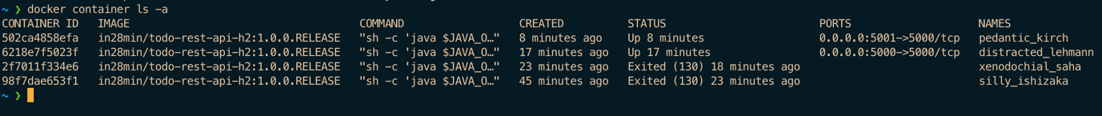

1. Running another container from same image:

It’s like running multiple instances

docker run -p <host-port>:<container-port> -d <repo-name>:<tag-name>

Same command, just change the host port to some other port number

Try docker container ls to see other running containers



1. Get list of all local images: Only the images which are present in local(pulled images)

docker images

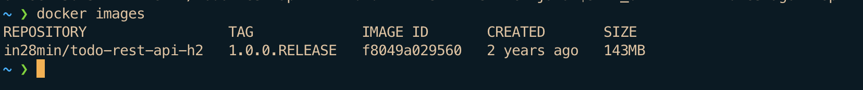

10 Stop a Docker container:

docker container stop <container-id>

