**KUBERNETES**

**NEED FOR KUBERNETES:**

**CLUSTER:**

Kubernetes manages your virtual servers.

Amazon calls these virtual servers as Elastic Compute Cloud (EC2)

Azure calls them Virtual Machines

Google Cloud calls them Compute Engines

Kubernetes calls them Nodes

So, Kubernetes manages Nodes. To manage 1000s of such nodes, Kubernetes uses managers or Master Nodes.

So, a Cluster is a combination of nodes and master nodes.

**Create a Kubernetes cluster:**

Go to Kubernetes Engine service in Console and then click Create Cluster. It will take some time to create.

**Connecting to Kubernetes Cluster:**

After creating the cluster, we need to connect to it. Go to your cluster.

Then Click on Connect.

This will give a command. Copy this command.

To Execute this command, we will use Cloud Shell. Click on Activate Shell to open Cloud Shell.

Then click to open Cloud Shell in new window:

Now we can execute commands in this shell.

Paste the previously copied command here. This will connect with our cluster.

**Connect to cluster:**

gcloud container clusters get-credentials ldeepak-cluster --zone us-central1-c --project clear-wind-342111

**Check Kubernetes version:**

kubectl version

**Create Deployment:**

kubectl create deployment hello-world-rest-api --image=in28min/hello-world-rest-api:0.0.1.RELEASE

**Exposing the Deployment:**

kubectl expose deployment hello-world-rest-api --type=LoadBalancer --port=8080

**Accessing the Exposed endpoint:**

Go to Services & Ingress:

Click on the Endpoint:

This will open it in new browser window:

**Here you can access API at** <http://35.239.100.38:8080/hello-world>

**get command:**

**kubectl get <thing>**

**thing={events, pods, replicasets, deployments, services, etc...}**

**explain command:**

**kubectl explain <thing>**

**thing={events, pods, replicasets, deployments, services, etc...}**

**PODS:**

Pod is a collection of containers that can run on a host.

**kubectl get pods:**



**kubectl describe pod <pod-name>:**

**REPLICASETS:**

Ensures that a specified number of pod replicas are running at any given time.

**kubectl get replicasets:**

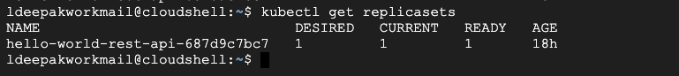

We can see we have one pod available. So even if we delete this pod, replicaset will ensure that one pod is available, so it will create another pod.

**kubectl delete pods <pod-id>:**

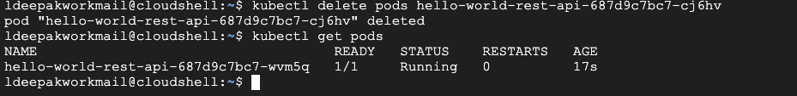

To have some more pods, we can scale our deployment to create more pods.

**kubectl scale deployment <pod-name> --replicas=<desired replica count>**

**DEPLOYMENT:**

A deployment allows you to describe an application’s life cycle, such as which images to use for the app, the number of pods there should be, and the way in which they should be updated.

**Kubectl get pods -o wide:**

Gives more info about the replica set. Like which image it is tied to.



To set a new image (i.e., changing the application to new version)

**Kubectl set image deployment <deployment-name> <container-name>=<image-name>**