Software Requirements Specification (SRS) for VD Computers

Introduction

In today’s digital era, managing a computer shop efficiently requires a robust system to handle various operations, including inventory management, Selling Products, customer relations, employee management, and repair services. The VD Computers Shop Management System is designed to streamline these tasks, ensuring a seamless workflow for the business
Managing a computer shop efficiently requires a well-organized system for handling inventory, sales, customer support, employee tasks, and repair services. VD Computers Shop Management System aims to simplify these processes and make business operations smoother.

1. Development Methodology
The development of the VD Computers website follows a hybrid approach, integrating Rational Unified Process (RUP) and Agile methodologies. This approach ensures a structured yet adaptable development cycle, promoting iterative improvements while maintaining architectural integrity.
1.1 Hybrid RUP and Agile Approach
This hybrid model leverages the structured framework of RUP while incorporating Agile’s flexibility for iterative development. The combination ensures:
- Well-defined phases (RUP): Provides a structured roadmap with clear milestones.
- Incremental and iterative development (Agile): Enables continuous feedback and adaptability.
- Risk management (RUP): Early identification and mitigation of potential risks.
- Continuous testing and updates (Agile): Ensures system reliability and improvements.

Development Phase (RUP) | Agile Adaptation
Inception (Planning) | Define project scope, establish key objectives, and gather stakeholder requirements. Agile backlog creation for iterative work.
Elaboration (Designing) | Develop system architecture, refine backlog items, and identify potential risks. Agile sprint planning begins.
Construction (Development & Testing) | Implement system functionalities through iterative two-week sprints, conduct rigorous testing, and refine features based on feedback. Continuous integration and deployment (CI/CD).
Transition (Deployment & Optimization) | Gradually roll out the system, collect user feedback, and optimize performance for scalability and efficiency. Continuous improvement based on real-world usage.

2. Scope
The VD Computers Shop Management System is designed to provide a robust, user-friendly, and efficient platform for managing a computer retail and service business. The system will cater to multiple stakeholders and cover the following functionalities:
2.1 System Users
- Customers: Browse products, place and track orders, request technical support, and submit feedback.
- Administrators: Manage inventory, process sales, generate reports, oversee customer interactions, and handle user accounts.
- Staff Members: Assist customers, manage repair services, and address inquiries.

1.4 Development Plan (Agile Sprints)
Each feature will be built in small steps called sprints (2-3 weeks each):
- Sprint 1: User accounts and login system.
- Sprint 2: Product catalog and inventory tracking.
- Sprint 3: Order management and online payments.
- Sprint 4: Sales reports, customer feedback, and complaint handling.
- Sprint 5: Repair services and staff assignments.
- Sprint 6: Final testing and official launch.
4. Why This Approach?
- Well-Planned Structure: Ensures every feature is well-documented and developed properly.
- Flexibility: Allows quick changes based on feedback.
- Continuous Improvement: New updates can be made without major delays.
- Reduced Risks: Problems are identified and fixed early in the process.
. Overview to use of Rup and Agile
The integration of RUP and Agile methodologies will enable VD Computers to maintain a structured yet flexible system, allowing for seamless updates and scalability. This ensures a superior online shopping experience, optimized inventory management, and exceptional customer service.

2. Overall Description

2.1 Product Perspective
The website will function as an e-commerce platform, integrating secure payment gateways and offering a responsive user interface.
Payment gateway – Razorpay

2.2 Software Interface
Compatible with all modern web browsers (Chrome, Firefox, Safari, Edge) and operating systems (Windows, macOS, Linux).

2.3 Hardware Interface
Client-Side Requirements:
- Client Computers (for users):
  - Processor: Intel Core i3 or higher / AMD equivalent.
  - OS – Windows 10
  - RAM: Minimum 4 GB (8 GB recommended).
  - Storage: 128 GB SSD or higher
- Server Side:
  - Network Interface: High-speed Ethernet/Wi-Fi adapter.
2. Web Server: Apache

5. Tools & Technologies
Programming Languages:
- Frontend: HTML, CSS, JavaScript
- Backend: PHP
- DATABASE - MYSQL
Development Environment:
- Visual Studio Code
- Frameworks and Libraries:
- Frontend: Bootstrap or Tailwind, jQuery
- Backend : Ajax

2.4 Communication Interface
The website will use HTTP/HTTPS protocols for secure client-server communication with encrypted data transmission.

2.5 System Constraints
- The platform will support operations in English only.
- Secure user authentication is required for transactions and sensitive actions.
- The system will be optimized for modern web browsers (Chrome, Firefox, Edge, Safari).
3. Specific Requirements

3.1 E-R Diagram

Admin use case Diagram

UPDATE
PROFILE

SEARCH
PROFILE
VIEW
REPORT
GENERATE


VIEW
REPORT

ADMIN
LOGIN
MANAGE
ORDER

Stock Levels

STOCK
MANAGE
New STOCK

USER’S
MANAGE

FEEDBACK
VIEW
COMPLAINT
VIEW
COMPLAINT
REJECT
ACTION
TAKE
COMPLAINT
REPLY

USE CASE | DESCRIPTION
Sign-in | The admin has to Sign In in order to start begin his work.
View Profile | Admin has his/her own profile containing personal and professional details
Update profile | The admin has the option to update his/her own profile
View Report | The admin can view reports.
Generate Report | The admin can generate reports.
Manage user | The admin is given the option to Manage the users – add , remove
Manage Order | Admin can assign orders to staff for processing.
Manage Stock | Admin monitors inventory levels and restocks products.
Manage Complaint | The admin can view complaints sent by users and take necessary actions, such as replying or rejecting them.
View Feedback | Admin review customer feedback for improvement

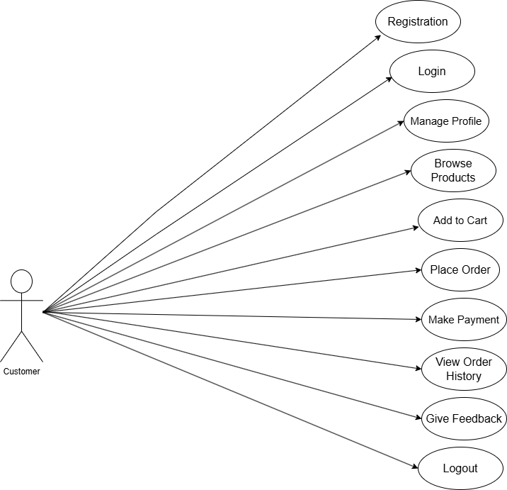
Customer use case Diagram

Use Case | Description
Registration | The user creates a new account by providing required details such as name, email, and password. Etc..
Login | The user logs into the web application using their credentials.
Manage Profile | The user can update personal details, change passwords, and manage account settings.
Browse Products | The user can explore available products, including laptops, desktops, accessories, and components.
Add to Cart | The user selects products and adds them to the shopping cart for purchase.
Place Order | The user confirms selected products and proceeds with the order placement.
Make Payment | The user selects a payment method (e.g., credit card, PayPal, UPI) and completes the payment.
View Order History | The user can check details of past orders, including status, invoices etc.
Give Feedback | The user provides feedback on products or services after purchase.
Customer Support | The user can request technical support, or complaints.
Logout | The user logs out of the system, ending their session securely.

3.3 Activity Diagram

User Registration Activity Diagram

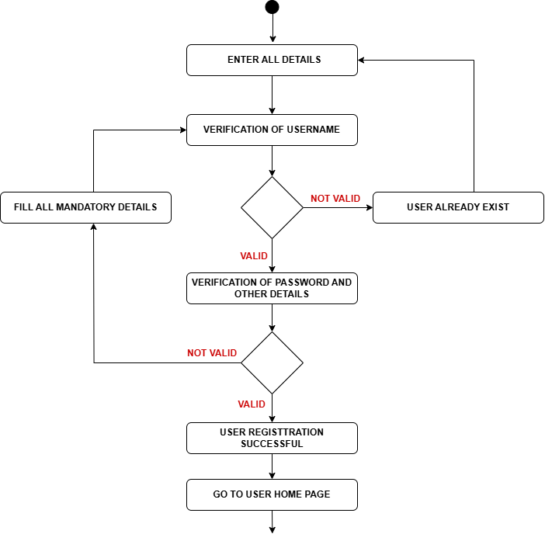

Admin Activity Diagram

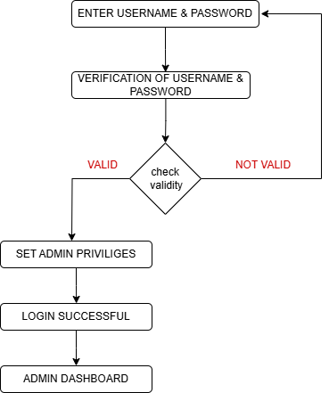

VD Computers Database Schema

1. Users Table
Stores all users (admins, employees, customers).
Column Name | Data Type | Description | Sample Data
user_id (PK) | INT | Unique identifier | 1
Full name | VARCHAR(100) | Full name | Raj Malhotra
email | VARCHAR(100) | Email address | Raj123@example.com
password | VARCHAR(255) | Hashed password | hashed_password_123
phone | VARCHAR(15) | Contact number | +91 8872211492
gender | ENUM(male/female/other) | Gender | male
dob | DATE | Date of birth | 1995-05-20
address | TEXT | Physical address | 123 Main St, City
role | ENUM(admin/employee/customer) | User role | customer
profile_image | VARCHAR(255) | Path to profile image | /images/john.jpg
created_at | TIMESTAMP | Account creation date | 2023-10-01 10:00:00
Linked Tables:
- Employees → user_id links to Employees.user_id.
- Customers → user_id links to Customers.user_id.
- Admins → user_id links to Admins.user_id.

2. Admins Table
Stores admin-specific details.
Column Name | Data Type | Description | Sample Data
admin_id (PK) | INT | Unique identifier | 1
user_id (FK) | INT | References Users.user_id | 1
access_level | ENUM(full/limited) | Admin access level | full
last_login | TIMESTAMP | Date of last login | 2023-10-01 10:00:00
Linked Tables:
- Users → Inherits user details via user_id.

3. Employees Table
Stores employee-specific details.
Column Name | Data Type | Description | Sample Data
employee_id (PK) | INT | Unique identifier | 1
user_id (FK) | INT | References Users.user_id | 2
position | VARCHAR(100) | Job position | Sales Manager
salary | DECIMAL(10,2) | Monthly salary | 4500.00
hire_date | DATE | Hire date | 2023-01-15
status | ENUM(active/resigned/terminated) | Employment status | active
Linked Tables:
- Users → Inherits user details via user_id.
- Sales → employee_id links to the employee handling the sale.
- Repairs → assigned_tech links to the technician (employee).

4. Customers Table
Stores customer-specific details.
Column Name | Data Type | Description | Sample Data
customer_id (PK) | INT | Unique identifier | 1
user_id (FK) | INT | References Users.user_id | 3
loyalty_points | INT | Reward points | 100
preferred_payment | VARCHAR(50) | Preferred payment method | Credit Card
last_purchase | TIMESTAMP | Date of last purchase | 2023-10-01 10:00:00
Linked Tables:
- Users → Inherits user details via user_id.
- Orders → customer_id links to customer orders.
- Complaints → customer_id identifies the complaining customer.
- Repairs → customer_id identifies the repair requester.

5. Suppliers Table
Stores supplier details for computer parts and accessories.
Column Name | Data Type | Description | Sample Data
supplier_id (PK) | INT | Unique identifier | 501
name | VARCHAR(150) | Supplier name | Tech Distributors
contact_person | VARCHAR(100) | Contact person name | Mark Spencer
phone | VARCHAR(15) | Contact number | +1123456789
email | VARCHAR(100) | Email address | supplier@example.com
address | TEXT | Physical address | 500 Industrial St, City
status | ENUM (active/inactive) | Supplier status | active
created_at | TIMESTAMP | Record creation date | 2023-09-10 08:30:00
Linked Tables:
- Products → supplier_id identifies the product supplier.

6. Categories Table
Stores product categories (e.g., Laptops, Desktops, Accessories).
Column Name | Data Type | Description | Sample Data
category_id (PK) | INT | Unique identifier | 1
name | VARCHAR(100) | Category name | Laptops
description | TEXT | Category description | High-performance laptops
created_at | TIMESTAMP | Category creation date | 2023-09-01 08:00:00
updated_at | TIMESTAMP | Last update date | 2023-10-01 10:00:00
Linked Tables:
- Products → category_id groups products by category.

7. Products Table
Stores computer products and accessories.
Column Name | Data Type | Description | Sample Data
product_id (PK) | INT | Unique identifier | 101
name | VARCHAR(150) | Product name | Dell XPS 15
category_id (FK) | INT | References Categories.category_id | 1
brand | VARCHAR(100) | Brand name | Dell
model | VARCHAR(100) | Model name | XPS 15 9520
description | TEXT | Product description | 15.6" FHD+, 16GB RAM, 512GB SSD
purchase_price | DECIMAL(10,2) | Cost price | 1200.00
selling_price | DECIMAL(10,2) | Selling price | 1499.99
warranty_period | INT | Warranty in months | 12
supplier_id (FK) | INT | References Suppliers.supplier_id | 501
added_at | TIMESTAMP | Product creation date | 2023-09-15 09:00:00
updated_at | TIMESTAMP | Last update date | 2023-10-01 11:00:00
Linked Tables:
- Categories → category_id classifies the product.
- Suppliers → supplier_id tracks the product’s supplier.
- Inventory → product_id tracks stock levels.
- Order_Items → product_id identifies items in orders.
- Transaction_Log → product_id logs inventory changes.

8. Inventory Table
Tracks stock movements for computer products.
Column Name | Data Type | Description | Sample Data
inventory_id (PK) | INT | Unique identifier | 1
product_id (FK) | INT | References Products.product_id | 101
stock_in | INT | Stock added | 25
stock_out | INT | Stock sold | 5
current_stock | INT | Current stock level | 20
last_updated | TIMESTAMP | Last update date | 2023-10-01 11:00:00
Linked Tables:
- Products → product_id maps to stock levels.
- Transaction_Log → Stock changes are logged here.

9. Orders Table
Tracks customer orders for computer products.
Column Name | Data Type | Description | Sample Data
order_id (PK) | INT | Unique identifier | 1001
customer_id (FK) | INT | References Users.user_id | 1
total_amount | DECIMAL(10,2) | Total order amount | 1579.98
order_status | ENUM(pending/shipped/delivered/canceled) | Status | delivered
order_date | TIMESTAMP | Order date | 2023-10-01 10:00:00
Linked Tables:
- Users → customer_id identifies the order owner.
- Order_Items → order_id breaks down order details.
- Sales → order_id finalizes the sale.
- Complaints → order_id links complaints to orders.

10. Sales Table
Tracks completed sales transactions.
Column Name | Data Type | Description | Sample Data
sale_id (PK) | INT | Unique identifier | 1
order_id (FK) | INT | References Orders.order_id | 1001
employee_id (FK) | INT | References Employees.employee_id | 3
total_sale | DECIMAL(10,2) | Total sale amount | 1579.98
sale_date | TIMESTAMP | Date of sale | 2023-10-01 10:30:00
Linked Tables:
- Orders → order_id references the original order.
- Employees → employee_id identifies the salesperson.

11. Expenses Table
Tracks shop expenses (e.g., rent, utilities).
Column Name | Data Type | Description | Sample Data
expense_id (PK) | INT | Unique identifier | 1
category | VARCHAR(100) | Expense category | Rent
amount | DECIMAL(10,2) | Expense amount | 1200.00
description | TEXT | Additional details | Monthly rent
date | TIMESTAMP | Expense date | 2023-10-01 09:00:00
Linked Tables:
- Independent but supports financial reporting (e.g., salaries linked to Employees).

12. Complaints Table
Stores customer complaints.
Column Name | Data Type | Description | Sample Data
complaint_id (PK) | INT | Unique identifier | 1
customer_id (FK) | INT | References Users.user_id | 1
order_id (FK) | INT | References Orders.order_id | 1001
complaint_text | TEXT | Complaint description | Received a defective product
status | ENUM(pending/resolved) | Complaint status | pending
resolved_date | TIMESTAMP | Date complaint was resolved | 2023-10-05 14:00:00
resolution_notes | TEXT | Details of resolution | Replaced defective unit
Linked Tables:
- Users → customer_id identifies the complainant.
- Orders → order_id links complaints to specific orders.

13. Repairs Table
Manages computer repair services.
Column Name | Data Type | Description | Sample Data
repair_id (PK) | INT | Unique identifier | 1
customer_id (FK) | INT | References Users.user_id | 5
device_type | VARCHAR(100) | Type of device | Laptop
brand | VARCHAR(100) | Device brand | HP
model | VARCHAR(100) | Device model | HP Pavilion 15
issue_details | TEXT | Description of the issue | Not turning on
repair_status | ENUM(pending/in progress/completed) | Status | In progress
assigned_tech (FK) | INT | References Employees.employee_id | 3
estimated_cost | DECIMAL(10,2) | Estimated repair cost | 150.00
actual_cost | DECIMAL(10,2) | Final repair cost | 145.00
repair_date | TIMESTAMP | Repair request date | 2023-10-05 14:00:00
completion_date | TIMESTAMP | Repair completion date | 2023-10-08 16:30:00
warranty_provided | INT | Warranty period (months) | 3
Linked Tables:
- Users → customer_id identifies the repair requester.
- Employees → assigned_tech links to the technician.

14. Order_Items Table
Tracks individual items in an order.
Column Name | Data Type | Description | Sample Data
order_item_id (PK) | INT | Unique identifier | 1
order_id (FK) | INT | References Orders.order_id | 1001
product_id (FK) | INT | References Products.product_id | 101
quantity | INT | Quantity purchased | 2
unit_price | DECIMAL(10,2) | Price per unit at sale time | 1499.99
Linked Tables:
- Orders → order_id groups items into an order.
- Products → product_id specifies the ordered item.

15. Transactions Table
Tracks inventory changes.
Column Name | Data Type | Description | Sample Data
transaction_id (PK) | INT | Unique identifier | 1
product_id (FK) | INT | References Products.product_id | 101
transaction_type | ENUM(restock/adjustment/return) | Type of change | restock
quantity | INT | Quantity changed | 10
reason | TEXT | Reason for change | Supplier restock
transaction_date | TIMESTAMP | Date of transaction | 2023-10-01 11:00:00
Linked Tables:
- Products → product_id tracks inventory changes.
- Inventory → Updates current_stock automatically.

3.3 Use-Case Reports
Customer Use-Case:

• Sign In: Login to access account.
• View Products: Browse by category or search.
• Add to Cart: Select and add products.
• Make Purchases: Complete transactions.
• Track Orders: Monitor order status.
• File Complaints: Report product/service issues.
Admin Use-Case:
• Manage Products: Add, update, or delete listings.
• View Sales Reports: Analyze data and generate reports.
• Handle Complaints: Resolve customer issues.
• Manage User Accounts: Create/update/deactivate users.
Support Staff Use-Case:
• Respond to Customer Inquiries: Provide assistance.

5. Technologies to be Used
• Database: MySQL.
• Development Tools: HTML, CSS, JavaScript.
• Web Server: .Laragon

6. Conclusion
The VD Computers website will provide a seamless online shopping experience with robust management features for administrators and support staff. Utilizing modern web technologies will ensure responsiveness, security, and efficiency in operations.

