BEEE LAB EVALUATION

Name : DEEPAK

UID-19BEC1024

Circuit diagram:-

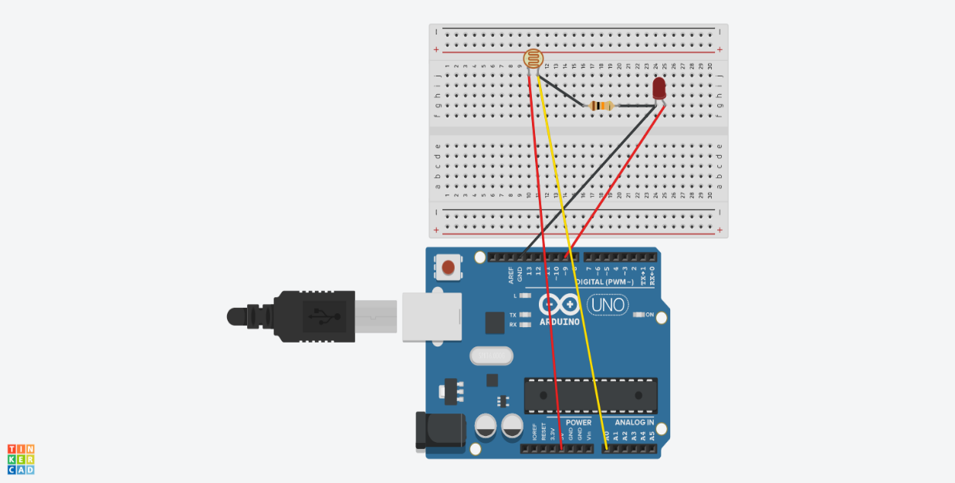

Theory:

Components used: Arduino UNO,LDR,LED,10k ohm resistor ,wires.

Coding:

int l = A0;

int sensorValue=0;

void setup()

{

Serial.begin(9600);

pinMode(9,OUTPUT);

}

void loop ()

{

sensorValue=analogRead(l);

Serial.println(sensorValue);

delay(100);

if(sensorValue>54)

{

digitalWrite(9,HIGH);

delay(500);

digitalWrite(9,LOW);

delay(500);

}

else

if(sensorValue>10)

{

digitalWrite(9,HIGH);

delay(100);

digitalWrite(9,LOW);

delay(100);

}

Precautions:

1)Always take care of negative and positive terminals.

2)Always disconnect the Arduino cable while testing the circuit.