SCHOOL OF COMPUTER SCIENCE AND ARTIFICIAL INTELLIGENCE |  |  |  |  | DEPARTMENT OF COMPUTER SCIENCE ENGINEERING
ProgramName:M. Tech |  |  |  | Assignment Type: Lab |  |  | AcademicYear:2025-2026
CourseCoordinatorName |  |  |  | Venkataramana Veeramsetty
CourseCode |  |  |  | CourseTitle |  | AI Assisted Problem Solving Using Python
Year/Sem |  |  | II/I | Regulation |  | R24
Date and Day  of Assignment |  |  | 10.11.2025 | Time(s)
Duration |  |  | 2 Hours | Applicableto  Batches
AssignmentNumber:8.3(Present assignment number)/24(Total number of assignments)
 | Q.No. | Question |  |  |  |  |  | ExpectedTime  to complete
 | 1 | Lab 8: Test-Driven Development with AI – Generating and Working with Test Cases  Lab Objectives:  - To introduce students to test-driven development (TDD) using AI code generation tools.  - To enable the generation of test cases before writing code implementations.  - To reinforce the importance of testing, validation, and error handling.  - To encourage writing clean and reliable code based on AI-generated test expectations.  Lab Outcomes (LOs):  After completing this lab, students will be able to:  - Use AI tools to write test cases for Python functions and classes.  - Implement functions based on test cases in a test-first development style.  - Use unittest or pytest to validate code correctness.  - Analyze the completeness and coverage of AI-generated tests.  - Compare AI-generated and manually written test cases for quality and logic  Task Description#1  Use AI to generate test cases for is_valid_email(email) and then implement the validator function.  Requirements:  - Must contain @ and . characters.  - Must not start or end with special characters.  - Should not allow multiple @.  Expected Output#1  - Email validation logic passing all test cases  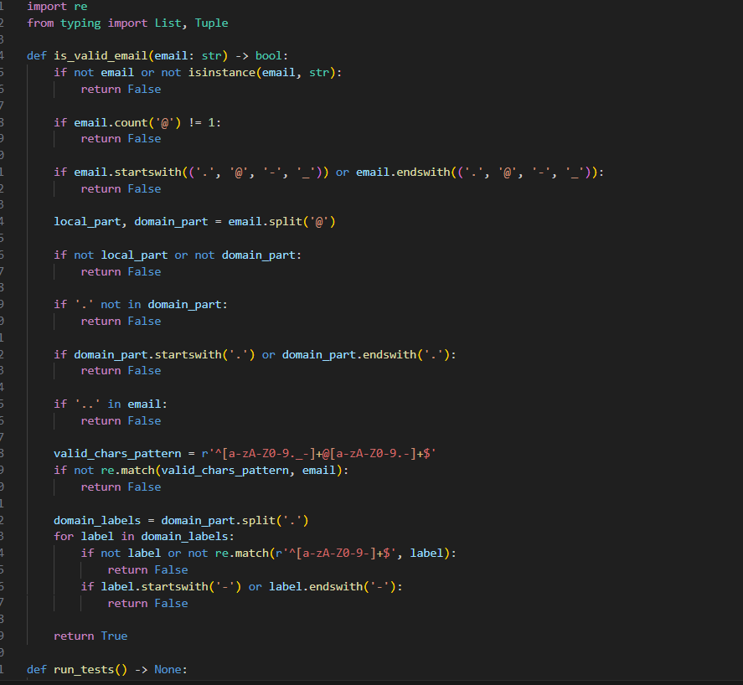  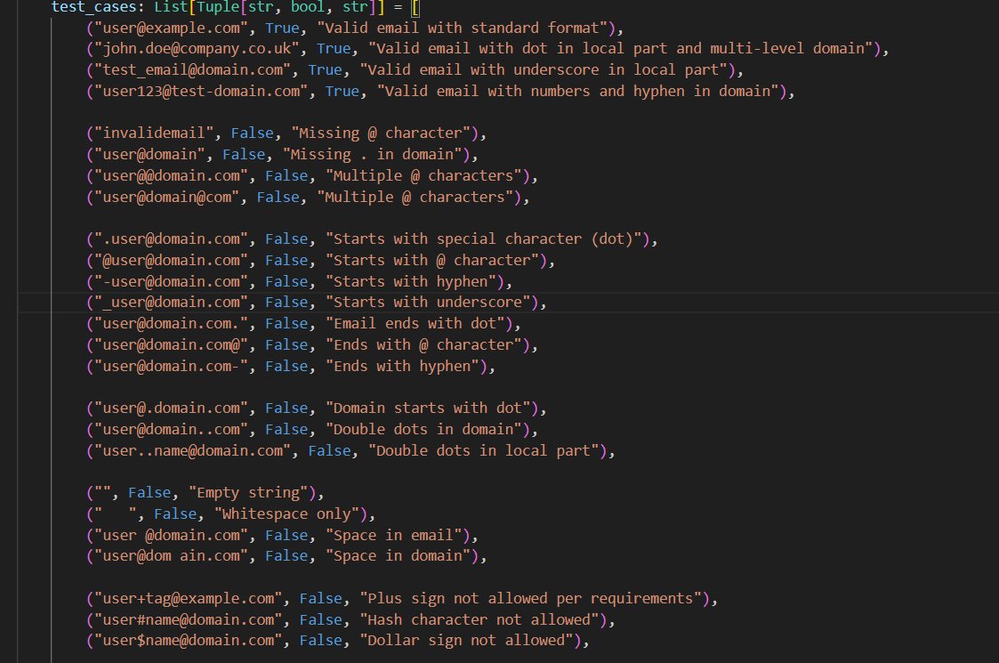  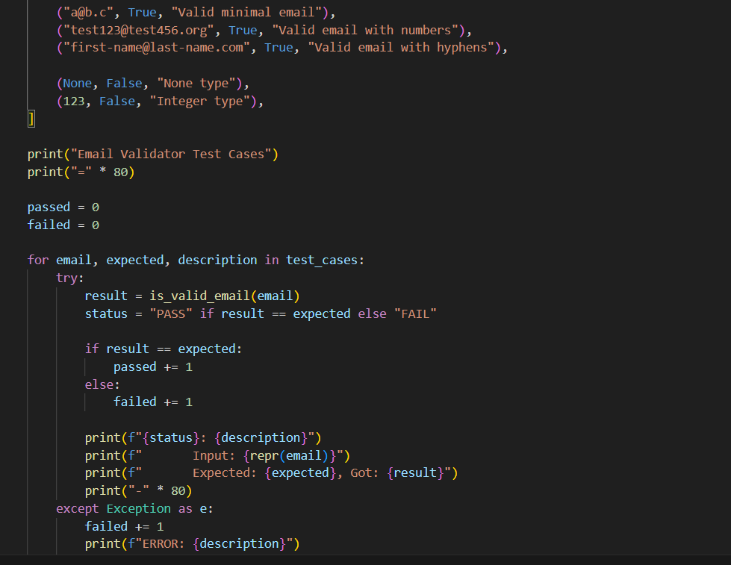  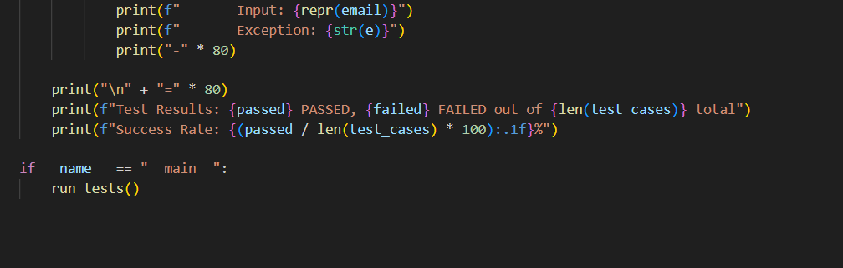  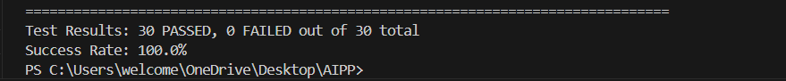  Task Description#2 (Loops)  - Ask AI to generate test cases for assign_grade(score) function. Handle boundary and invalid inputs.  Requirements  - AI should generate test cases for assign_grade(score) where: 90-100: A, 80-89: B, 70-79: C, 60-69: D, <60: F  - Include boundary values and invalid inputs (e.g., -5, 105, "eighty").  Expected Output#2  Grade assignment function passing test suite  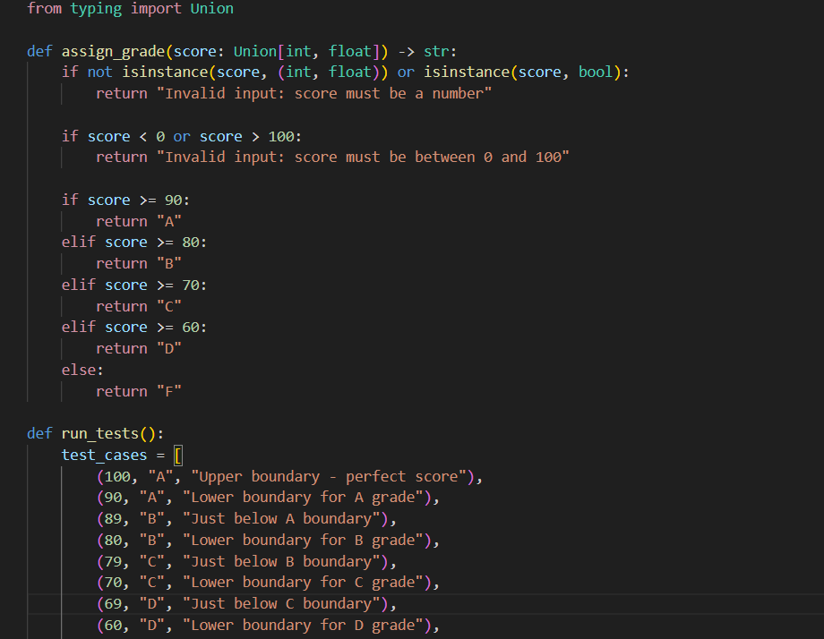  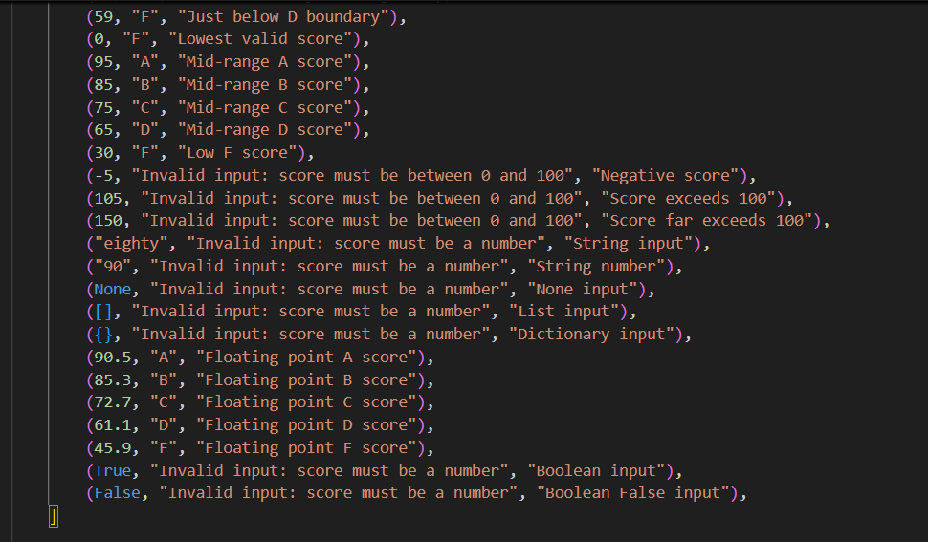  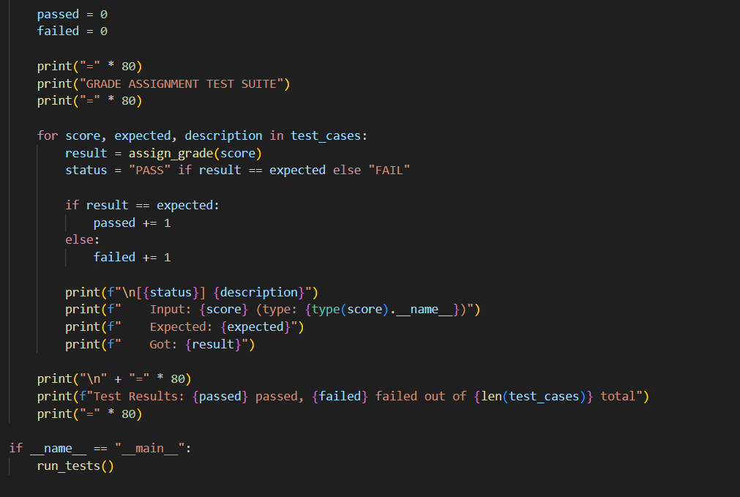  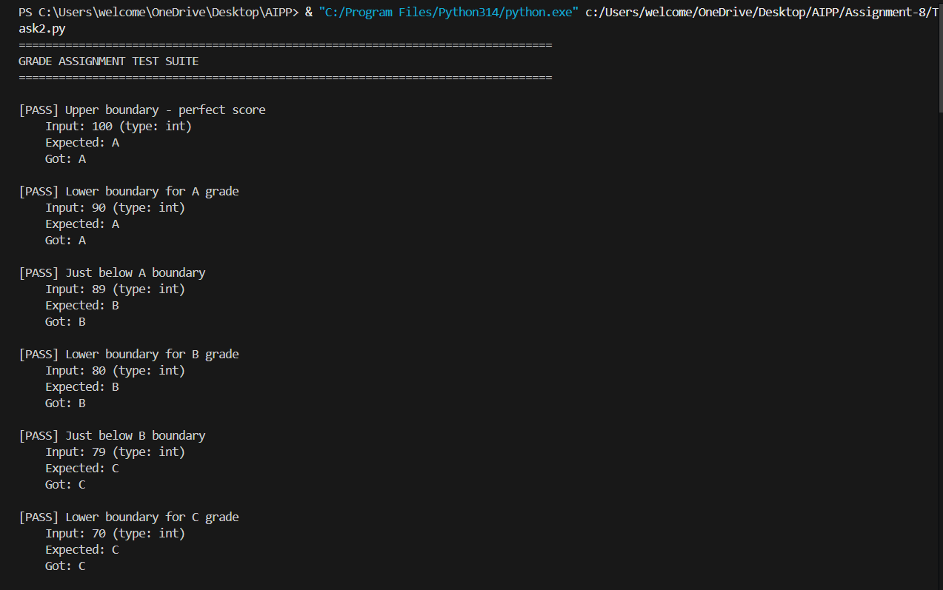  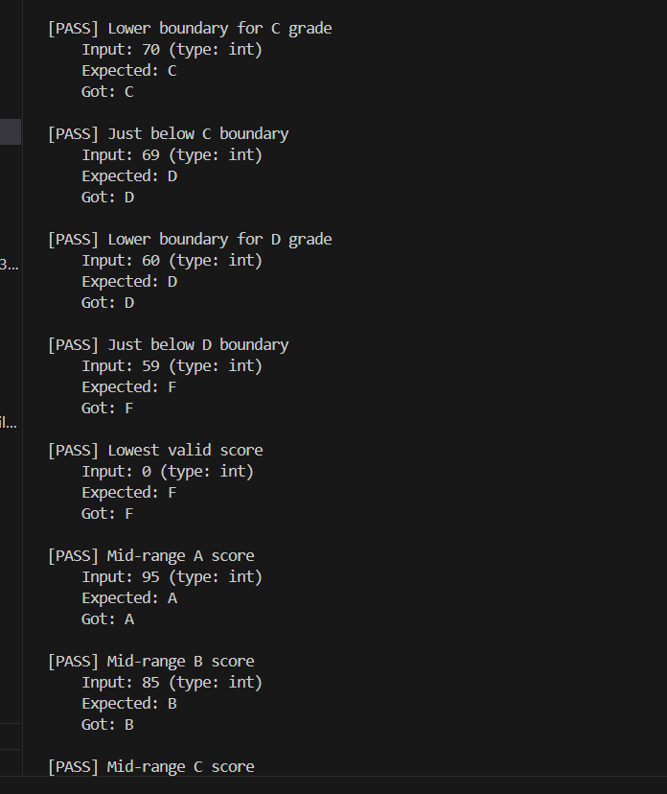  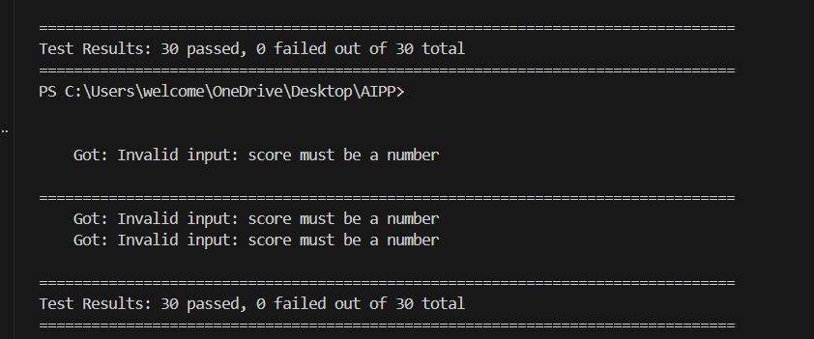  Task Description#3  - Generate test cases using AI for is_sentence_palindrome(sentence). Ignore case, punctuation, and spaces  Requirement  - Ask AI to create test cases for is_sentence_palindrome(sentence)  (ignores case, spaces, and punctuation).  - Example:  "A man a plan a canal Panama" → True  Expected Output#3  - Function returns True/False for cleaned sentences  - Implement the function to pass AI-generated tests.  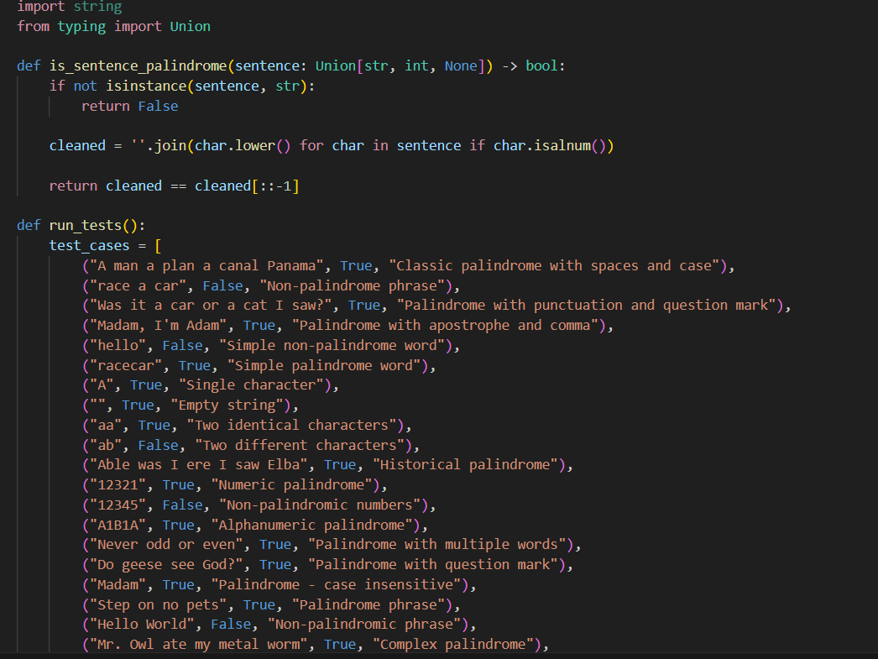  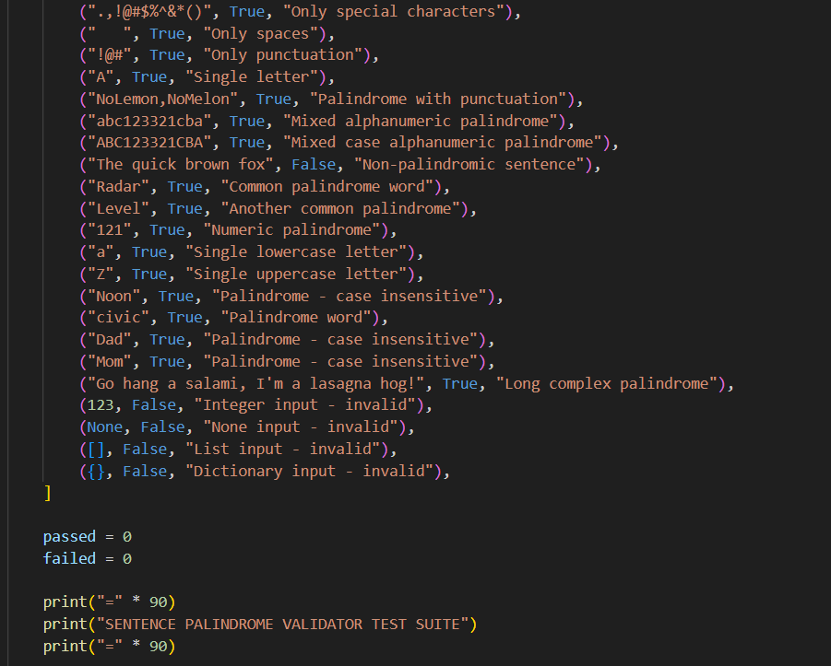  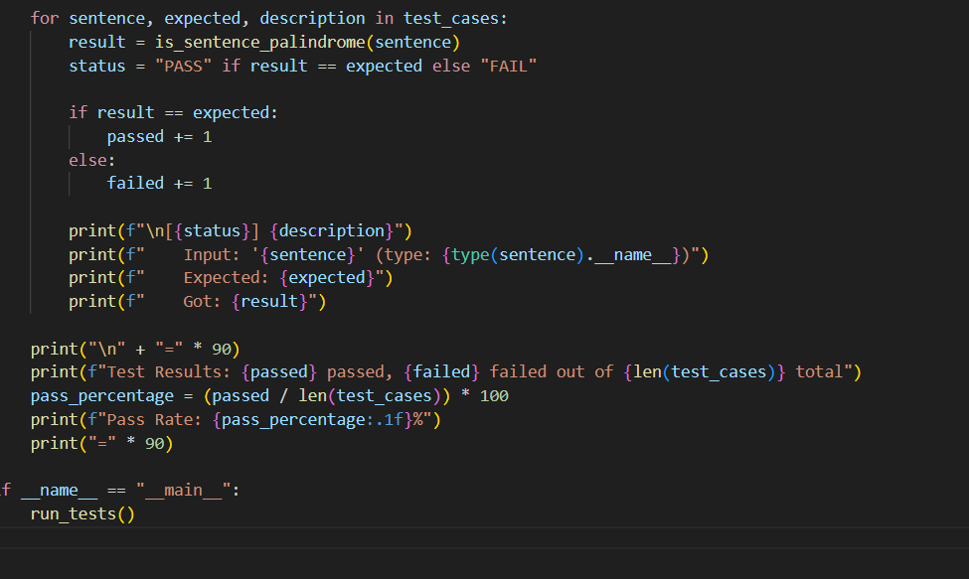  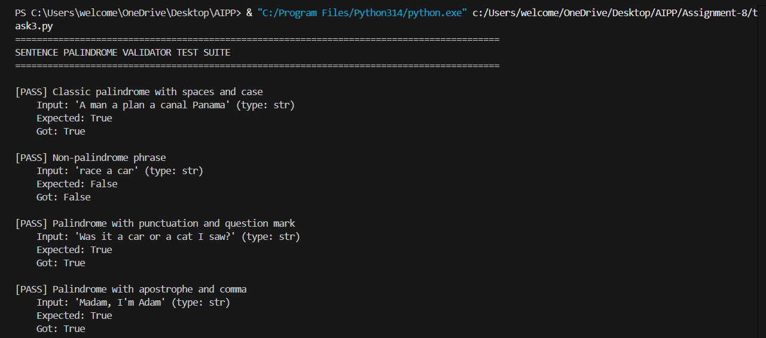  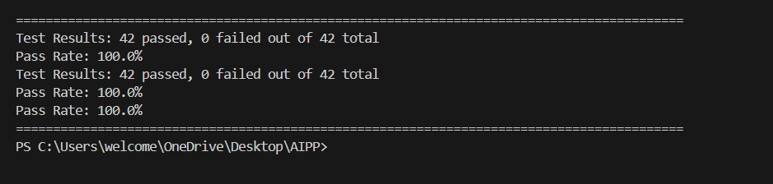  Task Description#4  - Let AI fix it Prompt AI to generate test cases for a ShoppingCart class (add_item, remove_item, total_cost).  Methods:  Add_item(name,orice)  Remove_item(name)  Total_cost()  Expected Output#4  - Full class with tested functionalities  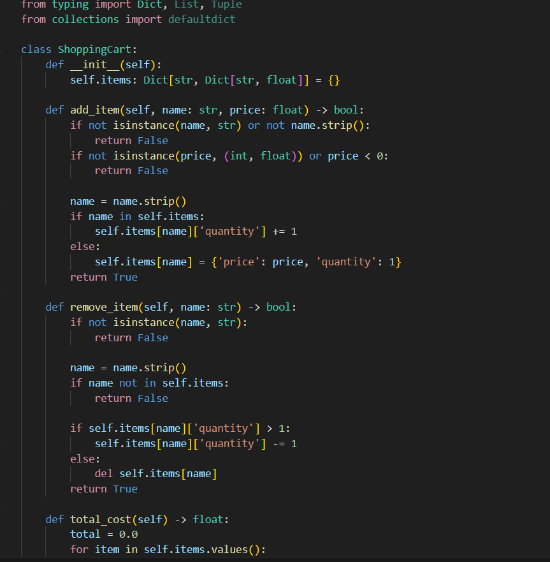  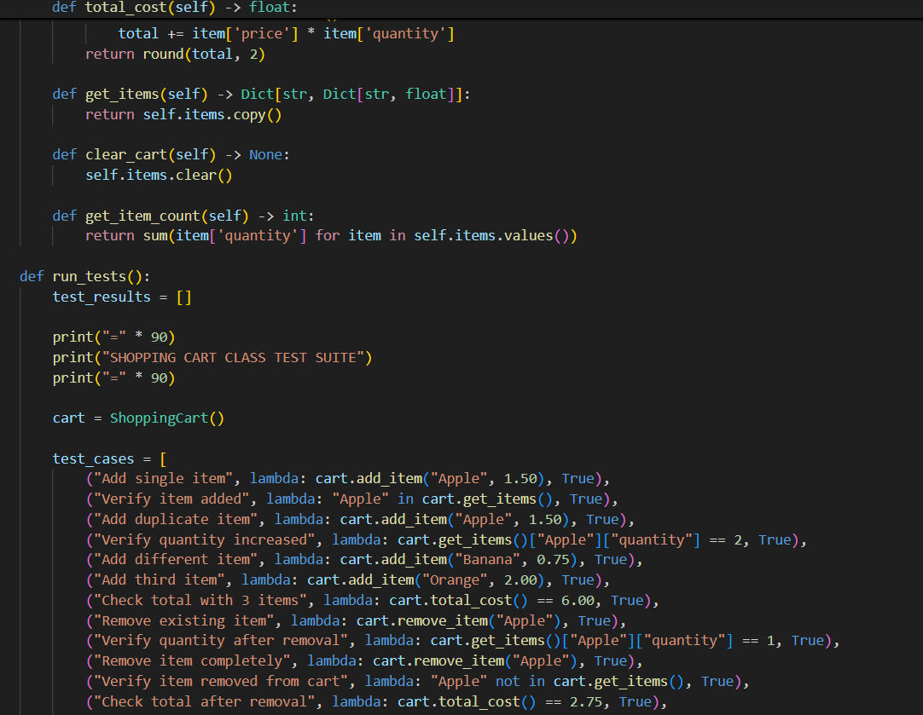  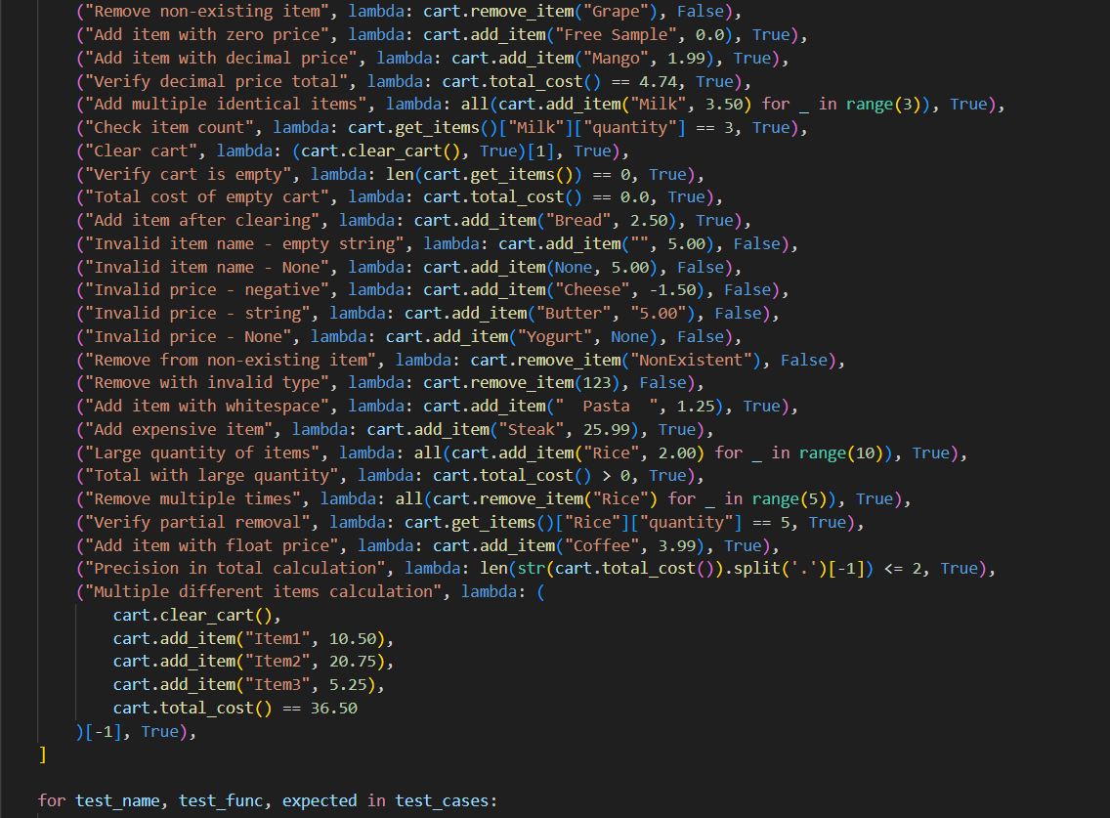  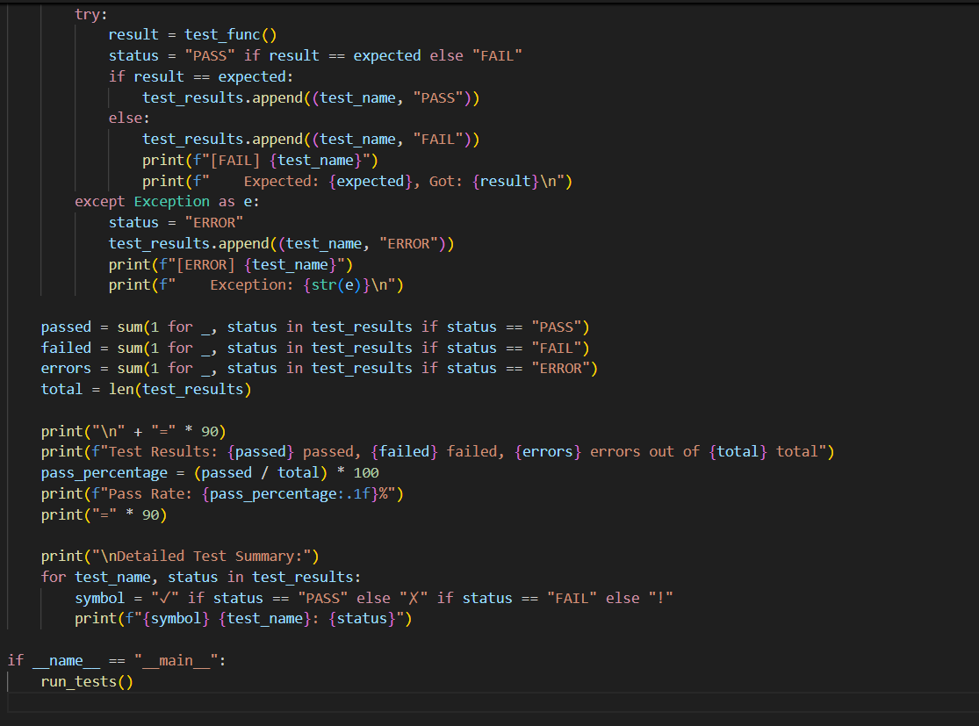  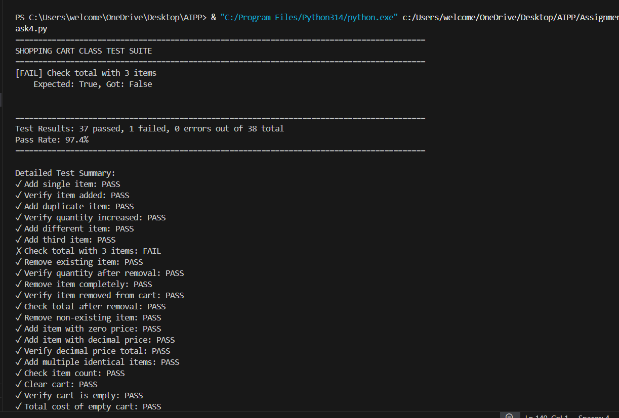  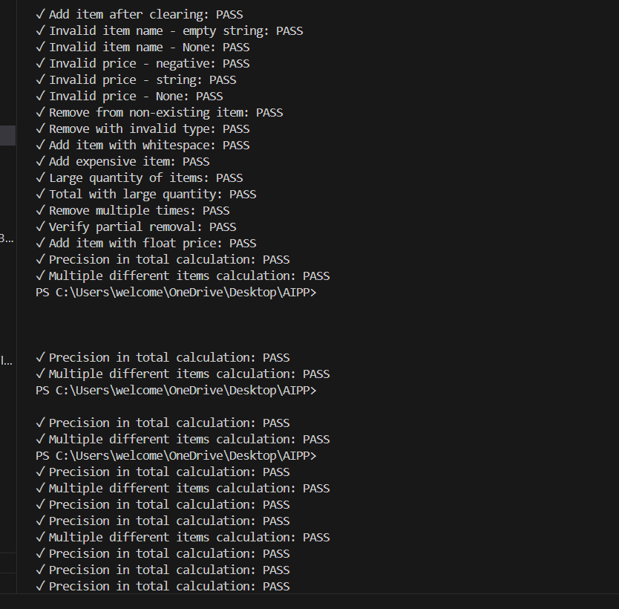  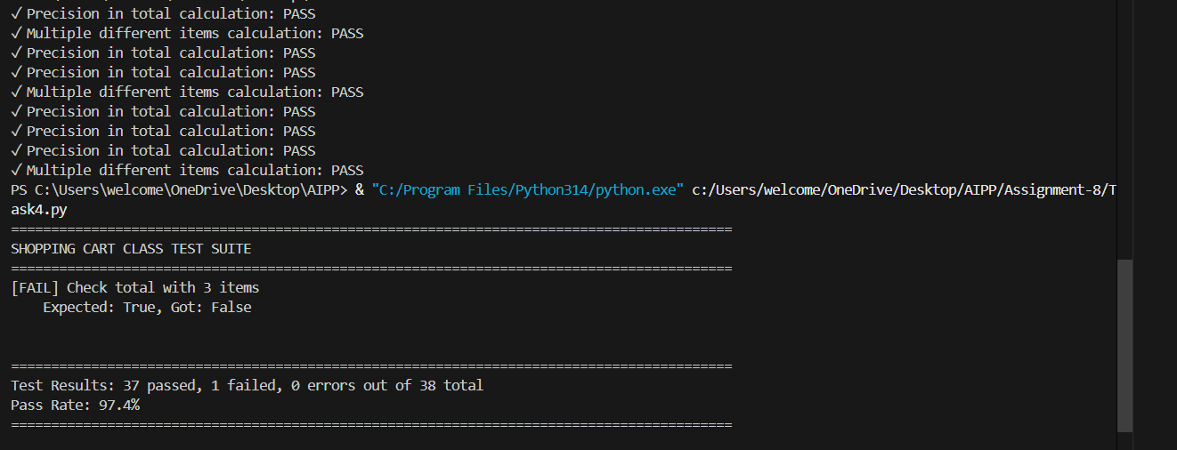  Task Description#5  - Use AI to write test cases for convert_date_format(date_str) to switch from "YYYY-MM-DD" to "DD-MM-YYYY".  Example: "2023-10-15" → "15-10-2023"  Expected Output#5  - Function converts input format correctly for all test cases  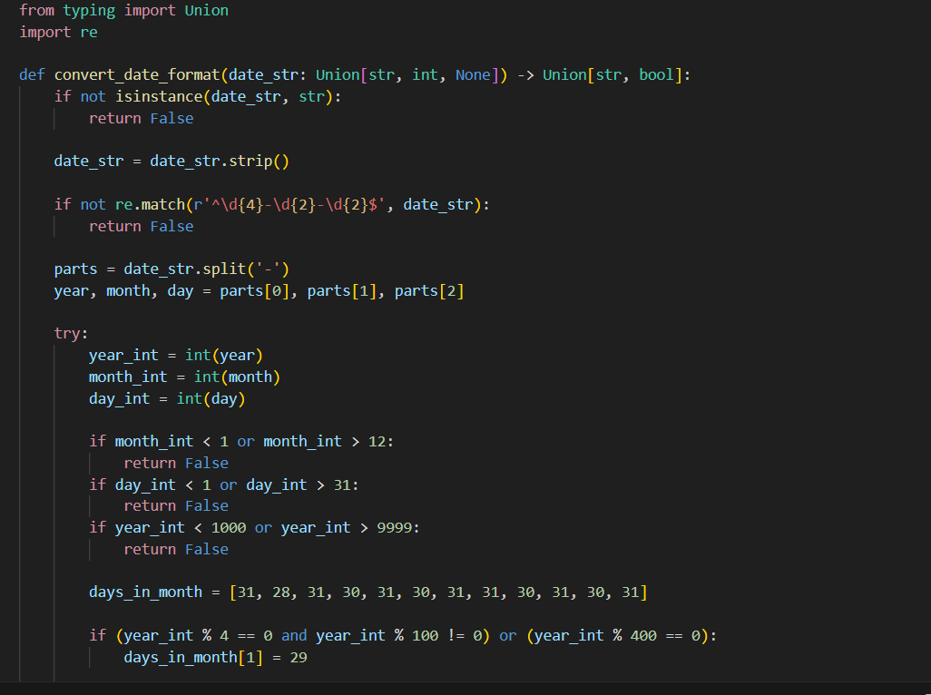  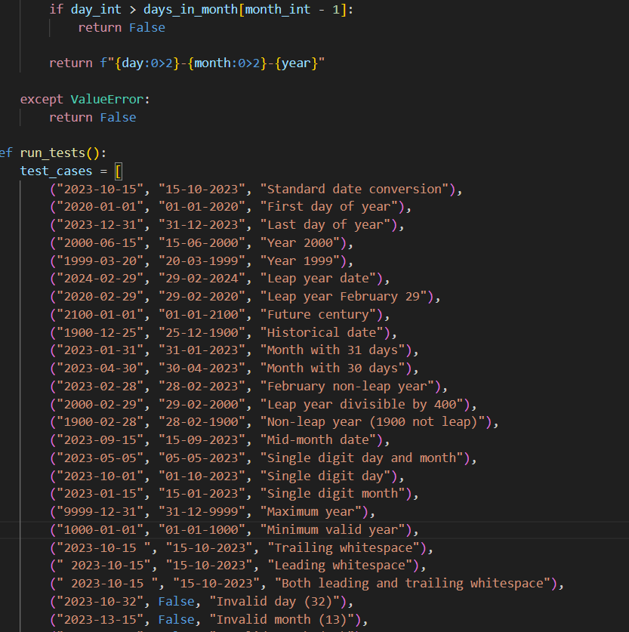  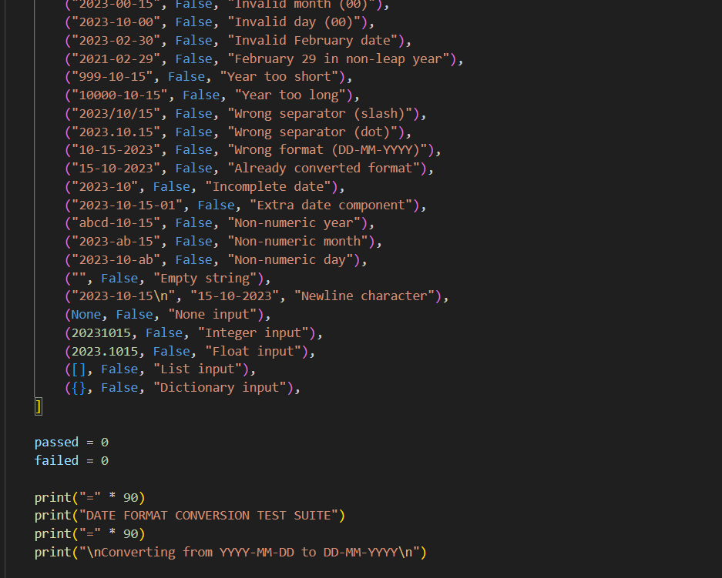  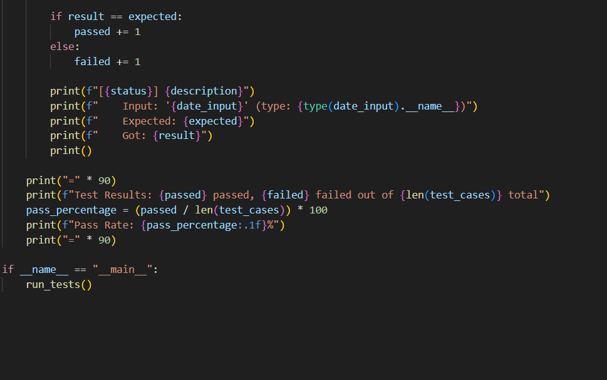  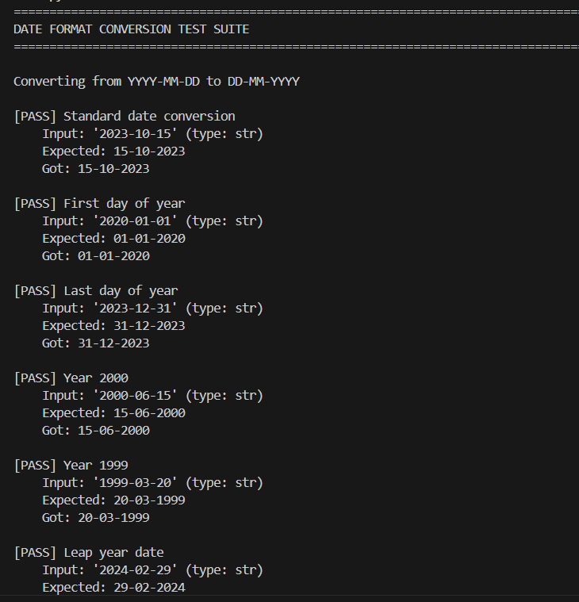  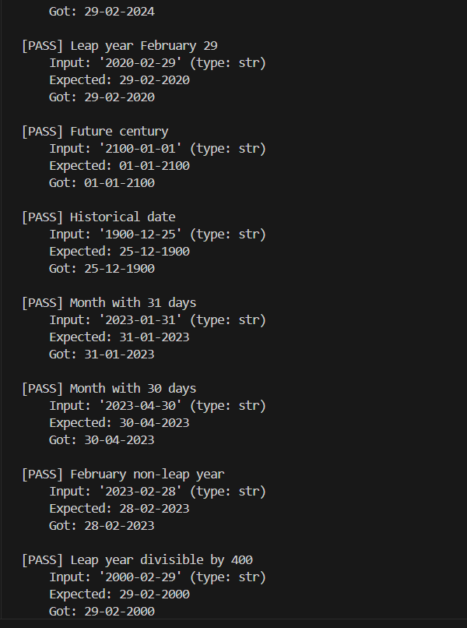  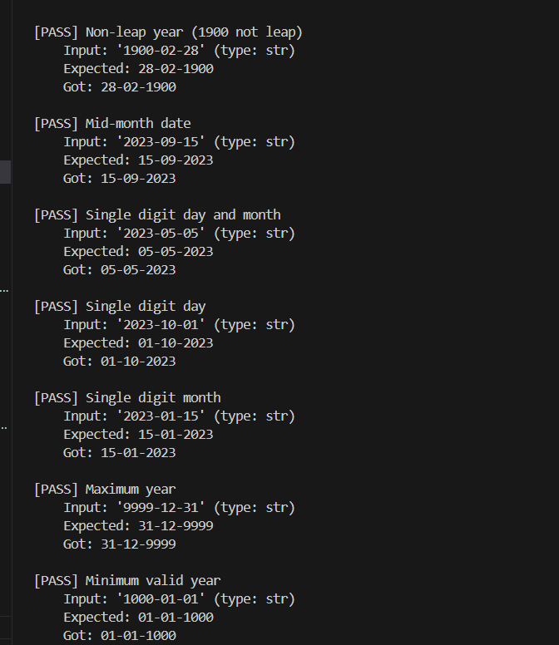  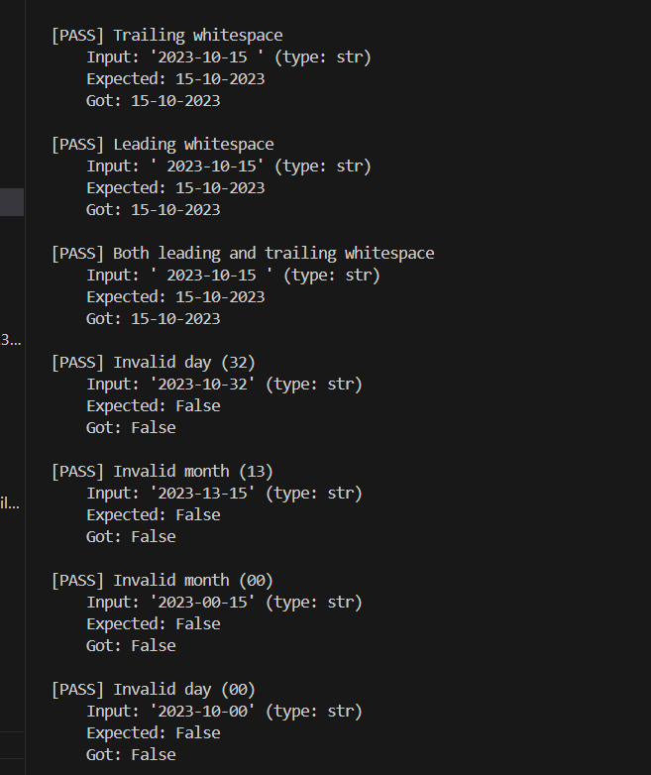  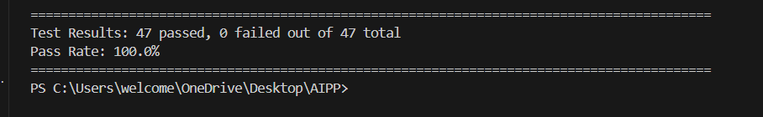  Note: Report should be submitted a word document for all tasks in a single document with prompts, comments & code explanation, and output and if required, screenshots |  |  |  |  |  | Week4 - Wednesday

