Set 3
5. Q1. Implement a Python class for a stack data structure (`push`, `pop`, `peek`). Use
GitHub Copilot to generate code, test its handling of edge cases, and explain any
improvements made.
PROMPT: create a python class to stack data structure.
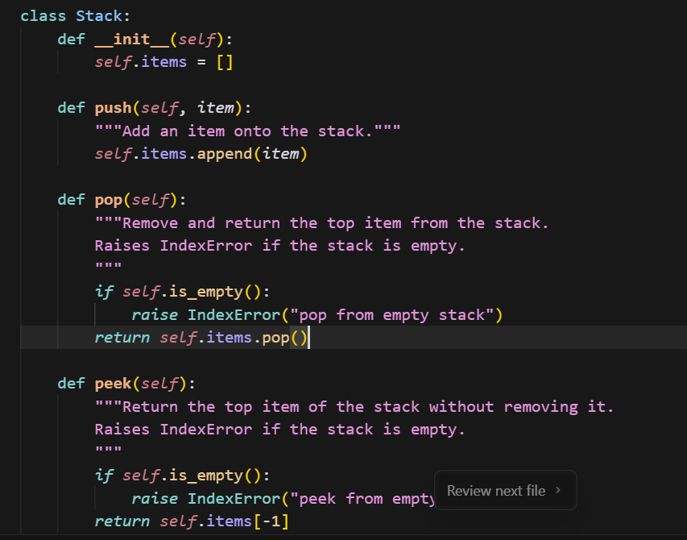
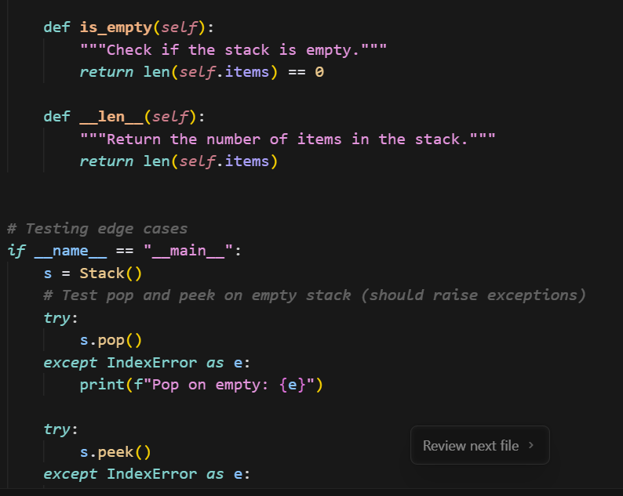
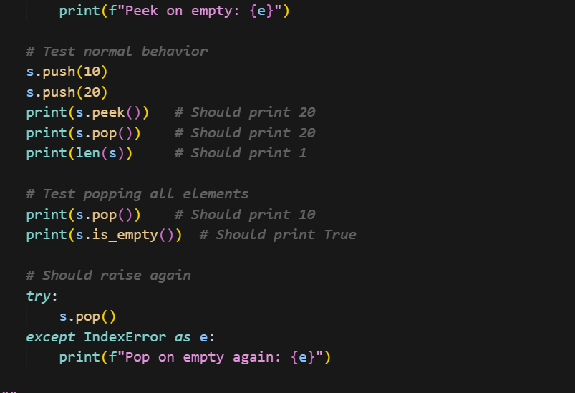
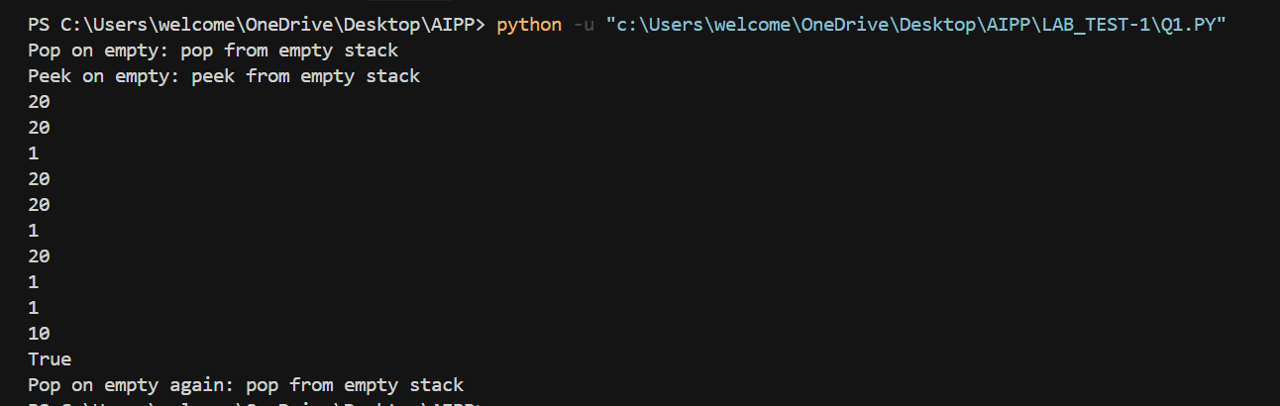
(Each question carries 5 marks)
6. Q2. Refactor a poorly commented Python function using an AI assistant for automatic
documentation. Evaluate clarity and completeness versus manual comments.
Prompt: To implement python function using AI assistant for automatic documentation.
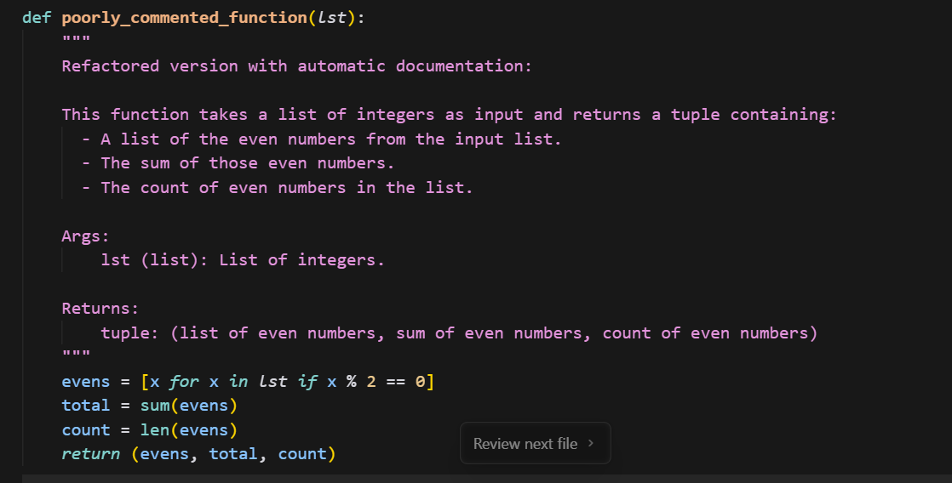
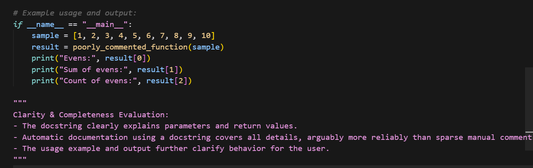
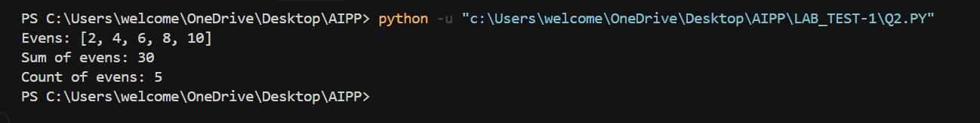
(Each question carries 5 marks)

