SCHOOL OF COMPUTER SCIENCE AND ARTIFICIAL INTELLIGENCE |  |  |  |  | DEPARTMENT OF COMPUTER SCIENCE ENGINEERING
Program Name: M. Tech/MCA |  |  |  | Assignment Type: Lab |  |  | AcademicYear:2025-2026
Course Coordinator Name |  |  |  | Venkataramana Veeramsetty
Course Code |  |  | 24CS002PC215 | Course Title |  | AI Assisted Problem Solving Using Python
Year/Sem |  |  | I/I | Regulation |  | R24
Date and Day  of Assignment |  |  | Week1 - Tuesday | Time(s)
Duration |  |  | 2 Hours | Applicable to  Batches |  | M. Tech/MCA
AssignmentNumber:03.3(Present assignment number)/24(Total number of assignments)
 | Q.No. | Question |  |  |  |  |  | ExpectedTime  to complete
 | 1 | Application for TGNPDCL  Objective: Build an application using Python program for TGNPDCL, to generate the bill based on energy consumption and type of customer with the help of AI tools.  Build a python application as per below instructions  - Read all the required data like PU,CU and Type of customer  - Calculate bill amount based on number of units consumed, type of customer and other charges  - Finally print the values of EC(Energy Charges),FC(Fixed Charges),CC(Customer Char-ges),ED(Electricity Duty Charges),bill as per expected output  Requirements:  - VS Code with Github Copilot and/or Google Colab with Gemini  - Students should bring power bill from their home  Deliverables:  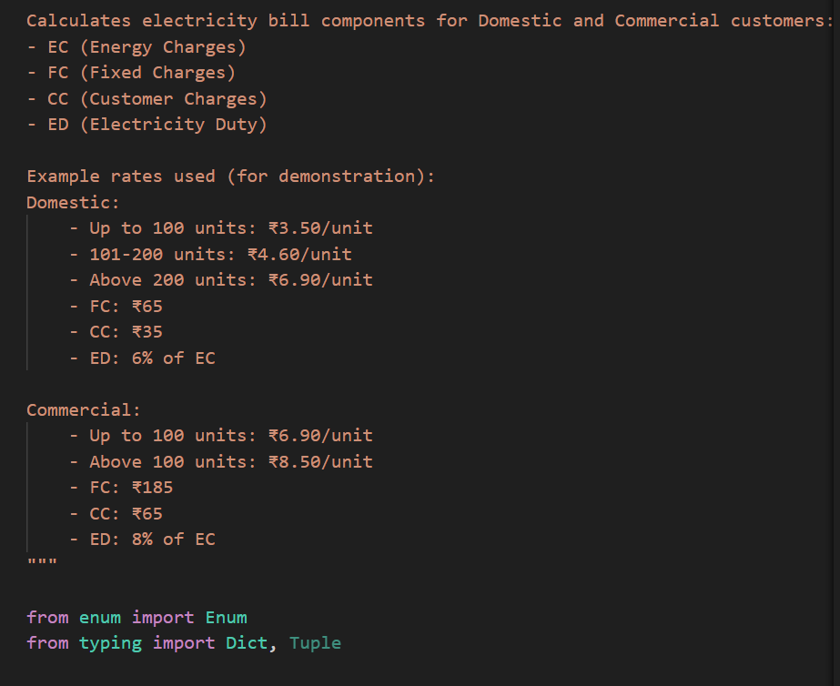  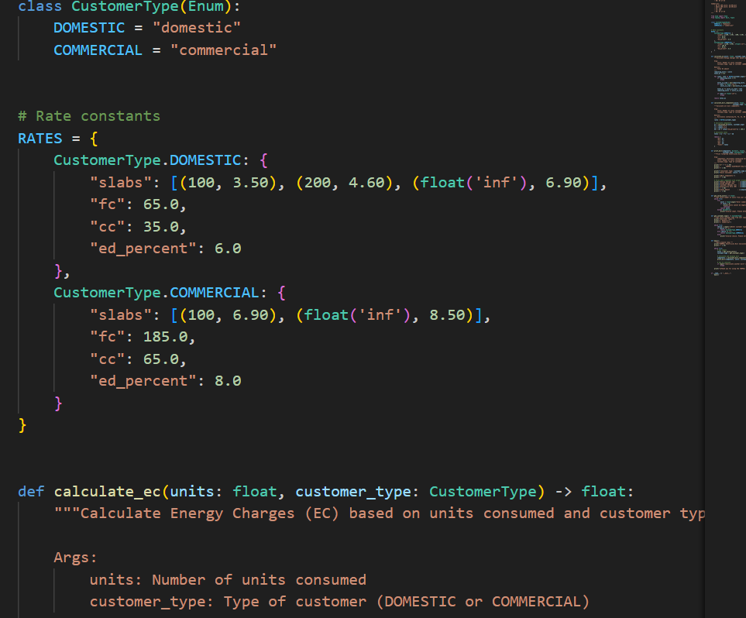  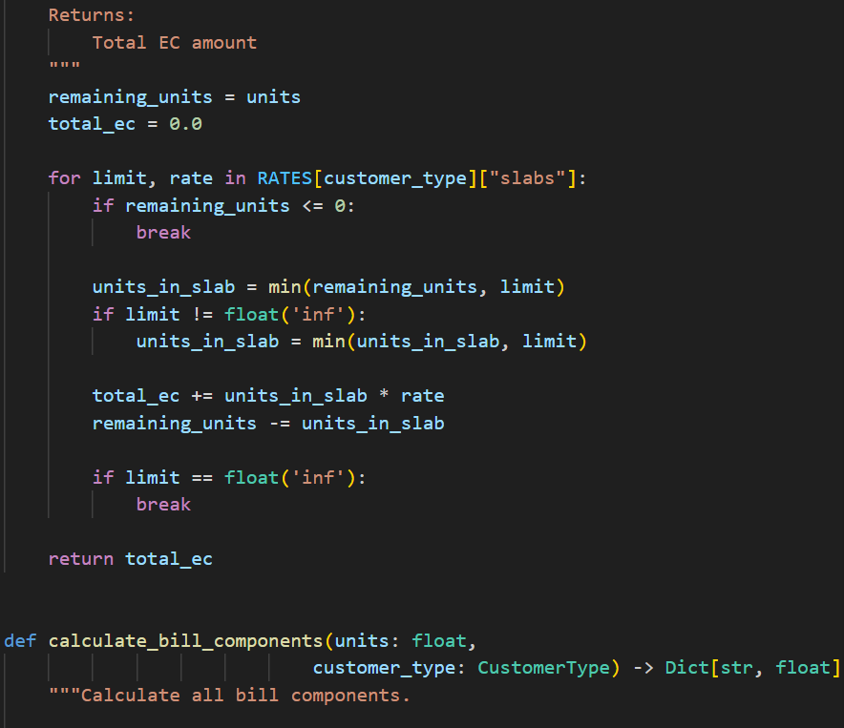  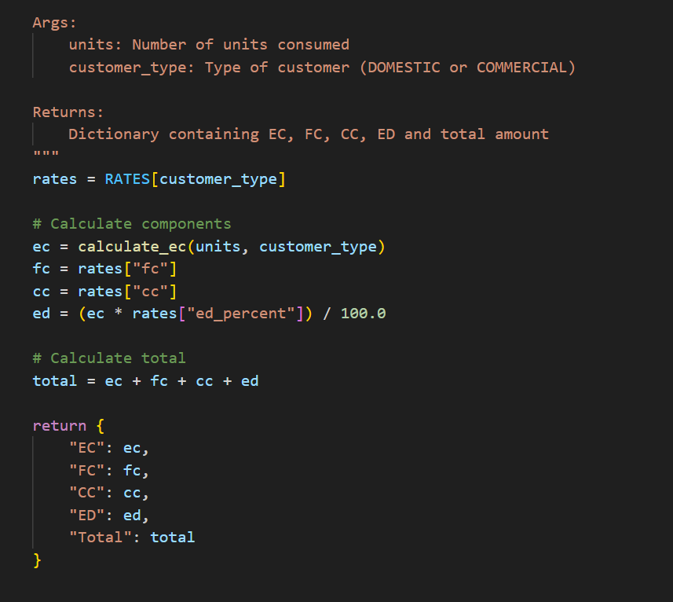  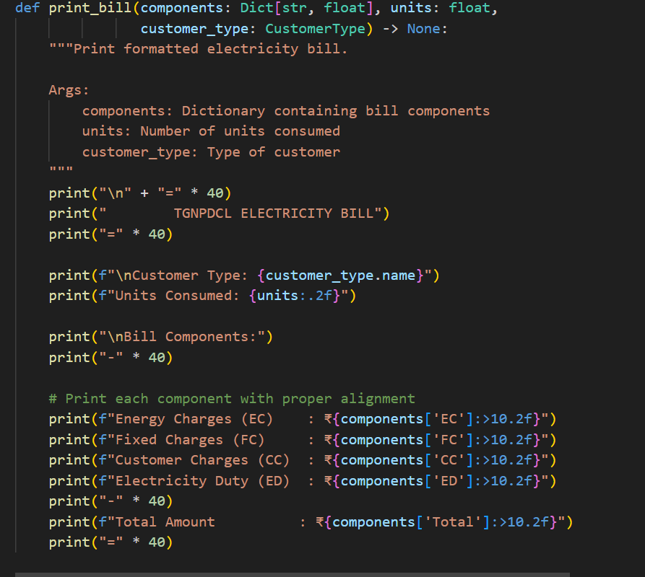  - 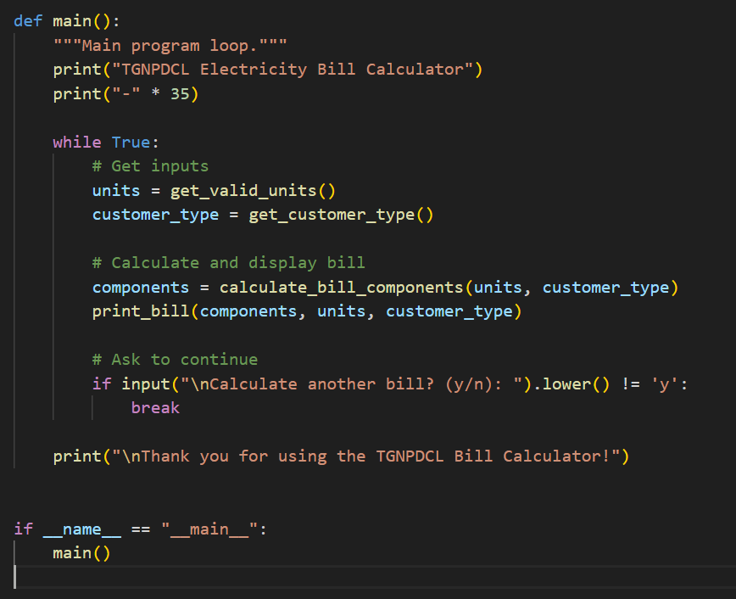  - 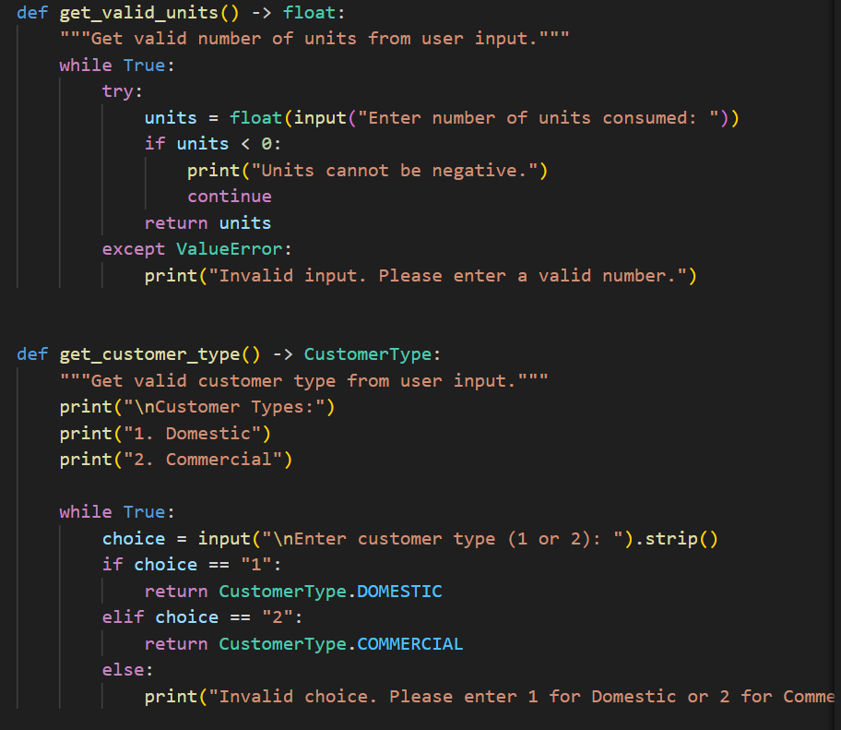  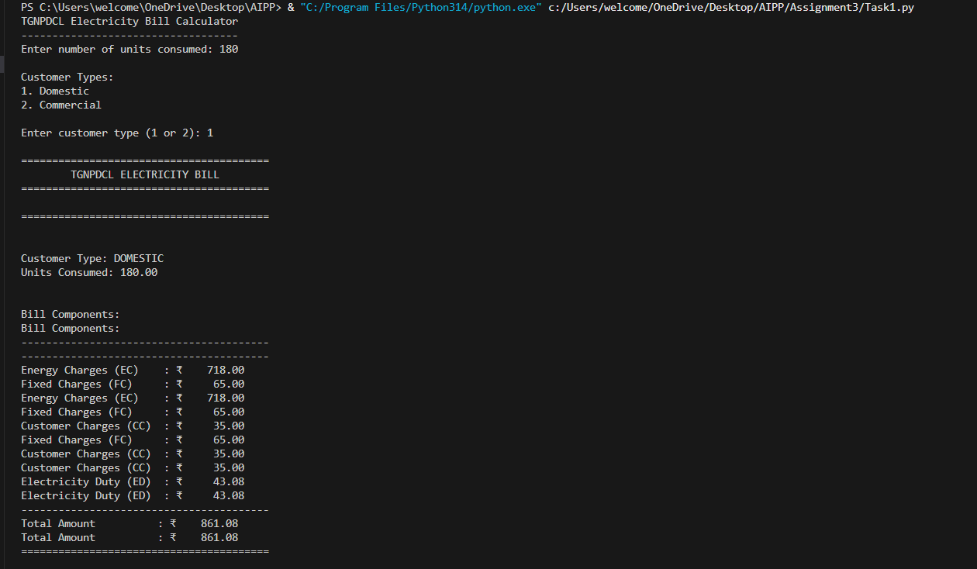  Print energy bill for given inputs and verify with bill taken by students |  |  |  |  |  | Week2 - Wednesday

