NAME: DEEPAK KUMAR
PROGRAMME: MCA
ENROLLMENT NUMBER: 2503B09911
2. A process is a program in execution.
In a real operating system, processes arrive at different times depending on user activity, I/O completion, or system load.
The First Come First Serve (FCFS) scheduling algorithm always selects the process that arrives first.
If there is a gap between the completion of one process and the arrival of the next, the CPU remains idle, and your program must correctly account for this idle time.

Scenario
A system is running multiple processes submitted by different users.
The CPU receives the following processes in a non-ordered (random) manner:
Process | Arrival Time | CPU Burst Time
P1 | 4 | 6
P2 | 1 | 3
P3 | 7 | 2
P4 | 0 | 4
P5 | 5 | 5
The operating system uses Non-Preemptive FCFS Scheduling.

Tasks
(1) Write a program to implement FCFS scheduling
Your program must:
- Input AT and BT for each process
- Sort processes in ascending order of arrival time
- Handle CPU idle time (if the next process has not yet arrived)
- Compute:
  - Completion Time (CT)
  - Turnaround Time (TAT = CT – AT)
  - Waiting Time (WT = TAT – BT)
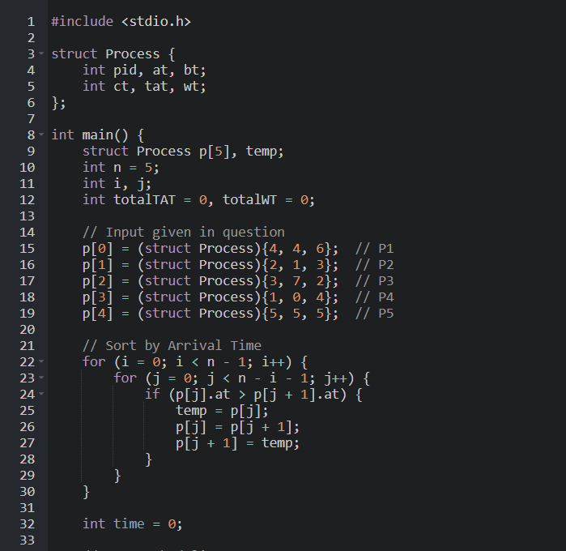
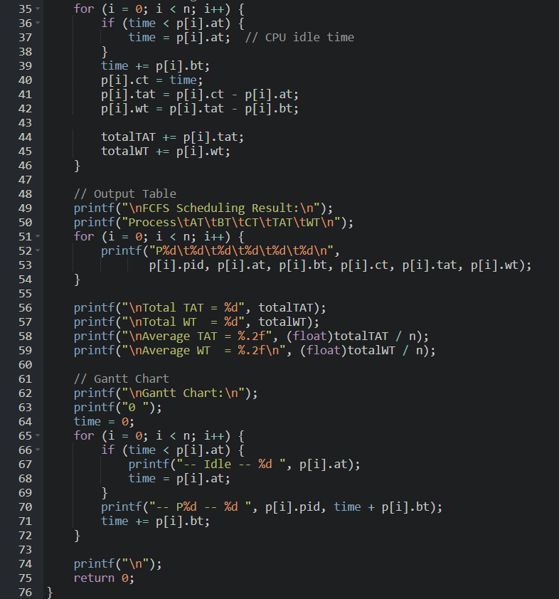
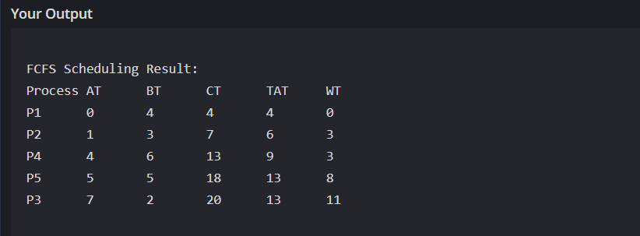
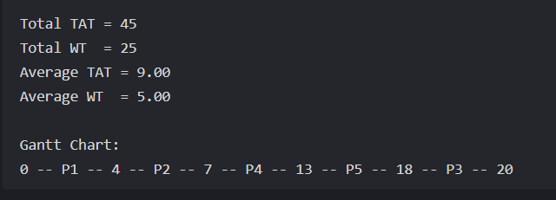

(2) Output Requirements
Your program must print:
- A properly formatted FCFS result table
- Total TAT and WT
- Average TAT and WT
- Gantt Chart showing idle time if present

(3) Manual Calculation Task for Students
Before running the code, students must manually:
- Order processes based on arrival time
- Show how CPU becomes idle when needed
- Compute CT, TAT, WT
- Draw the Gantt Chart
- Verify with program output

