Assignment 6: Java Array Programs
Five Java programs with source code and tested output screenshots
Student Name | Deepak
Student ID | 25SCS1003004869
Assignment | 6
Course / Section | Java Programming

Introduction
This assignment focuses on array manipulation in Java. It covers fundamental operations such as calculating the sum of elements, finding the largest value, searching for a specific item, reversing the order of elements, and counting occurrences. Each program was compiled and tested with representative inputs.

Programs Included
No. | Program | Purpose
1 | ArraySum.java | Calculates the sum of all elements in an array.
2 | LargestElement.java | Identifies the maximum value in an array.
3 | SearchElement.java | Locates a specific element and returns its index.
4 | ReverseArray.java | Reverses the sequence of elements in an array.
5 | CountOccurrence.java | Counts how many times a target element appears.

Problem 1: Find Sum of Array Elements
Iterates through the array and accumulates the total sum of all stored integers.

Java Source Code
import java.util.Scanner;
public class ArraySum {
public static void main(String[] args) {
Scanner input = new Scanner(System.in);
System.out.print("Enter the number of elements: ");
int n = input.nextInt();
int[] arr = new int[n];
int sum = 0;
System.out.println("Enter " + n + " elements:");
for (int i = 0; i < n; i++) {
arr[i] = input.nextInt();
sum += arr[i];
}
System.out.println("The sum of array elements is: " + sum);
input.close();
}
}

Program Output Screenshot
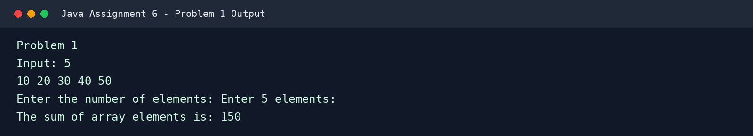

Problem 2: Find Largest Element in an Array
Initializes the largest variable with the first element and updates it as it scans the rest of the array.

Java Source Code
import java.util.Scanner;
public class LargestElement {
public static void main(String[] args) {
Scanner input = new Scanner(System.in);
System.out.print("Enter the number of elements: ");
int n = input.nextInt();
if (n <= 0) {
System.out.println("Invalid array size.");
return;
}
int[] arr = new int[n];
System.out.println("Enter " + n + " elements:");
for (int i = 0; i < n; i++) {
arr[i] = input.nextInt();
}
int largest = arr[0];
for (int i = 1; i < n; i++) {
if (arr[i] > largest) {
largest = arr[i];
}
}
System.out.println("The largest element in the array is: " + largest);
input.close();
}
}

Program Output Screenshot
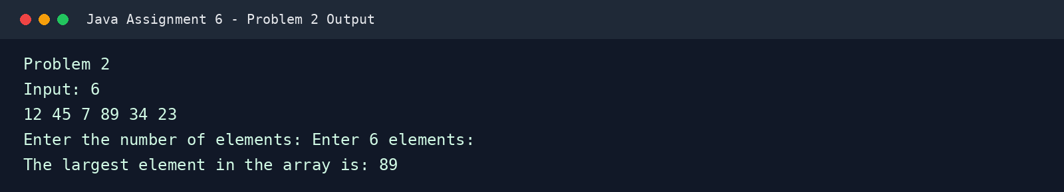

Problem 3: Search an Element in an Array
Performs a linear search to find the first occurrence of a target value and displays its position.

Java Source Code
import java.util.Scanner;
public class SearchElement {
public static void main(String[] args) {
Scanner input = new Scanner(System.in);
System.out.print("Enter the number of elements: ");
int n = input.nextInt();
int[] arr = new int[n];
System.out.println("Enter " + n + " elements:");
for (int i = 0; i < n; i++) {
arr[i] = input.nextInt();
}
System.out.print("Enter the element to search: ");
int target = input.nextInt();
int index = -1;
for (int i = 0; i < n; i++) {
if (arr[i] == target) {
index = i;
break;
}
}
if (index != -1) {
System.out.println("Element " + target + " found at index: " + index);
} else {
System.out.println("Element " + target + " not found in the array.");
}
input.close();
}
}

Program Output Screenshot
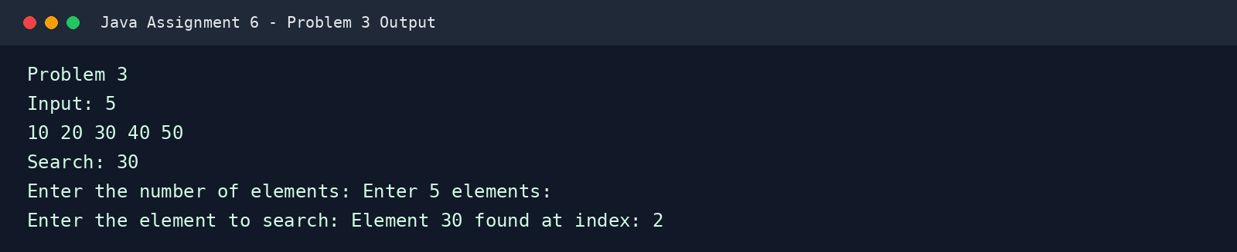

Problem 4: Reverse an Array
Swaps elements from the beginning and end of the array to invert their order in-place.

Java Source Code
import java.util.Scanner;
public class ReverseArray {
public static void main(String[] args) {
Scanner input = new Scanner(System.in);
System.out.print("Enter the number of elements: ");
int n = input.nextInt();
int[] arr = new int[n];
System.out.println("Enter " + n + " elements:");
for (int i = 0; i < n; i++) {
arr[i] = input.nextInt();
}
// Reversing the array
for (int i = 0; i < n / 2; i++) {
int temp = arr[i];
arr[i] = arr[n - 1 - i];
arr[n - 1 - i] = temp;
}
System.out.println("Reversed array:");
for (int i = 0; i < n; i++) {
System.out.print(arr[i] + " ");
}
System.out.println();
input.close();
}
}

Program Output Screenshot
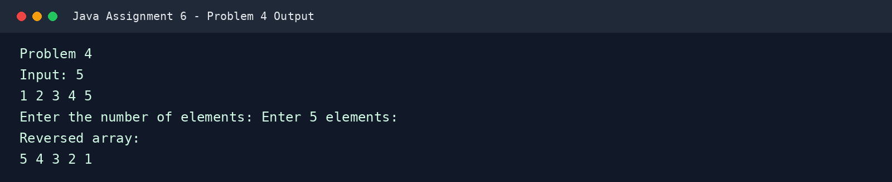

Problem 5: Count Occurrence of an Element in an Array
Scans the array and increments a counter whenever the target element is encountered.

Java Source Code
import java.util.Scanner;
public class CountOccurrence {
public static void main(String[] args) {
Scanner input = new Scanner(System.in);
System.out.print("Enter the number of elements: ");
int n = input.nextInt();
int[] arr = new int[n];
System.out.println("Enter " + n + " elements:");
for (int i = 0; i < n; i++) {
arr[i] = input.nextInt();
}
System.out.print("Enter the element to count: ");
int target = input.nextInt();
int count = 0;
for (int i = 0; i < n; i++) {
if (arr[i] == target) {
count++;
}
}
System.out.println("Element " + target + " occurs " + count + " times in the array.");
input.close();
}
}

Program Output Screenshot
