Assignment 10: Wrapper Classes in Java
Student Name | Deepak
Student ID | 25SCS1003004869
Assignment | 10 (Wrapper Classes)
Course / Section | Java Programming

Part A: Conceptual Questions

1. What are Wrapper Classes in Java?
Wrapper classes are object versions of Java’s primitive data types. Java provides them so primitive values can be used where an object is required, such as in collections, and so useful conversion and utility methods are available. Examples include Integer for int and Double for double.

2. Corresponding Wrapper Class for Each Primitive Type
byte → Byte
short → Short
int → Integer
long → Long
float → Float
double → Double
char → Character
boolean → Boolean

3. Primitive Data Type versus Wrapper Class
A primitive stores a simple value directly and is efficient for basic calculations; examples are int and double. A wrapper is an object containing the corresponding value; examples are Integer and Double. A primitive cannot be null, while a wrapper reference can be null. Wrapper classes also provide methods such as Integer.parseInt().

4. What is Autoboxing?
Autoboxing is the automatic conversion of a primitive value into its corresponding wrapper object. For example, int number = 100; Integer obj = number; converts the int to an Integer automatically.

5. What is Unboxing?
Unboxing is the automatic conversion of a wrapper object back into its corresponding primitive value. For example, Integer obj = 250; int number = obj; extracts the int value from the Integer object.

6. Integer.parseInt() and Integer.valueOf()
Integer.parseInt("250") returns the primitive int value 250. Integer.valueOf("250") returns an Integer object containing 250. Both parse a numeric string, but parseInt is useful when a primitive is needed, while valueOf is useful when an object is needed. Java may reuse cached Integer objects for some values.

Part B: Basic Programming

1. Primitive and Wrapper Variables
This program declares all eight primitive data types and their corresponding wrapper variables, then displays both values.
public class PrimitiveWrapperVariables {
public static void main(String[] args) {
byte primitiveByte = 10;
short primitiveShort = 200;
int primitiveInt = 1000;
long primitiveLong = 100000L;
float primitiveFloat = 12.5f;
double primitiveDouble = 99.99;
char primitiveChar = 'D';
boolean primitiveBoolean = true;
Byte wrapperByte = 10;
Short wrapperShort = 200;
Integer wrapperInt = 1000;
Long wrapperLong = 100000L;
Float wrapperFloat = 12.5f;
Double wrapperDouble = 99.99;
Character wrapperChar = 'D';
Boolean wrapperBoolean = true;
System.out.println("PRIMITIVE AND WRAPPER VARIABLES");
System.out.println("===============================");
System.out.println("byte : " + primitiveByte + " | Byte : " + wrapperByte);
System.out.println("short : " + primitiveShort + " | Short : " + wrapperShort);
System.out.println("int : " + primitiveInt + " | Integer : " + wrapperInt);
System.out.println("long : " + primitiveLong + " | Long : " + wrapperLong);
System.out.println("float : " + primitiveFloat + " | Float : " + wrapperFloat);
System.out.println("double : " + primitiveDouble + " | Double : " + wrapperDouble);
System.out.println("char : " + primitiveChar + " | Character : " + wrapperChar);
System.out.println("boolean : " + primitiveBoolean + " | Boolean : " + wrapperBoolean);
}
}
Program Output Screenshot:
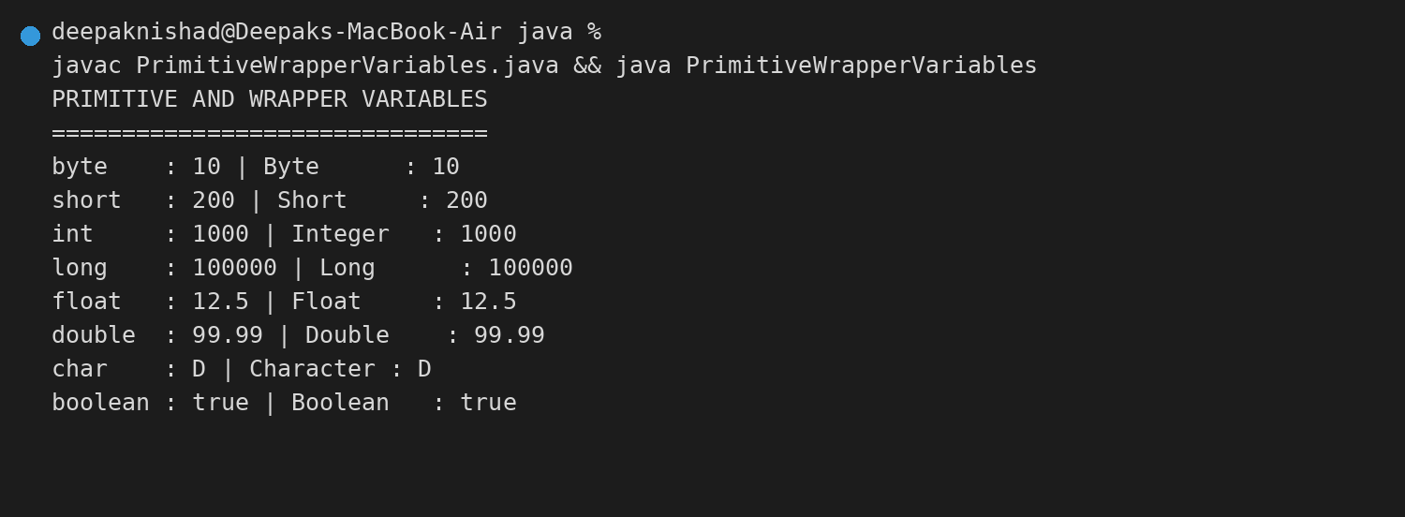

2. Autoboxing Demonstration
This program automatically converts int, double, char, and boolean primitive values into wrapper objects.
public class AutoboxingDemo {
public static void main(String[] args) {
int number = 100;
double price = 45.75;
char grade = 'A';
boolean passed = true;
Integer numberObject = number;
Double priceObject = price;
Character gradeObject = grade;
Boolean passedObject = passed;
System.out.println("AUTOBOXING DEMONSTRATION");
System.out.println("========================");
System.out.println("int -> Integer : " + numberObject);
System.out.println("double -> Double : " + priceObject);
System.out.println("char -> Character : " + gradeObject);
System.out.println("boolean -> Boolean : " + passedObject);
}
}
Program Output Screenshot:
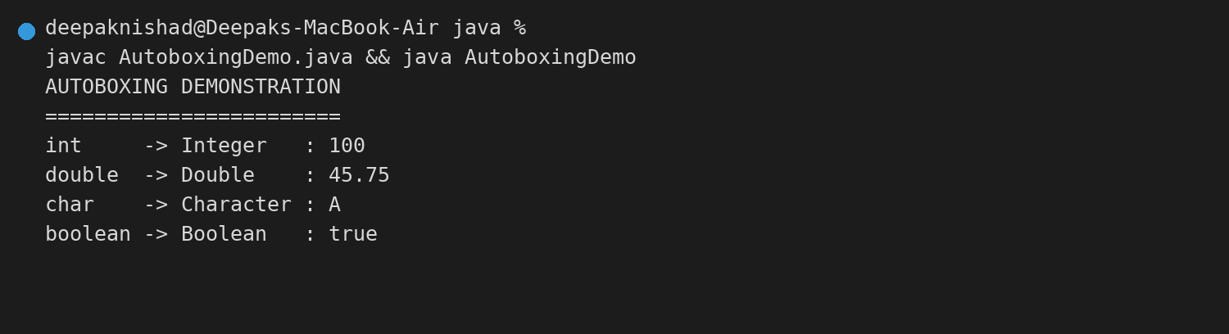

3. Unboxing Demonstration
This program automatically converts Integer, Double, Character, and Boolean objects into primitive values.
public class UnboxingDemo {
public static void main(String[] args) {
Integer numberObject = 250;
Double priceObject = 89.50;
Character gradeObject = 'B';
Boolean passedObject = false;
int number = numberObject;
double price = priceObject;
char grade = gradeObject;
boolean passed = passedObject;
System.out.println("UNBOXING DEMONSTRATION");
System.out.println("======================");
System.out.println("Integer -> int : " + number);
System.out.println("Double -> double : " + price);
System.out.println("Character -> char : " + grade);
System.out.println("Boolean -> boolean : " + passed);
}
}
Program Output Screenshot:


