Assignment 11: Constructors and Inheritance
Student Name | Deepak
Student ID | 25SCS1003004869
Assignment | 11 (Constructors and Inheritance)
Course / Section | Java Programming

Objective
The objective of this assignment is to understand constructors in Java and implement single and multilevel inheritance using practical programs.

Part A: Constructors
Constructors are special methods used to initialize objects. A default constructor assigns initial values without arguments, a parameterized constructor accepts values, and a copy constructor initializes a new object from another object.

Part B: Inheritance
Inheritance allows a child class to reuse fields and methods from a parent class. The super() keyword invokes the constructor of the immediate parent class.

1. Student Constructors
This program demonstrates a default constructor and a parameterized constructor in the Student class.
class Student {
private int studentId;
private String studentName;
private String course;
private int age;
Student() {
studentId = 0;
studentName = "Not Assigned";
course = "Not Assigned";
age = 0;
}
Student(int studentId, String studentName, String course, int age) {
this.studentId = studentId;
this.studentName = studentName;
this.course = course;
this.age = age;
}
void displayDetails() {
System.out.println("Student ID : " + studentId);
System.out.println("Student Name : " + studentName);
System.out.println("Course : " + course);
System.out.println("Age : " + age);
System.out.println();
}
}
public class StudentConstructorsDemo {
public static void main(String[] args) {
Student defaultStudent = new Student();
Student parameterizedStudent = new Student(101, "Deepak", "Computer Science", 21);
System.out.println("DEFAULT CONSTRUCTOR");
System.out.println("-------------------");
defaultStudent.displayDetails();
System.out.println("PARAMETERIZED CONSTRUCTOR");
System.out.println("-------------------------");
parameterizedStudent.displayDetails();
}
}
Program Output Screenshot:
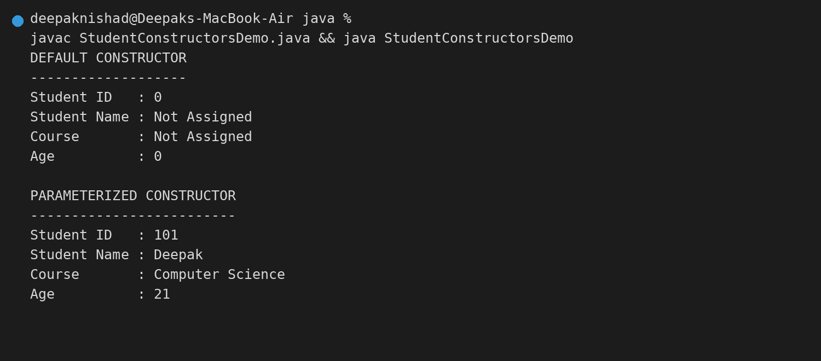

2. Employee Constructors
This program demonstrates default, parameterized, and copy constructors in the Employee class.
class Employee {
private int employeeId;
private String name;
private String designation;
private double salary;
Employee() {
employeeId = 0;
name = "Not Assigned";
designation = "Not Assigned";
salary = 0.0;
}
Employee(int employeeId, String name, String designation, double salary) {
this.employeeId = employeeId;
this.name = name;
this.designation = designation;
this.salary = salary;
}
Employee(Employee other) {
this.employeeId = other.employeeId;
this.name = other.name;
this.designation = other.designation;
this.salary = other.salary;
}
void displayDetails() {
System.out.println("Employee ID : " + employeeId);
System.out.println("Name : " + name);
System.out.println("Designation : " + designation);
System.out.printf("Salary : %.2f%n%n", salary);
}
}
public class EmployeeConstructorsDemo {
public static void main(String[] args) {
Employee defaultEmployee = new Employee();
Employee parameterizedEmployee = new Employee(501, "Deepak", "Software Developer", 65000.00);
Employee copiedEmployee = new Employee(parameterizedEmployee);
System.out.println("DEFAULT CONSTRUCTOR");
System.out.println("-------------------");
defaultEmployee.displayDetails();
System.out.println("PARAMETERIZED CONSTRUCTOR");
System.out.println("-------------------------");
parameterizedEmployee.displayDetails();
System.out.println("COPY CONSTRUCTOR");
System.out.println("----------------");
copiedEmployee.displayDetails();
}
}
Program Output Screenshot:
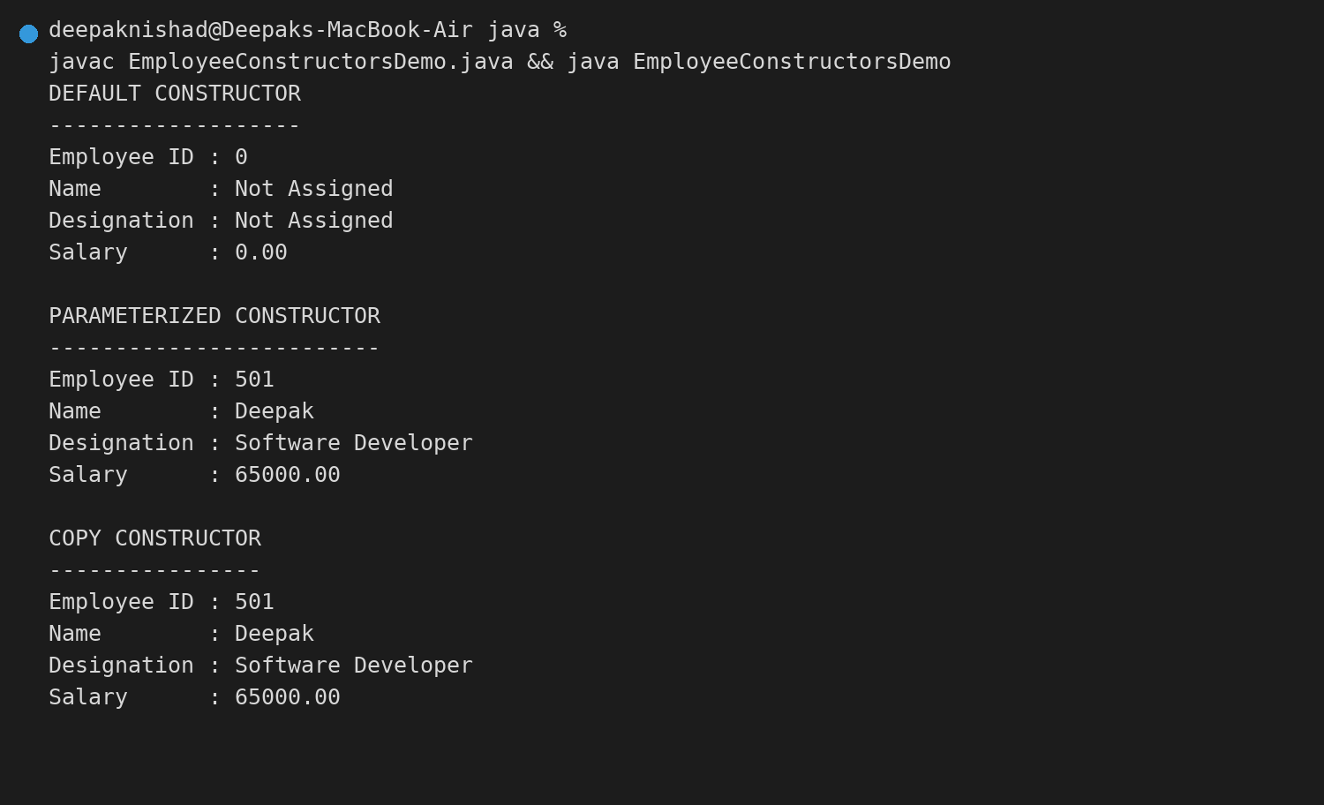

3. Single Inheritance
This program implements Person and Student using single inheritance and uses super() to call the parent constructor.
class Person {
protected String name;
protected int age;
protected String email;
Person(String name, int age, String email) {
this.name = name;
this.age = age;
this.email = email;
}
void displayPersonDetails() {
System.out.println("Name : " + name);
System.out.println("Age : " + age);
System.out.println("Email : " + email);
}
}
class Student extends Person {
private int studentId;
private String course;
Student(String name, int age, String email, int studentId, String course) {
super(name, age, email);
this.studentId = studentId;
this.course = course;
}
void displayStudentDetails() {
displayPersonDetails();
System.out.println("Student ID : " + studentId);
System.out.println("Course : " + course);
}
}
public class SingleInheritanceDemo {
public static void main(String[] args) {
Student student = new Student("Deepak", 21, "deepak@example.com", 101, "Computer Science");
System.out.println("STUDENT DETAILS USING SINGLE INHERITANCE");
System.out.println("=========================================");
student.displayStudentDetails();
}
}
Program Output Screenshot:


4. Multilevel Inheritance
This program implements Employee, Manager, and ProjectManager using multilevel inheritance and super() constructors.
class Employee {
protected int employeeId;
protected String employeeName;
protected double basicSalary;
Employee(int employeeId, String employeeName, double basicSalary) {
this.employeeId = employeeId;
this.employeeName = employeeName;
this.basicSalary = basicSalary;
}
}
class Manager extends Employee {
protected String department;
protected int teamSize;
Manager(int employeeId, String employeeName, double basicSalary, String department, int teamSize) {
super(employeeId, employeeName, basicSalary);
this.department = department;
this.teamSize = teamSize;
}
}
class ProjectManager extends Manager {
private String projectName;
private int projectDuration;
ProjectManager(int employeeId, String employeeName, double basicSalary, String department, int teamSize, String projectName, int projectDuration) {
super(employeeId, employeeName, basicSalary, department, teamSize);
this.projectName = projectName;
this.projectDuration = projectDuration;
}
void displayDetails() {
System.out.println("Employee ID : " + employeeId);
System.out.println("Employee Name : " + employeeName);
System.out.printf("Basic Salary : %.2f%n", basicSalary);
System.out.println("Department : " + department);
System.out.println("Team Size : " + teamSize);
System.out.println("Project Name : " + projectName);
System.out.println("Project Duration : " + projectDuration + " months");
}
}
public class MultilevelInheritanceDemo {
public static void main(String[] args) {
ProjectManager manager = new ProjectManager(701, "Deepak", 85000.00, "Technology", 8, "Campus Management System", 12);
System.out.println("PROJECT MANAGER DETAILS USING MULTILEVEL INHERITANCE");
System.out.println("=====================================================");
manager.displayDetails();
}
}
Program Output Screenshot:


