Assignment 8: Polymorphism in Java
Student Name | Deepak
Student ID | 25SCS1003004869
Assignment | 8 (Polymorphism)
Course / Section | Java Programming

Objective
The objective of this assignment is to understand the concept of Polymorphism, its different types, and the implementation of Method Overloading through practical programs.

Part A: Understanding of Theory Concept

1. Explain Polymorphism in Java
Polymorphism is a fundamental concept in Object-Oriented Programming (OOP) that means "many forms." In Java, it allows a single action to be performed in different ways. It occurs when there is a hierarchy of classes that are related to each other by inheritance.
Importance: Polymorphism is crucial because it promotes code flexibility and reusability. It allows developers to write more generic code that can handle objects of different classes through a single interface, making the system easier to maintain and extend.

2. Explain the Types of Polymorphism
There are two main types of polymorphism in Java:
a) Compile-Time Polymorphism (Static Polymorphism): This is achieved through Method Overloading. The compiler determines which method to call based on the method signature (name and parameters) during the compilation process.
b) Run-Time Polymorphism (Dynamic Polymorphism): This is achieved through Method Overriding. The decision about which method to execute is made by the Java Virtual Machine (JVM) at runtime based on the actual object type.

3. Explain Method Overloading
Method Overloading is a feature that allows a class to have more than one method with the same name, provided their parameter lists are different.
Rules:
- Methods must have the same name.
- Methods must have different parameter lists (number of parameters, types of parameters, or order of parameters).
- Return type can be different, but changing ONLY the return type is not sufficient.
Why return type only is not enough: The compiler identifies methods by their signatures (name + parameters). If two methods have the same name and parameters but different return types, the compiler cannot distinguish which one to call, leading to ambiguity.
Difference between Overloading and Overriding:
- Overloading occurs within the same class; Overriding occurs between a superclass and a subclass.
- Overloading requires different parameters; Overriding requires the exact same parameters.

Part B: Programming Questions

4. Calculator Addition (Method Overloading)
Implementation of a Calculator class with overloaded add() methods to handle integers and decimals.
class Calculator {
// Add two integers
public int add(int a, int b) {
return a + b;
}
// Add three integers
public int add(int a, int b, int c) {
return a + b + c;
}
// Add two decimal numbers
public double add(double a, double b) {
return a + b;
}
}
public class CalculatorAddition {
public static void main(String[] args) {
Calculator calc = new Calculator();
System.out.println("Addition of two integers (10, 20): " + calc.add(10, 20));
System.out.println("Addition of three integers (10, 20, 30): " + calc.add(10, 20, 30));
System.out.println("Addition of two decimal numbers (10.5, 20.5): " + calc.add(10.5, 20.5));
}
}
Program Output Screenshot:
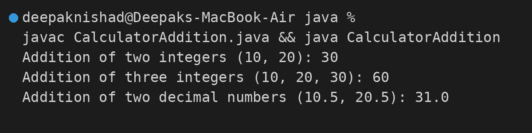

5. Display Method (Method Overloading)
Implementation of a Display class with overloaded show() methods to present student information in various formats.
class Display {
// Display only student's name
public void show(String name) {
System.out.println("Student Name: " + name);
}
// Display student's name and age
public void show(String name, int age) {
System.out.println("Student Name: " + name + ", Age: " + age);
}
// Display student's name, age, and marks
public void show(String name, int age, double marks) {
System.out.println("Student Name: " + name + ", Age: " + age + ", Marks: " + marks);
}
}
public class DisplayMethod {
public static void main(String[] args) {
Display disp = new Display();
disp.show("Rahul Sharma");
disp.show("Rahul Sharma", 20);
disp.show("Rahul Sharma", 20, 85.5);
}
}
Program Output Screenshot:
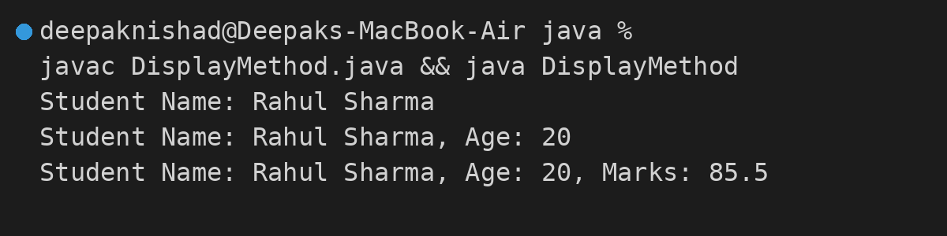

6. Find Maximum (Method Overloading)
Implementation of a MaxFinder class with overloaded max() methods to compare integers and decimal numbers.
class MaxFinder {
// Maximum between two integers
public int max(int a, int b) {
return (a > b) ? a : b;
}
// Maximum between three integers
public int max(int a, int b, int c) {
int temp = (a > b) ? a : b;
return (temp > c) ? temp : c;
}
// Maximum between two decimal numbers
public double max(double a, double b) {
return (a > b) ? a : b;
}
}
public class FindMaximum {
public static void main(String[] args) {
MaxFinder finder = new MaxFinder();
System.out.println("Maximum between 10 and 20: " + finder.max(10, 20));
System.out.println("Maximum between 10, 50, and 30: " + finder.max(10, 50, 30));
System.out.println("Maximum between 10.5 and 20.7: " + finder.max(10.5, 20.7));
}
}
Program Output Screenshot:
