Assignment 3: Java Input and Basic Operations
Three Java programs demonstrating the use of Scanner class
Student Name | Deepak
Student ID | 25SCS1003004869
Assignment | 3
Course / Section | Java Programming

Objective
The objective of this assignment is to learn how to take input from the keyboard using the Scanner class and perform basic operations in Java, such as arithmetic calculations and formatted string output.

Programs Included
No. | Program | Purpose
1 | SumOfTwoNumbers.java | Accepts two integers and calculates their sum.
2 | EmailAddressInput.java | Accepts name and email, then displays them formatted.
3 | SimpleInterestCalculator.java | Calculates simple interest based on user input.

Question 1: Sum of Two Numbers
Accepts two integer inputs and displays their arithmetic sum.

Java Source Code
import java.util.Scanner;
public class SumOfTwoNumbers {
public static void main(String[] args) {
Scanner input = new Scanner(System.in);
System.out.print("Enter First Number: ");
int num1 = input.nextInt();
System.out.print("Enter Second Number: ");
int num2 = input.nextInt();
int sum = num1 + num2;
System.out.println("Sum = " + sum);
input.close();
}
}

Program Output Screenshot
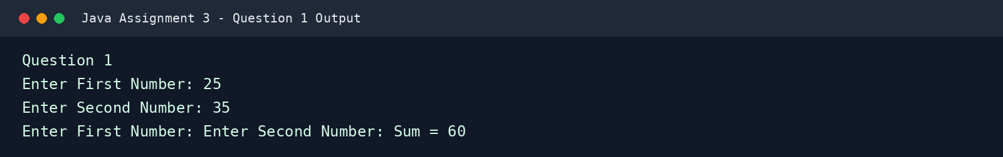

Question 2: Email Address Input
Uses Scanner to read string inputs and prints them in a structured student details format.

Java Source Code
import java.util.Scanner;
public class EmailAddressInput {
public static void main(String[] args) {
Scanner input = new Scanner(System.in);
System.out.print("Enter Name: ");
String name = input.nextLine();
System.out.print("Enter Email: ");
String email = input.nextLine();
System.out.println("Student Details");
System.out.println("---------------");
System.out.println("Name : " + name);
System.out.println("Email : " + email);
input.close();
}
}

Program Output Screenshot
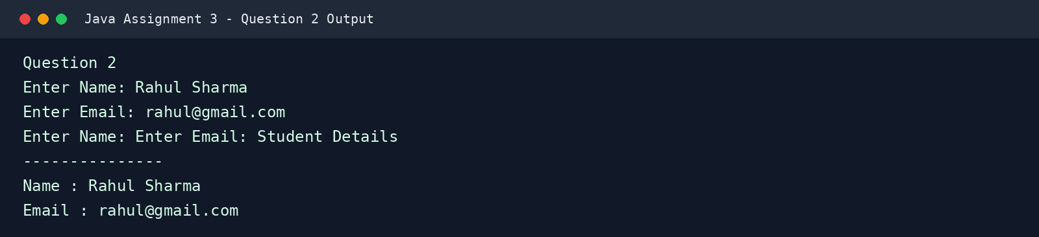

Question 3: Simple Interest Calculator
Takes Principal, Rate, and Time as inputs and applies the formula SI = (P * R * T) / 100.

Java Source Code
import java.util.Scanner;
public class SimpleInterestCalculator {
public static void main(String[] args) {
Scanner input = new Scanner(System.in);
System.out.print("Enter Principal Amount: ");
double principal = input.nextDouble();
System.out.print("Enter Rate of Interest: ");
double rate = input.nextDouble();
System.out.print("Enter Time (Years): ");
double time = input.nextDouble();
double simpleInterest = (principal * rate * time) / 100;
System.out.println("Simple Interest = " + simpleInterest);
input.close();
}
}

Program Output Screenshot
