Assignment 5: Java Loops and Number Programs
Five Java programs with source code and tested output screenshots
Student Name | Deepak
Student ID | 25SCS1003004869
Assignment | 5
Course / Section | Java Programming

Introduction
This assignment demonstrates Java loops, arithmetic operators, conditional statements, and user input. Each program was compiled and tested with a representative input. The corresponding output screenshot is included after each source-code listing.

Programs Included
No. | Program | Purpose
1 | SumFromOneToN.java | Finds the sum of numbers from 1 to N.
2 | MultiplesOfFive.java | Prints multiples of 5 from 1 to 100.
3 | CountDivisibleByThree.java | Counts numbers divisible by 3 between 1 and N.
4 | PrimeChecker.java | Checks whether an entered number is prime.
5 | ReverseNumber.java | Prints the reverse of a given number.

Problem 1: Find the Sum of Numbers from 1 to N
A for loop adds every integer from 1 through the user-entered value N.

Java Source Code
import java.util.Scanner;
public class SumFromOneToN {
public static void main(String[] args) {
Scanner input = new Scanner(System.in);
System.out.print("Enter N: ");
int n = input.nextInt();
int sum = 0;
for (int number = 1; number <= n; number++) {
sum += number;
}
System.out.println("The sum from 1 to " + n + " is: " + sum);
input.close();
}
}

Program Output Screenshot
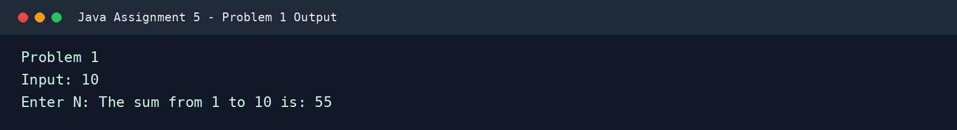

Problem 2: Print Multiples of 5 from 1 to 100
A for loop checks each number from 1 to 100. The remainder operator identifies values whose remainder is zero when divided by 5.

Java Source Code
public class MultiplesOfFive {
public static void main(String[] args) {
System.out.println("Multiples of 5 from 1 to 100:");
for (int number = 1; number <= 100; number++) {
if (number % 5 == 0) {
System.out.print(number + " ");
}
}
System.out.println();
}
}

Program Output Screenshot
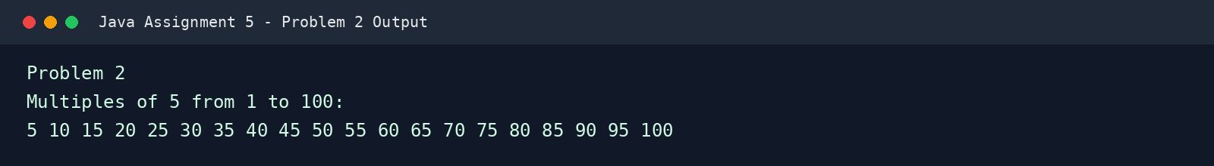

Problem 3: Count Numbers Divisible by 3 between 1 and N
A counter increases whenever a number in the range from 1 to N is exactly divisible by 3.

Java Source Code
import java.util.Scanner;
public class CountDivisibleByThree {
public static void main(String[] args) {
Scanner input = new Scanner(System.in);
System.out.print("Enter N: ");
int n = input.nextInt();
int count = 0;
for (int number = 1; number <= n; number++) {
if (number % 3 == 0) {
count++;
}
}
System.out.println("There are " + count + " numbers divisible by 3 between 1 and " + n + ".");
input.close();
}
}

Program Output Screenshot
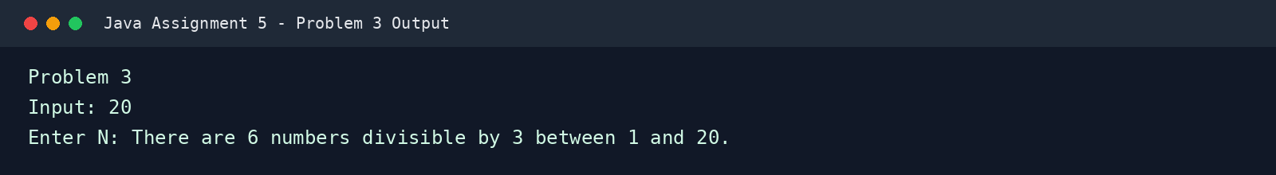

Problem 4: Check Whether a Number Is Prime
The program tests possible divisors beginning at 2. A number is prime when it is at least 2 and no divisor divides it evenly.

Java Source Code
import java.util.Scanner;
public class PrimeChecker {
public static void main(String[] args) {
Scanner input = new Scanner(System.in);
System.out.print("Enter a number: ");
int number = input.nextInt();
boolean isPrime = number >= 2;
for (int divisor = 2; divisor * divisor <= number && isPrime; divisor++) {
if (number % divisor == 0) {
isPrime = false;
}
}
if (isPrime) {
System.out.println(number + " is a prime number.");
} else {
System.out.println(number + " is not a prime number.");
}
input.close();
}
}

Program Output Screenshot
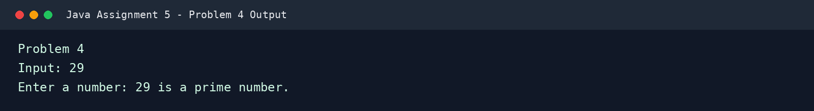

Problem 5: Reverse of a Given Number
A while loop extracts the last digit with the remainder operator and builds the reversed number one digit at a time.

Java Source Code
import java.util.Scanner;
public class ReverseNumber {
public static void main(String[] args) {
Scanner input = new Scanner(System.in);
System.out.print("Enter a number: ");
int number = input.nextInt();
int original = number;
int reverse = 0;
while (number != 0) {
int digit = number % 10;
reverse = reverse * 10 + digit;
number /= 10;
}
System.out.println("The reverse of " + original + " is: " + reverse);
input.close();
}
}

Program Output Screenshot
