- Hasan accpeted connection request but I get same notification twice so counter shows bumped up by 2 for same user/email
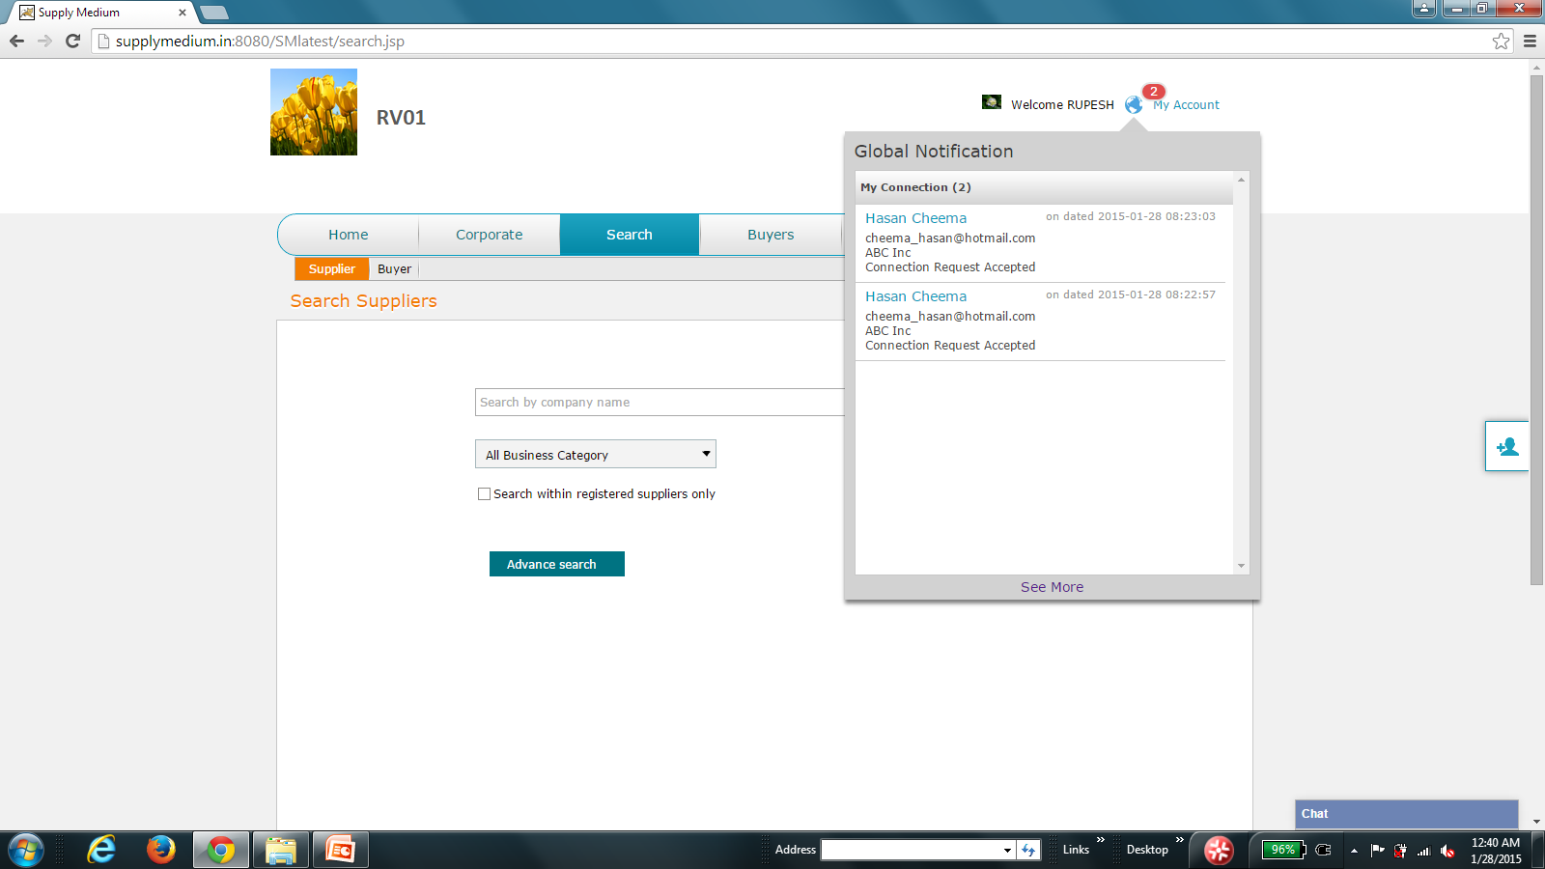

- Also in my connection page, there are 2 same contacts:
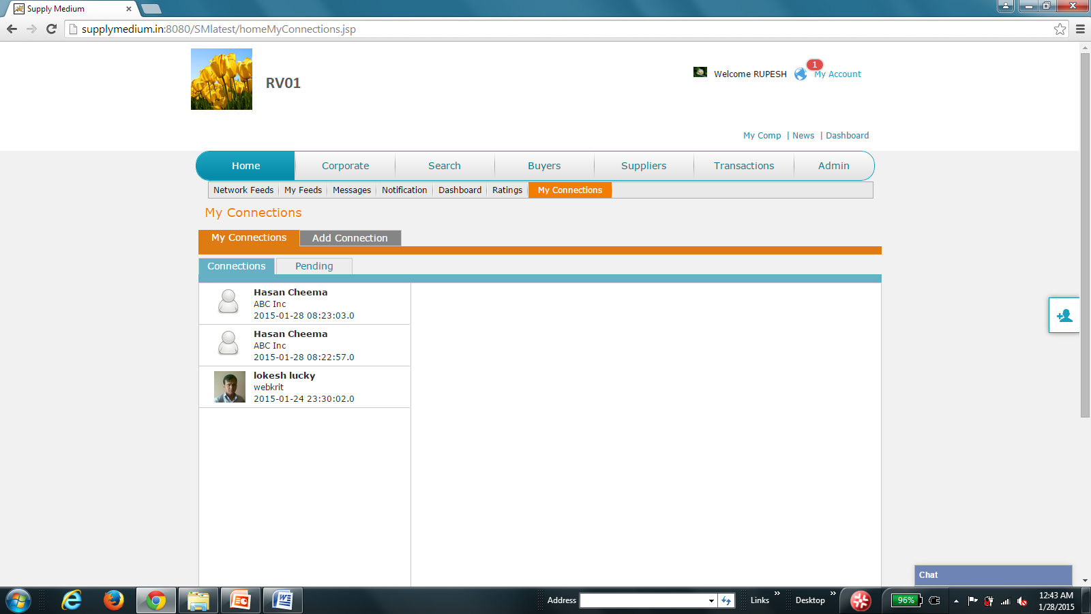
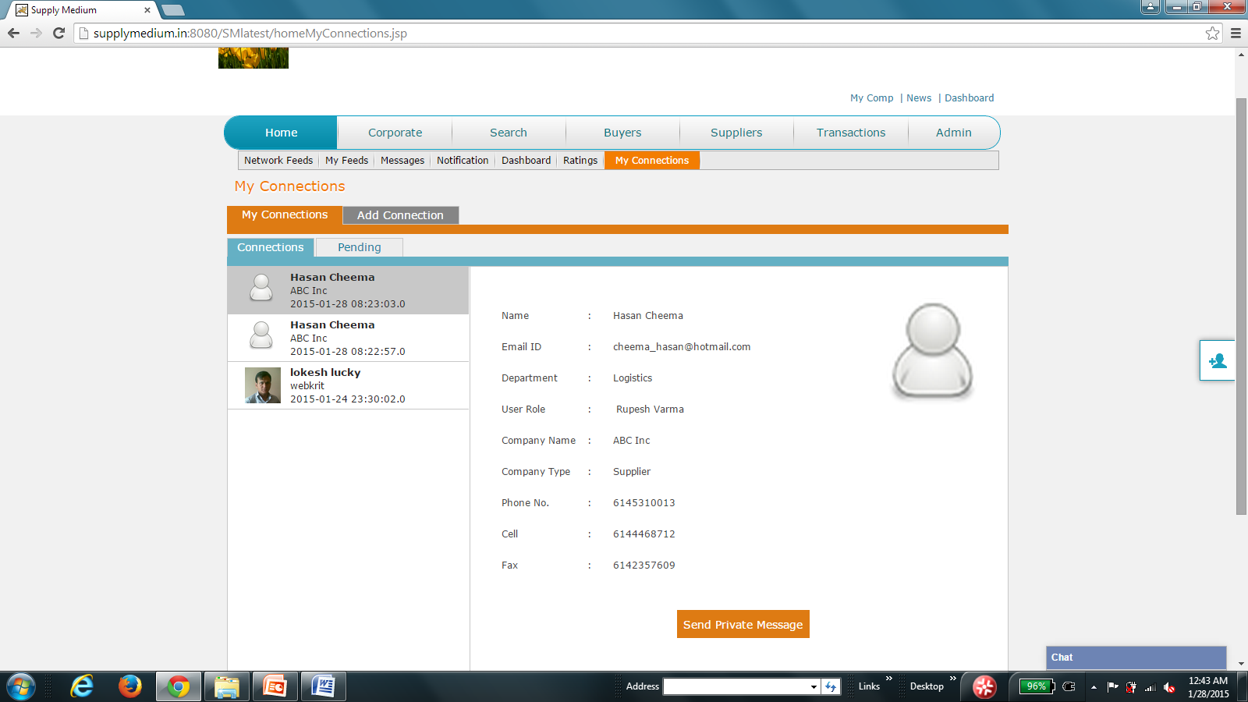
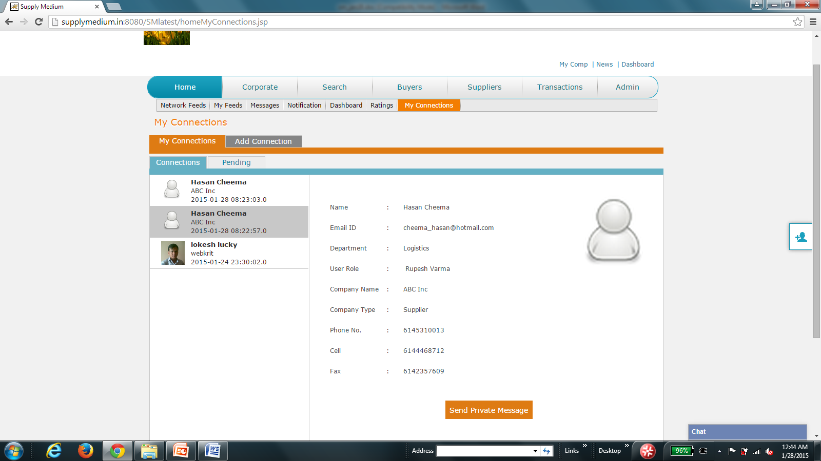
- Also in chat window, now it shows 2 Hasan cheema
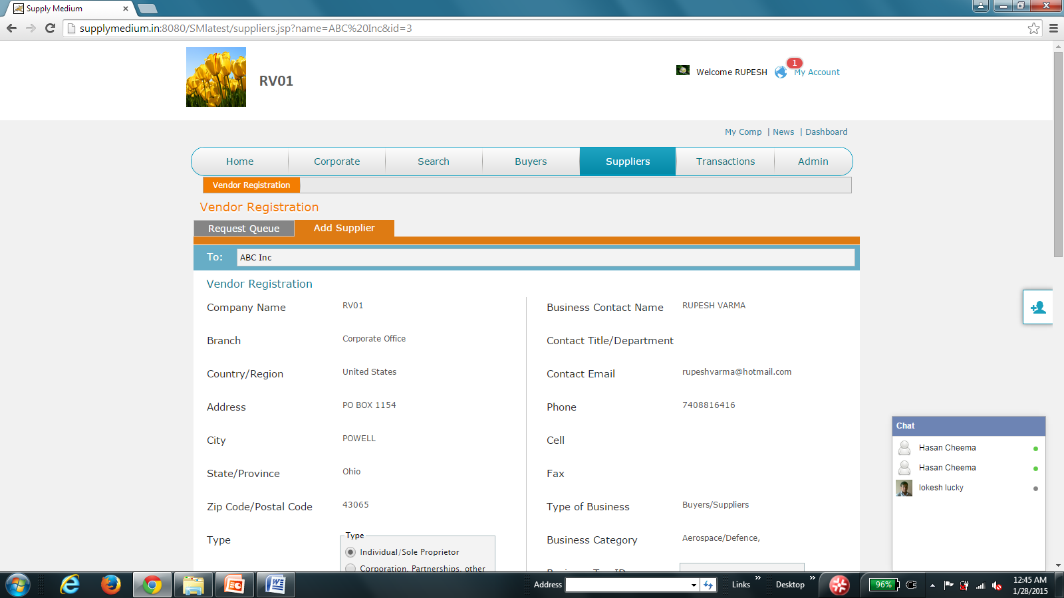
- Hasan sent me a msg but I didn’t get it displayed as a side dialog. I had to click on Hasan’s name and then it opened up a dialog next to chat
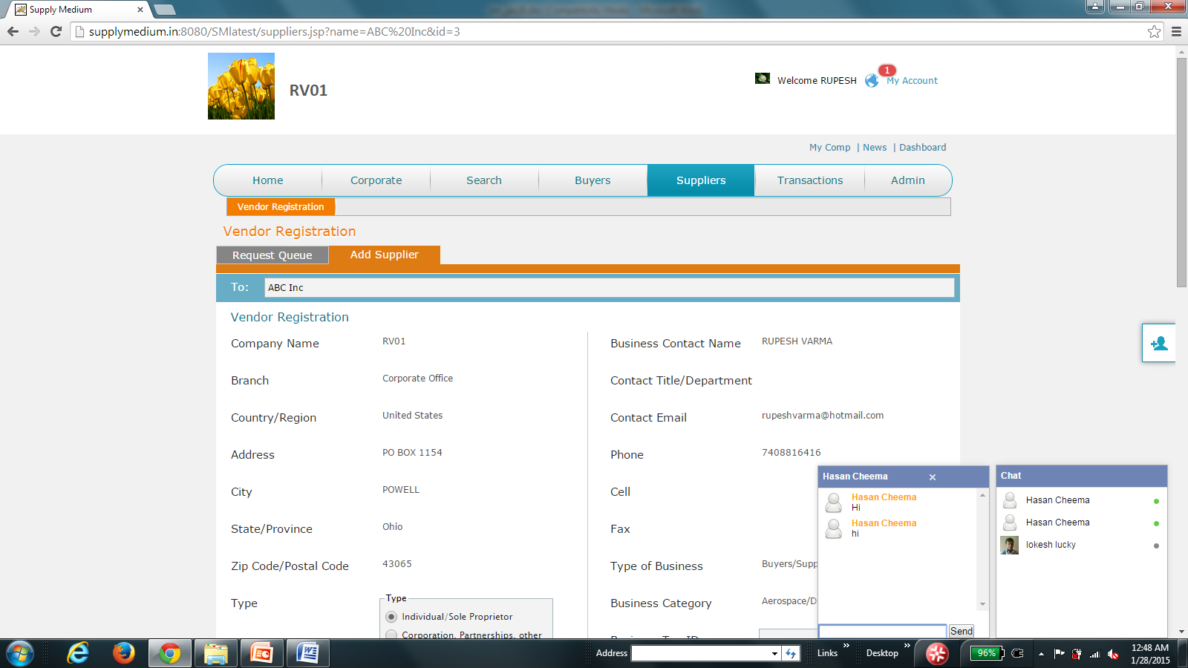
- Chat – enter key does not work. I have to use send button every time
- When msg goes down, it should auto scroll in chat window
- When a new msg arrives, it should open a window and blink so user knows new chat msg has arrived
- In one chat msg, my profile pic is next to my name in chat and in other msg I sent, pic is above my name
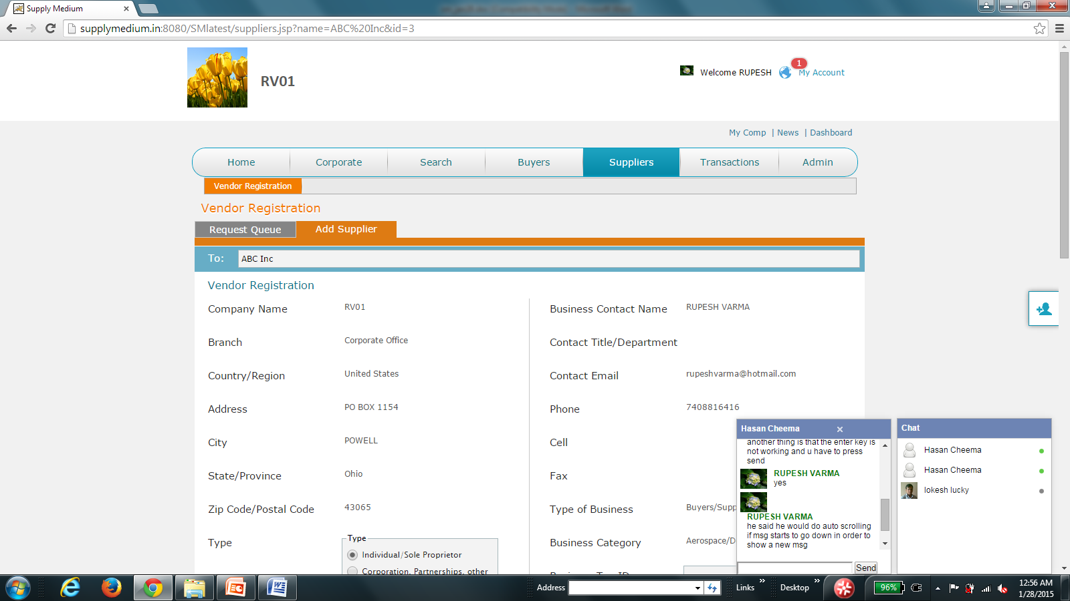
- I sent 2 more msg to hasan after the ones in screen shot below but it doesn’t show up on chat window …I checked with hasan and he didn’t get them too …although when I press send button it did go from my end since txt window became blank
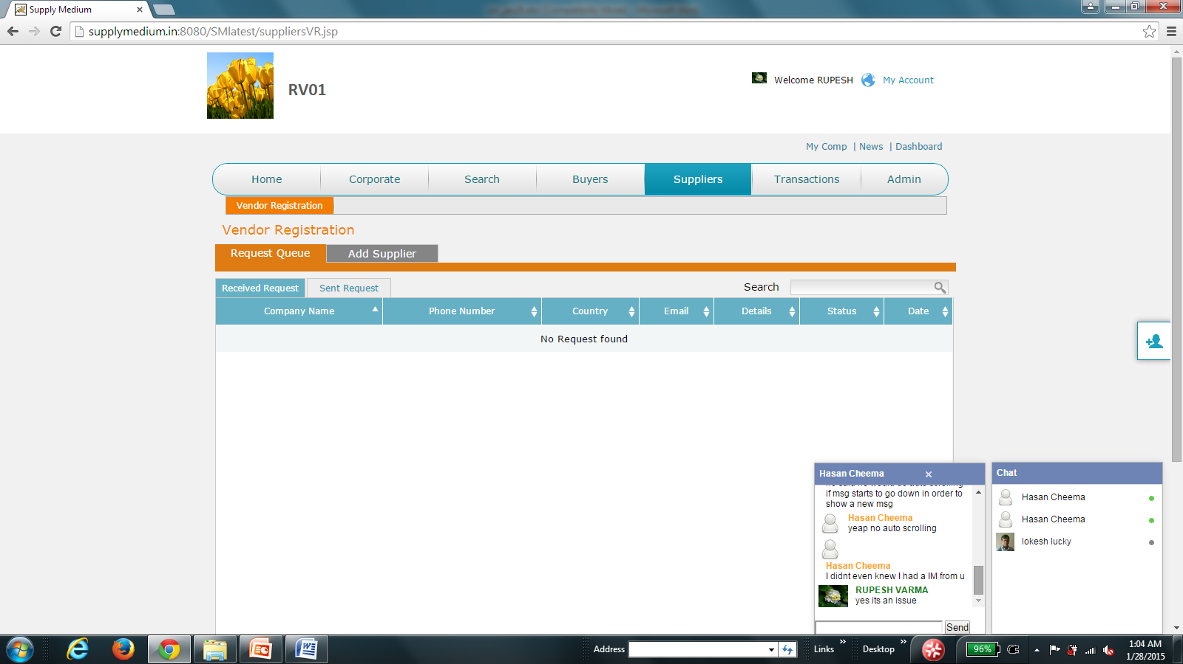

- I sent hasan vendor reg and he didn’t get it at all – got the global notification and the email but nothing in the vendor tabs --- this is show stopper bug

