1. The chat window shows email addresses and not names. Should be names. Also if I send the message my message is greyed out. Should be the same as Rupesh.

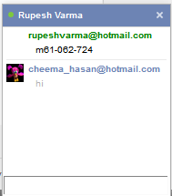

1. In the add user section in Firefox the list of user add is formatted incorrectly

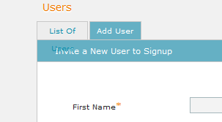

1. Also the columns are out of alignment in user tab

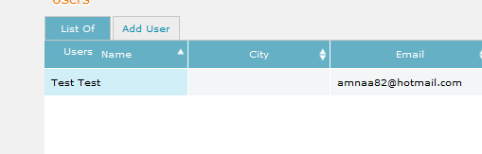

1. In the department page we can attach flies but cannot download them. Also the files should show up in the area infornt of the folder list

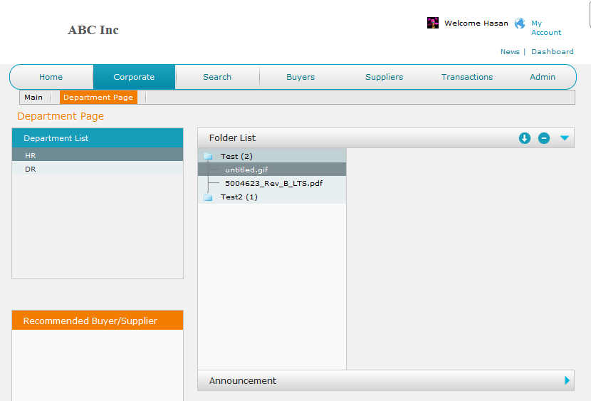

1. When I create a user in SupplyMedium and active it and the user gets an mail that he has been activated but when he clicks on the login button in the email he goes to the login page. Now the user doesn’t have a password and so he cannot login. User should get temporary password

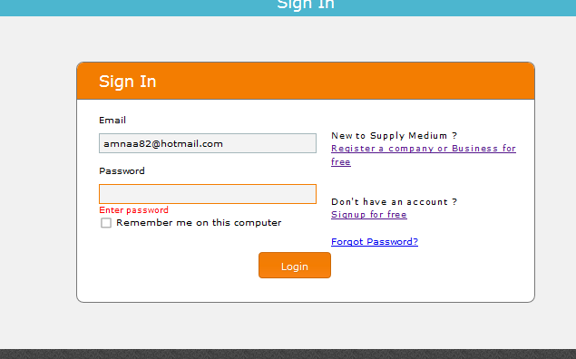

1. Send private message text

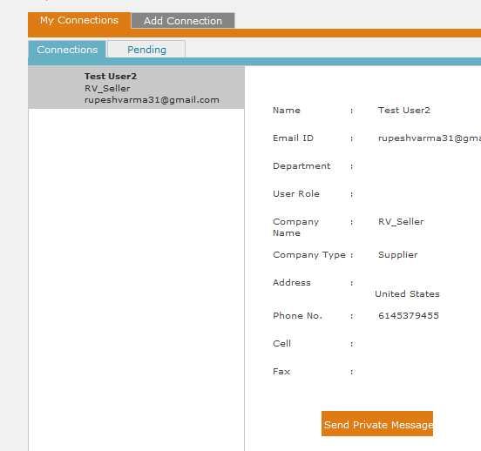

1. Rupesh send me a message. I got the notification in the global notification but when I click on it there is no messages in the under messages.

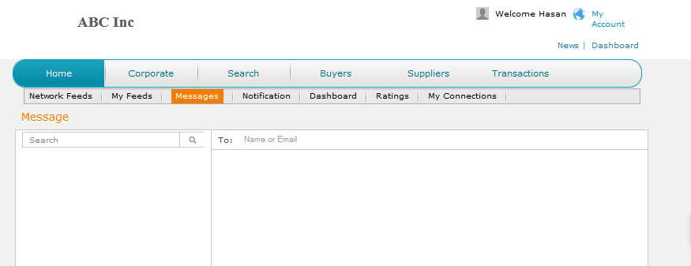

1. Once you delete a folder from the department you cannot reassign that folder to that department

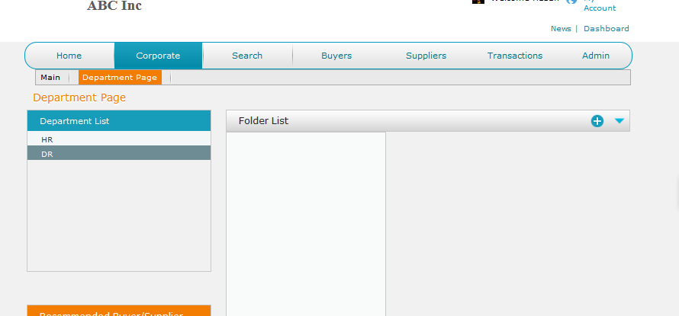

1. When I click the update button I don’t get and popup message

When select read only for one user gets selected for both users

Amna is an internet user but I can select privileges for her. Only regular users need to be displayed here.

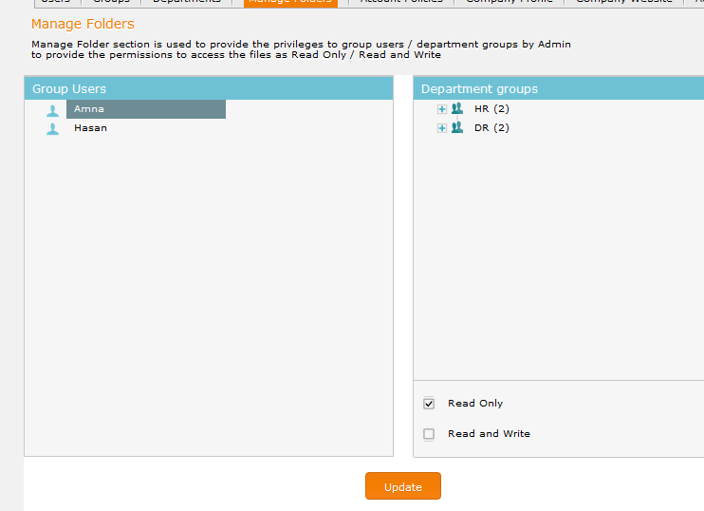

1. End session doesn’t work doesn’t log you out after 5 min

Password complexity is not working. Even when we deselect uppercase and non-alpha options it still asks for uppercase

If the admin gets locked out he must have the ability to unlock

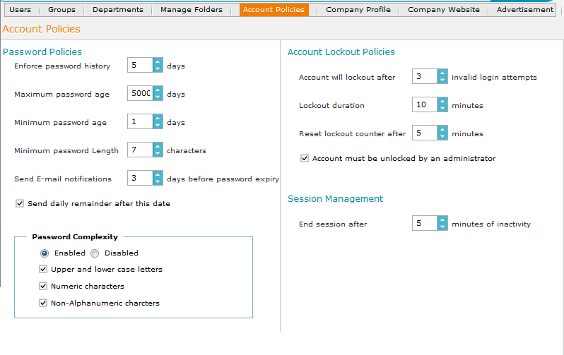

1. Gave Amna privileges to add and delete users but she doesn’t have these privileges

