**Application Manual:**

Hello team please follow these steps (application manual) for using this application

1. register account as company
2. confirm email
3. admin - users - add user - add user from company admin
4. confirm email from user
5. sign up new user in company
6. confirm email from company admin
7. admin - company profile - add user - upload/update company image
8. top links near global notification - account settings - upload/update user image
9. home - create watchlist
10. home - search member to add in watchlist
11. home - add member to watch list
12. home - view watchlist members
13. home - delete watchlist member
14. home - post new feeds (with or without images) in same business category at home
15. admin - group - create group
16. admin - group - add user to group
17. admin - department - create department
18. admin - department - add user to department
19. admin - department - add group to department
20. admin - department - create folder
21. admin - department - assign folder to department
22. admin - company website link any site - check it must be visible near notification
23. home - my feed - post feeds (with or without images)
24. home - my feed - left panel briefcase - create folders
25. home - my feed - left panel briefcase - select folder and upload image
26. home - my feed - left panel briefcase - select image and download image
27. corporate - internal page - post feeds
28. corporate - internal page - create folders
29. corporate - internal page - select folder and upload image
30. corporate - internal page - select image and download image
31. corporate - department page - select department at left panel (double click)
32. corporate - department page - related folders will be visible
33. corporate - department page - create new folders
34. corporate - department page - select any existed folder / newly created folder (double click)
35. corporate - department page - upload file to folders
36. corporate - department page - with same process download file from folders
37. corporate - department page - post announcements with or without companywide
38. corporate - internal page - see here all announcements posted companywide from department page are visible here
39. home - connections - list of registered users will be displayed here
40. home - connections - add connection - search a user by user name or email (company name is not added, we will add it today)
41. home - connections - user will be sent a global notification for connection request
42. home - connections - pending connections - user can accept or reject connection
43. buyer - add buyer - register a vender
44. buyer - sent request - we can inquire if no response from buyer for request sent (so that we have made it visible)
45. vendor registration is sent to buyer in supplier tab in their
46. vendor registration notification is in global notification - it is for following cases VR Form Sent / Inquire / Accepted / Rejected
47. supplier - request received - before accepting or rejecting supplier can inquire(so that we have made it visible)
48. home - ratings - user can rate a registered vendor by star rating and comments
49. Chat Module - List of registered connections are there either online or offline
50. Chat Module - you can chat with online or offline users
51. Search - search a buyer and supplier and send VR request or Send RFQ to selected ones
52. Transaction - See Your Product Catalog, Add Item to Product Catalog, Upload CSV
53. Transaction - Create your terms and conditions for RFQ, Quote, Purchase Order, Invoice
54. Transaction - generate RFQ, Quote, Purchase Order, Invoice or check Payments

Till today we have tested these areas and implemented all these areas.

transaction part is not touch till today for testing.

we have locked Dashboard and Transaction Tabs because these are not tested at our end. so please follow following steps of using this application while testing or follow testing steps as per your requirement

**Your suggestions:**

Basically when you do testing, look from a customer point of view..is he getting a flawless user experience, is he able to use features as they have been designed to perform without any hiccups, is he able to do end to end tasks for which he bought this software, etc.? If answer to any of these is No then he won't be a satisfied user and won't recommend our product.

So let's ensure we follow these when developing the software i.e. when coding, so that you meet the end result goal here..don't get me wrong, I know you and your team are working hard which is great so that we just need to go an extra mile to make a conscious effort to develop/test from users experience - ultimate goal should be to make users experience a 5 star hotel treatment or experience -- when users are using our software they should constantly be getting a 'Wow' experience

**Issues Resolved (based on IE9/IE10/Firefox/Safari/Chrome):**

Hello team, in this sheet few issues are captured by our testing team, and few are captured by our team,

these are the list of issues which are resolved (in green labels), and remain are left to be done.

**ISSUES ON DATED 11-November-2014**

1. **home - create watch list textbox must be blank after create new**
2. **home - added member should not be in search of watch list member while adding a new member**
3. **home - watch list member picture must be in add member**
4. **home - watch list member picture must be in search result**
5. **home - watch list member picture must be in view added members**
6. **connections - my connections - at down side double boxes**
7. **connections - pending connections - at down side double boxes**
8. **connections - add a connection - at down side double boxes**
9. **connections - My connections page**

**Machine generated alternative text:
Company **

1. **message - IE member image is not set**
2. **message - selected person name and email address is not visible at right side**
3. **File folder and images: Images are working**
4. **company internal page - after creating a folder - folder name text box must be blank**
5. **department page - after selecting a file and on-click of download icon, it should be downloaded**
6. **Supplier - Request Sent Page records are displaying one by one with gap of one record blank**
7. **Chat module is not working**
8. **Chat doesn’t work at all – only the user gets added but you can’t chat with that user at all. When you send a message – using send button because enter key doesn’t work – you can't see your message and neither can other user with whom you are chatting he also can't see the message The chat message are going as a global notification?? It should not go as global notification**
9. **SupplyMedium icon on IE**

Machine generated alternative text: Sign In
Email
Password
r
r
)

1. **Cannot select accept terms and conditions, captcha input button**

Machine generated alternative text: w
Company Info User Info
First Name Ahdullah Primary Phone 6145310014
Last Name Cheema Cell J
Title MR Fax
Department Email* ;haun,cheema 1@gmail.com ,‘
Manager/SUpervisor Password*
Confirm Password
Are you human? Conditóna
— — - Accept terms & condition
1+9 10
! Accept privacy & secUrity policies

1. **Tried to add a connection. Pressed request connection but no request send - our team need to retest on IE11**
2. **file/folder - uploading a file, folder - validate selection**
3. **file/folder - after upload last selection must be selected for files and folders**
4. **Company Website - near global notification it must be visible if company website is uploaded**
5. **Company Website - near global notification it is not linked**
6. **internal page - feeds are not visible on IE**
7. **my feed - validate file upload if file is blank**
8. **internal page - validate file upload if file is blank**
9. **department page - validate file upload if file is blank**
10. **file must be delete if folder delete**
11. **file must be selected before download**
12. **if there is one only folder then it must be auto selected**
13. **Home – My Connections – Add Connection: I searched for company named ‘ABC’ but no result. But when I search for person, then it returns person’s company ABC**
14. **I should be able to search on company name as well per our discussion**
15. **connection search company name must be here**
16. **Buyer - Vendor registration - inquire notification not generated**
17. **Supplier - Vendor registration - inquire notification not generated**
18. **chat - should not generate global notification**
19. **chat - should not saved in private message**
20. **chat - to submit/send a chat message enter key is not working**
21. **chat - after send message focus on text**
22. **my connect, list, add connection, pending connection - highlight selected**
23. **message - highlight selected**
24. **rating highlight selected**
25. **registering company - business category must be mandatory**
26. **registering company- radio buttons should not be auto selected**
27. **registering company- drop down of country**
28. **registering company- cancel doesnot word**
29. **admin - company profile - sign up as buyer / seller <!-- uncomment -->**
30. **phone number should only numbers**
31. **Sometimes this happens**

Machine generated alternative text: Welcome Abdullah Cheema 4
Account Settipas
Company Website I News I Dashboard
I npniit
Suppliers I Transactions Admin )
mpany Web site Advertisement

1. **Home - News room has red line under it**

Machine generated alternative text:
Hasan Inc 
Company 
Home 
Network Feeds 
Newsroom 
Newsroom 
Create Watchlist 
Watchlist 
Corporate 
My Feeds Messages 
Search 
Notification Dashboard 
Rat 
Newsroom 
Feed Title: 
Feed Description: 

1. **Company Profile - The arrow in front of Add Address**

Machine generated alternative text: City
Zip Code/Postal Code
State/Province Ohio
Add Address
e
E Cancel [ Save
Update Plan :

1. **Just send vendor registration so shouldn’t say respond to inquiry**

Machine generated alternative text: . . . L1
Filled Vendor registration Form
El Foreiqn: A concern which is not incorporated in the United States or an unincorporated concern having its principie piace of business outside the
United States.
Pubiic Sector: An agency of the Federai or State Government, or a local municipality.
D Alaska Native Corporations Indian Tripe that is not a small business.
Alaska Native Corporations or Indian Tribe: Not certified by the Small Business Administration as disadvantaged.
Additional Details
Close [ Accept 1 [ Reject ] I__Respond to Inquiry_]
fl

1. **buyer / supplier / transaction - inquire to send message - same in transaction**
2. **connection - on search a connection result - if we search again right panel does not become blank**
3. **chat - we need to reset the image size in chat window image and name of user replace of message**
4. **add connection - not has any hair line in two entries between highlighted and non-highlighted**
5. **add connection search result list - on select any connection highlight not working**
6. **Company Profile - it should list if we are registered as buyers or suppliers or both. We had that entry which was changeable but now we don’t have that now.**
7. **department page - notify ifno department exists and creating a folder**
8. **department page - notify ifno department exists and deleting a folder**
9. **department page - notify ifno department exists and uploading a file**
10. **department page - notify ifno department exists and deleting a file**
11. **department page - download alt title must be added as "Download file"**
12. **department page - download button should not work for folder - notify alert**
13. **Notification - global notification design is not properly working on notification tab**
14. **Notification page - not working**
15. **search - advance search buyer/supplier counting is zero why**
16. **chat - fluctuation on screen of chat window control it**
17. **private message - after posting should not reload - and should be auto selected**
18. **Company Profile - Company profile is especially slow**

**Machine generated alternative text: SC I
Browse
Ir fi e seieced
e s a ‘ r ç
r H e  ar .s
12 ‘-t D
r pzateOffic
V
...
. .
,- . LOADINQ•
. .
...**

1. **Company profile takes a long time to load**
2. **Company Profile - takes a long time to load and some of the drop down are not correct**

**Machine generated alternative text:
Profile 
Company Name 
Company Logo 
Business Category 
Selected Category 
Company Id 
Branch 
Country 
Address 
Hasan Inc 
Browse. 
Aerospace/Def ce 
Aerospace/Defence X 
Energy/utility X 
987654 
Corporate Office 
Afghanistan 
Pricing Plan 
Plan 
Maximum number of employee licenses 
Number of employees registered 
Maximum transaction volume per month 
Transaction volume per month 
Balance transaction allowed for this month 
Disk Quota 
0.00% of disk space used 
Used 
0.00ME3 of your 
disk space 
250. COMB 
Basic 
$250,01 
$250,01 
Payment Options 
Update Plan: C) 
Basic 
C) Plus 
C) Premium **

1. **Company Profile - page**

**Machine generated alternative text: 0.00% of disk space used
Used ‘:OMB of your 250.00MB disk space
Payment Options
Update Plan : 4 Basic © Plus © Premium
,.— we accept secure payments by PayPal
VISA D&CR1**

1. **Global notifications - not working, when I click on the notification I get alert**
2. **Clicking on global notification doesn’t work**
3. **vendor registration - my company name should not be in list**
4. **search / buyer / supplier - my company name should not be in list**
5. **search - advance search design is not perfect**
6. **tabs - sub tabs - child tabs disturbed by 40px**
7. **chat - enter is not working on server for chat**
8. **chat - received messages are working but after click**
9. **chat - chat with user should minimize/maximize**
10. **chat - sent messages are not working, sender's message must be quick display to senders**
11. **on all browsers chat user window minimize - maximize**
12. **on IE and Mozilla chat is not working**
13. **scroll chat message on IE1.**
14. **company website - Label and notification must be on screen where uploading/linking the site**
15. **header - Welcome Only First Name must be on header**
16. **company website - if http:// is here then ok else prefix it in company website**
17. **chat - list of chat users - user image is not visible.**
18. **department feed - if folder is deleted - file must be refreshed - blank**
19. **my feed - if folder is deleted - file must be refreshed - blank**
20. **company feed - if folder is deleted - file must be refreshed - blank**
21. **connection - search connection button on enter**
22. **home - underline - remove on newsroom**
23. **connection - pending request - after send a connection request**
24. **search - enter button also on search buyer and supplier**
25. **search - in search buyer and supplier (select distinct value)**
26. **company profile - padding on company profile - signed up as - company type at right**
27. **company profile - multiple business category gaps**
28. **company profile - PayPal image padding**
29. **all - email is not received at any area (vary from server to server)**
30. **Transaction - The attachment on the email are not working**
31. **When moving between sub tabs, each time page becomes blank and then loads. We should only show counter till it loads**
32. **Check validations in all areas: add item**
33. **Transactions are not working properly.**
34. **I accepted a RFQ and never got the generate quote**
35. **Adding item needs to be changed.**

**ISSUES AFTER DATED 11-November-2014**

1. **No images for company or the person - because whenever we upload fresh application data is blank**

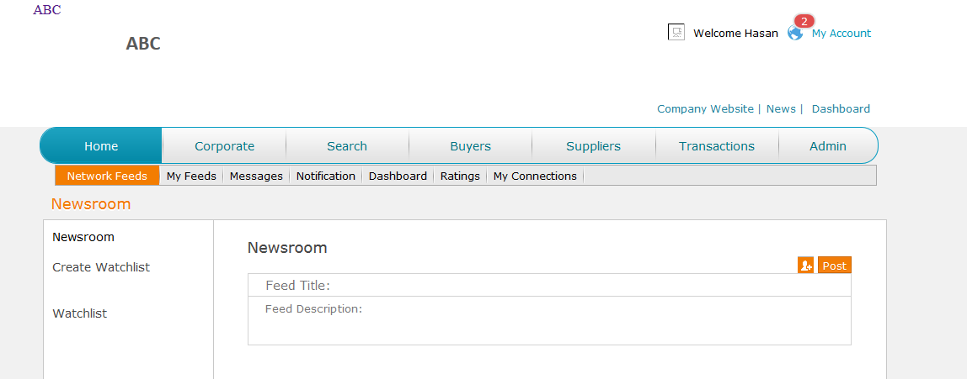

1. **When I add a picture it is not showing up in the chat or messages**

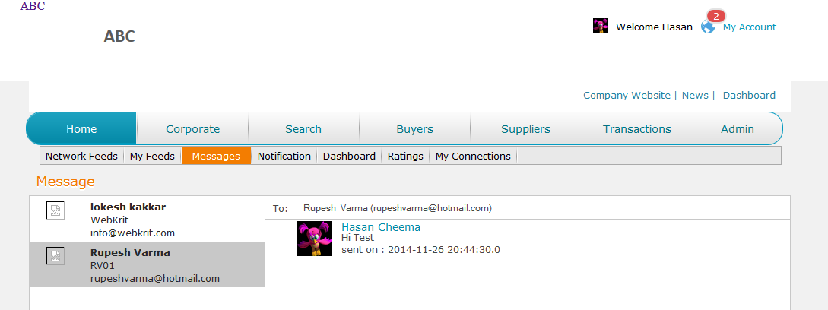

1. **Missing supplier name**

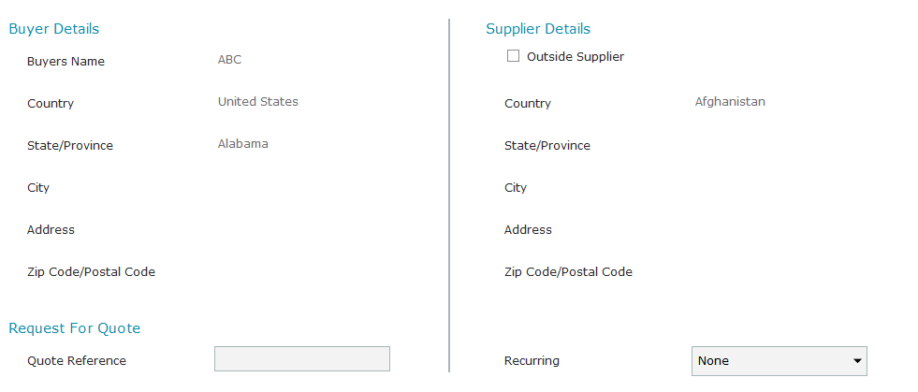

1. **In the RFQ we couldn’t enter the amount or date and the amount unit dropdown is not working**

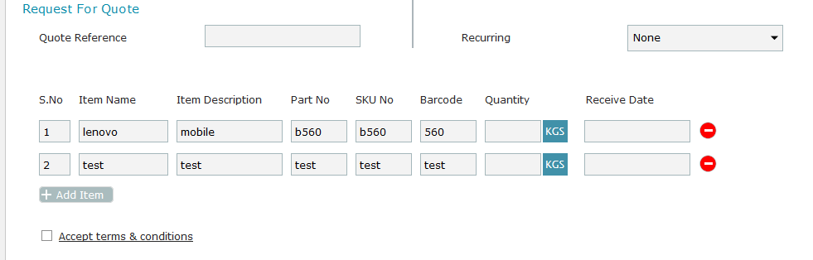

1. **I clicked on the RFQ multiple times and multiple entries were created. Never get the pop up RFQ send when we click send**

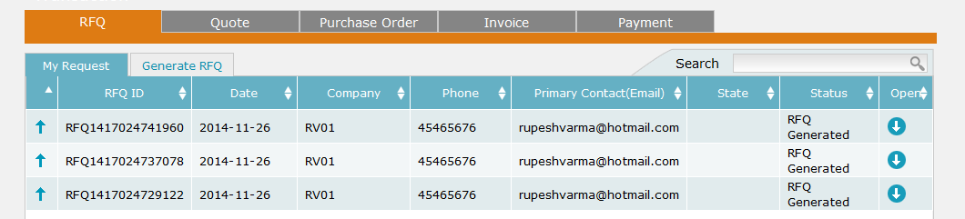

1. **When I send the message and open the sent message it is blank**

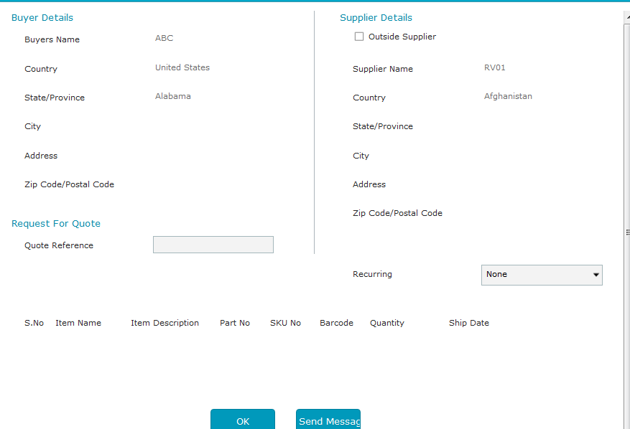

1. **R/Q/P/I - dialog not open on row click of outsider**
2. **R/Q/P/I - multiple items not visible if dialog open on row click**
3. **R/Q/P/I - after add item on screen unit and currency is undefined and transaction done by 0**
4. **on Generate Q/P/I link - add Item Validations and same issues may be occur like 119**
5. **setting of Accept Reject Button and status and transaction generated or not status**
6. **Date picker**
7. **Privileges**
8. **COMPANY WEBSITE - ADD TITLE HERE AND ON HOVER DISPLAY COMPANY WEBSITE LABEL**
9. **DEFAULT NO IMAGE USER PIC ON REGISTER USER / ADD NEW USER**
10. **remove payment options and paypal on company profile**
11. **company type change and change the session value**
12. **company website title - name of website**
13. **Search page Buyer/Supplier - Advance Search <b>press search now button to refresh your results</b>**
14. **Search result contact redirection must be set as per buyer/supplier**
15. **via global notification not generated for VR**
16. **via global notification not generated for INV**
17. **show item details pic is not visible**
18. **same on search existing product**
19. **NOT POSSIBLE - update product pic on row click here (TRICKY AND LENGTHY)**
20. **add new item remove barcode validation**
21. **partno remove - Batch/Lot No - on every level**
22. **qty price multipl date - changeable - on every level**
23. **PO to INVOICE - dt picker1 dt picker 2**
24. **PO to INOVICE curreny - qty unit**
25. **recurring on invoice area - it is floating - make it fixed**
26. **display shorten name of file uploaded - and on mouseover**
27. **display complete - or on click - select display complete name**
28. **payment after invoice is not working**
29. **Alignment issues on file name if length of file name is long(for long name set ... and display full name with alt and title)**

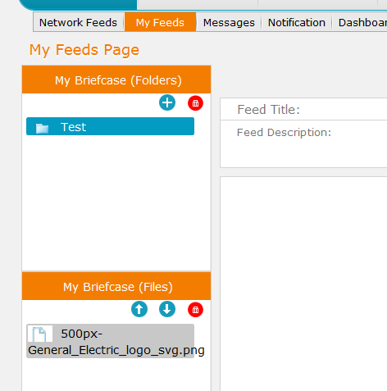

**ISSUES AFTER DATED 8-February-2015**

1. **BROUCHURE - iOS & Android Mobile Compatible**
2. **RFQ-do you want to broadcast it in Newsfeed as open BID**
3. **some places 2013 - do it 2015**
4. **some places 2014 - do it 2015**
5. **some places New York, USA - do it Ohio USA**
6. **add country code in fax - on ver 2.0**
7. **Social Medium Inc - do it Supply Medium**
8. **Supply Medium Inc - do it Supply Medium**
9. **when admin approve user sign up - must send an email to user that your account activated**
10. **country list - remove country - C, R, S**
11. **admin tabs some places shifted at bottom line while using on phone - set it same for all screens, all devices**
12. **global notification endless loop - set it**
13. **INOIVE Accepted - change it to INVOICE Accepted**
14. **Country Dropdown on register and sign up user not working**
15. post button (home feed/my feed) must be at back side of advertisements
16. transaction item - sequenced numbering - if deleted numbering not reset
17. at all transactions on record click PDF loading - remove it
18. QTE generated but not received in notification
19. bill of landing - INVOICE - weight unit dropdown - not working
20. test all transaction - global notification
21. RFQ/PO/QTE/INV - show loading without fill fields completely, test all transaction - without fill all fields and with one by one fill all fields
22. test all transaction - inquiry at both sides before accept and reject
23. test vendor registration - inquiry at both sides before accept and reject
24. TEST PAYMENT - updated or not while payment via INVOICE PAYMENT and Company Profile
25. TEST PAYMENT with live transaction
26. transactional xml / EDI / REPORTS