1. When I clivck on the global notification it doesn’t take me to the correct page. For example if I get a connection notification and I click it in the global notification it should take me to the that connection request.

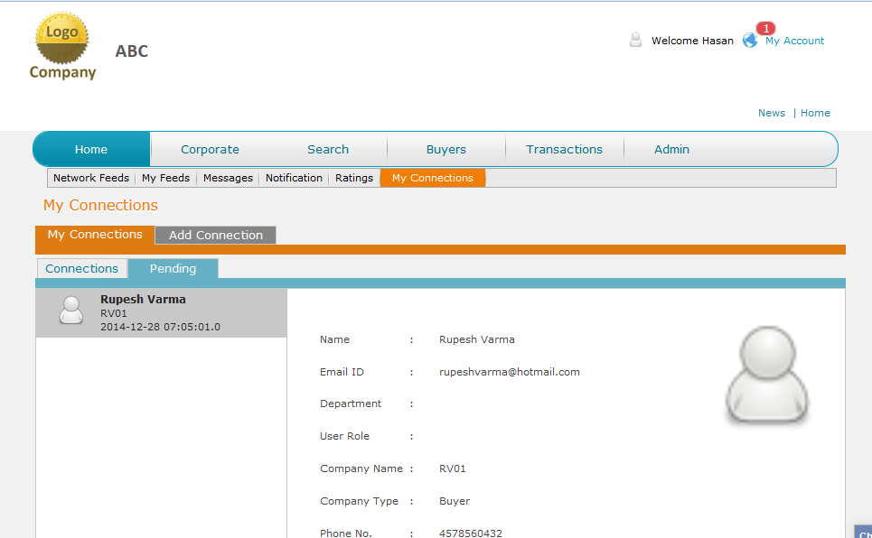

1. Accept but accept doesn’t go away until I refresh. I get the popup so when I get it should automatically refresh the page.

Machine generated alternative text: Email ID : rupeshvarma@hotmail.com
Department :
User Role :
Company Name : RVO1
Company Type : Buyer
Phone No. : 4578560432
Cell :
Fax :
Accept
Reject

1. The date stamp should be “dated 2014-12-28 at 07:11:29”

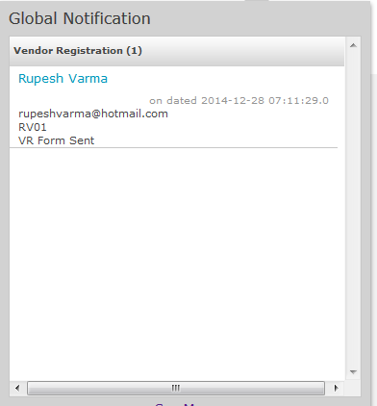

1. “Batch/Lot No” formating

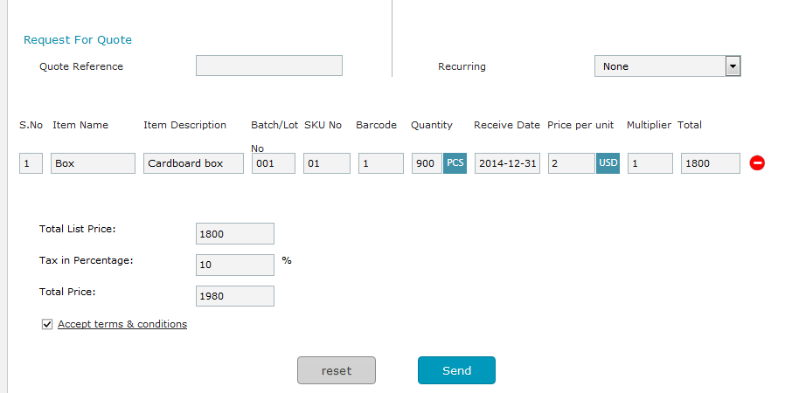

1. The quantity and the Price per Unit are zero

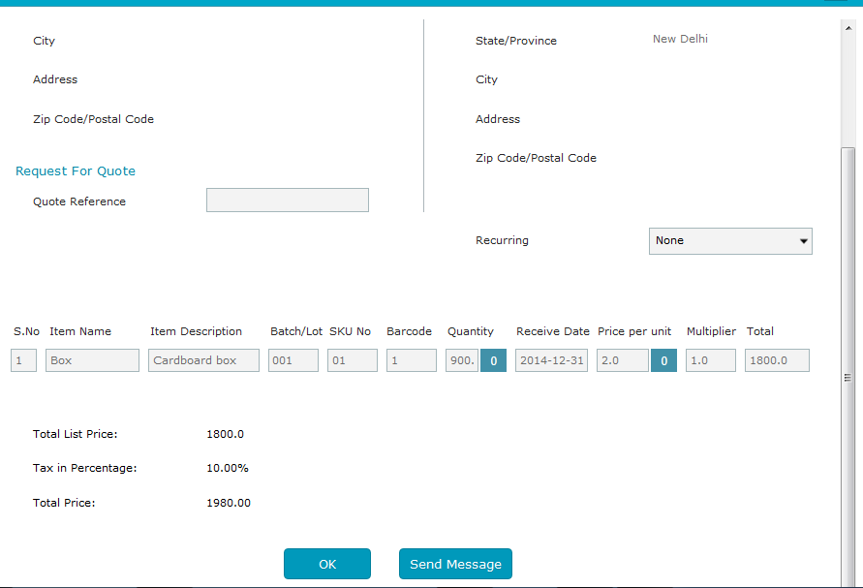

1. If I send a message and get a reply I don’t have the option to accept or reject the quote.

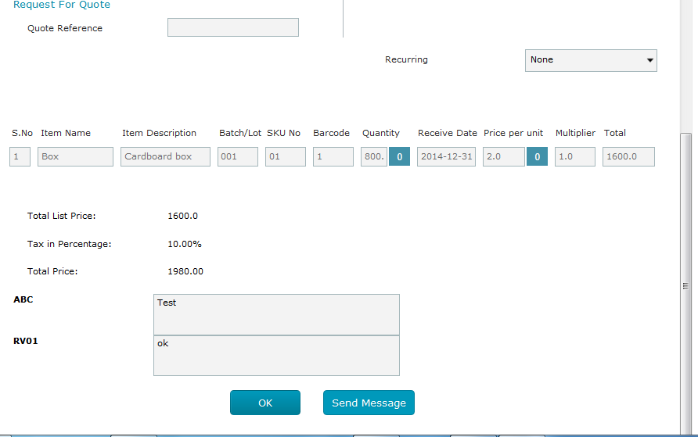

1. In invoice total price is wrong

Machine generated alternative text: C Quote Reference
Recurring None
S.No Item Name Item Description Batch/L0SKU No Barcode Quantity Shipped Receive Date Price per unit Multiplier Total
Li Box &rdboard &dT [dT ____ j 8OO.fl soo.1fl 2O14-1228 [Li fl [1o J _______
Total List Price: 3200.0
Tax in Percentage: 10.00%
Freight & Handling Charges: 0.00%
Total Price: 1980.00
Bill of Landing Information
Bill of Landing No. Freight Weight Date Shipped
16.00 fl 2014-12-31

1. In the pdf the state is wrong. I selected Afghanistanbut the state is new Delhi.

1. No shipping details in the invoice pdf

Machine generated alternative text: Trans Date
28-12-2014
To
Trans Id
INV 14 19741984675
Name: RVOI
Country: India
State/Province: Sew Delhi
City:
Address :
Zip Code:
SJ%o
Item sanie
Item
Decriptio
n
Quantity
Ship I)ale
Price per
Unit
Multiplier
Amount
I
Box
(‘irdhrd
\
800.000
28-12-2014
04.00
I
03200.0
Total
Amount
0 1600.0
Tax 10.0%
0 160.0
Billing
Amount
0 1980.0
From
Name: ABC
Country : Afghanistan
State/Province: New Delhi
City:
Address:
Zip Code:

1. When I add a user the user doesn’t get any email notification

Machine generated alternative text: ewsroom
reate Watchlist
/a tchlist
Newsroom
Feed Title:
Feed Description:
ABC
npany
U Welcome Hasan 4 My Account
News I Home

1. If I activate the account and the again click the row againit changes to pending

Machine generated alternative text: i-iome corporate earcn buyers I ransactions iamin
Users Groups Departments Account Policies Company Profile Company Website Advertisement
Use rs
Has Cheema shaun.chimal@gmail.com Pending Not Connected

1. Never got email that my account has been activated.
2. Enter not working in Firefox. Have to click send

Machine generated alternative text: m New Delhi
Rupesh Varma x Chat
Rupesh Varma Rupesh Varrna
Hasan Cheema
Hi
rsend -
1231 AM
4)) ( .111
____ 12/28/2014 Li

1. When Rupesh send me a chat message I have no way to know I got a chat message.