**BROCHURE**

1. In “About the Application” make the I capitol in invoice and change RFQ to RFQs
2. In “Application Features” change Invoices to Invoice
3. In the Page 4 it should be “ Quick and smart way to connect with businesses worldwide using SupplyMedium Social Network”
4. For WebKrit Address take out “Badal Colony, 500 Meters Ahead”
5. I think everything else looks fine and once these changes are done we can send this to print. Thanks

**APPLICATION**

1. I linked a company with the external website and when I clicked the link the SupplyMedium went in an infinite loop
2. Somehow when we register a company at the login the first page is company profile and then it automatically changes to home.
3. The send pending request is not showing up in pending tab. It shows up in pending when I click on global notifications.
4. Red icon in global notifications not working
5. If the vendor is not registered he doesn’t show up in the rfq drop down
6. I send a VR. Got the notification in the global notification and when I clicked on it nothing under thru received request in VR
7. Vendor reg – Inquire message comes twice – first when you enquire and then again it gives a txt box below to write again

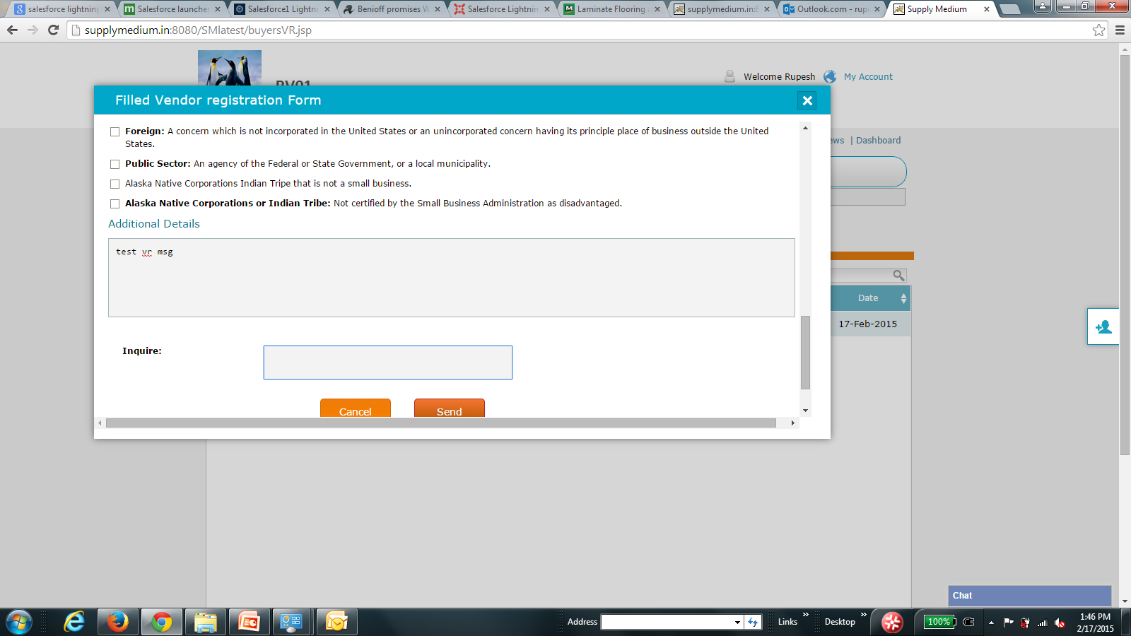

1. Simialry on other end when u receive VR enquire msg, and you write a msg in the txt and then it gives another enquire txt box to write again

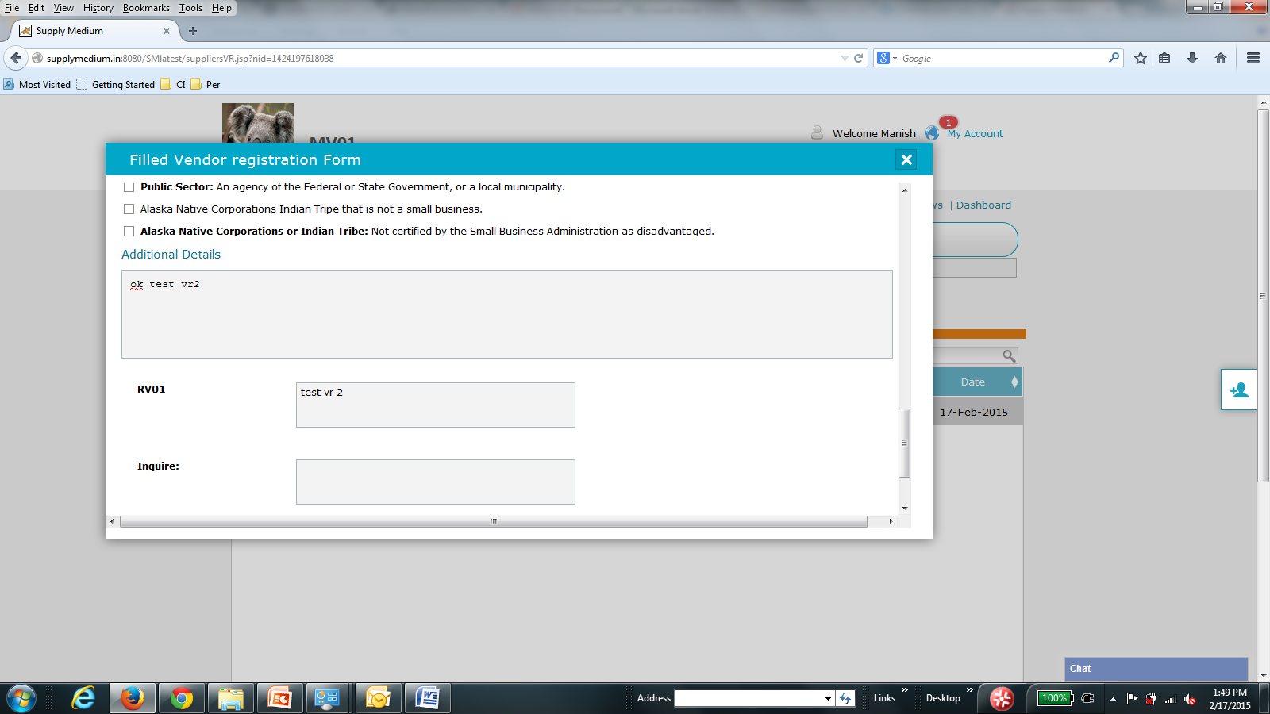

1. Counter reset issue was not specific to my connection and VR only - it was across the board for transactions too, at least on Firefox
2. Generate Quote OR PO – leave accept check box unchecked and click send --- it hangs with endless loading icon:

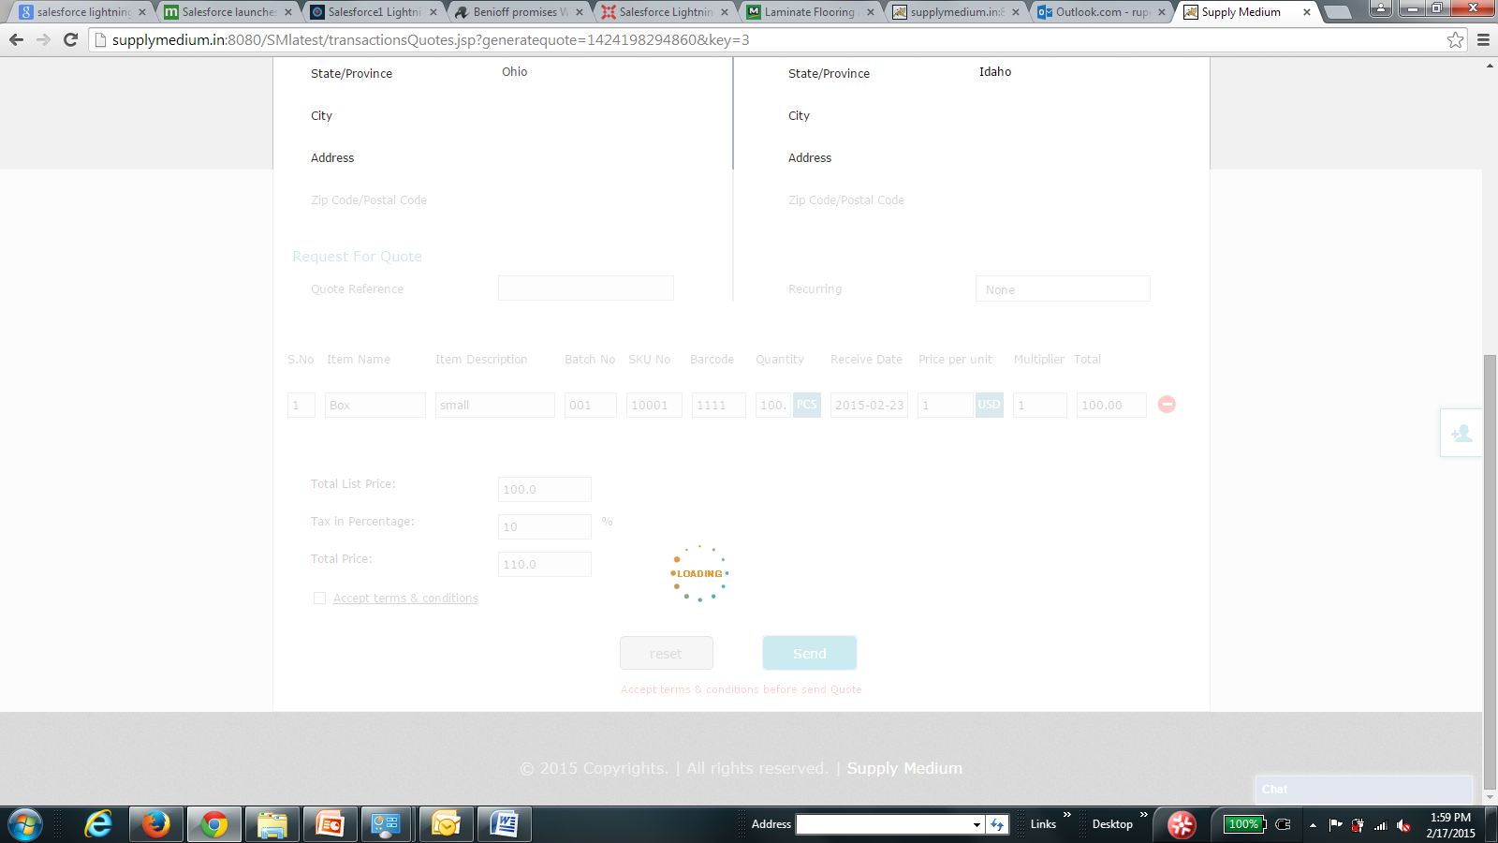

1. I'm thinking should we change our rate from $1 for all revenue areas to $1.99?
2. One of the problem with keeping at low figure of $1 is that it tells people that this is a simple software and may not serve enterprise usage but if we say we are charging $1.99 per user per month, then we are attaching more weightage to our software
3. Again no way of knowing it I received a chat message.
4. Enter button not working in chat
5. Send message not working in the connections page
6. If I click on delete conversation it deletes without asking me to confirm
7. Got a message from and when clicked on it in global notification took me to the message tab but the person not selected by default

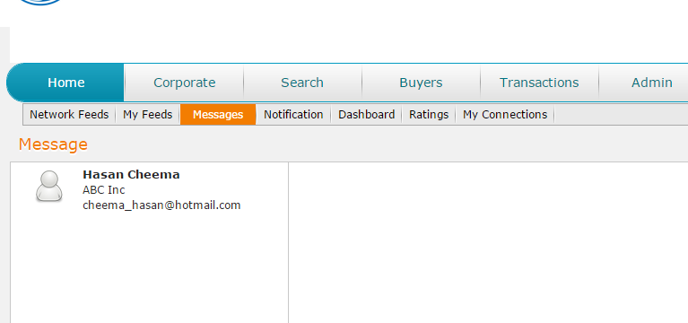

1. I registered RVO1 as a supplier but every time I receive global notification it goes into supplier tab which obvious lt does not have any rows since those are part of buyers rows

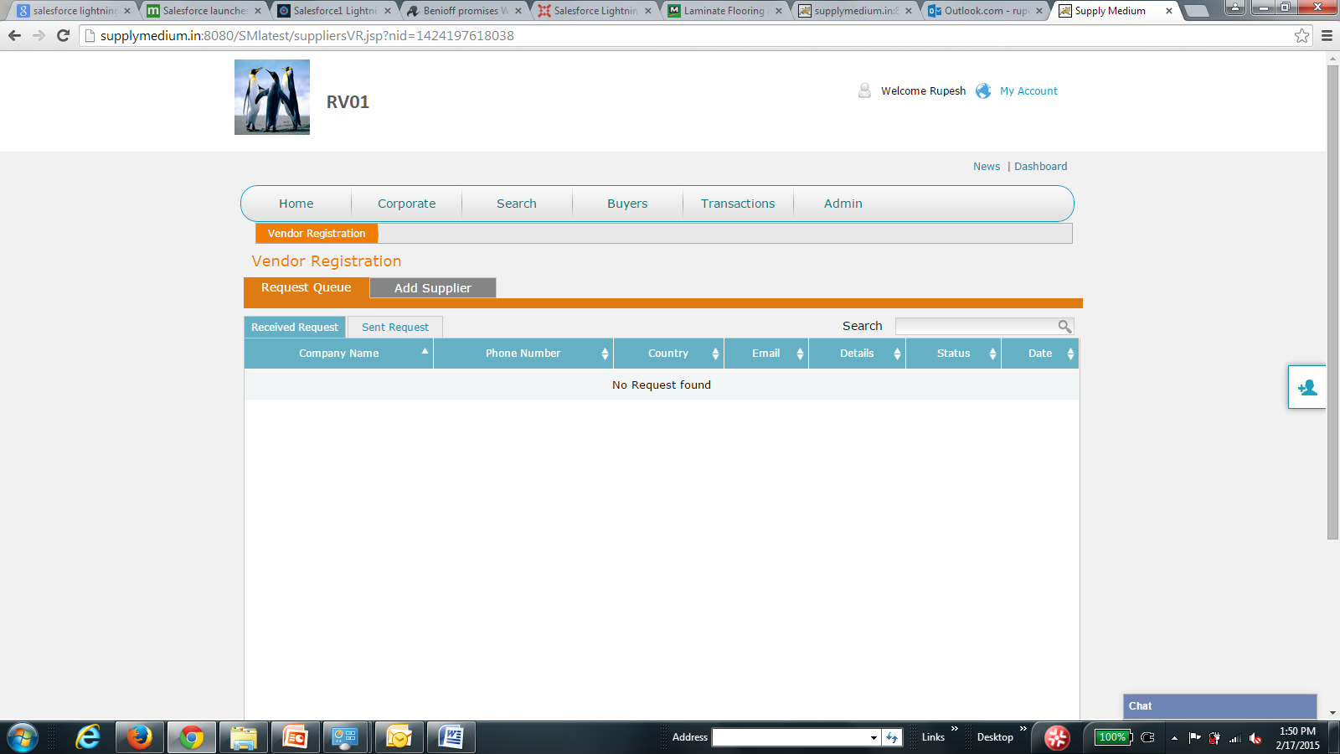

On buyer side, it shows correct tab of supplier with correct row from received notification

1. On buyers side, notifications are not getting reset and it remains even though I’ve clicked on it and selected it – it remains even when I refresh the screen. On supplier side, its correctly reset

