LAB 9 — SETUP & RUN GUIDE
Multi-agent Orchestration · Framework Choice · Chaos Drill
CrewAI · Azure Service Bus · Application Insights · Azure Monitor
Domain case study — CPG demand planning
A CPG company wants a multi-agent demand-planning assistant: one agent pulls sales, one models promotions, an orchestrator reconciles them, and a verifier/critic agent catches bad forecasts. You will build exactly this with CrewAI, wire the agents through Azure Service Bus, put a cost-per-decision number on it, and survive a live chaos drill.
Estimated time: 4 hours (incl. 30-min drill) · Level: Advanced · Language: India English

Contents

Part 0 — Before you start
This guide shows how to create the Azure services for Lab 9 and run every activity. A companion Outcomes Interpretation guide explains how to read the results. It is written in simple India English.

0.1 What you will produce (the artefacts)
# | Artefact | Where it comes from
1 | Multi-agent crew with a verifier agent | 01_run_crew.py (CrewAI on Azure)
2 | Inter-agent eventing on Service Bus | 02_service_bus_eventing.py + a Service Bus queue
3 | Cost-per-decision number | 03_cost_per_decision.py
4 | Chaos-drill scorecard | 04_chaos_drill.py

0.2 Offline first
Every activity runs offline: 01 with --mock (a deterministic pipeline), 02 with --local (an in-memory bus), and 03/04 need no Azure at all. Start offline to learn the flow, then switch on Azure. Use a NEW virtual environment for Lab 9.

0.3 Prerequisites
- An Azure subscription (Contributor) and the Azure CLI (az).
- Python 3.10–3.12. CrewAI installs a fair number of dependencies — allow a few minutes.
Safety note
The CPG sales/promo data is synthetic and only for teaching.

Part 1 — The multi-agent architecture
You are building the orchestrator-worker-verifier pattern. Two workers produce inputs, an orchestrator reconciles them, and a verifier/critic agent checks the result before it is published. Agents are decoupled through Azure Service Bus events.
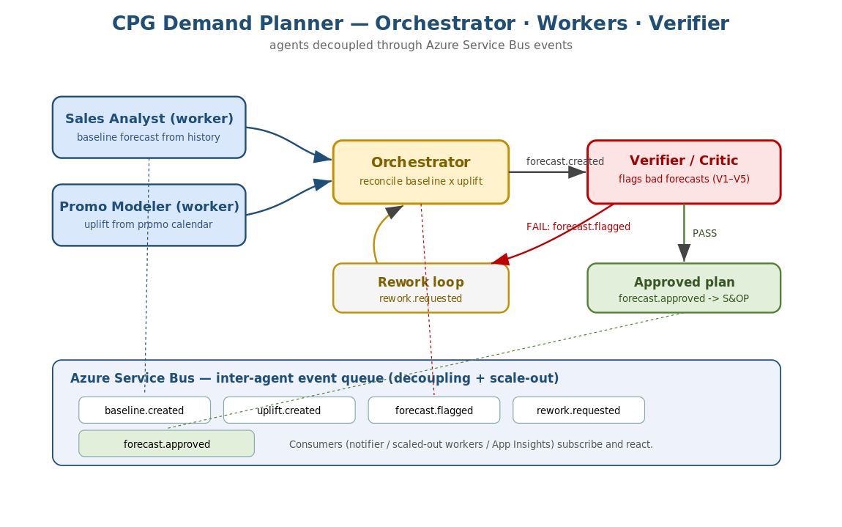
Figure 1 — CPG demand planner: workers, orchestrator, verifier, and the event bus.

1.1 Multi-agent patterns you will use
Pattern | What it means | Where in the lab
Orchestrator / sub-agent | A lead agent delegates to specialised workers | Orchestrator reconciles the two workers
Parallel agents | Independent workers run at the same time | Sales + Promo agents (no dependency)
Handoff | One agent passes work/state to another | Worker outputs handed to the orchestrator, then the verifier
Verifier / critic | A second agent checks the first's output | Verifier flags bad forecasts before publish

1.2 The four agents
Agent | Role | Tool it uses
Sales Analyst | Worker — baseline forecast from history | baseline_forecast
Promo Modeler | Worker — uplift from promotions | promo_uplift
Demand Planner | Orchestrator — reconcile the two | reconcile
Verifier Critic | Verifier — flag bad forecasts (V1–V5) | verify

Part 2 — Framework choice: CrewAI vs AutoGen vs OpenAI Swarm
Choosing the framework is a real design decision. Here is how the three compare for this workload.
Dimension | CrewAI | AutoGen | OpenAI Swarm
Mental model | Role-based crews with tasks | Conversational agents / group chat | Minimal handoffs + routines
Best for | Structured business workflows | Open-ended reasoning, coding, research | Teaching simple handoffs
Orchestration | Sequential + hierarchical process | Group chat / custom graphs | Lightweight function handoffs
Verifier pattern | Maps cleanly (a critic agent + task) | Doable via a reviewer agent | Manual
Production maturity | Growing, opinionated, good docs | Strong, Microsoft-backed | Educational / minimal
Azure fit | Via LiteLLM (azure/<deployment>) | Native Azure OpenAI support | OpenAI-centric
Why CrewAI for this lab
The demand planner has clear ROLES (sales, promo, planner, verifier) and a defined hand-off order. CrewAI's role-and-task model maps directly onto that, so the code reads like the org chart. AutoGen shines when the conversation is open-ended; Swarm is best kept for teaching the bare handoff idea. Pick the framework that matches the SHAPE of your workflow — here, that is CrewAI.

Part 3 — Create the Azure services
You need Azure OpenAI (the agents' brain), Azure Service Bus (inter-agent eventing), and Application Insights / Azure Monitor (telemetry). Portal and CLI paths follow.

3.1 Names to reuse
Placeholder | Example
Resource group | rg-lab9-agents
Region | eastus
Azure OpenAI + chat deployment | aoai-lab9-<init> / gpt-4o
Service Bus namespace + queue | sb-lab9-<init> / agent-events
Application Insights | appi-lab9
Reuse what you already have (don't recreate)
Resource group: if you already made one for an earlier lab (e.g. rg-lab8-agents), reuse it — you do NOT need a new resource group. Just use its name in the commands below.
Azure OpenAI: if you already have an Azure OpenAI resource with a gpt-4o deployment from a previous lab, reuse the SAME endpoint, key and deployment name. Do NOT create a new resource or fetch a new key — just paste the values you already have into .env (Part 4).
Application Insights: same idea — an existing App Insights connection string works fine.
The only resource that is genuinely NEW for Lab 9 is Azure Service Bus (Part 3.3).

3.2 Azure OpenAI (for CrewAI)
Already have an Azure OpenAI resource with a gpt-4o deployment from an earlier lab? Reuse it — skip this step and just paste your existing endpoint, key and deployment name into .env. There is no need to create a new resource or generate a new key. Only create the below if you do not already have one.
CrewAI reaches Azure OpenAI through LiteLLM using AZURE_API_KEY, AZURE_API_BASE and AZURE_API_VERSION, with the model id azure/<deployment>. Create the resource and a gpt-4o deployment (see Lab 8 Part 2 for the exact CLI). Then note the endpoint (AZURE_API_BASE) and key (AZURE_API_KEY).
az cognitiveservices account create --name aoai-lab9-vrl \
--resource-group rg-lab9-agents --location eastus --kind OpenAI --sku S0 --yes
az cognitiveservices account deployment create --name aoai-lab9-vrl \
--resource-group rg-lab9-agents --deployment-name gpt-4o \
--model-name gpt-4o --model-version 2024-08-06 --model-format OpenAI \
--sku-capacity 10 --sku-name Standard

3.3 Azure Service Bus (inter-agent eventing)
This is the one new resource for Lab 9.
Which pricing tier?
Basic is enough for this lab. The lab uses a single QUEUE (agent-events), and the Basic tier fully supports queues — it is the cheapest option.
Choose Standard only if you extend the lab to TOPICS / SUBSCRIPTIONS (publish-subscribe fan-out to several consumers). Basic does not support topics.
Premium (dedicated capacity) is for high-throughput production and is not needed here.

Portal
- Create a Service Bus namespace and choose the Basic pricing tier (Standard only if you plan to use topics).
- Add a Queue named agent-events.
- Under Shared access policies, open RootManageSharedAccessKey and copy the Primary Connection String.
- Click on Queue and create new queue and provide name and all values leave them to default. Copy the queue name and paste it in your .env file
One note: RootManageSharedAccessKey has full Manage rights, which is fine for the lab. For anything beyond the lab, create a narrower policy (Send/Listen only) scoped to the agent-events queue and use that connection string instead.

CLI
# Basic tier is enough for the lab (single queue). Reuse your existing RG name.
az servicebus namespace create --name sb-lab9-vrl \
--resource-group rg-lab9-agents --location eastus --sku Basic
az servicebus queue create --name agent-events \
--namespace-name sb-lab9-vrl --resource-group rg-lab9-agents
az servicebus namespace authorization-rule keys list \
--resource-group rg-lab9-agents --namespace-name sb-lab9-vrl \
--name RootManageSharedAccessKey --query primaryConnectionString -o tsv

3.4 Application Insights / Azure Monitor
Create an Application Insights resource (workspace-based) and copy its Connection String. See the note in the Lab 8 setup guide — you do NOT need to enable OTLP ingestion for this lab; the Azure Monitor Distro uses the connection string.
az extension add --name application-insights --only-show-errors
az monitor app-insights component create --app appi-lab9 \
--location eastus --resource-group rg-lab9-agents --application-type web \
--query connectionString -o tsv

Part 4 — Set up the code
cd code
python -m venv .venv && source .venv/bin/activate # Windows: .venv\Scripts\activate
pip install -r requirements.txt
python generate_cpg_data.py
cp .env.example .env # paste your Azure values
python test_offline.py # confirms everything works with no Azure
Expected: "ALL OFFLINE TESTS PASSED" — the crew pipeline, the verifier, the cost routing, and the chaos scorecards all run offline.

Part 5 — Lab 9-A: run the multi-agent crew
Goal: add a verifier/critic agent to the demand planner and run the whole crew.

Offline (deterministic pipeline)
python 01_run_crew.py --mock

On Azure (real CrewAI crew)
python 01_run_crew.py
Offline prints the forecast, the verifier report, the MAPE (accuracy vs held-out actuals), and the events emitted. On Azure, the four CrewAI agents run in sequence and the token usage is printed for the cost step.
Check
The verifier report shows passed=true for a healthy run; the final status is forecast.approved; MAPE is small (single digits on the synthetic data).

Part 6 — Lab 9-B: inter-agent eventing via Service Bus
Goal: decouple the agents by sending events through Azure Service Bus instead of direct calls.

Offline (in-memory bus)
python 02_service_bus_eventing.py --local

On Azure (real queue, two terminals)
# terminal 1 — producer
python 02_service_bus_eventing.py --role produce
# terminal 2 — consumer
python 02_service_bus_eventing.py --role consume
The producer publishes events (baseline.created, forecast.flagged, forecast.approved, ...). The consumer reads them off the queue and reacts. With Azure, producer and consumer run in separate processes/pods — that is the scale-out pattern.
Scale-out idea
Because agents talk via a queue, you can run many consumer instances to process events in parallel, and a slow or crashed consumer does not block the producers. This is why eventing beats direct calls for multi-agent systems.

Part 7 — The cost scenario (the CRO's number)
Two business questions: token costs jumped 4x after a model upgrade — cut them in 24 hours without losing quality; and the CRO wants a cost-per-decision number in 1 hour.
python 03_cost_per_decision.py --decisions 20000
This prints the cost-per-decision for a routed configuration (cheap models for the routine workers, the premium model only for the orchestrator), compares it to an all-premium configuration, shows the percentage saved and the monthly figure, and reports the forecast MAPE to prove quality did not drop.

7.1 The mitigation lever: model routing
Agent | All-premium | Routed (recommended)
Sales Analyst (worker) | gpt-4o | gpt-4o-mini
Promo Modeler (worker) | gpt-4o | gpt-4o-mini
Demand Planner (orchestrator) | gpt-4o | gpt-4o (keep strong)
Verifier Critic | gpt-4o | gpt-4o-mini
Edit the prices
cost.py has a MODEL_PRICES table (USD per 1M tokens). These are teaching values — replace them with your current Azure pricing before quoting a real number to the CRO. On real runs, take the token counts from Crew.usage_metrics.

Part 8 — The 30-minute chaos drill (runbook)
Mentors break things; the pod's agent must respond. Use 04_chaos_drill.py as the mentor's control panel.

8.1 Roles and timing
Time | Activity
0–5 min | Brief the pod: today's system, the four scorecard axes, rules of engagement
5–20 min | Mentors inject faults one at a time; pod diagnoses and responds live
20–27 min | Compound fault (e.g. timeout + cost spike); pod must prioritise
27–30 min | Debrief: scorecards, what would make every run 4/4

8.2 The fault menu
python 04_chaos_drill.py --faults sales_timeout
python 04_chaos_drill.py --faults bad_sales_data
python 04_chaos_drill.py --faults cost_spike
python 04_chaos_drill.py --faults verifier_bypass
python 04_chaos_drill.py --faults sales_timeout,cost_spike
python 04_chaos_drill.py --all # run the full sequence
Fault | What breaks | What the pod should show
sales_timeout | Sales worker hangs | Retry / fallback; system stays up
bad_sales_data | Worker returns a huge spike | Verifier flags it; rework loop fixes it
cost_spike | Model upgrade quadruples cost | Detect budget breach; route to cheaper models
verifier_bypass | Attempt to skip the critic | Cannot be skipped — verifier always runs

8.3 The scorecard
Each run scores four axes out of 4: stayed up, verifier caught the bad forecast, cost stayed within budget, and the failure was observable (events emitted). The debrief is about turning every 3/4 into a 4/4.

Part 9 — Evaluation and observability tools
These tools are referenced through the lab; here is where each fits.
Tool | Use it for | In this lab
Ragas | Score answer/forecast quality | MAPE is our built-in metric; Ragas can grade agent explanations
LangSmith | Trace agent runs, debug prompts | Set LANGCHAIN_* env vars to trace CrewAI/LiteLLM calls
Promptfoo | Regression-test prompts | Lock agent prompt behaviour before/after a model change
Application Insights / Azure Monitor | Live telemetry, dashboards, alerts | Watch the Service Bus events and agent spans; alert on cost/latency

9.1 LangSmith — enable tracing (the two optional .env values)
The .env file has two optional LangSmith values. They are OFF by default and the lab runs fine without them, but turning them on gives you a detailed, LLM-native trace of every agent step — which is very useful when a crew behaves oddly.
Variable | What it is | How to get it
LANGCHAIN_TRACING_V2 | A switch: set to true to send traces to LangSmith | Just set it to true in .env (no signup needed for this value)
LANGCHAIN_API_KEY | Your personal LangSmith API key | Create it in the LangSmith app (steps below)

How to get the LangSmith API key
- Go to smith.langchain.com and sign in (create a free account if you do not have one).
- Open Settings, then the API Keys section.
- Click Create API Key, give it a name (for example lab9), and copy the key (it is shown once).
- In your .env, set LANGCHAIN_TRACING_V2=true and LANGCHAIN_API_KEY=<the key>.
- Optionally set LANGCHAIN_PROJECT=lab9-demand-planner so this lab's traces group under one project.
# .env additions to turn LangSmith tracing on
LANGCHAIN_TRACING_V2=true
LANGCHAIN_API_KEY=ls__your_key_here
LANGCHAIN_PROJECT=lab9-demand-planner
With these set, run 01_run_crew.py (real, not --mock). CrewAI/LiteLLM emit a trace to LangSmith automatically — no code change needed. Open smith.langchain.com to view the run.
Why bother — the significance
A multi-agent crew makes many hidden LLM calls (each worker, the orchestrator, the verifier, plus retries). When output is wrong or costs jump, you need to see EACH call: its exact prompt, the tokens it used, how long it took, and which tool it invoked. LangSmith records that step-by-step tree so you can pinpoint the culprit agent or prompt in seconds, instead of guessing.

9.2 LangSmith vs Azure Application Insights — how they differ
They are complementary, not competing. Application Insights watches the SERVICE (infrastructure and operations); LangSmith watches the AGENTS (the LLM behaviour). Use both.
Aspect | Azure Application Insights | LangSmith
What it traces | App/infra telemetry: spans, requests, dependencies, exceptions, metrics, logs across the whole service | LLM/agent runs: each prompt, response, token count, tool call, and agent step tree
Best question it answers | Is the service healthy? latency, errors, cost/throughput, alerts | Why did the agent produce THIS output? which prompt/step went wrong?
Granularity | Service and request level | Per LLM call / per agent step
Owner / audience | Ops / SRE / platform teams | AI developers / prompt engineers
Where data lives | Your Azure subscription (Azure Monitor) | LangSmith cloud (a third-party SaaS)
Alerting & dashboards | Rich, native (Azure Monitor alerts, workbooks) | Run views, datasets, evals; lighter ops alerting
Set up in this lab | APPLICATIONINSIGHTS_CONNECTION_STRING | LANGCHAIN_TRACING_V2 + LANGCHAIN_API_KEY
Rule of thumb
Use Application Insights to answer 'is it up, fast, and within budget?' and to alert Ops. Use LangSmith to answer 'why did the agent decide that?' and to debug prompts. In production you keep App Insights always on; you may keep LangSmith on in dev/staging and sample it in production. Note LangSmith is a third-party SaaS, so check your data-governance rules before sending prompts to it.

Part 10 — Troubleshooting and cleanup
Symptom | Likely cause and fix
CrewAI auth error | Use AZURE_API_KEY / AZURE_API_BASE / AZURE_API_VERSION (not the Lab 8 names) and model azure/<deployment>
Service Bus timeout | Check the connection string and that the queue 'agent-events' exists
Costs look wrong | Update MODEL_PRICES in cost.py to your Azure prices; use real usage_metrics
Crew is slow/expensive | Route workers to a cheaper model (Part 7)
No telemetry | Confirm the connection string; traces take 1–3 minutes

10.1 Clean up
az group delete --name rg-lab9-agents --yes --no-wait

10.2 Outcomes checklist
- ✓ Multi-agent crew with a verifier agent (01).
- ✓ Inter-agent eventing on Azure Service Bus (02).
- ✓ Cost-per-decision number, with a quality check (03).
- ✓ Chaos-drill scorecards captured (04).

Next
Use the Outcomes Interpretation guide to read the crew output, verifier flags, events, cost number, and drill scorecards.

