LAB 9 — OUTCOMES GUIDE
Interpreting the multi-agent demand-planner results
What each output means · what 'good' looks like · how to judge your crew
How to use this guide
Run the labs with the Setup & Run guide, then come here to understand what you are seeing: the crew output, the verifier's flags, the Service Bus events, the cost-per-decision number, and the chaos-drill scorecards.

Contents

Part 1 — The mental model
Every result in this lab is a movement through the orchestrator-worker-verifier flow. Read the diagram first; then each output tells you where you are on it.
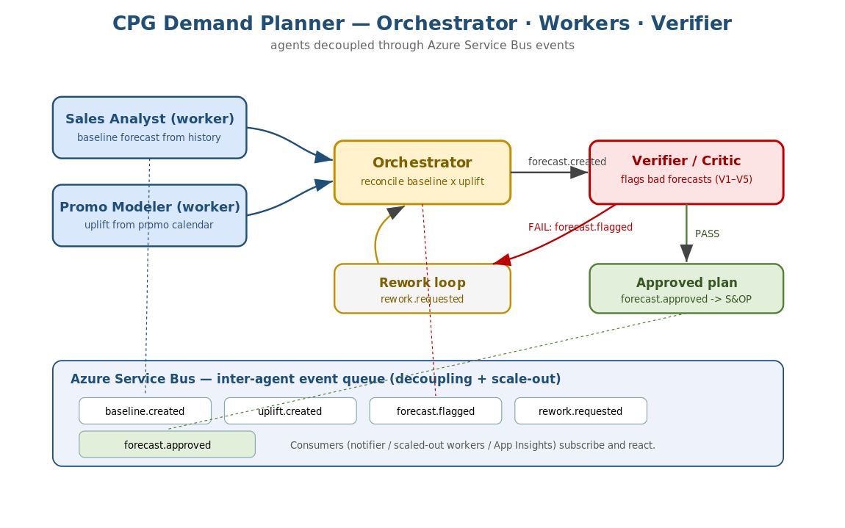
Figure 1 — Read every event and verdict as a step on this flow.
The lens
Two workers produce inputs in parallel, an orchestrator reconciles them, and a verifier decides whether the forecast is safe to publish. Events on the bus are the visible trail of that flow. If a result surprises you, ask: which agent produced it, and did the verifier pass or flag it?

Part 2 — Reading the crew output (Lab 9-A)
01_run_crew.py --mock prints a compact result. A healthy run looks like this:
final status : forecast.approved
reworked : False
MAPE vs actuals: 5.3 %
cost/decision : $ 0.0275
events : ['baseline.created','uplift.created','forecast.created','forecast.approved']
verifier report: { passed: true, flags: [] }

2.1 What each line means
Field | Meaning | What good looks like
final status | The last event — approved or rejected | forecast.approved
reworked | Did the verifier send it back once? | False on clean data; True if it caught+fixed a problem
MAPE | Forecast error vs held-out actuals (lower better) | Single digits on the synthetic data
cost/decision | Token cost of this run | Within your budget (see Part 5)
events | The trail published to the bus | baseline -> uplift -> forecast -> approved
verifier report | The critic's verdict | passed=true, no flags

2.2 The real CrewAI run
Without --mock, the four CrewAI agents run in sequence and you also see token usage. The agents' natural-language reasoning will vary run to run (they are probabilistic), but the verifier task should still end in a clear PASS/FAIL with reasons. Treat the deterministic pipeline as the reference for what the numbers SHOULD be.
What good looks like
Workers run before the orchestrator; the orchestrator's forecast is reconciled from both; the verifier gives a clear verdict; the token usage is captured so you can price the decision.

Part 3 — The verifier's flags (the critic)
The verifier is your safety net. Each flag names a rule and a reason, so a rejection is explainable. The rules:
Rule | Fires when | Why it matters
V1 | Forecast <= 0 | A zero/negative forecast is impossible
V2 | Forecast > capacity | You cannot make/ship more than capacity
V3 | Forecast > 1.6x recent max | A spike this large is usually an error
V4 | Forecast < 0.5x recent min | A collapse this large is usually an error
V5 | On promo but below recent average | The promo uplift was probably not applied

3.1 How to read a rejection
When you inject bad data (chaos), you will see the verifier flag it, then the pipeline rework and re-verify. For example a corrupted SKU forecast of 10,000,000 trips V2 (over capacity) and V3 (far above history); the rework loop caps it to capacity or restores the history-based baseline, and the second verify passes.
What good looks like
Bad forecasts never reach 'approved'. Each flag has a rule id and a human-readable reason. After rework, the re-verified forecast passes. This is the verifier earning its place in the crew.

3.2 Common misreading
- A flag is not a crash — it is the system working. The valuable outcome is that the bad number was CAUGHT, not that no bad number was ever proposed.

Part 4 — Service Bus events (Lab 9-B)
The producer publishes events as it works; the consumer reads them and reacts. Interpreting the trail:
Event | Emitted when | A consumer would…
baseline.created | Sales worker finishes | Log / trigger downstream prep
uplift.created | Promo worker finishes | Log / combine with baseline
forecast.created | Orchestrator reconciles | Hold for verification
forecast.flagged | Verifier rejects | Alert planners; start rework
rework.requested | Orchestrator re-runs a part | Re-invoke the affected worker
forecast.approved | Verifier passes | Publish the plan to the S&OP system

4.1 Why eventing matters (scale-out)
Because agents communicate through a queue, not direct calls, you can run many consumers in parallel, restart a consumer without losing events, and add new reactors (for example an alerting pod) without touching the producers. On Azure the producer and consumer run in different processes/pods and the queue carries the events between them — proof of decoupling.
What good looks like
At least the baseline/uplift/forecast/approved events appear in order. On Azure, a consumer in a second terminal reads the same events the producer wrote. Killing and restarting the consumer does not lose queued events.

Part 5 — Cost-per-decision (the CRO's number)
03_cost_per_decision.py gives the number the CRO asked for and shows the 4x mitigation. Reading it:
COST PER DECISION (routed config): $0.0275
all-premium per decision : $0.0737
routed per decision : $0.0275
saving : 62.8%
monthly (20,000 decisions): all-premium $1,475 routed $549 saved $926
forecast MAPE vs actuals : 5.3% verifier passed : True

5.1 How to interpret it
- Cost per decision is the token cost of one full planning run. Multiply by decisions per month for the budget line the CRO cares about.
- The saving comes from ROUTING: cheap models for the routine workers and verifier, the premium model only for the orchestrator's reconciliation.
- The quality check (MAPE + verifier passed) is the crucial second half: it proves you cut cost WITHOUT losing accuracy. Never quote the saving without it.

5.2 Answering the scenario
'Costs jumped 4x overnight after a model upgrade.' The upgrade put every agent on the premium model. The fix in 24 hours is to route: keep the premium model only where reasoning quality changes the answer (the orchestrator), and move the mechanical workers and the mostly-deterministic verifier to a mini model. The report shows the cost falling by roughly 60% while MAPE and the verifier verdict hold.
Judge it honestly
A good answer to the CRO is a single number (cost per decision) plus the monthly total AND a one-line quality guarantee (MAPE unchanged, verifier still passing). The prices in cost.py are teaching values — swap in live Azure pricing before quoting.

Part 6 — Chaos-drill scorecards
04_chaos_drill.py scores each run on four axes out of 4. Reading the scorecard:
Axis | Means | How it is judged
stayed_up | The system did not crash | The run completed (with retry/fallback if needed)
verifier_caught | The critic flagged injected bad data | forecast.flagged appeared for bad_sales_data
cost_controlled | Cost-per-decision within budget | <= the $0.05 budget after any spike
observable | The failure was visible | >= 3 events emitted to the bus

6.1 Per-fault interpretation
Fault | Expected scorecard | What it proves
sales_timeout | 4/4 (retry recovers) | Transient failure does not break the crew
bad_sales_data | 4/4 (verifier catches) | The critic stops a bad forecast reaching publish
cost_spike | 3/4 (cost breaches budget) | The system SEES the cost problem — then you route to fix it
verifier_bypass | 4/4 (cannot skip) | The verifier is not optional; it always runs

6.2 Reading a 3/4
A 3/4 is not a failure of the drill — it is the drill doing its job. The cost_spike case is meant to score 3/4 until the pod reacts by routing to cheaper models; then a re-run scores 4/4. The debrief question is always: what one change turns this 3/4 into a 4/4, and how fast could the pod make it in production?
What good looks like
No traceback on any fault. The verifier catches injected bad data. Budget breaches are detected (not hidden). Every failure is observable through events. The pod can explain, for each 3/4, exactly what they would change.

Part 7 — Reading traces: LangSmith vs Application Insights
If you turned on the two optional LangSmith values (setup guide Part 9.1), you now have TWO observability views. They answer different questions, so interpret them differently.

7.1 What a LangSmith trace shows (agent behaviour)
A LangSmith run is a TREE: the crew at the top, then each agent, then each LLM call under it, then any tool calls. For every node you see the exact input prompt, the output, the token counts, the latency, and any error. Read it top-down to answer 'why did the agent do that?'.
- Find the wrong step: expand the agent whose output looks off (e.g. the verifier said PASS when it should have failed) and read its actual prompt and response.
- Explain a cost spike: sort the calls by tokens; the call whose token count grew is the one driving the cost-per-decision number from Part 5.
- Explain slowness: the latency on each node shows which agent or tool call is the bottleneck.

7.2 What Application Insights shows (service health)
Application Insights shows the run as a SPAN (agent.run) plus dependency calls (e.g. Service Bus), exceptions, and metrics across the whole service. Read it to answer 'is it up, fast, and within budget?'.
- Transaction search: find the agent.run span and its duration; see failed dependencies or exceptions attached to it.
- Logs / metrics: chart latency and error rate over time; set an alert when they breach a threshold.
- Events: Service Bus publish/consume shows up as dependency calls, so you can confirm the event trail from Part 4 at the infra level.

7.3 Which one to open for a given question
Your question | Open this
Why did the verifier pass a bad forecast? | LangSmith — read the verifier call's prompt + output
Which agent's tokens caused the 4x cost jump? | LangSmith — sort calls by tokens
Is the service slow or erroring right now? | Application Insights — latency / failures
Did the Service Bus event actually get sent? | Application Insights — dependency call
Alert me when cost or latency breaches budget | Application Insights (Azure Monitor alerts)
Debug and compare prompts across runs | LangSmith — run history + datasets

7.4 Cross-referencing the two
They are strongest together. When Part 5 shows the cost-per-decision rising, App Insights tells you the business impact (budget, latency, alert), and LangSmith tells you the root cause (the exact call whose tokens grew). Tag runs with the same identifier (for example a run id or thread id) so you can line up the same execution in both tools. Remember the data lives in different places: App Insights in your Azure subscription; LangSmith in a third-party SaaS — so treat prompts sent to LangSmith per your data-governance rules.
What good looks like
You can point to a single agent step in LangSmith to explain any wrong or expensive output, AND show its health/impact in Application Insights. If you can only see one of the two, you are either flying blind on agent behaviour or blind on service health.

Part 8 — Framework reflection and artefacts

7.1 Did CrewAI fit?
Judge the framework choice against the workload. For a fixed pipeline of clear roles with a verifier gate, CrewAI's role-and-task model kept the code close to the org chart and made the verifier a first-class agent. If your workflow had been open-ended multi-turn reasoning, AutoGen's group chat might have fit better; for a bare handoff demo, Swarm. The lesson is to match the framework to the shape of the work, not to fashion.

7.2 Mapping outcomes to the four artefacts
Artefact | The outcome that proves it
Multi-agent crew with verifier | 01 prints a verifier verdict and an approved/rejected status
Inter-agent eventing on Service Bus | 02 producer/consumer exchange events through the queue
Cost-per-decision number | 03 prints the number, the monthly total, and a quality check
Chaos-drill survived | 04 scorecards: no crashes, verifier catches bad data, cost breaches detected

7.3 Quick self-assessment
Question | Yes = healthy
Does a bad forecast always get flagged before publish? | Yes
Do agents talk via events, not direct calls? | Yes
Can you state cost-per-decision AND show quality held? | Yes
Do all chaos faults end without a crash? | Yes
Can the pod turn each 3/4 into a 4/4 with one change? | Yes

The big idea
A multi-agent system earns trust through a verifier that catches bad output, decoupled eventing that scales and stays observable, a cost number the business can act on, and graceful behaviour under chaos. Every outcome in this lab is evidence of one of those four.

Part 9 — Command-by-command: what each run does and how to read it
This part walks through every command in the quick-start, in order. For each one it says what actually happens under the hood and how to read the result. The offline commands need no Azure and no CrewAI LLM calls; the Azure commands need a filled-in .env.

9.1 The offline runs (no Azure, no LLM calls)

python test_offline.py
What happens: runs the whole orchestration through the deterministic pipeline and asserts every path — the happy path, that routing is cheaper than all-premium, that the verifier catches an over-capacity spike, and that the three chaos faults behave. Nothing touches Azure or an LLM.
How to read it: you should see one line per check and then 'ALL OFFLINE TESTS PASSED'. A typical run:
[happy path] approved, MAPE=5.3%, cost/decision=$0.0275
[cost] routed $0.0275 vs premium $0.0737 -> 63% cheaper
[verifier] caught an over-capacity spike
[chaos: bad_sales_data] score 4/4, verifier caught it
[chaos: sales_timeout] stayed up via retry, score 4/4
[chaos: cost_spike] budget breach detected, score 3/4
ALL OFFLINE TESTS PASSED
Interpretation: if this passes, the pattern (workers -> orchestrator -> verifier), the cost model, and the chaos handling all work on your machine. If a single check fails, read its name — it points you straight at the broken module (verifier.py, cost.py, pipeline.py or chaos.py). Treat this as your green light before spending anything on Azure.

python 01_run_crew.py --mock
What happens: runs one demand-planning decision through the deterministic pipeline (not the LLM) and prints the plan, the verifier report, the accuracy (MAPE), the cost-per-decision, and the events published to the in-memory bus. This is the offline twin of Lab 9-A.
How to read it: see Part 2 for the field-by-field meaning. In short: final status should be forecast.approved, reworked False on clean data, MAPE in single digits, and the events list should read baseline -> uplift -> forecast -> approved. The verifier report should show passed=true with no flags.

python 02_service_bus_eventing.py --local
What happens: the producer runs a decision and PUBLISHES events to an in-memory bus; the consumer then READS them and prints the action it would take for each. No Azure queue is used, but the code path is the same as the real one.
How to read it: you should see the producer's event list, then the consumer reacting line by line, e.g. forecast.approved -> publish the plan to the S&OP system. See Part 4 for what each event means. The lesson is the DECOUPLING: the producer does not call the consumer; it drops an event and the consumer reacts.

python 03_cost_per_decision.py
What happens: computes the cost-per-decision for the routed configuration (the CRO's number), compares it against the all-premium configuration, prints the percentage and monthly saving, then runs the pipeline once to report the forecast MAPE — proving quality held.
How to read it: see Part 5. The headline is the single dollar figure; the mitigation is the routed-vs-premium comparison; the proof is that MAPE stays low and the verifier still passes. Remember the prices in cost.py are teaching values — swap in live Azure pricing before quoting.

python 04_chaos_drill.py --all
What happens: runs the drill once with no faults (baseline), then once for EACH fault, then a compound fault, printing a scorecard (out of 4) for every run.
How to read it: expected pattern —
Run | Expected score | Why
baseline (no faults) | 4/4 | Clean run: up, verifier passes, in budget, observable
sales_timeout | 4/4 | Retry/fallback recovers; system stays up
bad_sales_data | 4/4 | Verifier flags the injected spike
cost_spike | 3/4 | Budget breach is DETECTED (cost axis fails on purpose)
verifier_bypass | 4/4 | Verifier cannot be skipped; still runs
compound (timeout+cost_spike) | 3/4 | Recovers but cost still breaches budget
Interpretation: a 3/4 is the drill working, not failing — the cost_spike case is designed to breach the budget until the pod reacts by routing to cheaper models. See Part 6. No run should ever print a traceback; if one does, the system did not stay up and that is the real finding to discuss.

9.2 The Azure runs (need .env filled in)

python 01_run_crew.py (real CrewAI crew on Azure OpenAI)
What happens: builds the real four-agent CrewAI crew and calls kickoff(). Each agent makes live Azure OpenAI calls in sequence — Sales Analyst, Promotion Modeler, Demand Planner (orchestrator), then Verifier Critic. With verbose on, you see each agent's reasoning, tool calls, and hand-offs, then the final verifier verdict and the token usage_metrics.
How to read it: the agents' wording will vary run to run (they are probabilistic), so do not expect identical text each time. Judge it on structure, not prose: workers run before the orchestrator; the orchestrator's forecast is reconciled from both worker outputs; the verifier ends with a clear PASS/FAIL and reasons. Use the printed usage_metrics (token counts) as the REAL input to the cost-per-decision calculation — replace the illustrative token defaults in cost.py with these numbers. Treat the offline --mock run as the reference for what the numbers should look like.
If the crew and the mock disagree
The offline pipeline is deterministic and correct by construction. If the real crew produces an odd forecast or a wrong verdict, that is an agent/prompt issue — open the LangSmith trace (Part 7) to see which agent's call went wrong, rather than editing the deterministic tools.

python 02_service_bus_eventing.py (real Azure Service Bus)
What happens: the same producer/consumer, but events now travel through your real Azure Service Bus queue (agent-events). Run the producer in one terminal (--role produce) and the consumer in another (--role consume); the queue carries events between the two processes.
How to read it: the consumer in the second terminal should print the SAME events the producer wrote in the first — proof that the queue, not a direct call, carried them. Kill the consumer, run the producer, then start the consumer again: the queued events are still delivered, which demonstrates durability and scale-out. At the infra level you can confirm the same traffic in Application Insights as Service Bus dependency calls (Part 7). In the Azure portal, the queue's Active message count rises when you produce and falls when you consume.

9.3 One-line summary of each run
Command | Proves
test_offline.py | The whole pattern works locally (green light before Azure)
01_run_crew.py --mock | The demand plan + verifier verdict + MAPE + cost, deterministically
02_service_bus_eventing.py --local | Agents are decoupled via events (in-memory)
03_cost_per_decision.py | The CRO's cost number and the 4x mitigation, quality intact
04_chaos_drill.py --all | Graceful behaviour under each induced fault (scorecards)
01_run_crew.py (Azure) | The real four-agent CrewAI crew with token usage
02_service_bus_eventing.py (Azure) | Real queue carries events across processes/pods

