LAB 10 — OUTCOMES GUIDE
Interpreting the deploy, the eval gate, and the rollback
What each output means · what 'good' looks like · how to judge the pipeline
How to use this guide
Run the labs with the Setup guide, then come here to read the results: the app's health/version endpoints, the eval-gate verdict, Container Apps revisions and traffic weights, probe states, autoscale, and the rollback outcome.

Contents

Part 1 — The mental model
Everything in this lab is about moving traffic safely to a new version and moving it back fast if needed. Keep this pipeline picture beside you.
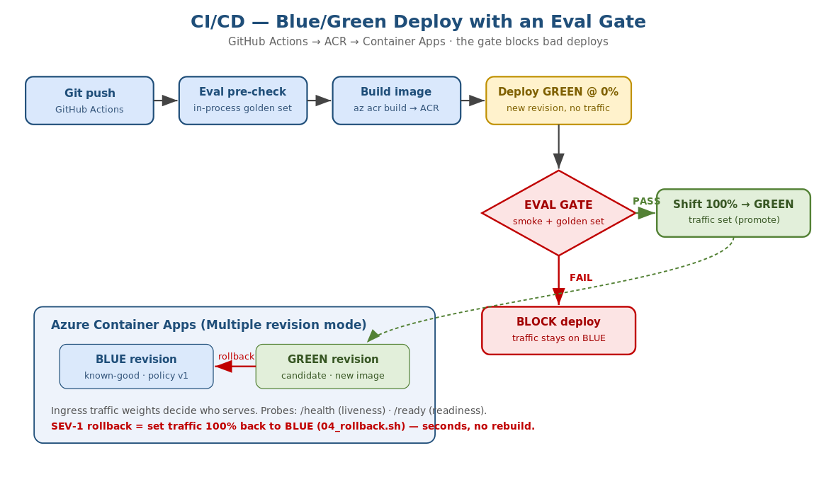
Figure 1 — build -> ACR -> GREEN@0% -> eval gate -> promote or block; rollback = traffic back to BLUE.
The lens
A deploy is not 'the new code is running' — it is 'traffic has moved to the new revision'. In Container Apps those are two separate things: a new revision can exist at 0% traffic. That gap is exactly where the eval gate lives, and why rollback is instant.

Part 2 — Reading the app endpoints
Endpoint | Healthy output | How to read it
GET /health | {"status":"alive"} | Process is up. If this fails, liveness restarts the container.
GET /ready | {"status":"ready","policy_version":"v1"} | A valid policy loaded. 503 => readiness holds traffic away.
POST /decide | {"decision":"block",...} | The triage decision + reason + policy_version.
GET /version | app_version, git_sha, policy_version | Exactly what is serving — your rollback truth check.
The most important field during an incident is policy_version on /version. It tells you, in one call, which version of the 'prompt' is live — so after a rollback you confirm it flipped back to the good one.
Example
POST /decide with amount_gbp=25000 and no HITL should return decision='block' on the good policy. If it returns 'approve', a bad policy is live — that is the 02:00 symptom.

Part 3 — Interpreting the eval gate
The eval gate runs the golden set (12 transactions with known-correct decisions) and prints a pass rate. It is the single thing that decides whether a deploy is allowed to take traffic.

3.1 A PASS
EVAL GATE: 12/12 passed (rate=100.00%, threshold=95%)
RESULT: PASS — safe to promote to production.
All golden cases matched, rate >= threshold, exit code 0. The pipeline proceeds to shift traffic to GREEN.

3.2 A BLOCK (the bad policy)
EVAL GATE: 7/12 passed (rate=58.33%, threshold=95%)
FAIL high_value_no_hitl_MUST_BLOCK: expected 'block' but got 'approve'
FAIL just_over_threshold_block: expected 'block' but got 'approve'
... (5 failures)
RESULT: FAIL — blocking the deploy. Do NOT shift traffic.
Read the failing case names — they tell you exactly what regressed. Here the high-value BLOCK rule was removed, so transactions that must be blocked are being approved. Exit code is non-zero, so the pipeline stops and production stays on the old revision. This is the gate doing its job.
What good looks like
Good changes pass 12/12 and promote automatically. Bad changes fail with named cases and never reach users. The threshold (default 95%) is your risk dial — raise it for a bank.

Part 4 — Reading Container Apps: revisions, traffic, probes, scale

4.1 Revisions and traffic weights
Every template change creates a new REVISION. In multiple revision mode, an INGRESS TRAFFIC WEIGHT decides who serves. Blue/green is just two revisions with weights 100/0, then 0/100.
az containerapp revision list --name $APP -g $RG -o table
# NAME ACTIVE TRAFFICWEIGHT CREATED
# bank-triage-agent--v-abc True 100 ...(BLUE, serving)
# bank-triage-agent--v-def True 0 ...(GREEN, candidate)
Read the TRAFFICWEIGHT column: 100 = serving users, 0 = deployed but idle. During blue/green you will see GREEN at 0 while it is tested, then 100 after promotion.

4.2 Probe states
Probe | What a failure means | What Container Apps does
Liveness (/health) | The process is wedged | Restarts the container
Readiness (/ready) | No valid policy loaded | Stops sending traffic to that replica (no restart)
Startup (/health) | Still booting | Delays liveness so a slow start is not killed
If /ready returns 503 (bad policy path), the replica stays up but receives no traffic — you will see requests not reaching it. That is readiness protecting users from a half-initialised instance.

4.3 Autoscale
With the http-concurrency rule at 50 and min/max 1/10, replica count rises under load and falls when quiet. Read the replica count over time: a spike in concurrent requests should add replicas within a few scaling intervals; an idle app returns to the minimum.
az containerapp replica list --name $APP -g $RG --revision <rev> -o table

Part 5 — Reading a blue/green promotion
03_bluegreen_promote.sh prints its progress. Interpret it as three moves:
- Deploy GREEN at 0%: the new revision exists but users still hit BLUE. Zero user impact so far.
- Validate GREEN: smoke test + eval gate run against GREEN's own URL. This is the safety check on real, running code before any user sees it.
- Flip: traffic set to GREEN=100 BLUE=0. Only now do users get the new version. BLUE stays deployed at 0% as the instant rollback target.
What good looks like
GREEN is validated at 0% before any traffic moves. After the flip, /version shows the new app_version and the good policy_version. BLUE remains available at 0% so rollback is one command away.
If the eval gate fails at step 2, the script exits and the flip never happens — you will see the app still 100% on BLUE. That is a blocked (not broken) deploy.

Part 6 — Reading the rollback (SEV-1)
04_rollback.sh shifts 100% traffic back to the previous known-good revision. Interpret the outcome by three signals:
Signal | Before rollback | After rollback
Traffic weight | BAD revision = 100 | GOOD revision = 100, BAD = 0
/version | policy_version = v2-bad | policy_version = v1 (good)
Behaviour / errors | High-value txns approved; error rate up | Correct blocks resume; error rate falls
The key property is SPEED: rollback is a traffic shift, not a rebuild, so it completes in seconds. That is why the runbook target is under 10 minutes end-to-end including detection and comms. After rollback, the bad revision is deactivated so it cannot silently take traffic again.
What good looks like
Within seconds of running the script, /version flips to the good policy and the bad behaviour stops. The team then records the timeline and opens a postmortem — see the runbook's Post-incident sheet.

Part 7 — Load testing & autoscaling
Load testing answers a different question from the eval gate: not ‘is the new version correct?’ but ‘does the service stay fast and available under concurrent traffic, and does it scale?’. load/locustfile.py drives POST /decide (a realistic approve / block / review mix) hard enough to trip the Container Apps HTTP-concurrency rule (50 concurrent requests per replica, min 1 / max 10 — deploy/containerapp.yaml), so you can watch the app scale OUT under load and back IN when it goes quiet. Install once with: pip install -r requirements-dev.txt

7.1 Scenario A — localhost smoke (offline)
Point Locust at the local app to confirm the scenario runs and to read a latency baseline. There is no autoscaling here — it is one local process — so this is about proving the load mix and that the app answers correctly under concurrency.
uvicorn main:app --app-dir app --port 8000 # terminal 1
locust -f load/locustfile.py --host http://localhost:8000 --headless -u 50 -r 25 -t 30s # terminal 2
Omit --headless to open the web UI at http://localhost:8089 and set users / spawn-rate by hand. A healthy local run is roughly 150 requests/second, 0% failures, and single-digit-millisecond latency (there is no network hop).

7.2 Scenario B — the deployed Azure app (see autoscaling)
Point Locust at the live Container App and ramp high enough that concurrency per replica exceeds 50, forcing Container Apps to add replicas. Watch the replica count climb in a second terminal while the load runs.
APP_FQDN=$(az containerapp show -n "$APP" -g "$RG" --query properties.configuration.ingress.fqdn -o tsv)
locust -f load/locustfile.py --host "https://$APP_FQDN" --headless -u 300 -r 30 -t 5m
# second terminal — watch replicas go 1 -> N -> back to 1:
watch -n 5 'az containerapp replica list -n "$APP" -g "$RG" --query "length(@)" -o tsv'
Latency is higher than local (real network + TLS) and spikes briefly at each scale-out step while a new replica warms, then settles. Scale-IN lags scale-out by a few minutes (Container Apps cool-down) — that is expected, not a fault.

7.3 Reading the results
Read the Locust stats table (throughput and latency percentiles) together with the replica count. Map each signal to what healthy looks like:
Signal | Healthy output | How to read it
Failures % | 0% (a tiny, transient count at scale-out is OK) | Sustained failures mean the app cannot keep up or a replica is unhealthy — check /ready and the probe/replica events.
Requests/s | Rises with users, then plateaus | The plateau is the throughput ceiling at the current replica count; it should step UP as Container Apps adds replicas.
p95 / p99 latency | Steady, with brief spikes at scale-out | A p95 that rises and never settles means you are past capacity — raise max replicas or lower the concurrency target.
Replica count (Azure) | 1 -> several under load -> back to 1 | The autoscaling proof. No movement = load never crossed 50 concurrent/replica; ramp more users (-u).

What good looks like
Locust holds 0% failures while requests/second climbs and p95 stays flat apart from short scale-out blips; on Azure the replica count rises from 1 to several as load builds and returns to 1 after the test. That is a service that is both correct (the eval gate) AND able to absorb load (autoscaling) — the two halves of a safe production deploy.

Part 8 — LLMOps: model card automation
The model card is the part of LLMOps that teams most often get wrong, so it is worth understanding properly. This section explains the problem it solves, how automation fixes it, and how to read the cards this lab produces.

8.1 The problem: hand-written model cards rot
A model card is a factsheet for a deployed model: what it is, what it is for, how it was evaluated, its limits, who owns it, and how to roll it back.
Written by hand, it goes stale immediately. You ship v1.0 with a good card, then ship v1.1 ... v1.7 without touching it. Six months later an auditor asks: 'What exactly was serving customers on 3 March, and what was its measured accuracy?' — and the document still describes v1.0. In a bank that is not untidiness, it is a governance failure.
The fix in one line
Make the model card a BUILD ARTEFACT, not a document. CI generates it from the real facts of that build, so it cannot disagree with what actually shipped.

8.2 The key idea: every field has a source of truth
Nothing in the card is typed by a human. scripts/model_card.py derives each field:
Field | Derived from
app_version, git_sha | The CI tag / commit SHA being built
policy (the 'prompt') | Read out of the ACTUAL policy JSON that ships inside the image
evaluation | The ACTUAL eval-gate score from this run
generated_utc | Build time
Because the card reads the same policy file the container will load, and the same eval result the gate produced, it is derived data. There is no path where the card says one thing and the running app does another.

8.3 Worked example — the good release
python scripts/model_card.py --app-version 1.4.0 --git-sha a1b2c3d \
--policy app/policies/policy_v1.json --eval-passed 12 --eval-total 12
This writes app/model_card.json, which is baked into the image and served at /modelcard:
{
"model_name": "bank-transaction-triage-agent",
"app_version": "1.4.0",
"git_sha": "a1b2c3d",
"generated_utc": "2026-07-13T09:14:02Z",
"intended_use": "Triage bank transactions into approve / review / block.",
"policy": {
"version": "v1",
"block_over_gbp": 10000,
"review_risk_levels": ["high"],
"sanctioned_countries": ["XX", "ZZ"]
},
"evaluation": { "golden_set_passed": 12, "golden_set_total": 12, "pass_rate": 1.0 },
"limitations": ["Deterministic policy demo — not a substitute for full AML screening."],
"owner": "Payments Platform Team",
"rollback": "Shift Container Apps traffic to the previous known-good revision."
}
How to read it: this single file tells you what shipped (1.4.0 / a1b2c3d), what rules it enforces (block over £10,000), how good it measured at release (12/12), and what to do if it misbehaves.

8.4 Worked example — the bad release (the smoking gun)
If the regressed policy were built, the generated card would read:
"policy": { "version": "v2-bad", "block_over_gbp": 1000000000000 },
"evaluation": { "golden_set_passed": 7, "golden_set_total": 12, "pass_rate": 0.58 }
The card is now the evidence. The £1-trillion block threshold and the 58% pass rate are right there in plain JSON. In this pipeline the eval gate blocks the deploy before it ships, but the card is the permanent record of WHY — and it makes the regression legible to a non-engineer. A risk officer can read '58%' without reading any Python.

8.5 The 02:00 use — a one-command diff
This is where model-card automation earns its keep during the incident. Instead of guessing what changed, compare the two revisions' cards:
curl -s https://<bad-revision-fqdn>/modelcard > bad.json
curl -s https://<good-revision-fqdn>/modelcard > good.json
diff good.json bad.json

- "version": "v1", "block_over_gbp": 10000, "pass_rate": 1.0
+ "version": "v2-bad", "block_over_gbp": 1000000000000, "pass_rate": 0.58
In seconds you know exactly what the bad deploy changed. That is step 2 (ASSESS) of the SEV-1 runbook, answered without opening the code.

8.6 Where it sits in the pipeline
The card is generated AFTER the eval gate produces a score and BEFORE the image is promoted, so it always carries a real measured number:
build image -> run eval gate -> generate model card (with the gate's score) -> promote
A hardening worth discussing
In this lab the workflow passes --eval-passed 12 --eval-total 12 as literals. In a stricter setup, eval_gate.py would WRITE its result to a JSON file and model_card.py would READ it — so a human cannot hand-wave a passing score into the card. That is the difference between 'automated' and 'genuinely trustworthy'.

8.7 What a production card adds beyond this lab
- Model + provider + version (e.g. azure/gpt-4o, api-version), temperature, and token cost per call — so a model upgrade is visible in the card.
- Prompt hash alongside the version, so even an untracked edit changes the card.
- Dataset / eval lineage — which golden set, what version, and a link to the CI run.
- Approvals — who signed off and when (a bank needs a named human).
- Broader evals — not just accuracy, but bias/fairness slices and safety checks.
The governing principle
If a fact about the model can change, it must be GENERATED, not typed. Anything hand-written in a model card is a future lie.

8.8 Prompt / policy version traceability
Every artefact carries the same identifiers: the image tag (git sha), the /version endpoint, and the model card all agree. During an incident this lets you answer 'what changed?' instantly — compare the policy_version on the bad revision with the last good one.
What good looks like
/modelcard on any running revision returns an accurate card whose policy and eval numbers match what that revision actually does. Two revisions' cards diff cleanly to show exactly what changed. No one has hand-edited a card.

Part 9 — Mapping outcomes to the artefacts
Required capability | The outcome that proves it
Container Apps deploy | az containerapp show returns a live FQDN; /health is 200
Auto-scaling + probes | replica count moves under load; /ready gates traffic
Blue/green CI/CD | GREEN validated at 0%, then traffic flips to 100%
Eval gate blocks bad deploys | bad policy scores below threshold; pipeline stops
Rollback runbook | 04_rollback.sh flips /version back to good in seconds

9.1 Quick self-assessment
Question | Yes = healthy
Does a new revision start at 0% traffic until validated? | Yes
Does the eval gate block the bad policy (not just warn)? | Yes
Can you roll back with one command in seconds? | Yes
Does /version tell you exactly what is serving? | Yes
Has the team rehearsed the 02:00 runbook? | Yes

The big idea
Safe production for an agent is not 'it works on my machine' — it is a pipeline that validates each change at 0% traffic, a gate that blocks bad prompts, and a rollback you can run half-asleep at 02:00. Every outcome in this lab is evidence of one of those.

