SEMANTIC LAYER IN PRODUCTION

FDE Trainee Case Studies & Thinking Workbook
dbt Semantic Layer / MetricFlow • Cube • LookML / Looker
Real-world references • Architecture scenarios • FDE questions • Design exercises

FDE objective
Do not learn “semantic layer = a tool.” Learn to recognize the architectural problem: multiple consumers need the same business meaning, join paths, dimensions, security rules, and metric calculations. Your job as an FDE is to determine whether centralizing that contract creates enough value to justify the operational and organizational cost.

1. What is the semantic layer?
A semantic layer is a governed abstraction between transformed warehouse data and downstream consumers. It defines business concepts such as Revenue, ARR, Active Customer, Conversion Rate, Order Count, dimensions, entities, relationships, and sometimes access policies in a reusable model. The goal is that different dashboards, applications, spreadsheets, APIs, and increasingly AI agents do not independently reinvent the same business logic.
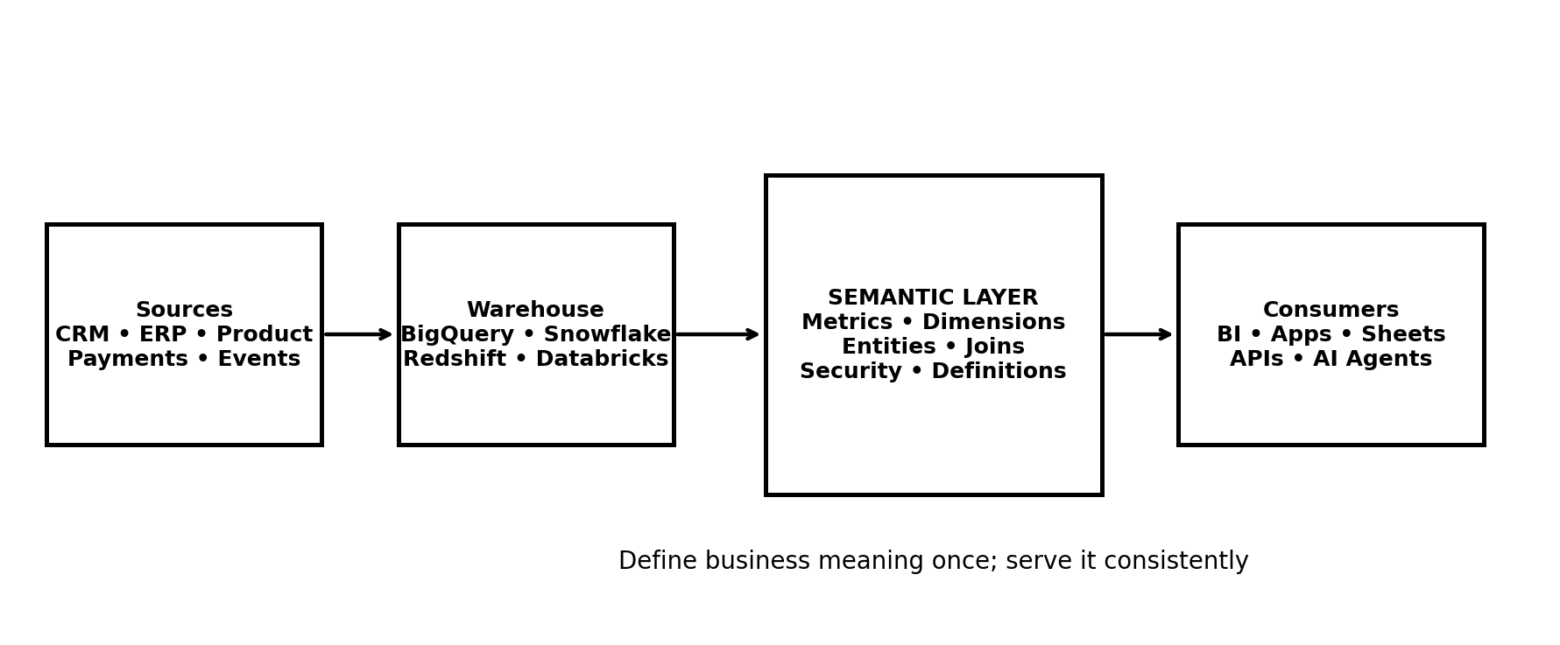
Reference architecture: warehouse remains storage/compute; semantic layer governs meaning and access.

2. The business problem: metric drift
Consider a company where Finance, Sales and Product all report “revenue.” Finance excludes refunds, Sales counts booked contracts, and Product counts successful payments. Each query can be technically correct while the organization still has no shared answer to “What is revenue?”
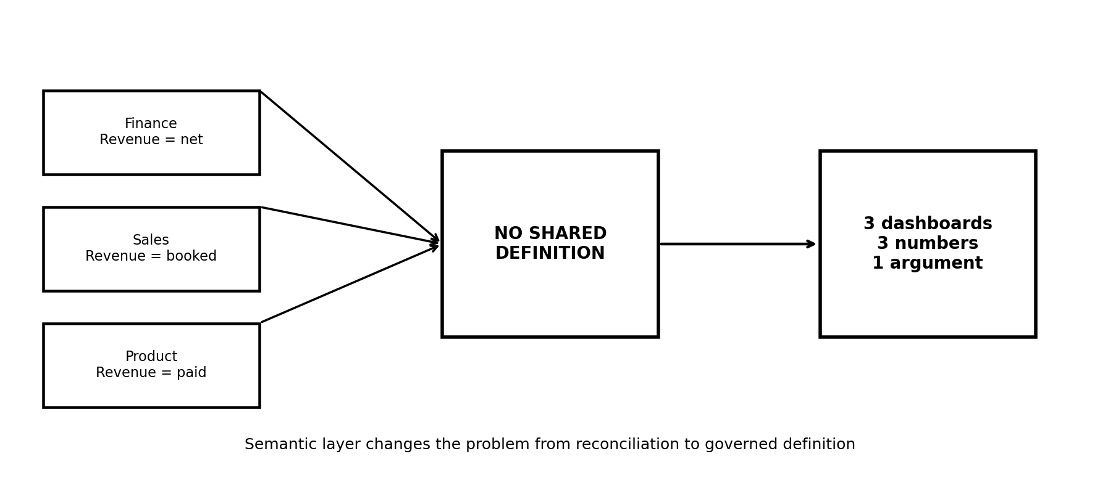
FDE diagnostic question
Before recommending a semantic layer, ask: “Is the pain caused by inconsistent business definitions, inconsistent joins, uncontrolled access, too many consumers, or simply poor data modeling?” A semantic layer should not be used to hide a bad warehouse model.

3. Case Study A — dbt Labs: ARR reporting and the single source of truth
dbt Labs describes a real internal problem involving company-wide Annual Recurring Revenue (ARR) reporting. Its data stack had roughly 50 active sources feeding the warehouse. The same business performance question was answered through a Looker dashboard, Salesforce reporting, a Finance-maintained Google Sheet, and a Hex dashboard based on a dbt model. The numbers frequently disagreed, and preparing for company All Hands required days of reconciliation.
- Pain: multiple systems independently encoded ARR logic.
- Operational symptom: time was spent debating numbers instead of discussing business performance.
- Architecture response: create a source-of-truth Business Overview and centralize important metric definitions.
- FDE lesson: the strongest signal is not “we have many dashboards”; it is “the same KPI is independently reimplemented and disputed.”
- Governance lesson: metric ownership matters. A definition needs a business owner, not only a data engineer.
Grounded reference — dbt Labs: Streamlining KPI dashboards with the dbt Semantic Layer — Official dbt Labs case/example describing the ARR reporting challenge and semantic-layer solution. https://www.getdbt.com/blog/streamlining-kpi-dashboards-dbt-semantic-layer

4. Case Study B — Breakthrough: Cube as a reusable semantic layer
Breakthrough provides analytics around truckload movements. Its earlier architecture relied on highly custom SQL against Postgres, and analytical queries could become very slow. The company moved to a stack in which data is processed in GCP, landed in BigQuery, transformed/audited with dbt, and then served through Cube as a semantic layer to React-based product experiences and Preset dashboards.
- Pain: custom SQL and duplicated calculations were tightly coupled to individual product surfaces.
- Architecture: GCP data processing → BigQuery → dbt → Cube → React/Preset consumers.
- Key benefit: a metric could be defined once and reused across SaaS and service-oriented analytics.
- FDE lesson: Cube is especially interesting when the semantic layer is not just for BI, but also for embedded analytics and application experiences.
- Performance lesson: a semantic serving layer can become an important architectural boundary when many interactive consumers repeatedly ask similar analytical questions.
Grounded reference — Cube: Breakthrough embedded dashboard case study — Official Cube case study describing the architecture, custom-SQL problem, and reusable metrics. https://cube.dev/case-studies/semantic-layer-speeds-time-to-market

5. Case Study C — Google Cloud Support: Looker for governed self-service
Google Cloud Support describes a global support analytics environment where metric drift had reduced trust. The organization needed a governed platform that could support thousands of users without requiring the BI team to manually build every query or dashboard. Looker was selected for its semantic layer and centralized governance.
- Pain: different teams could define operational KPIs differently.
- Scale problem: a small BI team had to support thousands of users and many data requests.
- Semantic-layer role: standardized measures, dimensions and governance so users could self-serve.
- AI extension: Google Cloud Support now describes conversational analytics grounded in the governed Looker model.
- FDE lesson: semantic layers become more valuable as the consumer-to-data-team ratio increases.
Grounded reference — Google Cloud: Google Cloud Support + Looker — Official Google Cloud customer case study covering metric drift, governance, self-service and conversational analytics. https://cloud.google.com/customers/gcs-looker

6. Case Study D — Applied Systems: LookML as a governed business model
Applied Systems built a semantic layer using LookML on top of a BigQuery data foundation. The semantic models standardized dimensions, KPI calculations, data maps and persona-based governance controls. A change to a definition could propagate across dashboards and Explores rather than requiring hundreds of individual reports to be edited.
- Pain: changing a business definition across many reports creates consistency and maintenance risk.
- Design: define the business logic once in LookML and reuse it across analytical surfaces.
- Security: semantic modeling can participate in persona-based access control.
- FDE lesson: ask whether a customer needs a governed semantic contract inside one BI platform, or a tool-agnostic serving layer for many consumers.
Grounded reference — Google Cloud: Applied Systems case study — Official Google Cloud customer case study describing LookML semantic modeling, KPI standardization and governance. https://cloud.google.com/customers/applied-systems

7. Case Study E — Telenor Norway: semantic layer as an AI grounding mechanism
Telenor Norway describes using Looker and Conversational Analytics to move from centralized analytics toward self-service and AI-assisted analysis. The company explicitly describes LookML as important for grounding AI because business rules, KPIs and data relationships are defined in the semantic model.
- AI problem: an LLM can produce a syntactically valid query that applies the wrong business definition.
- Semantic-layer response: give the AI access to governed business definitions and relationships.
- FDE lesson: if an AI agent is allowed to query raw warehouse tables, ask how metric definitions and authorization are enforced.
- Do not confuse: semantic grounding is not the same as prompt engineering. It is an architectural control.
Grounded reference — Google Cloud: Telenor Norway — Official customer case study on LookML, self-service analytics and AI grounding. https://cloud.google.com/customers/telenor-looker

8. What changes between dbt Semantic Layer, Cube and LookML?
Dimension | dbt Semantic Layer / MetricFlow | Cube | LookML / Looker
Primary architectural fit | Semantic definitions closely aligned with dbt models and transformations | Definition + serving layer for BI, embedded analytics and APIs/AI | Semantic modeling deeply integrated with Looker BI
Model style | YAML semantic models/metrics; MetricFlow query generation | Cubes/models in code; query/serving layer | LookML explores, dimensions, measures, joins
Consumer strategy | Tool-agnostic APIs/integrations; strong fit for dbt-centric stacks | Many downstream surfaces, including embedded apps | Strongest when Looker is the central analytics experience
Performance pattern | Warehouse executes generated SQL; MetricFlow optimizes query generation | Can use caching/pre-aggregations and centralized serving | Looker manages query generation and caching within its platform
AI relevance | Governed metrics can be exposed to AI systems | Designed for governed analytics and AI-agent consumption | LookML can ground Looker/Google Cloud AI experiences
Key FDE question | Is the customer already standardized on dbt and wants metrics close to transformations? | Does the customer need one semantic model across apps, BI and AI? | Is Looker already the strategic BI platform and semantic model?

dbt official product page — Current overview of dbt Semantic Layer capabilities. https://www.getdbt.com/product/semantic-layer
dbt official architecture explanation — Explains semantic models, MetricFlow query generation and downstream consumption. https://www.getdbt.com/blog/how-the-dbt-semantic-layer-works
Cube official documentation — Explains Cube Core, semantic modeling and consumption by humans and AI agents. https://docs.cube.dev/docs/introduction
Google Cloud official Looker modeling — Overview of LookML and Looker’s semantic layer. https://cloud.google.com/looker-modeling

9. When should an FDE recommend a semantic layer?
Scenario | What it looks like | Recommendation
Multiple teams use the same KPI | Finance, Sales, Product and Operations all need “Revenue,” “Active Customer,” “Churn,” or “Conversion Rate.” | Strong candidate.
Multiple BI tools consume the same data | Example: Looker + Power BI + Tableau + notebooks. | Strong candidate if definitions are being duplicated.
Embedded analytics is part of the product | Customers need analytics inside the SaaS application, not only in internal BI. | Strong candidate; serving architecture matters.
AI agents answer business questions | Agents need governed metrics, joins, dimensions and access rules. | Strong candidate; semantic layer can reduce metric drift and unsafe query generation.
Regulated or sensitive data | Different personas should see different rows/columns or business domains. | Potentially strong candidate, but validate security architecture separately.
Frequent dashboard disputes | Executives spend meetings reconciling whose number is correct. | Very strong signal.
Small team + one BI tool + simple metrics | One warehouse, one dashboarding tool, few metrics, low organizational complexity. | May not justify the extra layer yet.
Warehouse model is immature | Raw tables are duplicated, grains are unclear, joins are unreliable. | Fix foundational modeling first.

10. FDE scenario lab
For each scenario, trainees should decide: (1) semantic layer or not, (2) why, (3) what belongs in it, (4) what stays in dbt/warehouse/BI, and (5) how success will be measured.

Scenario A — Revenue disagreement
A 1,000-person SaaS company has Finance reporting $42M ARR, Sales reporting $45M, and Product reporting $39M. Each dashboard is technically correct according to its local SQL. The CEO wants one number.
- What would you ask before recommending a solution?
- What metric definitions, dimensions, entities and join paths belong in the semantic contract?
- What should remain ad hoc?
- How would you test correctness and prevent regression?

Scenario B — Embedded customer analytics
A logistics SaaS product wants each customer to see shipment volume, on-time delivery %, cost per mile and exception rate inside the product. The same metrics are also needed by internal operations.
- What would you ask before recommending a solution?
- What metric definitions, dimensions, entities and join paths belong in the semantic contract?
- What should remain ad hoc?
- How would you test correctness and prevent regression?

Scenario C — AI analyst over raw tables
A company gives an AI agent read access to 300 warehouse tables. Users ask: “What was net revenue last quarter by region?” The agent generates different joins and definitions across similar questions.
- What would you ask before recommending a solution?
- What metric definitions, dimensions, entities and join paths belong in the semantic contract?
- What should remain ad hoc?
- How would you test correctness and prevent regression?

Scenario D — Small startup
A 12-person startup has BigQuery, dbt and one Looker dashboard. There are 15 metrics, one analyst and no embedded analytics. The founder asks whether they need a semantic layer.
- What would you ask before recommending a solution?
- What metric definitions, dimensions, entities and join paths belong in the semantic contract?
- What should remain ad hoc?
- How would you test correctness and prevent regression?

Scenario E — Multi-region security
A global company has country managers who may only see their own region, while executives can see all regions. The same revenue metric is used in dashboards, spreadsheets and an internal AI assistant.
- What would you ask before recommending a solution?
- What metric definitions, dimensions, entities and join paths belong in the semantic contract?
- What should remain ad hoc?
- How would you test correctness and prevent regression?

Scenario F — Metric explosion
A team proposes putting every possible calculation into the semantic layer, including one-off ratios used once by an analyst. The model becomes difficult to govern.
- What would you ask before recommending a solution?
- What metric definitions, dimensions, entities and join paths belong in the semantic contract?
- What should remain ad hoc?
- How would you test correctness and prevent regression?

11. FDE thinking questions
- What is the actual problem the semantic layer is solving in this customer environment?
- Which metric currently has the highest business risk if defined incorrectly?
- Who owns the definition of that metric: Finance, Product, Sales, Operations, or a shared data governance group?
- What is the grain of the underlying fact model? Could a semantic layer hide a grain mismatch?
- Which joins are safe? Where can fan-out or double counting occur?
- If “revenue” changes from gross to net, how many downstream systems must change today?
- How many consumers need the same definition: dashboards, APIs, applications, spreadsheets, notebooks, AI agents?
- Does the customer need a definition layer, a serving/cache layer, or both?
- Should the semantic model be centralized across tools or tightly integrated with one BI platform?
- What belongs in dbt transformations versus semantic definitions versus BI presentation logic?
- How will a metric change be reviewed, tested, versioned and communicated?
- How will row-level or tenant-level security be enforced?
- How will the team detect semantic drift after deployment?
- What is the latency and concurrency requirement? Is warehouse execution sufficient?
- How will query cost be measured after introducing generated SQL?
- What happens when an AI agent asks for a metric that does not exist?
- Should the agent be allowed to compose new calculations from certified metrics?
- What evidence would make you reject a semantic-layer proposal?
- What is the smallest useful semantic layer you could implement first?
- What business KPI would prove that the implementation succeeded?

12. Example semantic contract — e-commerce
Use this as a trainee exercise. Assume the warehouse has orders, order_items, customers and products. Do not start by choosing a tool. First define the business contract.
Business concept | Definition | Dimensions | Risk to validate
Gross Revenue | Sum of item selling price before refunds; clarify tax/shipping treatment. | day, region, product, customer segment | Double counting order_items after joins
Net Revenue | Gross revenue minus approved refunds; define refund timing. | day, region, channel | Refund attribution and late-arriving events
Orders | Distinct completed order IDs. | day, region, channel | Order status transitions
Average Order Value | Net Revenue / distinct completed orders. | day, region, channel | Zero-order periods and denominator definition
Active Customer | Customer with at least one completed order in trailing 30 days. | day, region, segment | Time-window semantics

13. Suggested implementation pattern for an FDE
- Identify 5–10 business-critical metrics with real disagreement or reuse.
- Document owner, definition, grain, source model, dimensions, exclusions and known edge cases.
- Validate the underlying dbt/warehouse models and relationships before modeling metrics.
- Choose the serving/modeling approach based on consumers: dbt Semantic Layer, Cube, Looker, or another fit-for-purpose solution.
- Create semantic definitions as code where possible; put them under Git review and CI.
- Create metric-level tests: totals, reconciliation against an authoritative source, join/cardinality tests, and edge-case tests.
- Expose only certified metrics to self-service and AI consumers initially.
- Instrument query latency, warehouse cost, cache hit rate where applicable, error rate and metric adoption.
- Establish a metric-owner review process for definition changes.
- Expand only after the first metrics demonstrate measurable business value.

14. What “good” looks like
- One definition of a critical KPI is reused across multiple consumers.
- Metric logic is version-controlled and reviewable.
- The business owner of the metric is explicit.
- Join paths and entity relationships are documented and tested.
- Security policies are enforced consistently with the consuming application’s authorization model.
- AI agents are constrained to certified definitions rather than inventing business logic from raw tables.
- Warehouse cost and query latency remain observable after introducing generated queries.
- The semantic layer stays intentionally small: business-critical and reusable concepts first.

15. Grounded reference pack
- dbt Labs — Semantic Layer: What it is and when to adopt it
https://www.getdbt.com/blog/semantic-layer-introduction
- dbt Labs — Five use cases for the dbt Semantic Layer
https://www.getdbt.com/blog/five-use-cases-for-the-dbt-semantic-layer
- dbt Labs — How the dbt Semantic Layer works with MetricFlow
https://www.getdbt.com/blog/how-the-dbt-semantic-layer-works
- dbt Labs — Streamlining KPI dashboards with the dbt Semantic Layer
https://www.getdbt.com/blog/streamlining-kpi-dashboards-dbt-semantic-layer
- Cube — Breakthrough embedded dashboard case study
https://cube.dev/case-studies/semantic-layer-speeds-time-to-market
- Cube — Semantic Layer Architecture in the AI Era
https://cube.dev/articles/semantic-layer-architecture
- Cube — Official documentation
https://docs.cube.dev/docs/introduction
- Google Cloud — Google Cloud Support + Looker
https://cloud.google.com/customers/gcs-looker
- Google Cloud — Applied Systems + Looker
https://cloud.google.com/customers/applied-systems
- Google Cloud — Telenor Norway + Looker
https://cloud.google.com/customers/telenor-looker
- Google Cloud — Wego + Looker
https://cloud.google.com/customers/wego
- Google Cloud — Ocean Network Express + Looker
https://cloud.google.com/customers/one-looker
- Google Cloud — Looker modeling
https://cloud.google.com/looker-modeling

16. Trainer discussion prompt
Final FDE challenge
A customer says: “We have metric inconsistency, so we need a semantic layer.” Do not immediately agree. Spend 10 minutes proving or disproving the claim. Identify the current architecture, consumers, metric owners, data-model quality, security requirements, performance requirements, and expected business outcome. Then recommend the smallest architecture that solves the demonstrated problem. Defend why you selected dbt Semantic Layer, Cube, LookML/Looker, or no semantic layer.

Prepared as an FDE learning workbook • References are official vendor/customer sources and should be re-checked for current product capabilities.

