GIT

**Set Up and Create a Git Repository:**

**Git Repository Installed:**

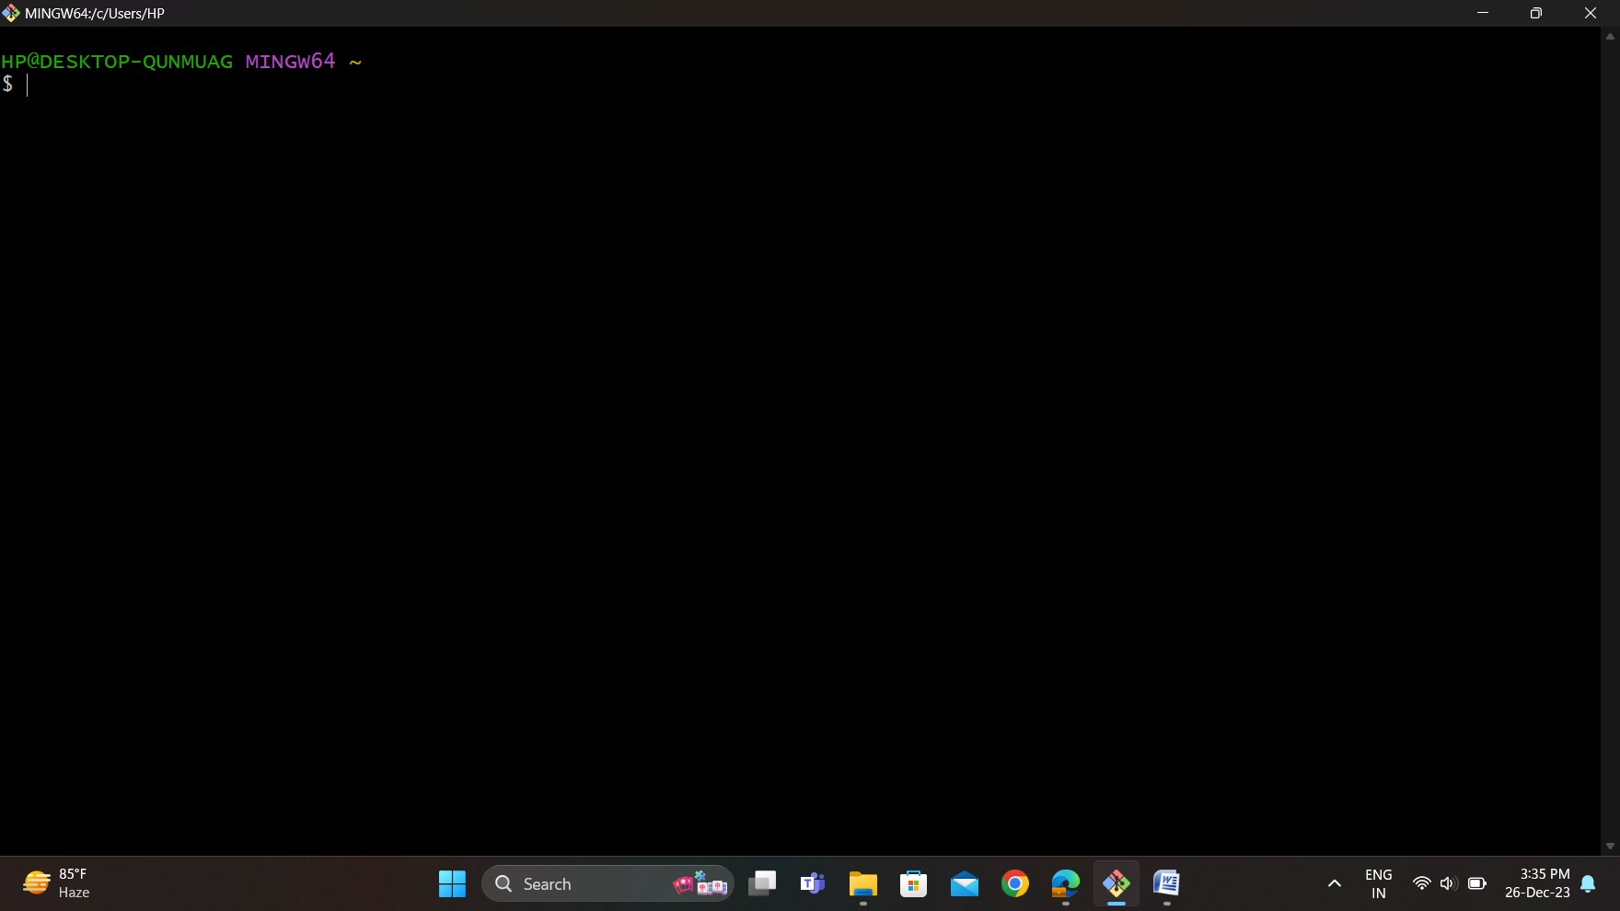

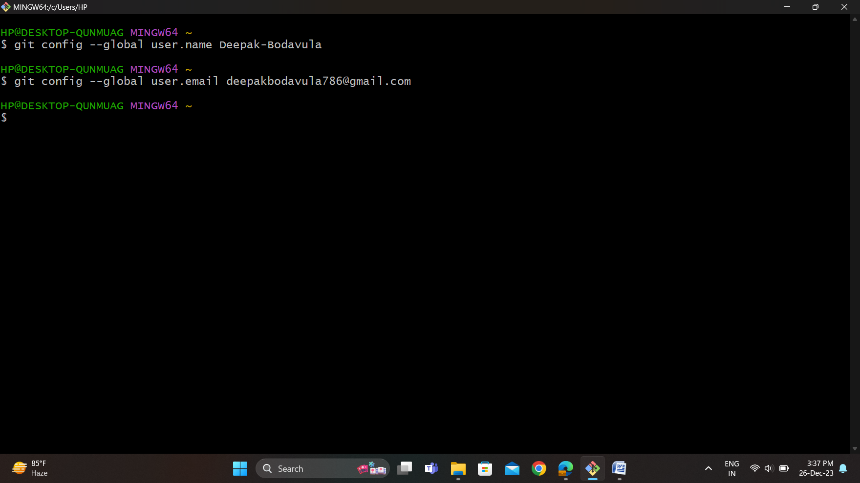**Configure GIT:**

**Create new directory:**

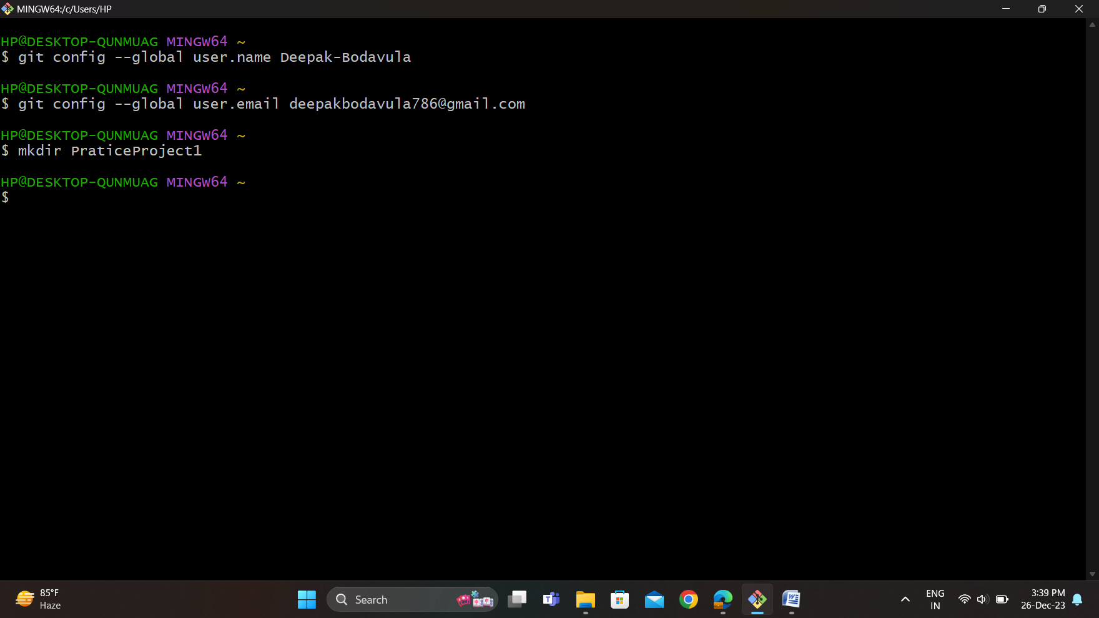

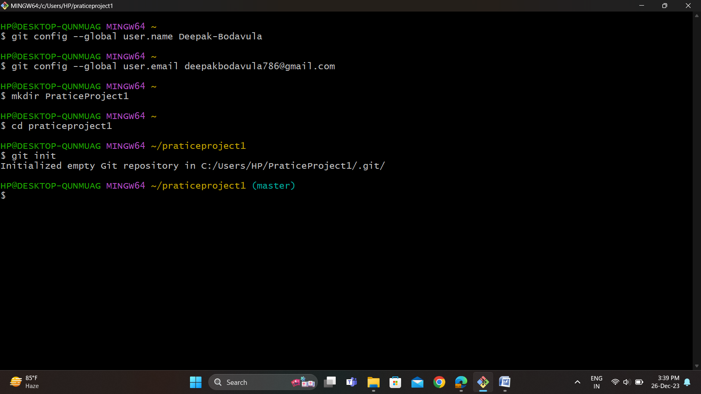**Initialize a Git repository:**