Research article

Self-supervised vision transformer versus transfer-learned and from-scratch CNNs for coral reef health classification and cover mapping: a controlled comparative study
Deepak E L^{a,*}, [Co-author name(s)]ª
ªDepartment of Computer Science and Engineering (Artificial Intelligence), Amrita School of Computing, Amrita Vishwa Vidyapeetham, Chennai, Tamil Nadu, India
* Corresponding author. E-mail address: [corresponding author e-mail]

Highlights
- Six CNN and ViT models compared like-for-like on 404,255 expert reef points
- Point-centred crops are essential: 68% of quadrats contain all three classes
- DINOv2 ViT is most accurate and most robust (macro-F1 0.831; cover MAE 3.1 pp)
- A 4.2 M-parameter SE-CNN from scratch is fastest and best at recalling dead coral
- Occlusion is faithful for all families; Grad-CAM fails on the transformer
Abstract
Automated analysis of benthic photo-quadrats is essential for scaling coral reef monitoring, yet competing model families are rarely compared under identical conditions or evaluated on the ecological quantities that reef managers use. We present a controlled comparison of three families for three-class reef health classification (Healthy Coral, Dead/Degraded, Substrate/CCA): four ImageNet-pretrained convolutional neural networks (MobileNetV2, ResNet18, EfficientNet-B0, ShuffleNetV2), a squeeze-and-excitation residual CNN trained from scratch (CoralCNN-SE) and a self-supervised vision transformer (DINOv2 ViT-S/14). Using 404,255 expert point annotations on 2,455 quadrat images, a quadrat-grouped split, point-centred crops and a shared training and prior-shift correction pipeline, we evaluated all models on 6,000 test points and by dense sliding-window mapping of 150 held-out quadrats, together with inference cost and quantitative explainability. A label-purity analysis showed that 68.1% of quadrats contain all three classes, motivating point-level training. DINOv2 achieved the highest point accuracy (86.70%, 95% CI 85.83–87.55) and macro-F1 (0.831) and the most accurate live-coral cover estimates (mean absolute error 3.11 percentage points, r = 0.981), and it was the most robust model on under-represented image sources. Its advantage over ResNet18 (85.97%, 0.819; 3.23 percentage points) was, however, not statistically significant for cover estimation, while requiring 3.6 times more computation per quadrat. CoralCNN-SE, with 4.2 M parameters and no pre-training, rivalled the pretrained compact CNNs, was the fastest model on the GPU (4.12 ms per crop) and had the highest Dead/Degraded recall. Confusion between dead or algal-covered framework and substrate dominated the errors of all models, and plain balanced sampling outperformed focal loss and image mixing. Occlusion was the most faithful explanation method for every family, whereas Grad-CAM was unreliable for the transformer. These results provide evidence-based guidance for selecting models for operational reef monitoring.
Keywords: Coral reef monitoring; Benthic image classification; Vision transformer; DINOv2; Transfer learning; Explainable artificial intelligence; Percent cover estimation; Class imbalance

1. Introduction
Coral reefs occupy a small fraction of the sea floor yet support a disproportionate share of marine biodiversity, fisheries and coastal protection. They are also among the ecosystems most exposed to anthropogenic change: ocean warming, acidification, nutrient enrichment and overfishing interact to drive recurrent mass bleaching, coral mortality and shifts towards algal-dominated states [1–3]. The back-to-back bleaching events of the last decade have shortened the recovery windows between disturbances to the point where many reefs no longer return to their former coral cover [4, 5], and global syntheses report sustained declines in live hard-coral cover across most reef regions [6]. Managing this decline requires monitoring that is frequent, spatially extensive and quantitatively consistent [7].
The workhorse of reef monitoring is the photo-quadrat survey. Divers or towed and autonomous platforms collect thousands of downward-facing images, and trained analysts then classify the benthos under a set of randomly placed points to estimate percentage cover of each category [8]. Image collection now scales easily; expert annotation does not. Manual point annotation is slow, expensive and subject to substantial inter- and intra-observer variability, and it has become the main bottleneck between image acquisition and ecological information [9–11]. Automated annotation, first with hand-crafted texture and colour descriptors [12, 13] and later with deep convolutional neural networks (CNNs) [14–17], has therefore become a central research topic, and operational platforms such as CoralNet now provide machine suggestions for tens of millions of annotated points [18, 19]. These tools sit within a broader shift towards computer vision as a routine instrument in ecology [20–22].
Despite this progress, three practical questions remain difficult to answer from the literature. First, which family of architectures should a monitoring programme adopt? Studies typically evaluate a single network, or several networks under different pre-processing, sampling, training budgets and test protocols, so reported differences conflate architecture with pipeline [16, 23]. The arrival of vision transformers (ViTs) [24, 25] and of self-supervised foundation models such as DINOv2 [26] adds a further axis: early coral studies suggest that foundation-model features adapt well to reef imagery [27], but they have rarely been compared like-for-like against well-tuned ImageNet CNNs and against compact networks trained from scratch on reef data. Second, how well does point-level accuracy translate into the ecological quantity that managers actually use, namely percentage cover per quadrat? Most benchmarks stop at patch accuracy, whereas the end product of a survey is a cover estimate whose error must be judged against human inter-observer variability [9]. Third, what do these models look at, and can the explanation be trusted? Saliency maps are often shown qualitatively, but explanation methods behave differently across architectures and require quantitative faithfulness checks before they can support scientific conclusions [28, 29].
A further, often overlooked complication is the mismatch between how reef images are labelled and how classifiers are commonly trained. Quadrat images are annotated with sparse points, and a single image typically contains live coral, dead or algal-covered framework and abiotic substrate together. Assigning a single image-level label to such a mixed scene introduces systematic label noise. In addition, the benthic class distribution is strongly skewed towards substrate, so a classifier trained on class-balanced data faces a prior shift at deployment [30, 31], with direct consequences for the minority classes that matter most ecologically.
This paper addresses these questions through a controlled comparative study of three model families for three-class reef health classification (Healthy Coral, Dead/Degraded, Substrate/CCA): four ImageNet-pretrained CNNs (MobileNetV2, ResNet18, EfficientNet-B0, ShuffleNetV2) [32–35], a residual CNN with squeeze-and-excitation attention trained from scratch (CoralCNN-SE) [36], and a self-supervised vision transformer (DINOv2 ViT-S/14) [26]. All six models share the same data, split, crops, augmentation, optimiser family, model-selection rule and inference post-processing. The specific contributions are as follows:
- A like-for-like benchmark of transfer-learned CNNs, a from-scratch attention CNN and a self-supervised ViT on 404,255 expert point annotations from 2,455 quadrat images, using a quadrat-grouped split that prevents spatial leakage [37].
- A quantitative justification for point-centred training crops over whole-image labels, based on a label-purity analysis of the annotations.
- Two complementary evaluation protocols: (A) point-crop classification with bootstrap confidence intervals, and (B) dense sliding-window mapping of whole held-out quadrats, scored both at expert points and as live-coral cover error, with non-parametric tests across 150 quadrats.
- A systematic treatment of class imbalance and prior shift, including an ablation of four imbalance-handling recipes and a validation-tuned logit-adjustment step whose trade-off between accuracy and Dead-class recall is reported explicitly.
- A deployment-oriented cost analysis (parameters, FLOPs, GPU/CPU latency, throughput, Pareto fronts) and a quantitative explainability analysis comparing Grad-CAM, Integrated Gradients and Occlusion across the three families using centre-mass, pointing-game and insertion/deletion faithfulness metrics.
The remainder of the paper is organised as follows. Section 2 reviews related work. Section 3 describes the data, models, training and evaluation protocols. Section 4 reports the results, Section 5 discusses their ecological and practical implications together with the study's limitations, and Section 6 concludes.

2. Related work

2.1. Automated annotation of benthic survey imagery
Early automated annotation relied on engineered descriptors. Beijbom et al. [12] introduced the Moorea Labelled Corals (MLC) dataset and a multi-scale texture-and-colour pipeline for point classification, and Shihavuddin et al. [13] combined several texture descriptors with kernel classifiers for coral classification and thematic mapping. Beijbom et al. [9] then quantified the variability among human experts and showed that automated cover estimates could approach inter-observer agreement when used in appropriate operational modes. Subsequent work demonstrated large-scale deployments, using semi-automated image collection and CNN-based annotation to scale reef measurements across regions [10, 11, 19], and explored complementary imaging modalities such as wide-band fluorescence [38]. CoralNet's current engine uses a deep feature extractor trained on a very large pool of annotated points [18].
On the deep-learning side, Mahmood et al. [15] used ImageNet CNN features for coral image classification, Gómez-Ríos et al. [16, 39] showed that fine-tuned CNNs with data augmentation achieve high accuracy on coral texture datasets, Raphael et al. [17] applied CNNs to Red Sea benthos, and Lumini et al. [23] studied ensembles of CNNs for plankton and coral classification. Dense approaches propagate sparse point labels into full segmentations [40, 41]. Most of these studies, however, use a single dataset-specific pipeline and report patch-level metrics, which makes it difficult to isolate the contribution of the architecture itself.

2.2. Transfer learning, training from scratch and transformers
Transfer learning from ImageNet remains the default strategy when labelled data are limited [42, 43], and compact architectures such as MobileNetV2, ShuffleNetV2 and EfficientNet were designed to reduce computation for edge deployment [32, 34, 35]. Channel attention through squeeze-and-excitation (SE) blocks improves representational efficiency at small cost [36], making SE-augmented residual networks attractive candidates for training from scratch on domain data. Vision transformers replace convolutional inductive biases with global self-attention [24, 25] and appear to integrate information differently from CNNs, retaining more global context in early layers [44]. Self-supervised pre-training of ViTs on curated web-scale data, as in DINOv2 [26], produces general-purpose features that transfer with little or no fine-tuning; in the coral domain, Shao et al. [27] reported that a DINOv2 backbone adapted with low-rank adapters outperformed conventional networks for multi-label coral condition classification.

2.3. Class imbalance and prior shift
Benthic class frequencies are highly skewed, and deep networks trained on imbalanced data are biased towards majority classes [31, 45]. Common remedies include re-sampling, class-weighted or focal losses [46] and heavy augmentation [47]. When a model is trained on re-balanced data but deployed on the natural distribution, its posterior probabilities must be corrected for the change in class priors. Saerens et al. [30] derived the Bayes-optimal adjustment, and logit adjustment generalises this with a tunable strength [48]. Calibration of the resulting probabilities is a separate but related concern [49].

2.4. Evaluating explanations
Gradient-weighted class activation mapping (Grad-CAM) [50] is the most widely used saliency method for CNNs; Integrated Gradients [51] and occlusion analysis [52] offer gradient-integral and perturbation-based alternatives. Saliency maps can look plausible while being unfaithful to the model, which motivates quantitative tests such as the pointing game [53] and perturbation-based deletion and insertion curves [28]. Transformers pose additional difficulties because attention and gradient signals are distributed over tokens [54]. To our knowledge, these quantitative checks have not previously been applied across CNN and ViT families for coral reef classification.

3. Materials and methods
Fig. 1 summarises the experimental pipeline. Every design decision described below was applied identically to all six models unless explicitly stated.
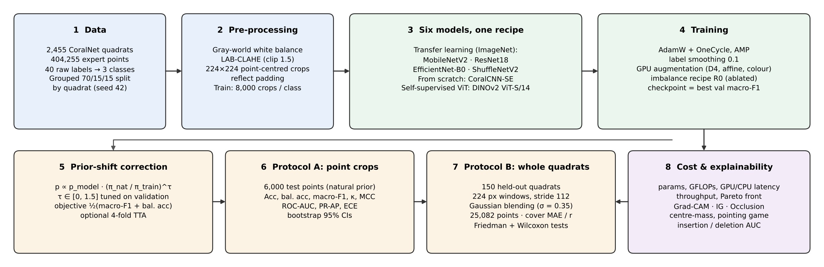
Fig. 1. Overview of the comparative pipeline. All six models share the same data split, point-centred crops, augmentation, model-selection rule, prior-shift correction and evaluation protocols, so that differences in outcome can be attributed to the architecture and its pre-training.

3.1. Dataset and label taxonomy
We used a public aggregation of CoralNet-style point-annotated photo-quadrats distributed through Kaggle [55]. The majority of images originate from the Moorea Coral Reef Long-Term Ecological Research (MCR LTER) programme and correspond to the Moorea Labelled Corals collection (fringing reef and 10 m and 17 m outer-reef habitats, 2008–2010) [12]; a smaller set of images from additional sources carries sparser annotation (about 19 points per image). Each annotation record gives the image name, the pixel row and column of the point, and the expert label.
The 40 raw labels were mapped onto three ecologically interpretable health classes (Table 1). Twenty-seven label strings, covering 25 coral taxa and two soft-coral labels, were mapped to Healthy Coral; dead coral, coral rubble, turf algae, macroalgae and fleshy algae to Dead/Degraded; and crustose coralline algae (CCA), hard substrate, rock and sand to Substrate/CCA. Grouping algae with dead coral follows the view that algal colonisation of coral framework is a primary indicator of reef degradation and phase shift [2, 3]. Points labelled off, bad or dark, and points whose image could not be found on disk, were discarded. The final dataset contained 404,255 valid points on 2,455 quadrat images (mean 164.7 points per image).
Table 1. Mapping of raw annotation labels to the three health classes.
Health class | Raw labels (number) | Ecological rationale
Healthy Coral | porites, pocillopora, montipora, pavona, acropora, millepora, montastraea, leptastrea, goniastrea, fungia, astreopora, gardineroseris, herpolitha, lobophyllia, favia, platygyra, echinopora, cyphastrea, acanthastrea, psammocora, stylophora, favites, leptoseris, sandolitha, tuba, soft_coral, soft (27) | Living, tissue-covered coral
Dead / Degraded | dead_coral, broken_coral_rubble, turf, macroalgae, algae, green_fleshy_algae (6) | Dead framework or algal overgrowth; indicator of degradation
Substrate / CCA | crustose_coralline_algae, hard_substrate, rock, sand (4) | Abiotic or reef-building calcified substrate
Ignored | off, bad, dark (3) | Unusable or non-benthic points

3.2. Grouped data split and sampling
Points from the same quadrat are spatially and visually correlated, so random point-level splitting would leak information between training and test data [37]. We therefore split at the level of quadrat images, stratified by each image's majority class, into 70% training, 15% validation and 15% test (random seed 42), and verified that no image appears in more than one split. Within each split, crops were sampled as follows (Table 2): the training set was class-balanced with 8,000 points per class (24,000 crops), whereas validation (5,000 points) and test (6,000 points) were sampled at random and so retain the natural class distribution. The natural class prior estimated from all training-split points was π_{nat} = (0.170, 0.168, 0.662) for Healthy, Dead/Degraded and Substrate/CCA respectively; it is used only for prior-shift correction (Section 3.6) and never touches validation or test labels.
Table 2. Quadrat-grouped split. Training crops are class-balanced; validation and test crops keep the natural reef distribution.
Split | Quadrat images | Valid points | Crops used | Healthy | Dead/Degraded | Substrate/CCA | Distribution
Train | 1,718 | 285,305 | 24,000 | 8,000 | 8,000 | 8,000 | balanced
Validation | 368 | 59,434 | 5,000 | 885 | 913 | 3,202 | natural
Test | 369 | 59,516 | 6,000 | 928 | 1,031 | 4,041 | natural

3.3. Underwater colour correction and point-centred crops
Light attenuation in water removes red wavelengths first and gives underwater images a blue-green cast whose strength varies with depth, turbidity and camera settings [56]. To reduce this nuisance variation consistently for all models, each quadrat was processed once with a gray-world white balance [57] followed by contrast-limited adaptive histogram equalisation (CLAHE) [58] on the lightness channel of the CIE-LAB representation. For each colour channel c with mean m_{c}, the gain g_{c} = clip(m̄ / m_{c}, 0.5, 2.5) was applied through a look-up table, where m̄ is the mean of the three channel means; CLAHE used a clip limit of 1.5 and an 8 × 8 tile grid.
Each expert point was then represented by a 224 × 224 pixel crop centred on the point (Fig. 2). Images were reflection-padded by 112 pixels so that points near the border also yield full crops, and the point coordinates were clipped to the image extent. All crops were cached once as 8-bit arrays; images that could not be decoded were dropped rather than replaced by blank crops.
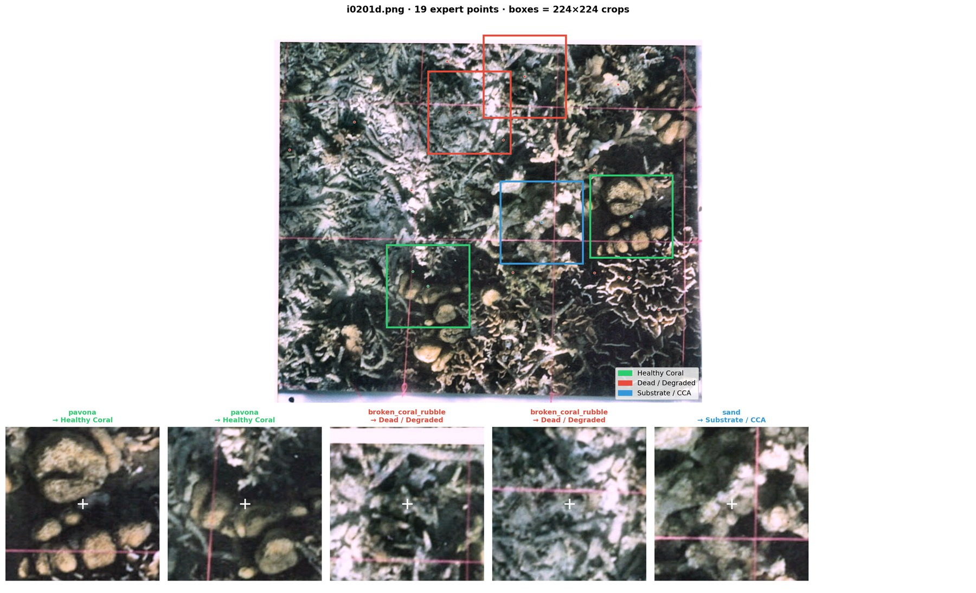
Fig. 2. A held-out quadrat after colour correction, with expert points coloured by health class and 224 × 224 pixel crop windows (top), and the resulting point-centred crops with their raw labels (bottom). The white cross marks the annotated point at the crop centre.

3.4. Models
Six models from three families were compared (Table 3). The four transfer-learning CNNs were initialised from torchvision ImageNet weights, and their final classifier was replaced by dropout (p = 0.2) and a three-way linear layer; all layers were fine-tuned. Inputs were normalised with ImageNet statistics.
The CNN from scratch, CoralCNN-SE, is a compact residual network designed for this task. A two-layer convolutional stem (16 then 32 channels, the first with stride 2) is followed by four stages with widths 64, 128, 192 and 256 and depths 1, 2, 2 and 2. Each residual block contains two 3 × 3 convolutions with batch normalisation and SiLU activation, a squeeze-and-excitation block with reduction ratio 8 [36], and an identity or 1 × 1 projection shortcut. Stochastic depth [59] increases linearly to 0.1 in the deepest stage, the last batch-normalisation scale of every block is zero-initialised so that each block starts as an identity mapping, and the head comprises global average pooling, dropout (p = 0.3) and a linear classifier. The network has 4.16 M parameters and was trained with random initialisation, using the mean and standard deviation of the training crops for input normalisation.
The vision transformer is DINOv2 ViT-S/14 [26], a 21-M-parameter ViT pre-trained by self-distillation on the curated LVD-142M image collection. For a 224 × 224 input it produces 16 × 16 = 256 patch tokens of dimension 384. Rather than using only the class token, we mean-pooled the patch tokens of each of the last four transformer blocks and concatenated them into a 1,536-dimensional descriptor, which combines mid-level texture information with high-level semantics. A head of Linear(1536→256), LayerNorm, GELU, dropout (p = 0.2) and Linear(256→3) produced the logits. The top four transformer blocks and the final normalisation layer were fine-tuned with a small learning rate, and the remaining blocks were frozen.
Table 3. Models compared. GFLOPs are counted for one 224 × 224 crop (one multiply–add counted as two operations).
Model | Family | Pre-training | Params (M) | GFLOPs | Key design elements
MobileNetV2 [32] | Transfer learning | ImageNet-1k | 2.23 | 0.60 | Inverted residuals, linear bottlenecks, depthwise convolutions
ResNet18 [33] | Transfer learning | ImageNet-1k | 11.18 | 3.63 | Residual basic blocks, standard 3 × 3 convolutions
EfficientNet-B0 [34] | Transfer learning | ImageNet-1k | 4.01 | 0.77 | Compound scaling, MBConv blocks with SE
ShuffleNetV2 1.0× [35] | Transfer learning | ImageNet-1k | 1.26 | 0.29 | Channel split and shuffle, hardware-aware design
CoralCNN-SE (ours) | CNN from scratch | None (random init.) | 4.16 | 2.02 | Residual SE blocks, stochastic depth, zero-init residuals
DINOv2 ViT-S/14 [26] | Vision transformer | Self-supervised (LVD-142M) | 22.45 | 11.03 | Multi-layer patch-token pooling, top-4 blocks fine-tuned

3.5. Training procedure
All models were trained with AdamW [60], differential learning rates for the backbone and the head, a one-cycle schedule with 20% warm-up, label smoothing of 0.1 [61], gradient-norm clipping at 5, automatic mixed precision and a batch size of 64 (Table 4). The checkpoint with the highest validation macro-F1 was retained; because the validation set has the natural class distribution, this criterion rewards minority-class performance rather than overall accuracy. Early stopping was applied with a model-specific patience.
Because benthic photo-quadrats are taken looking straight down, their content has no canonical orientation, and all eight dihedral transformations (horizontal and vertical flips combined with 90° rotations) are label-preserving. Augmentation was executed on the GPU and comprised these dihedral transformations, a small random affine transform (rotation ±20°, scale ±15%, translation ±6% with reflection padding) and colour jitter. Translations were kept small so that the labelled point remains near the crop centre. Running augmentation on the GPU removed the CPU bottleneck of the two-core cloud environment used for the experiments.
Table 4. Training hyperparameters (AdamW, one-cycle schedule with 20% warm-up, label smoothing 0.1, gradient clipping 5, batch 64, mixed precision for all models).
Model | LR backbone | LR head | Weight decay | Max epochs | Patience | Trainable part
MobileNetV2 | 4 × 10⁻⁴ | 2 × 10⁻³ | 0.01 | 12 | 5 | All layers
ResNet18 | 3 × 10⁻⁴ | 1.5 × 10⁻³ | 0.01 | 12 | 5 | All layers
EfficientNet-B0 | 4 × 10⁻⁴ | 2 × 10⁻³ | 0.01 | 12 | 5 | All layers
ShuffleNetV2 | 5 × 10⁻⁴ | 2 × 10⁻³ | 0.01 | 12 | 5 | All layers
CoralCNN-SE | 2 × 10⁻³ | 2 × 10⁻³ | 0.02 | 40 | 12 | All layers
DINOv2 ViT-S/14 | 1.5 × 10⁻⁵ | 1 × 10⁻³ | 0.05 | 10 | 4 | Top 4 blocks + norm + head

3.6. Class-imbalance recipe and prior-shift correction
Before training the final models, four imbalance-handling recipes were compared on ResNet18 with an eight-epoch budget: R0, the baseline described above (balanced sampling, dihedral and mild affine and colour augmentation, cross-entropy); R1, R0 with additional class-aware strong augmentation of the minority classes; R2, R1 with CutMix/MixUp image mixing [47]; and R3, R2 with a focal loss (γ = 1) [46] and a Dead-class weight of 1.3. The recipe with the highest validation score was then used for all six models.
Training on class-balanced crops implicitly assumes a uniform prior π_{train} = (1/3, 1/3, 1/3), whereas deployment data follow π_{nat}. Following the Bayes-optimal adjustment of Saerens et al. [30] and its tunable generalisation [48], the model posterior p(y | x) was corrected as
p̃(y | x) ∝ p(y | x) · (π_{nat,y} / π_{train,y})^{τ} (1)
where τ = 0 leaves the posterior unchanged and τ = 1 is the full Bayes correction. For each model τ was selected from {0, 0.1, …, 1.5} by maximising the validation objective ½(macro-F1 + balanced accuracy). Two alternative objectives (accuracy + macro-F1, and macro-F1 alone) were also evaluated to expose the trade-off between overall accuracy and Dead-class recall. Unless stated otherwise, headline results use a single forward pass with the tuned τ; four-fold test-time augmentation (TTA) over dihedral transforms is reported as an ablation.

3.7. Evaluation protocol A: point-crop classification
Protocol A classifies the 6,000 held-out test crops, each centred on one expert point. We report overall accuracy, balanced accuracy, macro- and weighted-F1, macro one-vs-rest ROC-AUC and average precision (PR-AP), Cohen's κ, the Matthews correlation coefficient (MCC) [62], per-class precision, recall and F1, and the expected calibration error (ECE) with 15 equal-width confidence bins [49]. Macro-F1 is the primary metric because it weights the three classes equally despite their imbalance. Uncertainty in accuracy and macro-F1 was estimated with a non-parametric bootstrap of the test set [63] (5,000 multinomial resamples of each model's confusion matrix, percentile 95% intervals).

3.8. Evaluation protocol B: dense sliding-window mapping of whole quadrats
Protocol B reproduces how a deployed system would analyse an entire survey image. For each of 150 randomly selected held-out test quadrats (25,082 expert points), the colour-corrected, reflection-padded image was tiled with 224 × 224 windows at a stride of 112 pixels (50% overlap). Every window was classified with the prior-corrected model, and the class-probability vectors were blended into a dense map using a Gaussian weighting kernel (σ = 0.35 in normalised window coordinates) centred on each window, computed at one-quarter resolution. The arg-max of the blended map was then read out at every expert point to compute point accuracy, balanced accuracy, macro-F1 and Dead-class recall. Predicted live-coral cover was computed as the fraction of the quadrat area assigned to Healthy Coral and compared with the expert cover, defined as the fraction of expert points labelled Healthy Coral. We report the mean absolute error (MAE), root-mean-square error, Pearson correlation and mean bias of cover in percentage points (pp), the corresponding error for dead/degraded cover, and the agreement of a four-level reef-status category derived from live-coral cover (Poor < 10%, Moderate 10–30%, Good 30–50%, Excellent ≥ 50%). A stride study (224, 112 and 56 pixels) on 20 quadrats used the model with the highest validation score.
Because all models were applied to the same quadrats, differences in absolute cover error were tested with a Friedman test across the six models, followed by paired two-sided Wilcoxon signed-rank tests of each model against the best model with Holm correction for multiple comparisons [64, 65]. Paired bootstrap 95% intervals (5,000 resamples of quadrats) are reported for the mean difference in absolute error.

3.9. Computational cost
Inference cost was measured for a single 224 × 224 crop in 32-bit floating point on an NVIDIA Tesla T4 GPU, with explicit CUDA synchronisation after each call and warm-up iterations discarded; we report the mean, standard deviation and the 50th, 95th and 99th latency percentiles. Throughput was measured with batches of 64 under mixed precision, the setting used for sliding-window inference. CPU latency was measured on two virtual CPU cores. FLOPs were counted with the PyTorch FLOP counter. Pareto-optimal models were identified on the macro-F1–latency plane.

3.10. Explainability analysis
Grad-CAM [50] was computed for the best transfer-learning model by validation score (ResNet18, last residual stage, 7 × 7 map), CoralCNN-SE (stage 4, 7 × 7) and DINOv2 (patch tokens of the last block reshaped to 16 × 16). Because the label belongs to the point at the crop centre, a well-localised explanation should concentrate near the centre. On 300 random test crops we computed (i) the centre-mass, the share of normalised CAM mass within 56 pixels of the centre, compared with 0.196 for a uniform map; (ii) the pointing game [53], the percentage of crops whose CAM peak lies within 32 pixels of the centre, compared with 6.4% for a random peak; and (iii) a deletion test, the drop in predicted-class probability when the top 20% of CAM pixels are replaced by the image mean, compared with deleting a random 20%. To test whether conclusions depend on the explanation method, Integrated Gradients [51] and Occlusion [52] were additionally computed for the same three models on 150 crops, and all methods were compared with deletion and insertion curves [28], summarised by their areas under the curve (AUC) and the difference Insertion − Deletion (higher is more faithful).

3.11. Implementation
Experiments were implemented in PyTorch 2.11 [66] with scikit-learn [67] for metrics and run on a single NVIDIA Tesla T4 (16 GB) in Google Colaboratory with a fixed random seed of 42. Model weights, per-epoch logs, every table and figure, and per-window and per-quadrat predictions were exported to support reproduction.

4. Results

4.1. Characteristics of the annotated data
The label-purity analysis (Fig. 3, Table 5) shows that quadrat images are overwhelmingly mixed scenes. Although 88.1% of images contain at least one live-coral point, only 17.1% have Healthy Coral as their majority class; 68.1% contain all three health classes, and only 24.8% are at least 90% pure. A classifier trained on one label per image would therefore learn from targets that misdescribe most of the pixels it sees, and the image-level class imbalance is considerably more severe than the point-level imbalance. These observations motivated the use of point-centred crops.
Table 5. Label purity of the quadrat images (purity = share of points belonging to the image's majority class).
Statistic | Value
Annotated quadrat images | 2,455
Mean expert points per image | 164.7
Images containing any live-coral point | 88.1%
…of which majority-labelled Healthy Coral | 17.1%
Images containing all three classes | 68.1%
Images with purity < 0.5 | 9.1%
Images with purity ≥ 0.9 | 24.8%

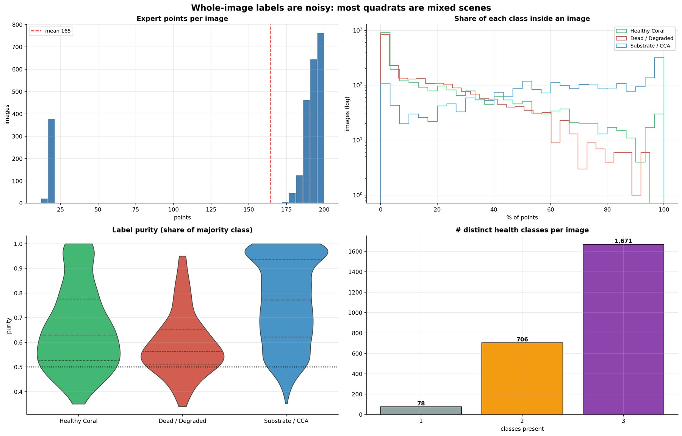
Fig. 3. Label purity of quadrat images: (top left) expert points per image; (top right) share of each class within an image (log scale); (bottom left) purity of the majority class by majority label; (bottom right) number of distinct health classes per image.
Simple colour statistics of the training crops differed little between classes (Table 6): mean brightness was 120.8, 121.6 and 136.1 for Healthy, Dead/Degraded and Substrate/CCA, and the blue-to-green ratio ranged only from 0.94 to 0.97. The clearest difference was in high-frequency texture: the Laplacian variance of Dead/Degraded crops (1,660) was 1.7 times that of Healthy Coral crops (965), consistent with the fine filamentous structure of turf algae and rubble. The classes are therefore not separable by global colour shortcuts, and models must rely on texture and structure.
Table 6. Mean colour and texture statistics of training crops by class (400 crops per class).
Class | R | G | B | Brightness | Contrast | Saturation | Sharpness (Laplacian var.) | Blue/green
Healthy Coral | 127.1 | 119.2 | 112.1 | 120.8 | 55.9 | 62.3 | 965 | 0.94
Dead / Degraded | 125.0 | 121.0 | 115.7 | 121.6 | 56.4 | 64.9 | 1,660 | 0.96
Substrate / CCA | 138.3 | 135.9 | 131.4 | 136.1 | 54.9 | 55.9 | 1,503 | 0.97

4.2. Choice of class-imbalance recipe
The simplest recipe was clearly the best (Table 7, Fig. 4). R0 reached a validation score of 0.813 and, on the test set, 84.67% accuracy, macro-F1 0.809 and Dead-class recall 0.746. Each additional measure reduced performance: class-aware strong augmentation (R1) lowered test macro-F1 to 0.752, and image mixing (R2) and the focal loss with class weighting (R3) recovered some accuracy but left Dead-class recall at only 0.48–0.53. Strong photometric and geometric augmentation appears to destroy the fine texture cues that distinguish dead and algal-covered framework from bare substrate, and image mixing blends textures from different classes into ambiguous training targets. R0 was therefore used for all subsequent experiments.
Table 7. Imbalance-recipe ablation on ResNet18 (8 epochs). Validation score = ½(macro-F1 + balanced accuracy) after τ tuning. Best values in bold.
Recipe | τ | Val. score | Test acc. (%) | Test macro-F1 | Test bal. acc. (%) | Recall H | Recall D | Recall S
R0 baseline | 0.1 | 0.813 | 84.67 | 0.809 | 83.56 | 0.901 | 0.746 | 0.860
R1 + class-aware strong aug. | 0.0 | 0.746 | 80.58 | 0.752 | 76.44 | 0.860 | 0.583 | 0.850
R2 R1 + CutMix/MixUp | 0.0 | 0.735 | 83.53 | 0.767 | 76.29 | 0.899 | 0.478 | 0.912
R3 R2 + focal loss + weight | 0.0 | 0.758 | 83.72 | 0.776 | 77.86 | 0.902 | 0.534 | 0.900

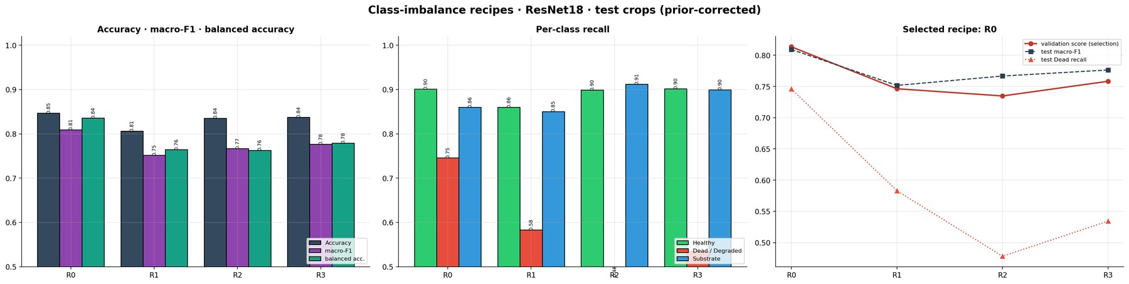
Fig. 4. Imbalance-recipe ablation on ResNet18: validation score, test macro-F1 and Dead-class recall for recipes R0–R3. Heavier imbalance treatments reduced, rather than improved, minority-class recall.

4.3. Training behaviour
Table 8 summarises training. The pretrained models converged within 6–9 epochs; DINOv2 reached its best validation macro-F1 (0.816) at epoch 6, and EfficientNet-B0 had the best validation accuracy (84.7%). CoralCNN-SE required the full 40-epoch budget (best epoch 34) and 18.1 min of training, and its best validation macro-F1 (0.760) was the lowest, as expected for a network without pre-training. Training curves (Fig. 5) show no sign of severe over-fitting: training accuracy exceeded validation accuracy by about 5–7 percentage points for the pretrained CNNs, consistent with strong augmentation and label smoothing.
Table 8. Training summary (best epoch selected by validation macro-F1).
Model | Epochs run | Best epoch | Final train acc. (%) | Best val. acc. (%) | Best val. macro-F1 | Training time (min)
MobileNetV2 | 12 | 8 | 89.3 | 82.7 | 0.791 | 9.3
ResNet18 | 12 | 9 | 87.8 | 83.0 | 0.803 | 7.0
EfficientNet-B0 | 12 | 7 | 91.9 | 84.7 | 0.812 | 12.8
ShuffleNetV2 | 12 | 9 | 86.3 | 80.8 | 0.780 | 6.2
CoralCNN-SE | 40 | 34 | 82.5 | 77.9 | 0.760 | 18.1
DINOv2 ViT-S/14 | 10 | 6 | 89.8 | 83.5 | 0.816 | 12.1

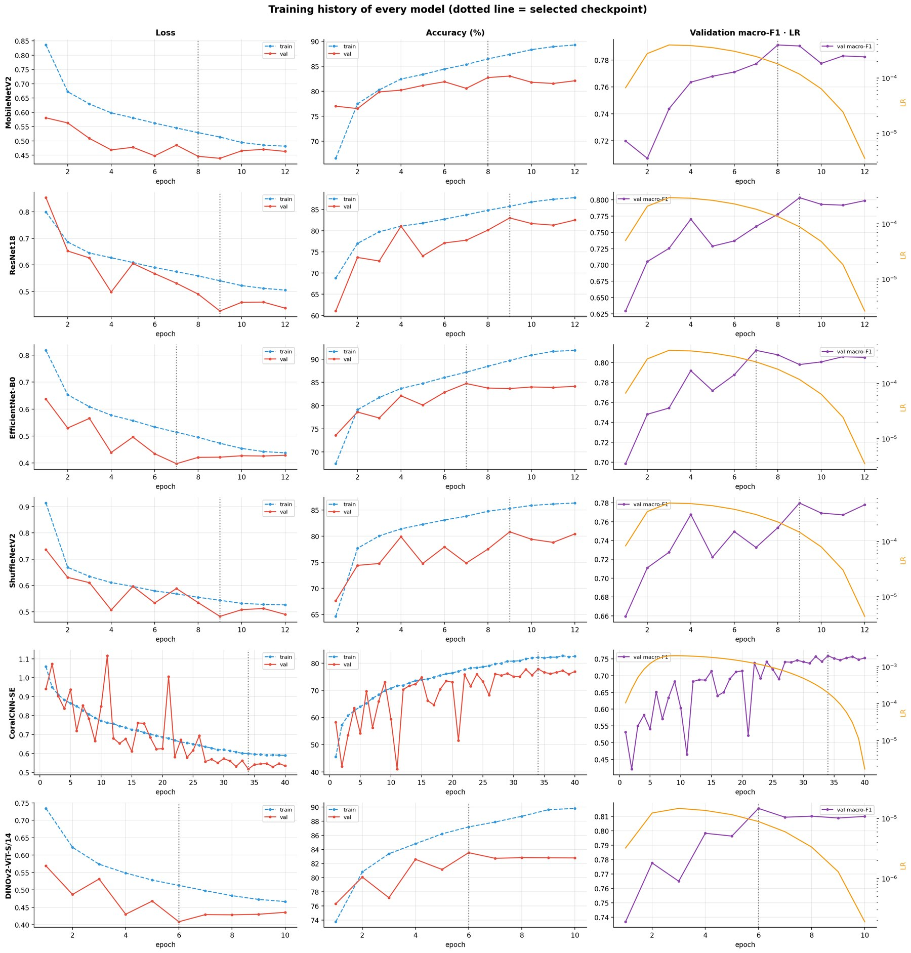
Fig. 5. Training and validation loss, accuracy and macro-F1 per epoch for the six models. Stars mark the checkpoints selected by validation macro-F1.

4.4. Protocol A: point-crop classification
Table 9 reports the headline point-crop results. DINOv2 ViT-S/14 achieved the best value on every discrimination metric: 86.70% accuracy (95% CI 85.83–87.55), macro-F1 0.831 (0.820–0.842), balanced accuracy 83.94%, ROC-AUC 0.956, PR-AP 0.909, κ 0.734 and MCC 0.735. ResNet18 was the best transfer-learning CNN (85.97%, macro-F1 0.819) and EfficientNet-B0 a close third (85.82%, 0.815). The confidence intervals of DINOv2 and ResNet18 overlap substantially, so the advantage of the transformer over the best CNN on this protocol, +0.73 percentage points (pp) of accuracy and +0.012 macro-F1, is modest. CoralCNN-SE, trained without any pre-training, reached macro-F1 0.800, higher than the two most compact ImageNet models (MobileNetV2 0.792, ShuffleNetV2 0.794), and it achieved the highest Dead-class recall of all models (0.745). EfficientNet-B0 was the best-calibrated model (ECE 0.032), and all models had ECE ≤ 0.052.
Table 9. Protocol A: point-crop test results (6,000 crops, natural distribution, single forward pass with validation-tuned τ). 95% bootstrap intervals in brackets. Best values in bold.
Model | Family | Accuracy (%) | Macro-F1 | Bal. acc. (%) | ROC-AUC | PR-AP | κ | MCC | ECE | Dead recall | τ
MobileNetV2 | TL | 83.85 [82.93, 84.77] | 0.792 [0.780, 0.804] | 81.32 | 0.937 | 0.863 | 0.683 | 0.684 | 0.033 | 0.659 | 0.0
ResNet18 | TL | 85.97 [85.10, 86.87] | 0.819 [0.808, 0.831] | 82.84 | 0.949 | 0.892 | 0.720 | 0.720 | 0.038 | 0.709 | 0.3
EfficientNet-B0 | TL | 85.82 [84.95, 86.70] | 0.815 [0.803, 0.826] | 82.40 | 0.948 | 0.891 | 0.715 | 0.716 | 0.032 | 0.673 | 0.0
ShuffleNetV2 | TL | 83.48 [82.53, 84.42] | 0.794 [0.782, 0.805] | 82.29 | 0.939 | 0.868 | 0.682 | 0.685 | 0.047 | 0.720 | 0.2
CoralCNN-SE | Scratch | 83.68 [82.77, 84.58] | 0.800 [0.788, 0.811] | 82.57 | 0.939 | 0.871 | 0.685 | 0.689 | 0.052 | 0.745 | 0.3
DINOv2 ViT-S/14 | ViT | 86.70 [85.83, 87.55] | 0.831 [0.820, 0.842] | 83.94 | 0.956 | 0.909 | 0.734 | 0.735 | 0.047 | 0.734 | 0.4

The per-class results (Table 10, Figs. 6 and 7) identify Dead/Degraded as the hardest class for every model, with F1 between 0.665 (MobileNetV2) and 0.711 (DINOv2), compared with 0.81–0.88 for Healthy Coral and 0.88–0.91 for Substrate/CCA. The confusion matrices show that the dominant error is confusion between Dead/Degraded and Substrate/CCA, in both directions. For DINOv2, 24.1% of Dead/Degraded points (248 of 1,031) were predicted as Substrate/CCA and 7.8% of Substrate/CCA points (317 of 4,041) as Dead/Degraded, whereas Healthy Coral was rarely confused with Dead/Degraded (2.6%). Because Substrate/CCA is four times more frequent than Dead/Degraded in the test set, even a small false-positive rate on Substrate translates into low Dead-class precision: CoralCNN-SE, which predicted Dead/Degraded most liberally, attained the highest Dead recall but the lowest Dead precision (0.615).
Table 10. Per-class precision (P), recall (R) and F1 on the point-crop test set. Support: Healthy 928, Dead/Degraded 1,031, Substrate/CCA 4,041.
Model | Healthy P | Healthy R | Healthy F1 | Dead P | Dead R | Dead F1 | Substr. P | Substr. R | Substr. F1
MobileNetV2 | 0.750 | 0.914 | 0.824 | 0.672 | 0.659 | 0.665 | 0.908 | 0.867 | 0.887
ResNet18 | 0.826 | 0.884 | 0.854 | 0.694 | 0.709 | 0.702 | 0.912 | 0.893 | 0.902
EfficientNet-B0 | 0.801 | 0.904 | 0.849 | 0.715 | 0.673 | 0.693 | 0.908 | 0.895 | 0.902
ShuffleNetV2 | 0.743 | 0.900 | 0.814 | 0.653 | 0.720 | 0.685 | 0.918 | 0.849 | 0.882
CoralCNN-SE | 0.806 | 0.883 | 0.843 | 0.615 | 0.745 | 0.674 | 0.919 | 0.850 | 0.883
DINOv2 ViT-S/14 | 0.865 | 0.888 | 0.876 | 0.689 | 0.734 | 0.711 | 0.917 | 0.896 | 0.906

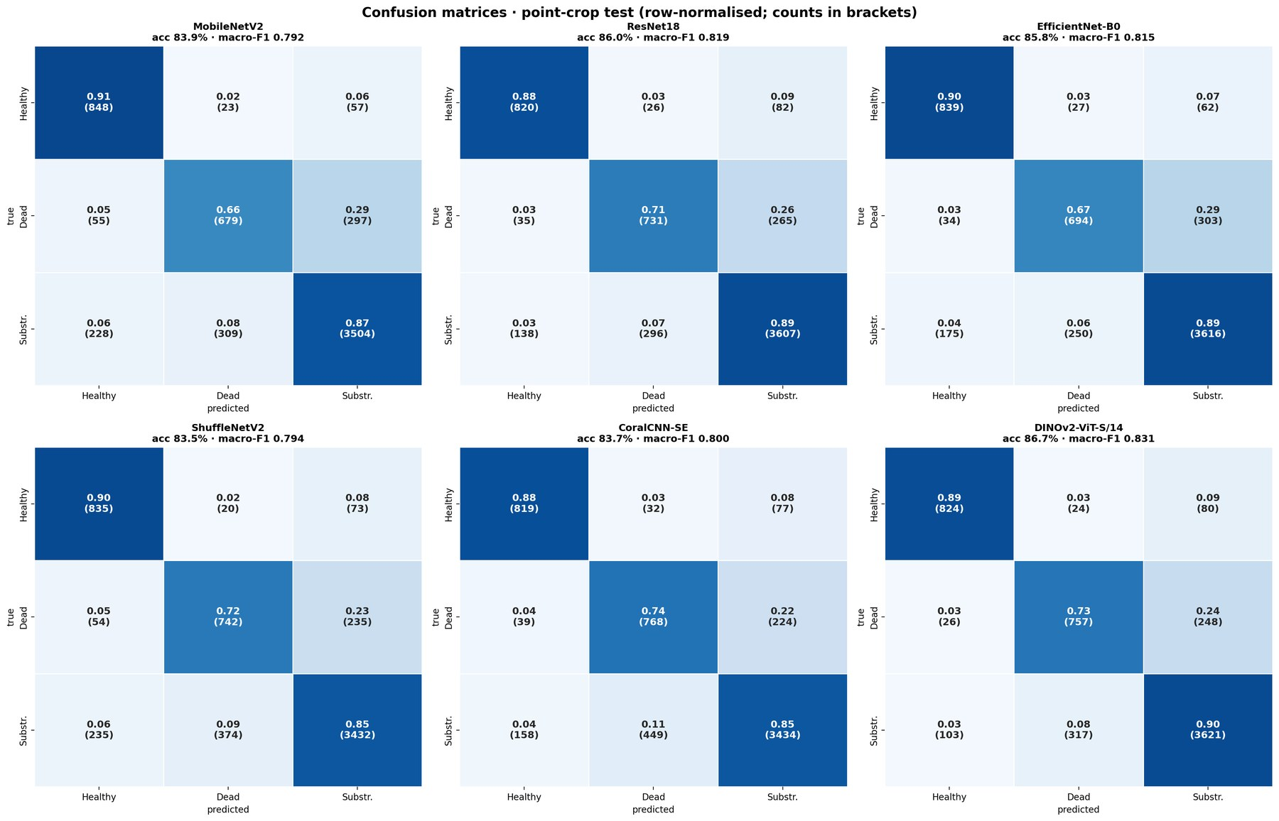
Fig. 6. Row-normalised confusion matrices on the point-crop test set. Most errors are confusions between Dead/Degraded and Substrate/CCA.
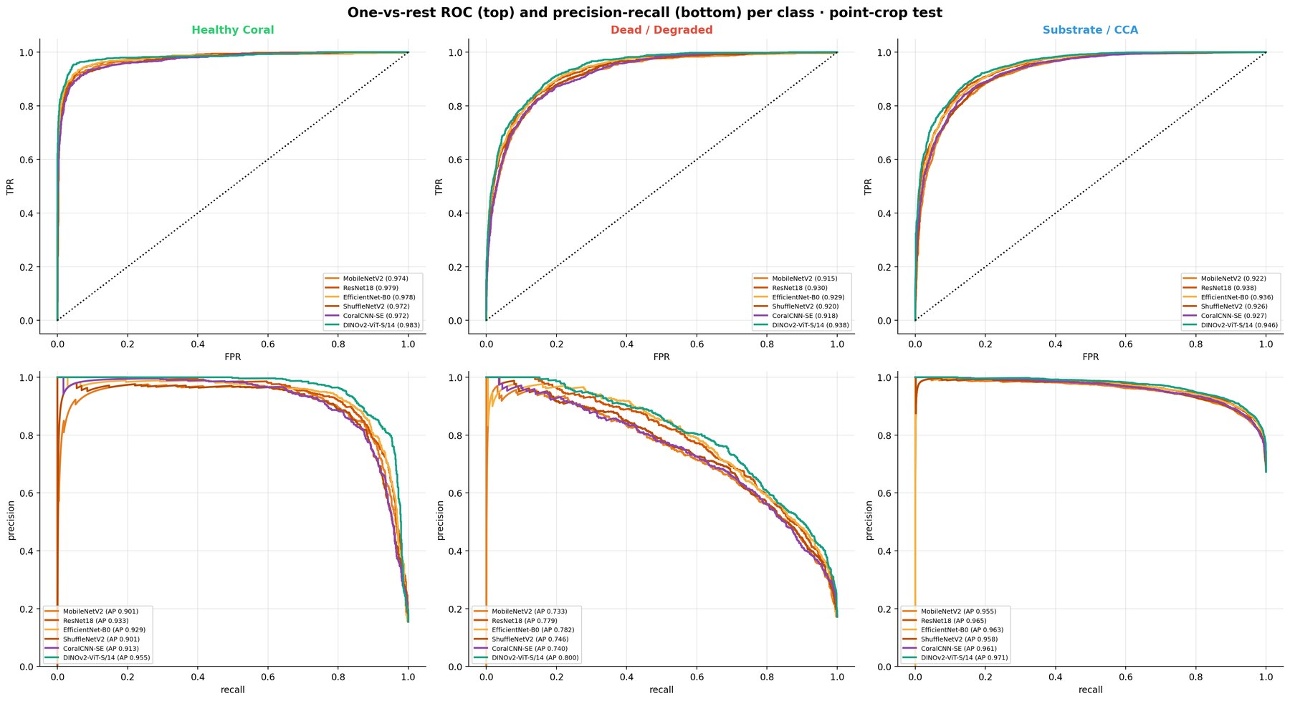
Fig. 7. One-vs-rest ROC (top) and precision–recall (bottom) curves per class for the six models. The Dead/Degraded class has the lowest average precision for every model.

4.5. Effect of prior-shift correction and test-time augmentation
The validation-tuned correction selected τ = 0 for MobileNetV2 and EfficientNet-B0 and τ between 0.2 and 0.4 for the other four models (Fig. 8). Where τ > 0, it increased test accuracy by 1.6–2.8 pp and macro-F1 by 0.011–0.020 (Table 11); the largest gain was for CoralCNN-SE (80.90% → 83.68%). The correction necessarily lowers Dead-class recall, because it moves probability mass towards the frequent Substrate class: DINOv2's Dead recall fell from 0.800 to 0.734 and CoralCNN-SE's from 0.816 to 0.745. The choice of tuning objective controls this trade-off. For DINOv2, the accuracy-oriented objective selected τ = 0.7 and gave the highest accuracy of any configuration (87.62%) but only 0.660 Dead recall, whereas the balanced objective used here retained 0.734 Dead recall at a cost of 0.9 pp accuracy. Four-fold TTA added a further 0.5–1.5 pp of accuracy for every model; DINOv2 with TTA reached 87.35% accuracy and macro-F1 0.838. All models were reasonably well calibrated (Fig. 8), with slight under-confidence in the high-confidence bins that is typical of training with label smoothing.
Table 11. Ablation of prior-shift correction (τ) and four-fold TTA on the point-crop test set.
Model | Acc. raw (%) | F1 raw | Dead rec. raw | Acc. +τ (%) | F1 +τ | Dead rec. +τ | Acc. +τ+TTA (%) | F1 +τ+TTA | Dead rec. +τ+TTA
MobileNetV2 | 83.85 | 0.792 | 0.659 | 83.85 | 0.792 | 0.659 | 84.65 | 0.803 | 0.675
ResNet18 | 84.40 | 0.808 | 0.761 | 85.97 | 0.819 | 0.709 | 86.55 | 0.825 | 0.704
EfficientNet-B0 | 85.82 | 0.815 | 0.673 | 85.82 | 0.815 | 0.673 | 86.28 | 0.820 | 0.678
ShuffleNetV2 | 81.47 | 0.777 | 0.752 | 83.48 | 0.794 | 0.720 | 84.95 | 0.812 | 0.743
CoralCNN-SE | 80.90 | 0.780 | 0.816 | 83.68 | 0.800 | 0.745 | 84.28 | 0.805 | 0.746
DINOv2 ViT-S/14 | 84.50 | 0.817 | 0.800 | 86.70 | 0.831 | 0.734 | 87.35 | 0.838 | 0.726

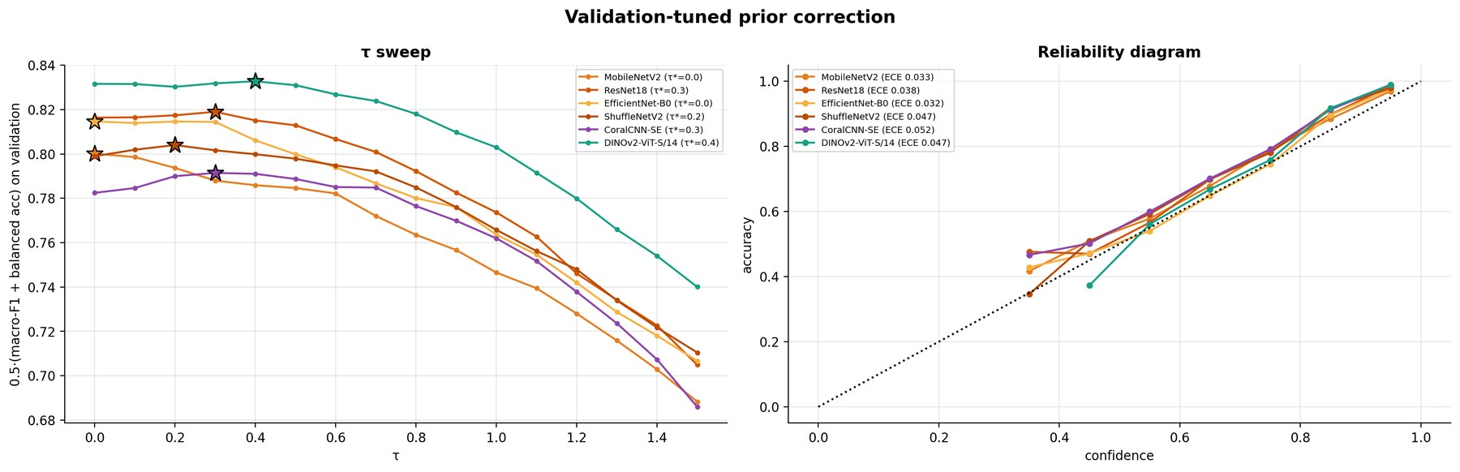
Fig. 8. Left: validation objective ½(macro-F1 + balanced accuracy) as a function of the prior-correction strength τ; stars mark the selected τ*. Right: reliability diagrams on the test set with expected calibration error (ECE).

4.6. Protocol B: dense mapping of whole quadrats
Moving from centred crops to whole-quadrat sliding-window inference changed point accuracy by at most 1.9 pp (from +0.3 pp for ShuffleNetV2 to −1.9 pp for DINOv2; Table 12): every model still exceeded 82% accuracy at the 25,082 expert points of the 150 held-out quadrats, and the ranking by macro-F1 was preserved at the top (DINOv2 0.805, ResNet18 0.803). Qualitatively, the blended maps delineate coral colonies, algal patches and sand plausibly (Fig. 9). The largest relative decline was in Dead-class recall (for example, DINOv2 from 0.734 to 0.647), because Dead/Degraded patches are small and fragmented, so windows straddling a patch boundary are dominated by the surrounding substrate. CoralCNN-SE retained the highest Dead recall (0.714) and the highest balanced accuracy (81.09%) in this protocol.
Table 12. Protocol B: sliding-window results on 150 held-out quadrats (stride 112 px). Point metrics are evaluated at the 25,082 expert points; cover metrics compare predicted and expert live-coral cover per quadrat. Best values in bold.
Model | Pt acc. (%) | Bal. acc. (%) | Macro-F1 | Dead recall | Cover MAE (pp) | Cover RMSE (pp) | Pearson r | Bias (pp) | Dead-cover MAE (pp) | Status agr. (%) | ms / quadrat
MobileNetV2 | 82.49 | 78.69 | 0.773 | 0.600 | 5.54 | 9.68 | 0.939 | +3.24 | 5.91 | 80.7 | 174
ResNet18 | 84.64 | 80.48 | 0.803 | 0.655 | 3.23 | 6.34 | 0.972 | −1.15 | 5.12 | 92.7 | 140
EfficientNet-B0 | 84.10 | 80.08 | 0.795 | 0.631 | 3.72 | 7.40 | 0.959 | +0.39 | 5.61 | 89.3 | 235
ShuffleNetV2 | 83.75 | 80.77 | 0.795 | 0.667 | 3.66 | 6.06 | 0.973 | +0.76 | 4.57 | 90.7 | 115
CoralCNN-SE | 82.86 | 81.09 | 0.792 | 0.714 | 3.51 | 6.94 | 0.964 | −0.09 | 5.41 | 90.7 | 99
DINOv2 ViT-S/14 | 84.82 | 80.29 | 0.805 | 0.647 | 3.11 | 5.17 | 0.981 | +0.15 | 4.52 | 92.0 | 506

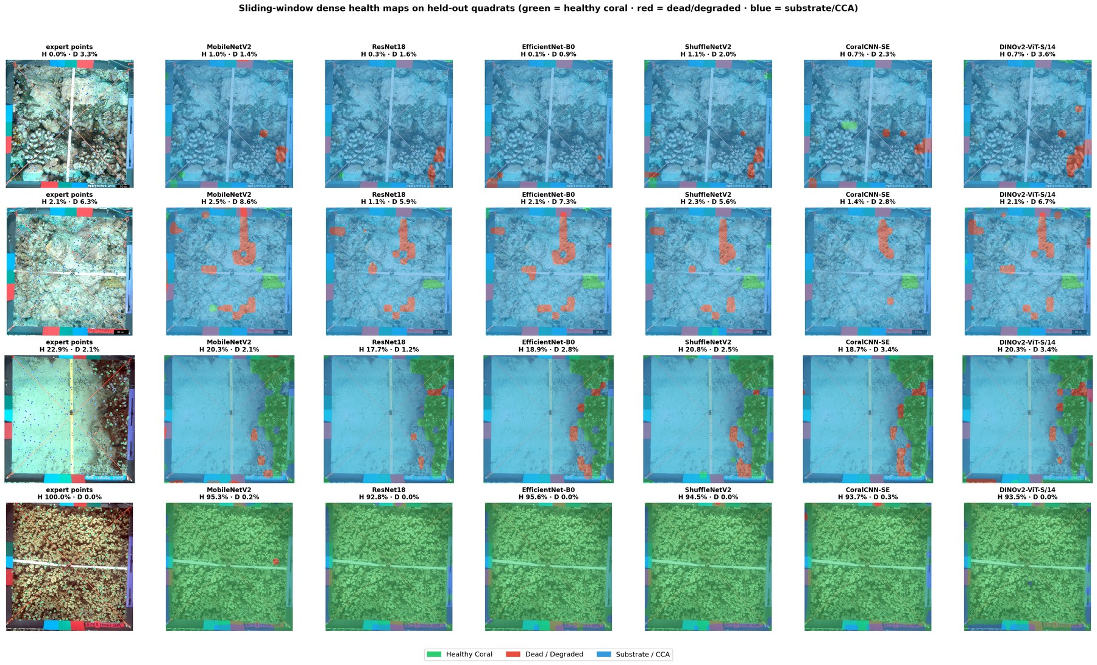
Fig. 9. Dense health maps produced by sliding-window inference on four held-out quadrats spanning the range of live-coral cover (rows). The first column shows the expert points; the title of each panel gives the predicted live-coral (H) and dead/degraded (D) cover. Green: Healthy Coral; red: Dead/Degraded; blue: Substrate/CCA.
At the level of the ecological end product, all models produced cover estimates that tracked the expert values closely (Fig. 10). DINOv2 achieved the lowest live-coral cover MAE (3.11 pp), the lowest RMSE (5.17 pp), the highest correlation (r = 0.981) and the lowest dead-cover MAE (4.52 pp), with negligible bias (+0.15 pp). ResNet18 (MAE 3.23 pp) and CoralCNN-SE (3.51 pp, bias −0.09 pp) followed. MobileNetV2 was a clear outlier, with an MAE of 5.54 pp and a systematic over-estimation of coral cover (+3.24 pp) that lowered its reef-status agreement to 80.7%, compared with 89.3–92.7% for the other models.
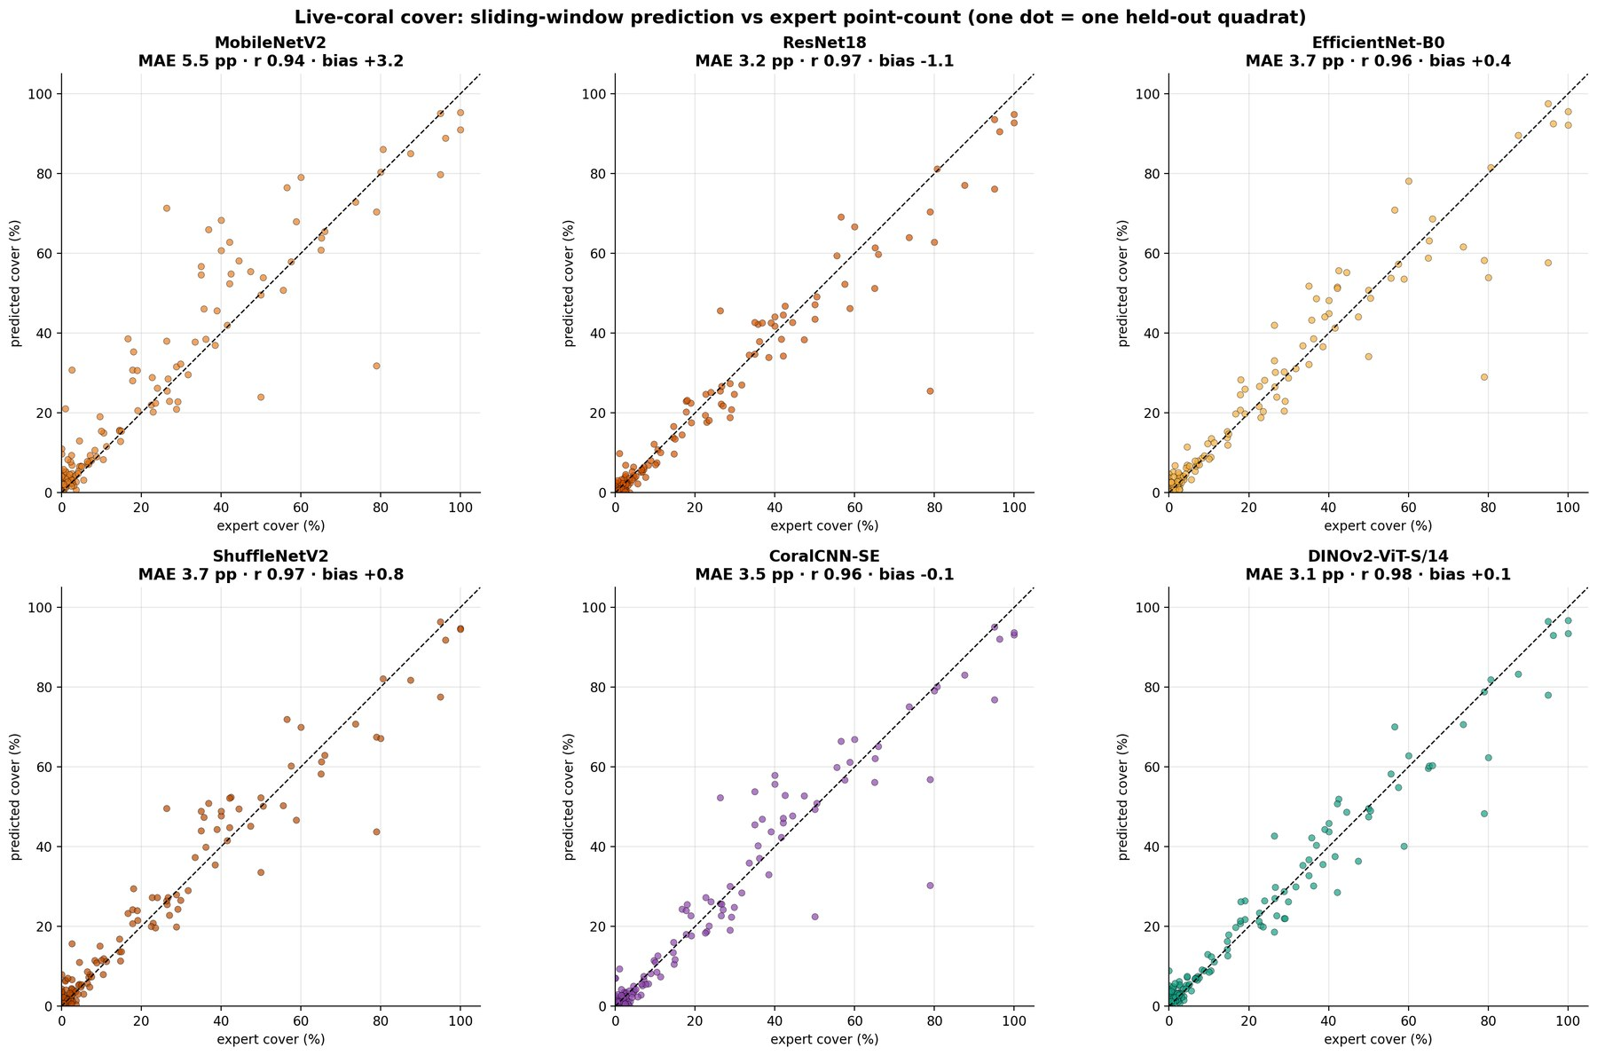
Fig. 10. Predicted versus expert live-coral cover per held-out quadrat for each model (sliding-window protocol). The dashed line is the 1:1 line; MAE, bias and Pearson r are given in each panel.
The statistical analysis of per-quadrat absolute errors (Fig. 11, Table 13) qualifies the ranking. The Friedman test confirmed that the six models differ in cover error (χ²(5) = 41.8, p < 0.001; for dead cover, χ²(5) = 18.6, p = 0.002). However, after Holm correction only MobileNetV2 was significantly worse than DINOv2 (mean difference +2.43 pp, 95% CI 1.47–3.45, adjusted p < 0.001). The differences between DINOv2 and ResNet18 (+0.12 pp), CoralCNN-SE (+0.41 pp) and EfficientNet-B0 (+0.61 pp) were not significant, and the Friedman mean ranks of ResNet18 (3.20), CoralCNN-SE (3.27), DINOv2 (3.30) and EfficientNet-B0 (3.33) were nearly identical. CoralCNN-SE had the lowest median absolute error (1.40 pp), whereas DINOv2's lower mean error comes mainly from fewer large failures.
Table 13. Pairwise comparison of per-quadrat absolute live-coral cover error against DINOv2 ViT-S/14 (150 quadrats). ΔMAE > 0 means the model is worse than DINOv2.
Model | MAE (pp) | Median AE (pp) | Friedman mean rank | ΔMAE vs DINOv2 (pp) [95% CI] | Wilcoxon p | Holm-adjusted p
DINOv2 ViT-S/14 | 3.11 | 1.90 | 3.30 | — | — | —
ResNet18 | 3.23 | 1.49 | 3.20 | +0.12 [−0.34, 0.65] | 0.652 | 1.000
CoralCNN-SE | 3.51 | 1.40 | 3.27 | +0.41 [−0.34, 1.18] | 0.833 | 1.000
ShuffleNetV2 | 3.66 | 2.21 | 3.52 | +0.55 [0.05, 1.07] | 0.031 | 0.123
EfficientNet-B0 | 3.72 | 1.57 | 3.33 | +0.61 [−0.05, 1.32] | 0.893 | 1.000
MobileNetV2 | 5.54 | 2.32 | 4.37 | +2.43 [1.47, 3.45] | < 0.001 | < 0.001

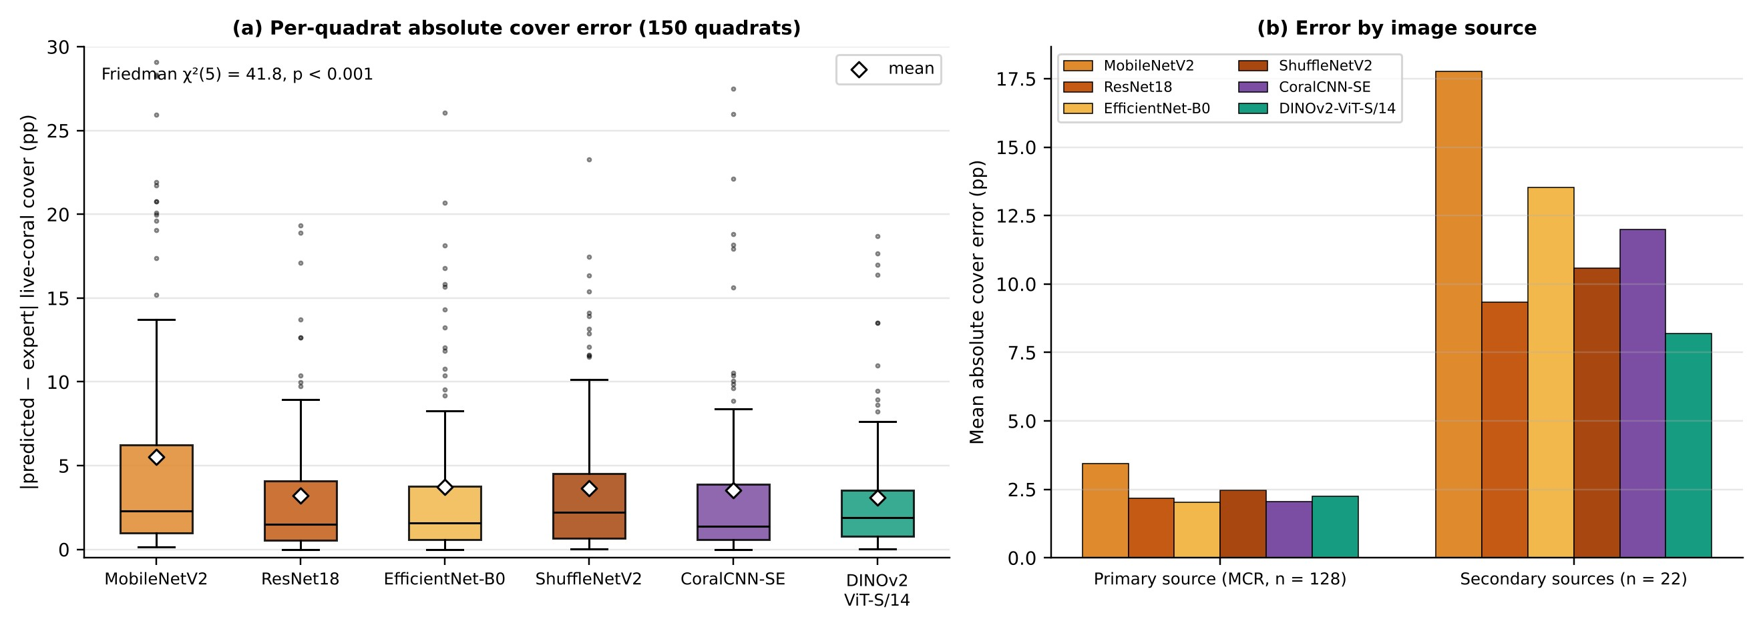
Fig. 11. (a) Distribution of per-quadrat absolute live-coral cover error over the 150 held-out quadrats (box: inter-quartile range; line: median; diamond: mean). (b) Mean absolute error split by image source: the primary Moorea (MCR LTER) quadrats and the secondary, sparsely annotated quadrats.
Splitting the quadrats by source (Fig. 11b) reveals where the differences arise. On the 128 primary-source quadrats (about 193 expert points each), all models except MobileNetV2 achieved MAE between 2.03 and 2.47 pp, with EfficientNet-B0 (2.03) and CoralCNN-SE (2.05) marginally best. On the 22 secondary-source quadrats, which are under-represented in training and carry only about 19 expert points each, errors were four to five times larger and the models separated clearly: DINOv2 (8.18 pp) was best, followed by ResNet18 (9.33 pp), while CoralCNN-SE (12.00 pp), EfficientNet-B0 (13.53 pp) and MobileNetV2 (17.78 pp) degraded most. This pattern is consistent with the broader pre-training of DINOv2 conferring robustness to appearance shift, while the from-scratch CNN is most specialised to the dominant source. Part of the larger secondary-source error reflects the expert estimate itself, since a cover estimate from about 19 points carries a binomial standard error of up to 11 pp.
The stride study (Table 14, Fig. 12) quantifies the cost–accuracy trade-off of window overlap for DINOv2. Halving the stride from 224 to 112 pixels increased point accuracy from 83.19% to 87.67% and macro-F1 from 0.791 to 0.849 and reduced cover MAE from 3.52 to 2.78 pp, at three times the computation. A further halving to 56 pixels improved point metrics again (89.58%, 0.873) but did not improve cover MAE (2.93 pp), while increasing time per quadrat to 1.8 s. A stride of 112 pixels is therefore a good default for cover estimation.
Table 14. Sliding-window stride study (DINOv2 ViT-S/14, 20 held-out quadrats).
Stride (px) | Overlap (%) | Windows / quadrat | Point acc. (%) | Macro-F1 | Cover MAE (pp) | ms / quadrat
224 | 0 | 75 | 83.19 | 0.791 | 3.52 | 178
112 | 50 | 292 | 87.67 | 0.849 | 2.78 | 530
56 | 75 | 1,138 | 89.58 | 0.873 | 2.93 | 1,835

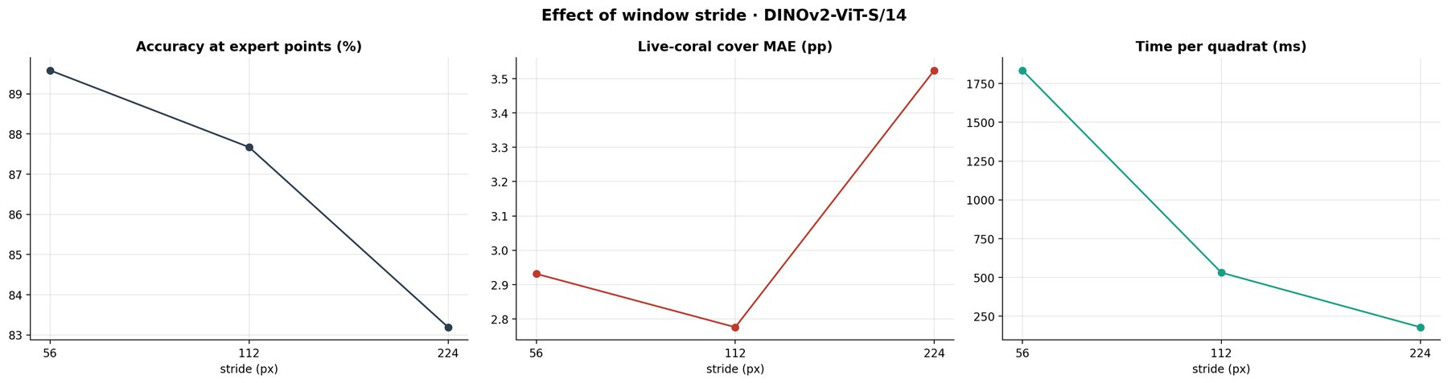
Fig. 12. Effect of sliding-window stride on point accuracy, macro-F1, live-coral cover MAE and computation time per quadrat.

4.7. Computational cost
Inference cost varied by more than an order of magnitude across models (Table 15, Fig. 13). On the GPU at batch size 1, the from-scratch CoralCNN-SE was the fastest model (4.12 ms per crop, 95th percentile 4.71 ms) and achieved the highest batched throughput (3,508 crops/s), followed by ResNet18 (5.06 ms). The nominally lightweight MobileNetV2, ShuffleNetV2 and EfficientNet-B0 were slower than ResNet18 on the GPU despite needing roughly 5–13 times fewer FLOPs, because their depthwise and channel-shuffle operations are memory-bound and poorly parallelised at small batch sizes [35]. On two CPU cores the ranking reversed: ShuffleNetV2 was fastest (17.5 ms), and DINOv2 was the slowest model on every measure (8.50 ms GPU, 135 ms CPU, 678 crops/s, 506 ms per quadrat). The Pareto front of macro-F1 against GPU latency consisted of CoralCNN-SE, ResNet18 and DINOv2; against CPU latency it consisted of ShuffleNetV2, CoralCNN-SE, EfficientNet-B0, ResNet18 and DINOv2.
Table 15. Inference cost per 224 × 224 crop (Tesla T4 GPU, fp32, batch 1; throughput with batch 64 and mixed precision; CPU column on 2 vCPUs). Best values in bold.
Model | Params (M) | Size (MB) | GFLOPs | GPU mean (ms) | GPU p95 (ms) | GPU p99 (ms) | Throughput (img/s) | CPU mean (ms) | SW ms / quadrat
MobileNetV2 | 2.23 | 8.5 | 0.60 | 6.12 | 10.33 | 11.85 | 2,076 | 29.3 | 174
ResNet18 | 11.18 | 42.6 | 3.63 | 5.06 | 6.10 | 7.77 | 2,459 | 43.2 | 140
EfficientNet-B0 | 4.01 | 15.3 | 0.77 | 8.84 | 10.20 | 14.11 | 1,535 | 32.1 | 235
ShuffleNetV2 | 1.26 | 4.8 | 0.29 | 7.64 | 9.12 | 11.51 | 3,348 | 17.5 | 115
CoralCNN-SE | 4.16 | 15.9 | 2.02 | 4.12 | 4.71 | 7.37 | 3,508 | 30.4 | 99
DINOv2 ViT-S/14 | 22.45 | 85.6 | 11.03 | 8.50 | 11.07 | 11.89 | 678 | 135.1 | 506

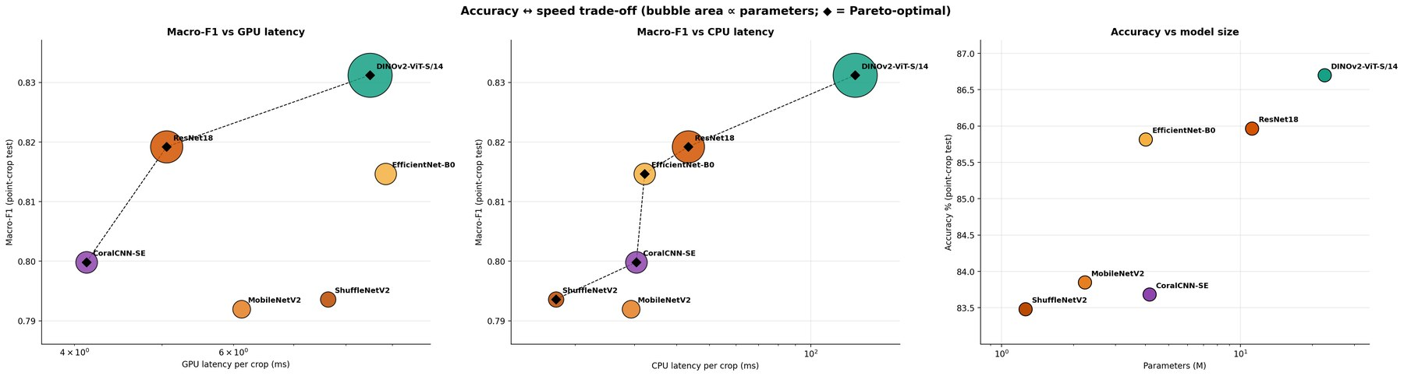
Fig. 13. Accuracy–cost trade-offs: macro-F1 versus GPU latency (left) and CPU latency (centre), and accuracy versus number of parameters (right). Bubble area is proportional to the number of parameters; diamonds and dashed lines mark the Pareto front.

4.8. Explainability
The three families attended to the images in visibly different ways (Fig. 14). ResNet18 produced compact maps centred on the labelled point; CoralCNN-SE produced broader maps covering the textured region around the point; and DINOv2's Grad-CAM maps were diffuse and patchy, often highlighting texture throughout the crop. The quantitative checks (Table 16) confirm this. ResNet18 placed 55.0% of its CAM mass within 56 pixels of the point (uniform baseline 19.6%) and its CAM peak fell within 32 pixels of the point in 91.3% of crops (random baseline 6.4%). CoralCNN-SE (27.2%, 22.7%) and DINOv2 (21.8%, 10.7%) were much less centred. Localisation is not the same as faithfulness, however: erasing the top 20% of Grad-CAM pixels reduced the predicted-class probability 6.2 times more than erasing random pixels for ResNet18 and 5.8 times more for DINOv2, but only 2.1 times more for CoralCNN-SE.
Table 16. Quantitative Grad-CAM evaluation on 300 test crops (ground truth: the labelled point at the crop centre).
Model | Explained layer | Centre-mass (r ≤ 56 px) | Uniform baseline | Pointing hit (%) (r ≤ 32 px) | Random-peak hit (%) | Deletion drop, top-20% CAM | Deletion drop, random 20% | Faithfulness ratio
ResNet18 | layer4 (7 × 7) | 0.550 | 0.196 | 91.3 | 6.4 | 0.240 | 0.038 | 6.24
CoralCNN-SE | stage 4 (7 × 7) | 0.272 | 0.196 | 22.7 | 6.4 | 0.169 | 0.082 | 2.06
DINOv2 ViT-S/14 | last block tokens (16 × 16) | 0.218 | 0.196 | 10.7 | 6.4 | 0.129 | 0.022 | 5.84

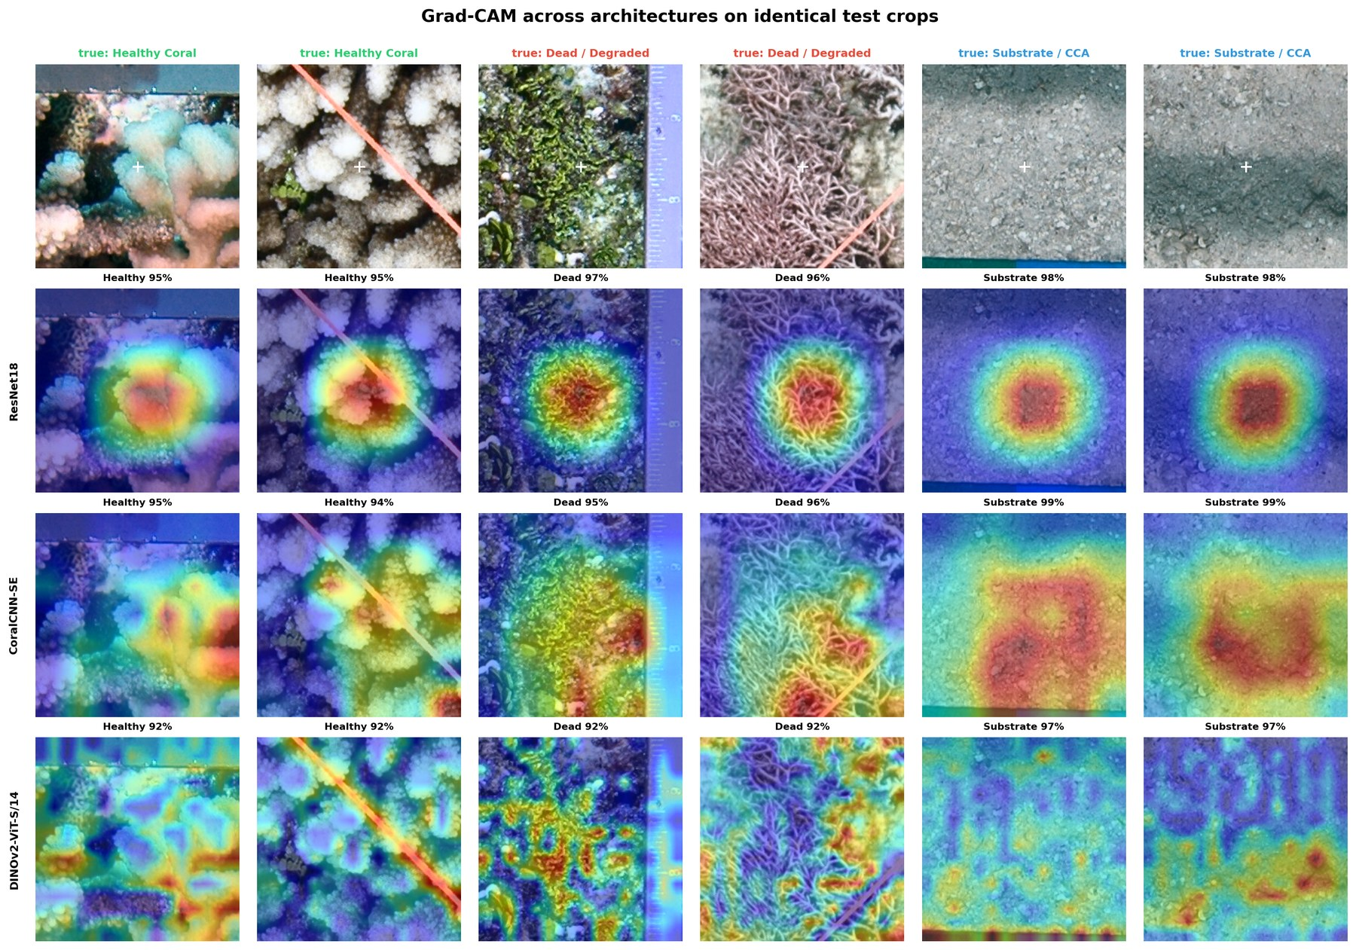
Fig. 14. Grad-CAM maps of ResNet18, CoralCNN-SE and DINOv2 ViT-S/14 on identical test crops (two per class). Predicted class and confidence are shown above each map; the white cross marks the labelled point.
Comparing explanation methods with insertion and deletion curves (Table 17, Fig. 15) showed that the best method depends on the architecture, but that Occlusion was the most faithful method for all three models (Insertion − Deletion of 0.208, 0.076 and 0.079 for ResNet18, CoralCNN-SE and DINOv2). Grad-CAM was reasonably faithful for ResNet18 (0.065) but performed below the random baseline on DINOv2's insertion curve (Insertion − Deletion −0.185), indicating that gradients at the last-block token map do not capture the evidence the ViT actually uses. Integrated Gradients was the least faithful method for the two CNNs. Every method nonetheless outperformed random attribution on the deletion curve, so all three models rely on spatially structured evidence rather than on global image statistics.
Table 17. Faithfulness of three explanation methods (150 test crops). Deletion AUC: lower is better; insertion AUC and Insertion − Deletion: higher is better. Best method per model in bold.
Model | Method | Deletion AUC | Insertion AUC | Insertion − Deletion | Centre-mass | Pointing hit (%)
ResNet18 | Grad-CAM | 0.653 | 0.719 | 0.065 | 0.556 | 93.3
 | Integrated Gradients | 0.605 | 0.589 | −0.016 | 0.418 | 58.7
 | Occlusion | 0.546 | 0.755 | 0.208 | 0.433 | 40.7
 | Random | 0.747 | 0.527 | −0.220 | 0.191 | 3.3
CoralCNN-SE | Grad-CAM | 0.581 | 0.596 | 0.015 | 0.282 | 24.7
 | Integrated Gradients | 0.552 | 0.481 | −0.071 | 0.354 | 28.0
 | Occlusion | 0.521 | 0.598 | 0.076 | 0.403 | 34.0
 | Random | 0.642 | 0.433 | −0.209 | 0.198 | 3.3
DINOv2 ViT-S/14 | Grad-CAM | 0.668 | 0.483 | −0.185 | 0.208 | 10.0
 | Integrated Gradients | 0.704 | 0.507 | −0.197 | 0.274 | 38.7
 | Occlusion | 0.595 | 0.674 | 0.079 | 0.343 | 30.0
 | Random | 0.787 | 0.529 | −0.258 | 0.198 | 6.0

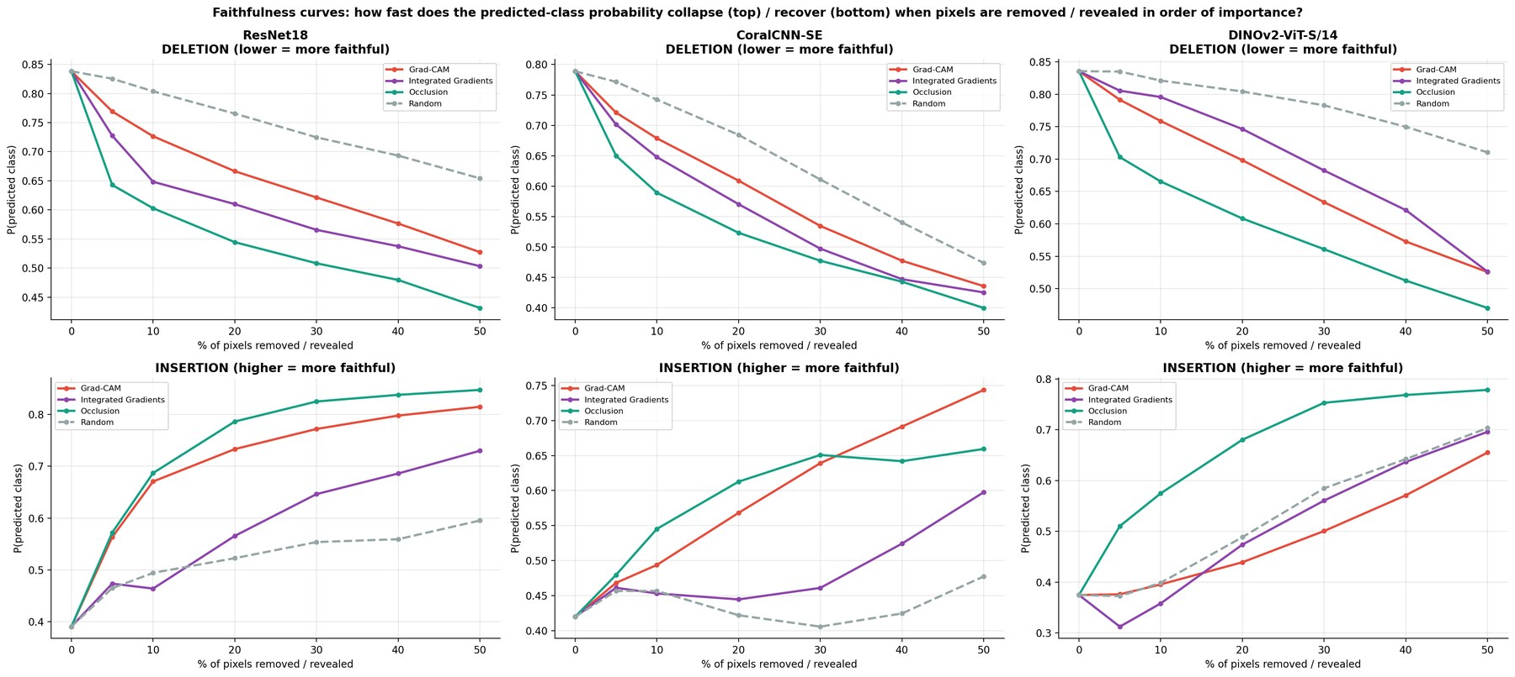
Fig. 15. Deletion (top; lower is more faithful) and insertion (bottom; higher is more faithful) curves for Grad-CAM, Integrated Gradients, Occlusion and random attribution on ResNet18, CoralCNN-SE and DINOv2 ViT-S/14.

4.9. Overall comparison
Table 18 consolidates the comparison. Ranked by the mean of four accuracy criteria (crop accuracy, crop macro-F1, sliding-window macro-F1 and cover MAE), DINOv2 ranked first on all four, ResNet18 second, and EfficientNet-B0 third. Ranked by cost (GPU latency, CPU latency and parameters), ShuffleNetV2, MobileNetV2 and CoralCNN-SE led and DINOv2 was last. An overall rank weighting accuracy four times as heavily as GPU latency placed DINOv2 first, ResNet18 second and CoralCNN-SE third. Within families, the best models were ResNet18 among transfer-learning CNNs (macro-F1 0.819), CoralCNN-SE among CNNs trained from scratch (0.800) and DINOv2 among transformers (0.831).
Table 18. Master comparison across protocols. Accuracy rank = mean rank over crop accuracy, crop macro-F1, sliding-window macro-F1 and cover MAE; efficiency rank = mean rank over GPU latency, CPU latency and parameters; overall rank weights accuracy 4 : 1 against GPU latency.
Model | Family | Crop acc. (%) | Crop macro-F1 | SW macro-F1 | Cover MAE (pp) | GPU ms | CPU ms | Train min | Accuracy rank | Efficiency rank | Overall rank
MobileNetV2 | TL | 83.85 | 0.792 | 0.773 | 5.54 | 6.12 | 29.3 | 9.3 | 5.50 | 2.33 | 6
ResNet18 | TL | 85.97 | 0.819 | 0.803 | 3.23 | 5.06 | 43.2 | 7.0 | 2.00 | 4.00 | 2
EfficientNet-B0 | TL | 85.82 | 0.815 | 0.795 | 3.72 | 8.84 | 32.1 | 12.8 | 3.75 | 4.33 | 4
ShuffleNetV2 | TL | 83.48 | 0.794 | 0.795 | 3.66 | 7.64 | 17.5 | 6.2 | 4.50 | 2.00 | 5
CoralCNN-SE | Scratch | 83.68 | 0.800 | 0.792 | 3.51 | 4.12 | 30.4 | 18.1 | 4.25 | 2.67 | 3
DINOv2 ViT-S/14 | ViT | 86.70 | 0.831 | 0.805 | 3.11 | 8.50 | 135.1 | 12.1 | 1.00 | 5.67 | 1

For context, Table 19 lists the results of earlier development versions of the same models that were trained on whole-image majority labels (1,718 training images rather than 24,000 point crops). Because the test unit differs (whole images rather than points), these numbers are not directly comparable; nevertheless, the shift to point-centred training raised macro-F1 from 0.70–0.76 to 0.79–0.83 for the transfer-learning CNNs and from 0.52 to 0.80 for CoralCNN-SE, which suffered most from noisy image-level labels.
Table 19. Reference results of earlier development versions trained on whole-image labels (indicative only; different test unit).
Model (earlier version) | Training / test unit | Accuracy (%) | Weighted-F1 | Macro-F1 | Macro-F1, this study
MobileNetV2 | whole image (369 test images) | 81.0 | 0.821 | 0.709 | 0.792
ResNet18 | whole image (369) | 82.4 | 0.835 | 0.732 | 0.819
EfficientNet-B0 | whole image (369) | 82.1 | 0.827 | 0.704 | 0.815
ShuffleNetV2 | whole image (369) | 84.3 | 0.852 | 0.763 | 0.794
CoralCNN-SE | whole image (361) | 65.7 | 0.687 | 0.524 | 0.800
DINOv2 ViT-S/14 (frozen) | point crop (4,000) | 77.7 | 0.851 | — | 0.831

5. Discussion

5.1. Self-supervised transformer versus well-tuned CNNs
Under identical conditions, the self-supervised DINOv2 ViT-S/14 was the most accurate model on every discrimination metric of both protocols and produced the most accurate cover maps. Three properties plausibly contribute. Its self-distillation pre-training on a large curated corpus yields features that are less tied to ImageNet object categories than supervised CNN features [26]; pooling patch tokens from four depths gives the head access to both fine texture statistics and higher-level context; and self-attention integrates information across the whole crop from early layers onwards [44], which is useful when the class of a point depends on the surrounding colony or substrate. Its markedly smaller error on the under-represented secondary-source quadrats (8.2 pp versus 9.3–17.8 pp MAE for the other models) is consistent with the reported transferability of DINOv2 features to coral imagery [27].
The size of the advantage, however, is the more practically important finding. On point crops, DINOv2 led ResNet18 by 0.73 pp accuracy with overlapping 95% confidence intervals, and on cover estimation the difference from ResNet18, CoralCNN-SE and EfficientNet-B0 was neither statistically significant nor ecologically meaningful (0.1–0.6 pp). DINOv2 achieved this with twice the parameters of ResNet18, three times the FLOPs and 3.6 times the sliding-window time per quadrat. These results echo earlier observations that, once training is well controlled, differences among modern backbones are often small compared with differences caused by data and protocol [43]. For the coral domain, the evidence here suggests that the choice between a ViT and a good CNN should be driven by robustness requirements and computational budget rather than by headline accuracy.

5.2. A compact CNN trained from scratch is competitive
CoralCNN-SE, with 4.2 M parameters and no pre-training, matched or exceeded two ImageNet-pretrained compact networks on macro-F1, had the highest Dead-class recall in both protocols (0.745 and 0.714), the lowest median cover error (1.40 pp) and the smallest cover bias (−0.09 pp), and was the fastest model on the GPU. This contradicts the common assumption that small reef datasets demand transfer learning. Two factors explain it. First, the move from 1,718 whole-image labels to 24,000 clean point crops supplied enough well-labelled data to train a compact network; the earlier whole-image version of the same architecture reached only 0.52 macro-F1 (Table 19). Second, squeeze-and-excitation recalibration [36] and residual learning give a strong inductive bias for the texture-dominated discrimination required here (Table 6). Its weaknesses are equally clear: it needed the longest training, its Grad-CAM evidence was the least concentrated and least faithful, and it generalised worst to the under-represented secondary source. CoralCNN-SE is therefore an attractive option for in-region, resource-constrained deployment, such as on-board processing on underwater vehicles, but less so for multi-region programmes.

5.3. Point-centred training and the meaning of the labels
The label-purity analysis showed that whole-image labels misdescribe most quadrats, and the comparison with earlier whole-image versions indicates that point-centred crops are the single most effective design decision in the pipeline. This aligns the training target with the unit of measurement used in point-count surveys [8, 9] and allows the same models to be applied densely, so that one classifier serves both point annotation and cover mapping.
The persistent difficulty of the Dead/Degraded class merits ecological interpretation. Dead coral is rapidly colonised by turf algae, CCA and other encrusting organisms, so the boundary between "dead or algal-covered framework" and "CCA or hard substrate" is gradual, and even trained annotators disagree substantially on such categories [9]. Most model errors fell exactly on this boundary, while Healthy Coral was rarely confused with either degraded class. From a monitoring perspective this is reassuring, because live coral cover, the most widely used indicator of reef condition [6], was estimated with high accuracy (r up to 0.98), whereas finer distinctions within non-living benthos may require more specific classes, higher-resolution imagery or complementary modalities [38].

5.4. Imbalance handling and prior shift
Two results are relevant to practitioners. First, more elaborate imbalance treatments did not help: class-aware strong augmentation, image mixing and focal loss each reduced Dead-class recall relative to plain balanced sampling. This differs from the experience in object-centric benchmarks [46, 47] and is plausibly specific to texture-defined classes, where aggressive transformations destroy the very cues that separate the classes. Second, correcting for the shift from balanced training to natural deployment priors [30, 48] improved accuracy by up to 2.8 pp, but at the cost of minority-class recall. There is no single correct setting: a programme that primarily reports live-coral cover can tune for accuracy, whereas one that targets early detection of degradation should tune for balanced accuracy or recall. Making τ an explicit, validation-tuned parameter exposes this trade-off to the user instead of hiding it inside the training procedure.

5.5. From point accuracy to ecological estimates
Point-level errors partly cancel when aggregated to cover. Apart from MobileNetV2, models with 83–85% point accuracy produced live-coral cover estimates with MAE of 3.1–3.7 pp and correlation above 0.95, and on the well-annotated primary-source quadrats the error fell to about 2 pp. This is of the same order as the disagreement between human annotators reported for point-count cover estimates [9], and is consistent with the operational accuracy reported for large-scale automated reef monitoring [11, 19]. Bias matters as much as variance for trend detection: the systematic +3.2 pp over-estimation by MobileNetV2 would propagate directly into time series, whereas the near-zero bias of CoralCNN-SE and DINOv2 is preferable. The reef-status agreement of 89–93% for all models except MobileNetV2 indicates that automated maps can support categorical reporting, with the residual disagreements concentrated near category thresholds.

5.6. Explanations depend on the explainer
The explainability analysis cautions against drawing conclusions about model behaviour from a single saliency method. ResNet18's Grad-CAM maps were strongly centred on the labelled point; because every training label sits at the crop centre, this may partly reflect a learned spatial prior rather than object-specific evidence, and the deletion test confirms that this central evidence is nevertheless used by the model. DINOv2's Grad-CAM maps appeared diffuse and failed the insertion test, yet Occlusion showed that the ViT relies on spatially coherent evidence as faithfully as the CNNs do. The diffuse appearance is thus largely an artefact of applying a CNN-oriented gradient method to token representations [54]. For cross-architecture comparisons in reef imagery we recommend perturbation-based methods such as Occlusion, together with quantitative faithfulness metrics [28], over gradient-based maps alone.

5.7. Practical recommendations
Table 20 translates the results into recommendations for common deployment scenarios.
Table 20. Model recommendations by deployment scenario, based on the results of this study.
Scenario | Recommended model | Rationale
Maximum accuracy; multi-region or multi-source archives | DINOv2 ViT-S/14 | Best point and cover accuracy; most robust on under-represented sources; GPU required
Balanced accuracy and speed on a GPU server | ResNet18 | Second in accuracy; cover error statistically indistinguishable from DINOv2; 1.7× faster per crop and 3.6× faster per quadrat
Edge / on-vehicle GPU; early detection of degradation | CoralCNN-SE | Fastest GPU model, highest Dead-class recall, lowest cover bias; best within the training region
CPU-only or very low memory | ShuffleNetV2 | Fastest on CPU (17.5 ms), 4.8 MB; cover error close to the larger models
Not recommended | MobileNetV2 | Significantly larger and biased cover errors without a speed advantage

5.8. Limitations and future work
Several limitations should be acknowledged. (i) The experiments use a single data aggregation dominated by one site (Moorea) and a single random split; although the split is grouped by quadrat, it is not grouped by site or year, so the results measure within-distribution generalisation rather than transfer to new reefs. Leave-site-out and leave-year-out evaluation is a priority. (ii) Each configuration was trained once; seed-to-seed variance was not estimated, so differences smaller than about one percentage point should be treated as provisional; repeated runs or cross-validated designs with paired tests [68] would strengthen these conclusions. (iii) The bootstrap intervals for Protocol A treat points as independent, which understates uncertainty because points within a quadrat are correlated; the quadrat-level tests of Protocol B do not have this limitation. (iv) The three-class taxonomy merges ecologically distinct categories, notably turf algae, macroalgae and dead coral, and the mapping itself encodes judgements that other programmes may make differently. (v) Expert cover estimates are themselves noisy, particularly for the sparsely annotated secondary-source images, and no repeated expert annotations were available to quantify human variability on this data. (vi) Latency was measured on a single GPU and CPU configuration, and the DINOv2 model was only partially fine-tuned; parameter-efficient adaptation [27] and model compression could change the cost comparison. Future work should extend the comparison to larger, multi-region benchmarks, finer taxonomies, segmentation-native architectures [40, 41] and explicit domain adaptation.

6. Conclusions
This study compared transfer-learned CNNs, a compact attention CNN trained from scratch and a self-supervised vision transformer for coral reef health classification under a single controlled pipeline, from point-level accuracy through dense cover mapping to computational cost and explanation faithfulness. The main conclusions are:
- Training on point-centred crops rather than whole-image labels is essential, because 68% of quadrats contain all three health classes; it raised macro-F1 of all models and was decisive for the network trained from scratch.
- DINOv2 ViT-S/14 was the most accurate model (86.70% accuracy, macro-F1 0.831; cover MAE 3.11 pp, r = 0.981) and the most robust on under-represented image sources, but its advantage over ResNet18 was small and not statistically significant for cover estimation, at 3.6 times the per-quadrat computation.
- A 4.2-M-parameter SE-ResNet trained from scratch was competitive with ImageNet-pretrained compact CNNs, was the fastest model on the GPU and achieved the highest Dead-class recall and lowest cover bias.
- Dead/Degraded versus Substrate/CCA is the dominant source of error for every architecture; plain balanced sampling outperformed heavier imbalance treatments, and validation-tuned prior correction trades accuracy against degraded-class recall in a controllable way.
- For all but one model, live-coral cover was estimated with mean absolute errors of 3.1–3.7 pp overall and about 2 pp on the well-annotated primary-source quadrats, comparable to human inter-observer variability, supporting the use of automated dense mapping for reef monitoring.
- Explanation quality depends on the pairing of architecture and method: Occlusion was the most faithful explainer for all three families, whereas Grad-CAM was unreliable for the transformer.
These findings provide an evidence base for selecting models for operational reef monitoring and highlight robustness to new sites, rather than in-distribution accuracy, as the main open challenge.

CRediT authorship contribution statement
Deepak E L: Conceptualization, Methodology, Software, Formal analysis, Investigation, Visualization, Writing – original draft. [Co-author name(s)]: [Contribution roles], Writing – review & editing. [Supervisor name]: Supervision, Writing – review & editing.

Declaration of competing interest
The authors declare that they have no known competing financial interests or personal relationships that could have appeared to influence the work reported in this paper.

Data and code availability
The annotated quadrat images are publicly available on Kaggle (dataset "coral-reef-dataset") [55]. The complete pipeline (data preparation, training, evaluation and explainability) is available as a Google Colaboratory notebook at https://colab.research.google.com/drive/1mITD_pCL3SODsILwt3VUXWFDiemTLxzA. Trained model weights, per-epoch logs, per-window and per-quadrat predictions and all tables are available from the corresponding author on request and will be deposited in a public repository upon acceptance.

Funding
This research did not receive any specific grant from funding agencies in the public, commercial, or not-for-profit sectors.

Acknowledgements
The authors thank the Moorea Coral Reef Long-Term Ecological Research programme and the CoralNet community for making expert-annotated benthic imagery available, and the course instructors of 22AIE442 for their guidance. [Add further acknowledgements as appropriate.]

References
[1] O. Hoegh-Guldberg, P.J. Mumby, A.J. Hooten, R.S. Steneck, P. Greenfield, E. Gomez, et al., Coral reefs under rapid climate change and ocean acidification, Science 318 (2007) 1737–1742. https://doi.org/10.1126/science.1152509
[2] D.R. Bellwood, T.P. Hughes, C. Folke, M. Nyström, Confronting the coral reef crisis, Nature 429 (2004) 827–833. https://doi.org/10.1038/nature02691
[3] T.P. Hughes, M.J. Rodrigues, D.R. Bellwood, D. Ceccarelli, O. Hoegh-Guldberg, L. McCook, et al., Phase shifts, herbivory, and the resilience of coral reefs to climate change, Current Biology 17 (2007) 360–365. https://doi.org/10.1016/j.cub.2006.12.049
[4] T.P. Hughes, J.T. Kerry, M. Álvarez-Noriega, J.G. Álvarez-Romero, K.D. Anderson, A.H. Baird, et al., Global warming and recurrent mass bleaching of corals, Nature 543 (2017) 373–377. https://doi.org/10.1038/nature21707
[5] T.P. Hughes, K.D. Anderson, S.R. Connolly, S.F. Heron, J.T. Kerry, J.M. Lough, et al., Spatial and temporal patterns of mass bleaching of corals in the Anthropocene, Science 359 (2018) 80–83. https://doi.org/10.1126/science.aan8048
[6] D. Souter, S. Planes, J. Wicquart, M. Logan, D. Obura, F. Staub (Eds.), Status of Coral Reefs of the World: 2020, Global Coral Reef Monitoring Network (GCRMN) and International Coral Reef Initiative (ICRI), 2021.
[7] J.D. Hedley, C.M. Roelfsema, I. Chollett, A.R. Harborne, S.F. Heron, S. Weeks, et al., Remote sensing of coral reefs for monitoring and management: a review, Remote Sensing 8 (2016) 118. https://doi.org/10.3390/rs8020118
[8] K.E. Kohler, S.M. Gill, Coral Point Count with Excel extensions (CPCe): a Visual Basic program for the determination of coral and substrate coverage using random point count methodology, Computers & Geosciences 32 (2006) 1259–1269. https://doi.org/10.1016/j.cageo.2005.11.009
[9] O. Beijbom, P.J. Edmunds, C. Roelfsema, J. Smith, D.I. Kline, B.P. Neal, et al., Towards automated annotation of benthic survey images: variability of human experts and operational modes of automation, PLoS ONE 10 (2015) e0130312. https://doi.org/10.1371/journal.pone.0130312
[10] M. González-Rivero, O. Beijbom, A. Rodriguez-Ramirez, T. Holtrop, Y. González-Marrero, A. Ganase, et al., Scaling up ecological measurements of coral reefs using semi-automated field image collection and analysis, Remote Sensing 8 (2016) 30. https://doi.org/10.3390/rs8010030
[11] I.D. Williams, C.S. Couch, O. Beijbom, T.A. Oliver, B. Vargas-Angel, B.D. Schumacher, R.E. Brainard, Leveraging automated image analysis tools to transform our capacity to assess status and trends of coral reefs, Frontiers in Marine Science 6 (2019) 222. https://doi.org/10.3389/fmars.2019.00222
[12] O. Beijbom, P.J. Edmunds, D.I. Kline, B.G. Mitchell, D. Kriegman, Automated annotation of coral reef survey images, in: Proc. IEEE Conference on Computer Vision and Pattern Recognition (CVPR), 2012, pp. 1170–1177. https://doi.org/10.1109/CVPR.2012.6247798
[13] A.S.M. Shihavuddin, N. Gracias, R. Garcia, A.C.R. Gleason, B. Gintert, Image-based coral reef classification and thematic mapping, Remote Sensing 5 (2013) 1809–1841. https://doi.org/10.3390/rs5041809
[14] Y. LeCun, Y. Bengio, G. Hinton, Deep learning, Nature 521 (2015) 436–444. https://doi.org/10.1038/nature14539
[15] A. Mahmood, M. Bennamoun, S. An, F. Sohel, F. Boussaid, R. Hovey, G. Kendrick, R.B. Fisher, Deep image representations for coral image classification, IEEE Journal of Oceanic Engineering 44 (2019) 121–131. https://doi.org/10.1109/JOE.2017.2786878
[16] A. Gómez-Ríos, S. Tabik, J. Luengo, A.S.M. Shihavuddin, B. Krawczyk, F. Herrera, Towards highly accurate coral texture images classification using deep convolutional neural networks and data augmentation, Expert Systems with Applications 118 (2019) 315–328. https://doi.org/10.1016/j.eswa.2018.10.010
[17] A. Raphael, Z. Dubinsky, D. Iluz, N.S. Netanyahu, Neural network recognition of marine benthos and corals, Diversity 12 (2020) 29. https://doi.org/10.3390/d12010029
[18] Q. Chen, O. Beijbom, S. Chan, J. Bouwmeester, D. Kriegman, A new deep learning engine for CoralNet, in: Proc. IEEE/CVF International Conference on Computer Vision Workshops (ICCVW), 2021, pp. 3693–3702.
[19] M. González-Rivero, O. Beijbom, A. Rodriguez-Ramirez, D.E.P. Bryant, A. Ganase, Y. Gonzalez-Marrero, et al., Monitoring of coral reefs using artificial intelligence: a feasible and cost-effective approach, Remote Sensing 12 (2020) 489. https://doi.org/10.3390/rs12030489
[20] B.G. Weinstein, A computer vision for animal ecology, Journal of Animal Ecology 87 (2018) 533–545. https://doi.org/10.1111/1365-2656.12780
[21] S. Christin, É. Hervet, N. Lecomte, Applications for deep learning in ecology, Methods in Ecology and Evolution 10 (2019) 1632–1644. https://doi.org/10.1111/2041-210X.13256
[22] D. Tuia, B. Kellenberger, S. Beery, B.R. Costelloe, S. Zuffi, B. Risse, et al., Perspectives in machine learning for wildlife conservation, Nature Communications 13 (2022) 792. https://doi.org/10.1038/s41467-022-27980-y
[23] A. Lumini, L. Nanni, G. Maguolo, Deep learning for plankton and coral classification, Applied Computing and Informatics 19 (2023) 265–283. https://doi.org/10.1016/j.aci.2019.11.004
[24] A. Dosovitskiy, L. Beyer, A. Kolesnikov, D. Weissenborn, X. Zhai, T. Unterthiner, et al., An image is worth 16x16 words: transformers for image recognition at scale, in: Proc. International Conference on Learning Representations (ICLR), 2021.
[25] S. Khan, M. Naseer, M. Hayat, S.W. Zamir, F.S. Khan, M. Shah, Transformers in vision: a survey, ACM Computing Surveys 54 (2022) 200:1–200:41. https://doi.org/10.1145/3505244
[26] M. Oquab, T. Darcet, T. Moutakanni, H. Vo, M. Szafraniec, V. Khalidov, et al., DINOv2: learning robust visual features without supervision, Transactions on Machine Learning Research (2024).
[27] X. Shao, H. Chen, F. Zhao, K. Magson, J. Chen, P. Li, J. Wang, J. Sasaki, Multi-label classification for multi-temporal, multi-spatial coral reef condition monitoring using vision foundation model with adapter learning, Marine Pollution Bulletin 223 (2026) 119054.
[28] W. Samek, A. Binder, G. Montavon, S. Lapuschkin, K.-R. Müller, Evaluating the visualization of what a deep neural network has learned, IEEE Transactions on Neural Networks and Learning Systems 28 (2017) 2660–2673. https://doi.org/10.1109/TNNLS.2016.2599820
[29] A. Adadi, M. Berrada, Peeking inside the black-box: a survey on explainable artificial intelligence (XAI), IEEE Access 6 (2018) 52138–52160. https://doi.org/10.1109/ACCESS.2018.2870052
[30] M. Saerens, P. Latinne, C. Decaestecker, Adjusting the outputs of a classifier to new a priori probabilities: a simple procedure, Neural Computation 14 (2002) 21–41. https://doi.org/10.1162/089976602753284446
[31] M. Buda, A. Maki, M.A. Mazurowski, A systematic study of the class imbalance problem in convolutional neural networks, Neural Networks 106 (2018) 249–259. https://doi.org/10.1016/j.neunet.2018.07.011
[32] M. Sandler, A. Howard, M. Zhu, A. Zhmoginov, L.-C. Chen, MobileNetV2: inverted residuals and linear bottlenecks, in: Proc. IEEE/CVF Conference on Computer Vision and Pattern Recognition (CVPR), 2018, pp. 4510–4520.
[33] K. He, X. Zhang, S. Ren, J. Sun, Deep residual learning for image recognition, in: Proc. IEEE Conference on Computer Vision and Pattern Recognition (CVPR), 2016, pp. 770–778. https://doi.org/10.1109/CVPR.2016.90
[34] M. Tan, Q.V. Le, EfficientNet: rethinking model scaling for convolutional neural networks, in: Proc. 36th International Conference on Machine Learning (ICML), PMLR 97, 2019, pp. 6105–6114.
[35] N. Ma, X. Zhang, H.-T. Zheng, J. Sun, ShuffleNet V2: practical guidelines for efficient CNN architecture design, in: Proc. European Conference on Computer Vision (ECCV), 2018, pp. 116–131.
[36] J. Hu, L. Shen, S. Albanie, G. Sun, E. Wu, Squeeze-and-excitation networks, IEEE Transactions on Pattern Analysis and Machine Intelligence 42 (2020) 2011–2023. https://doi.org/10.1109/TPAMI.2019.2913372
[37] D.R. Roberts, V. Bahn, S. Ciuti, M.S. Boyce, J. Elith, G. Guillera-Arroita, et al., Cross-validation strategies for data with temporal, spatial, hierarchical, or phylogenetic structure, Ecography 40 (2017) 913–929. https://doi.org/10.1111/ecog.02881
[38] O. Beijbom, T. Treibitz, D.I. Kline, G. Eyal, A. Khen, B. Neal, et al., Improving automated annotation of benthic survey images using wide-band fluorescence, Scientific Reports 6 (2016) 23166. https://doi.org/10.1038/srep23166
[39] A. Gómez-Ríos, S. Tabik, J. Luengo, A.S.M. Shihavuddin, F. Herrera, Coral species identification with texture or structure images using a two-level classifier based on convolutional neural networks, Knowledge-Based Systems 184 (2019) 104891. https://doi.org/10.1016/j.knosys.2019.104891
[40] I. Alonso, M. Yuval, G. Eyal, T. Treibitz, A.C. Murillo, CoralSeg: learning coral segmentation from sparse annotations, Journal of Field Robotics 36 (2019) 1456–1477. https://doi.org/10.1002/rob.21915
[41] M. Yuval, I. Alonso, G. Eyal, D. Tchernov, Y. Loya, A.C. Murillo, T. Treibitz, Repeatable semantic reef-mapping through photogrammetry and label-augmentation, Remote Sensing 13 (2021) 659. https://doi.org/10.3390/rs13040659
[42] F. Zhuang, Z. Qi, K. Duan, D. Xi, Y. Zhu, H. Zhu, H. Xiong, Q. He, A comprehensive survey on transfer learning, Proceedings of the IEEE 109 (2021) 43–76. https://doi.org/10.1109/JPROC.2020.3004555
[43] S. Kornblith, J. Shlens, Q.V. Le, Do better ImageNet models transfer better?, in: Proc. IEEE/CVF Conference on Computer Vision and Pattern Recognition (CVPR), 2019, pp. 2661–2671.
[44] M. Raghu, T. Unterthiner, S. Kornblith, C. Zhang, A. Dosovitskiy, Do vision transformers see like convolutional neural networks?, in: Advances in Neural Information Processing Systems (NeurIPS) 34, 2021, pp. 12116–12128.
[45] J.M. Johnson, T.M. Khoshgoftaar, Survey on deep learning with class imbalance, Journal of Big Data 6 (2019) 27. https://doi.org/10.1186/s40537-019-0192-5
[46] T.-Y. Lin, P. Goyal, R. Girshick, K. He, P. Dollár, Focal loss for dense object detection, IEEE Transactions on Pattern Analysis and Machine Intelligence 42 (2020) 318–327. https://doi.org/10.1109/TPAMI.2018.2858826
[47] C. Shorten, T.M. Khoshgoftaar, A survey on image data augmentation for deep learning, Journal of Big Data 6 (2019) 60. https://doi.org/10.1186/s40537-019-0197-0
[48] A.K. Menon, S. Jayasumana, A.S. Rawat, H. Jain, A. Veit, S. Kumar, Long-tail learning via logit adjustment, in: Proc. International Conference on Learning Representations (ICLR), 2021.
[49] C. Guo, G. Pleiss, Y. Sun, K.Q. Weinberger, On calibration of modern neural networks, in: Proc. 34th International Conference on Machine Learning (ICML), PMLR 70, 2017, pp. 1321–1330.
[50] R.R. Selvaraju, M. Cogswell, A. Das, R. Vedantam, D. Parikh, D. Batra, Grad-CAM: visual explanations from deep networks via gradient-based localization, International Journal of Computer Vision 128 (2020) 336–359. https://doi.org/10.1007/s11263-019-01228-7
[51] M. Sundararajan, A. Taly, Q. Yan, Axiomatic attribution for deep networks, in: Proc. 34th International Conference on Machine Learning (ICML), PMLR 70, 2017, pp. 3319–3328.
[52] M.D. Zeiler, R. Fergus, Visualizing and understanding convolutional networks, in: Proc. European Conference on Computer Vision (ECCV), 2014, pp. 818–833.
[53] J. Zhang, S.A. Bargal, Z. Lin, J. Brandt, X. Shen, S. Sclaroff, Top-down neural attention by excitation backprop, International Journal of Computer Vision 126 (2018) 1084–1102. https://doi.org/10.1007/s11263-017-1059-x
[54] H. Chefer, S. Gur, L. Wolf, Transformer interpretability beyond attention visualization, in: Proc. IEEE/CVF Conference on Computer Vision and Pattern Recognition (CVPR), 2021, pp. 782–791.
[55] jxwleong, Coral Reef Dataset [dataset], Kaggle. https://www.kaggle.com/datasets/jxwleong/coral-reef-dataset (accessed 2026).
[56] C.O. Ancuti, C. Ancuti, C. De Vleeschouwer, P. Bekaert, Color balance and fusion for underwater image enhancement, IEEE Transactions on Image Processing 27 (2018) 379–393. https://doi.org/10.1109/TIP.2017.2759252
[57] G. Buchsbaum, A spatial processor model for object colour perception, Journal of the Franklin Institute 310 (1980) 1–26. https://doi.org/10.1016/0016-0032(80)90058-7
[58] S.M. Pizer, E.P. Amburn, J.D. Austin, R. Cromartie, A. Geselowitz, T. Greer, et al., Adaptive histogram equalization and its variations, Computer Vision, Graphics, and Image Processing 39 (1987) 355–368. https://doi.org/10.1016/S0734-189X(87)80186-X
[59] G. Huang, Y. Sun, Z. Liu, D. Sedra, K.Q. Weinberger, Deep networks with stochastic depth, in: Proc. European Conference on Computer Vision (ECCV), 2016, pp. 646–661.
[60] I. Loshchilov, F. Hutter, Decoupled weight decay regularization, in: Proc. International Conference on Learning Representations (ICLR), 2019.
[61] C. Szegedy, V. Vanhoucke, S. Ioffe, J. Shlens, Z. Wojna, Rethinking the Inception architecture for computer vision, in: Proc. IEEE Conference on Computer Vision and Pattern Recognition (CVPR), 2016, pp. 2818–2826.
[62] D. Chicco, G. Jurman, The advantages of the Matthews correlation coefficient (MCC) over F1 score and accuracy in binary classification evaluation, BMC Genomics 21 (2020) 6. https://doi.org/10.1186/s12864-019-6413-7
[63] T.J. DiCiccio, B. Efron, Bootstrap confidence intervals, Statistical Science 11 (1996) 189–228. https://doi.org/10.1214/ss/1032280214
[64] J. Demšar, Statistical comparisons of classifiers over multiple data sets, Journal of Machine Learning Research 7 (2006) 1–30.
[65] S. Holm, A simple sequentially rejective multiple test procedure, Scandinavian Journal of Statistics 6 (1979) 65–70.
[66] A. Paszke, S. Gross, F. Massa, A. Lerer, J. Bradbury, G. Chanan, et al., PyTorch: an imperative style, high-performance deep learning library, in: Advances in Neural Information Processing Systems (NeurIPS) 32, 2019, pp. 8024–8035.
[67] F. Pedregosa, G. Varoquaux, A. Gramfort, V. Michel, B. Thirion, O. Grisel, et al., Scikit-learn: machine learning in Python, Journal of Machine Learning Research 12 (2011) 2825–2830.
[68] T.G. Dietterich, Approximate statistical tests for comparing supervised classification learning algorithms, Neural Computation 10 (1998) 1895–1923. https://doi.org/10.1162/089976698300017197

