Karnataka Law Society’s

GOGTE INSTITUTE OF TECHNOLOGY

Udyambag Belagavi -590008

Karnataka, India.



A Project Report on

**E-COMMERCE WEBSITE**

Submitted for the requirements of 3rd semester B.E. in CSE

for **“WEB PROGRAMING (18CSL36)”**

**Submitted by**

**NAME USN**

Harshita Nimbal2GI19CS049

Girija Kademani2GI19CS044

Irfan Kamate 2GI19CS052

Deepak Kumble2GI19CS038

**Under the guidance of**

**Mrs. Manjula Ramannavar**

**Asst. Prof., Dept. of CSE, KLS GIT**

**Academic Year 2020-2021 (Odd semester)**

Karnataka Law Society’s

GOGTE INSTITUTE OF TECHNOLOGY

Udyambag Belagavi -590008

Karnataka, India.

**Department of Computer Science and Engineering**



**Certificate**

This is to certify that the Project work titled **“E-Commerce Website”** carried out by **Harshita Nimbal, Girija Kademani, Irfan Kamate and Deepak Kumble** bearing **USNs:** **2GI19CS049, 2GI19CS044, 2GI19CS052 and 2GI19CS038** is submittedin partial fulfilment of the requirements for 3rd semester B.E. in **COMPUTER SCIENCE AND ENGINEERING,** Visvesvaraya Technological University, Belagavi. It is certified that all corrections/ suggestions indicated have been incorporated in the report. The project report has been approved as it satisfies the academic requirements in respect of research work prescribed for the said degree.

Date:                        Signature of Guide

Place: Belagavi                            Mrs. Manjula Ramannavar

Asst. Prof., Dept. of CSE,

                                                      KLS Gogte Institute of Technology, Belagavi

Name of the Examiners                                                                Signature of the Examiners

      1.___________________                   1.____________________

     2.____________________   2.____________________

**TABLE OF CONTENTS**

**S.NO    ITEM    PAGE**

1. TITLE OF THE PROJECT  4
2. STATEMENT OF THE PROBLEM 4
3. OBJECTIVES OF THE PROJECT 4-7
4. HARDWARE AND SOFTWARE  8
5. METHODOLOGY / DESIGN 8-11
6. SCREENSHOTS 11-17
7. CONCLUSION 18
8. REFERENCES 18

**E-COMMERCE WEBSITE**

**PROBLEM STATEMENT**

To create an E-Commerce website using HTML, CSS AND JavaScript that will have a home page which will consist of the latest products, featured products and exclusive products. Each product will have a separate product details page which will give all the information regarding the product such as price, description etc. It will also have an accounts page and a shopping cart page. The Account page will allow the customer to login or register which will be programmed using JavaScript to toggle between the login and register parts. Finally, the shopping cart page will show the products that the customer has added to their cart.

**OBJECTIVES**

Following are the objectives of any general E-Commerce website:

* **Reduce management costs:** Businesses aim at reducing the costs incurred for the betterment of their revenue. Automating the ecommerce business can help in reducing the management cost significantly. Moreover, the right use of digital marketing can help in reducing the cost spent on driving customers to such an extent that businesses can bring customers for free of cost.
* **Boosting the efficiency of services:** With the continually evolving technology, you need to enhance the efficiency of your services. By choosing an online ecommerce platform to create an online store, you can efficiently reduce the cost of managing and selling online. You have various opportunities to boost the efficiency of your service that eventually enhances the revenue earned.
* **Making responsive ecommerce website:** With the increasing use of smartphones for shopping online, it has become more than mandatory for ecommerce businesses to go mobile. It is one of the major objectives of all leading ecommerce businesses. By responsive, it means to create a website that can be viewed from any devices of varying screen size, equally.
* **Increasing sales:** The objective of increasing sales will always remain continuous and constant for an ecommerce business. In order to thrive in the ecommerce industry, you need to boost your sales, constantly. All other objectives are zeroed down to make this objective happen.

**What is the Scope?**

E-commerce has bloomed over the years and is one of the fastest-growing domains in the online world. Though it took some time for this to be accept. Today we are at a point where the majority of the people love to shop online. There were numerous concerns revolving around online shopping at its launch, but over years people tend to have started trusting E-commerce for all their shopping needs. In India, people prefer shopping online these days rather than having to visit the physical store. The payment features that are smart and secure as well as the cash on delivery (COD), which makes the payment, even more, safer with hassle-free shipping, easy returns and reach out.

**ADVANTAGES**

* ***Increased Customer Reach*:** An online store puts your products or services right in the palms of client’s hands on their phone or tablet, no matter where in the world they are located. Whenever someone needs something you sell, all they need to do is whip out their smartphone or tablet, browse through your store, and click to purchase. Your online store will provides a new channel through which you can reach an even bigger audience of potential customers.
* ***No Time Restrictions*:** Have you ever heard the expression “Make money while you sleep”?  An ecommerce website is open 24/7, meaning there are no restrictions on when people can shop for and purchase your products, whether it is the middle of the day or the middle of the night.
* ***Low Start Up and Running Costs*:** As compared to a traditional bricks and mortar store, an online store can be set up for a fraction of the cost.  When working with the right platform and the great partners, an ecommerce shop can be smoothly set up in just weeks. Once you’re up and running, many of the marketing and customer relationship functions can be automated.
* ***Run Your Business from Anywhere*:** An online store gives you another unique advantage over most brick-and-mortar businesses; you can run it from any location in the world. As long as you have access the internet, your email, and maybe phone service, you can administer your store from wherever you are:  be that in your office, at Starbucks, or on the beach.

**DISADVANTAGES**

### *Security*: The biggest drawback of e-commerce is the issue of security. People fear to provide personal and financial information, even though several improvements have been made in relation to data encryption. Certain websites do not have capabilities to conduct authentic transactions. Fear of providing credit card information and risk of identity limit the growth of e-commerce.

### *Lack of privacy*: Many websites do not have high encryption for secure online transaction or to protect online identity. Some websites illegally collect statistics on consumers without their permission. Lack of privacy discourages people to use internet for conducting commercial transactions,

### *Tax issue*: Sales tax is another bigger issue when the buyer and seller are situated in different locations. Computation of sales tax poses problems when the buyer and seller are in different states. Another factor is that physical stores will lose business if web purchases are free from tax.

### *Fear*: People fear to operate in a paperless and faceless electronic world. Some of the business organizations do not have physical existence, People do not know with whom they are conducting commercial transactions. This aspect makes people to opt physical stores for purchases.

### *Technical limitations*: It may not be possible to browse through a particular page due to lack of standardized software. Insufficient telecommunication bandwidth may also pose technical problems.

**HARDWARE AND SOFTWARE**

The following E-commerce program code was executed in Brackets.

With an overall view referring the online applications like Amazon, Flipkart, Myntra, etc. here's an example for an software which basically gives us an idea how online shopping is done.

The code displays basic essential needs with it's detailed information. A separate page will show our selected (added) items in the cart which we wish to buy.

**DESIGN/METHODOLOGY**

To create this website we have made use of CSS for separation of presentation and content, including layout, colors, and fonts. This separation can improve content accessibility, provide more flexibility and control in the specification of presentation characteristics, and enable multiple web pages to share formatting by specifying the relevant CSS in a separate .css file which reduces complexity and repetition in the structural content.

In CSS, selectors declare which part of the markup a style applies to by matching tags and attributes in the markup itself. Selectors may apply to the following elements specified by attribute, in particular:

1. **id:** an identifier unique within the document.

For example in our homepage, we have used id attribute to create the menu items.

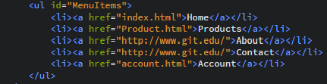

1. **class:** an identifier that can annotate multiple elements in a document

For example in our homepage, we have used class attribute in order to separate the products into rows & columns for better orientation.

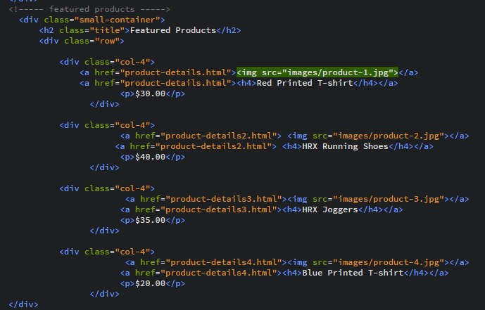

* Pseudo-classes are used in CSS selectors to permit formatting based on information that is not contained in the document tree. One example of a widely used pseudo-class is :hover, which identifies content only when the user "points to" the visible element, usually by holding the mouse cursor over it. The :hover selector is used to select elements when you mouse over them. It is appended to a selector as in a :hover or #elementid:hover. We have used hover effect on the images of the products.

C:\Users\SanjanaKumble\Pictures\Screenshots\Screenshot (1374).png

* We have used JavaScript in order to create login/register page.

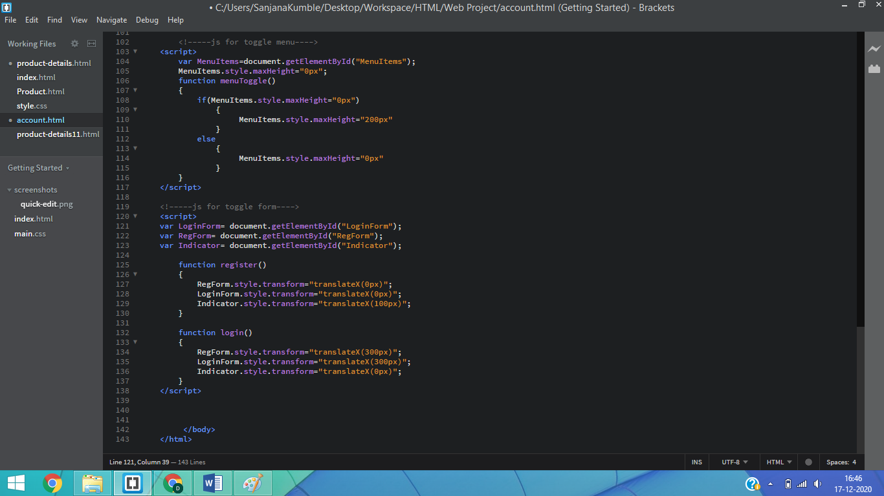

**style.transform:** The transform property applies a 2D or 3D transformation to an element. This property allows you to rotate, scale, move, and skew, etc., elements.

**Syntax:** object.style.transform;

**translateX(x):** Defines a translation, using only the value for the X-axis

* We have used media query in order to make our website responsive. Media query is a CSS technique introduced in CSS3. It uses the @media rule to include a block of CSS properties only if a certain condition is true. We made a web page with rows and columns, and it was responsive, but it did not look good on a small screen. Media queries can help with that. We can add a breakpoint where certain parts of the design will behave differently on each side of the breakpoint.
* Normal size

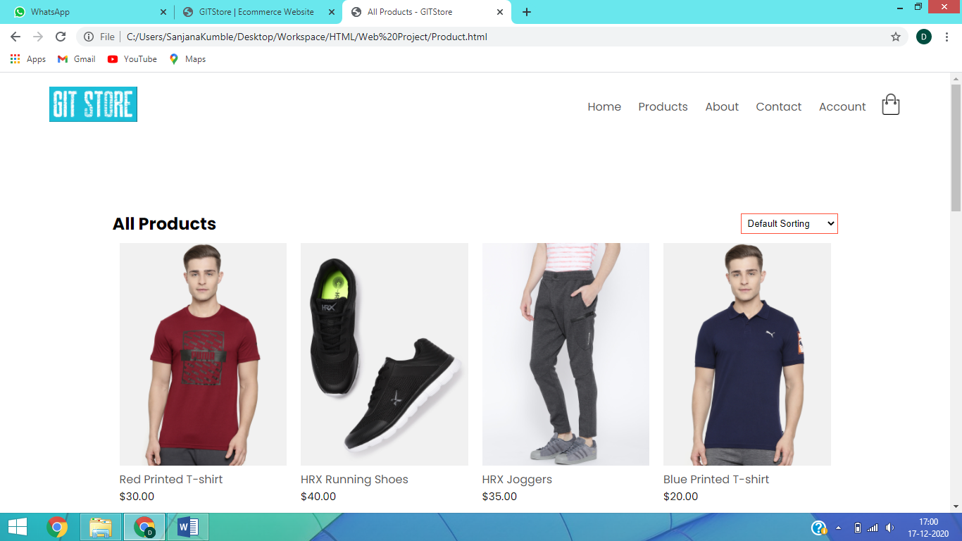

* Below 600 pixels

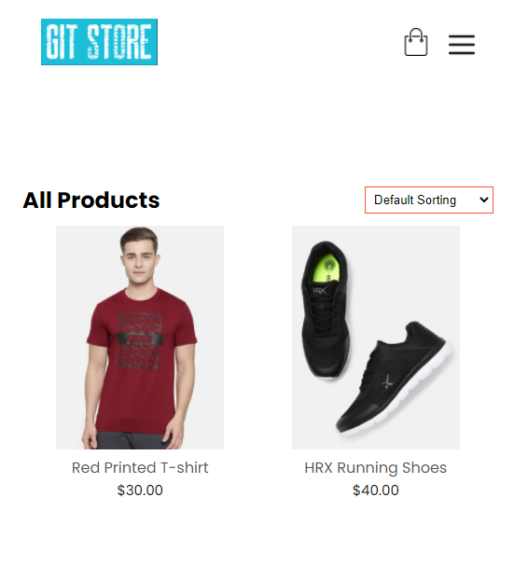

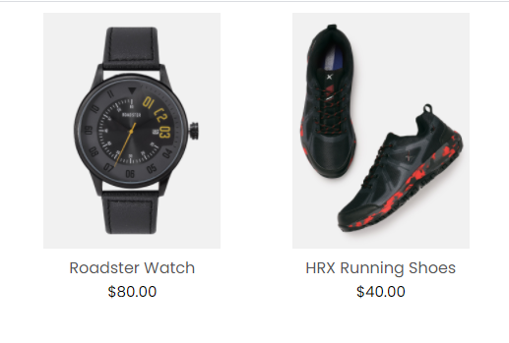

**SCREENSHOTS**

1. Home page

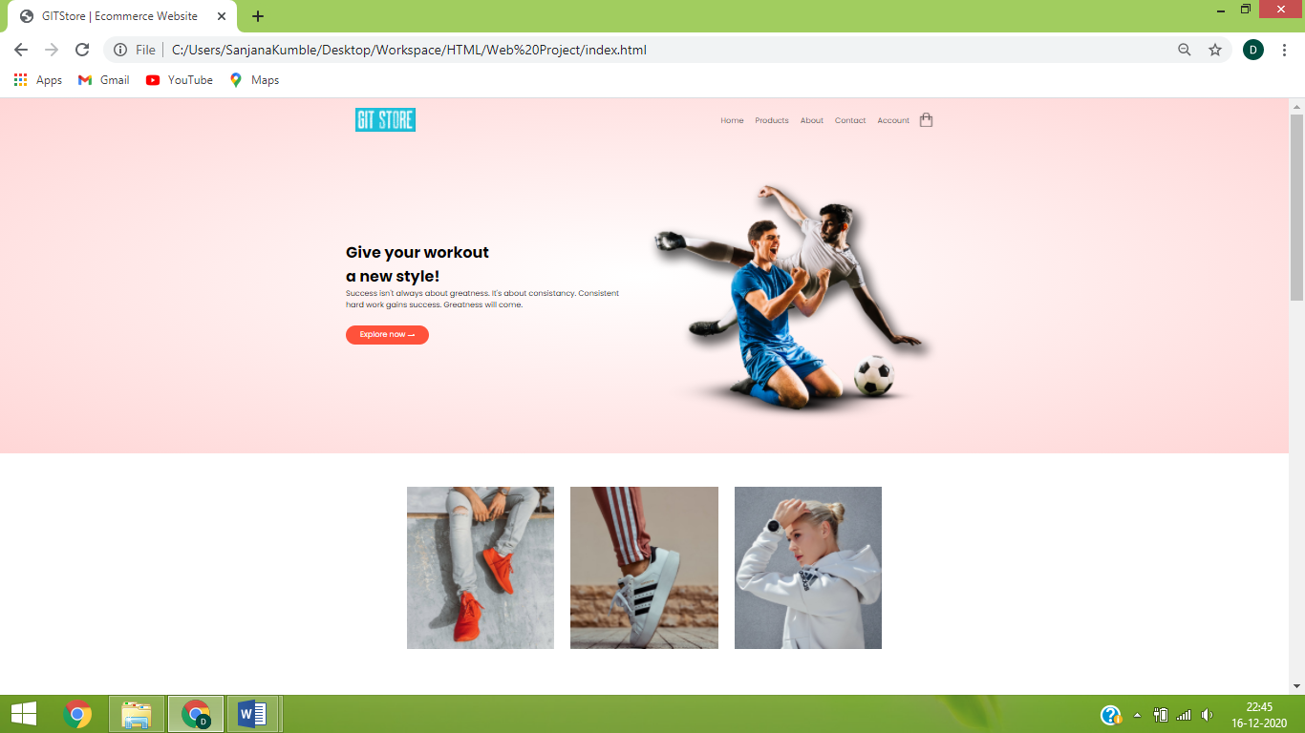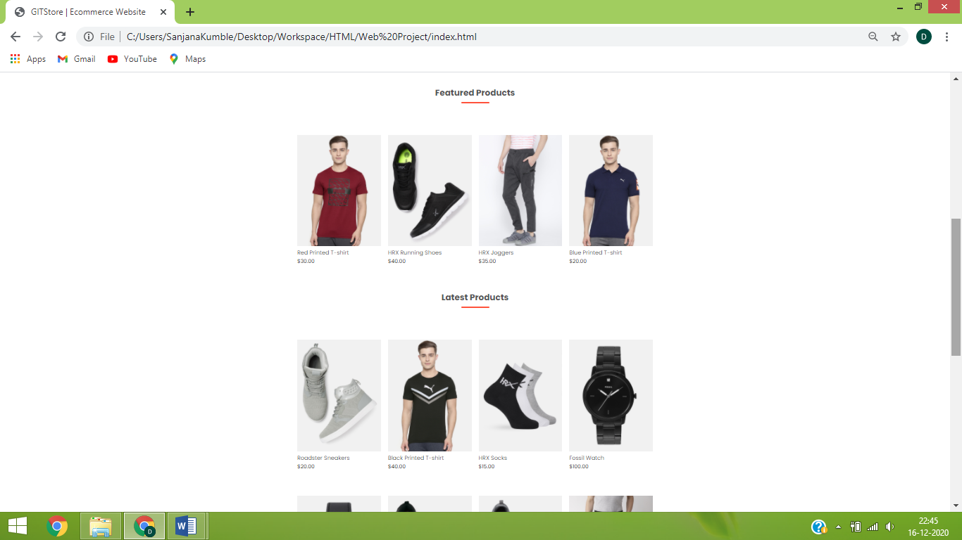

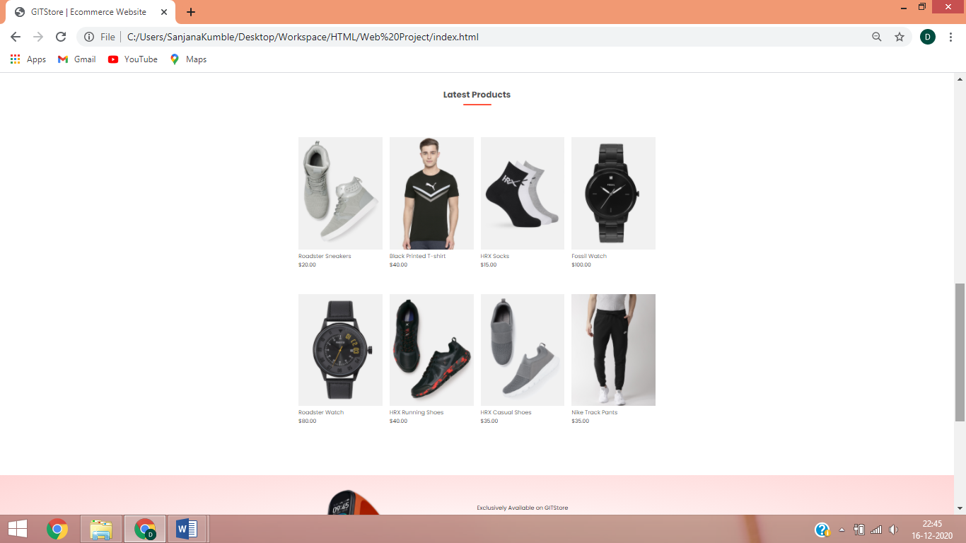

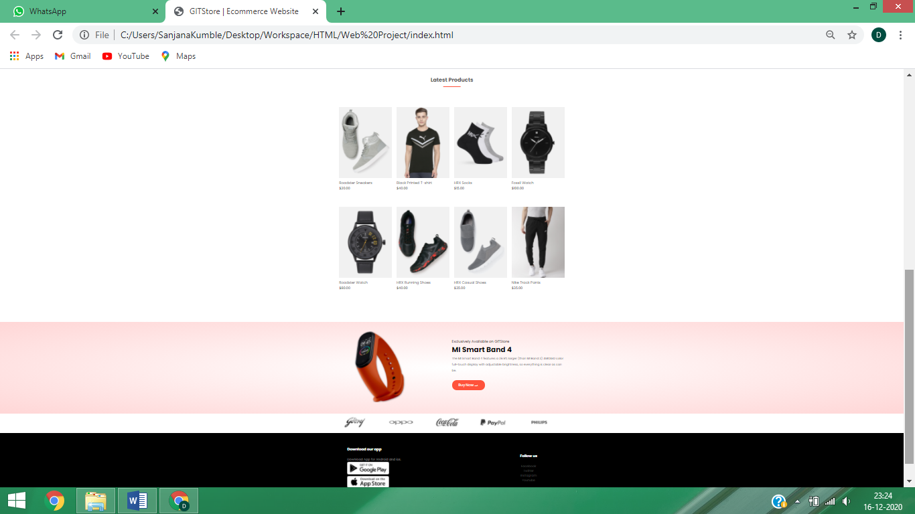

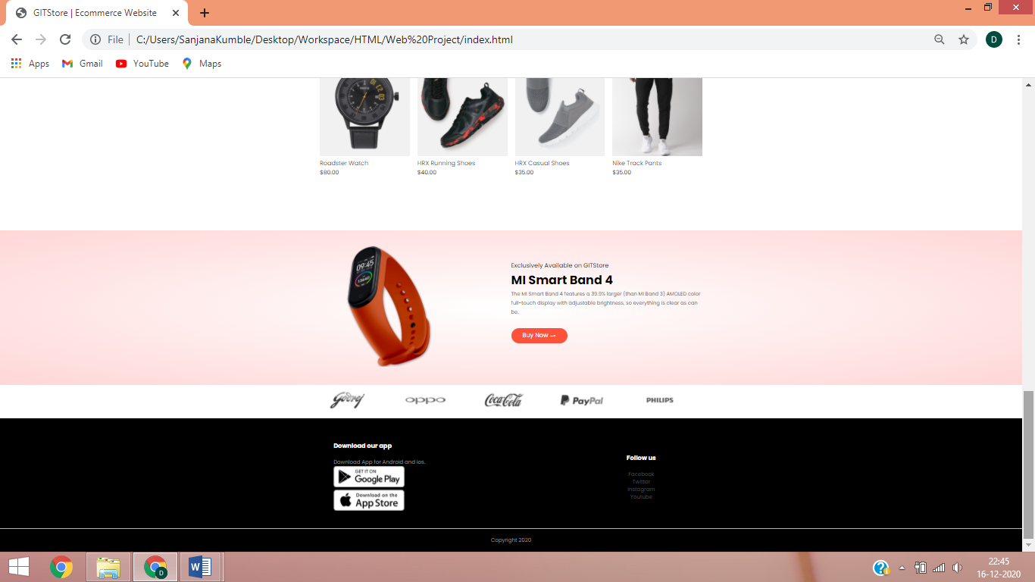

1. All Products Page

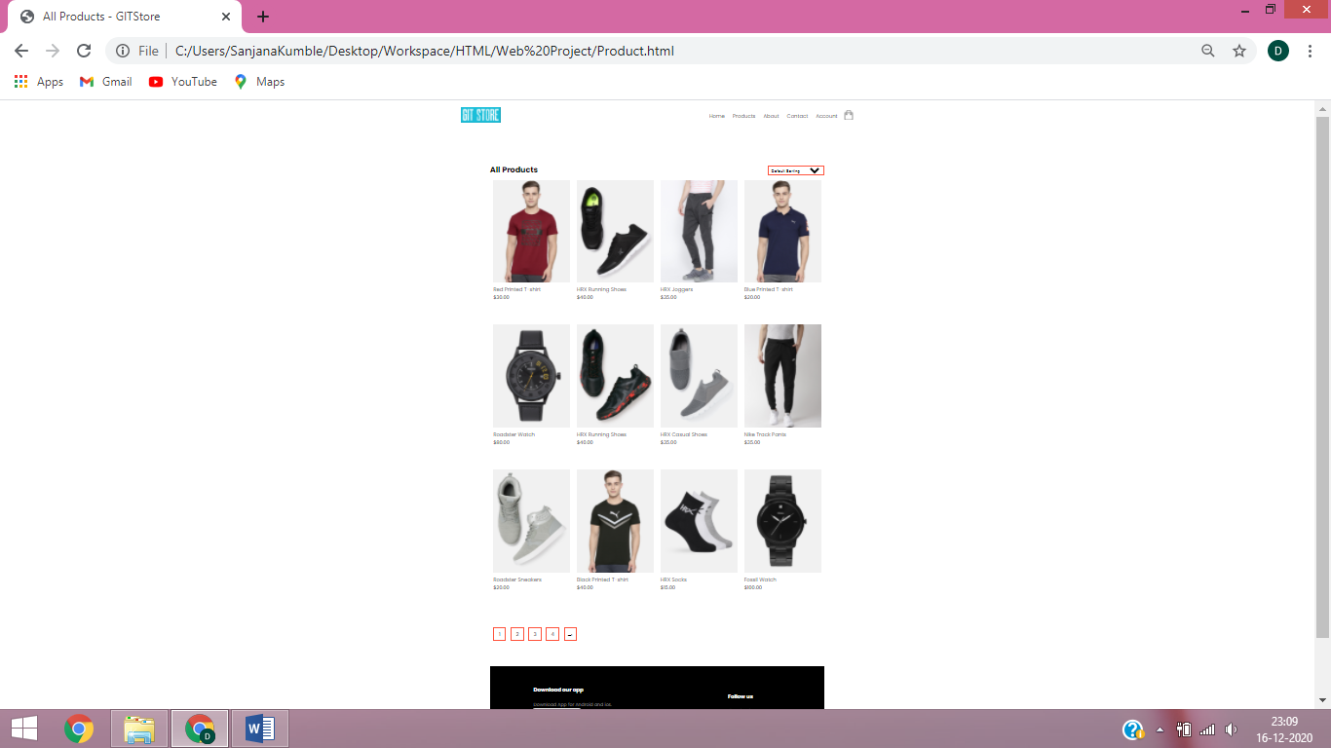

1. Individual Product Details Page

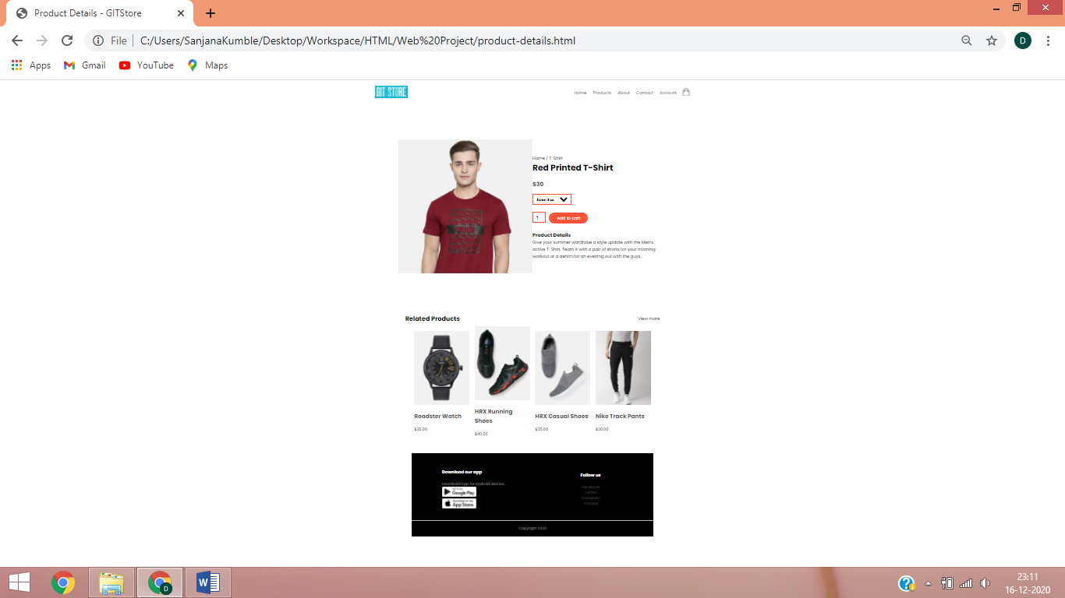

1. Login/Register Page

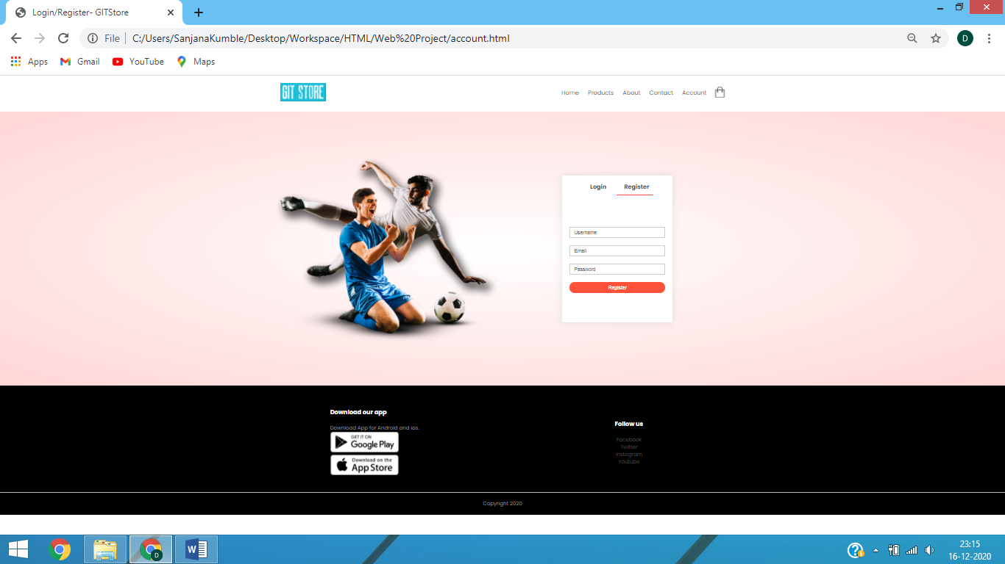

1. Shopping Cart Page

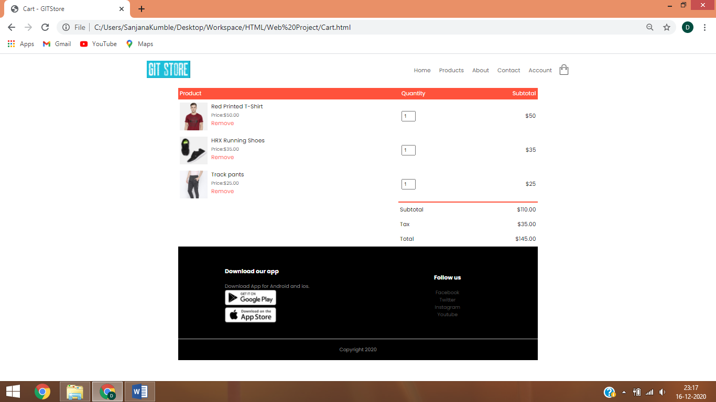

**CONCLUSION**

E-commerce markets are growing at noticeable rates. The online market is expected to grow by 56% in the next 5 years. Traditional markets are only expected 2% growth during the same time. Many larger retailers are able to maintain a presence offline and online by linking physical and online offerings.

In March 2020, global retail website traffic hit 14.3 billion visits signifying an unprecedented growth of e-commerce during the lockdown of 2020. Studies show that in the US, as many as 29% of surveyed shoppers state that they will never go back to shopping in person again; in the UK, 43% of consumers state that they expect to keep on shopping the same way even after the lockdown is over.

Retail sales of e-commerce shows that COVID-19 has a significant impact on e-commerce and its sales are expected to reach $6.5 trillion by 2023.

**REFERENCES**

* Wienclaw, Ruth A. (2013) "E-Commerce." Research Starters: Business
* Power, Michael 'Mike' (19 April 2013). ["Online highs are old as the net: the first e-commerce was a drugs deal"](https://www.theguardian.com/science/2013/apr/19/online-high-net-drugs-deal). The Guardian. London. Retrieved 17 June 2013.
* [National Institute of Standards and Technology](https://en.wikipedia.org/wiki/National_Institute_of_Standards_and_Technology). [United States Department of Commerce](https://en.wikipedia.org/wiki/United_States_Department_of_Commerce). October 2001. Retrieved 21 August 2019.
* [Four Products for On-Line Transactions Unveiled"](https://books.google.com/books?id=3u9H-xL4sZAC&pg=PA3). [Computerworld](https://en.wikipedia.org/wiki/Computerworld). IDG Enterprise. 10(4): 3. 26 January 1976.
* 1988 Palmer.C Using IT for competitive advantage at Thomson Holidays, Long range Planning Vol 21 No.6 p26-29, Institute of Strategic Studies Journal, London- December 1988.
* WIKIPEDIA