**SET - I**

**Question 1: Explain any five features of Java.**  
Answer: Java is a widely used programming language known for its versatility and ease of use. Here are five key features of Java, explained in detail:

**1. Object-Oriented**  
Java is an object-oriented programming (OOP) language, which means it is based on the concept of "objects." Objects are instances of classes, which can hold data in the form of fields (attributes) and code in the form of methods (functions). The main principles of OOP are:

* **Encapsulation:** Bundling data and methods that operate on the data within one unit, typically a class.
* **Inheritance:** Creating new classes from existing ones, promoting code reuse.
* **Polymorphism:** Allowing methods to do different things based on the object it is acting upon.
* Abstraction: Hiding complex implementation details and showing only the necessary features of an object.

**2. Platform-Independent**

One of Java's most significant advantages is its platform independence. This means that Java programs can run on any device or operating system that has the Java Virtual Machine (JVM) installed. This "Write Once, Run Anywhere" capability is made possible by Java bytecode, which is an intermediate representation of the compiled code. The JVM interprets this bytecode into machine code suitable for the host machine.

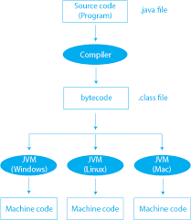

**3. Robust and Secure**

Java is designed to be robust, meaning it can handle unexpected events and errors effectively. It achieves robustness through strong memory management, exception handling, and a lack of pointers, which reduces the chances of security breaches and memory corruption. Security is another critical feature of Java. It has built-in security features such as the Java security manager and bytecode verifier, which prevent malicious code from accessing unauthorized resources and ensure code adheres to Java's safety rules.

**4. Multithreading**

Java supports multithreading, which allows multiple threads to run concurrently within a program. This feature is beneficial for developing applications that require performing several tasks simultaneously, such as games, servers, and graphical user interfaces.

Java's built-in thread management features make it easy to create and manage threads. The language provides a rich set of APIs for synchronizing and coordinating multiple threads, ensuring smooth and efficient multitasking.

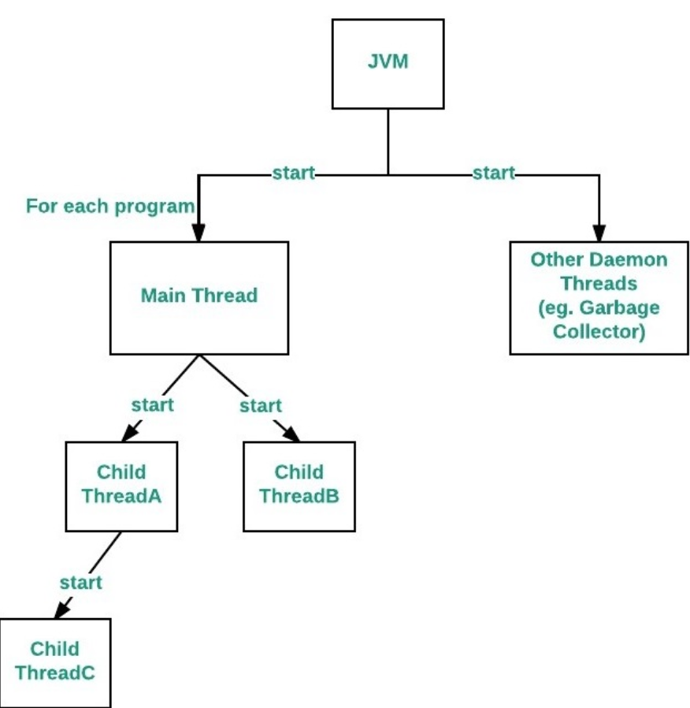

5. Rich Standard Library

Java boasts a comprehensive standard library, also known as the Java API, which provides a vast array of classes and methods for performing various tasks. This library covers everything from data structures, networking, and database connectivity to graphical user interface development and more.

The extensive nature of the Java API allows developers to build complex applications with less code, as many functionalities are readily available in the library.

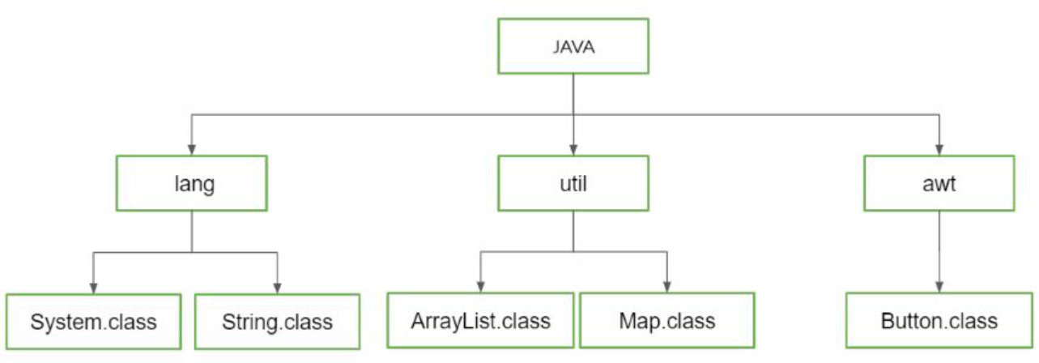

Conclusion

Java's object-oriented nature, platform independence, robustness, security, multithreading capabilities, and rich standard library make it a powerful and versatile programming language. These features contribute to its popularity and wide adoption in various fields, from web development and mobile applications to enterprise systems and scientific computing. By understanding and leveraging these features, developers can create efficient, reliable, and scalable software solutions.

**Question 2: What are the different types of operators used in Java?**

Answer: Java, a popular programming language, supports a variety of operators to perform different types of operations on variables and values. These operators are categorized based on the type of operations they perform. Here are the main types of operators used in Java:

**1. Arithmetic Operators**

Arithmetic operators are used to perform basic mathematical operations such as addition, subtraction, multiplication, division, and modulus. The primary arithmetic operators in Java are:

* **Addition (+)**: Adds two operands. Example: a + b
* **Subtraction (-)**: Subtracts the second operand from the first. Example: a - b
* **Multiplication (*)**: Multiplies two operands. Example: a * b
* **Division (/)**: Divides the numerator by the denominator. Example: a / b
* **Modulus (%)**: Returns the remainder after division. Example: a % b

**2. Unary Operators**

Unary operators operate on a single operand. They are primarily used to perform operations such as incrementing/decrementing a value, negating an expression, or inverting a boolean value. Key unary operators include:

* **Unary plus (+)**: Indicates a positive value. Example: +a
* **Unary minus (-)**: Negates a value. Example: -a
* **Increment (++)**: Increases a value by one. Example: a++ or ++a
* **Decrement (--)**: Decreases a value by one. Example: a-- or --a
* **Logical complement (!)**: Inverts a boolean value. Example: !true is false

**3. Relational Operators**

Relational operators are used to compare two values. The result of a relational operation is a boolean value: true or false. Common relational operators include:

* **Equal to (==)**: Checks if two values are equal. Example: a == b
* **Not equal to (!=)**: Checks if two values are not equal. Example: a != b
* **Greater than (>)**: Checks if the first value is greater than the second. Example: a > b
* **Less than (<)**: Checks if the first value is less than the second. Example: a < b
* **Greater than or equal to (>=)**: Checks if the first value is greater than or equal to the second. Example: a >= b
* **Less than or equal to (<=)**: Checks if the first value is less than or equal to the second. Example: a <= b

**4. Logical Operators**

Logical operators are used to perform logical operations on boolean values. These operators are essential for controlling the flow of the program based on conditions. The main logical operators are:

* **Logical AND (&&)**: Returns true if both operands are true. Example: a && b
* **Logical OR (||)**: Returns true if at least one operand is true. Example: a || b
* **Logical NOT (!)**: Inverts the boolean value. Example: !a

**5. Assignment Operators**

Assignment operators are used to assign values to variables. Besides the basic assignment operator, =, there are compound assignment operators that perform an operation and assign the result simultaneously. Key assignment operators include:

* **Assignment (=)**: Assigns the right-hand side value to the left-hand side variable. Example: a = b
* **Addition assignment (+=)**: Adds the right-hand side value to the left-hand side variable and assigns the result. Example: a += b
* **Subtraction assignment (-=)**: Subtracts the right-hand side value from the left-hand side variable and assigns the result. Example: a -= b
* **Multiplication assignment (*=)**: Multiplies the left-hand side variable by the right-hand side value and assigns the result. Example: a *= b
* **Division assignment (/=)**: Divides the left-hand side variable by the right-hand side value and assigns the result. Example: a /= b
* **Modulus assignment (%=)**: Applies the modulus operation on the left-hand side variable with the right-hand side value and assigns the result. Example: a %= b

**6. Bitwise Operators**

Bitwise operators perform operations on binary representations of integers. These operators are less common but are powerful in certain situations, such as low-level programming. Key bitwise operators include:

* **AND (&)**: Performs a bitwise AND operation. Example: a & b
* **OR (|)**: Performs a bitwise OR operation. Example: a | b
* **XOR (^)**: Performs a bitwise XOR operation. Example: a ^ b
* **Complement (~)**: Inverts the bits of the operand. Example: ~a
* **Shift left (<<)**: Shifts bits to the left. Example: a << 2
* **Shift right (>>)**: Shifts bits to the right. Example: a >> 2
* **Unsigned shift right (>>>)**: Shifts bits to the right without sign extension. Example: a >>> 2

**Conclusion**

Java's diverse set of operators allows developers to perform a wide range of operations efficiently. From arithmetic calculations to logical decision-making, these operators are fundamental tools for programming in Java. Understanding and using these operators effectively is crucial for writing robust and efficient Java code.

**Question 3: What do you mean by an array? Explain with an example?**

Answer: An array is a data structure in Java that allows you to store a fixed-size sequential collection of elements of the same type. Arrays are useful when you need to keep multiple values together and access them by an index. This structure helps in organizing data efficiently, enabling quick access and manipulation of data elements.

**Characteristics of Arrays:**

1. **Fixed Size**: Once an array is created, its size cannot be changed. The size must be specified at the time of array creation.
2. **Same Data Type**: All elements in an array must be of the same data type, such as all integers, all floats, or all strings.
3. **Index-Based**: Elements in an array are indexed, starting from zero. This means the first element is accessed with index 0, the second element with index 1, and so on.

**Syntax for Declaring and Creating Arrays:**

In Java, an array is declared and created using the following syntax:

dataType[] arrayName;

arrayName = new dataType[arraySize];

Alternatively, you can combine the declaration and creation in one step:

java

dataType[] arrayName = new dataType[arraySize];

**Example of an Array:**

Let’s consider an example to illustrate the concept of arrays. Suppose you want to store the marks of five students in a class. You can use an array to achieve this:

int [] marks = new int[5]; // Declare and create an array to store 5 integers

// Assign values to the array elements

marks[0] = 85;

marks[1] = 90;

marks[2] = 75;

marks[3] = 80;

marks[4] = 95;

// Access and print the array elements

for(int i = 0; i < marks.length; i++) {

System.out.println("Mark of student " + (i+1) + ": " + marks[i]);

}

In this example:

* int[] marks = new int[5]; declares and initializes an array named marks that can hold 5 integers.
* The array elements are assigned values using the index positions: marks[0] = 85;, marks[1] = 90;, and so on.
* The for loop iterates over the array elements and prints each student's mark.

**Multi-Dimensional Arrays:**

Java also supports multi-dimensional arrays, which are arrays of arrays. The most used multi-dimensional array is the two-dimensional array, often used to represent a matrix or a table of values.

**Example of a Two-Dimensional Array:**

Suppose you want to store a 3x3 matrix of integers:

int[][] matrix = new int[3][3]; // Declare and create a 3x3 matrix

// Assign values to the matrix elements

matrix[0][0] = 1;

matrix[0][1] = 2;

matrix[0][2] = 3;

matrix[1][0] = 4;

matrix[1][1] = 5;

matrix[1][2] = 6;

matrix[2][0] = 7;

matrix[2][1] = 8;

matrix[2][2] = 9;

// Access and print the matrix elements

for(int i = 0; i < 3; i++) {

for(int j = 0; j < 3; j++) {

System.out.print(matrix[i][j] + " ");

}

System.out.println(); // Move to the next line after each row

}

In this example:

* int[][] matrix = new int[3][3]; declares and initializes a two-dimensional array (a 3x3 matrix) named matrix.
* Values are assigned to the matrix elements using two indices: matrix[0][0] = 1;, matrix[0][1] = 2;, and so on.
* The nested for loops iterate over the matrix elements and print each row of the matrix.

**Conclusion:** Arrays in Java provide a way to store and manage collections of data efficiently. They are widely used in programming for their simplicity and ease of use in accessing elements through indexing. By understanding how to declare, initialize, and manipulate arrays, you can handle data more effectively in your Java programs.

Question 4: What is the difference between errors and exceptions?  
  
Answer: In Java, understanding the difference between errors and exceptions is crucial for effective error handling and robust application development. Both represent abnormal conditions that disrupt the normal flow of a program, but they have different implications and handling mechanisms.

**Errors**

Errors in Java are serious issues that are typically external to the application and beyond the control of the programmer. They represent conditions that a reasonable application should not try to catch. Errors are usually related to the environment in which the application is running.

**Characteristics of Errors:**

1. **Unrecoverable**: Errors are generally not meant to be caught or handled within the program. They usually indicate serious problems that a typical application cannot resolve.
2. **Examples**: Common examples of errors include OutOfMemoryError, StackOverflowError, and VirtualMachineError.
3. **Origin**: Errors often arise from resource limitations, system crashes, or other critical failures in the runtime environment.

**Handling Errors**

Because errors indicate serious issues, they are not intended to be handled by the application. However, in some cases, developers might log errors or notify the user before terminating the application.

**Example:**

public class ErrorExample {

public static void main(String[] args) {

try {

causeStackOverflow();

} catch (StackOverflowError e) {

System.err.println("Stack Overflow Error occurred!");

e.printStackTrace();

}

}

public static void causeStackOverflow() {

causeStackOverflow(); // Recursive call leading to StackOverflowError

}

}

In this example, a StackOverflowError is caught and logged, but typically, such errors are not handled in practice due to their critical nature.

**Exceptions**

Exceptions are events that occur during the execution of a program that disrupt its normal flow. Unlike errors, exceptions are conditions that applications can handle and recover from. Exceptions are divided into two main categories: checked exceptions and unchecked exceptions.

**1. Checked Exceptions**

Checked exceptions are exceptions that are checked at compile-time. If a method throws a checked exception, it must be either caught within the method or declared in the method's throws clause.

**Examples**: IOException, SQLException, ClassNotFoundException.

**Handling Checked Exceptions**:

public class CheckedExceptionExample {

public static void main(String[] args) {

try {

readFile("example.txt");

} catch (IOException e) {

System.err.println("An IOException occurred: " + e.getMessage());

}

}

public static void readFile(String fileName) throws IOException {

FileReader file = new FileReader(fileName);

BufferedReader fileInput = new BufferedReader(file);

fileInput.close();

}

}

In this example, IOException is a checked exception, and it is handled using a try-catch block.

**2. Unchecked Exceptions**

Unchecked exceptions are not checked at compile-time but are checked at runtime. These exceptions are usually a result of programming errors, such as logic mistakes or improper use of APIs.

**Examples**: NullPointerException, ArrayIndexOutOfBoundsException, ArithmeticException.

**Handling Unchecked Exceptions**:

public class UncheckedExceptionExample {

public static void main(String[] args) {

try {

int result = divide(10, 0);

} catch (ArithmeticException e) {

System.err.println("An ArithmeticException occurred: " + e.getMessage());

}

}

public static int divide(int a, int b) {

return a / b; // This will throw ArithmeticException if b is 0

}

}

In this example, ArithmeticException is an unchecked exception and is caught and handled at runtime.

**Key Differences**

* **Recoverability**: Errors are typically unrecoverable, while exceptions can often be handled and recovered from.
* **Checking**: Checked exceptions are checked at compile-time, whereas unchecked exceptions are checked at runtime.
* **Handling**: Errors generally should not be caught or handled within the application, while exceptions should be caught and handled appropriately to ensure smooth program execution.

**Conclusion**

Understanding the distinction between errors and exceptions is fundamental for writing robust Java applications. Errors indicate serious issues that often cannot be fixed by the application, whereas exceptions represent conditions that can be anticipated and handled.

Question 5: Explain the Synchronization of Threads.  
  
Answer: Synchronization of threads is a critical concept in concurrent programming, ensuring that multiple threads can operate correctly and efficiently without interfering with each other. It addresses the challenges of coordinating the access of shared resources among threads to prevent issues such as race conditions, deadlocks, and data inconsistencies.

**Understanding Threads and Synchronization**

Threads are the smallest units of execution within a process, sharing the same memory space but operating independently. When multiple threads access shared resources concurrently, synchronization is required to manage their interactions and maintain data integrity. Without proper synchronization, threads may read or write shared data in an unpredictable manner, leading to erroneous or inconsistent results.

**Race Conditions**

A race condition occurs when the outcome of a program depends on the non-deterministic timing of thread execution. For instance, if two threads attempt to update a shared variable simultaneously, the final value of that variable might be incorrect if the operations are not atomic (indivisible). This unpredictability can lead to bugs that are difficult to reproduce and fix.

**Synchronization Mechanisms**

To avoid race conditions and ensure proper thread coordination, several synchronization mechanisms are employed:

1. **Mutexes (Mutual Exclusions):** Mutexes are locks that allow only one thread to access a critical section of code at a time. When a thread acquires a mutex, other threads trying to acquire the same mutex are blocked until the mutex is released. This ensures that only one thread can modify shared resources at a time.
2. **Semaphores:** Semaphores are synchronization primitives that control access to a shared resource by maintaining a count. A semaphore with a count greater than zero allows threads to proceed, decrementing the count each time a thread acquires it and incrementing it when a thread releases it. Semaphores can be used to manage access to a pool of resources or limit the number of threads accessing a particular section of code.
3. **Condition Variables:** Condition variables work in conjunction with mutexes to allow threads to wait for specific conditions to be met before proceeding. A thread can signal other threads waiting on a condition variable when a certain condition is fulfilled, thus allowing those threads to continue execution. This mechanism is useful for scenarios where threads need to wait for certain states or events before they can proceed.
4. **Read/Write Locks:** Read/Write locks distinguish between read operations and write operations. Multiple threads can acquire read locks simultaneously if no thread holds a write lock. However, write locks are exclusive, meaning that if a thread holds a write lock, no other thread can acquire either a read or write lock. This allows multiple readers to access the resource concurrently while ensuring exclusive access for writers.
5. **Atomic Operations:** Atomic operations are indivisible operations that complete in a single step relative to other threads. They are used for simple data manipulations and can be performed without the need for explicit locks. For example, atomic increment operations on a shared counter ensure that the counter value remains consistent even when accessed by multiple threads.

**Challenges and Considerations**

Synchronization introduces overhead and can affect performance due to the time spent acquiring and releasing locks. Overuse of synchronization can lead to contention, where threads spend more time waiting for access than performing useful work. Therefore, careful design is needed to balance the need for synchronization with performance considerations.

**Deadlocks** and **livelocks** are potential issues when using synchronization mechanisms. A deadlock occurs when two or more threads are waiting indefinitely for each other to release resources. A livelock happens when threads keep changing states in response to each other but fail to make progress. Proper design and strategies, such as avoiding nested locks and using timeout mechanisms, can help mitigate these problems.

**Conclusion**

Synchronization of threads is essential for ensuring correct and efficient concurrent execution. By employing mechanisms like mutexes, semaphores, condition variables, read/write locks, and atomic operations, developers can manage the complexities of multi-threaded programming, ensuring that shared resources are accessed in a controlled and predictable manner. Proper synchronization helps avoid race conditions, deadlocks, and other concurrency issues, leading to robust and reliable software systems.

**Question 6: Explain the life cycle of a Servlet.**

**Answer:** The life cycle of a Servlet, a Java-based server-side component used in web applications, encompasses the stages it goes through from its creation to its destruction. Understanding this life cycle is crucial for developing efficient and functional servlets in a Java web application. The servlet life cycle is managed by the servlet container, which is responsible for handling HTTP requests and responses.

**1. Loading and Instantiation**

The servlet life cycle begins when the servlet container loads the servlet class into memory. This occurs typically at the server startup or when the servlet is first requested. The container instantiates the servlet by creating an object of the servlet class. The instantiation process ensures that the servlet is ready to handle requests.

**2. Initialization**

After instantiation, the servlet undergoes initialization. This is managed by the init() method, which is called only once during the servlet’s life cycle. The init() method is used to perform one-time initialization tasks, such as setting up resources (e.g., database connections) or reading configuration parameters.

The init() method receives a ServletConfig object as an argument, which contains initialization parameters specified in the web application's deployment descriptor (web.xml). The ServletConfig object allows the servlet to retrieve configuration information and initialize itself accordingly.

**3. Request Handling**

Once initialized, the servlet is ready to handle client requests. For each request, the container creates a new thread and calls the service() method of the servlet. The service() method is responsible for processing incoming requests and generating responses. It receives HttpServletRequest and HttpServletResponse objects as parameters.

The HttpServletRequest object provides data about the client request, such as request parameters and headers, while the HttpServletResponse object is used to construct the response that will be sent back to the client. The servlet processes the request, interacts with other components or resources as needed, and writes the response data to the HttpServletResponse object.

**4. Destruction**

When the servlet needs to be removed from service, usually when the server is shutting down or the servlet is being reloaded, the container invokes the destroy() method. This method allows the servlet to release any resources it holds, such as closing database connections or terminating background threads.

The destroy() method is called only once before the servlet instance is garbage collected. It ensures that the servlet cleans up properly and does not leave any dangling resources that could lead to memory leaks or other issues.

**5. Garbage Collection**

After the destroy() method has been called, the servlet object is eligible for garbage collection. The garbage collector reclaims the memory used by the servlet instance, allowing the system to free up resources and maintain efficient operation.

**Servlet Life Cycle Summary**

1. **Loading and Instantiation:** Servlet class is loaded and an instance is created.
2. **Initialization:** init() method is called for one-time setup.
3. **Request Handling:** service() method handles client requests and generates responses.
4. **Destruction:** destroy() method is called for cleanup before the servlet is destroyed.
5. **Garbage Collection:** The servlet object is garbage collected.

In summary, the servlet life cycle involves loading, initialization, request handling, and destruction. The servlet container manages this lifecycle, ensuring that servlets are efficiently created, utilized, and disposed of. Understanding this life cycle helps developers design and implement servlets that are robust, responsive, and resource-efficient.