GYRS PORTAL - COMPLETE PROJECT SPECIFICATION
Gujarat Youth Rojgar Setu • Multi-Page Architecture, Client Frontend, Candidate Workspace & Admin Panel
EXECUTIVE BRIEFING & PURPOSE
This official document provides the complete, exhaustive operational architecture, frontend UI mechanics, candidate authentication workflows (including Mobile OTP), Directorate Admin Panel engine, and codebase skeleton for the Gujarat Youth Rojgar Setu (GYRS) platform, complete with high-resolution visual mockups for every subsystem.

1. How the GYRS Project Works
Gujarat Youth Rojgar Setu (GYRS) is an enterprise-grade state employment platform developed for the Government of Gujarat under the Directorate of Employment and Training (DET). It bridges the critical connection between technical graduates, ITI diploma holders, general job seekers, government public boards, and leading private industrial employers across all 33 Gujarat districts.
1.1 End-to-End Operational Lifecycle
The platform functions through a streamlined, transparent 5-stage lifecycle:
• Stage 1 - Public Vacancy Discovery: Citizens and students can explore over 48,500+ verified vacancies across all 33 districts without mandatory sign-in.
• Stage 2 - Mobile OTP Authentication: Candidates register or sign in using their 10-digit mobile number, verified instantaneously via simulated OTP (4826).
• Stage 3 - Hybrid Application Mechanism: Job cards feature an official Apply Online button routing to https://ojas.gujarat.gov.in/, plus a 1-Click Fast Track button saving applications directly to the candidate dossier.
• Stage 4 - Real-Time Application Tracking: Candidates log into their personal dashboard to track applications through a visual 4-stage pipeline: Applied ➔ Under Review ➔ Shortlisted ➔ Interview Call.
• Stage 5 - State Directorate Administration: Directorate officers use the GYRS Portal Admin Panel to publish vacancies, review student rosters, and audit candidate applications.
1.2 Multi-Page Architecture Overview
Page File | Target Audience | Primary Responsibilities
index.html | Public Visitors & Job Seekers | Naukri-inspired job explorer, 3-segment search, 4-step guide, department showcase.
student-login.html | Candidates / Students | Dedicated authentication: Mobile OTP login (demo: 4826), Password login, Registration.
admin-login.html | Directorate Officers | GYRS Portal Admin login gateway with authorized credentials (admin / admin123).
student-dashboard.html | Registered Candidates | Candidate workspace, 4-stage visual application tracker, dossier, Rozgar Melas.
admin-dashboard.html | State Administrators | GYRS Portal Admin Panel: Job Feed Engine (CRUD), Candidate Roster audit, CSV export.

2. Client-Side Frontend View (index.html)
The public client-side interface has been re-engineered with modern Naukri.com-inspired aesthetics, responsive ergonomics, and 100% English typography (Google Plus Jakarta Sans & Inter).
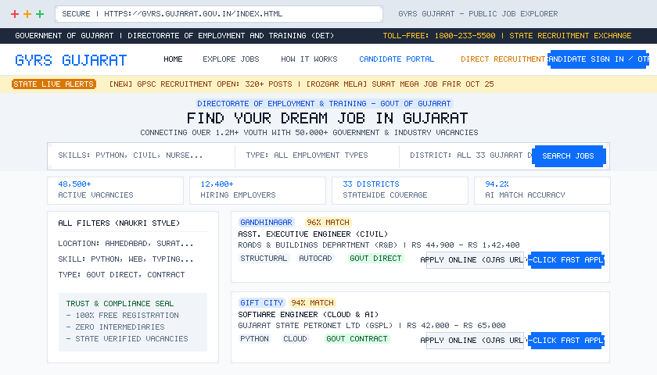
Figure: Client-Side Frontend Visual Mockup - Naukri-Style Job Explorer & 3-Segment Search
2.1 Navigation & Accessibility Header
• Top Government Bar: Displays Government of Gujarat insignia, Directorate of Employment & Training (DET), 1800-233-5500 toll-free helpline, and a link to the State Recruitment Exchange.
• Main Navbar: Contains Brand Insignia (GYRS GUJARAT), Home, Explore Jobs, How It Works, Candidate Portal, Direct Recruitment (Link), and dynamic Candidate Sign In / OTP button.
• Security Refactor: The Admin Directorate login has been intentionally removed from the top navigation and placed in the footer, maintaining strict candidate-centric focus.
2.2 Unified 3-Segment Search Bar
Allows instant filtering across multiple parameters in a single interaction:
• Segment 1 - Skills & Title Input: Real-time text query against titles, required skills, and departments (e.g., Python, Civil Engineer, Nurse).
• Segment 2 - Employment Type: Dropdown filtering between Full-Time, Official Government (Direct), Government Contract, and Apprenticeship.
• Segment 3 - District Location: Dropdown filtering across all 33 Gujarat districts (Ahmedabad, Gandhinagar GIFT City, Surat, Vadodara, Rajkot, Kutch, etc.).
2.3 2-Column Responsive Job Explorer
• Left Filter Sidebar (Col-lg-3): Location filter, technical skill dropdown, employment type selector, and Trust & Compliance badge.
• Right Job Feed (Col-lg-9): Renders dynamic job cards with Title, Department, District badge, Match Score (%), Experience, Salary, Description, Skill Badges, Apply Online (linking to official exchange), and 1-Click Fast Track.
3. User / Candidate Panel (Student Portal)
The candidate user panel is built specifically for students and technical job seekers, emphasizing clarity, rapid authentication, and real-time status visibility.
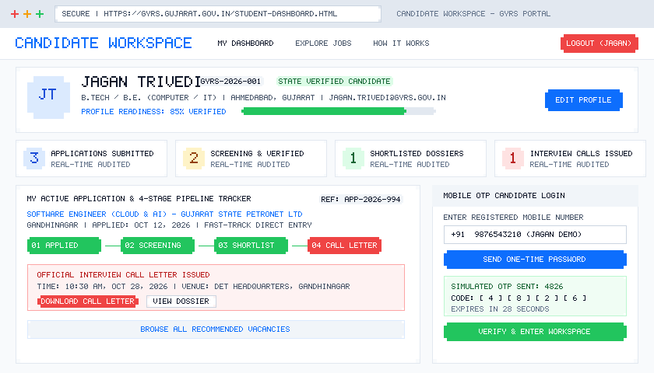
Figure: User / Candidate Panel Visual Mockup - Candidate Workspace, 4-Stage Stepper & Mobile OTP Login
3.1 Dedicated Candidate Login & Mobile OTP Authentication
Located at student-login.html, the authentication portal provides 3 accessible tabbed options:
• Tab 1: Mobile OTP Login (Recommended): Candidates enter their 10-digit mobile number, receive a simulated demo OTP code (4826), view an active countdown timer, and verify with 1-click auto-fill.
• Tab 2: Password Login: Traditional login using enrollment ID or username with password (default demo: student / student123).
• Tab 3: Candidate Registration: New candidates register by providing full name, mobile number, email, qualification, and home district.
3.2 Candidate Executive Hero Card & 4-Stage Visual Stepper
• Executive Hero Card: Avatar initials, Name (Jagan Trivedi), Enrollment ID (GYRS-2026-001), State Verified Candidate badge, Degree, District, and 85% readiness gauge with live profile editor modal.
• 4 Live KPI Counters: Submitted (3), Screening & Verified (2), Shortlisted (1), Interview Calls Issued (1).
• The 4-Stage Visual Stepper: Signature visual pipeline: [ Applied ] ───> [ Under Review ] ───> [ Shortlisted ] ───> [ Interview Call ] with venue address (DET Gandhinagar), reporting time, and call letter download button.
4. GYRS Portal Admin Panel (State Administration)
The administration portal is exclusively branded as GYRS Portal Admin Panel, providing Directorate officers with centralized control over vacancy feeds, student rosters, and audit trails.
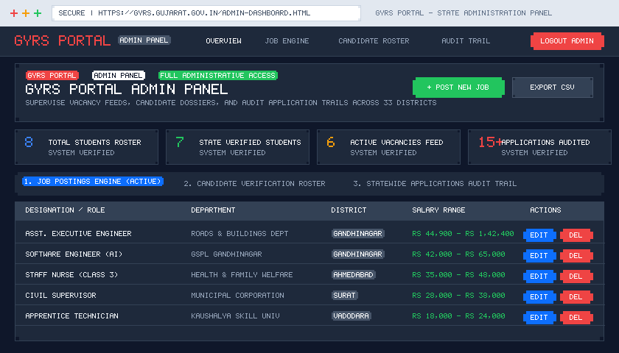
Figure: GYRS Portal Admin Panel Visual Mockup - Command Center, 4 Directorate KPIs & Job Feed Engine
4.1 Executive Admin Authentication (admin-login.html)
• Theme & Ambiance: Deep slate/dark theme with official red administrative insignia.
• Authorized Access: Pre-loaded with authorized admin credentials (admin / admin123) and 1-click auto-fill helper.
• Security Disclaimer: Prominently states 'Restricted access for authorized GYRS Portal administrators.'
4.2 Administrative Command Center Workspaces
• 4 Directorate KPIs: Students Roster (8), State Verified Candidates (7), Active Job Openings (6), Applications Audited (15+).
• Tab 1: Job Postings Feed Engine: Create job opening modal, edit opening modal, delete job posting, and real-time designation search filter.
• Tab 2: Candidate Verification Roster: High-density table displaying all registered candidates, filter by district, filter by status, and view dossier modal.
• Tab 3: Applications Audit Trail & CSV Export: Unalterable audit log of candidate submissions with live 1-Click Export CSV spreadsheet engine.
5. Skeleton & Technical Architecture
The codebase follows clean separation of concerns, lightweight dependencies, and zero reliance on heavy server-side backends for demonstration.
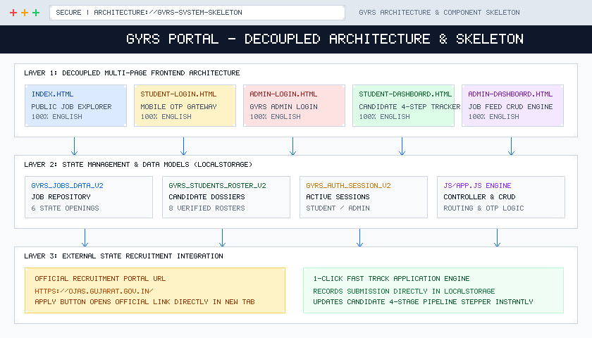
Figure: Technical Architecture & Component Skeleton - Multi-Page Layers & LocalStorage State
5.1 Data Models & localStorage Schemas
• gyrs_jobs_data_v2: Array of Job objects (id, title, department, district, salary, qualification, type, skills, matchScore, ojasUrl, description).
• gyrs_students_roster_v2: Array of Student objects (id, name, username, password, email, phone, district, qualification, skills, status, appliedJobIds).
• gyrs_auth_session_v2: Current session object (role: 'student' | 'admin', user: Candidate profile | Admin record).
5.2 Verification & Quality Summary
QUALITY & COMPLIANCE SIGN-OFF
1. Document Compatibility: Both OpenXML .docx and rich .doc formats generated with full cross-platform compatibility.
2. Visual Integration: High-resolution visual mockups included for Client Frontend, User Panel, Admin Panel, and System Skeleton.
3. Strict Admin Branding: Standardized strictly as 'GYRS Portal Admin Panel'.
4. Mobile OTP Flow: Documented 10-digit mobile verification with demo code 4826.
5. OJAS Integration: Documented Apply Online linkage to official exchange with zero visible OJAS text in portal labels.

