MATH:

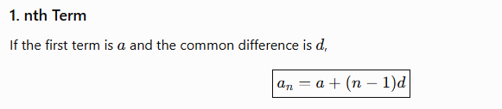
AP:

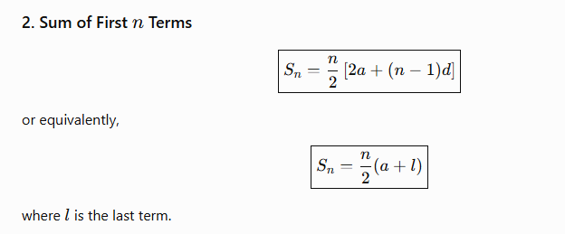
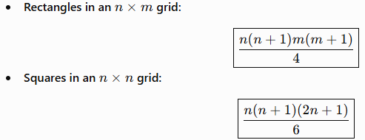

Shapes in m x n Grid:

Collinear:
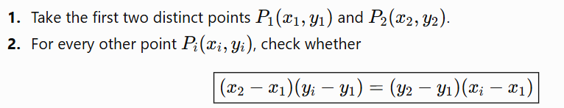
Area Of Triangle (BOOMERANG):
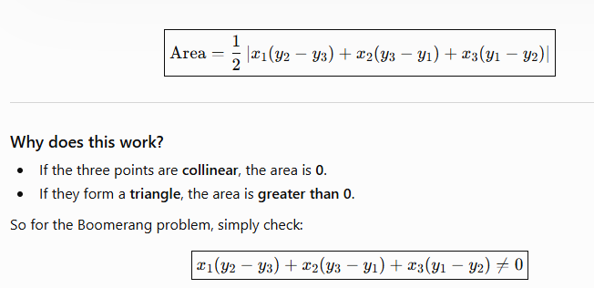
To Find Overlapping Rectangle Coordinates:
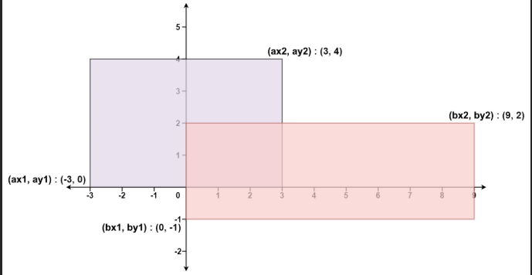
>>> (max(ax1,bx1),max(ay1,by1))
>>>(min(ax2,bx2),min(ay2,by2))

