BIKE SALES PERFORMANCE ANALYSIS
Objective & Subjective Question Documentation

OBJECTIVE QUESTIONS

Question 1: Which education level has the highest percentage of bike purchasers? (Useful for understanding education influence on decision-making.)
Answer: Bachelors degree holders have the highest percentage of bike purchasers (35%).
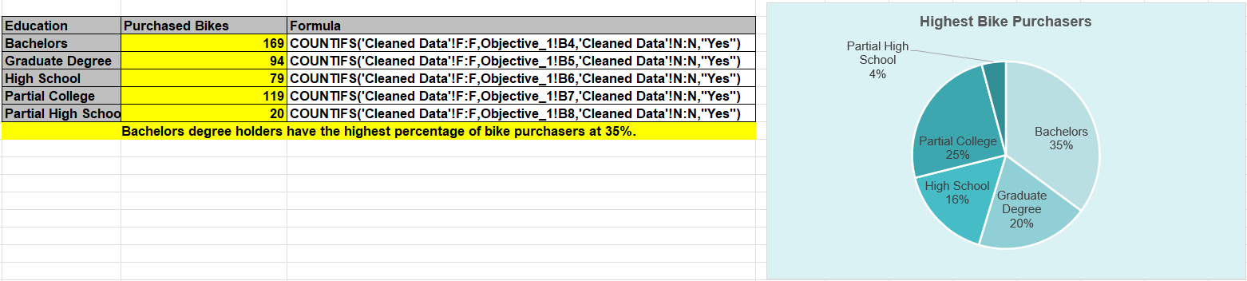

Question 2: Among customers who own more than one car, how many still purchase bikes? (Tests whether car ownership affects bike purchases.)
Answer: 178 customers who own more than one car still purchased a bike, though their purchase rate (36.63%) is much lower than customers with 0-1 cars (58.95%).
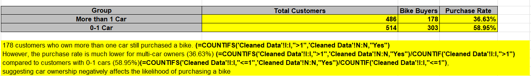

Question 3: Create an 'Age Brackets' column that categorizes individuals into one of the following ranges: '25-31', '32-54', or '55-89' based on their age.
Answer: 'Age-Group' column was created in the Cleaned Data sheet using a nested IF formula, categorizing customers into 25-31, 32-54, and 55-89 age ranges.

Question 4: What is the average income of customers with more than 2 children who purchased a bike?

Answer: The average income of customers with more than 2 children who purchased a bike is $67,241.38.
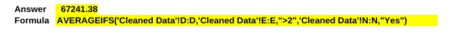
Question 5: What percentage of customers in each occupation category purchased a bike? (Use a bar chart or horizontal stacked column.)
Answer: Professional customers have the highest purchase rate (54.35%), followed by Clerical (49.72%), Manual (46.22%), Skilled Manual (45.10%), and Management (42.20%).

Question 6: What is the most common occupation among customers who did not purchase a bike? (Useful for identifying underperforming segments.)
Answer: Skilled Manual is the most common occupation among customers who did not purchase a bike (140 customers).
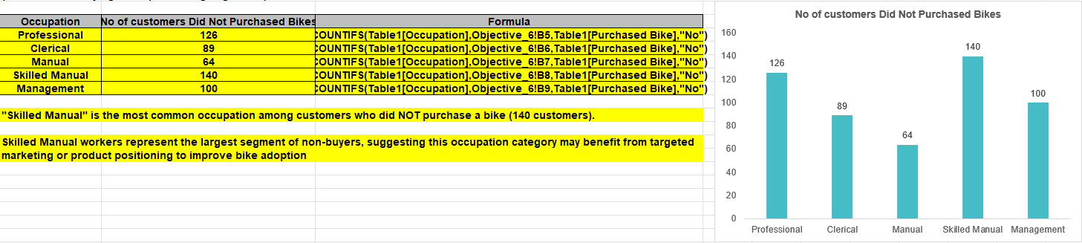

Question 7: What is the average number of cars owned by customers who purchased bikes vs. those who didn't? (Helps compare lifestyle or transportation choices.)
Answer: Bike buyers own an average of 1.21 cars, while non-buyers own an average of 1.66 cars.
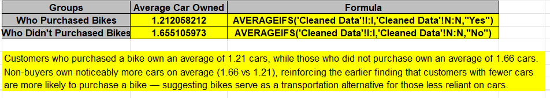

Question 8: How many single females purchased a bike? (Combines filters: Marital Status + Gender + Purchase.)
Answer: 131 single females purchased a bike.
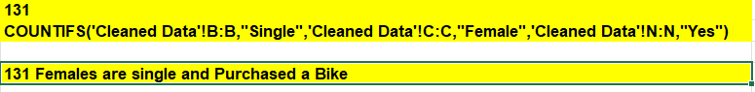

Question 9: Which age group has the lowest bike purchase rate?

Answer: The 55-89 age group has the lowest bike purchase rate (31.22%).
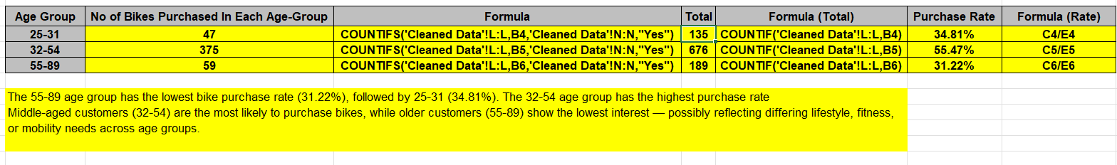

Question 10: How many customers with an income below $40,000 purchased a bike?
Answer: 113 customers with an income below $40,000 purchased a bike.
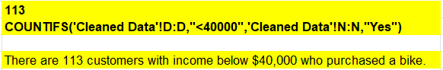

Question 11: Highlight incomes above $90,000 in green and below $40,000 in red using formatting.

Answer:
  - Conditional formatting has been applied to the Income column ('Cleaned Data'!D:D).
  - Incomes greater than $90,000 are highlighted in GREEN.
  - Incomes less than $40,000 are highlighted in RED.
Approach: Applied via Home → Conditional Formatting → New Rule. Rule 1: Format cells where value > 90000 → Green Fill. Rule 2: Format cells where value < 40000 → Red Fill.

Question 12: Identify the top 3 occupations with the highest average income among customers who purchased a bike.

Answer: The top 3 occupations by average income among bike purchasers are Management ($87,945.21), Professional ($75,266.67), and Skilled Manual ($53,826.09).
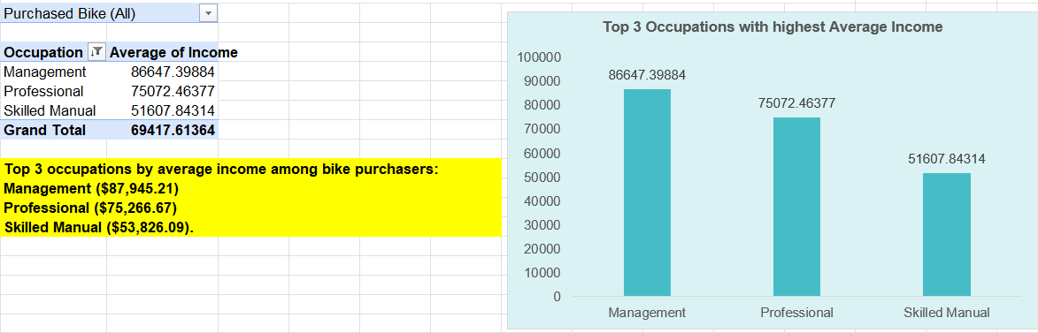

Question 13: Build a formula that flags customers who meet all of these conditions: income above $70,000, commute distance less than 5, owns 0 cars, and purchased a bike.
Answer: 18 customers meet all four conditions (income above $70,000, commute distance less than 5, owns 0 cars, and purchased a bike).

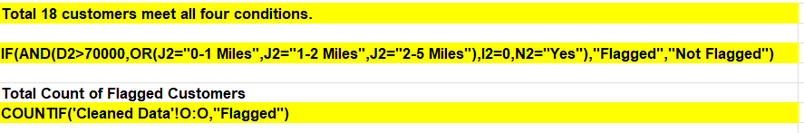

SUBJECTIVE QUESTIONS

Question 1: How does the sales performance vary across different regions or locations?
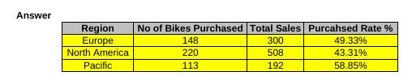

Approach: Since the dataset does not contain a revenue/sales-amount field, "sales performance" was measured using the number of bikes purchased and the purchase rate by region. A Pivot Table was used to calculate the total customers, number of buyers, and purchase rate for each region, visualized through bar charts.

Key Findings:
- North America has the highest number of bike buyers (220 out of 508 total customers) but the lowest purchase rate (43.31%), indicating it is the largest market with significant untapped potential.
- Pacific has the highest purchase rate (58.85%) with 113 buyers out of 192 customers, despite having the smallest customer base among the three regions.
- Europe falls in between, with 148 buyers out of 300 customers, giving a purchase rate of 49.33%.
Recommendations:
1. Focus Marketing on North America (Highest Priority): With the largest customer base but the lowest conversion rate, targeted promotions and awareness campaigns in North America could unlock significant additional sales.
2. Study and Replicate Pacific's Success: Pacific's high conversion rate (58.85%) suggests effective customer engagement in that region — the strategies driving this performance should be studied and applied to Europe and North America.
3. Maintain Steady Growth in Europe: With a moderate purchase rate (49.33%), Europe should continue current strategies while testing incremental improvements from Pacific's approach.
Method/Charts Used:
- Pivot Table: Region in Rows, Count of Purchased Bike (filtered to "Yes") in Values.
- Bar Chart 1: "Bike Purchase Volume by Region" — shows raw buyer count.
- Bar Chart 2: "Bike Purchase Rate by Region" — shows conversion percentage.

Question 2: Are there any correlations between customer demographics (such as age or gender) and the type of bike purchased?

Answer:
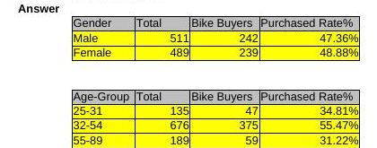
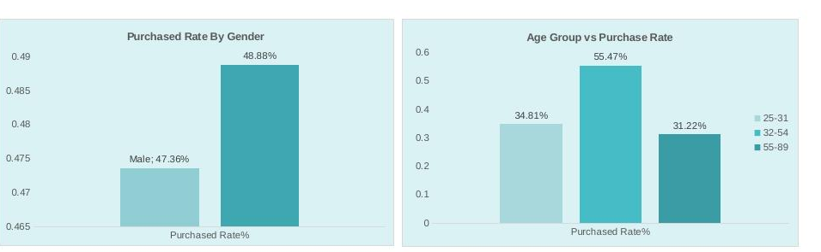
Approach:
The dataset does not include a "bike type/model" field, so the correlation between demographics and bike type could not be directly analyzed. Instead, this analysis examines how gender and age relate to the purchase decision (Yes/No), using Pivot Tables and bar charts.
Key Findings:
Gender shows minimal difference in purchase behavior — Female customers have a purchase rate of 48.88%, only slightly higher than Male customers at 47.36%. Gender is not a strong predictor of purchase.
Age shows a much stronger pattern: the 32-54 age group has the highest purchase rate (55.47%), while both younger (25-31: 34.81%) and older (55-89: 31.22%) groups show significantly lower rates.
Recommendations:
Prioritize Age-Based Targeting Over Gender-Based Targeting: Since age is a far stronger differentiator (55.47% vs 31-35% in other groups) while gender shows almost no difference, marketing budgets should focus on age-segmented campaigns rather than gender-segmented ones.
Focus Campaigns on the 32-54 Age Group: This segment already shows the highest conversion, so continuing to nurture and upsell within this group is likely to yield strong returns.
Investigate Barriers for 55-89 and 25-31 Groups: Further research (e.g., surveys) could uncover why these segments purchase less — possibly mobility concerns for older customers or budget constraints for younger ones.
Method/Charts Used:
Pivot Table: Gender in Rows, Count of Purchased Bike (filtered to "Yes") in Values.
Pivot Table: Age-Group in Rows, Count of Purchased Bike (filtered to "Yes") in Values.
Bar Chart 1: "Purchase Rate by Gender"
Bar Chart 2: "Purchase Rate by Age Group".

Question 3: How does commute distance vary between different regions?

Answer:
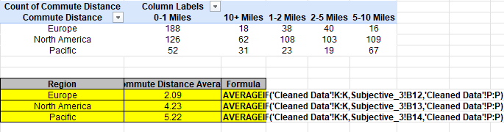

Approach:
A Pivot Table was created with Region in Rows and Commute Distance in Columns to see the distribution across distance buckets. A helper column converting each bucket into a numeric midpoint was also added to calculate the average commute distance per region.
Key Findings:
Europe has the shortest average commute distance (2.09 miles), with the majority of customers (188 out of 300) living within 0-1 miles.
Pacific has the longest average commute distance (5.22 miles), with a large share of customers (67 out of 192) in the 5-10 mile range.
North America falls in between (4.23 miles average), with a fairly even spread across all distance buckets.
Recommendations:
Position Bikes as a Short-Commute Solution in Europe: Given the short average commute (2.09 miles), marketing in Europe should emphasize convenience and quick trips.
Highlight Fitness/Endurance Benefits in Pacific: With longer average commutes (5.22 miles), Pacific marketing could focus on bikes suited for longer rides or combined commute + fitness use cases.
Use Flexible Messaging in North America: Given the even distribution across distances, a broader range of bike types/messaging (short-commute vs long-commute) may work best here.
Method/Charts Used:
Pivot Table: Region in Rows, Commute Distance in Columns, Count of ID in Values.
Helper Column: Commute Midpoint (converts distance bucket to numeric value).
Bar Chart: "Average Commute Distance by Region"
Stacked Column Chart: "Commute Distance Distribution by Region"

Question 4: How does home ownership status impact bike purchase behavior when segmented by occupation? Use pivot tables and visualizations to explain patterns.

Answer:
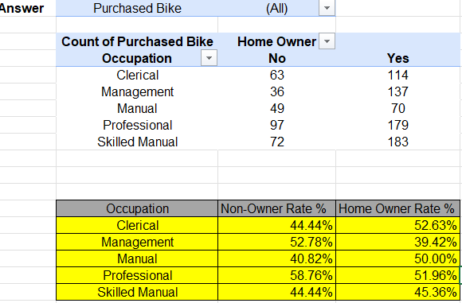
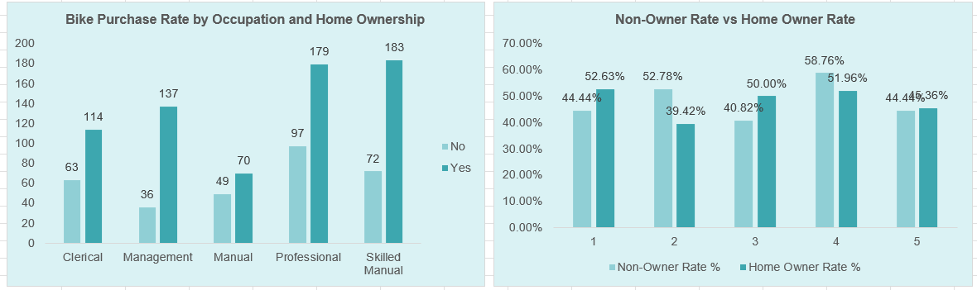
Approach:
A Pivot Table was created with Occupation in Rows and Home Owner status in Columns, filtered to bike purchasers, to combine lifestyle (home ownership) with profession. Purchase rates were calculated for each Occupation × Home Owner combination and visualized using a clustered column chart.
Key Findings:
Non-homeowner Professionals show the highest purchase rate overall (58.76%), suggesting professionals without a home may rely more on bikes as a practical transportation option.
Homeowner Managers show the lowest purchase rate (39.42%) — interestingly, owning a home seems to reduce bike interest specifically within the Management occupation.
The pattern is not consistent across occupations: for Clerical, Manual, and Skilled Manual roles, homeowners actually purchase at a slightly HIGHER rate than non-homeowners — the opposite of the Management/Professional trend.
Recommendations:
Target Non-Homeowner Professionals (Highest Priority): This segment shows the strongest purchase behavior (58.76%) — marketing should emphasize bikes as a smart transportation choice for professionals without personal home/garage-based vehicle storage.
Re-Engage Homeowner Managers: With the lowest rate (39.42%), this segment may need different messaging — possibly positioning bikes as a leisure/fitness product rather than a commute tool, since they likely already have reliable transportation.
Avoid One-Size-Fits-All Messaging: Since the home-ownership effect flips direction across occupations, marketing strategy should be occupation-specific rather than applying a single home-ownership-based rule.

Method/Charts Used:
Pivot Table: Occupation in Rows, Home Owner in Columns, Count of Purchased Bike (filtered to "Yes") in Values.
Purchase Rate Table: Calculated using COUNTIFS combinations (Occupation + Home Owner + Purchased="Yes") divided by (Occupation + Home Owner totals).
Clustered Column Chart: "Purchase Rate by Occupation and Home Ownership.

Question 5: Create a profile of the ideal customer based on income, marital status, number of cars, and education. Who is most likely to purchase a bike? Support with data and visuals.

Answer :
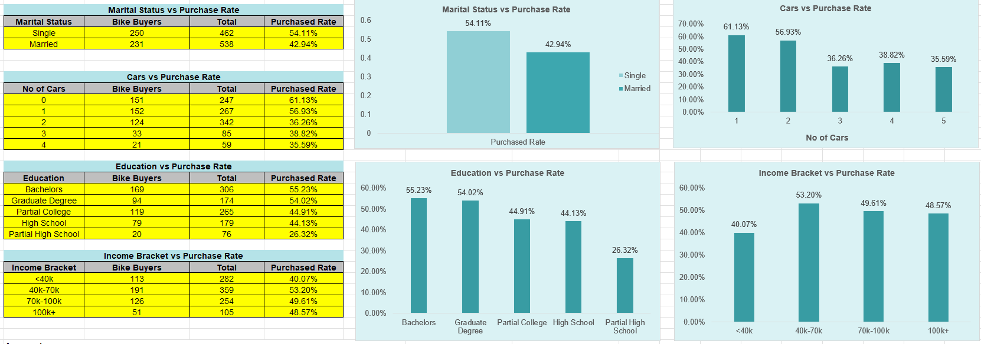

Approach:
Instead of only averaging buyer demographics, purchase rates were calculated across four key dimensions — marital status, number of cars, education, and income bracket — to identify which specific combination shows the highest likelihood of purchase, using formula-based tables and bar charts.
Key Findings:
Single customers purchase at a much higher rate (54.11%) than Married customers (42.94%).
Customers with 0 cars have the highest purchase rate (61.13%), decreasing sharply as car ownership increases.
Bachelor's degree holders have the highest purchase rate (55.23%), closely followed by Graduate Degree holders (54.02%).
Middle-income customers (40k-70k) show the highest purchase rate (53.20%) — higher income brackets do NOT convert best, showing income alone doesn't drive purchases.
Ideal Customer Profile: A Single individual, with 0 cars, holding a Bachelor's degree, earning between $40,000-$70,000 — this combination reflects the segments with the highest purchase rates across every dimension analyzed.
Recommendations:
Target Car-Free, Single Professionals (Highest Priority)
Focus on Middle-Income, Not High-Income Marketing
Leverage Education-Based Channels (Bachelor's/Graduate degree networks)
Method/Charts Used:
4 formula-based tables (Marital Status, Cars, Education, Income Bracket vs Purchase Rate) with corresponding bar charts.

Question 6: Evaluate whether having children affects the likelihood of purchasing a bike. What trends do you observe across different family sizes?
Answer:
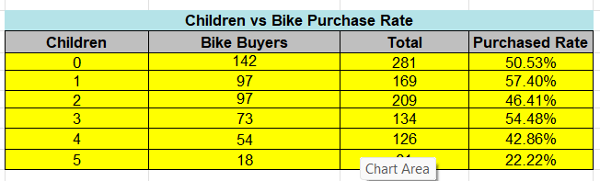
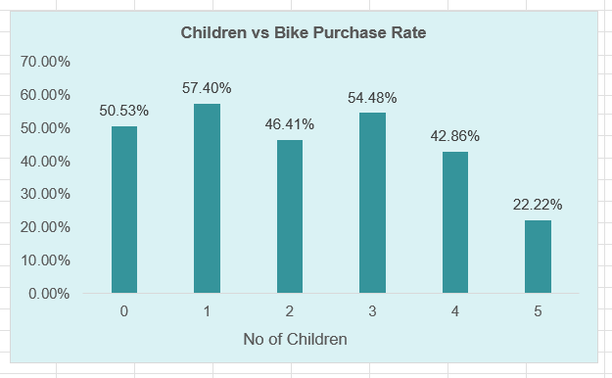
Approach:
A formula-based table was created showing purchase rate for each number of children (0-5), using COUNTIFS to calculate buyers and COUNTIF for total customers per group, visualized with a bar chart.
Key Findings:
The pattern is non-linear: 1 child (57.40%) and 3 children (54.48%) show the highest purchase rates, while 0 children (50.53%) and 2 children (46.41%) fall in between.
Families with 5 children show a dramatic drop to just 22.22% — the lowest rate by a wide margin, more than double the drop compared to any other group.
Overall, small-to-medium family sizes (1-3 children) tend to purchase more than very large families (5 children) or childless customers.
Recommendations:
Target Small Families (1-3 Children) as Primary Segment (Highest Priority): This group shows consistently higher purchase rates (46-57%), likely reflecting bikes as a practical family/lifestyle transportation or recreational choice.
Investigate Large-Family Barriers: The sharp drop-off at 5 children (22.22%) suggests budget constraints or shifted spending priorities toward other family needs — consider family-pack pricing or multi-child discounts to re-engage this segment.
Avoid Assuming a Simple "More Children = Less Interest" Rule: Since the relationship isn't strictly linear (3 children outperforms 2 children), messaging should be tailored by specific family size rather than a broad childless-vs-parent split.
Method/Charts Used:
Formula-based table: Children (0-5) vs Purchase Rate, using COUNTIFS and COUNTIF.
Bar Chart: "Children vs Bike Purchase Rate"

Question 7: If the company wants to increase bike purchases among customers with lower income or education levels, what strategies would you recommend based on your analysis?

Answer:

Approach:
This question builds on earlier findings (Q1, Q5, and Q10-Objective) to identify strategies for underserved segments. Purchase rates for low-income (<$40k: 40.07%) and low-education (High School: 44.13%, Partial High School: 26.32%) customers were compared against the overall average purchase rate (48.1%) to quantify the gap and inform recommendations.

Key Findings:
Low-income customers (<$40k) purchase at 40.07%, about 8 percentage points below the overall average.
Partial High School educated customers show the largest gap — only 26.32% purchase rate, nearly 22 points below average — making this the most underserved segment.
High School educated customers (44.13%) are closer to average but still underperforming.
Both segments overlap significantly with the "5 children" and "2+ cars" groups (from Q6 and Q2), suggesting affordability and existing transportation alternatives are likely key barriers, not lack of interest.
Recommendations (Prioritized):
Affordable Financing/EMI Options (Highest Priority): Since income is a clear barrier (40.07% vs 48.1% average), offering installment-based payment plans can make bikes accessible without requiring large upfront costs.
Entry-Level/Budget Bike Models: Introduce a lower-cost product line specifically positioned for price-sensitive segments, rather than only marketing premium bikes to this group.
Simplified, Practical Messaging: Shift marketing language from lifestyle/premium branding to functional benefits — cost savings on commute, health benefits, low maintenance — which resonate more with practical, budget-conscious buyers.
Partner with Community/Vocational Programs: Since Partial High School education shows the steepest drop-off (26.32%), targeted outreach through vocational training centers or community programs could improve awareness and trust in this segment.
Bundle or Referral Discounts: Family/group discounts could help offset the "large family, low purchase rate" pattern seen in Q6, making bikes more attractive for budget-conscious households.
Method/Charts Used:
Reference to previously calculated Purchase Rate data (Income Bracket table from Q5, Education table from Q5).
Comparison Table: Low-Income/Low-Education segments vs Overall Average (48.1%).
Bar Chart: "Low Income/Education Segments vs Overall Purchase Rate.

Question 8: How do bike purchase patterns vary across different age brackets? Create visualizations to support your analysis.
Answer:
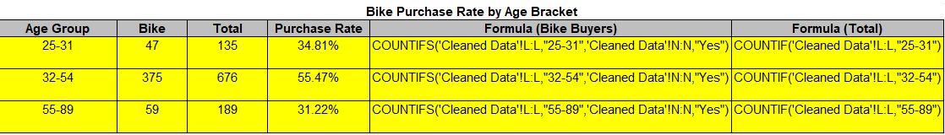
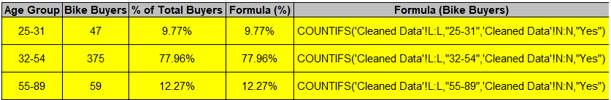
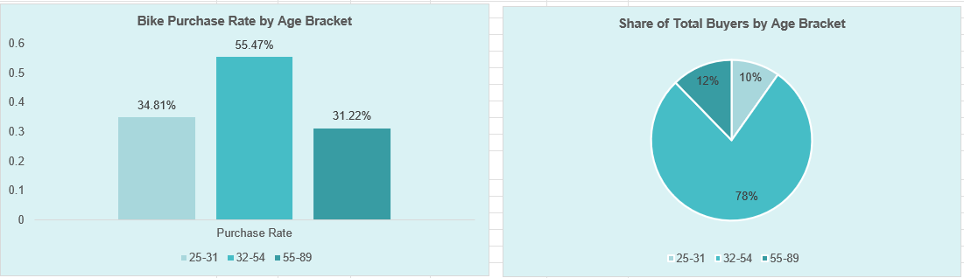
Approach:
Purchase patterns were examined from two angles — purchase rate within each age bracket, and each bracket's share of total buyers — using formula tables and bar/pie charts.
Key Findings:
32-54 age group has both the highest purchase rate (55.47%) AND accounts for the vast majority of buyers (77.96% of all 481 buyers) — this is by far the company's core customer base.
25-31 and 55-89 groups each contribute a small share (9.77% and 12.27% respectively) with similarly low conversion rates (34.81% and 31.22%).
The pattern shows heavy concentration risk: nearly 4 out of 5 buyers come from a single age bracket.
Recommendations:
Protect and Grow the Core (32-54) Segment: Since this group drives ~78% of sales, retention and loyalty programs here are critical.
Diversify into Younger/Older Segments: Heavy reliance on one age group is risky — targeted campaigns for 25-31 and 55-89 could reduce this concentration over time.
Different Messaging per Bracket: Younger buyers may respond to affordability/trend messaging, while older buyers may need comfort/health-focused positioning.

Method/Charts Used: Two formula tables (Purchase Rate + Share of Total Buyers), Bar Chart, Pie Chart.

Question 9: What trend do you observe between commute distance and bike purchase decisions? Use charts to explain your findings.

Answer:
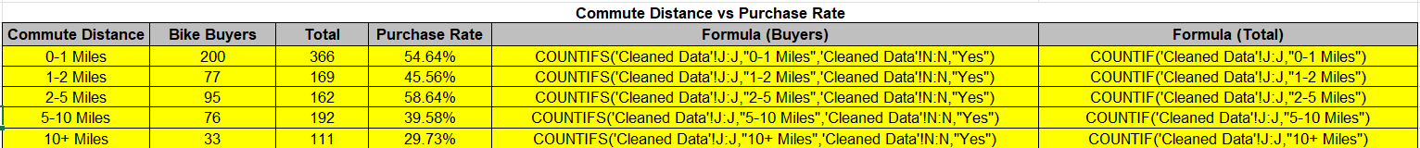

Approach:
Purchase rate was calculated for each commute distance bucket using COUNTIFS/COUNTIF formulas, visualized with a bar chart to observe the trend.

Key Findings:
2-5 Miles shows the highest purchase rate (58.64%), followed closely by 0-1 Miles (54.64%).
Purchase rate steadily declines as commute distance increases beyond 5 miles — 5-10 Miles drops to 39.58%, and 10+ Miles falls to just 29.73% (the lowest).
The overall trend forms an inverted-U pattern: very short commutes perform well, moderate commutes (2-5 miles) perform best, and long commutes (10+ miles) perform worst.
Recommendations:
Position Bikes as the Ideal Solution for 0-5 Mile Commutes (Highest Priority): This range shows the strongest conversion — marketing should directly target customers within this commute range.
Address Long-Commute Hesitancy: For 10+ mile commuters (29.73%), consider promoting e-bikes or hybrid models that make longer distances more feasible.
Use Location-Based Targeting: Since commute distance strongly predicts purchase likelihood, geographic/proximity-based marketing (e.g., targeting customers living near office hubs) could improve conversion.
Method/Charts Used: Formula table (Commute Distance vs Purchase Rate), Bar Chart "Purchase Rate by Commute Distance."

Question 10: How does the relationship between average income and gender influence the decision to purchase a bike? Provide a visual breakdown.

Answer:
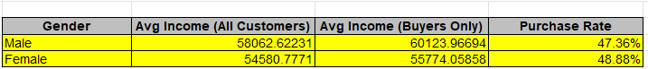

Approach: Average income was calculated separately for all customers and for buyers only, broken down by gender, alongside purchase rate by gender, to see whether income and gender together influence purchase decisions.
Key Findings:
Male buyers have a slightly higher average income ($60,123.97) than Female buyers ($55,774.06) — about a $4,350 gap.
Despite this income difference, purchase rate is nearly identical between genders — Female (48.88%) is actually marginally higher than Male (47.36%).
This shows income and gender don't combine to create a strong purchasing advantage for either group — Males earn more on average but aren't more likely to buy; Females earn less but buy at a comparable (even slightly higher) rate.
Recommendations:
Don't Rely on Income-Gender Combined Segmentation: Since purchase rate is nearly equal across genders regardless of the income gap, marketing budgets shouldn't be split by gender-income combinations — other factors (age, cars, commute distance) are stronger predictors, as shown in earlier questions.
Gender-Neutral Messaging: Given the near-identical purchase rates, campaigns can use unified messaging across genders rather than gender-specific pricing or product positioning.
Focus Spend on Proven Predictors: Redirect targeting resources toward the stronger signals already identified — age (32-54), car ownership (0 cars), and commute distance (2-5 miles) — rather than gender or income-gender combinations.
Method/Charts Used: Formula table (Gender vs Avg Income All/Buyers/Purchase Rate), Clustered Column Chart "Average Income by Gender (All vs Buyers)," Bar Chart "Purchase Rate by Gender”.

